Deliverables
Git Repository Link
https://github.com/Mlddi/csd-310
Screenshot of Repository
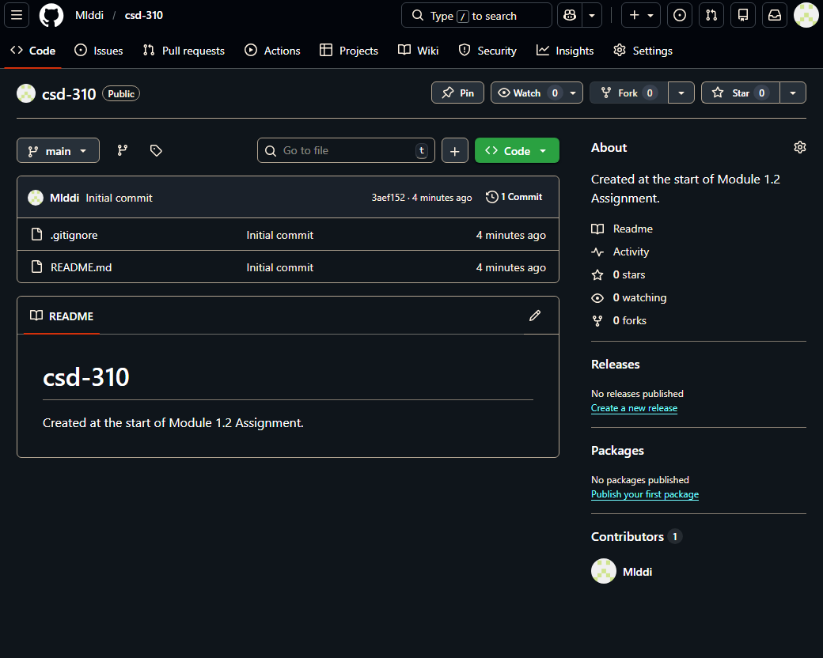
Screenshot of local directory
