Image
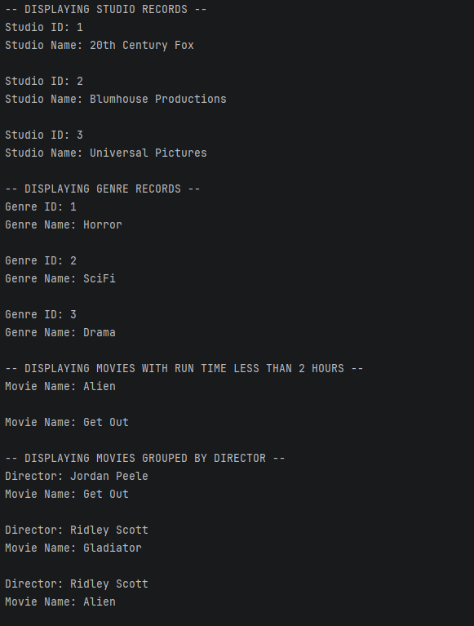
Link
https://cyberactive.bellevue.edu/ultra/courses/_544698_1/outline/assessment/_17778121_1/overview/attempt/create?linkContentId=_17778121_1&courseId=_544698_1

