Deliverables
Debugging
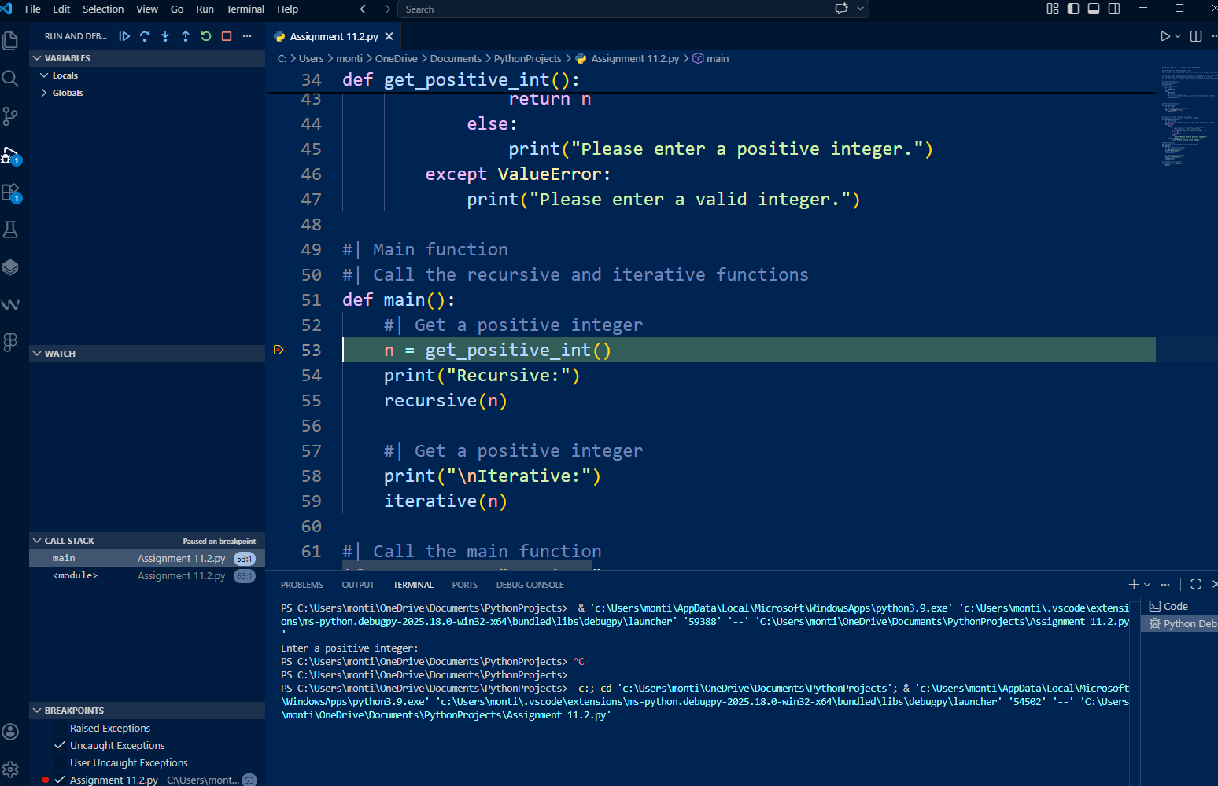
Correct Code Running in Debugger
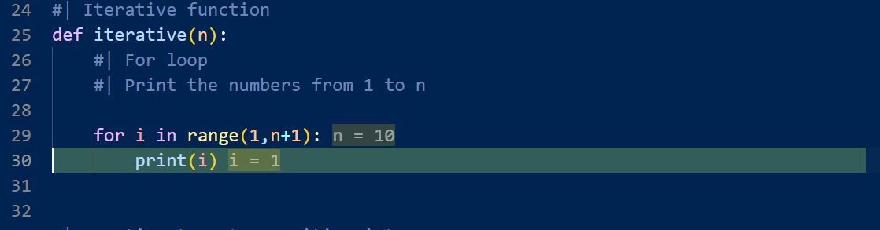
Incorrect Code Ends Code Prematurely, Caught by Debugger
