**Application Of Neural Networks To Robot Animals**

**Final Project CS547**

Matthew A. Letter

&

Lin sun

University of New Mexico

Neural Networks 547

mletter1@unm.edu

sun@unm.edu

Table of Contents

Abstract 3

1. Introduction 3

2. Approach 3

2.1 Architecture 0: No movement, measure lifetime 3

2.2 Architecture 1: Movement, measure lifetime as a function of speed without eating food 3

2.3 Architecture 2: Movement, measure lifetime as a function of speed with eating food 4

2.4 Architecture 3: Neuronal Classification of food using Food RGB Values 4

2.5 Architecture 4: Neuronal Movement towards brightest object 4

2.6 Architecture 5: Move robot based on intensity and eat based on classification 6

2.7 Architecture 6: Neuronal Classification of food using Food RGB Percentage 6

2.8 Architecture 7: Eat Objects based on Neuron Classification using RGB Percentage 6

2.9 Architecture 8: Classify objects based on visual lights and acoustic sounds: 6

3. Results 7

3.1 Architecture 0: No movement, measure lifetime 7

3.2 Architecture 1: Movement, measure lifetime as a function of speed without eating food 7

3.3 Architecture 2: Movement, measure lifetime as a function of speed with eating food 8

3.4 Architecture 3: Neuronal Classification of food 10

3.5 Architecture 4: Neuronal Movement towards brightest object 10

3.6 Architecture 5: Eat objects based on neuronal classification 11

4. Discussion 11

5. Summary and Conclusion 11

6. Acknowledgements 11

7. References 11

8. Appendix A 12

# Abstract

Add abstract here, single space, 12pt intentionally blank

# 1. Introduction

This paper rigorously establishes that neural network design models can be used to manipulate learning on simulated biological system. All the research was done using professor Thomas Caudell’s animal robot environmental model. (Caudell) The starting point of the research involved 3 architectures, used to establish the parameters of life with respect to the simulated organism and its environment. These provide a basis for analyzing the implemented neural network algorithms, the goal of which is to create a “neuron” based brain for the robot organism to live as long as possible in its environment, and determine what neuronal design structures degrade or enhance this attribute.

# 2. Approach

### 2.1 Architecture 0: No movement, measure lifetime

For the first architecture, we will test the basic metabolic consumption for the robot. The robot’s speed was set to 0; therefore the robot was programmed to do nothing until it dies. Finally the lifespan was measured for analysis.

### 2.2 Architecture 1: Movement, measure lifetime as a function of speed without eating food

This test is designed to explore the effect of the robots speed variation on its run lifespan and varying the robots direction correlated to lifespan. The goal of this experiment is to determine a correlation between the speed of the robot and its metabolism. Furthermore, the direction change should yield insight into the world around the robot. The robot will start at the same position where the direction and speed will be varied. To try test different directions, we will turn the neuron head to 5 degree counter-clockwise each time. When the neuron is moving, it will always head to the brightest object in the space, no matter if the food is poisonous or not. The robot will be set to eat nothing in the world.

### 2.3 Architecture 2: Movement, measure lifetime as a function of speed with eating food

This test is designed to explore the effect eating on robot’s lifetime. This is different from Architecture 1 in that neuron will eat all of the food it encounters. When the robot is moving, it will always head to the brightest object in the space, no matter what type of object it is. To get a well-distributed random speed, the initial robot head angle will be changed for each run, but the initial position will be held constant at the point of origination.

### 2.4 Architecture 3: Neuronal Classification of food using Food RGB Values

This test will check classification of food as either good or bad based on whether the food could increase or decrease energy of the robot using LMS neuron architecture. If the food increases the energy of the robot, the food is classified as good; otherwise, we say that the food is bad. For a simple starting neural architecture an LMS neuron to classify the food. In order to classify the objects, we should know the weights for classification neuron. Using the objects eaten in the world, training of the neuron will be conducted.

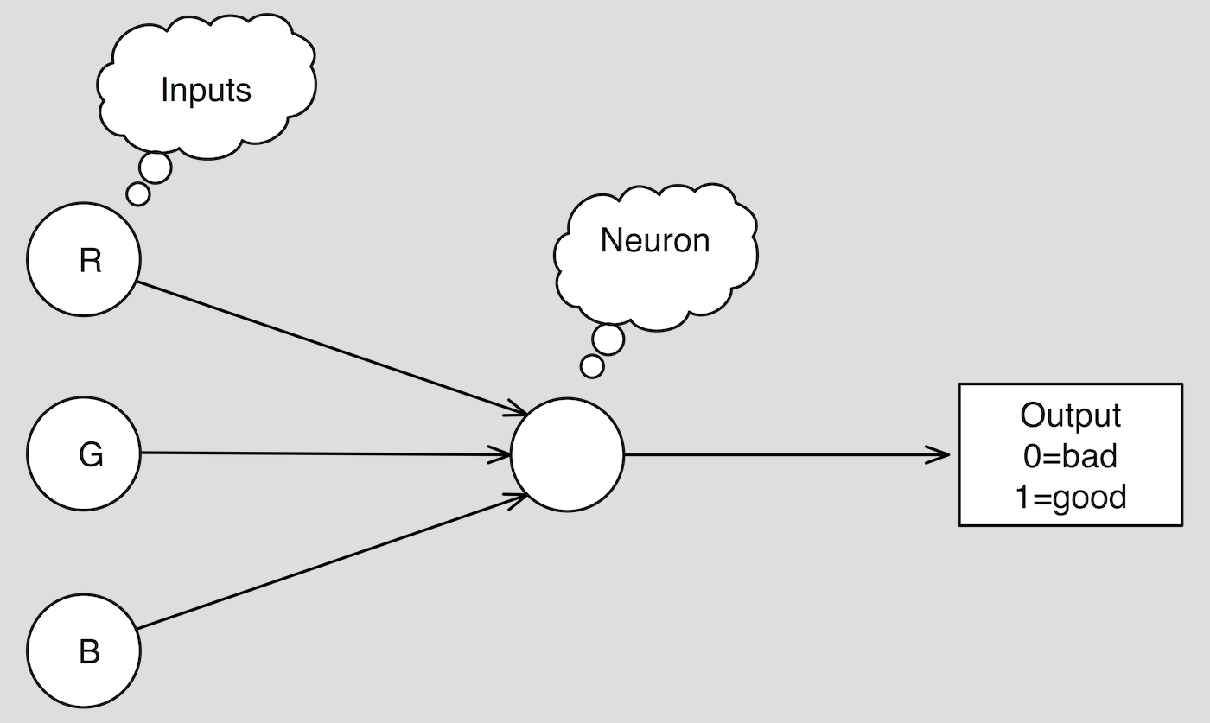

Figure 1: Network diagram of the LMS neuron for classifying food

### 2.5 Architecture 4: Neuronal Movement towards brightest object

The goal of this architecture is to move towards the brightest object using a winner takes all neuronal networks implementation. Movement is the next logical step after classification of food since we have to have a way of moving toward objects. In order to give the robot the ability to seek out objects a neuron will be added that will make a direction choice.

The neuron will choose the direction based on the incoming light intensity. It is known that the light intensity is inversely related to the distance between the robot and an object. Meaning that objects having higher light intensity are closer to the robot than other objects with lower light intensity. In the simulation world, the robot wants to survive for as long as possible. Therefore, it should try to move towards the objects in the world closer to it. Equation 1.1 shows the equation for deciding which direction to move towards. Based on the thought process above, a neuron like the one in Fig 2 will be tested. The inputs for the input are RGB lights waves from 31 directions, while the output is the angle of the lightest object with respect to the horizontal line. So the direction that the neuron will change towards is the direction of the robot automatically based on light intensity.

$d = argmax\left(\sum{\left(r^{2} + g^{2} + b^{2}\right)}\right)$ (eq 1.1)

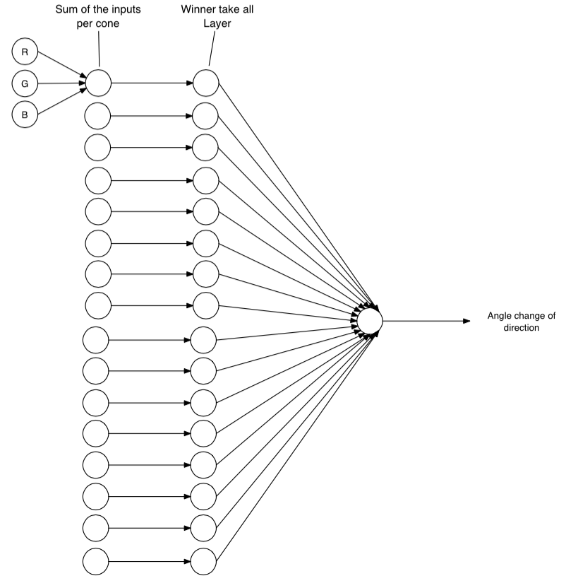

Figure 2: This is a three layer neural network where the RGB circles denotes the intensity signal bands being received by the first layer. The second layer is a winner-take all network which selects the brightest cone. The third layer is a neuron, which computes the angle change for movement

### 2.6 Architecture 5: Move robot based on intensity and eat based on classification

Architecture 5 is very similar to architecture 3 except that we are normalizing the RGB input vectors to solve the problem of intensity that is given off from objects at different distances. The goal of this neuron is to classify objects without bias on the distance.



Figure 1: Network diagram of the LMS neuron for classifying food with the caveat of normalized inputs

### 2.7 Architecture 6: Neuronal Classification of food using Food RGB Percentage

In architecture 3, we use RGB values to classify objects. However, if robot is far away from the object, the light value is decreased for each single bandwidth. Therefore, it cannot be trusted to classify objects, which are far away from the robot. The goal of this architecture is to see if a normalized RGB value can be used to generate the same result as the original RGB values.

### 2.8 Architecture 7: Eat Objects based on Neuron Classification using RGB Percentage

In architecture 6, we use normalized RGB value to classify the object. So we will choose the direction based on both intensity and poisonous. So we will choose the most intense direction, which has nonpoisonous objects.

### 2.9 Architecture 8: Classify objects based on visual lights and acoustic sounds:

# 3. Results

### 3.1 Architecture 0: No movement, measure lifetime

Table 1: Over 200 runs, every run of a stationary robot had a lifespan of 5001 cycles

| No Movement Lifetime | | |
| --- | --- | --- |
| Speed Rate | Lifetime Mean (Cycles) | Lifetime Standard Deviation |
| 0.02 | 4541 | 884 |

From Table 1, we see that the robot life is 5001 cycles if it does not move and does not eat any food. The robot needs one cycle to jump out the loop initial start. So totally there are 5000 cycles of life given initially by the world to the robot at birth. Therefore, we could see that the basic metabolic rate should be 0.0002 unit/cycle.

### 3.2 Architecture 1: Movement, measure lifetime as a function of speed without eating food

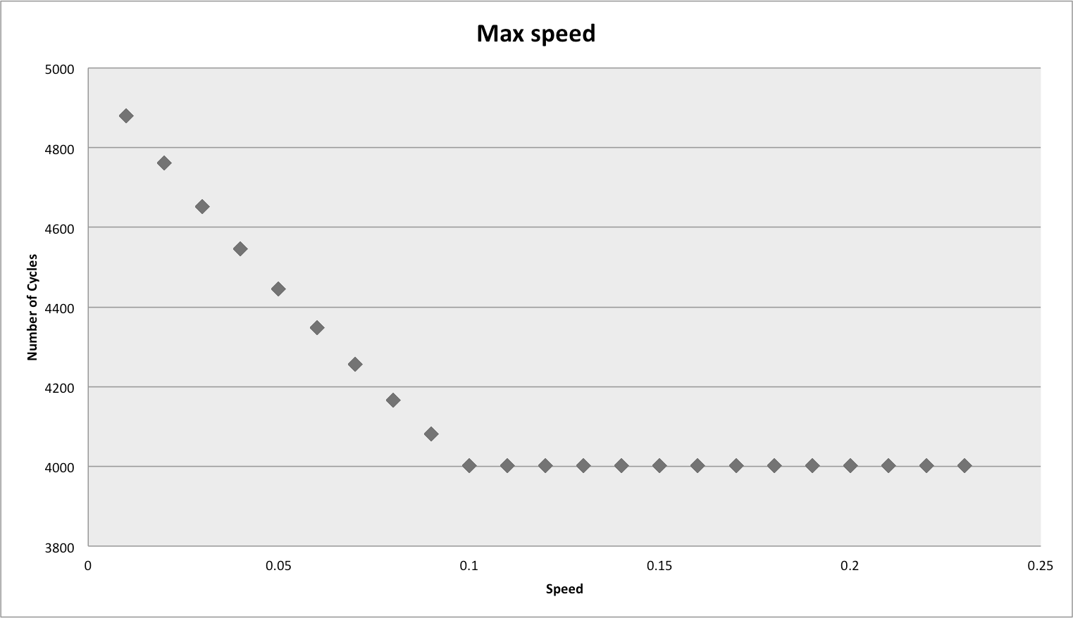

Figure 1: Shows the max speed of the robot to be 0.1

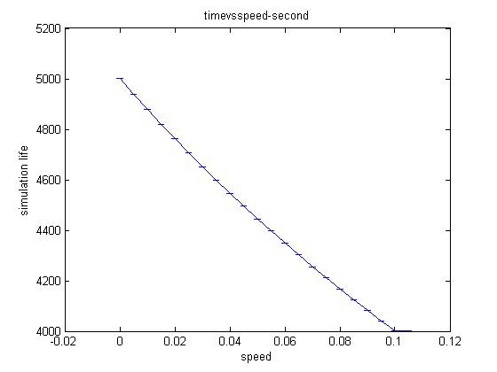

Figure 2: Linear function of the life cycles with respect to the Robots speed.

From Figure 1, we could see lifetime is related with the robot’s speed. When the speed is low, the lifetime has a nearly linear function with speed. As speed increases, the lifetime is decreased. But when the speed is over 0.1, the lifetime is stabilized. So the speed will not change even though the speed is increasing. Besides, even though we change the head angle from the same origin, the lifetime for the same speed is still the same. Therefore, the standard deviation for lifetime at the same speed is the 0.

### 3.3 Architecture 2: Movement, measure lifetime as a function of speed with eating food

Figure 3: Error bar graph of varying speeds and directions

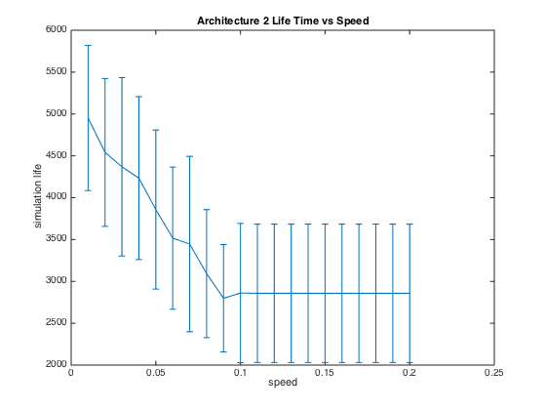

Table 2: Robot Lifetime Mean and Standard Deviation for Different Speed Rate

| Robot Lifetime Mean and Standard Deviation for Different Speed Rate | | |
| --- | --- | --- |
| Speed Rate | Lifetime Mean (Cycles) | Lifetime Standard Deviation |
| 0.02 | 4541 | 884 |
| 0.04 | 4233 | 973 |
| 0.06 | 3517 | 849 |
| 0.08 | 3093 | 765 |
| 0.10 | 2861 | 832 |
| 0.12 | 2858 | 827 |
| 0.14 | 2858 | 827 |

Fig 3 shows the final result of lifetime vs speed while robot could eat food in the word. Like Architecture 2, the lifetime is relevant with speed when the speed is low. As speed increases, the lifetime is decreased. But when robot speed goes over 0.1, the lifetime is stabilized even though there is still standard deviation for the same speed with different initial head angle.

### 3.4 Architecture 3: Neuronal Classification of food

Fig 4 RMS vs lifetime training result

| Table … Classification Neuron Weights after training | | | | |
| --- | --- | --- | --- | --- |
| Weight Index | 0 | 1 | 2 | 3 |
| Value | -0.0593627 | -0.0574903 | 0.643285 | -0.0570887 |

Fig 4 shows training result for the classification neuron. We could see that at the beginning the RMS drops very quickly and dramatically. However, after a few cycles, the RMS values is stabilized but still tremble within 0.2 and 0.35. So we could see that the neuron is trained well after that. Table … shows the weight for the final trained neuron using RGB values. Therefore, in the following experience, we could use these weight to classify the objects robot meets and decide if robot should eat the objects or not.

### 3.5 Architecture 4: Neuronal Movement towards brightest object

In 2.5, we have shown the theory about how to make decision on direction for the neuron. However, we need to verify if the neuron algorithm we implement is correct or not. Fortunately, there is an internal implemented function called intensity_winner_takes_all which returns the index of the receptor which got the most intensity. Then we will compare the result from our function and the internal function to see if they are the same. Fig … shows the result for both functions. We can see that the neuron implemented here generates the same result as the internal functions. Therefore, our function is right.

Need plot the data

Fig … Direction Decision Neuron Checking

### 3.6 Architecture 5: Eat objects based on neuronal classification

In this architecture, we will let neuron

# 4. Discussion

# 5. Summary and Conclusion

# 6. Acknowledgements

# 7. References

1. Caudell, Thomas. "Flatworld."
2. Haykin, Simon S. *Neural Networks: A Comprehensive Foundation*. Upper Saddle River, NJ: Prentice Hall, 1999. Print

# 8. Appendix A