1b.

* Tool: BALSTP
* Algorithm: blastp (protein-protein BLAST)
* Scoring Matrix: PAM 30
* Gap penalty: Existence: 9, Extension: 1
* Query Length: 380

1c.

Name: cytochrome b

Organism: Homo sapiens neanderthalensis

Accession: YP_002124314

Version: YP_002124314.2

1d.

Accession number: YP_002124314.2

Max score: 789

Total score: 789

Query cover: 100%

E-value: 0

Per identity: 100.00%

Yes, I get an exact match because per identity is 100% and query cover is 100%.

2a.

ORIGIN

1 gatcacaggt ctatcaccct attaaccact cacgggagct ctccatgcat ttggtatttt

61 cgtctggggg gtgtgcacgc gatagcattg cgagacgctg gagccggagc accctatgtc

121 gcagtatctg tctttgattc ctgccccatt ccattattta tcgcacctac gttcaatatt

181 acaggcgagc atacttactg aagtgtgtta attaattaat gcttgtagga cataataata

241 acgactaaat gtctgcacag ctgctttcca cacagacatc ataacaaaaa atttccacca

301 aaccccccct cccccgcttc tggccacagc acttaaacac atctctgcca aaccccaaaa

361 acaaagaacc ctaacaccag cctaaccaga tttcaaattt tatcttttgg cggtatacac

421 ttttaacagt caccccctaa ctaacacatt attttcccct cccactccca tactactaat

481 ctcatcaata caacccccgc ccatcctacc cagcacacac cgctgctaac cccatacccc

541 gagccaacca aaccccaaag acacccccca cagtttatgt agcttacctc ctcaaagcaa

601 tacactgaaa atgtttagac gggctcacat caccccataa acaaataggt ttggtcctag

661 cctttctatt agctcttagt aagattacac atgcaagcat ccccattcca gtgagttcac

721 cctctaaatc accacgatca aaagggacaa gcatcaagca cgcaacaatg cagctcaaaa

781 cgcttagcct agccacaccc ccacgggaaa cagcagtgat aagcctttag caataaacga

841 aagtttaact aagctatact aaccccaggg ttggtcaatt tcgtgccagc caccgcggtc

901 acacgattaa cccaagtcaa tagaagccgg cgtaaagagt gttttagatc accccctccc

961 caataaagct aaaactcacc tgagttgtaa aaaactccag ttgacacaaa ataaactacg

1021 aaagtggctt taacatatct gaacacacaa tagctaagac ccaaactggg attagatacc

1081 ccactatgct tagccctaaa cctcaacagt taaatcaaca aaactgctcg ccagaacact

1141 acgagccaca gcttaaaact caaaggacct ggcggtgctt catatccctc tagaggagcc

1201 tgttctgtaa tcgataaacc ccgatcaacc tcaccacctc ttgctcagcc tatataccgc

1261 catcttcagc aaaccctgat gaaggctaca aagtaagcgc aagtacccac gtaaagacgt

1321 taggtcaagg tgtagcccat gaggtggcaa gaaatgggct acattttcta ccccagaaaa

1381 ctacgatagc ccttatgaaa cctaagggtc gaaggtggat ttagcagtaa actgagagta

1441 gagtgcttag ttgaacaggg ccctgaagcg cgtacacacc gcccgtcacc ctcctcaagt

1501 atacttcaaa ggacatttaa ctaaaacccc tacgcattta tatagaggag acaagtcgta

1561 acatggtaag tgtactggaa agtgcacttg gacgaaccag agtgtagctt aacacaaagc

1621 acccaactta cacttaggag atttcaactt aacttgaccg ctctgagcta aacctagccc

1681 caaacccact ccaccttact accaaacaac cttagccaaa ccatttaccc aaataaagta

1741 taggcgatag aaattgaaac ctggcgcaat agatgtagta ccgcaaggga aagatgaaaa

1801 attataacca agcataatat agcaaggact aacccctata ccttctgcat aatgaattaa

1861 ctagaaataa ctttgcaagg agagccaaag ctaagacccc cgaaaccaga cgagctacct

1921 aagaacagct aaaagagcac acccgtctat gtagcaaaat agtgggaaga tttataggta

1981 gaggcgacaa acctaccgag cctggtgata gctggttgtc caagatagaa tcttagttca

2041 actttaaatt tacccacaga accctctaaa tccccttgta aatttaactg ttagtccaaa

2101 gaggaacagc tctttggaca ctaggaaaaa accttgtaga gagagtaaaa aatttaacac

2161 ccatagtagg cctaaaagca gccaccaatt aagaaagcgt tcaagctcaa cacccactac

2221 ctaaaaaatc ccaaacatat aactgaactc ctcacaccca attggaccaa tctatcaccc

2281 tatagaagaa ctaatgttag tataagtaac atgaaaacat tctcctccgc ataagcctgc

2341 gtcagattaa aacactgaac tgacaattaa cagcccaata tctacaatca accaacaagt

2401 cattattacc ctcactgtca acccaacaca ggcatgctca taaggaaagg ttaaaaaaag

2461 taaaaggaac tcggcaaatc ttaccccgcc tgtttaccaa aaacatcacc tctagcatta

2521 ccagtattag aggcaccgcc tgcccagtga cacatgttta acggccgcgg taccctaacc

2581 gtgcaaaggt agcataatca cttgttcctt aaatagggac ctgtatgaat ggctccacga

2641 gggttcagct gtctcttact tttaaccagt gaaattgacc tgcccgtgaa gaggcgggca

2701 taacacagca agacgagaag accctatgga gctttaattt attaatgcaa acagtaccta

2761 acaaacccac aggtcctaaa ctaccaaacc tgcattaaaa atttcggttg gggcgacctc

2821 ggagcacaac ccaacctccg agcagtacat gctaagacct caccagtcaa agcgaactac

2881 catactcaat tgatccaata acttgaccaa cggaacaagt taccctaggg ataacagcgc

2941 aatcctattc tagagtccat atcaacaata gggtttacga cctcgatgtt ggatcaggac

3001 atcccaatgg tgcagccgct attaaaggtt cgtttgttca acgattaaag tcctacgtga

3061 tctgagttca gaccggagta atccaggtcg gtttctatct acttcaaatt cctccctgta

3121 cgaaaggaca agagaaataa ggcctacttc acaaagcgcc ttcccccgta aatgatatca

3181 tctcaactta gtattatacc cacacccacc caagaacagg gtttgttaag atggcagagc

3241 ccggtaatcg cataaaactt aaaactttac agtcagaggt tcaattcctc ttcttaacaa

3301 cacacccatg gccaacctcc tactcctcgt tgtacccatt ctaatcgcaa tggcattcct

3361 aatgcttacc gaacgaaaaa ttctaggcta tatgcaacta cgcaaaggtc ccaacgttgt

3421 aggcccctac gggctactac aacccttcgc tgacgccata aaactcttca ccaaagaacc

3481 cctaaaaccc gccacatcca ccatcaccct ctacatcacc gccccgacct tagctctcac

3541 catcgctctt ctactatgaa cccccctccc catacccaac cccctggtta acctcaacct

3601 aggcctccta tttattctag ccacctctag cctagccgtt tactcaatcc tctgatcagg

3661 gtgagcatca aactcaaact acgccctgat cggcgcactg cgagcagtag cccaaacaat

3721 ctcatatgaa gtcaccctag ccatcattct actatcaaca ttactaataa gtggctcctt

3781 taacctctcc acccttatca cagcacaaga acacctctga ttactcctgc catcatgacc

3841 cttggccata atatgattta tctccacact agcagagacc aaccgaaccc ccttcgacct

3901 tgctgaaggg gaatccgaac tagtctcagg ctttaacatc gaatacgccg caggcccctt

3961 cgccctattc ttcatagccg aatacacaaa cattattata ataaacaccc tcaccactac

4021 aatcttccta ggaacaacat ataacgcact ctcccctgaa ctctacacaa catattttgt

4081 caccaagacc ctacttctga cctccctgtt cttatgaatt cgaacagcat acccccgatt

4141 ccgctacgac caactcatac acctcctatg aaaaaacttc ctaccactca ccctagcact

4201 acttatatga tatgtctcca tacccattac aatctccagc attccccctc aaacctaaga

4261 aatatgtctg ataaaagagt tactttgata gagtaaataa taggagttta aaccccctta

4321 tttctaggac tatgagaatc gaacccatcc ctgagaatcc aaaattctcc gtgccaccta

4381 tcacacccca tcctaaagta aggtcagcta aataagctat cgggcccata ccccgaaaat

4441 gttggttata cccttcccgt actaattaat cccctggccc aacccgtcat ctactctacc

4501 atctttgcag gcacactcat cacagcacta agctcgcact gattttttac ctgagtgggc

4561 ctagaaataa acatgctagc ttttattcca gttctaacca aaaaaataaa ccctcgttcc

4621 acagaagctg ccatcaagta tttcctcacg caagcaaccg catccataat ccttctaata

4681 gctatcctct tcaacaatat actctccgga caatgaacca taaccaatac taccaatcaa

4741 tactcatcat taataatcat aatggctata gcaataaaac taggaatagc cccctttcac

4801 ttctgagtcc cagaggttac ccaaggcacc cctctgacat ccggcctgct ccttctcaca

4861 tgacaaaaac tagcccccat ctcaatcata taccaaattt ctccctcact aaacgtaagc

4921 ctcctcctca ctctttcaat cttatccatc atagcaggca gttgaggtgg attaaaccaa

4981 acccagctac gcaaaatctt agcatactcc tcaattaccc acataggatg aataatagca

5041 gttctaccgt acaaccctaa cataaccatt cttaatttaa ctatttatat tatcctaact

5101 actaccgcat tcctactact caacttaaac tccagcacca cgaccctact actatctcgc

5161 acctgaaaca agctaacatg actaacaccc ttaattccat ccaccctcct ctccctagga

5221 ggcctgcccc cgctaaccgg ctttttgccc aaatgggcca ttatcgaaga attcacaaaa

5281 aacaatagcc tcatcatccc caccatcata gccaccatca ccctccttaa cctctacttc

5341 tacctacgcc taatctactc cacctcaatc acactactcc ctatatctaa caacgtaaaa

5401 ataaaatgac agtttgaaca tacaaaaccc accccattcc tccccacact catcaccctt

5461 accacactac tcctacctat ctcccctttt atactaatag tcttatagaa atttaggtta

5521 aatacagacc aagagccttc aaagccctca gtaagttgca atacttaatt tctgcaacag

5581 ctaaggactg caaaacccca ctctgcatca actgaacgca aatcagccac tttaattaag

5641 ctaagccctt actagaccaa tgggactcaa acccacaaac acttagttaa cagctaagca

5701 ccctaatcaa ctggcttcaa tctacttctc ccgccgccgg gaaaaaaggc gggagaagcc

5761 ccggcaggtt tgaagctgct tcttcgaatt tgcaattcaa tatgaaaatc acctcagagc

5821 tggtaaaaag aggcttaacc cctgtcttta gatttacagt ccaatgcttc actcagccat

5881 tttacctcac ccccactgat gttcgccgac cgttgactat tctctacaaa ccacaaagac

5941 attggaacac tatacctact attcggcgca tgagctggag tcctaggcac agctctaagc

6001 ctccttattc gagccgaact gggccagcca ggcaaccttc taggtaacga ccacatctac

6061 aacgttatcg tcacagccca tgcatttgta ataatcttct tcatagtaat acccatcata

6121 atcgggggct ttggcaactg actagttccc ttaataatcg gtgcccccga tatggcgttt

6181 ccccgcataa acaatataag cttctgactc ttacctccct ctctcctact cctgctcgca

6241 tctgctatag tggaagccgg cgcaggaaca ggttgaacag tctaccctcc cttagcaggg

6301 aactactccc accctggagc ctccgtagac ctaaccatct tctccttaca cctagcaggt

6361 gtctcctcta tcttaggggc catcaatttc atcacaacaa ttattaatat aaaaccccct

6421 gccataaccc aataccaaac gccccttttc gtctgatccg tcctaatcac agcagtccta

6481 cttctcctat ctctcccagt cctagctgct ggcatcacta tactactaac agaccgcaac

6541 ctcaacacca ccttcttcga ccccgccgga ggaggagacc ccattctata ccaacaccta

6601 ttctgatttt tcggccaccc tgaagtttat attctcatcc taccaggctt cggaataatc

6661 tcccatattg taacttacta ctccggaaaa aaagaaccat ttggatacat aggtatggtc

6721 tgagctatga tatcaattgg cttcctaggg tttatcgtgt gagcacacca tatatttaca

6781 gtaggaatag acgtagacac acgagcatat ttcacctccg ctaccataat catcgctatc

6841 cccaccggcg tcaaagtatt tagctgactc gccacactcc acggaagcaa tatgaaatga

6901 tctgctgcag tgctctgagc cctaggattc atctttcttt tcaccgtagg tggcctgact

6961 ggcattgtat tagcaaactc atcactagac atcgtactac acgacacgta ctacgttgta

7021 gctcacttcc actatgtcct atcaatagga gctgtatttg ccatcatagg aggcttcatt

7081 cactgatttc ccctattctc cggctacacc ctagaccaaa cttacgccaa aatccatttc

7141 actatcatat tcatcggcgt aaatctaact ttcttcccac aacactttct cggcctatcc

7201 ggaatgcccc gacgttactc ggactacccc gatgcataca ccacatgaaa tatcctatca

7261 tctgtaggct cattcatttc tctaacagca gtaatattaa taattttcat gatttgagaa

7321 gccttcgctt cgaagcgaaa agtcctaata gtagaagaac cctccataaa cctggagtga

7381 ctatatggat gccccccacc ctaccacaca ttcgaagagc ccgtatacat aaaatctaga

7441 caaaaaagga aggaatcgaa ccccccaaag ctggtttcaa gccaacccca tggcctccat

7501 gactttttca aaaagatatt agaaaaacca tttcataact ttgtcaaagt taaattatag

7561 gctaaatcct atatatctta atggcacatg cagcgcaagt aggtctacaa gacgctactt

7621 cccctatcat agaagagctt atcatctttc atgatcacgc cctcataatc attttcctta

7681 tctgcttcct agtcctgtat gcccttttcc taacactcac aacaaaacta actaatacta

7741 gcatctcaga cgctcaggaa atagaaaccg tctgaactat cctgcccgcc atcatcctag

7801 tcctcatcgc cctcccatcc ctacgcatcc tttacataac agacgaggtc aacgacccct

7861 cctttaccat caaatcaatt ggccatcaat ggtactgaac ctacgagtac accgactacg

7921 gcggactaat cttcaactcc tacatacttc ccccattatt cctagaacca ggcgacctgc

7981 gactccttga cgttgacaat cgagtagtac tcccggttga agcccccatt cgtataataa

8041 ttacatcaca agacgtctta cactcatgag ctgtccccac attaggctta aaaacagatg

8101 caattcccgg acgtctaaac caaaccactt tcaccgctac acgaccgggg gtatactacg

8161 gtcaatgctc tgaaatctgt ggagcaaacc acagtttcat gcccatcgtc ctagaattaa

8221 ttcccctaaa aatctttgaa atagggcccg tatttaccct atagcacccc ctctaccccc

8281 tctagagccc actgtaaagc taacttagca ttaacctttt aagttaaaga ttaagagaac

8341 cagcacctct ttacagtgag atgccccaac taaatactac tgtatggccc accataatta

8401 tccccatact ccttacacta ttcctcatca cccaactaaa aatattaaat acaaattacc

8461 acttacctcc ctcaccaaag cccataaaaa taaaaaacta taacaaaccc tgagaaccaa

8521 aatgaacgaa aatctgttcg cttcattcat tgcccccaca atcctaggcc tacccgccgc

8581 agtactgatc attctatttc cccctctatt gatccccacc tccaaatatc tcatcaacaa

8641 ccgactaatt accacccaac aatgactaat caaactaacc tcaaaacaaa tgatagccat

8701 acacaacact aagggacgaa cctgatctct tatactagta tccttaatca tttttattac

8761 cacaactaac ctcctcggac tcctgcctca ctcatttaca ccaaccaccc aactatctat

8821 aaacctagcc atggccatcc ccttatgagc gggcgcagtg attataggct ttcgctctaa

8881 gattaaaaat gccctagccc acttcttacc acaaggcaca cctacacccc ttatccctat

8941 actagttatt atcgaaacca tcagcctact cattcaacca gtagccctgg ccgtacgcct

9001 aaccgctaac attactgcag gtcacctact catgcaccta attggaaacg ccaccctagc

9061 aatatcaacc attaaccttc cctctacact tatcatcttc acaattctaa ttctactgac

9121 tatcctagaa atcgctgtcg ccttaatcca agcctacgtt ttcacacttc tagtaagcct

9181 ctacctgcac gacaacacat aatgacccac caatcacatg cctatcatat agtaaaaccc

9241 agcccatgac ccctaacagg ggccctctca gccctcctaa tgacctccgg cctagccatg

9301 tgatttcact tccactccac aaccctcctc atactaggct tactaaccaa cacactaacc

9361 atataccaat gatggcgcga tgtaacacga gaaagcacat accaaggcca ccacacacca

9421 cctgtccaaa aaggccttcg atacgggata gtcctattta ttacctcaga agtttttttc

9481 ttcgcaggat ttttctgagc cttttaccac tccagcctag cccctacccc ccaactagga

9541 gggcactggc ccccaacagg catcaccccg ctaaatcccc tagaagtccc actcctaaac

9601 acatccgtat tactcgcatc aggagtatca atcacctgag ctcaccatag tctaatagaa

9661 aacaaccgaa accaaataat tcaagcactg cttattacaa ttttactggg tctctatttt

9721 accctcctac aagcctcaga gtacttcgaa tctcccttca ccatttccga cggcatctac

9781 ggctcaacat tttttgtagc cacaggcttc cacggacttc acgtcattat tggctcaact

9841 ttcctcacta tctgcttcat ccgtcaacta atatttcact ttacatccaa acatcacttt

9901 ggcttcgaag ccgccgcctg atactggcat tttgtagatg tggtttgact atttctgtat

9961 gtctccatct attgatgagg gtcttactct tttagtataa atagtaccgt taacttccaa

10021 ttaactagtt ttgacaacat tcaaaaaaga gtaataaact tcgccttaat tttaataatc

10081 aacaccctcc tagccctact actaataatt attacatttt gactaccaca actcaacggc

10141 tacatagaaa aatccacccc ttacgagtgc ggcttcgacc ctatatcccc cgcccgcgtc

10201 cctttctcca taaaattctt cttagtagct attaccttct tattatttga cctagaaatt

10261 gccctccttt tacccttacc atgagcccta caaacaacta atctaccact aatagttacg

10321 tcatccctct tattaatcat catcctagcc ctaagtctgg cctatgaatg actacaaaaa

10381 ggattagact gagccgaatt ggtatatagt ttaaacaaaa cgaatgattt cgactcatta

10441 aattatgata atcatattta ccaaatgccc ctcatttaca taaatattat actagcattt

10501 accatctcac ttctgggaat actagtgtat cgctcacacc tcatatcctc cctactatgc

10561 ctagaaggaa taatactatc gctgttcatt atagctactc tcataaccct caacacccac

10621 tccctcttag ccaatattgt gcctattgcc atactagttt ttgccgcctg cgaagcagcg

10681 gtaggcctag ccctactagt ctcaatctcc aacacatatg gcctagacta cgtacataac

10741 ctaagcctac tccaatgcta aaactaatcg tcccaacaat tatattacta ccactgacat

10801 gactctccaa aaaacacata atttgaatca acacaaccac ccacagccta attattagca

10861 tcatccccct actatttttt aaccaaatca acaacaacct atttagctgc tccccaacct

10921 tttcctccga ccccctaaca acccccctcc taatactaac tacctgactc ctacccctca

10981 caatcatggc aagccaacgc cacttatcca gtgaaccact atcacgaaaa aaactctacc

11041 tctctatact aatctcccta caaatctcct taattataac attcacagcc acagaactaa

11101 tcatatttta tatcttcttc gaaaccacac ttatccccac cttggctatc atcacccgat

11161 gaggcaacca gccagaacgc ctgaacgcag gcacatactt cctattctac accctagtag

11221 gctcccttcc cctactcatc gcactaattt acactcacaa caccctaggc tcactaaaca

11281 ttctactact cactctcact gcccaagaac tatcaaactc ctgagccaac aacttaatat

11341 gactagctta cacaatagct tttatagtaa agatacccct ttacggactc cacttatgac

11401 tccctaaagc ccatgtcgaa gcccccatcg ctgggtcaat agtacttgcc gctgtactct

11461 taaaactagg cggctatggt ataatacgcc tcacactcat tctcaacccc ctgacaaaac

11521 atatagccta ccccttcctt gtactatccc tatggggcat aattataaca agctccatct

11581 gcctgcgaca aacagaccta aaatcgctca ttgcatattc ttcaatcagc cacatagccc

11641 tcgtagtaac agccattctc atccaaaccc cctgaagctt caccggcgca gtcattctca

11701 taatcgccca cggacttaca tcctcattac tattctgcct agcaaactca aactacgaac

11761 gcacccacag tcgcatcata atcctctctc aaggacttca aactctactc ccactaatag

11821 ctttttgatg acttctagca agcctcgcta acctcgcctt accccccact attaacctac

11881 tgggagaact ctctgtgcta gtaaccacat tctcctgatc aaatatcact ctcctactta

11941 cagggctcaa catactagtc acagccctat actccctcta catatttacc acaacacaat

12001 ggggctcact cacccaccac attaacaaca taaaaccctc attcacacga gaaaacaccc

12061 tcatattcat acacctatcc cccattctcc tcctatccct caaccccgac atcattaccg

12121 ggttttcctc ttgtaaatat agtttaacca aaacatcaga ttgtgaatct gacaacagag

12181 gctcacgacc ccttatttac cgagaaagct cacaagaact gctaactcat gcccccatgt

12241 ctaacaacat ggctttctca acttttaaag gataacagct atccattggt cttaggcccc

12301 aaaaattttg gtgcaactcc aaataaaagt aataaccatg cacaccacta taaccaccct

12361 gaccctgact tccctaattc cccccatcct taccaccctc attaacccta acaaaaaaaa

12421 ctcatacccc cattatgtaa aatccattgt cgcatccacc tttattatta gtctcttccc

12481 cacaacaata ttcatgtgcc tagaccaaga agttattatc tcgaactgac actgagccac

12541 aacccaaaca acccagctct ccctaagctt caaactagac tacttctcca taatattcat

12601 ccctgtagca ttgttcgtta catggtccat catagaattc tcactgtgat atataaactc

12661 agacccaaac attaatcagt tcttcaaata tctactcatt ttcctaatta ccatactaat

12721 cttagttacc gctaacaacc tattccaact gttcatcggc tgagagggcg taggaattat

12781 atccttcttg ctcatcagtt gatgatacgc ccgagcagat gccaacacag cagccattca

12841 agcaatccta tacaaccgca tcggcgatat cggtttcatc ctcgccttag catgatttat

12901 cctacactcc aactcatgag acccacaaca aatagccctt ctaaacgcta atccaagcct

12961 caccccacta ctaggcctcc tcctagcagc agcaggcaaa tcagcccaat taggtctcca

13021 cccctgactc ccctcagcca tagaaggccc caccccagtc tcagccctac tccactcaag

13081 cactatagtc gtagcaggag tcttcttact catccgcttc caccccctag cagaaaatag

13141 cccactaatc caaactctaa cactatgctt aggcgctatc accactctat tcgcagcagt

13201 ctgcgccctt acacaaaatg acatcaaaaa aatcgtagcc ttctccactt caagtcaact

13261 agggctcata gtagttacaa tcggcatcaa ccaaccacac ctagcattcc tgcacatctg

13321 tacccacgcc ttcttcaaag ccatactatt tatatgctcc gggtccatca tccacaacct

13381 taacaatgaa caagatattc gaaaaatagg aggactactc aaaaccatac ctctcacttc

13441 aacctccctc accattggca gcctagcatt agcaggaata cctttcctca caggtttcta

13501 ctccaaagac cacatcatcg aaaccgcaaa catatcatac acaaacgcct gagccctatc

13561 tattactctc atcgctacct ccctgacaag cgcctatagc actcgaataa ttcttctcac

13621 cctaacaggt caacctcgct tccccaccct cactaacatt aacgaaaata accctaccct

13681 actaaacccc attaaacgcc tagcagccgg aagcctattc gcaggatttc tcattactaa

13741 caacatttcc cccgcatccc ccttccaaac aacaatcccc ctctacctaa aactcgcagc

13801 cctcgctgtc actttcctag gacttctaac agccctagac ctcaactacc taaccaacaa

13861 acttaaaata aaaaccccac tatacacatt ttatttctcc aacatactcg ggttctaccc

13921 tagcatcaca caccgcacaa tcccctatct aggccttctt acgagccaaa acctgcccct

13981 actcctccta gacctaacct gactagaaaa gctattacct aaaacaattt cacagcacca

14041 aatctccgcc tccatcacca cctcaaccca aaaaggcata attaaacttt acttcctctc

14101 tttcttcttc ccactcatcc taaccctact cctaatcata taacctattc ccccgagcaa

14161 tctcaattac aacatataca ccaacaaaca atgttcaacc agtaactact actaatcaac

14221 gcccataatc atacaaagcc cccgcaccaa taggatcctc ccgaatcaac cctgacccct

14281 ctccttcata gattattcag cttcctacac tattaaagtt taccacaacc accaccccat

14341 catactcttt cacccacagc accaatccta cctccatcgc taaccccact aaaacactca

14401 ccaagacctc aacccctgac ccccatgcct caggatactc ctcaatagcc atcgctgtag

14461 tatatccaaa gacaaccatc attcccccta aataaattaa aaaaactatt aaacccatat

14521 aacctccccc aaaattcaga ataataacac acccaaccac accgctaaca atcaatacta

14581 aacccccata aataggagaa ggcttagaag aaaaccccac aaaccccatt actaaaccca

14641 cactcaacag aaacaaagca tacatcatta ttctcgcacg gactacaacc acgaccaatg

14701 atatgaaaaa ccatcgttgt atttcaacta caagaacacc aatgacccca atacgcaaaa

14761 ttaaccccct aataaaatta attaaccact cattcatcga cctccccacc ccatccaaca

14821 tctccgcatg atgaaacttc ggctcactcc ttggcgcctg cctgatcctc caaatcacca

14881 caggactatt cctagccatg cactactcac cagacgcctc gaccgccttt tcatcaatcg

14941 cccacatcac tcgagacgta aattatggct gaatcatccg ctaccttcac gccaatggcg

15001 cctcaatatt ctttatctgc ctcttcctac acatcggacg aggcctatat tacggatcat

15061 ttctctactc aaaaacctga aacatcggca ttatcctcct gcttgcaact atagcaacag

15121 ccttcatagg ctatgtcctc ccatgaggcc aaatatcatt ctgaggggcc acagtaatta

15181 caaacctact atccgccatc ccatacattg ggacagacct ggttcagtga atctgaggag

15241 gctactcagt agacagtccc accctcacac gattctttac ctttcacttt atcttaccct

15301 tcattattgc agccctagca gcactccacc tcctattctt gcacgaaaca ggatcaaaca

15361 accccctagg aatcacctcc cattccgata aaatcacctt ccacccttac tacacaatca

15421 aagacgccct cggcttattt ctcttccttc tctccttaat gacattaaca ctactctcac

15481 cagacctcct aggcgaccca gacaattata ccctagccaa ccccttaaac acccctcccc

15541 acatcaagcc cgaatgatat ttcctattcg cctacacaat tctccgatcc gtccctaaca

15601 aactaggagg cgtccttgcc ctactactat ccatcctcat cctggcaata atccccatcc

15661 ttcatgtatc caaacaacaa agcataatat ttcgcccact aagccaatca ctttattgac

15721 tcctagccgc agacctcctc attctaacct gaatcggagg acaaccagta agctaccctt

15781 ttatcatcat tggacaagta gcatccgtac tatacttcac aacaatccta atcctaatac

15841 caaccatctc cctaattgaa aacaaaatac tcaaatgggc ctgtccttgt agtataaact

15901 aatacaccag tcttgtaaac cggagatgaa aacctttttc caaggacaaa tcagagaaaa

15961 agtctttaac tccaccatta gcacccaaag ctaagattct aatttaaact attctctgtt

16021 ctttcatggg ggagcagatt tgggtaccac ccaagtattg actcacccat cagcaaccgc

16081 tatgtatttc gtacattact gccagccacc atgaatattg tacagtacca taattacttg

16141 actacctgca gtacataaaa acctaatcca catcaacccc ccccccccat gcttacaagc

16201 aagcacagca atcaaccttc aactgtcata catcaactac aactccaaag acgcccttac

16261 acccactagg atatcaacaa acctacccac ccttgacagt acatagcaca taaagtcatt

16321 taccgtacat agcacattac agtcaaatcc cttctcgccc ccatggatga cccccctcag

16381 ataggggtcc cttgatcacc atcctccgtg aaatcaatat cccgcacaag agtgctactc

16441 tcctcgctcc gggcccataa cacttggggg tagctaaagt gaactgtatc cgacatctgg

16501 ttcctacttc agggccataa agcctaaata gcccacacgt tccccttaaa taagacatca

16561 cgatg

2b.

Accession: NC_011137

Max score: 502

Total score: 502

Query cover: 100%

E-value: 4e-149

Per identity: 73.77%

Gap penalty: Existence 9, extension 1

4a.

* Tool: BALSTP
* blastp (protein-protein BLAST)
* Database: refseq_protein
* Scoring matrix: pam 250
* Gap penalty: Existence 14 Extension 2

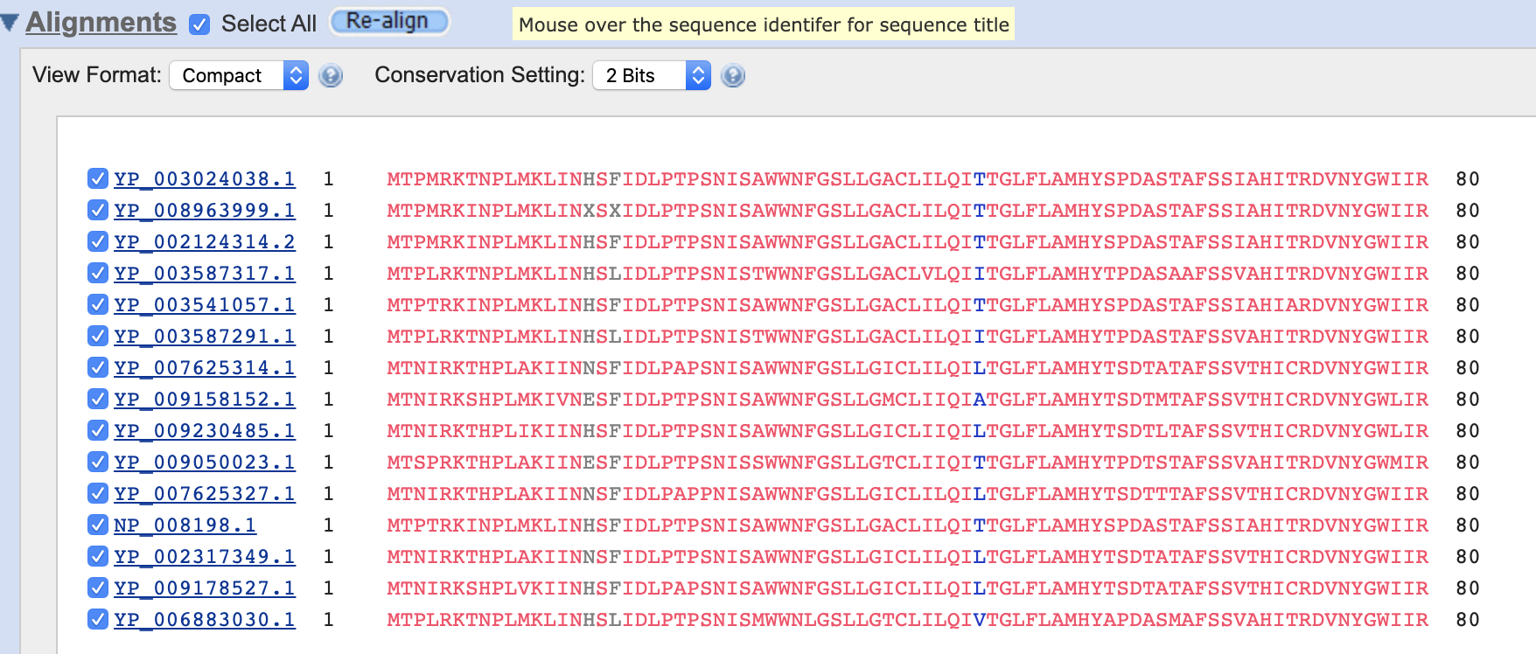4b.

4c.

The tree shows an evolutionary relationship because all the sub-branches are developed from 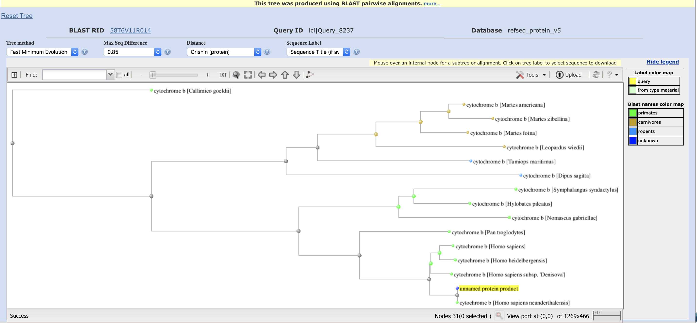the root node, indicating that they shared an ancestor before.

5a.

* Tool: BALSTP

5b.

* Algorithm: blastp (protein-protein BLAST)
* Scoring Matrix: PAM 30
* Gap penalty: Existence: 9, Extension: 1
* Length: 380

5c.

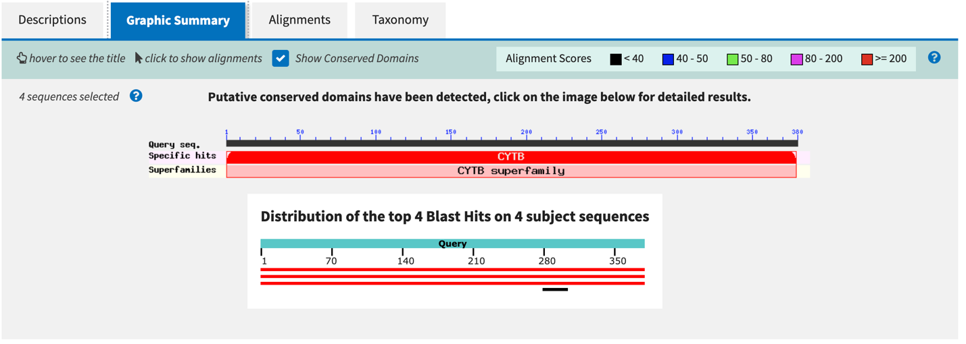

5d.

Max score: 789

Total score: 789

Query cover: 100%

E-value: 0

Per identity: 100%

Accession: YP_003024038

All queries are covered because both query cover and per identity are 100%.

5e.

Max score: 37.1

Total score: 37.1

Query cover: 6%

E-value: 0.055

Per identity: 61.54%

Accession: NP_001273093 XP_005245252

The best hit covered all query but the worst hit covered the query around 280 to 310.

5f.

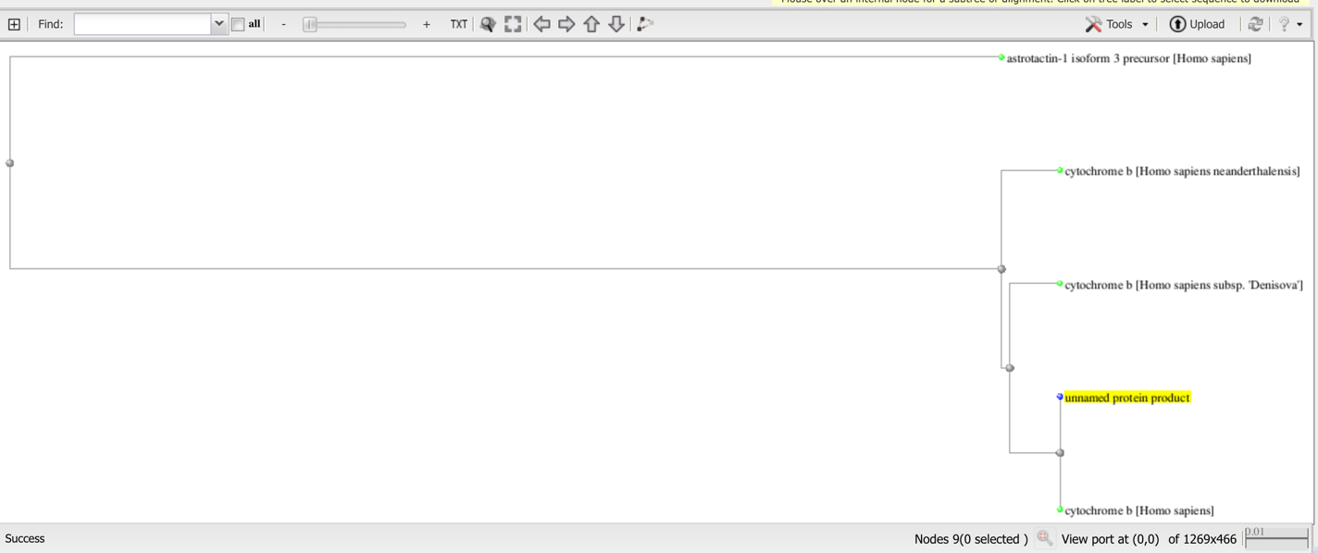

The reason some human hits is distantly related to other is that they are not the same protein in one species. Some protein developed then time changes.

6.

The protein is translated from human mitochondrial genome.