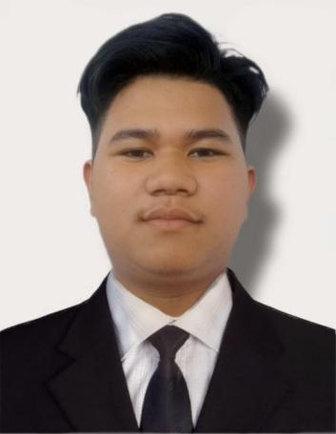

PERONAL RESUME

High School

Talugtug National High School

Villa Boado Elementary School

I am passionate about my work. Because I love what I do, I have steady source of motivation that drives me to do my best.

Work Experience

Skills

▪HTML

▪ CSS

▪javaScript

▪Jquery

▪Bootstrap

▪Sass

▪Typescript

▪React.js

**Freelancing present work**

▪Design and build Ui

▪Design responsive website.

▪ Deal with APIs.

Evaluation

Purok 2, Villa Boado Talugtug Nueva Ecja

agustinmlvn1230@gmail.com

09664525291

Education

Contact

Elementary

Front End Web Developer

**Melvin agustin**