Stacked

Auto Encoder

CNN

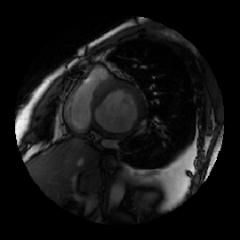

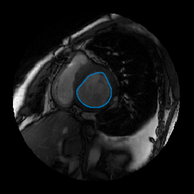

Deformable Models

Stack of MRI

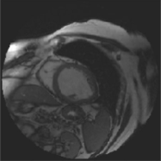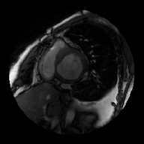

ROI

Detection

Shape Infer

&

Initialization

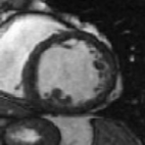

Segmentation

&

Alignment

LV Segmentation

54

54

6

6

100



64

64

Input Image

Convolved Features

Convolutions

9

9

100

Pooled Features

Subsampling

32

32

100



100

Output

11