Task 1:

Forked GitHub Repo
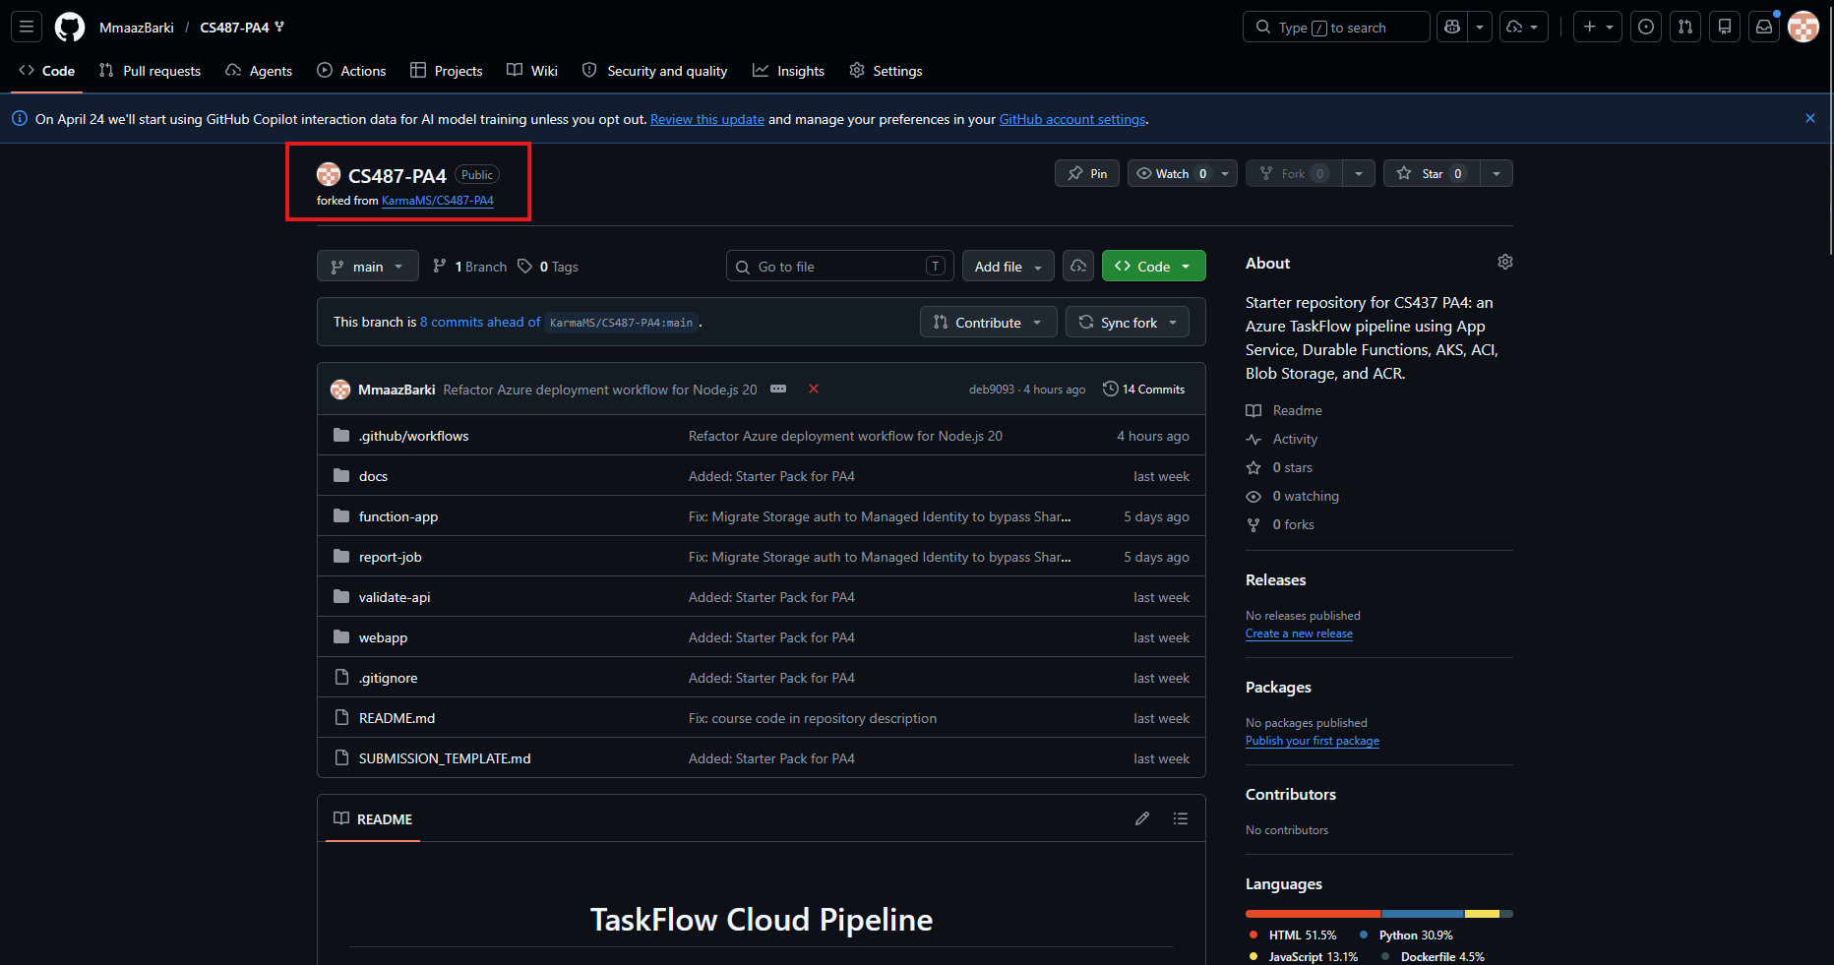

Web App Overview: Running Status
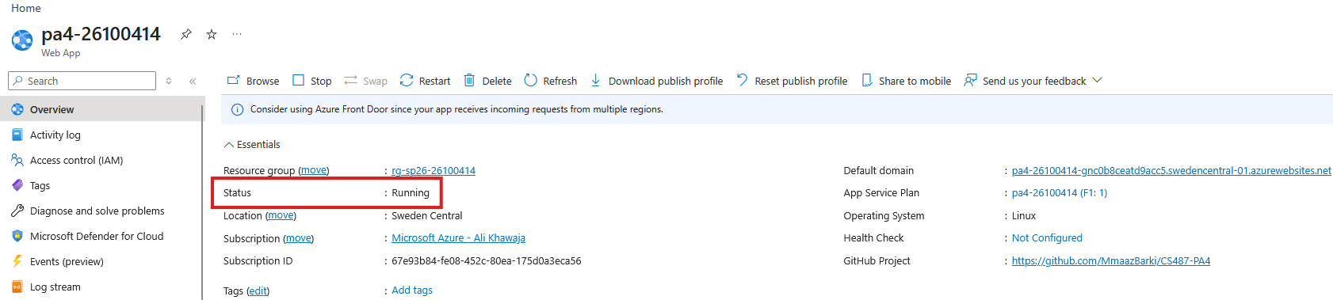

Deployment Center: GitHub Source
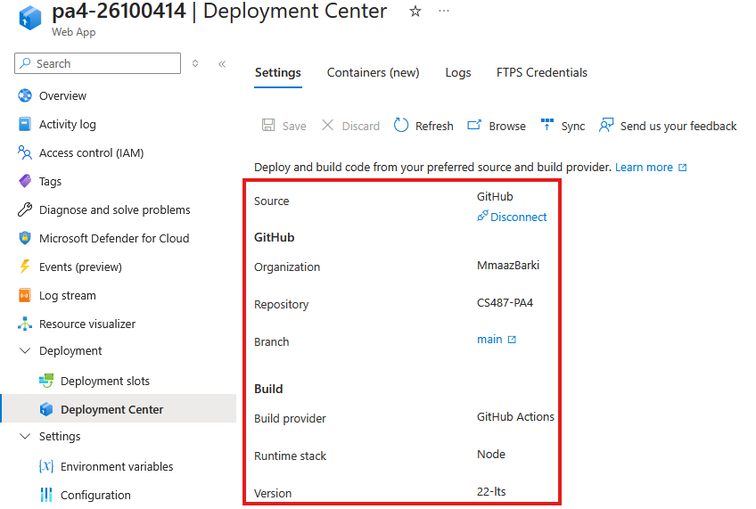

Dashboard Loading in Browser:
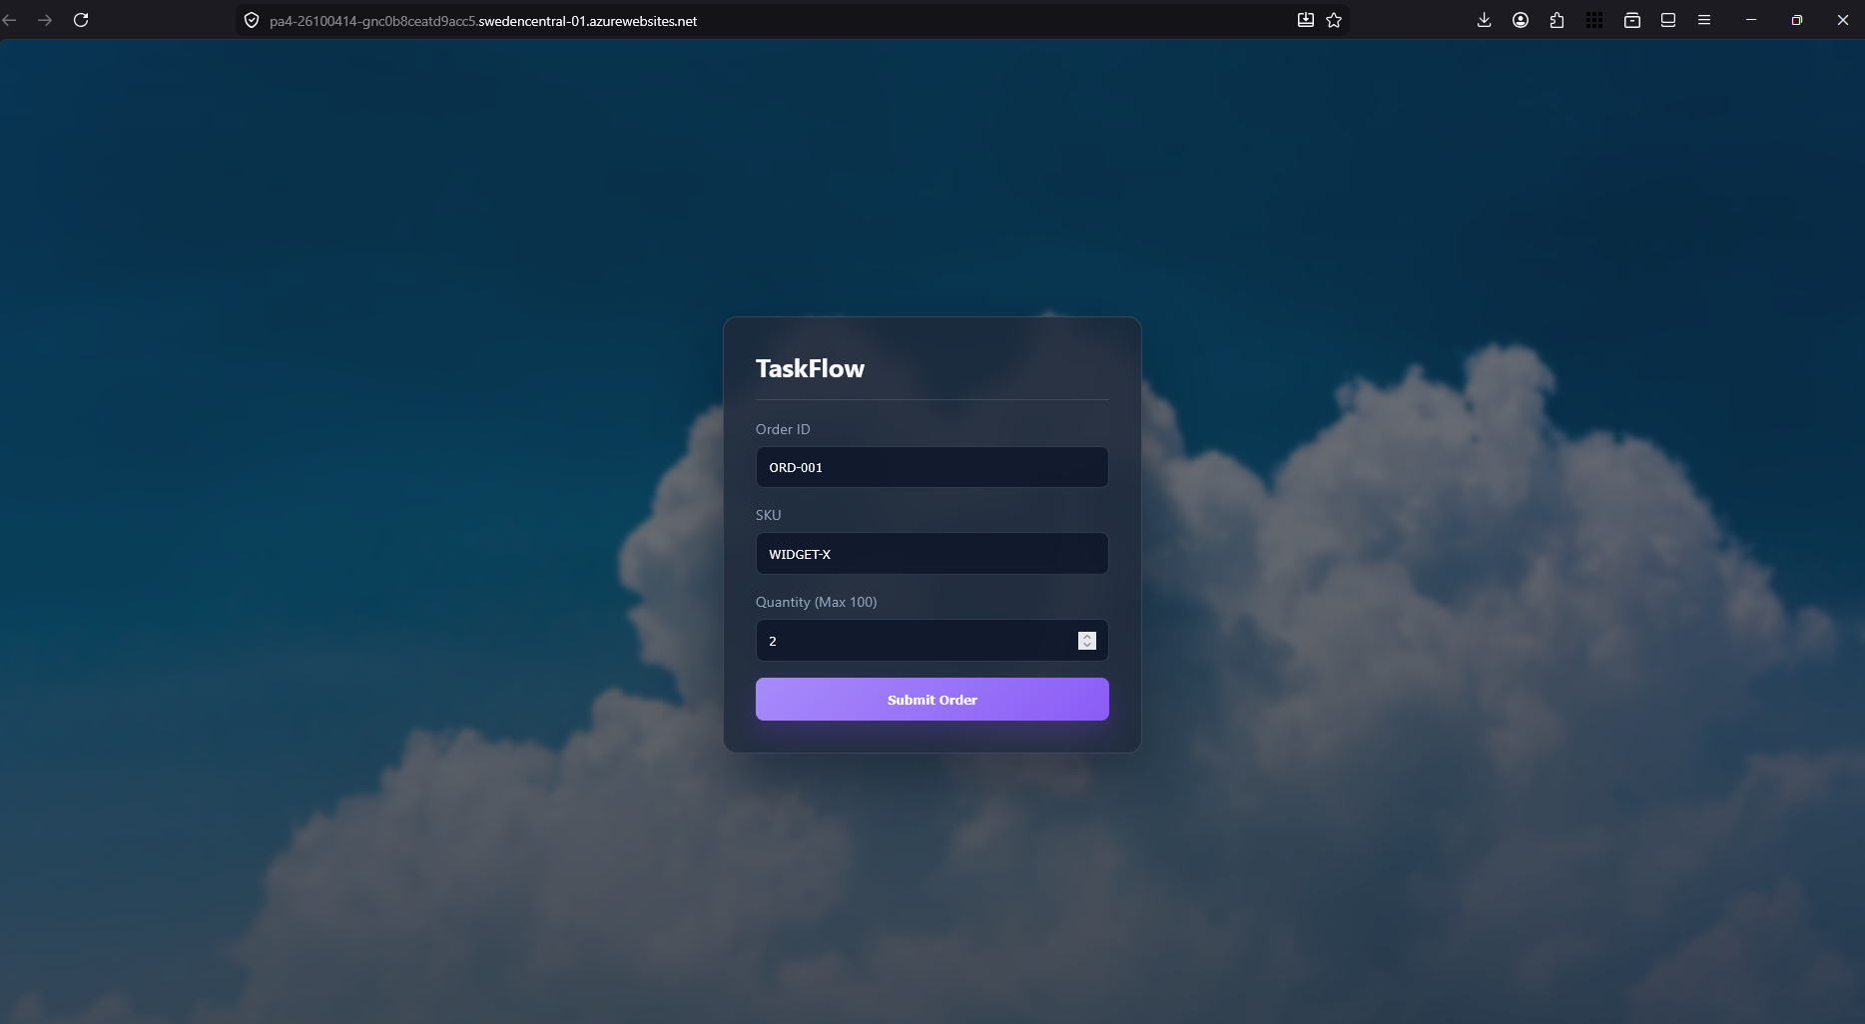

Configured Application Settings:
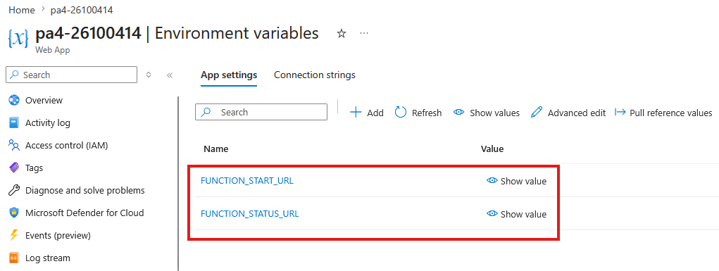

Task 2:

ACR Overview Success:
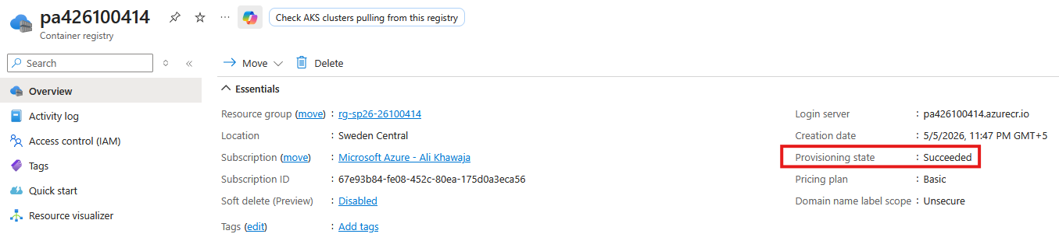

Successful Docker Builds

Successful local validator test

Image Tagging Commands:
docker tag validate-api:latest pa426100414.azurecr.io/validate-api:v1
docker tag report-job:latest pa426100414.azurecr.io/report-job:v1
docker tag func-app:latest pa426100414.azurecr.io/func-app:v1

Image Pushing Commands:
docker push pa426100414.azurecr.io/validate-api:v1
docker push pa426100414.azurecr.io/report-job:v1
docker push pa426100414.azurecr.io/func-app:v1

Successful Image Push:
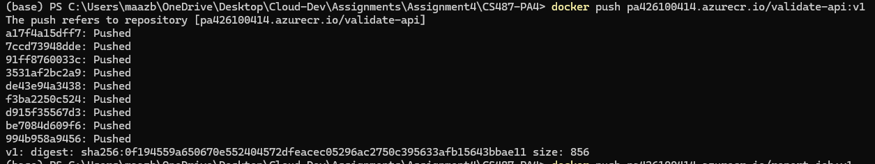

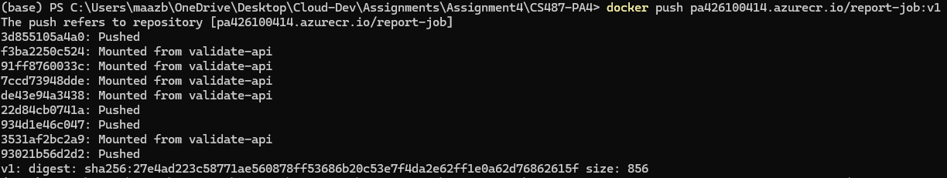

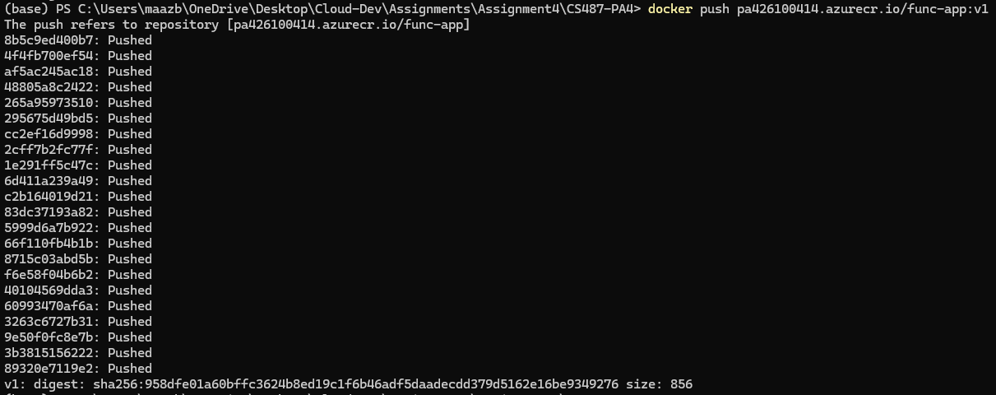

Task 3:

Durable Functions visible on func start:
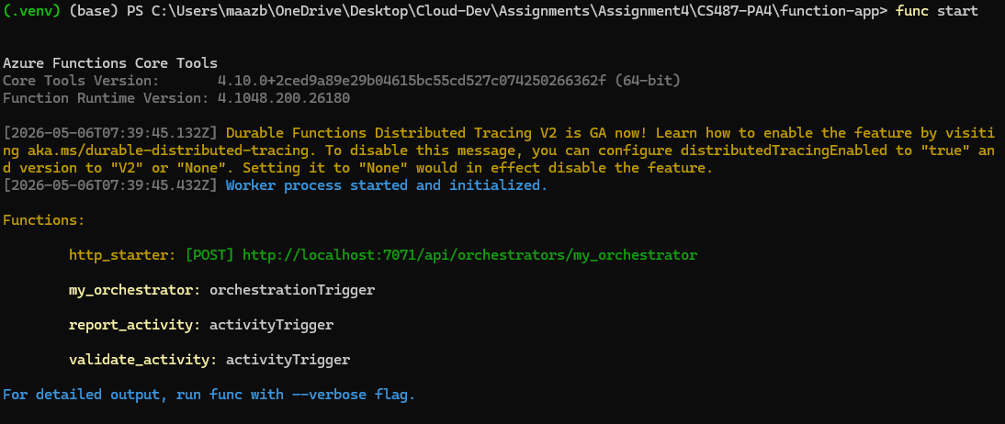

Task 4:

Container Image Configuration:
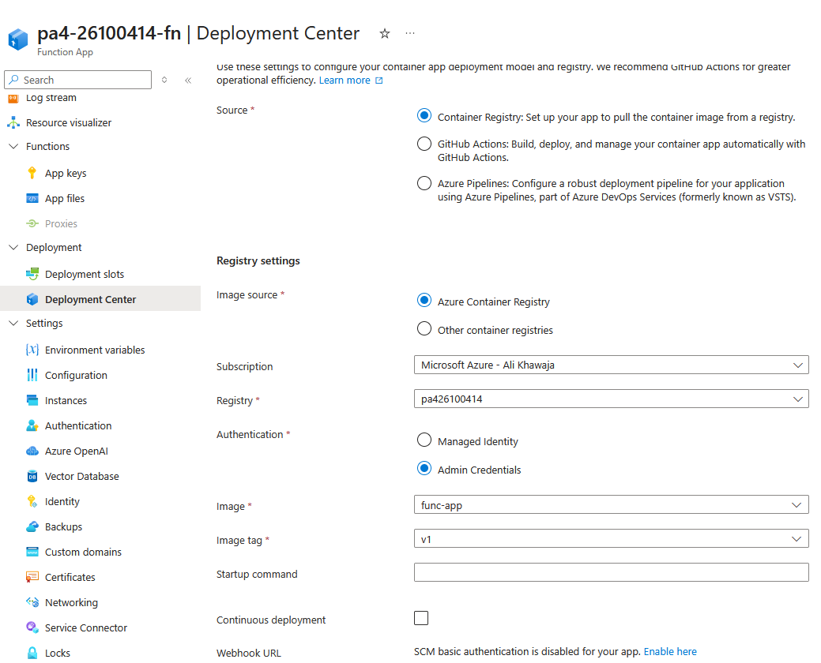

Functions list in Overview:
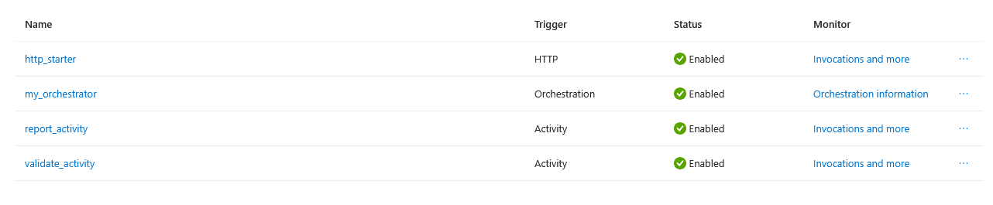

Curl output:
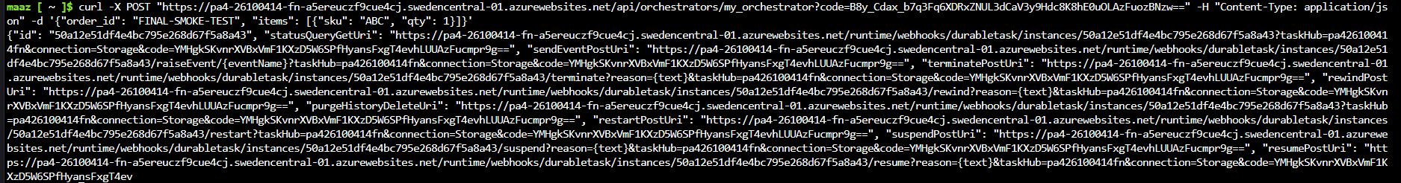

"statusQueryGetUri": "https://pa4-26100414-fn-a5ereuczf9cue4cj.swedencentral-01.azurewebsites.net/runtime/webhooks/durabletask/instances/50a12e51df4e4bc795e268d67f5a8a43?taskHub=pa426100414fn&connection=Storage&code=YMHgkSKvnrXVBxVmF1KXzD5W6SPfHyansFxgT4evhLUUAzFucmpr9g=="
"Id":
"50a12e51df4e4bc795e268d67f5a8a43"

Status URL Query Json:
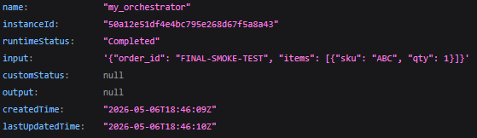

Task 5

Kubectl get nodes:

Kubectl get pods:

Kubectl get service:

Good order:
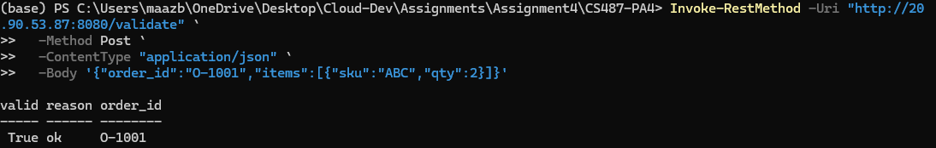

Bad order:
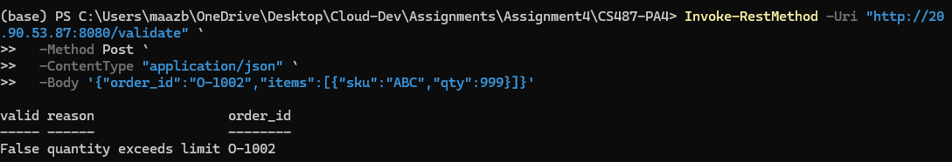

Function App Application Setting (Validate URL):
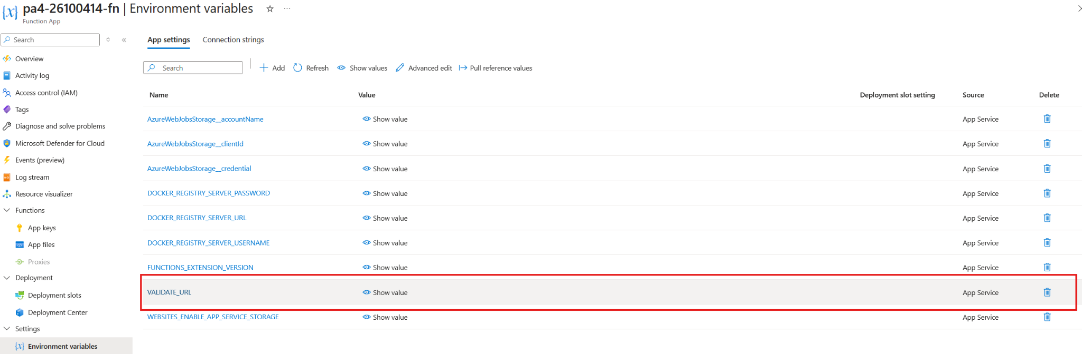

Task 6

reports blob creation:
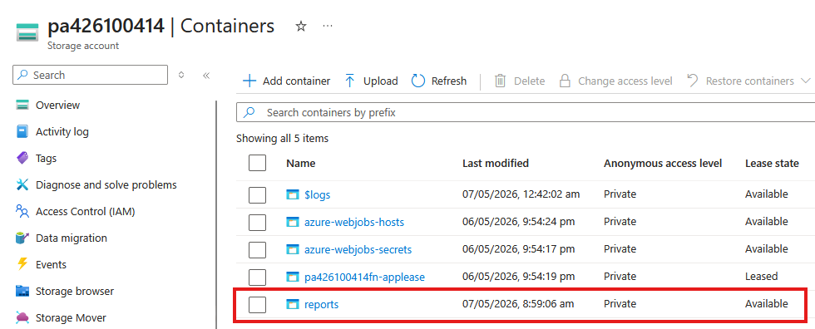

Successful container show (for ci-report-test):

Container logs terminal output:

PDF in reports container:
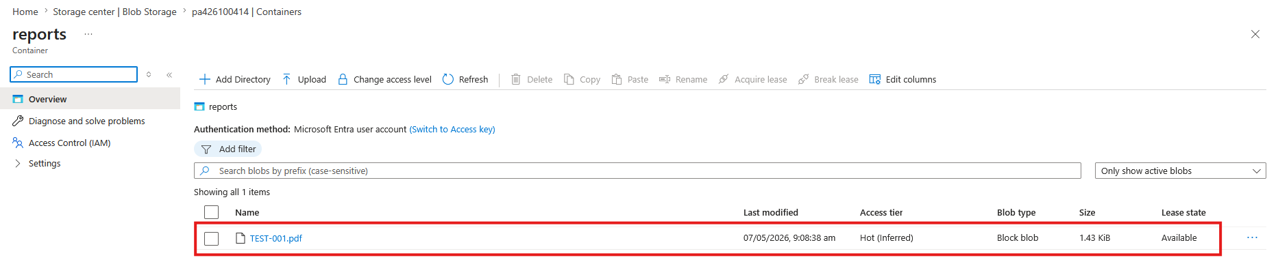

Function App Identity Blade (showing Managed Identity):
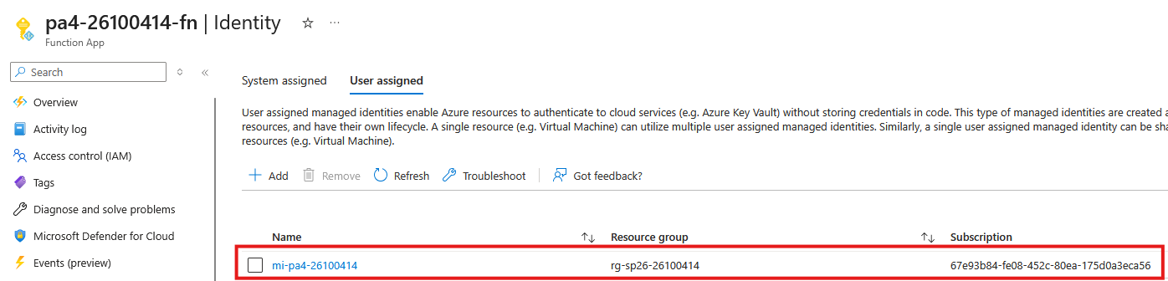

Function App settings

REPORT_*:
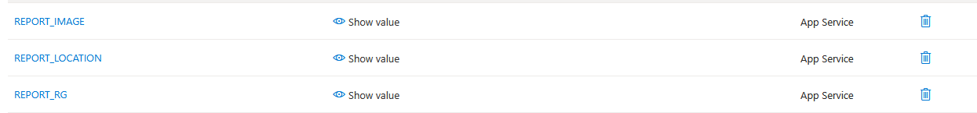
ACR_*:
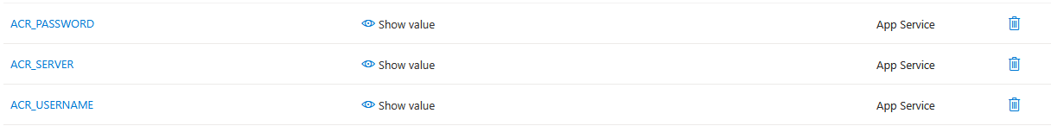
STORAGE_ACCOUNT_URL:

Task 7

Filled Form:
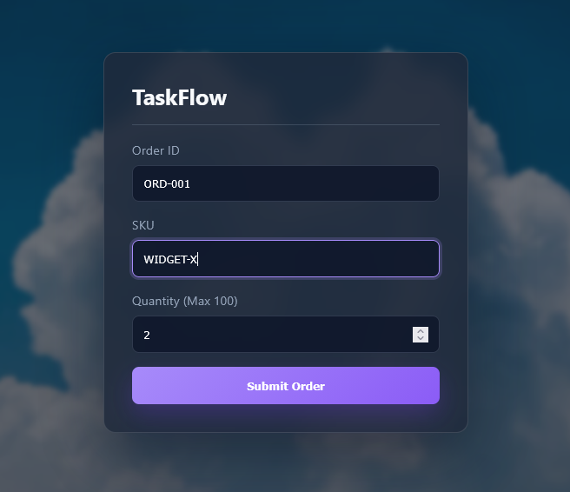

Function Invocations (Log Stream):
