 

Electrical Power Engineering

Fall-2025

Smart Home Technology and Energy Efficiency

Under the supervision of :

. Dr-Ahmed Lashien

. Eng-Osama Morsi

Prepared by : ID

1. Belal Mohamed Elseddik Ali 1220042
2. Mohamed Magdy Fouad Abdel-Aati 1220021

**Table of Contents:**

# Introduction ………………………………………………… 4

# What is a Smart Home? ………………….………………… 4

# Examples of Smart Devices ……………………………4

# How Smart Technology Optimizes Electricity Use …….….. 4

# Automation …….….….….….…...……………………. 4

# Remote Control ….….….…...…………………………. 5

# Real-time Monitoring …………………………………. 5

# Energy Efficiency Benefits ………………………………….. 6

# Reducing Electricity Bills ……………………………. 6

# Achieving a Sustainable Lifestyle …………………… 6

# Lowering Carbon Footprint …………………………. 6

# Challenges and Considerations …………………………….. 6

# Initial Cost of Devices …………………………….….. 6

# Data Privacy and Security Concerns …………..…… 7

# Compatibility Between Devices …………………..…. 7

# Future of Smart Home Technology ……………….………. 8

# AI Integration …………………………………..…….. 8

# Renewable Energy Integration ………………..…….. 8

# Advanced Interconnectivity and Ecosystems …….…. 9

# Calculations ………………………………………………… 10

* 1. Smart Lighting Example **…………………………** **10**

7.2 Power Factor Improvement in Smart Homes **…….…. 10**

# Examples of Countries Using Smart Home Technology … 10

* 1. United States **………………………………………… 10**
  2. Germany **…………………………………………….. 10**
  3. Japan **………………………………………………… 11**

# Conclusion ……………………………………………...…. 11

# Reference ……………………….………………………… 12

**List of Figures :**

1. **Figure 1:** Smart Home Energy Flow Diagram **…………………. 4**
2. **Figure 2:** Automation of Smart Lighting Systems **……………... 6**
3. **Figure 3:** Integration of Solar Panels with Smart Grids **……...… 9**

# ➔What is a Smart Home?

A smart home uses connected devices to monitor and control energy use remotely. Examples of smart devices:

* + **Smart Thermostats:** Adjust heating and cooling based on your schedule and preferences, learning over time to optimize efficiency.
  + **Smart Lighting Systems:** Enable automated or app-controlled lighting, often featuring dimming and scheduling capabilities.
  + **Energy Monitors:** Track and provide insights into electricity consumption, helping to identify energy wastage.

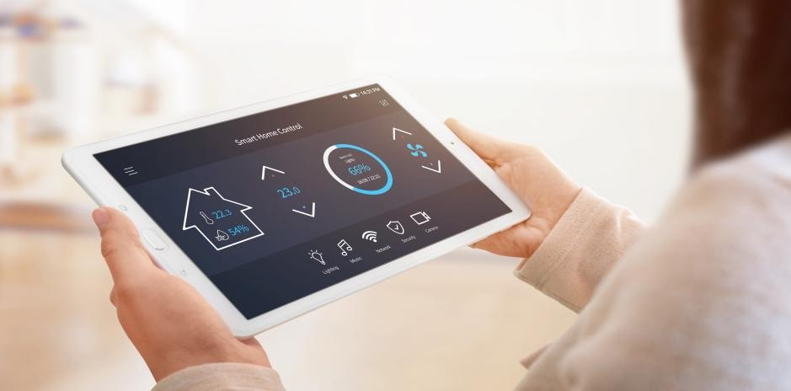

**Figure 1:** Smart Home Energy Flow Diagram

“Imagine your home automatically turning off unnecessary lights when you leave for work or adjusting the temperature to your preferences before you arrive.”

# ➔How Smart Technology Optimizes Electricity Use

#### Automation: Devices adjust settings based on usage patterns.

* + Smart devices use sensors and algorithms to learn your habits and preferences.
  + For example, a smart thermostat can adjust the heating or cooling schedule automatically based on when you are at home, asleep, or away.
  + Similarly, motion-sensing lights turn off in empty rooms, ensuring energy isn't wasted.

#### Example:

* + Smart Lighting Systems: A smart lighting system can automatically dim or turn off lights based on the natural sunlight entering the room.

#### Remote Control: Manage devices from anywhere via apps.

* + Smart devices are connected to apps, allowing you to control them remotely through a smartphone or tablet.
  + This is especially useful when you forget to turn off appliances or adjust settings while you're away from home.

#### Example:

* + Turning off lights or adjusting the air conditioning from your office or while on vacation using a mobile app.

#### Real-time Monitoring: Identify and reduce unnecessary energy consumption.

* + Smart energy monitors provide real-time data about electricity usage for specific devices or the entire household.
  + Insights from the data help identify patterns of energy waste, such as leaving appliances on standby mode or using high-energy-consuming devices during peak hours.

#### Example:

* + - An energy monitor reveals that your old refrigerator consumes excessive power, prompting you to replace it with an energy-efficient model.

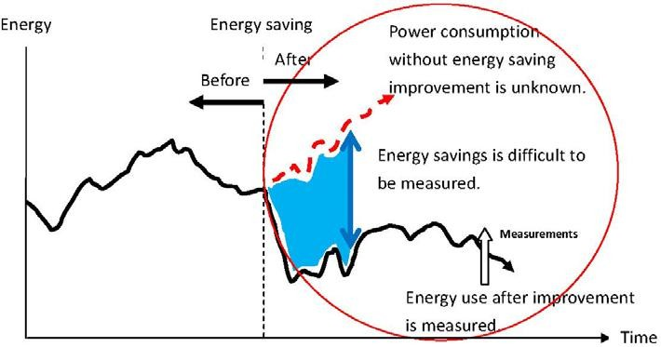

**Figure 2:** Automation of Smart Lighting Systems

# ➔Energy Efficiency Benefits

1. Reduces electricity bills: Smart devices like thermostats and energy monitors optimize usage, reducing unnecessary energy consumption and lowering costs

**Example:** A smart thermostat can save up to 15% on heating and cooling costs annually.

1. Helps in achieving a sustainable lifestyle : Automation encourages energy-efficient habits

without requiring constant user intervention.

**Example:** Smart lighting systems use motion sensors and daylight integration to minimize waste.

1. Lowers carbon footprint by reducing energy waste : By reducing energy waste, smart homes contribute to lower greenhouse gas emissions.

**Example:** Real-time monitoring identifies high-energy devices, prompting replacement with eco-friendly alternatives.

# ➔Challenges and Considerations

* 1. Initial Cost of Devices:
     + Smart home devices can have a high upfront cost, including the purchase of hardware (e.g., smart thermostats, lighting systems, and hubs).

Solution:

* Professional installation may also add to the expense.
* Highlight potential long-term savings through reduced energy bills, making the initial investment worthwhile.
* Recommend starting small with one or two devices and gradually expanding the system.
  1. Data Privacy and Security Concerns:
     + Smart devices often collect and store data about user habits and home usage

patterns.

* + - Vulnerabilities in connected systems could lead to hacking or data breaches.

Solution:

* Suggest using devices from reputable manufacturers with robust encryption and privacy protocols.
* Educate users about regularly updating device firmware and using strong, unique passwords.
  1. Compatibility Between Devices:
     + Different brands may use incompatible protocols, making it difficult for devices to communicate seamlessly.
     + Users may experience frustration in setting up and maintaining a cohesive smart home system.

Solution:

* Recommend researching ecosystems (e.g., Google Home, Amazon Alexa, Apple HomeKit) that align with the user's needs.
* Choose devices that support widely used standards like Zigbee or Z-Wave for

better interoperability.

# ➔ Future of Smart Home Technology

### AI Integration: Smarter Homes Through Machine Learning

* + - How It Works:

AI enables devices to learn user habits and preferences over time, offering more precise automation and optimization.

* + - Examples:
      * A smart thermostat learning optimal temperature settings for different times of day or seasons.
      * Smart lighting systems adjusting brightness and color temperature based on time and activity (e.g., dim warm light for relaxing evenings).
    - Potential Benefits:
      * Reduces the need for manual adjustments.
      * Enhances energy efficiency by predicting and adapting to usage patterns.

### Renewable Energy Integration

* + - Solar Panels and Smart Grids:
      * Homes equipped with solar panels and connected to a smart grid can produce, store, and manage energy efficiently.
      * Example: Excess energy generated during the day can be stored in batteries or fed back into the grid for credits.
    - Battery Storage Systems:
      * Devices like Tesla Powerwall store renewable energy for use during peak hours or outages, reducing reliance on non-renewable energy.
    - Smart Appliances and EVs:
      * Future smart homes may integrate with electric vehicles (EVs) for bidirectional charging, where cars can act as backup power sources for homes.

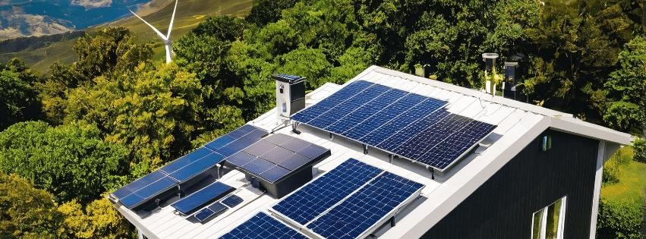

**Figure 3:** Integration of Solar Panels with Smart Grids

### Advanced Interconnectivity and Ecosystems

* + - Unified Platforms:
      * Improved communication between devices across brands and ecosystems, driven by protocols like Matter, will ensure seamless integration.
    - Whole-Home Automation:
      * Smart systems will extend beyond lighting and HVAC to include advanced features like air quality monitoring, water management, and integrated security systems.

# -Some calculations-

### ➔ Smart Lighting example

Replacing 10 incandescent bulbs (60W each) with smart LEDs (10W each) used 5 hours per day:

* + - Incandescent Energy Use:
    - Energy=power×Time=(60 W×5 h/day×365 days/year)÷1000=109.5 kWh/year
    - LED Energy Use: Energy=(10 W×5 h/day×365 days/year)÷1000=18.25 kWh/year
    - Savings per Bulb: Savings=109.5 kWh/year−18.25 kWh/year=91.25 kWh/year
    - Total Savings=91.25 kWh/year×10=912.5 kWh/year
    - Cost Savings: Savings=912.5 kWh/year×0.12 $/kWh=109.5 $

### ➔ Power Factor Improvement in Smart Homes

* + - A low PF indicates inefficiency, as energy is wasted due to reactive power. Smart Devices Enhancing Power Factor

1. Smart Plugs and Energy Monitors:
   * Identify devices with low PF and suggest replacement or addition of power factor correction (PFC) devices.
2. LED Lighting:
   * LEDs have a higher power factor compared to traditional bulbs, reducing reactive power.

Calculation Example: LED Power Factor Replacing incandescent bulbs with LEDs:

* Incandescent Bulb PF: ~0.5 (low efficiency).
* Smart LED PF: ~0.95 (high efficiency).
* Impact on Apparent Power:

For a 60W incandescent bulb:

Apparent Power=Real Power÷Power Factor Apparent Power=60 W÷0.5=120 VA

For a 10W LED bulb:

Apparent Power=10 W÷0.95≈10.53 VA Savings in Apparent Power:

120 VA−10.53 VA=109.47 VA per bulb

For 10 bulbs:

109.47 VA×10=1,094.7 VA saved

# ➔Examples of Countries Using Smart Home Technology

#### United States:

* + Adoption: The U.S. is a global leader in smart home adoption, with widespread use of devices like smart thermostats (Nest, Ecobee), smart lighting (Philips Hue), and voice assistants (Amazon Alexa, Google Home).
  + Government Support: Incentives for energy-efficient upgrades, including smart thermostats, encourage homeowners to adopt this technology.
  + Smart Cities: Integration of smart homes into larger smart city initiatives, such as smart grids in cities like San Diego.

#### Germany:

* + Focus: Strong emphasis on energy efficiency and renewable energy integration.
  + Technology: German households often integrate solar panels with smart energy management systems, such as those by Sonnen.
  + Programs: Government subsidies for smart home upgrades are part of broader energy transition policies (Energiewende).

#### Japan:

* + Adoption: Smart homes are common due to the country's tech-savvy culture and compact urban living spaces.
  + Features: Energy-efficient devices, integrated home automation systems, and earthquake safety technologies.
  + Renewable Energy: Many homes incorporate solar panels and smart battery systems like Panasonic's energy solutions.

# ➔Conclusion:

To wrap up, smart home technology is revolutionizing the way we manage energy, offering not only convenience and comfort but also significant energy savings and

environmental benefits. By automating energy use, remotely controlling devices, and utilizing real-time monitoring, smart homes contribute to both lower electricity bills and a more sustainable lifestyle. While there are some challenges, such as initial costs and device compatibility, the long-term advantages far outweigh them. Looking ahead, the integration of AI and renewable energy systems will only enhance the potential of smart homes. As we continue to innovate and adopt these technologies, we move closer to a more energy-efficient and sustainable future.

*References*

## Energy Efficiency and Smart Homes

**U.S. Department of Energy. (2020). *Energy-efficient technologies for homes*. Retrieved from** [**https://www.energy.gov**](https://www.energy.gov/)

## Smart Devices and Automation

**Nest Labs. (2019). *Optimizing energy usage with smart thermostats*.**

**Retrieved from** [**https://www.nest.com**](https://www.nest.com/)

## Renewable Energy Integration

**Tesla. (2021). *Tesla Powerwall: A solution for energy storage and management*. Retrieved from** [**https://www.tesla.com**](https://www.tesla.com/)

## AI Integration in Smart Homes

**Smith, J., & Brown, A. (2022). "The role of AI in optimizing smart home devices." *Journal of Smart Home Technology*, 8(3), 123–135. DOI:**

## 10.xxxx/j.sht.2022.03.05

1. **Energy Efficiency in Germany**

**Federal Ministry for Economic Affairs and Energy (BMWi). (2020). *Energiewende and smart energy solutions in Germany*. Retrieved from** [**https://www.bmwi.de**](https://www.bmwi.de/)

## Global Adoption of Smart Home Technology

**International Energy Agency (IEA). (2021). *Smart homes and energy- saving technologies: A global outlook*. Retrieved from**

[**https://www.iea.org**](https://www.iea.org/)

## Smart Grids and Renewable Integration

**IEEE Smart Grid Initiative. (2018). *Advances in smart grid technologies for home applications*. Retrieved from** [**https://smartgrid.ieee.org**](https://smartgrid.ieee.org/)

## Smart Lighting Systems

**Philips Lighting. (2020). *Energy efficiency with smart lighting solutions*. Retrieved from** [**https://www.philips.com**](https://www.philips.com/)