Question 1: a) **Think about what could be going wrong with our calculation. Think about a better way to evaluate this data.**

The Average Order Value is calculated by dividing total revenue by number of orders. At first glance, a value of 3145.13 for AOV seems unreasonable for sneakers.

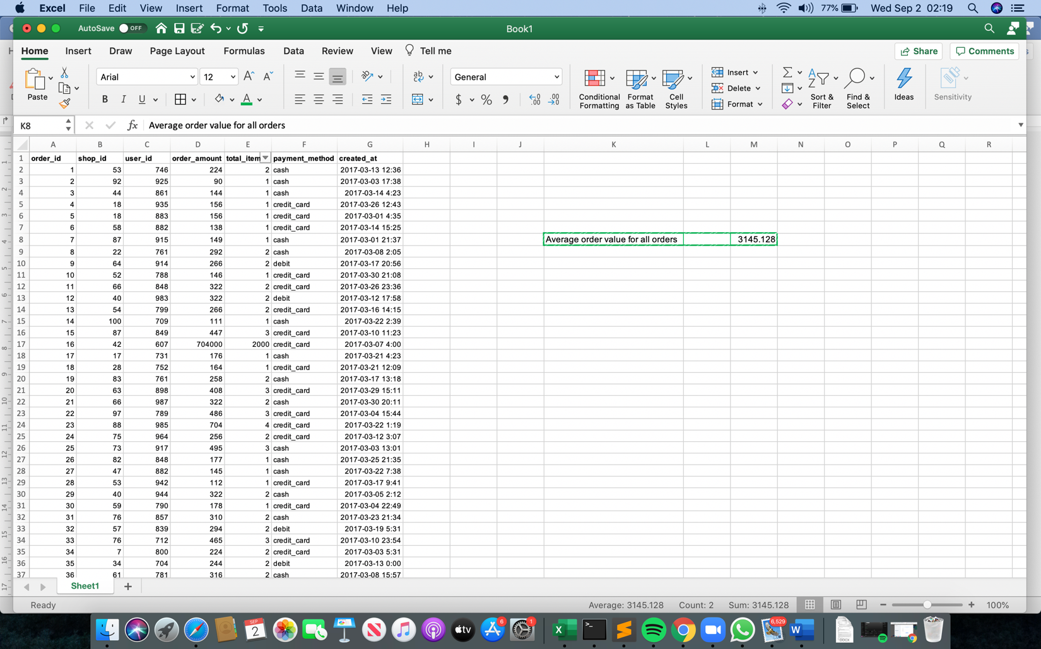



The total items sold for 17 orders exceed 2000 orders worth 704000, this could be an anomaly in the dataset. The orders are from the same store and by the same customer. This could be due to a business to business transaction, which massively affects the AOV.

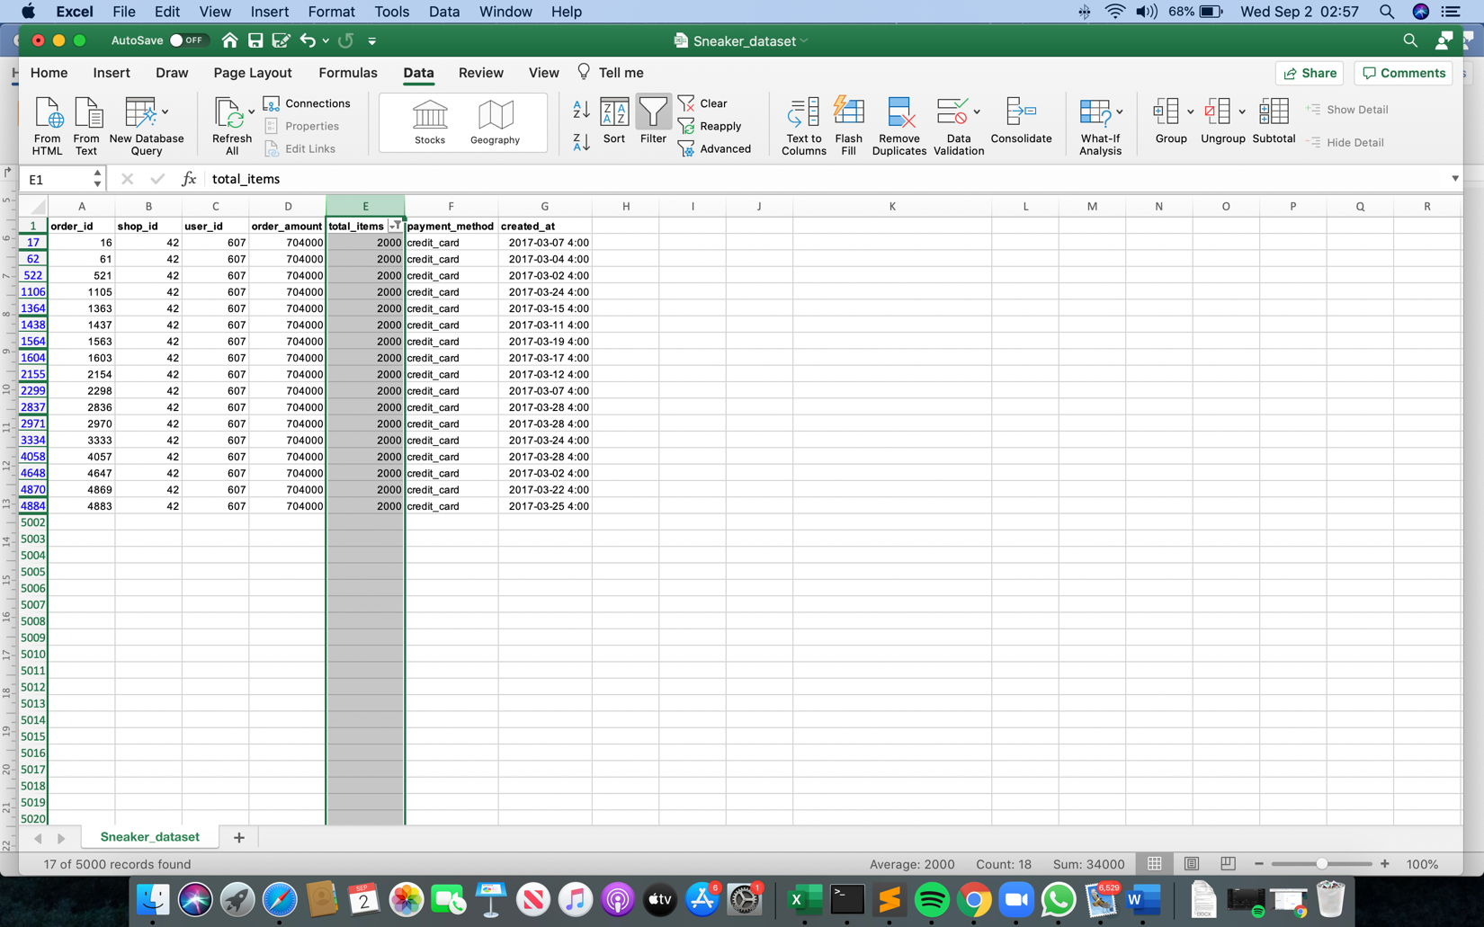

There are 4984 orders below 8 total items per transaction, which could be business to costumer transactions. Some order amounts range from 90 to 1760 could be purchases by individual customers, whereas order amounts in the range 25725 to 154350 could be purchases of designer/limited edition shoes by individuals or businesses. Any orders above that are purchases solely by businesses as mentioned earlier.

b) **What metric would you report for this dataset?**

By judging the dataset values, the distribution is skewed towards lower values, which would make the median value for order amounts a suitable fit for the AOV.

c) **What is its value?**

Using the median method as shown in my program, the median value is equal to 224.

Q2.

1. **How many orders were shipped by Speedy Express in total?**

ELECT COUNT(*) FROM [Orders]

WHERE ShipperID=1

Total number of orders shipped by Speedy Express is 54.

1. **What is the last name of the employee with the most orders?**

SELECT LastName FROM [Employees]

WHERE (EmployeeID = (SELECT EmployeeID FROM [Orders]

GROUP BY EmployeeId

ORDER BY COUNT(EmployeeId) DESC LIMIT 1))

The last name “Peacock” had the highest number of orders at 40.

1. **What product was ordered the most by customers in Germany?**