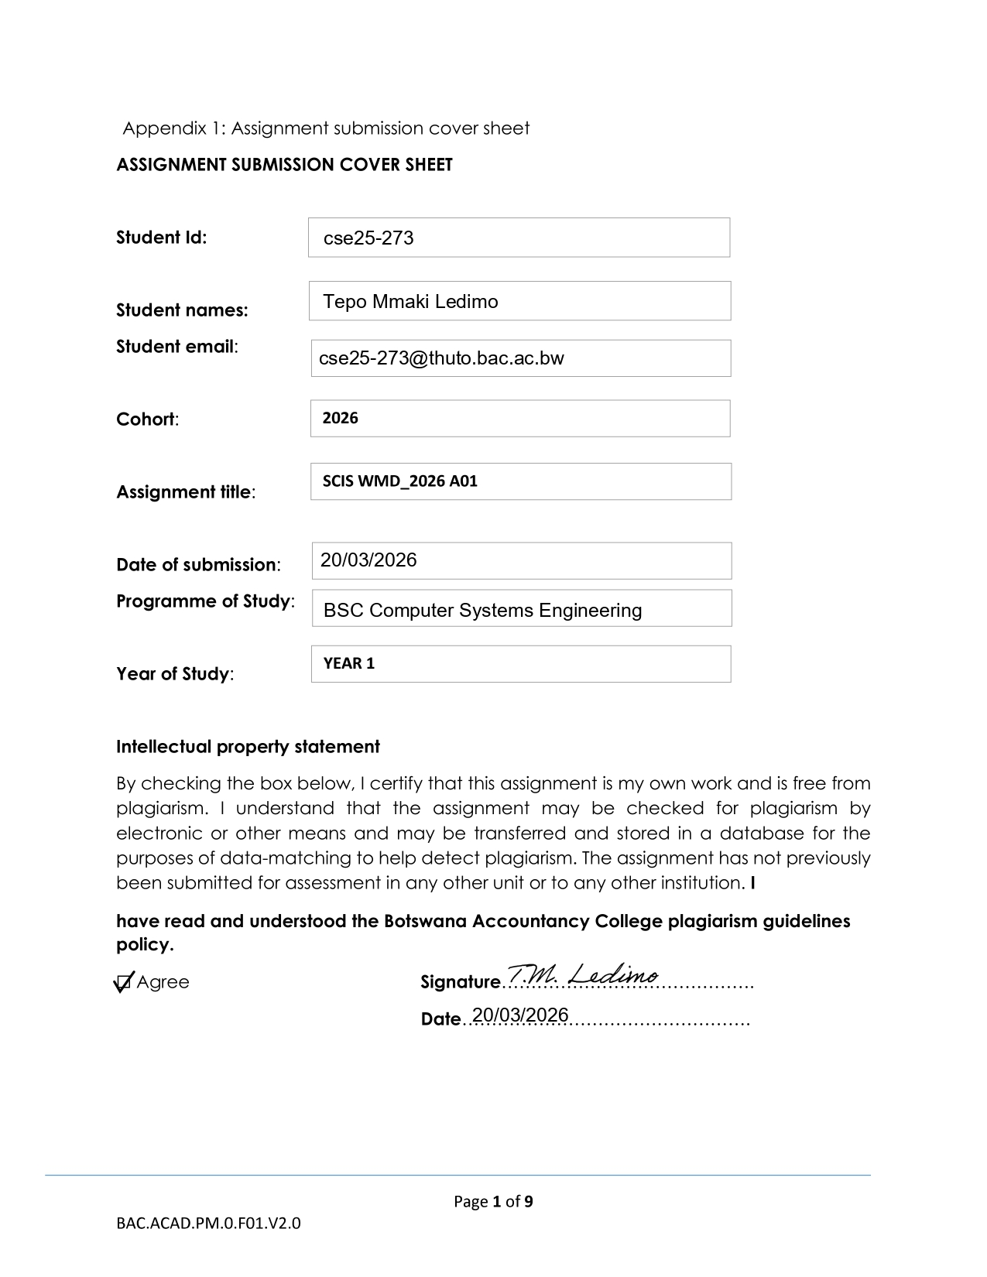

Web and Multimedia Development

Part A-Website Specifications

The website aims to provide budget-friendly, quality, user-friendly and technical support and goods to the public market to help foster advancements in the tech department countrywide as well as broaden the country’s technological economy and market.

Business goals

- Foster nationwide technological advancement by lowering the prices for high quality hardware and services.
- To stimulate the country’s digital economy by creating a reliable and competitive tech marketplace.
- To provide a user-friendly experience that simplifies the complex purchase and set up of technical goods.
- To reach the young market mainly students who need quality tech services and products but cannot compete with the high and marked-up prices of the available goods.
- To digitize more services to the public market, making life easier.

Target Audience

Target audience: Mostly students, small and medium business owners and general customers across the country spanning across a wide range of age groups from old school parents wanting to upgrade their desktop setup or various major and minor installations like smart homes, farms and more not limited to location or age.

Technical Aptitude: The site will cater for a broad range of various users with different technical skills and not just the tech savvy or experts, its designed for the broad public with a contact us link to refer to a customer service personnel who would help fulfil the user’s needs performing tasks like online troubleshooting and purchase assistance as well as advise on what the customer would like to buy basing of needs and budget along with the follow up order confirmation.

Type of Website and Content

Website type: Service and E-Commerce-based website that focuses on providing online, physical and purchase related customer support services.

Content: Website will feature at least five interlinked pages including the main website page with various information as well as a dedicated feedback page with real reviews from real customers and a secure payment portal for purchases as well as high quality images for the customers to better entice visitors or prospective customers.

Information Design

The Flowchart below illustrates how users navigate through the website.

- Users begin at the Home page where they access all main sections via the navigation bar
- From there: Users may visit the Shop page to browse product categories
- Within the shop users select categories such as Android Windows MacOS or Audio
- Users can then proceed to view products and optionally navigate through contact and signup
- Alternatively: Users may also directly access information like About to learn more about the company
- Or go to Contact to make queries

HOME(Index.html)

Signup
Contact
Shop
AboutUs

Product, Categories

Android
Technical Support
Accessories
Audio
Apple
Windows

View Products

Contact / Sign up

Page template design

----------------------------------------------------------------------------------------
| LOGO | NAV (Home | About | Contact |Signup | Shop) |
----------------------------------------------------------------------------------------
CAROUSEL(SLIDESHOW)
----------------------------------------------------------------------------------------
(Images, Promotions, Sale, Marketing text, Shop, Helpline) |
----------------------------------------------------------------------------------------
| Warranty | Money Back | Community | Cart | Delivery|
--------------------------------------------------------------------------------------
|Android |Windows | Apple | Audio |Accessories | Technical Support|
--------------------------------------------------------------------------------------
FOOTER
--------------------------------------------------------------------------------------

Explanation
The site uses a modern intuitive layout inspired by commercial technology websites and a navigation bar is fixed at the top for accessibility

Features
- Carousel slideshow section to highlight promotions
- A section to build trust (warranty, money-back, community)
- Shop for easy purchase
- Helpline section for easy access to technical and customer inquiries or help about purchased goods

The layout ensures:
- Clean clear content separation
- Good use of white space
- Mobile responsiveness via Bootstrap

Technical Brief

Frontend technologies:
- HTML5: For structuring web pages
- CSS: For styling and layout
- Bootstrap 5: For responsive design and UI components
- JavaScript: (Bootstrap bundle) for interactive elements like the carousel

Development Tools
- Visual Studio Code: Code Editor
- GitHub: Repository Hosting
- GitHub Pages: Website Hosting

Design Tools
- GIMP/CANVA: For image editing and logo designs

Other Resources
- Stock images for product visuals
- Custom CSS file for additional styling

