XGBoost in Credit Risk Modeling: A Comprehensive Technical Guide

# 1. Introduction

XGBoost (eXtreme Gradient Boosting) is a highly optimized and scalable implementation of gradient boosting machines.  
It is widely used in structured data problems, particularly in the financial sector for credit risk modeling.  
This document presents an in-depth understanding of how XGBoost works internally, the impact of its hyperparameters,  
and how it provides superior performance in the context of risk modeling compared to other machine learning algorithms.

# 2. Why Use XGBoost in Credit Risk Modeling?

Credit risk modeling requires high predictive accuracy and interpretability to assess the likelihood of borrower default.  
XGBoost offers a powerful framework to meet these needs with:  
- High predictive accuracy through boosting  
- Built-in regularization to reduce overfitting  
- Capability to handle imbalanced data natively  
- Rich model interpretability using SHAP values and feature importance  
- Scalability and efficient memory usage via DMatrix structure

# 3. Internal Mechanics of XGBoost

## 3.1 Data Preparation and Input Format

XGBoost accepts data in a special structure called DMatrix which optimizes performance and memory usage. It can handle missing values natively and allows specification of labels and weights directly.

## 3.2 Learning Process (Iteration-wise)

XGBoost works by sequentially adding trees to correct the errors of previous iterations. Each iteration consists of:  
1. Prediction using current ensemble  
2. Computation of gradient and hessian (1st and 2nd order derivatives)  
3. Tree structure generation to minimize loss  
4. Weight assignment to leaves  
5. Model update using learning rate  
6. Repeat until convergence or max rounds  
  
 3.3 Objective Function and Optimization  
  
The core of XGBoost’s learning process is based on optimizing an objective function that balances the model's accuracy and its complexity. The general form of the objective function is:  
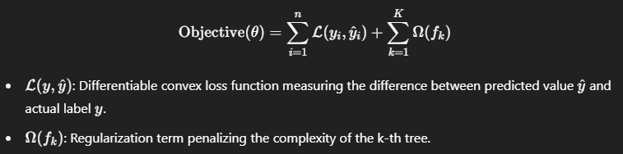  
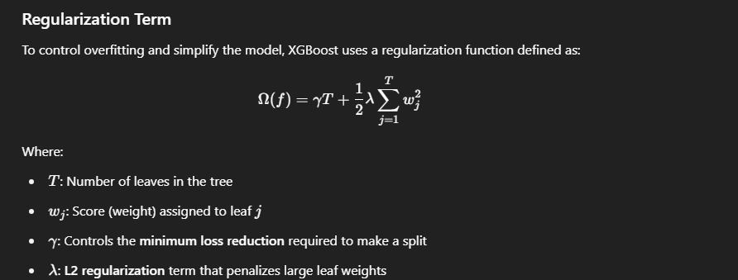

Impact on Model Training:  
1. Gamma (γ) ensures that splits are only made when they reduce the loss function by a significant margin, thereby simplifying the tree.  
2. Lambda (λ) smoothens model predictions by preventing overly large values in leaf scores.  
3. This formulation allows XGBoost to grow trees that are both accurate and generalizable, making it suitable for high-stakes domains like risk modeling.

During each iteration, the algorithm uses the first and second derivatives (gradient and hessian) of the loss function to construct a new tree that improves the prediction. The optimization ensures that each new tree added contributes minimally to overfitting.

# 4. Hyperparameter Deep Dive

|  |  |  |  |
| --- | --- | --- | --- |
| Parameter | Description | Effect | When to Use |
| max_depth | Max depth of trees | Controls complexity of trees | Use lower depth (2-4) to prevent overfitting |
| eta | Learning rate | Controls contribution of each tree | Lower value (0.01-0.1) for more robust learning |
| n_estimators | Number of trees | More trees improve accuracy | Higher if eta is low |
| subsample | Row sampling ratio | Adds randomness | 0.6-0.9 for better generalization |
| colsample_bytree | Feature sampling | Prevents overfitting by limiting features per tree | Use 0.6-0.9 |
| lambda | L2 regularization | Smooths weights | Use when overfitting is suspected |
| alpha | L1 regularization | Promotes sparsity | Useful for feature selection |
| gamma | Minimum loss to split | Prunes trees | Set high (10-50) for simpler trees |
| min_child_weight | Minimum hessian sum in leaf | Avoids learning from noisy data | Set high for imbalanced data |
| scale_pos_weight | Weight for positive class | Balances classes | Set = num(neg)/num(pos) for class imbalance |

## 5. Final Prediction and Risk Application

After training, the final output of XGBoost is a weighted sum of all individual trees. For binary classification, the output is passed through a sigmoid function to yield a probability:  
ŷ = 1 / (1 + exp(-score))  
This probability can then be:  
- Interpreted as probability of default (PD)  
- Used in cutoff thresholds for decisioning (e.g. approve, refer, decline)

- Incorporated in risk scorecards and PD models for regulatory reporting

6. Model Interpretability  
  
Interpretability is essential in risk modeling due to regulatory scrutiny. XGBoost offers two primary ways to understand model behavior:  
  
 6.1 Feature Importance Metrics  
  
XGBoost provides feature importance using the following metrics:  
  
-Gain: Measures the relative contribution of a feature to the model based on the improvement in loss achieved at each split involving the feature. High gain indicates a feature is impactful.  
-Coverage: The number of observations affected by the splits that use the feature. It indicates how broadly the feature is used in the dataset.  
- Frequency: How often a feature is used in all the trees. A higher frequency indicates the model frequently relies on this feature.  
  
6.2 SHAP Values (SHapley Additive exPlanations)  
  
SHAP values offer a unified measure of feature attribution. For any single prediction, SHAP quantifies how much each feature contributed to the deviation of the output from the average prediction.  
  
How SHAP is Calculated:  
- SHAP is based on cooperative game theory. It computes the marginal contribution of a feature across all possible combinations of input features.  
- For tree models, like XGBoost, the SHAP algorithm efficiently computes exact SHAP values using Tree SHAP.

Benefits in Risk Modeling:  
- SHAP values allow for both global interpretability (how important each feature is on average) and local interpretability (why a specific prediction was made).  
- They are especially useful for identifying patterns in loan defaults, such as how debt-to-income ratio or credit history length influences individual predictions.  
- SHAP summary plots and dependence plots help stakeholders and regulators understand model behavior transparently.  
  
Practical Usage:  
- Plotting SHAP values across observations helps identify key drivers of default.

- Regulators can audit model decisions by reviewing feature attributions for any prediction.

# 7. Comparison with Other Models

XGBoost provides a strong balance of accuracy, interpretability, and flexibility compared to traditional and modern ML models.

|  |  |  |  |  |
| --- | --- | --- | --- | --- |
| Model | Accuracy | Interpretability | Handles Missing Values | Imbalance Handling |
| XGBoost | High | High (SHAP) | Yes (native) | Yes (`scale_pos_weight`) |
| Logistic Regression | Moderate | High (coefficients) | No | No (needs resampling) |
| Random Forest | Good | Moderate | Partial | Moderate |
| Neural Networks | Very High | Low | No | Requires tuning |

# 8. Codes



# Extended: How XGBoost Works Internally

Detailed Internal Mechanism of XGBoost

XGBoost operates under the gradient boosting framework, where models are built sequentially. Each model attempts to correct the errors made by the previous model by focusing more on the residuals.

#### Step-by-Step Iteration in XGBoost:

1. Initial Model: XGBoost begins with a base prediction, often the log-odds for classification problems. This prediction is constant across all data points.

2. Gradient and Hessian Calculation: For each data point, the gradient (first derivative of the loss) and the Hessian (second derivative) are computed. These derivatives quantify the direction and confidence of the error.

3. Constructing a Tree: A new decision tree is trained to fit the gradients (pseudo-residuals). Each split in the tree aims to reduce the loss the most, guided by a 'gain' metric that incorporates both the gradient and Hessian.

4. Leaf Weight Assignment: For each terminal node (leaf), XGBoost calculates an optimal weight using the gradients and Hessians of all data points that fall into that node. This weight minimizes the objective function locally.

5. Prediction Update: The predictions of the model are updated by adding the output of the new tree, scaled by the learning rate (eta).

6. Iteration: Steps 2 to 5 are repeated for the number of boosting rounds (n_estimators). Each tree improves the prediction by correcting errors from the previous iteration.

7. Final Prediction: After all trees are trained, the final prediction is the sum of the initial prediction and the contributions of all trees, each scaled by eta.

This iterative correction mechanism allows XGBoost to progressively refine predictions, making it highly accurate and efficient.

For more info go through:

* <https://dimleve.medium.com/xgboost-mathematics-explained-58262530904a>
* <https://www.youtube.com/watch?v=ZVFeW798-2I>
* <https://medium.com/@cristianleo120/the-math-behind-xgboost-3068c78aad9d>