The New Generation Breakthrough

So recently a news was making headlines that an algorithm called Dijkstras algorithm had been beaten in 70 years. What was said to be impossible was made possible. It made me curious to research, what is Dijkstras algorithm.

On searching, I found out that it is a greedy algorithm used to discover the shortest path between two nodes. It's application are immense! From Google maps to routing in networks saving loads of time by deciding the most optimum path. It's mechanism is that it starts from a source ( distance=0 ) and every other point is said to be at infinity. One by one it scans each of its nearby nodes and determines the shortest distance between each successive node. Once a node is traversed through it is marked visited to avoid confusion. Hence following this step, the path of minimum distance is determined.
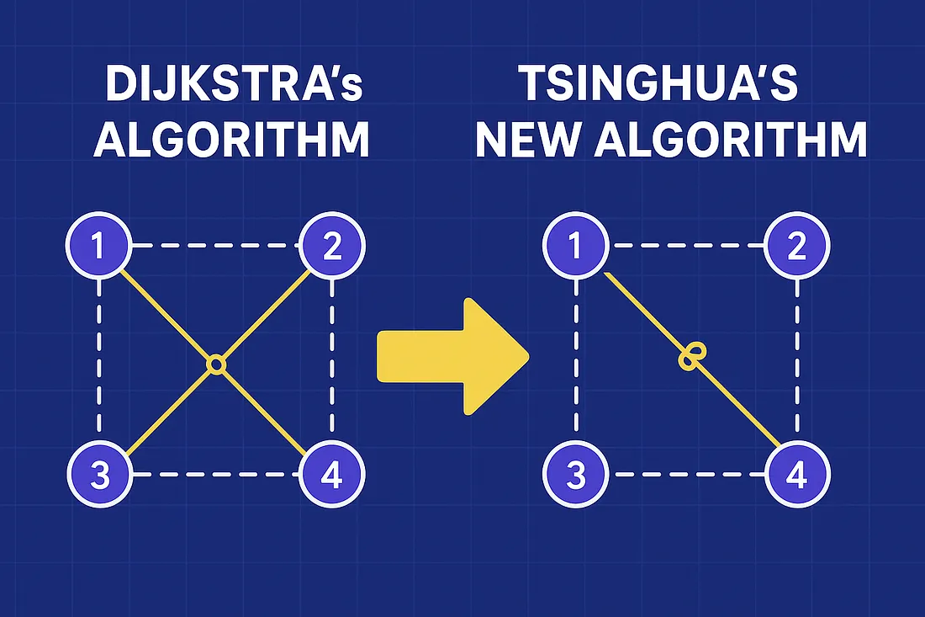

I was surprised to know that the above algorithm was developed by a person while he was casually spending his time drinking tea. Recently some researchers as Tsinghua university along with those at Stanford have found a faster algorithm as a replacement to the above. Instead of visiting the next nearest node, it uses clustering mechanism which is the grouping of nodes together to avoid repetitive checks thereby reducing the computational process. It was found to have a better time complexity. Despite its speed it has a few disadvantages. Firstly it's a more complex code to understand, it has a greater space complexity and a more intricate code.

At the end it teaches us an important message that even those things which were thought to be impossible to improve on have a better solution. Many scientists had given up on the thought of improving the above algorithm but some persisted. It is important to question each every thing, why it is done, what further advancements can me made etcetera. Although it might not soon replace Dijkstras algorithm, it has a fair chance of becoming an equal rival to this algorithm.

Link to original blog : Move Over Dijkstra: The New Algorithm That Just Rewrote 70 Years of Computer Science | by The Latency Gambler | Aug, 2025 | Medium

