Learning Management System (LMS)
Database Models, Schema & Architecture Specification
Project Component | Target Engine | ORM Framework | Specification Status
Concept-to-Mastery Bridge (CMB) | PostgreSQL 15+ | SQLAlchemy 2.0 / Alembic | Approved & Synchronized (3NF)

1. Executive Summary & Architectural Overview
This document specifies the authoritative, third-normal-form (3NF) relational database design and object-relational mapping (ORM) implementation for the Learning Management System (LMS) enhanced with the Concept-to-Mastery Bridge (CMB). The schema strictly adheres to the approved database architecture described in the project documentation and LMS_DATABASE_SCHEMA.md, translating conceptual and logical specifications into a resilient PostgreSQL schema powered by SQLAlchemy 2.0.
The LMS architecture is structured into three strictly tiered horizontal modules with an invariant dependency direction:
- 1. Foundation LMS Tier: Manages user authentication, role-based access control, administrator approval of lecturers, course catalogues, student enrolments, course reading materials, section-level text extraction, assignment lifecycles, student submissions, and question-level marking.
- 2. Concept-to-Mastery Bridge (CMB) Engine (Primary Feature): A post-marking learning-repair state machine that opens only after marks are formally released by the course lecturer. CMB diagnoses student misconceptions using two to four short items per flagged concept, establishes candidate explanations (hypotheses), connects students to lecturer-approved reading passages, and verifies learning change using fresh items rather than original assessment tasks.
- 3. Complementary Presentation Tier & Audit Gateway: Provides structured data for visual concept maps and progress paths, enforces small-group analytics suppression for lecturer privacy compliance, logs security access events polymorphically, and restricts external AI provider calls through an isolated AI Gateway that logs source grounding passages.
[PRIMARY ARCHITECTURAL RULE] Core Architectural Invariant: Deterministic server-side code decides user identity, access permissions, result release gates, and CMB availability. AI models NEVER decide permissions or release status. AI is restricted to wording assistance and practice drafting grounded strictly in lecturer-approved reading passages.

2. Conceptual & Logical Entity-Relationship (ER) Diagram
Figure 1 illustrates the high-level Conceptual and Logical Entity-Relationship (ER) architecture of the Learning Management System. The diagram represents the domain entities, high-level business relationships, and workflow pathways linking the foundation LMS tier, the Concept-to-Mastery Bridge (CMB) state machine, and the security/audit subsystems.
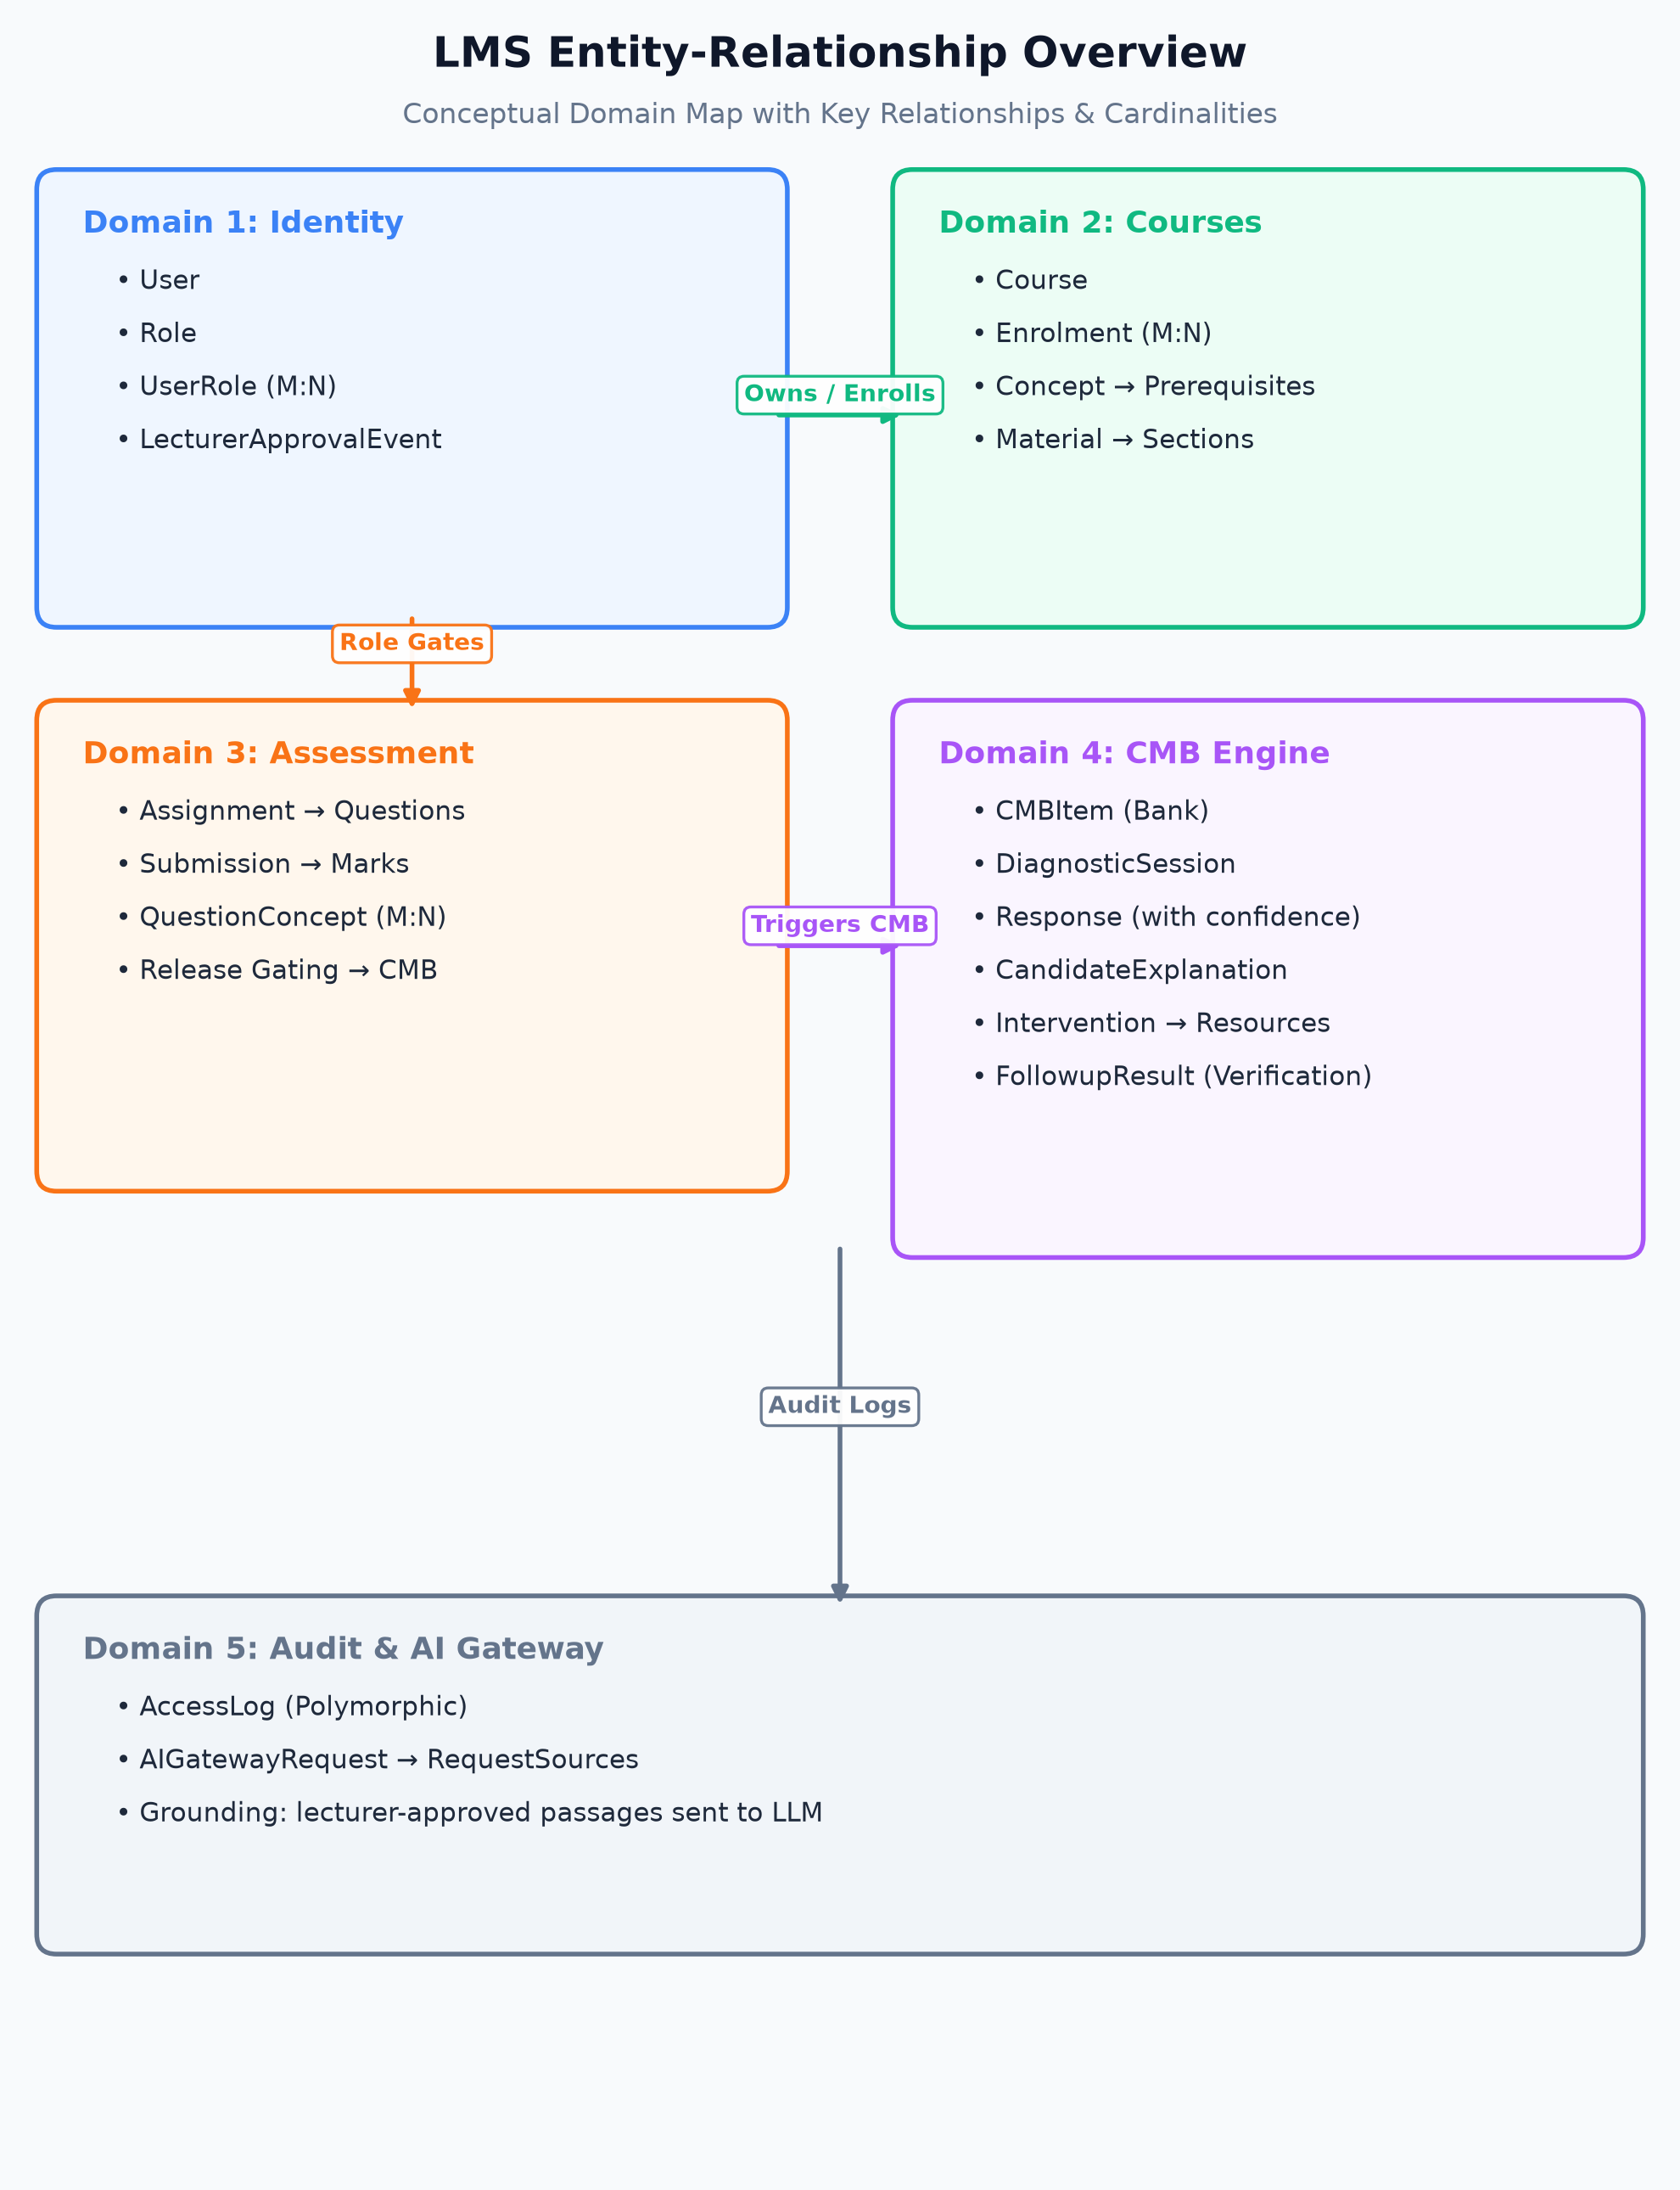
Figure 1: Conceptual & Logical Entity-Relationship (ER) Diagram of the LMS Architecture.
The logical architecture is partitioned into five distinct functional domains:
- 1. Identity & Access: Users, system roles, role assignments, and administrator approval events for lecturers.
- 2. Courses & Materials: Courses, enrolments, concepts, prerequisite dependency graphs, documents, and citable sections.
- 3. Assessment Lifecycle: Assignments, position-indexed questions, submissions, and question-level marks.
- 4. Concept-to-Mastery Bridge (CMB): Diagnostic sessions, student responses, candidate explanation hypotheses, interventions, recommended reading passages, and fresh verification items.
- 5. Audit & AI Gateway: Polymorphic user activity logs, external AI Gateway requests, and prompt grounding citations.

3. Complete Physical Relational Database Schema Diagram
Figure 2 presents the Complete Physical Relational Database Schema Diagram, depicting the exact physical DDL structure of all 27 tables implemented in PostgreSQL 15+ via SQLAlchemy 2.0. Each table box details its physical column names, SQL data types, primary key [PK] constraints, foreign key [FK] linkages, unique [UQ] indexes, and referential cascade behaviors.
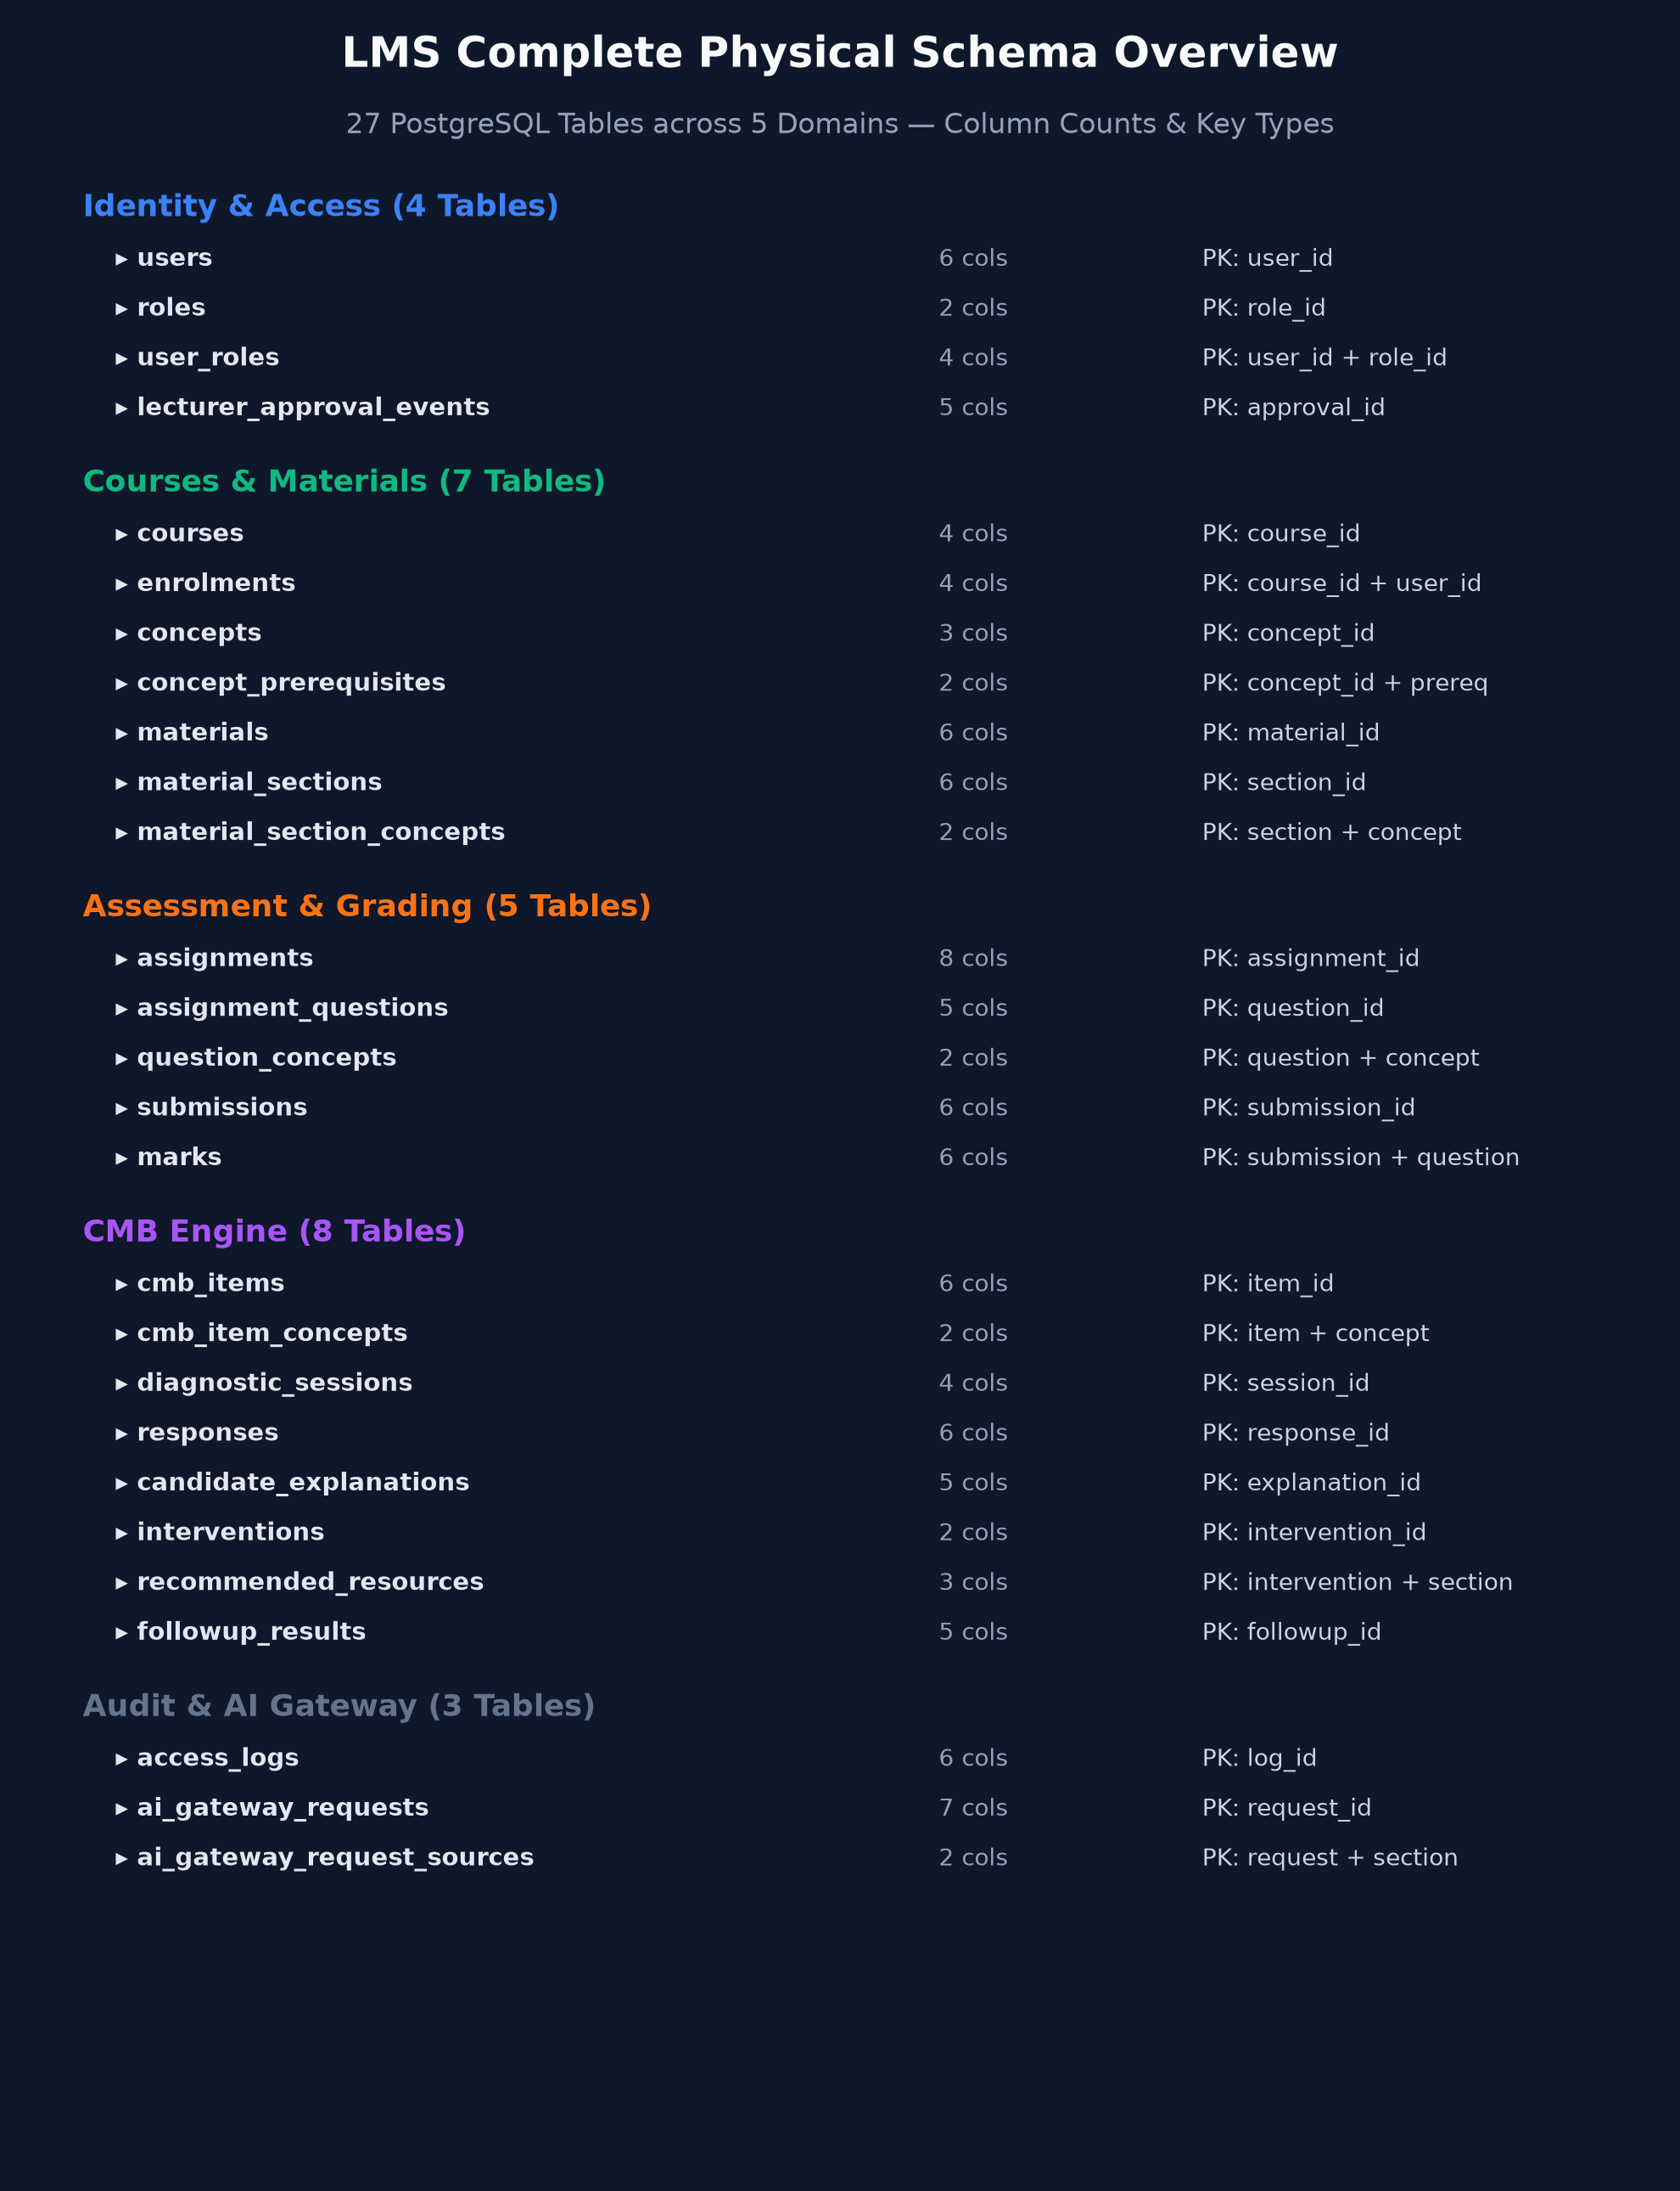
Figure 2: Complete Physical Relational Database Schema Diagram (All 27 PostgreSQL Tables).
Key physical implementation characteristics displayed in the schema diagram include:
- • Primary Keys: Surrogate auto-incrementing integer keys (SERIAL) on entity tables; composite natural keys on associative junction tables.
- • Foreign Key Linkages: Explicit referential constraints with ON DELETE CASCADE on subordinate hierarchy trees and ON DELETE SET NULL / RESTRICT on historical audit logs.
- • Temporal Precision: All timestamp columns use TIMESTAMP WITH TIME ZONE (TIMESTAMPTZ) with default now() in UTC.
- • Text & Numeric Integrity: NUMERIC(5,2) for exact grade calculations; TEXT for unconstrained prompts, sections, and comments.

4. Domain Organization & Relationship Cardinalities
Table 1 details the relationship cardinalities, foreign key references, and cascading deletion/update behaviors configured across all 27 tables. In particular, cascading deletes are strictly enforced on dependent child entities (e.g. course deletion cascades to materials, sections, concepts, and assignments), while historical audit actors in logs and grading events utilize ON DELETE RESTRICT or ON DELETE SET NULL to preserve audit trail integrity.
Parent Table | Child Table | Cardinality | Foreign Key Column | On Delete | On Update
users | user_roles | 1 : N (M:N to roles) | user_roles.user_id | CASCADE | CASCADE
roles | user_roles | 1 : N (M:N to users) | user_roles.role_id | CASCADE | CASCADE
users | user_roles (assigner) | 1 : N (Audit) | user_roles.assigned_by | SET NULL | CASCADE
users | lecturer_approval_events | 1 : N (Lecturer) | lecturer_user_id | CASCADE | CASCADE
users | lecturer_approval_events | 1 : N (Admin) | administrator_user_id | RESTRICT | CASCADE
users | courses | 1 : N (Ownership) | courses.owner_user_id | RESTRICT | CASCADE
courses | enrolments | 1 : N (M:N to users) | enrolments.course_id | CASCADE | CASCADE
users | enrolments | 1 : N (M:N to courses) | enrolments.user_id | CASCADE | CASCADE
courses | concepts | 1 : N | concepts.course_id | CASCADE | CASCADE
concepts | concept_prerequisites | 1 : N (Graph Node) | concept_id | CASCADE | CASCADE
concepts | concept_prerequisites | 1 : N (Prerequisite Node) | prerequisite_concept_id | CASCADE | CASCADE
courses | materials | 1 : N | materials.course_id | CASCADE | CASCADE
users | materials | 1 : N (Uploader) | materials.uploaded_by | RESTRICT | CASCADE
materials | material_sections | 1 : N | material_sections.material_id | CASCADE | CASCADE
material_sections | material_section_concepts | 1 : N (M:N) | material_section_concepts.section_id | CASCADE | CASCADE
concepts | material_section_concepts | 1 : N (M:N) | material_section_concepts.concept_id | CASCADE | CASCADE
courses | assignments | 1 : N | assignments.course_id | CASCADE | CASCADE
users | assignments | 1 : N (Releaser) | assignments.results_released_by | SET NULL | CASCADE
assignments | assignment_questions | 1 : N | assignment_questions.assignment_id | CASCADE | CASCADE
assignment_questions | question_concepts | 1 : N (M:N) | question_concepts.question_id | CASCADE | CASCADE
concepts | question_concepts | 1 : N (M:N) | question_concepts.concept_id | CASCADE | CASCADE
assignments | submissions | 1 : N | submissions.assignment_id | CASCADE | CASCADE
users | submissions | 1 : N | submissions.user_id | CASCADE | CASCADE
submissions | marks | 1 : N (Question Marks) | marks.submission_id | CASCADE | CASCADE
assignment_questions | marks | 1 : N (Question Marks) | marks.question_id | CASCADE | CASCADE
users | marks | 1 : N (Grader Audit) | marks.graded_by | RESTRICT | CASCADE
courses | cmb_items | 1 : N | cmb_items.course_id | CASCADE | CASCADE
users | cmb_items | 1 : N (Approver) | cmb_items.approved_by | SET NULL | CASCADE
cmb_items | cmb_item_concepts | 1 : N (M:N) | cmb_item_concepts.item_id | CASCADE | CASCADE
concepts | cmb_item_concepts | 1 : N (M:N) | cmb_item_concepts.concept_id | CASCADE | CASCADE
submissions | diagnostic_sessions | 1 : N (Release Gated) | diagnostic_sessions.submission_id | CASCADE | CASCADE
diagnostic_sessions | responses | 1 : N | responses.session_id | CASCADE | CASCADE
cmb_items | responses | 1 : N | responses.item_id | RESTRICT | CASCADE
diagnostic_sessions | candidate_explanations | 1 : N | candidate_explanations.session_id | CASCADE | CASCADE
concepts | candidate_explanations | 1 : N | candidate_explanations.concept_id | CASCADE | CASCADE
candidate_explanations | interventions | 1 : N | interventions.explanation_id | CASCADE | CASCADE
interventions | recommended_resources | 1 : N (M:N) | recommended_resources.intervention_id | CASCADE | CASCADE
material_sections | recommended_resources | 1 : N (M:N) | recommended_resources.section_id | CASCADE | CASCADE
interventions | followup_results | 1 : N | followup_results.intervention_id | CASCADE | CASCADE
cmb_items | followup_results | 1 : N (Verification) | followup_results.item_id | RESTRICT | CASCADE
users | access_logs | 1 : N (Actor Audit) | access_logs.user_id | SET NULL | CASCADE
users | ai_gateway_requests | 1 : N (Requestor) | ai_gateway_requests.user_id | RESTRICT | CASCADE
courses | ai_gateway_requests | 1 : N | ai_gateway_requests.course_id | CASCADE | CASCADE
ai_gateway_requests | ai_gateway_request_sources | 1 : N (M:N) | ai_gateway_request_sources.request_id | CASCADE | CASCADE
material_sections | ai_gateway_request_sources | 1 : N (M:N) | ai_gateway_request_sources.section_id | CASCADE | CASCADE

5. Table-by-Table Attribute Specifications (All 27 Entities)
This section documents every attribute, data type, key status, nullability, default generator, and integrity constraint for each of the 27 models implemented in app/model/.

5.A Domain 1: Identity & Access Control Schema
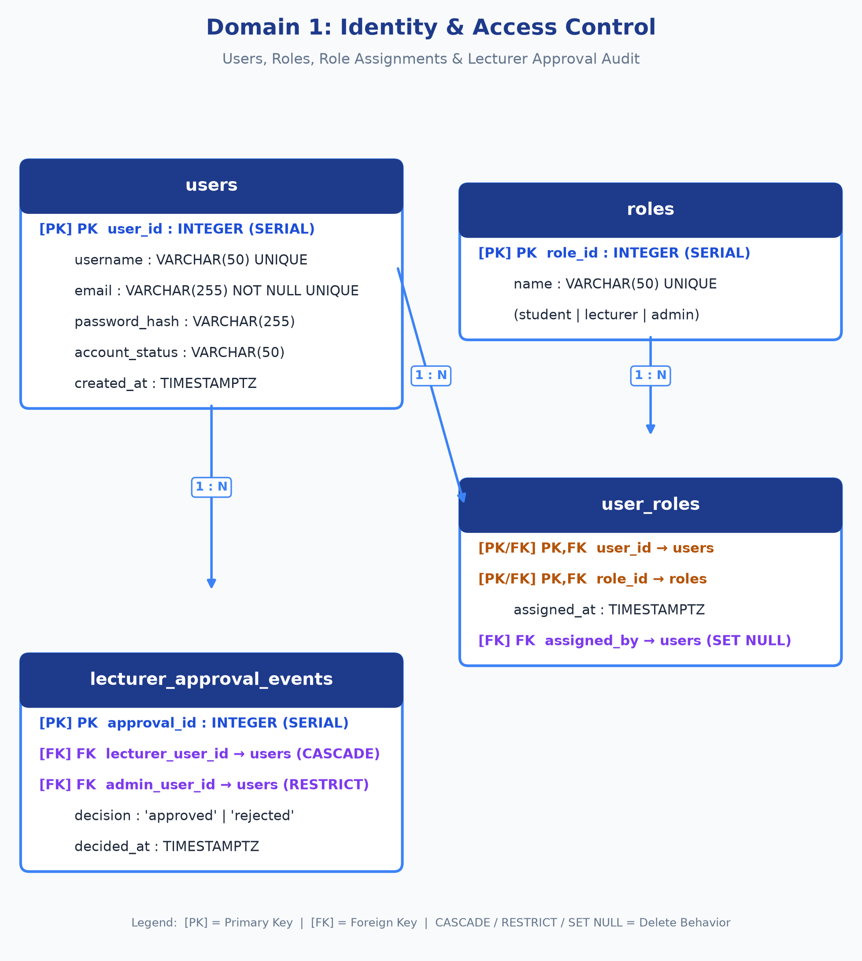
Figure 3: Domain 1 Physical Relational Schema - Identity & Access Control.

5.1. Table: users
Domain: Identity & Access Control | Primary user identity record representing students, lecturers, and system administrators.
Column Name | Type | Null | Key | Default | Index / Ref | Description
user_id | INTEGER | NO | PK | Autoincrement | Indexed | Surrogate primary key for unique user identity.
username | VARCHAR(50) | YES | None | NULL | UNIQUE, Indexed | Optional unique username for login and interface display.
email | VARCHAR(255) | NO | None | None | UNIQUE, Indexed | Canonical user email address used for login authentication.
password_hash | VARCHAR(255) | NO | None | None | None | Cryptographic hash of the user password (bcrypt/argon2).
account_status | VARCHAR(50) | NO | None | 'active' | None | Lifecycle status: 'pending_approval', 'active', 'suspended', 'inactive'.
created_at | TIMESTAMPTZ | NO | None | now() | None | UTC timestamp when the user registered in the system.
Primary Key: user_id
Foreign Keys: None (Root Entity)
Explicit Constraints: UNIQUE(email); UNIQUE(username)

5.2. Table: roles
Domain: Identity & Access Control | Lookup table of canonical system roles defining access tiers.
Column Name | Type | Null | Key | Default | Index / Ref | Description
role_id | INTEGER | NO | PK | Autoincrement | Indexed | Surrogate primary key for role.
name | VARCHAR(50) | NO | None | None | UNIQUE, Indexed | Canonical role name: 'student', 'lecturer', 'administrator'.
Primary Key: role_id
Foreign Keys: None (Root Entity)
Explicit Constraints: UNIQUE(name)

5.3. Table: user_roles
Domain: Identity & Access Control | Many-to-many junction table assigning roles to users with assignment audit metadata.
Column Name | Type | Null | Key | Default | Index / Ref | Description
user_id | INTEGER | NO | PK, FK | None | users.user_id | Foreign key to assigned user; part of composite primary key.
role_id | INTEGER | NO | PK, FK | None | roles.role_id | Foreign key to assigned role; part of composite primary key.
assigned_at | TIMESTAMPTZ | NO | None | now() | None | UTC timestamp when the role assignment was enacted.
assigned_by | INTEGER | YES | FK | NULL | users.user_id | Admin user who granted this role (ON DELETE SET NULL).
Primary Key: user_id, role_id
Foreign Keys: user_id -> users.user_id (ON DELETE CASCADE); role_id -> roles.role_id (ON DELETE CASCADE); assigned_by -> users.user_id (ON DELETE SET NULL)
Explicit Constraints: Composite PK (user_id, role_id)

5.4. Table: lecturer_approval_events
Domain: Identity & Access Control | Immutable historical log of administrator decisions approving or rejecting lecturer registration requests.
Column Name | Type | Null | Key | Default | Index / Ref | Description
approval_id | INTEGER | NO | PK | Autoincrement | Indexed | Surrogate primary key for the approval decision record.
lecturer_user_id | INTEGER | NO | FK | None | users.user_id | Candidate lecturer being reviewed (ON DELETE CASCADE).
administrator_user_id | INTEGER | NO | FK | None | users.user_id | Administrator who made the decision (ON DELETE RESTRICT).
decision | VARCHAR(50) | NO | None | None | CHECK constraint | Decision outcome: must be 'approved' or 'rejected'.
decided_at | TIMESTAMPTZ | NO | None | now() | None | UTC timestamp when administrator reviewed the account.
Primary Key: approval_id
Foreign Keys: lecturer_user_id -> users.user_id (ON DELETE CASCADE); administrator_user_id -> users.user_id (ON DELETE RESTRICT)
Explicit Constraints: CHECK (decision IN ('approved', 'rejected'))

5.B Domain 2: Courses, Prerequisite Map & Materials Schema
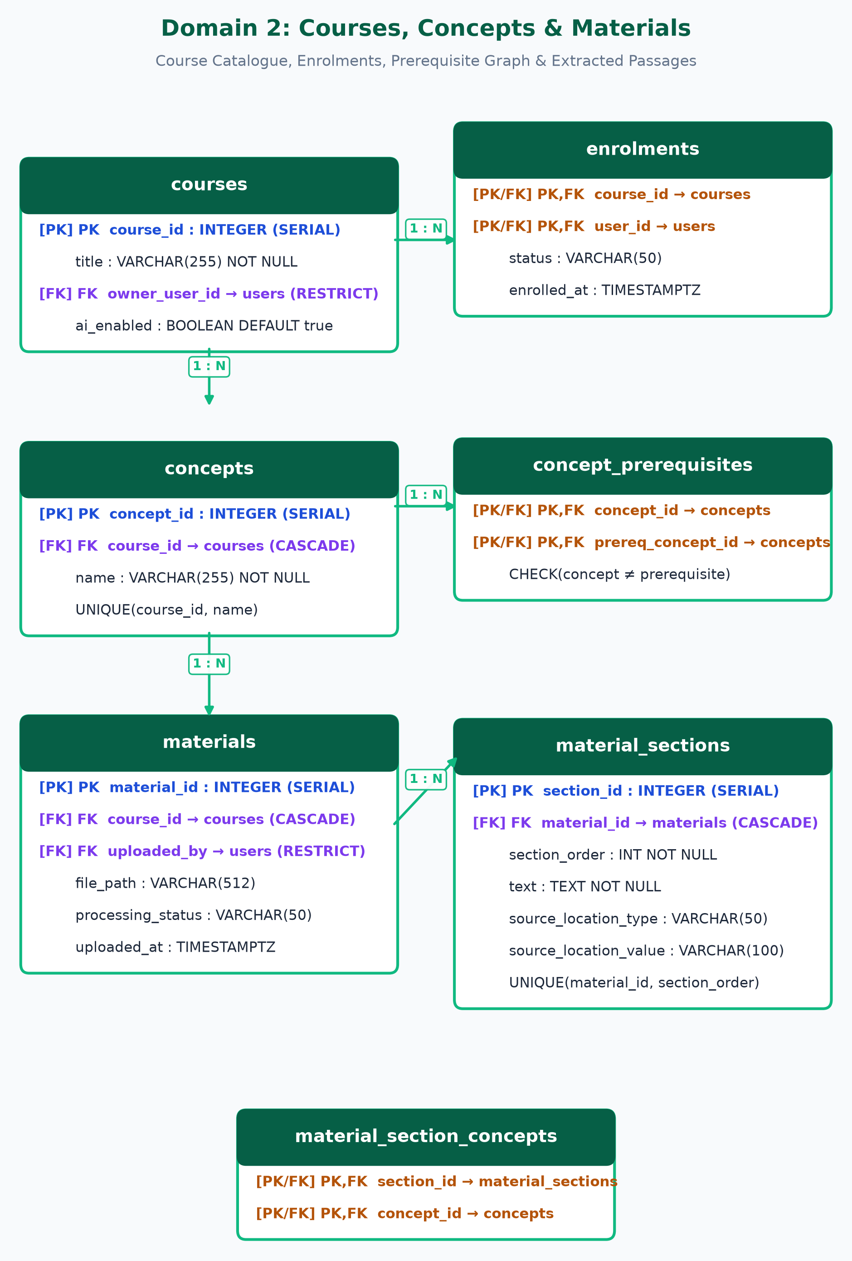
Figure 4: Domain 2 Physical Relational Schema - Courses, Materials & Concept Graph.

5.5. Table: courses
Domain: Courses & Materials | Academic course catalogue entry owned by a lecturer with global AI enablement toggle.
Column Name | Type | Null | Key | Default | Index / Ref | Description
course_id | INTEGER | NO | PK | Autoincrement | Indexed | Surrogate primary key for course.
title | VARCHAR(255) | NO | None | None | Indexed | Course title (e.g. 'CS101 Intro to Python Programming').
owner_user_id | INTEGER | NO | FK | None | users.user_id | Owning lecturer user ID (ON DELETE RESTRICT).
ai_enabled | BOOLEAN | NO | None | true | None | Master switch enabling/disabling external AI features for the course.
Primary Key: course_id
Foreign Keys: owner_user_id -> users.user_id (ON DELETE RESTRICT)

5.6. Table: enrolments
Domain: Courses & Materials | Many-to-many junction associating students with enrolled courses and tracking progress status.
Column Name | Type | Null | Key | Default | Index / Ref | Description
course_id | INTEGER | NO | PK, FK | None | courses.course_id | Foreign key to course; part of composite primary key.
user_id | INTEGER | NO | PK, FK | None | users.user_id | Foreign key to enrolled student; part of composite primary key.
status | VARCHAR(50) | NO | None | 'enrolled' | None | Enrolment lifecycle: 'enrolled', 'completed', 'dropped'.
enrolled_at | TIMESTAMPTZ | NO | None | now() | None | UTC timestamp when the student enrolled in the course.
Primary Key: course_id, user_id
Foreign Keys: course_id -> courses.course_id (ON DELETE CASCADE); user_id -> users.user_id (ON DELETE CASCADE)
Explicit Constraints: Composite PK (course_id, user_id)

5.7. Table: concepts
Domain: Courses & Materials | Pedagogical learning objectives or skills defined and curated by the course lecturer.
Column Name | Type | Null | Key | Default | Index / Ref | Description
concept_id | INTEGER | NO | PK | Autoincrement | Indexed | Surrogate primary key for concept.
course_id | INTEGER | NO | FK | None | courses.course_id | Course scope for this concept (ON DELETE CASCADE).
name | VARCHAR(255) | NO | None | None | UQ with course | Pedagogical skill name (e.g. 'Recursion', 'Scope', 'Base Case').
Primary Key: concept_id
Foreign Keys: course_id -> courses.course_id (ON DELETE CASCADE)
Explicit Constraints: UNIQUE (course_id, name)

5.8. Table: concept_prerequisites
Domain: Courses & Materials | Directed dependency graph linking concepts to their prerequisites within a course.
Column Name | Type | Null | Key | Default | Index / Ref | Description
concept_id | INTEGER | NO | PK, FK | None | concepts.concept_id | Dependent target concept (requires prerequisite).
prerequisite_concept_id | INTEGER | NO | PK, FK | None | concepts.concept_id | Required prerequisite concept.
Primary Key: concept_id, prerequisite_concept_id
Foreign Keys: concept_id -> concepts.concept_id (ON DELETE CASCADE); prerequisite_concept_id -> concepts.concept_id (ON DELETE CASCADE)
Explicit Constraints: Composite PK (concept_id, prerequisite_concept_id); CHECK (concept_id != prerequisite_concept_id)

5.9. Table: materials
Domain: Courses & Materials | Course documents (PDFs, slide decks, lecture notes) uploaded by the lecturer.
Column Name | Type | Null | Key | Default | Index / Ref | Description
material_id | INTEGER | NO | PK | Autoincrement | Indexed | Surrogate primary key for uploaded material.
course_id | INTEGER | NO | FK | None | courses.course_id | Owning course for the document (ON DELETE CASCADE).
uploaded_by | INTEGER | NO | FK | None | users.user_id | Lecturer user who uploaded the file (ON DELETE RESTRICT).
file_path | VARCHAR(512) | NO | None | None | None | Physical or object-storage path where the raw file is stored.
processing_status | VARCHAR(50) | NO | None | 'pending' | None | Ingestion status: 'pending', 'processing', 'completed', 'failed'.
uploaded_at | TIMESTAMPTZ | NO | None | now() | None | UTC timestamp of the file upload.
Primary Key: material_id
Foreign Keys: course_id -> courses.course_id (ON DELETE CASCADE); uploaded_by -> users.user_id (ON DELETE RESTRICT)

5.10. Table: material_sections
Domain: Courses & Materials | Discrete extracted passages, paragraphs, or slide chunks suitable for pinpoint citations.
Column Name | Type | Null | Key | Default | Index / Ref | Description
section_id | INTEGER | NO | PK | Autoincrement | Indexed | Surrogate primary key for document section.
material_id | INTEGER | NO | FK | None | materials.material_id | Parent document this section was extracted from.
section_order | INTEGER | NO | None | None | UQ with material | Sequential integer position within the parent document.
text | TEXT | NO | None | None | None | Extracted text content of the passage or slide.
source_location_type | VARCHAR(50) | NO | None | None | None | Citation type indicator: 'page', 'slide', or 'section'.
source_location_value | VARCHAR(100) | NO | None | None | None | Citation value: 'Page 14', 'Slide 6', 'Section 2.3'.
Primary Key: section_id
Foreign Keys: material_id -> materials.material_id (ON DELETE CASCADE)
Explicit Constraints: UNIQUE (material_id, section_order)

5.11. Table: material_section_concepts
Domain: Courses & Materials | Many-to-many junction indexing extracted material sections against pedagogical concepts.
Column Name | Type | Null | Key | Default | Index / Ref | Description
section_id | INTEGER | NO | PK, FK | None | material_sections.section_id | Extracted section reference.
concept_id | INTEGER | NO | PK, FK | None | concepts.concept_id | Pedagogical concept tagged to this section.
Primary Key: section_id, concept_id
Foreign Keys: section_id -> material_sections.section_id (ON DELETE CASCADE); concept_id -> concepts.concept_id (ON DELETE CASCADE)
Explicit Constraints: Composite PK (section_id, concept_id)

5.C Domain 3: Assessment, Questions & Grading Lifecycle Schema
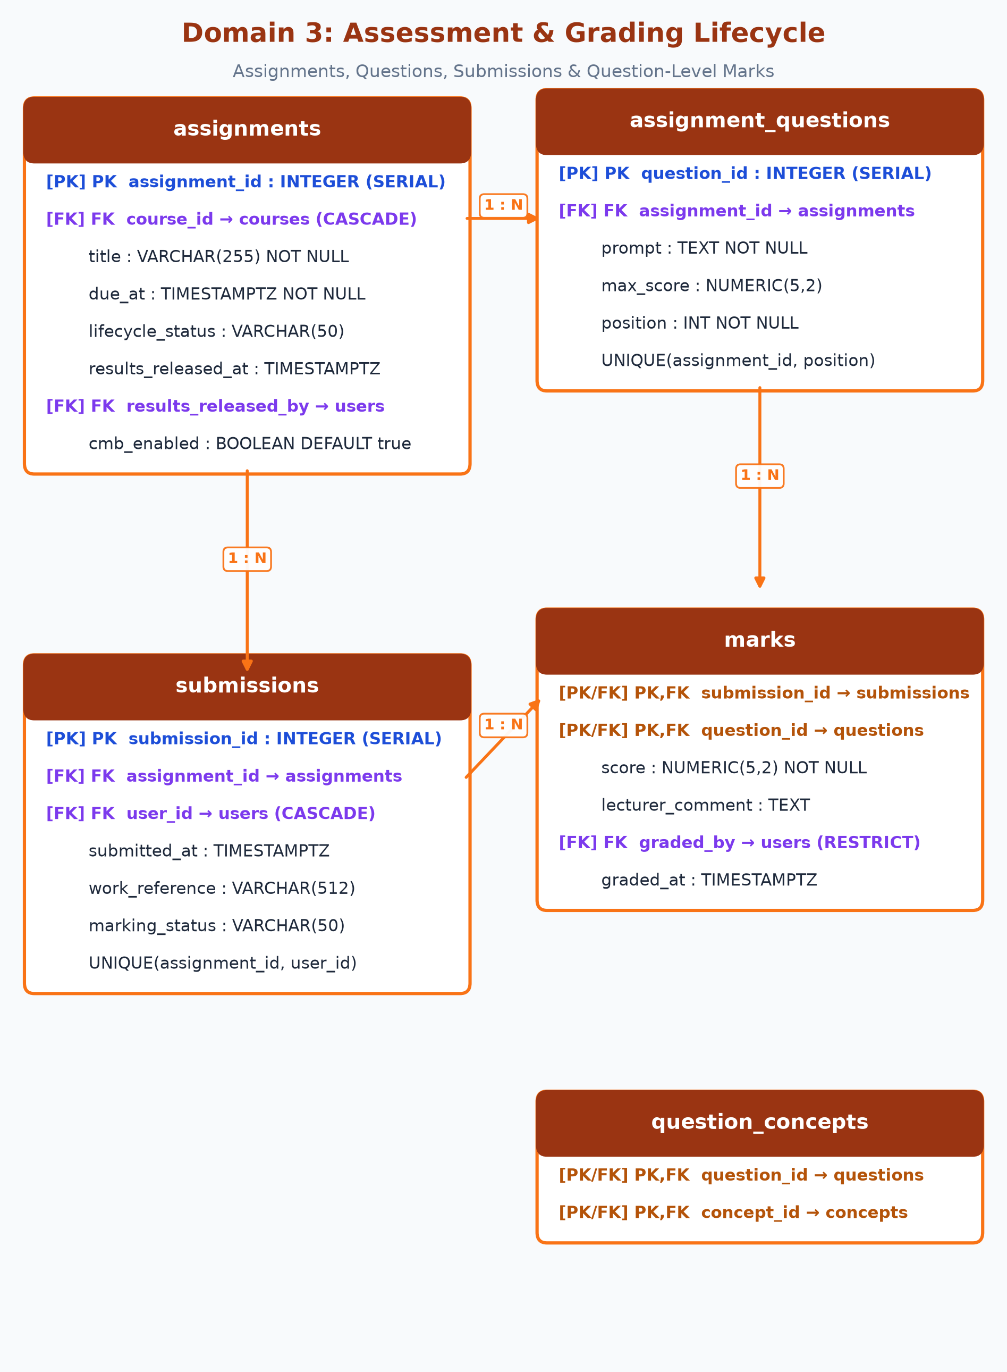
Figure 5: Domain 3 Physical Relational Schema - Assessment & Submissions.

5.12. Table: assignments
Domain: Assessment & Submissions | Graded assessment holding deadlines, release gates, and CMB enablement controls.
Column Name | Type | Null | Key | Default | Index / Ref | Description
assignment_id | INTEGER | NO | PK | Autoincrement | Indexed | Surrogate primary key for assignment.
course_id | INTEGER | NO | FK | None | courses.course_id | Owning course for the assignment (ON DELETE CASCADE).
title | VARCHAR(255) | NO | None | None | None | Assignment title (e.g. 'Recursion & Dynamic Programming Lab').
due_at | TIMESTAMPTZ | NO | None | None | None | Submission deadline in UTC timezone.
lifecycle_status | VARCHAR(50) | NO | None | 'draft' | None | Lifecycle status: 'draft', 'published', 'closed', 'marked'.
results_released_at | TIMESTAMPTZ | YES | None | NULL | None | UTC timestamp when marks were released. NULL means UNRELEASED.
results_released_by | INTEGER | YES | FK | NULL | users.user_id | Lecturer user who released results (ON DELETE SET NULL).
cmb_enabled | BOOLEAN | NO | None | true | None | Boolean switch enabling CMB diagnostic bridge for this assignment.
Primary Key: assignment_id
Foreign Keys: course_id -> courses.course_id (ON DELETE CASCADE); results_released_by -> users.user_id (ON DELETE SET NULL)

5.13. Table: assignment_questions
Domain: Assessment & Submissions | Individual questions comprising an assignment, each with maximum score limit.
Column Name | Type | Null | Key | Default | Index / Ref | Description
question_id | INTEGER | NO | PK | Autoincrement | Indexed | Surrogate primary key for question.
assignment_id | INTEGER | NO | FK | None | assignments.assignment_id | Parent assignment (ON DELETE CASCADE).
prompt | TEXT | NO | None | None | None | Full question prompt and instructions.
max_score | NUMERIC(5,2) | NO | None | None | None | Maximum possible score for this question item.
position | INTEGER | NO | None | None | UQ with assignment | Display sequence order (1, 2, 3...) within the assignment.
Primary Key: question_id
Foreign Keys: assignment_id -> assignments.assignment_id (ON DELETE CASCADE)
Explicit Constraints: UNIQUE (assignment_id, position)

5.14. Table: question_concepts
Domain: Assessment & Submissions | Many-to-many junction mapping assignment questions to target course concepts.
Column Name | Type | Null | Key | Default | Index / Ref | Description
question_id | INTEGER | NO | PK, FK | None | assignment_questions.question_id | Assignment question reference.
concept_id | INTEGER | NO | PK, FK | None | concepts.concept_id | Pedagogical concept tested by this question.
Primary Key: question_id, concept_id
Foreign Keys: question_id -> assignment_questions.question_id (ON DELETE CASCADE); concept_id -> concepts.concept_id (ON DELETE CASCADE)
Explicit Constraints: Composite PK (question_id, concept_id)

5.15. Table: submissions
Domain: Assessment & Submissions | Coursework submitted by a student for a specific assignment.
Column Name | Type | Null | Key | Default | Index / Ref | Description
submission_id | INTEGER | NO | PK | Autoincrement | Indexed | Surrogate primary key for student submission.
assignment_id | INTEGER | NO | FK | None | assignments.assignment_id | Parent assignment (ON DELETE CASCADE).
user_id | INTEGER | NO | FK | None | users.user_id | Student who submitted the work (ON DELETE CASCADE).
submitted_at | TIMESTAMPTZ | NO | None | now() | None | UTC timestamp of the student submission.
work_reference | VARCHAR(512) | NO | None | None | None | File storage URI or code repository link of student work.
marking_status | VARCHAR(50) | NO | None | 'submitted' | None | Marking status: 'submitted', 'marking_in_progress', 'marked'.
Primary Key: submission_id
Foreign Keys: assignment_id -> assignments.assignment_id (ON DELETE CASCADE); user_id -> users.user_id (ON DELETE CASCADE)
Explicit Constraints: UNIQUE (assignment_id, user_id)

5.16. Table: marks
Domain: Assessment & Submissions | Question-level evaluations and feedback awarded by lecturers.
Column Name | Type | Null | Key | Default | Index / Ref | Description
submission_id | INTEGER | NO | PK, FK | None | submissions.submission_id | Student submission reference.
question_id | INTEGER | NO | PK, FK | None | assignment_questions.question_id | Question evaluated in this mark.
score | NUMERIC(5,2) | NO | None | None | None | Numeric score awarded by the grading lecturer.
lecturer_comment | TEXT | YES | None | NULL | None | Formative text feedback from the grader.
graded_by | INTEGER | NO | FK | None | users.user_id | Lecturer user who entered the grade (ON DELETE RESTRICT).
graded_at | TIMESTAMPTZ | NO | None | now() | None | UTC timestamp when the mark was recorded.
Primary Key: submission_id, question_id
Foreign Keys: submission_id -> submissions.submission_id (ON DELETE CASCADE); question_id -> assignment_questions.question_id (ON DELETE CASCADE); graded_by -> users.user_id (ON DELETE RESTRICT)
Explicit Constraints: Composite PK (submission_id, question_id)

5.D Domain 4: Concept-to-Mastery Bridge (CMB) Engine Schema
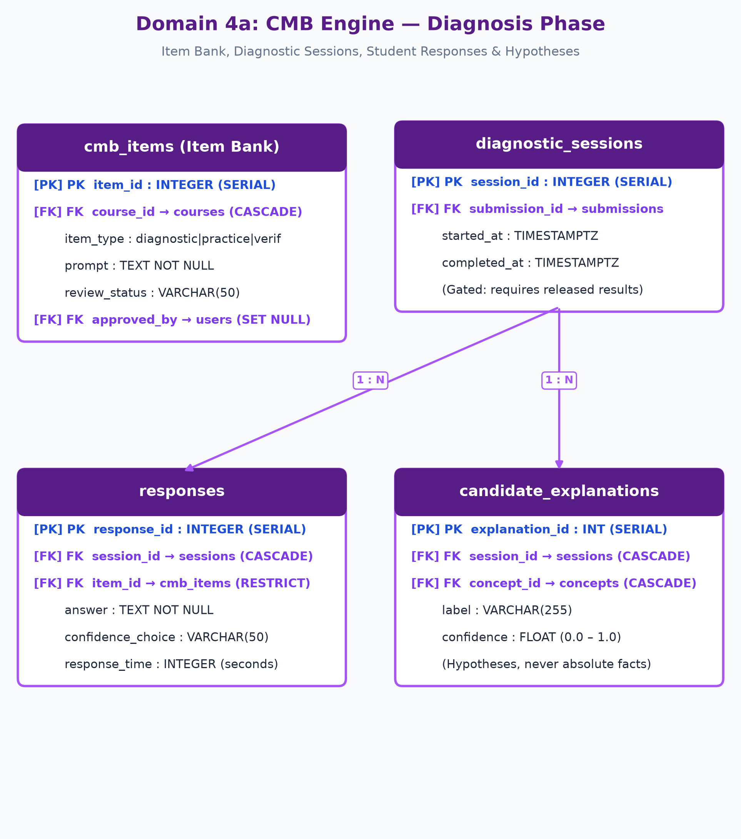
Figure 6a: Domain 4 Physical Relational Schema - CMB Diagnosis Phase.
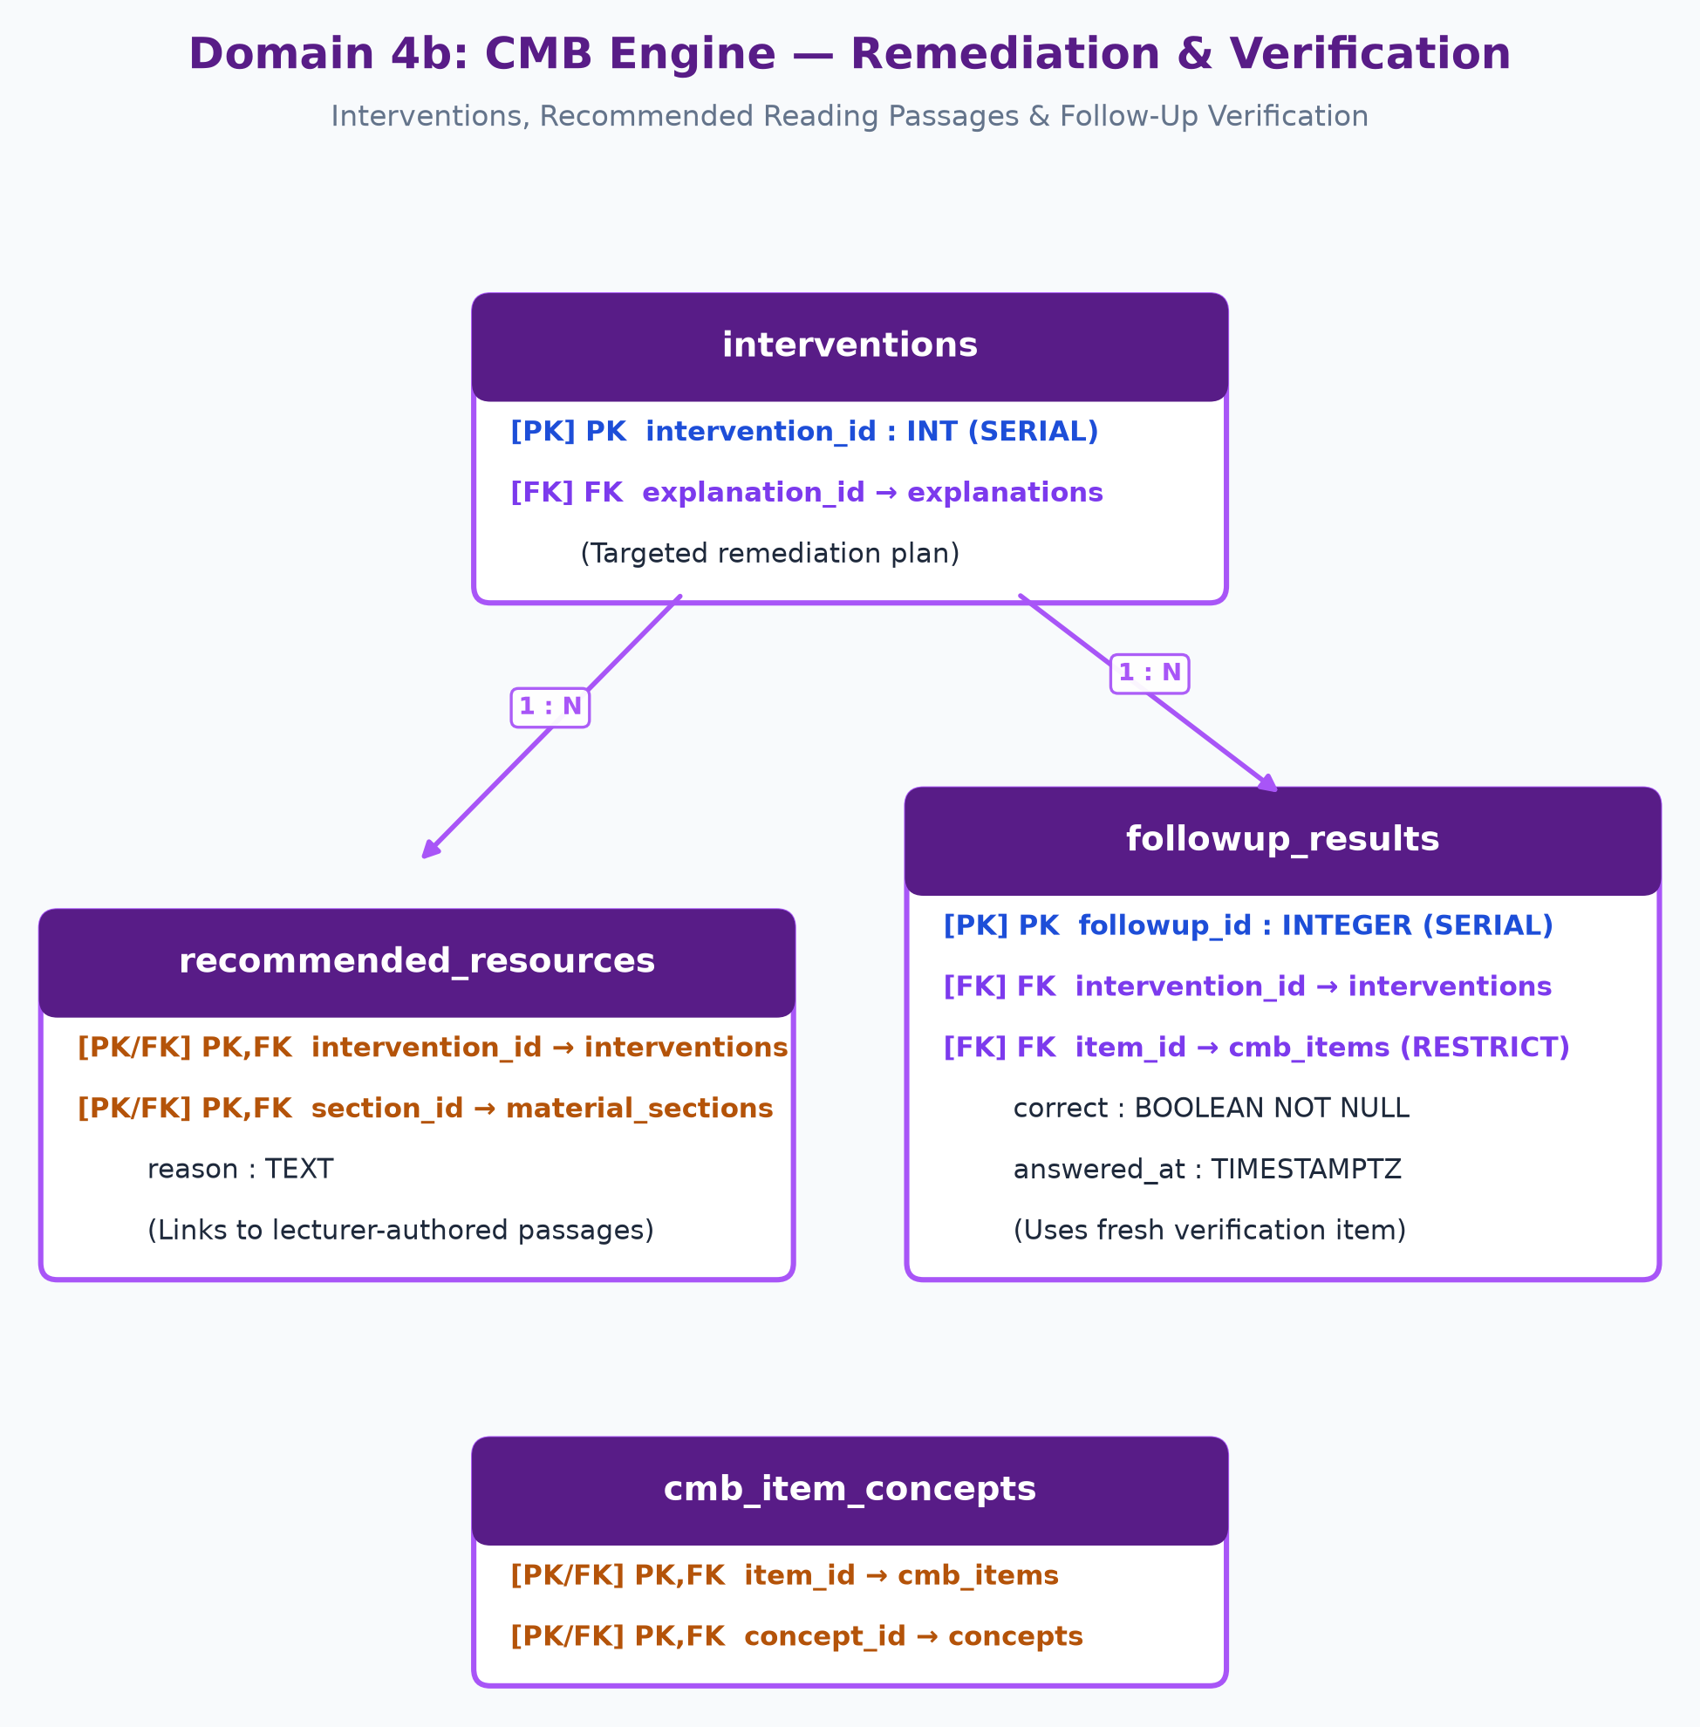
Figure 6b: Domain 4 Physical Relational Schema - CMB Remediation & Verification Phase.

5.17. Table: cmb_items
Domain: Concept-to-Mastery Bridge | Reusable items in the question bank used for diagnosis, practice, or verification.
Column Name | Type | Null | Key | Default | Index / Ref | Description
item_id | INTEGER | NO | PK | Autoincrement | Indexed | Surrogate primary key for CMB bank item.
course_id | INTEGER | NO | FK | None | courses.course_id | Course scope for this item (ON DELETE CASCADE).
item_type | VARCHAR(50) | NO | None | None | CHECK constraint | Must be 'diagnostic', 'practice', or 'verification'.
prompt | TEXT | NO | None | None | None | Text of the diagnostic/practice/verification task.
review_status | VARCHAR(50) | NO | None | 'draft' | None | Quality state: 'draft', 'approved', or 'rejected'.
approved_by | INTEGER | YES | FK | NULL | users.user_id | Lecturer who reviewed and approved this item (ON DELETE SET NULL).
Primary Key: item_id
Foreign Keys: course_id -> courses.course_id (ON DELETE CASCADE); approved_by -> users.user_id (ON DELETE SET NULL)
Explicit Constraints: CHECK (item_type IN ('diagnostic', 'practice', 'verification'))

5.18. Table: cmb_item_concepts
Domain: Concept-to-Mastery Bridge | Many-to-many junction mapping CMB bank items to targeted course concepts.
Column Name | Type | Null | Key | Default | Index / Ref | Description
item_id | INTEGER | NO | PK, FK | None | cmb_items.item_id | CMB item reference.
concept_id | INTEGER | NO | PK, FK | None | concepts.concept_id | Target pedagogical concept reference.
Primary Key: item_id, concept_id
Foreign Keys: item_id -> cmb_items.item_id (ON DELETE CASCADE); concept_id -> concepts.concept_id (ON DELETE CASCADE)
Explicit Constraints: Composite PK (item_id, concept_id)

5.19. Table: diagnostic_sessions
Domain: Concept-to-Mastery Bridge | Diagnostic session initiated by a student after marks release to investigate gaps.
Column Name | Type | Null | Key | Default | Index / Ref | Description
session_id | INTEGER | NO | PK | Autoincrement | Indexed | Surrogate primary key for diagnostic session.
submission_id | INTEGER | NO | FK | None | submissions.submission_id | Submission that triggered this diagnostic (ON DELETE CASCADE).
started_at | TIMESTAMPTZ | NO | None | now() | None | UTC timestamp when the student initiated gap exploration.
completed_at | TIMESTAMPTZ | YES | None | NULL | None | UTC timestamp when the diagnostic session was finished.
Primary Key: session_id
Foreign Keys: submission_id -> submissions.submission_id (ON DELETE CASCADE)

5.20. Table: responses
Domain: Concept-to-Mastery Bridge | Student response to a diagnostic item capturing answer, time, and confidence choice.
Column Name | Type | Null | Key | Default | Index / Ref | Description
response_id | INTEGER | NO | PK | Autoincrement | Indexed | Surrogate primary key for student response.
session_id | INTEGER | NO | FK | None | diagnostic_sessions.session_id | Parent diagnostic session (ON DELETE CASCADE).
item_id | INTEGER | NO | FK | None | cmb_items.item_id | Diagnostic CMB item answered (ON DELETE RESTRICT).
answer | TEXT | NO | None | None | None | Student's raw answer text or selected choice.
confidence_choice | VARCHAR(50) | YES | None | NULL | None | Metacognitive rating: 'high', 'medium', 'low', 'unsure'.
response_time | INTEGER | YES | None | NULL | None | Time elapsed in seconds before submitting response.
Primary Key: response_id
Foreign Keys: session_id -> diagnostic_sessions.session_id (ON DELETE CASCADE); item_id -> cmb_items.item_id (ON DELETE RESTRICT)

5.21. Table: candidate_explanations
Domain: Concept-to-Mastery Bridge | Probabilistic hypotheses regarding underlying causes of difficulty; never stored as absolute facts.
Column Name | Type | Null | Key | Default | Index / Ref | Description
explanation_id | INTEGER | NO | PK | Autoincrement | Indexed | Surrogate primary key for hypothesis.
session_id | INTEGER | NO | FK | None | diagnostic_sessions.session_id | Parent diagnostic session (ON DELETE CASCADE).
concept_id | INTEGER | NO | FK | None | concepts.concept_id | Diagnosed concept experiencing misconceptions.
label | VARCHAR(255) | NO | None | None | None | Descriptive hypothesis label (e.g. 'Conflating return with base case').
confidence | FLOAT | NO | None | None | None | Engine confidence metric (0.0 to 1.0) derived from rules and graph.
Primary Key: explanation_id
Foreign Keys: session_id -> diagnostic_sessions.session_id (ON DELETE CASCADE); concept_id -> concepts.concept_id (ON DELETE CASCADE)

5.22. Table: interventions
Domain: Concept-to-Mastery Bridge | Targeted remediation plan linking a hypothesis to recommended reading passages and follow-up.
Column Name | Type | Null | Key | Default | Index / Ref | Description
intervention_id | INTEGER | NO | PK | Autoincrement | Indexed | Surrogate primary key for intervention plan.
explanation_id | INTEGER | NO | FK | None | candidate_explanations.explanation_id | Hypothesis triggering this remediation (ON DELETE CASCADE).
Primary Key: intervention_id
Foreign Keys: explanation_id -> candidate_explanations.explanation_id (ON DELETE CASCADE)

5.23. Table: recommended_resources
Domain: Concept-to-Mastery Bridge | Association mapping an intervention to lecturer-authored passages with targeted justification.
Column Name | Type | Null | Key | Default | Index / Ref | Description
intervention_id | INTEGER | NO | PK, FK | None | interventions.intervention_id | Remediation intervention reference.
section_id | INTEGER | NO | PK, FK | None | material_sections.section_id | Lecturer-authored section passage recommended.
reason | TEXT | YES | None | NULL | None | Pedagogical explanation why this passage aids recovery.
Primary Key: intervention_id, section_id
Foreign Keys: intervention_id -> interventions.intervention_id (ON DELETE CASCADE); section_id -> material_sections.section_id (ON DELETE CASCADE)
Explicit Constraints: Composite PK (intervention_id, section_id)

5.24. Table: followup_results
Domain: Concept-to-Mastery Bridge | Verification outcome evaluating whether student understanding improved using a fresh bank item.
Column Name | Type | Null | Key | Default | Index / Ref | Description
followup_id | INTEGER | NO | PK | Autoincrement | Indexed | Surrogate primary key for verification attempt.
intervention_id | INTEGER | NO | FK | None | interventions.intervention_id | Intervention plan being verified (ON DELETE CASCADE).
item_id | INTEGER | NO | FK | None | cmb_items.item_id | Fresh verification item (must NOT be original assignment question).
correct | BOOLEAN | NO | None | None | None | Verification outcome: True if student successfully applied concept.
answered_at | TIMESTAMPTZ | NO | None | now() | None | UTC timestamp of the follow-up attempt.
Primary Key: followup_id
Foreign Keys: intervention_id -> interventions.intervention_id (ON DELETE CASCADE); item_id -> cmb_items.item_id (ON DELETE RESTRICT)

5.E Domain 5: Security Audit Trail & AI Gateway Schema
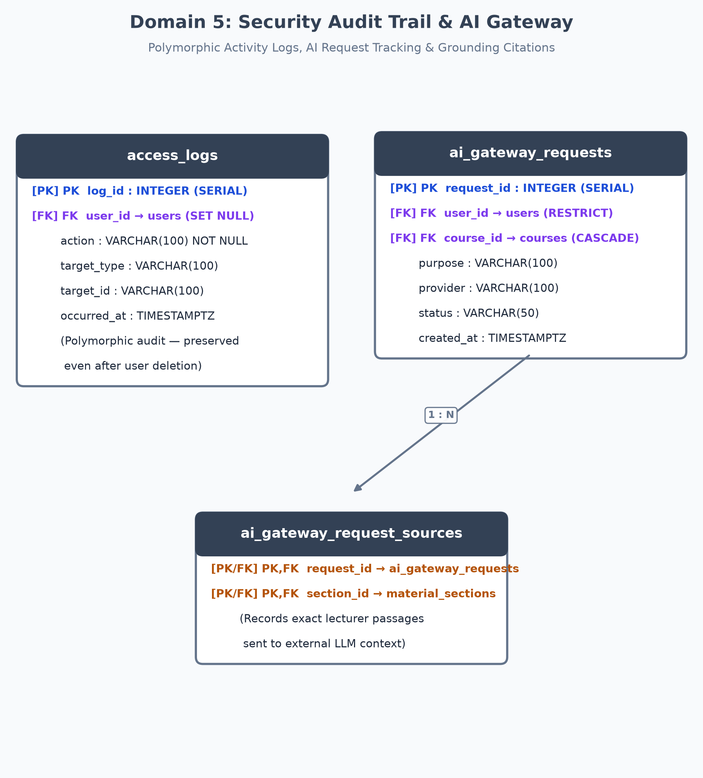
Figure 7: Domain 5 Physical Relational Schema - Security Audit & AI Gateway.

5.25. Table: access_logs
Domain: Audit Trail & AI Gateway | Polymorphic audit log recording user security operations, results releases, and record access.
Column Name | Type | Null | Key | Default | Index / Ref | Description
log_id | INTEGER | NO | PK | Autoincrement | Indexed | Surrogate primary key for audit log entry.
user_id | INTEGER | YES | FK | NULL | users.user_id | Acting user ID (ON DELETE SET NULL to preserve audit trail).
action | VARCHAR(100) | NO | None | None | Indexed | Operation type: 'login', 'release_results', 'view_submission', etc.
target_type | VARCHAR(100) | NO | None | None | Indexed | Polymorphic target entity: 'submission', 'course', 'session'.
target_id | VARCHAR(100) | NO | None | None | Indexed | String identifier of target entity.
occurred_at | TIMESTAMPTZ | NO | None | now() | Indexed | UTC timestamp when the operation transpired.
Primary Key: log_id
Foreign Keys: user_id -> users.user_id (ON DELETE SET NULL)
Explicit Constraints: Polymorphic Reference (target_type, target_id)

5.26. Table: ai_gateway_requests
Domain: Audit Trail & AI Gateway | Audit trail of external LLM invocations routed strictly through the AI Gateway.
Column Name | Type | Null | Key | Default | Index / Ref | Description
request_id | INTEGER | NO | PK | Autoincrement | Indexed | Surrogate primary key for AI Gateway request.
user_id | INTEGER | NO | FK | None | users.user_id | User requesting AI assistance (ON DELETE RESTRICT).
course_id | INTEGER | NO | FK | None | courses.course_id | Associated course context (ON DELETE CASCADE).
purpose | VARCHAR(100) | NO | None | None | None | Gateway purpose: 'reword_explanation', 'draft_practice_item'.
provider | VARCHAR(100) | NO | None | None | None | Hosted provider identifier: 'anthropic', 'openai', 'gemini'.
status | VARCHAR(50) | NO | None | None | Indexed | Execution status: 'queued', 'completed', 'timeout', 'failed'.
created_at | TIMESTAMPTZ | NO | None | now() | Indexed | UTC timestamp when request was initiated.
Primary Key: request_id
Foreign Keys: user_id -> users.user_id (ON DELETE RESTRICT); course_id -> courses.course_id (ON DELETE CASCADE)

5.27. Table: ai_gateway_request_sources
Domain: Audit Trail & AI Gateway | Junction recording which lecturer-approved sections grounded each AI Gateway request.
Column Name | Type | Null | Key | Default | Index / Ref | Description
request_id | INTEGER | NO | PK, FK | None | ai_gateway_requests.request_id | AI Gateway request reference.
section_id | INTEGER | NO | PK, FK | None | material_sections.section_id | Lecturer-approved passage sent to grounding context.
Primary Key: request_id, section_id
Foreign Keys: request_id -> ai_gateway_requests.request_id (ON DELETE CASCADE); section_id -> material_sections.section_id (ON DELETE CASCADE)
Explicit Constraints: Composite PK (request_id, section_id)

6. Relational Normalization Analysis & Formal Decisions
A rigorous database design for an educational system must eliminate update anomalies, avoid insertion contradictions, and prevent orphaned records while maximizing query efficiency. The schema has been normalized to Third Normal Form (3NF) and complies with Boyce-Codd Normal Form (BCNF) requirements across all domains.

6.1 First Normal Form (1NF): Atomicity & Elimination of Repeating Groups
1NF requires that all attributes contain atomic (indivisible) values and that no multivalued groups, comma-delimited strings, or arrays are stored within table cells:
- • Roles: Instead of a comma-separated 'roles' column on the users table (e.g. 'lecturer,admin'), a discrete lookup table roles and a normalized junction table user_roles are utilized.
- • Pedagogical Concepts: Concepts are mapped to material sections, assignment questions, and CMB items via explicit junction tables (material_section_concepts, question_concepts, cmb_item_concepts), preventing nested concept lists.
- • Diagnostic Evidence: Each diagnostic answer and verification result is stored as an atomic row in responses and followup_results, retaining individual timestamps and confidence ratings rather than serialized JSON blobs.

6.2 Second Normal Form (2NF): Full Functional Dependency on Composite Primary Keys
2NF requires compliance with 1NF and guarantees that every non-key attribute is functionally dependent upon the ENTIRE primary key, eliminating partial dependencies in composite key tables:
- • enrolments (course_id, user_id): The non-key attribute status (e.g. 'enrolled', 'completed') describes the specific membership state of that student in that particular course. It does not depend solely on user_id or course_id.
- • marks (submission_id, question_id): Attributes score and lecturer_comment depend strictly on the composite key. A score belongs to a specific question attempt on a specific submission, not the assignment generally.
- • recommended_resources (intervention_id, section_id): The pedagogical reason for recommending a reading passage depends both on the specific student misconception (intervention_id) and the recommended passage (section_id).

6.3 Third Normal Form (3NF): Elimination of Transitive Dependencies
3NF requires compliance with 2NF and mandates that no non-key attribute depends transitively on the primary key through another non-key attribute (X -> Y and Y -> Z):
- • User Identity vs Approval History: Lecturer approval attributes (decision, decided_at, administrator_user_id) are segregated into lecturer_approval_events rather than stored on the users table. If stored on users, decision would depend on administrator_user_id which in turn depends on user_id, introducing a transitive dependency.
- • Entity Titles & Descriptions: Course titles reside in courses, concept names in concepts, and section texts in material_sections. Dependent tables store only foreign keys (course_id, concept_id, section_id), ensuring zero data duplication.
- • Grade Totals & Derived Metrics: In compliance with 3NF and project requirements, grade totals, class averages, and CMB eligibility flags are NOT persisted as redundant columns. Instead, they are calculated dynamically via deterministic aggregate queries over marks and submissions, avoiding synchronization anomalies.

7. Access Control & Security Design
The system implements a deterministic, server-enforced Role-Based Access Control (RBAC) model. Every client request passes through the application server's authentication and authorization middleware before reaching business logic, database queries, or the AI Gateway.

7.1 User Roles and Permissions Matrix
Functional Area / Action | Student | Lecturer | Administrator
Register Account | Self-service; active immediately | Self-service; pending approval | Created by system bootstrap
Approve Lecturer Accounts | Denied | Denied | Granted (lecturer_approval_events)
Manage Users & Disable AI | Denied | Denied | Granted
Create & Manage Courses | Denied | Granted (Owned courses) | Granted (System-wide)
Upload Materials & Concepts | Denied | Granted (Owned courses) | Granted
Create Assignments & Questions | Denied | Granted (Owned courses) | Granted
Submit Coursework | Granted (Enrolled courses) | Denied | Denied
Grade Submissions & Marks | Denied | Granted (Owned courses) | Denied
Release Marks to Students | Denied | Granted (Owned courses) | Denied
Explore Learning Gaps (CMB) | Granted (Only after marks release) | Denied (Uses aggregate view) | Denied
Review / Correct AI Bank Items | Denied | Granted (Owned courses) | Granted
View Class Analytics | Denied (Own results only) | Granted (Hides groups < N) | Granted

7.2 Lecturer Registration Approval Workflow
To guarantee pedagogical integrity and prevent unauthorized access to course creation and student records, lecturer registration follows a mandatory two-step approval process:
- 1. When a lecturer registers, their account status in users is initialized to 'pending_approval' and their role in user_roles is flagged as inactive.
- 2. A system administrator reviews the applicant. Upon approval, an immutable record is inserted into lecturer_approval_events (recording lecturer_user_id, administrator_user_id, decision='approved', decided_at=now()), and the user's account_status is transitioned to 'active'.

7.3 Release Gating & CMB Availability Rules
A cornerstone of the CMB learning-repair cycle is deterministic release gating. Students are blocked from opening 'Explore My Learning Gaps' until six strict server-side predicates are satisfied simultaneously:
- Predicate 1: The requesting user is enrolled in the course (enrolments.status = 'enrolled').
- Predicate 2: The student has submitted coursework (submissions.user_id = caller).
- Predicate 3: The submission has been marked by the lecturer (submissions.marking_status = 'marked').
- Predicate 4: Assignment results have been formally released (assignments.results_released_at IS NOT NULL).
- Predicate 5: CMB is enabled on the assignment (assignments.cmb_enabled = TRUE).
- Predicate 6: The caller possesses the 'student' role. Lecturers and administrators are refused diagnostic sessions.
[SECURITY INVARIANT] Zero Information Leaking: Before results_released_at is populated by the lecturer, the student interface displays a plain explanation of feature unavailability. No preliminary scores, AI hints, or diagnostic items are accessible.

8. Security Audit Trail & AI Gateway Governance
The system incorporates comprehensive, non-repudiable audit logging alongside strict AI governance to satisfy educational data privacy regulations (FERPA/GDPR compliance).

8.1 Polymorphic Access Logging
The access_logs table records all security-sensitive operations, results releases, and student record access. It employs a polymorphic design with target_type and target_id, enabling uniform logging across diverse entities (submissions, marks, diagnostic sessions, courses) without proliferating audit tables. To guarantee non-repudiation, user_id foreign keys specify ON DELETE SET NULL, ensuring audit logs remain intact even if a user account is deleted.

8.2 AI Gateway Compliance & Grounding Integrity
The AI Gateway is the single egress point to external LLM providers (Anthropic, OpenAI, Google Gemini). It enforces three architectural constraints:
- 1. Source Passage Grounding: Calls to generate practice items or reword explanations MUST cite specific lecturer-approved sections. These grounding passages are captured in ai_gateway_request_sources, providing complete reproducibility and provenance.
- 2. Prompt Sanitization & Privacy: Raw student identifiable information (names, emails, submission files) is NEVER transmitted to external LLMs. Prompts contain only sanitized pedagogical concept tokens and lecturer passage texts.
- 3. Lecturer Kill Switch: Lecturers can disable external AI features per course via courses.ai_enabled = FALSE. When disabled, the CMB engine runs purely on rule-based heuristics and pre-approved lecturer question banks without degradation.

8.3 Student Privacy & Analytics Suppression
Lecturers review aggregated concept heat-maps and misconception summaries. To prevent de-anonymization of students in small cohorts, the analytics service enforces small-group suppression: any concept aggregate representing fewer than a configurable threshold of students (e.g. N < 5) is withheld from the lecturer summary view.
Additionally, the student reading companion is completely ungraded. It is structurally forbidden from reading marks, and creates zero diagnostic records unless the student explicitly opts into a self-check session.

9. Verification, Consistency & Migration Summary
The model implementation has been validated against both static structural invariants and dynamic runtime migrations:
Verification Check | Scope & Method | Validation Result
Model Discovery | Base.metadata across app.model package | 27 / 27 tables registered with zero missing definitions
Mapper Configuration | SQLAlchemy configure_mappers() compile test | Passed with 0 warnings and 0 ambiguous join errors
Check Constraints | IntegrityError tests on self-prerequisites & item types | Self-prerequisites blocked; item types enforced
Cascade Behavior | Deletions across course, material, and submission graphs | Child entities cascade; audit users set null / restricted
Alembic Migration | Alembic revision 6b52c0da0093 upgraded on PostgreSQL | Applied successfully to live postgresql://localhost:5432/lms_db
Backward Compatibility | Re-exports in User.py, Role.py, user_role.py, models/ | Legacy imports and seed-data endpoints run without changes

Conclusion: The LMS database schema is fully implemented, verified, normalized, and migrated in strict compliance with all project requirements.

