Table of Contents

Context Cost Verifier (ccv): Measuring Whether Shrinking an LLM Prompt Really Saves Cost
Undergraduate major project — formal report. The full analysis is in the companion findings report; the development record behind every chapter is in docs/REPORT_NOTES.md.

Abstract
Production LLM systems routinely shrink their prompts — truncating documents, dropping old conversation turns, compressing context with tools such as LLMLingua-2 — on the assumption that fewer input tokens means lower cost. That assumption ignores two effects. First, output tokens are far more expensive than input tokens: commercial price lists charge roughly five times more per output token, and on the hardware every output token is a separate sequential decode step. Second, a model that loses context can write longer answers and get more of them wrong. ccv (Context Cost Verifier) is an open-source command-line tool that measures this trade-off before a context change ships. It sends benchmark tasks to any OpenAI-compatible endpoint, records physical cost on the GPU (prefill time, decode time, GPU-seconds, energy), attributes every prompt token exactly to one of six context segments using the served model’s own tokenizer and chat template, and runs an exact Shapley analysis over all 64 subsets of those segments. Statistical tests (exact McNemar, paired bootstrap, Benjamini–Hochberg) separate real effects from run-to-run noise. The study runs at zero cost on a free Kaggle T4 GPU with Qwen2.5-7B-Instruct (AWQ) served by vLLM. Over 3,090 measured requests on a calibrated 30-task benchmark:
- A decode token cost 19× a prefill token, against the 5× of price lists.
- In 19% of cases, removing a prompt segment raised GPU cost, almost always because format instructions were removed.
- Truncation and LLMLingua-2 lost significant accuracy even when they kept 75–85% of the context.

1. Introduction

1.1 Background
A request to a large language model has two phases. Prefill processes the whole prompt in parallel and produces the first output token; its cost grows with prompt length but is highly parallel on a GPU. Decode then produces the answer one token at a time; every token is a full forward pass, so decode cost grows with answer length and is memory-bandwidth bound. Commercial APIs reflect this by pricing output tokens at several times the price of input tokens.
Prompts in real applications are assembled from several parts: a system persona, instructions, tool definitions, few-shot examples, retrieved documents, and conversation history. When a prompt gets long, engineers trim it. Whether that actually saves money depends on what happens to the output: if the model, deprived of context, rambles, hedges, asks clarifying questions or answers wrongly and needs a retry, the saving on input can be wiped out.

1.2 Problem statement
There is no lightweight, reproducible way for an engineer to answer, before shipping a context change: which parts of my prompt are worth their tokens, and does removing them really make requests cheaper on my hardware? Price lists give a per-token price but say nothing about how output length and accuracy respond to context, and accuracy benchmarks report quality but not cost.

1.3 Objectives
- Build a pip-installable, MIT-licensed CLI that measures physical inference cost per request on real hardware against any OpenAI-compatible endpoint.
- Attribute every prompt token exactly to a named context segment, using the served model’s own tokenizer and chat template.
- Quantify each segment’s contribution to accuracy and to cost with an exact Shapley analysis over all 64 segment subsets, and compare realistic reduction strategies (truncation, LLMLingua-2 compression, document reordering) at equal token budgets.
- Separate genuine effects from run-to-run noise with a measured noise floor and appropriate paired statistics.
- Ship a calibrated benchmark of ~30 tasks over three workloads with machine-checkable graders, and the raw JSONL traces.

1.4 Scope
- One GPU type (NVIDIA T4, 16 GB, free on Kaggle), one main model (Qwen2.5-7B-Instruct, AWQ 4-bit) served by vLLM 0.29.
- Three workloads: question answering, structured extraction to JSON, and tool calling.
- Unbatched serving, so that each request’s GPU time is attributable to it. Batched production serving is out of scope and discussed as a limitation.
- Llama-3.1-8B is supported by the tool and tested offline, but its GPU sweep was cut for time (§9.2).

1.5 Organisation of the report
Chapter 2 surveys related work. Chapter 3 analyses the existing approaches and the feasibility of the proposed system. Chapter 4 is the software requirements specification. Chapter 5 presents the design with UML, Chapter 6 the implementation and key algorithms, and Chapter 7 the testing. Chapter 8 reports results, and Chapter 9 concludes with future scope.

2. Literature survey
Work | Finding | Relevance to ccv
Liu et al., 2023, Lost in the Middle: How Language Models Use Long Contexts | Accuracy is highest when the relevant document is at the start or end of the context and drops when it is in the middle | Motivates the reorder:{first,middle,last} ablation family
Shi et al., 2023, Large Language Models Can Be Easily Distracted by Irrelevant Context | Adding irrelevant context measurably reduces accuracy on reasoning tasks | Motivates near-miss distractor documents in every task, and the question of whether removing context can help
Hong et al. (Chroma), 2025, Context Rot | Performance degrades non-uniformly as input length grows, even on simple tasks | Motivates measuring rather than assuming the effect of context size
Pan et al., 2024, LLMLingua-2: Data Distillation for Efficient and Faithful Task-Agnostic Prompt Compression | A token-classification model can compress prompts 2–5× with modest accuracy loss | The learned-compression baseline compared against plain truncation at equal budgets
Jiang et al., 2023, LLMLingua | Coarse-to-fine prompt compression with a small LM | Predecessor of LLMLingua-2
Shapley, 1953, A Value for n-Person Games; Lundberg & Lee, 2017, SHAP | The Shapley value is the unique attribution satisfying efficiency, symmetry, dummy and additivity | The attribution method for segment contributions; with six segments it is computed exactly over 64 subsets rather than approximated
Grabisch & Roubens, 1999, An axiomatic approach to the concept of interaction among players | The Shapley interaction index measures synergy between pairs of players | Reports which segments only help together (e.g. retrieved documents and history)
Kwon et al., 2023, Efficient Memory Management for LLM Serving with PagedAttention (vLLM) | High-throughput serving engine with continuous batching and prefix caching | The serving engine; ccv deliberately disables batching and prefix caching for measurement validity
Lin et al., 2024, AWQ: Activation-aware Weight Quantization | 4-bit weight quantisation with small accuracy loss | Makes a 7B model fit and run on a 16 GB T4
McNemar, 1947; Efron & Tibshirani, 1993; Benjamini & Hochberg, 1995 | Paired test for proportions; bootstrap confidence intervals; false discovery rate control | The statistical toolkit (§6.5)
Gap. Prior work measures either accuracy as a function of context or throughput of a serving system, but not both on the same requests, and not with exact per-segment attribution. Commercial cost calculators assume a fixed price ratio and ignore output length changes. ccv joins physical cost, exact token attribution and accuracy on the same runs.

3. System analysis

3.1 Existing approaches and their limits
- Price-list arithmetic. Multiply input tokens by the input price. Ignores output length changes and accuracy loss entirely; assumes a fixed output:input price ratio (commonly 5:1) that may not match the hardware.
- Accuracy benchmarks with long contexts (needle-in-a-haystack, long-context QA). Report quality but not cost, and rarely let you ablate your prompt’s parts.
- Ad-hoc A/B tests in production. Expensive, slow, confounded by traffic changes and batching, and only possible after shipping.
- Leave-one-out ablation. Removes one segment at a time. Misses interactions: if two segments are each sufficient on their own, leave-one-out says neither matters.

3.2 Proposed system
A CLI that, for a fixed benchmark and model, (a) measures cost on the physical device per request, (b) attributes prompt tokens exactly, (c) evaluates all 64 segment subsets so Shapley values and pairwise interactions are exact, (d) compares realistic reduction strategies at equal token budgets, and (e) reports results with noise-aware statistics and Pareto frontiers of cost against accuracy.

3.3 Feasibility
- Technical. vLLM 0.29 supports AWQ on the T4’s Turing architecture with fp16 and the Triton attention backend, and exposes per-request server timings. Hugging Face tokenizers expose character offsets, which makes exact attribution possible. All four models used are ungated on Hugging Face. Verified on 17 Sep 2026 (see docs/DECISIONS.md).
- Economic. Zero budget: Kaggle provides a free T4 with a weekly GPU quota (~30 hours); all software is open source. The full Qwen sweep took 2.36 GPU-hours (2 h 56 min of wall time), plus about 40 minutes of calibration and debugging runs.
- Operational. Free GPU sessions are time-limited and can die. The runner is resumable, writes every record durably, and stops itself before Kaggle’s session limit, so no completed work is ever lost.

4. Software requirements specification

4.1 Purpose and users
ccv serves ML and platform engineers who own a prompt and want to know whether a context change saves cost, and researchers studying context effects. Users interact through a command line.

4.2 Functional requirements
ID | Requirement
FR1 | Run named suites (calibrate, noise, shapley, ablations) of benchmark tasks against an OpenAI-compatible chat endpoint
FR2 | Resume an interrupted run without repeating finished requests or losing completed records
FR3 | Record per request: prompt and output tokens, client and server TTFT, decode time, GPU-seconds, GPU utilisation, peak memory, energy, finish reason, output text and tool calls
FR4 | Attribute every prompt token exactly to one of system, instructions, tools, examples, retrieved, history, query, template, and flag whether the local count matches the server’s
FR5 | Generate context variants: all 64 segment subsets; truncation at 0.8/0.5/0.2; LLMLingua-2 compression at the same rates; gold-document reordering to first/middle/last
FR6 | Precompute and cache LLMLingua-2 compressions so GPU runs never need the compression library
FR7 | Grade outputs for three workloads (QA, JSON extraction, tool call) at analysis time
FR8 | Compute the noise floor, exact Shapley values and pairwise interactions, paired significance tests, output-expansion statistics, per-token cost fits and Pareto frontiers
FR9 | Produce CSV tables, a Markdown summary and PNG figures
FR10 | Start the vLLM server with measurement-safe flags from a single command
FR11 | Validate all tasks and estimate run time offline (--dry-run) without a GPU or server
FR12 | Report a per-task calibration table (passes with full context, fails with query only)

4.3 Non-functional requirements
ID | Requirement | How it is met
NFR1 Reproducibility | Same inputs give the same requests and comparable measurements | Greedy decoding, fixed seed, pinned template date, task hashes in every record, config hashes
NFR2 Fault tolerance | A killed session loses at most the in-flight request | Append + flush + fsync per record; resume repairs a half-written last line; --max-minutes
NFR3 Measurement validity | GPU time per request is attributable to that request | Unbatched server (--max-num-seqs 1), prefix caching off, warm-up, shuffled order
NFR4 Portability | Works with any OpenAI-compatible endpoint; authoring and analysis need no GPU | vLLM is a separate process reached over HTTP; analysis is pure Python
NFR5 Low overhead | Measurement must not perturb the GPU | NVML sampling every 100 ms in a background thread; streaming client
NFR6 Maintainability | Small enough to read in one sitting | Seven modules, ~1,450 lines; stdlib argparse
NFR7 Accessibility of results | Figures readable by colour-blind readers | Colour-blind-validated palette; every figure has a CSV table view

4.4 Hardware and software requirements
 | Development / analysis | Measurement
Hardware | Any PC; no GPU needed (developed on Windows 11, RTX 3050 4 GB) | NVIDIA GPU with ≥ 16 GB (Kaggle T4)
OS | Windows, Linux or macOS | Linux
Software | Python ≥ 3.10; httpx, pyyaml, transformers, jinja2, numpy, scipy, pandas, matplotlib | vLLM 0.29, nvidia-ml-py; llmlingua only for ccv compress

5. System design

5.1 Architecture
benchmark/tasks/*.yaml ─► tasks.py (request for a config) ─► attribution.py (exact tokens per segment)
▲ ablations.py (64 subsets, truncate, reorder, LLMLingua-2 cache)
runner.py ── streamed HTTP ──► vLLM server on a Kaggle T4 (or any OpenAI-compatible API)
│ + NVML sampler thread (utilisation, memory, energy)
▼
results/<model>.jsonl (append + fsync, resumable)
▼
analysis.py (grade, Shapley, statistics) ─► report.py (figures) ─► analysis/*.csv, summary.md, *.png

5.2 UML diagrams
Sources are in docs/uml/ (render with the PlantUML extension for VS Code, or java -jar plantuml.jar docs/uml/*.puml):
Diagram | File | Shows
Use case | use_case.puml | LLM app developer and researcher actors, the vLLM server as an external system; author tasks, start a server, run suites (noise, Shapley, ablations), resume, attribute, analyse
Class | class.puml | Module-level design (Python modules shown as classes): Task, Grader, Config, Suite, Prompter, runner and analysis
Sequence | sequence.puml | One ccv run: CLI → runner → variant → layout → Prompter → NVML sampler → vLLM server → results.jsonl
Activity | activity.puml | The resumable run loop: load tasks, skip finished runs, warm up, budget check, build, stream, append
Deployment | deployment.puml | Team laptop (authoring, LLMLingua-2, analysis) and the Kaggle VM with the T4 running vLLM and the runner over HTTP

5.3 Data design
Task file (YAML). One file per task under benchmark/tasks/<workload>/. Fields: id, workload, segments (system, instructions, tools, examples, retrieved as a list of {title, text}, history as alternating user/assistant turns), query, gold_doc (index of the answer-bearing document), and grader (qa: answers, distractors; json: expected, strict; tool_call: name, arguments). Shared segments are referenced as "@kestrel_persona" and "@kestrel_tools".
Result record (one JSON line per request). Identity (run_id, request_hash, model, suite, task_id, task_hash, workload, config_id, repeat), outcome (status, error, output, tool_calls, finish_reason), tokens (prefill_tokens, decode_tokens, attribution per segment, attribution_ok), timing (prefill_ms, decode_ms, queue_ms, client_ttft_ms, client_e2e_ms, gpu_seconds, decode_tok_s, server_metrics), GPU (energy_j, gpu_util_mean, gpu_mem_max_mb), variant details (compression, achieved kept fraction) and env (server version, GPU name, driver). A sample record is in Appendix B.
Configuration identifiers. subset:<6 bits> in the fixed segment order system, instructions, tools, examples, retrieved, history (bit order = mask order), truncate:<rate>, lingua2:<rate>, reorder:<position>.

6. Implementation

6.1 Modules
Module | Lines | Responsibility
tasks.py | 171 | Load and validate tasks, lay segments out as chat messages, grade outputs
attribution.py | 84 | Exact per-segment token counts with the served model’s tokenizer and template
ablations.py | 114 | Context variants, suites, LLMLingua-2 cache
runner.py | 324 | Streaming client, NVML sampler, durable resumable run loop, dry run
analysis.py | 360 | Grading, noise floor, exact Shapley, statistics, cost models, Pareto, calibration
report.py | 269 | Ten PNG figures
cli.py | 123 | ccv serve | run | attribute | compress | analyze

6.2 Prompt layout
The system message holds system, then ## Instructions, then ## Examples; history becomes prior user/assistant turns; the final user message holds ## Documents (numbered) and ## Question; tools is passed as the request’s tools parameter. Every piece carries its own header and separator, so removing a segment removes exactly its characters and nothing else.

6.3 Exact token attribution
- Render the chat template once with every segment replaced by a unique placeholder string.
- Substitute the real text back, recording the character span of each segment, and assert that the result equals a direct render of the real messages (this catches templates that rewrite content).
- Tokenize with add_special_tokens=False and offset mapping, exactly as vLLM does. Each token belongs to the segment whose span contains its start offset; tokens outside every span are template overhead.
- tools is charged the marginal cost of adding the tools parameter (render with and without), which includes the template’s tool preamble.
- attribution_ok records whether the local total equals the server’s usage.prompt_tokens.
Making the local prompt byte-identical to the server’s needed three fixes: normalising tool dictionaries to vLLM’s exact serialised shape, pinning the date that Llama’s template writes into every prompt, and shipping vLLM’s Llama tool template inside the package.

6.4 Exact Shapley values
With six segments there are 2⁶ = 64 coalitions, all of which are measured, so the Shapley value is exact rather than sampled:
φᵢ = Σ_{S ⊆ N∖{i}} |S|! (n − |S| − 1)! / n! · [v(S ∪ {i}) − v(S)]
where v(S) is the mean metric (pass rate, output tokens, GPU-seconds, energy or price-list cost) over tasks when only segments S and the query are kept. Efficiency (Σφᵢ = v(N) − v(∅)) holds by construction and is asserted in the tests. The pairwise Shapley interaction index
Iᵢⱼ = Σ_{S ⊆ N∖{i,j}} |S|! (n − |S| − 2)! / (n − 1)! · [v(S ∪ {i,j}) − v(S ∪ {i}) − v(S ∪ {j}) + v(S)]
identifies segments that only help together. Leave-one-out values are reported alongside for contrast.

6.5 Statistics
- Noise floor per task from 30 identical repeats: standard deviation, the 95th percentile of repeat-to-repeat differences, identical-output rate, pass flip rate and timing coefficients of variation. Effects smaller than the noise floor are labelled “within noise”.
- Accuracy: exact McNemar test on discordant pairs (scipy.stats.binomtest).
- Costs: paired bootstrap over tasks (10,000 resamples), with a null-centred p-value and +1 smoothing so it is never exactly zero.
- Multiplicity: Benjamini–Hochberg per model and workload.
- Output expansion: ratio of output tokens to the baseline; median, p90, maximum, shares above 1.5× and 2×, the capped-run rate, and how often a context reduction raised total cost.
- Cost models: physical (GPU-seconds, energy) and price-list (input + 5 × output). A linear fit of prefill time per input token and decode time per output token gives the measured decode:prefill cost ratio.

6.6 Resumable runner
run_id = sha256(model, suite, task_id, task_hash, config_id, repeat, sampling). On start the runner reads the JSONL, tolerates a half-written final line, and skips IDs already recorded as ok; error records are retried. Suites run in order, requests are shuffled within a suite, and three unrecorded warm-up requests run first. Every record is appended, flushed and fsynced. --max-minutes stops new requests before the GPU session limit.

6.7 Development challenges
The most instructive problems (full list in docs/REPORT_NOTES.md): - Two suites measuring the same baseline produced identical run IDs, so resume silently skipped one of them; the suite was added to the hash. - The first benchmark draft made the conversation history necessary in 39 of 45 tasks, which would have made history dominate every Shapley result; 24 queries were rewritten so only 16 tasks need history. - A stale compression cache crashed a whole GPU session at the first compressed configuration; missing cache entries are now error records that are retried later. - A review of the 45 drafted tasks before any GPU time found 33 defects, including contradictions between tasks, answers a correct reply would have failed, and gold identifiers leaked through example values in the shared tool catalogue.

7. Testing

7.1 Strategy
- Automated tests (tests/test_ccv.py, 12 tests, pytest, about 30 s, no GPU): mathematical identities, statistics, graders, every task’s own gold answer, variants, server flags, exact attribution on two real tokenizers, and a full end-to-end pipeline against a fake vLLM-style HTTP server that renders prompts with the real tokenizer.
- Manual CLI tests: error handling and user-facing commands.
- Offline validation: --dry-run builds and attributes all 3,090 requests of the frozen benchmark without a server.
- Live validation: sanity checks on real runs (attribution_ok, server metrics, energy, no duplicate IDs).

7.2 Automated test cases
ID | Test | Input | Expected | Actual | Status
T1 | test_shapley_efficiency_and_symmetry | Random 64-coalition game; symmetric game v(S)= | S | ² | Σφ = v(N) − v(∅); all φ equal for the symmetric game
T2 | test_shapley_pure_pair_and_additive_games | Pure pair game; additive game with weights 3,1,4,1,5,9 | φ = (0.5, 0.5, 0, …), interaction I₀₁ = 1; additive: φ = weights, interactions 0, leave-one-out = weights | As expected | Pass
T3 | test_statistics | Discordant pairs; all-zero and positive differences; Pareto points | McNemar p = 2·0.5¹⁰; bootstrap CI excludes 0 for positive diffs, p = 1 for zeros; correct frontier | As expected | Pass
T4 | test_graders | Correct, near-miss, hedged, fenced-JSON, extra-key, prose tool-call outputs | Accept correct (incl. JSON in code fences, args as JSON strings); reject 112.5 kg for 12.5 kg, hedging, extra keys under strict, prose tool calls | As expected | Pass
T5 | test_every_task_grades_its_own_gold_answer | All 45 tasks | Each grader accepts its own gold answer and rejects every listed distractor | As expected (caught 2 faulty tasks when first added) | Pass
T6 | test_variants | qa-01 under subset, reorder, LLMLingua-2 and truncate configs | Correct segments kept; gold doc at positions 0/2/4; missing cache raises a clear error; truncation within budget; original task untouched | As expected | Pass
T7 | test_variants_need_tokenizer_for_truncation | truncate:0.5 without a tokenizer | ValueError mentioning tokenizer | As expected | Pass
T8 | test_serve_command | serve_command("llama3.1-8b", …) | Unbatched, prefix cache off, per-request metrics, fp16, Llama template and parser, extra args passed through | As expected | Pass
T9 | test_attribution_is_exact[qwen2.5-0.5b] | All 45 tasks; 6 masks on one task per workload | Segment counts sum to the total; total equals a direct render; a segment has tokens iff its bit is set | As expected | Pass
T10 | test_attribution_is_exact[llama3.1-8b] | Same, Llama-3.1 tokenizer and vendored template | Same | As expected | Pass
T11 | test_pipeline_end_to_end | 3 tasks, all four suites against a fake server; run killed after 7 requests with a half-written line, then resumed, then rerun | 3 × 107 records, no duplicates, all attribution_ok; calibration keeps all 3 tasks; Shapley recovers the planted structure; cost fit recovers 0.2 ms/prefill token and 25 ms/decode token; ≥ 9 figures written | As expected | Pass
T12 | test_presets_have_templates_on_disk | Model presets | Every referenced template file exists in the package | As expected | Pass

7.3 Manual test cases (run 30 Oct 2026)
ID | Description | Input | Expected | Actual | Status
M1 | Dead endpoint | ccv run … --endpoint http://127.0.0.1:9/v1 --limit 2 | No crash; each request written as an error record for retry | Warning “could not list served models; continuing”; two ConnectError error records written; exit code 0 | Pass
M2 | Unknown task | ccv attribute zz-99 --model qwen2.5-7b | Clear message | no task 'zz-99' in benchmark | Pass
M3 | Empty results file | ccv analyze empty.jsonl | Clear message, no traceback | no records found | Pass
M4 | Invalid suite name | ccv run --suite bogus … | Argument error listing valid suites | invalid choice: 'bogus' (choose from calibrate, noise, shapley, ablations) | Pass
M5 | Server flags | ccv serve --model qwen2.5-7b --print-only | Unbatched, no prefix cache, metrics, fp16, hermes parser | Exact command printed with all flags | Pass
M6 | Attribution of a variant | ccv attribute qa-01 --model qwen2.5-7b --config truncate:0.5 | Per-segment table that sums to the total | 1,573 tokens; tools 994 (63.2%), retrieved 255, system 148 … | Pass
M7 | Version | ccv --version | Version string | ccv 0.1.0 | Pass
M8 | Offline validation | ccv run --suite noise shapley ablations --dry-run | All tasks valid; counts and time estimate | 3,090 runs (noise 900, Shapley 1,920, ablations 270); mean prompt 1,789 tokens (noise), max 2,365; none awaiting ccv compress | Pass
M9 | Live sanity checks | Kaggle run K2 output (3,330 records) | attribution_ok, server metrics and energy on every record; no duplicate IDs | All 3,330 attributed exactly; metrics and energy on every record; 0 duplicates | Pass

8. Results
Filled from the real runs; see findings_report.md for full tables and figures.

8.1 Live validation
The main sweep ran in one Kaggle T4 session on 30 Oct 2026, from 08:26 to 11:22 UTC. It made 3,090 requests: noise 900, Shapley 1,920 and ablations 270, over the 30 frozen tasks. The checks gave:
Check (test M9) | Result
Requests completed | 3,090 / 3,090
attribution_ok (local token count = server count) | 3,330 / 3,330, including calibration
Server-side timings and energy present | every record
Duplicate run_id | 0
Runs that hit the 1,024-token cap | 1
Answers dropped by the streaming parser and recovered | 417 (all extraction), 0 failures
GPU time and energy | 2.36 GPU-hours, 0.155 kWh
Test M9 passes.
Repeating each task 30 times produced byte-identical outputs every time, and timing varied by at most 2.3%. Every difference reported below is therefore caused by the context change, not by noise.
The notebook’s final summary cell failed with ModuleNotFoundError. This happened after all the data was written, so Kaggle marked the run as an error even though it was complete. The cause: an editable pip install is registered through a .pth file that Python reads only at start-up, after the notebook kernel had already started. The cell now adds the package to sys.path itself.

8.2 Headline findings
Full tables and figures are in findings_report.md, §6.
- Decode costs 19× prefill per token. The fits give 25.5 ms per output token against 1.33 ms per input token (R² 0.998 and 0.983). Price lists assume 5×. Output is 28% of the GPU time of a full prompt, but only 9% of its price-list cost.
- Shorter prompts are often more expensive. In 19% of the 1,890 segment-removal cases, GPU time rose above that of the full prompt; the price-list model detects only 6%. Of those cases, 98.6% had lost the instructions segment. Without instructions, QA answers grew by 40 tokens and cost 43% more GPU time.
- Shapley values separate value from cost.
  - Accuracy comes from the retrieved documents (φ = 0.53), then tools, instructions and history (0.13–0.16); the system persona contributes nothing.
  - On cost, instructions (−1.46 GPU-s) and examples (−0.59) are net-negative because they shorten answers.
  - The tool catalogue is the most expensive segment on the price list (43%), but physically the documents cost more.
- Truncation and compression lose accuracy at every rate. Keeping 75% of the long text by truncation left 53% accuracy; keeping 85% with LLMLingua-2 left 80%. Most of the truncation losses come from dropping whole history turns. Compression took 0.88 s per task on the same GPU, more than the GPU time it saved.
- Position matters little. With the gold document in the middle, accuracy was 0.90, against 1.00 first and 0.97 last; the difference is not significant.
- The cheapest sufficient prompts drop unused segments. Keeping only the segments each workload needs passed every task at 66% (QA), 49% (extraction) and 14% (tool calling) less GPU time. These were chosen in-sample, so they were re-run on 13 held-out tasks (run K3). The savings replicated (−70%, −48%, −17%), and the single shared prompt scored 0.92 against 0.93 in-sample. The two held-out failures both came from dropping the few-shot examples, which turned out to define field meanings.

8.3 Key figures
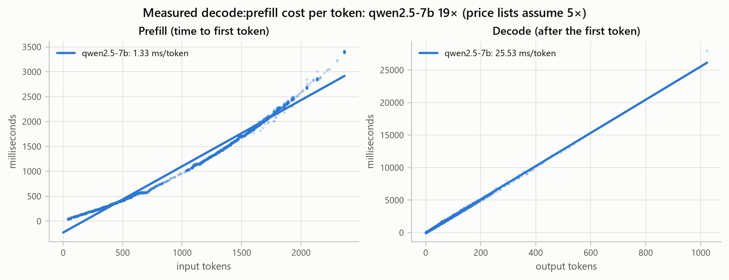
Figure 8.1. Prefill and decode time against token count over all 3,090 runs, with linear fits: 1.33 ms per input token, 25.5 ms per output token.
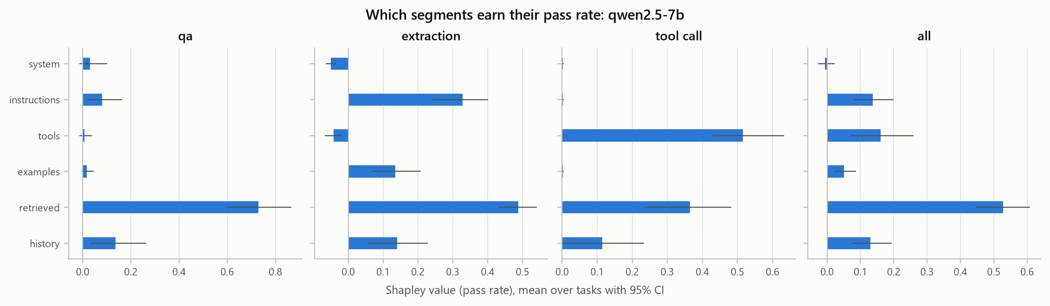
Figure 8.2. Shapley value of each segment for pass rate, per workload, with 95% bootstrap intervals.
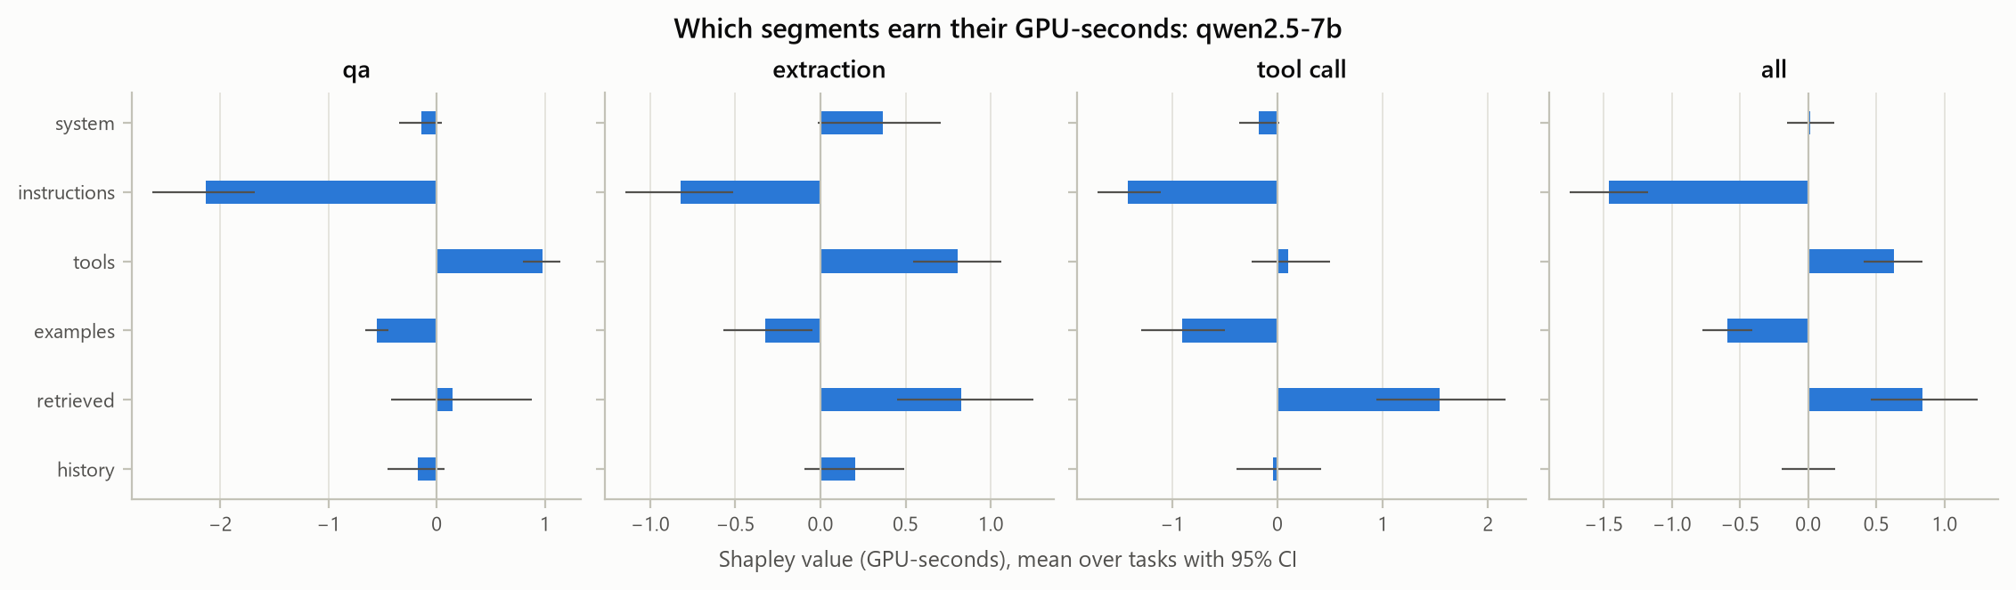
Figure 8.3. Shapley value of each segment for GPU-seconds. Instructions and examples have negative cost: they shorten the answer.
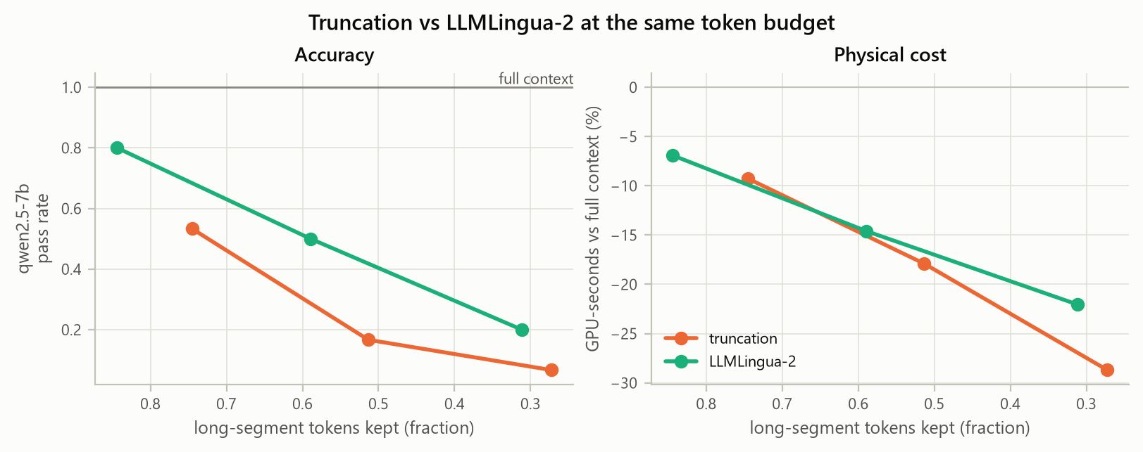
Figure 8.4. Truncation against LLMLingua-2 at equal token budgets.
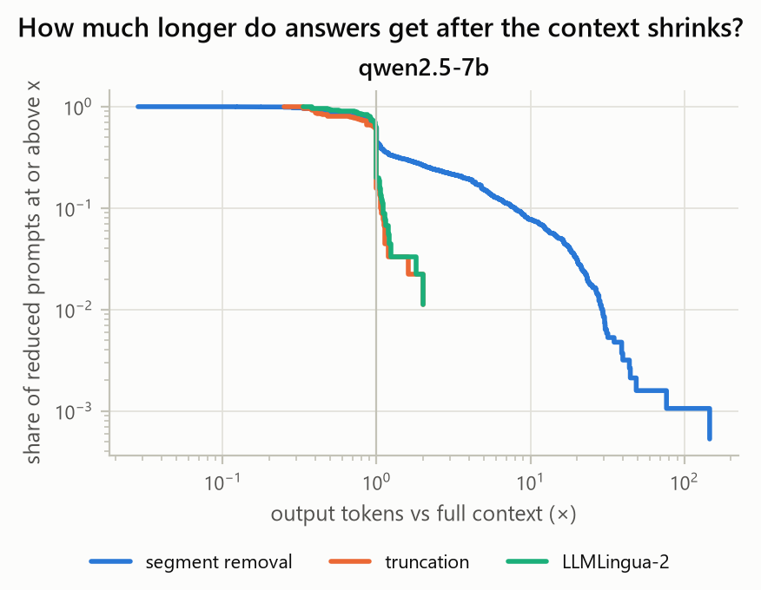
Figure 8.5. How much longer outputs get after each kind of context reduction (complementary CDF, log scales).
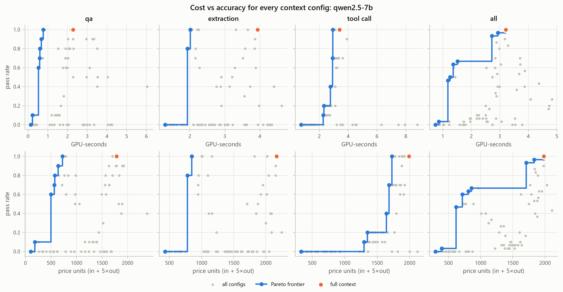
Figure 8.6. Cost against accuracy for all configurations, under the physical (top) and price-list (bottom) cost models.

9. Conclusion and future scope

9.1 Conclusion
The project met its objectives. ccv joins physical GPU cost, exact per-segment token attribution and graded accuracy on the same requests. It is fault-tolerant and reproducible on a free GPU: all 3,090 measured requests completed in one session, with exact attribution on every one.
The measurements contradict the usual assumption that fewer input tokens means lower cost:
- A decode token cost 19× a prefill token.
- Removing a segment raised the physical cost in one case in five, almost always because the instructions that keep answers short were removed.
- Truncation and compression reduced cost only modestly, and lost accuracy even at mild rates.
The exact Shapley analysis turned these observations into a ranking of segments by value and by cost. That ranking supports a concrete rule: remove the segments a workload does not use, keep the instructions, and test every change on accuracy and physical cost before shipping it.
Development also uncovered two silent faults in a widely used serving stack: vLLM’s streaming tool parser dropped answers and mislabelled a capped run. Both were caught only because ccv checks its own measurements.

9.2 Future scope
- A second model. Run the full sweep on Llama-3.1-8B (the tool, template and tests already support it) to check whether segment values transfer across model families.
- Batched serving. Measure cost under continuous batching with a fixed concurrency, attributing GPU time by token share, to bring the numbers closer to production.
- More segments with sampled Shapley. Beyond six segments, exact enumeration becomes expensive; permutation sampling or KernelSHAP would scale it.
- Sampling-based decoding. Repeat the study with temperature > 0 and more repeats.
- Newer GPUs and attention kernels. FlashAttention on Ampere or later changes the prefill:decode cost ratio.
- Continuous integration running the offline test suite on every commit.

10. References
- N. F. Liu et al., “Lost in the Middle: How Language Models Use Long Contexts,” TACL, 2024.
- F. Shi et al., “Large Language Models Can Be Easily Distracted by Irrelevant Context,” ICML, 2023.
- K. Hong, A. Troynikov, J. Huber, “Context Rot: How Increasing Input Tokens Impacts LLM Performance,” Chroma technical report, 2025.
- Z. Pan et al., “LLMLingua-2: Data Distillation for Efficient and Faithful Task-Agnostic Prompt Compression,” Findings of ACL, 2024.
- H. Jiang et al., “LLMLingua: Compressing Prompts for Accelerated Inference of Large Language Models,” EMNLP, 2023.
- L. S. Shapley, “A Value for n-Person Games,” in Contributions to the Theory of Games II, 1953.
- S. M. Lundberg, S.-I. Lee, “A Unified Approach to Interpreting Model Predictions,” NeurIPS, 2017.
- M. Grabisch, M. Roubens, “An axiomatic approach to the concept of interaction among players in cooperative games,” Int. J. Game Theory, 1999.
- W. Kwon et al., “Efficient Memory Management for Large Language Model Serving with PagedAttention,” SOSP, 2023.
- J. Lin et al., “AWQ: Activation-aware Weight Quantization for LLM Compression and Acceleration,” MLSys, 2024.
- Q. McNemar, “Note on the sampling error of the difference between correlated proportions or percentages,” Psychometrika, 1947.
- B. Efron, R. J. Tibshirani, An Introduction to the Bootstrap, Chapman & Hall, 1993.
- Y. Benjamini, Y. Hochberg, “Controlling the False Discovery Rate,” J. R. Stat. Soc. B, 1995.
- Qwen Team, “Qwen2.5 Technical Report,” arXiv:2412.15115, 2024.

Appendix A — CLI usage
pip install -e ".[dev]" # laptop
ccv serve --model qwen2.5-7b -- --attention-backend TRITON_ATTN # GPU box
ccv run --model qwen2.5-7b --suite noise shapley ablations --out results/qwen2.5-7b.jsonl --max-minutes 500
ccv run --model qwen2.5-7b --suite noise --out results/x.jsonl --dry-run # offline validation
ccv attribute qa-01 --model qwen2.5-7b --config truncate:0.5
ccv compress --rates 0.8 0.5 0.2
ccv analyze results/*.jsonl --out analysis/

Appendix B — Sample JSONL record
One full-context QA request from the real run (results/qwen2.5-7b.jsonl):
{
"run_id": "0f0815591071afc1", "model": "qwen2.5-7b", "suite": "shapley",
"task_id": "qa-09", "task_hash": "ac6b5c443e857444", "workload": "qa",
"config_id": "subset:111111", "repeat": 0, "request_hash": "150d13da0fa760bf",
"status": "ok", "error": null,
"prefill_tokens": 1600, "decode_tokens": 8, "finish_reason": "stop",
"prefill_ms": 1848.48, "decode_ms": 190.20, "queue_ms": 0.007,
"client_ttft_ms": 1864.64, "client_e2e_ms": 2054.16, "decode_tok_s": 36.8,
"gpu_seconds": 2.0387, "server_metrics": true,
"gpu_util_mean": 99.8, "gpu_mem_max_mb": 13937, "energy_j": 129.436,
"output": "1.75% per month", "tool_calls": null,
"attribution": {"system": 148, "instructions": 58, "tools": 994, "examples": 66,
"retrieved": 238, "history": 53, "query": 20, "template": 23, "total": 1600},
"attribution_ok": true, "compression": null,
"env": {"ccv": "0.1.0", "server": "0.29.0", "gpu": "Tesla T4",
"sampling": {"temperature": 0, "seed": 0, "max_tokens": 1024}},
"ts": "2026-10-30T09:39:49+00:00"
}
Timings are rounded to two decimals here, and env.host is omitted.

