End-to-End Evaluation of RF-DETR-Based

Microscopy Specimen Quality Assessment
  - Object detection • independent threshold calibration • final expert-referenced downstream evaluation
Generated 29 July 2026

Item | Locked value
Detector | RFDETR2XLarge, HPO configuration 009, EMA checkpoint
Internal model resolution | 880 × 880 pixels
SAHI full-FOV slice size | 640 × 640 pixels with 20% overlap
Class confidence thresholds | Leucocyte=0.36; Squamous Epithelial Cell=0.35
Final downstream set | 98 FOVs from 34 samples
Code provenance | 27c95e88 — https://github.com/Mmose95/AIPoweredMicroscope/commit/27c95e8875da3f11b486a03f522a0a27e82ab529

Headline outcomes
Evaluation stage | Primary result
Held-out object detection | COCO AP@50:95 0.6179; AP@50 0.8685
Independent calibration | Macro F1 0.9335 at Leucocyte=0.36 and Epithelial=0.35
Final downstream task | Accuracy 58.16%; balanced accuracy 57.11%; macro F1 0.5678

Contents
Headline outcomes 1
Contents 2
1. Executive summary 3
2. Evaluation design and data separation 3
3. Final model and locked inference settings 3
3.1 Model selection and training 3
3.2 Locked downstream inference 4
3.3 Count-to-quality rule 4
4. Held-out object-detection evaluation 4
Per-class standard COCO metrics 5
Locked operating point at IoU=0.50 5
5. Independent confidence-threshold calibration 7
6. Final downstream quality evaluation 9
6.1 Cohort flow and runtime 9
6.2 Overall downstream performance 10
6.3 Class-level performance 10
6.4 Error direction and detected-count patterns 11
7. Integrated interpretation 12
8. Limitations 12
9. Reproducibility and result artifacts 12
Appendix A. Downstream exclusions 14
Appendix B. Misclassified downstream FOVs 14

1. Executive summary
This report consolidates the complete three-stage evaluation of the final two-class RF-DETR model. The detector was first assessed on a held-out object-detection test split. Class-specific confidence thresholds were then selected on a separate calibration set. Those thresholds and all downstream inference settings were locked before the expert-referenced downstream FOV labels were analyzed.
- The detector achieved COCO AP@50:95 of 0.6179 and AP@50 of 0.8685 on 331 held-out 640 × 640 patches containing 4,004 objects.
- Independent calibration on 53 patches containing 776 objects selected confidence thresholds of 0.36 for Leucocyte and 0.35 for Squamous Epithelial Cell; joint macro F1 was 0.9335.
- The final downstream evaluation included 98 expert-labeled FOVs after four prespecified exclusions. Accuracy was 58.16%, balanced accuracy was 57.11%, and macro F1 was 0.5678.
- Downstream errors were predominantly conservative: 33 of 41 errors assigned a worse quality category than the clinical reference, while 8 assigned a more favorable category.
- No threshold or quality-rule parameter was changed after the downstream labels were inspected.

2. Evaluation design and data separation
The study design deliberately separates model fitting, standard detector testing, threshold calibration, and final downstream testing. This prevents downstream test performance from influencing the confidence thresholds used to decide whether detections enter the count-based quality rule.
Partition/stage | Samples | Images | Leucocyte | Epithelial | Purpose
Detector training | 28 | 829 | 10978 | 1890 | Model fitting
Detector validation | 9 | 291 | 3430 | 639 | HPO/model selection
Detector test | 11 | 331 | 2851 | 1153 | Held-out object detection
Calibration | 11 | 53 | 572 | 204 | Threshold selection only
Downstream test | 34 | 98 | — | — | Final FOV quality evaluation

The detector split was sample-wise (28/9/11 samples for train/validation/test). The downstream workbook contained 102 non-header image rows: 98 were eligible, one image was marked as not present in the annotation project, and three were considered too difficult for a reliable clinical classification.

3. Final model and locked inference settings

3.1 Model selection and training
Parameter | Value
Selected configuration | HPO configuration 009
Architecture | RFDETR2XLarge
Checkpoint | checkpoint_best_ema.pth
Internal resolution | 880
Input data mode | 640 pixel source patches
Queries | 600
Batch size / gradient accumulation | 6 / 1
Learning rate | 8.0e-05
Weight decay / dropout | 0.0007 / 0.15
Multi-scale training | True
Maximum epochs / best epoch | 160 / 8
Validation AP@50 | 0.9086
Validation mAP@50:95 | 0.7364
Random seed | 42
Patch size / attention windows | 20 / 2

The microscopy patches remained 640 × 640 at the data interface. RF-DETR internally resized them to the selected 880 × 880 model resolution. The same distinction was retained for downstream SAHI: the slice is 640 × 640, while the model internally operates at 880.

3.2 Locked downstream inference
Setting | Locked value
SAHI slice | 640 × 640
Slice overlap | 20% horizontal and vertical
Standard whole-image prediction | False
Class confidence thresholds | Leucocyte=0.36; Squamous Epithelial Cell=0.35
Within-class postprocess | GREEDYNMM, IOU=0.50, class-aware
Cross-class duplicate suppression | IOS≥0.75, IoU≥0.35, area ratio≥0.55

3.3 Count-to-quality rule
Component | Observed count | Score
Leucocyte | <10 | −1
Leucocyte | 10–25 | 0
Leucocyte | 26–50 | +1
Leucocyte | >50 | +2
Squamous epithelial | <10 | 0
Squamous epithelial | 10–25 | −1
Squamous epithelial | >25 | −2

The component scores were summed. An FOV was Qualified when the total score was at least +1 and fewer than 10 epithelial cells were detected; it was Not Qualified when the total was −1 or lower; all remaining cases were Partially Qualified.

4. Held-out object-detection evaluation
Standard COCO ranking metrics were calculated from detections retained at the numerical score floor of 0.001. They do not use the calibrated thresholds. The confusion matrix and operating-point precision/recall/F1 are threshold-dependent and use the independently calibrated class-specific thresholds at IoU=0.50.
Metric | Overall result
COCO AP@50:95 | 0.6179
AP@50 | 0.8685
AP@75 | 0.7048
AR@1 | 0.1082
AR@10 | 0.4598
AR@100 | 0.7249

Per-class standard COCO metrics
Class | AP@50:95 | AP@50 | AP@75 | AR@100
Leucocyte | 0.5094 | 0.7950 | 0.5665 | 0.6499
Squamous Epithelial Cell | 0.7265 | 0.9421 | 0.8430 | 0.7999

Locked operating point at IoU=0.50
Thresholds | TP | FP | FN | Precision | Recall | F1 | FP/image
Leucocyte=0.36; Squamous Epithelial Cell=0.35 | 3345 | 891 | 659 | 0.7897 | 0.8354 | 0.8119 | 2.692

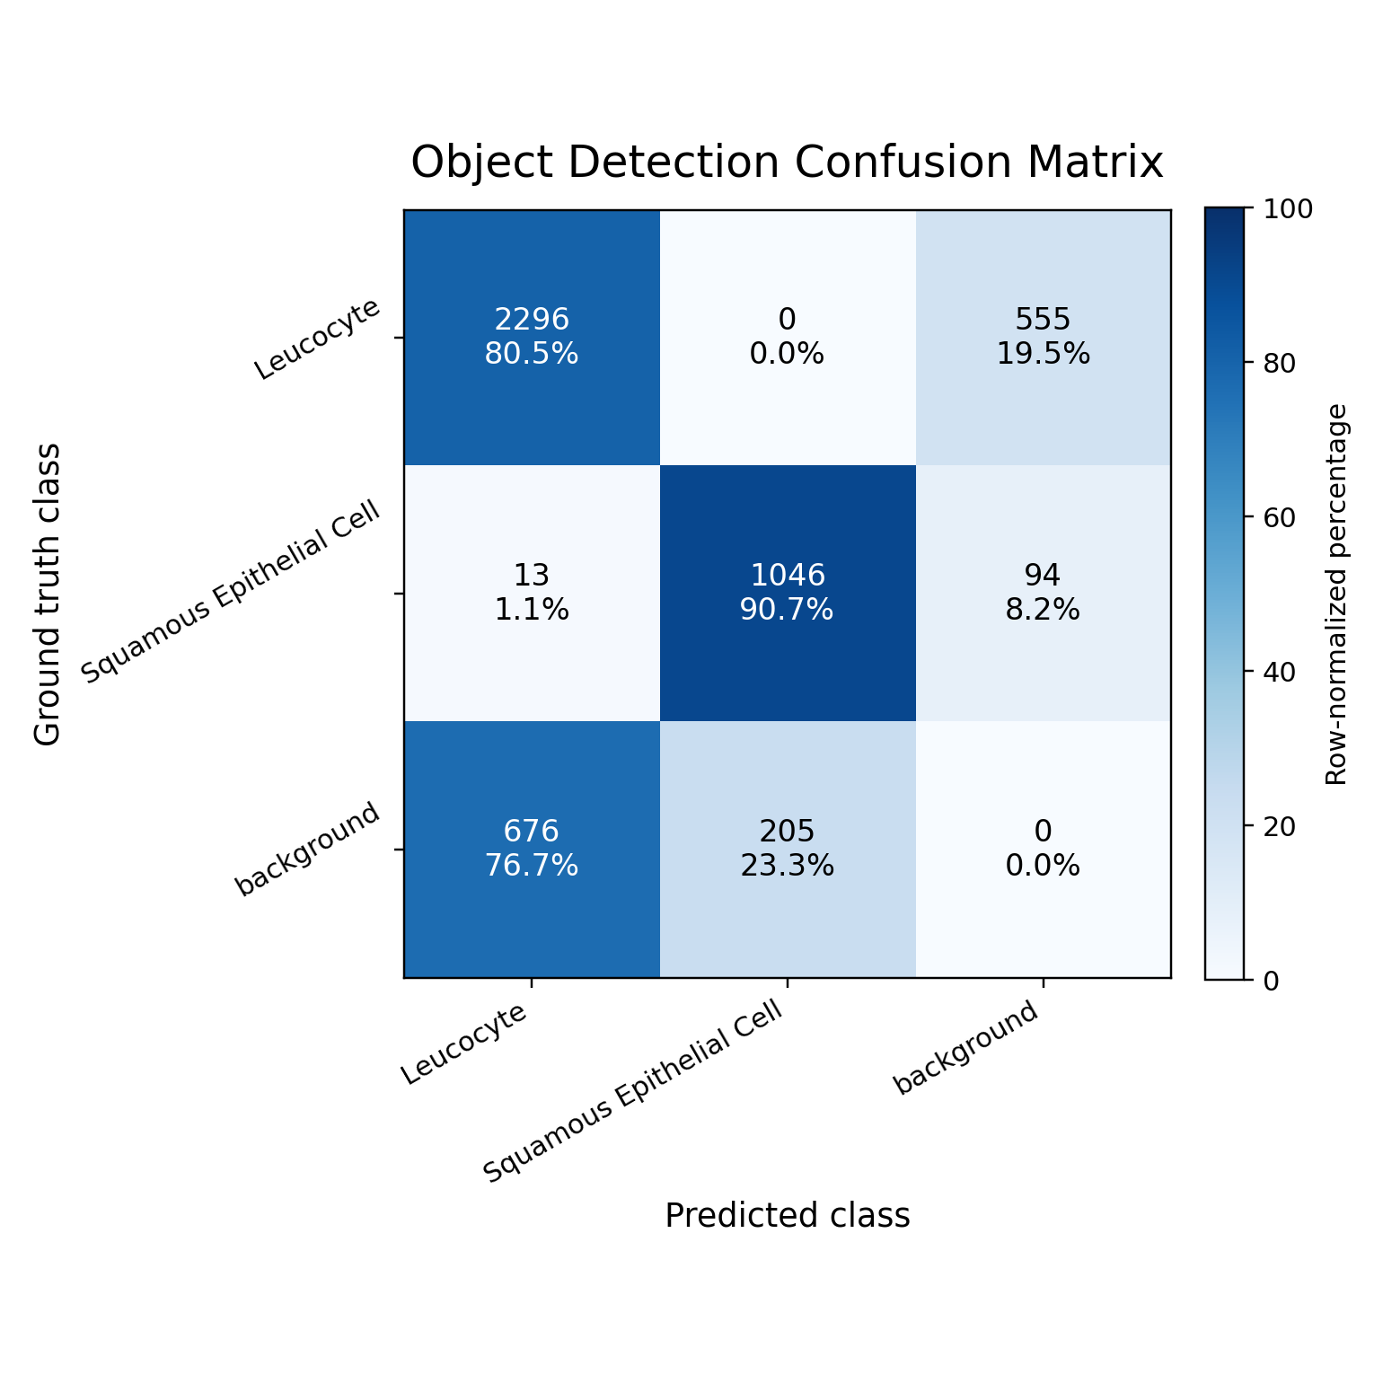
Figure 1. Object-detection confusion matrix at the locked class-specific confidence thresholds and IoU=0.50. Rows are ground truth; columns are predictions. Background indicates misses or unmatched detections.
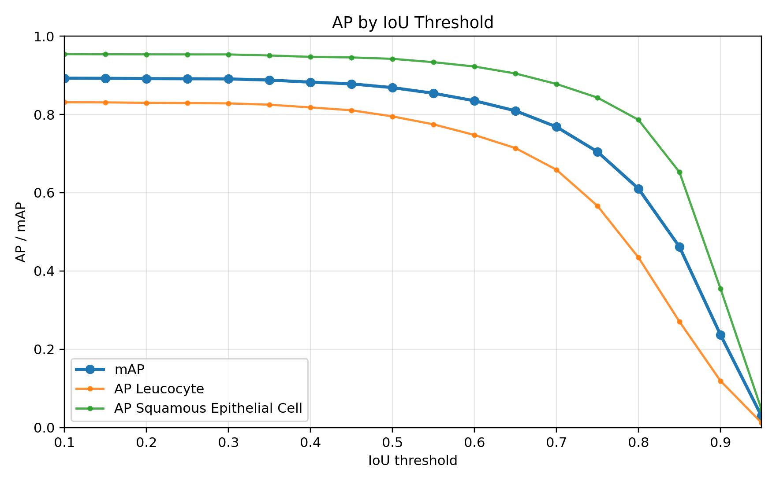
Figure 2. Detector AP across IoU thresholds. The standard headline COCO result remains AP@50:95.
The test set contained 2,851 annotated leucocytes and 1,153 squamous epithelial cells. At the locked operating point, the confusion matrix recorded 2,296 correctly localized leucocytes and 1,046 correctly localized epithelial cells. Epithelial cells showed higher localization performance than leucocytes across AP@50:95, AP@50, AP@75, and AR@100.
The saved test threshold sweep is descriptive sensitivity analysis only. Its test-set maximum was not used to select or revise the operating thresholds and is intentionally not reported as a selected operating point.

5. Independent confidence-threshold calibration
Calibration used 53 images from 11 tasks, with 572 leucocyte and 204 squamous epithelial annotations. Predictions were matched at IoU=0.50. Thresholds from 0.00 to 0.95 were evaluated at 0.01 increments, with extra observed-score candidates, and macro F1 was the prespecified selection criterion.
Class | Threshold | TP | FP | FN | Precision | Recall | F1 | Jaccard
Leucocyte | 0.36 | 513 | 57 | 59 | 0.9000 | 0.8969 | 0.8984 | 0.8156
Squamous Epithelial Cell | 0.35 | 201 | 10 | 3 | 0.9526 | 0.9853 | 0.9687 | 0.9393

Joint metric | Result
TP / FP / FN | 714 / 67 / 62
Micro precision | 0.9142
Micro recall | 0.9201
Micro F1 | 0.9171
Macro precision | 0.9263
Macro recall | 0.9411
Macro F1 | 0.9335
Macro Jaccard | 0.8774

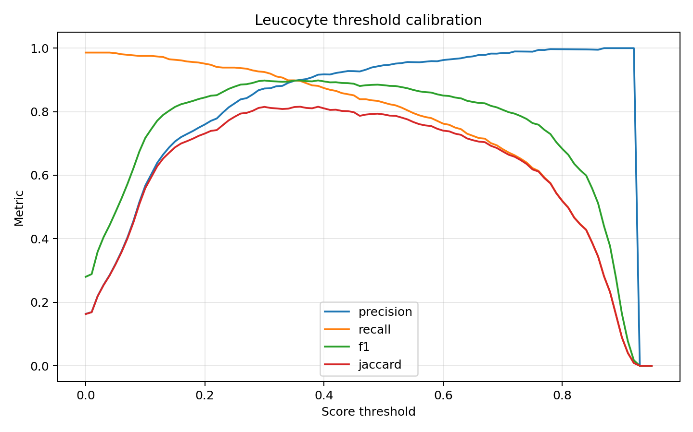
Figure 3. Leucocyte precision, recall, F1, and Jaccard across confidence thresholds. The selected F1-maximizing threshold was 0.36.
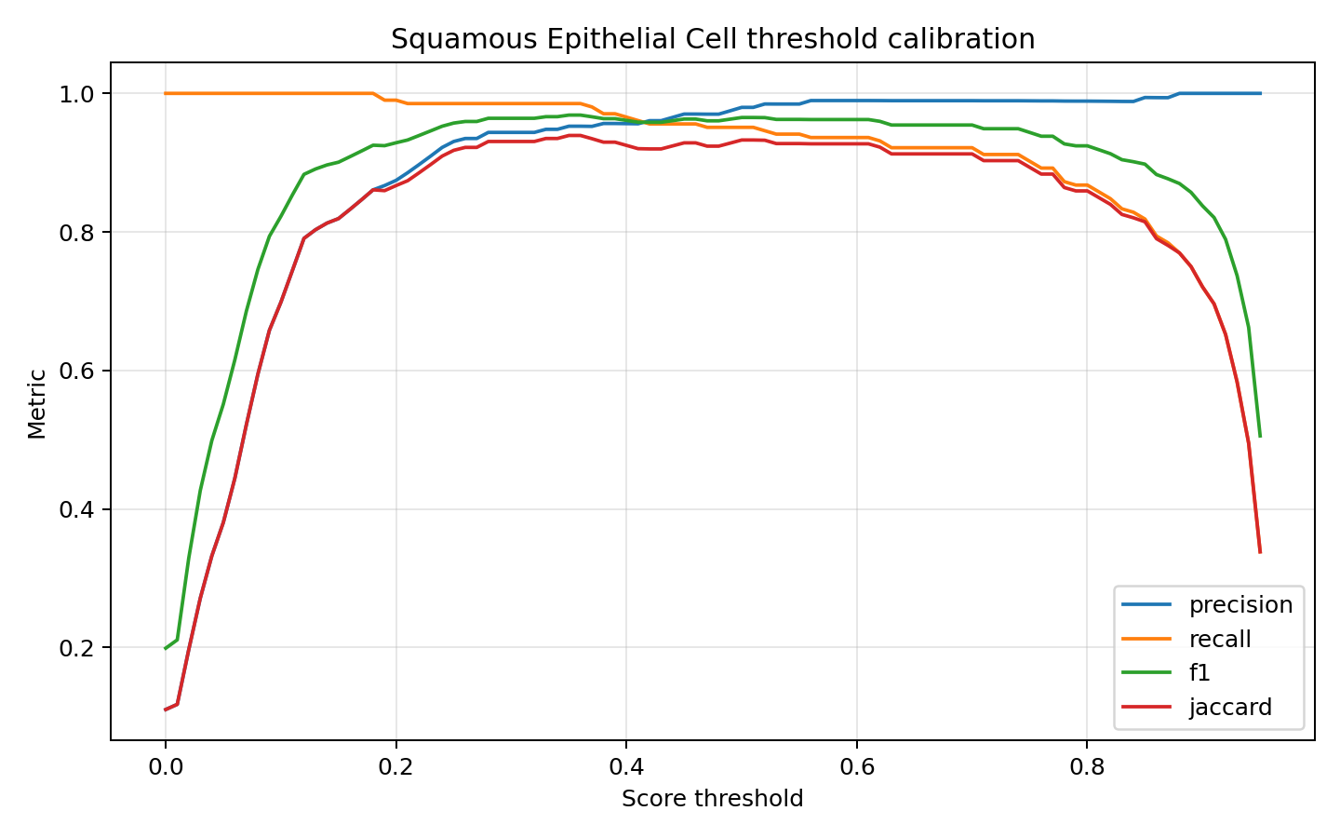
Figure 4. Squamous epithelial cell calibration curves. The selected F1-maximizing threshold was 0.35.
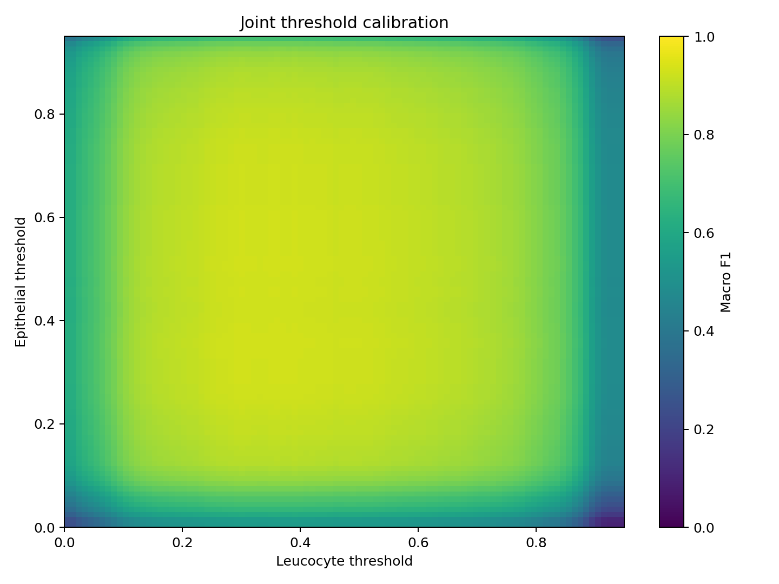
Figure 5. Joint macro-F1 surface for the two class-specific confidence thresholds.
The calibrated thresholds were subsequently treated as fixed method parameters. They were applied to the threshold-dependent detector results and carried unchanged into downstream SAHI inference.

6. Final downstream quality evaluation

6.1 Cohort flow and runtime
Item | Count/result
Workbook rows reviewed | 102
Eligible FOVs analyzed | 98
Represented samples | 34
Excluded FOVs | 4
Qualified references | 42
Partially Qualified references | 26
Not Qualified references | 30
Total evaluation time | 125.3 s
Mean detector time per FOV | 1.14 s

All 98 eligible images completed without inference failure, and an annotated overlay was produced for every included FOV.

6.2 Overall downstream performance
Uncertainty intervals are percentile 95% confidence intervals from 10,000 cluster-bootstrap replicates, resampling the 34 source samples with replacement (seed 42). This preserves within-sample FOV correlation better than an image-level bootstrap.
Metric | Estimate | Cluster-bootstrap 95% CI
Accuracy | 0.5816 | 0.4343–0.7253
Balanced accuracy | 0.5711 | 0.4357–0.7085
Macro F1 | 0.5678 | 0.4232–0.6972
Cohen's kappa | 0.3796 | 0.1756–0.5752
Quadratic-weighted kappa | 0.5779 | 0.3583–0.7669

Additional metric | Result
Weighted precision | 0.6730
Weighted recall | 0.5816
Weighted F1 | 0.5977
Mean absolute class error | 0.4898
Within-one-class accuracy | 0.9286

6.3 Class-level performance
Class | Support | TP | FP | FN | Precision | Recall | F1 | Specificity
Qualified | 42 | 25 | 0 | 17 | 1.0000 | 0.5952 | 0.7463 | 1.0000
Partially Qualified | 26 | 10 | 18 | 16 | 0.3571 | 0.3846 | 0.3704 | 0.7500
Not Qualified | 30 | 22 | 23 | 8 | 0.4889 | 0.7333 | 0.5867 | 0.6618

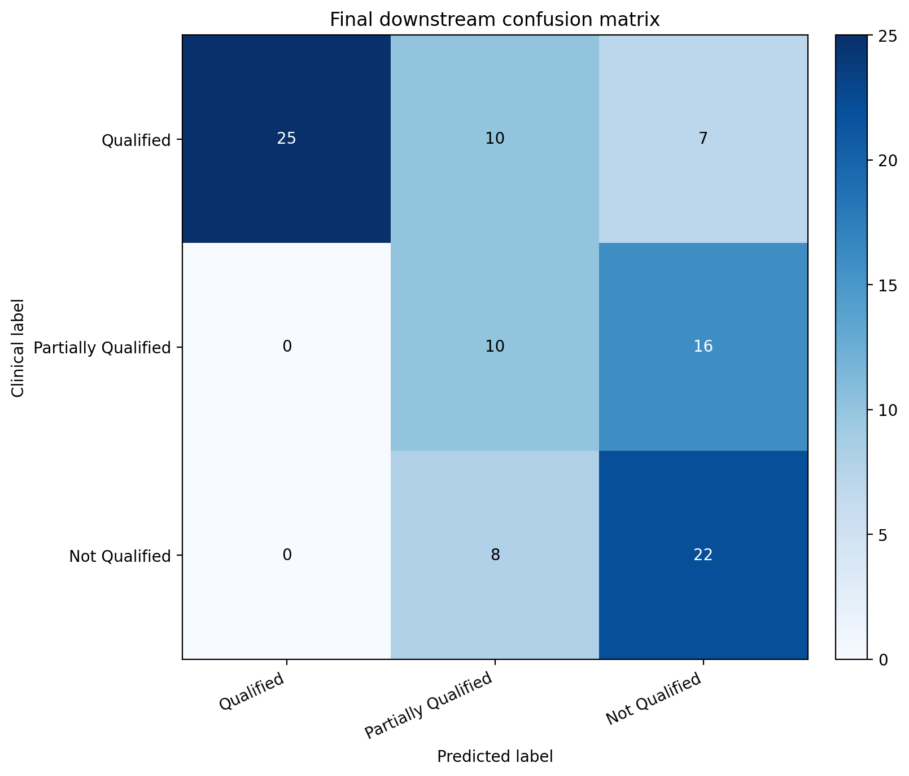
Figure 6. Final downstream confusion matrix. Rows are clinical reference labels and columns are locked pipeline predictions.
The pipeline correctly classified 57 of 98 FOVs. Qualified predictions had precision 1.00: no clinically Partially Qualified or Not Qualified image was predicted as Qualified. However, Qualified recall was 0.595, reflecting a conservative acceptance threshold. Partially Qualified was the most difficult class (F1 0.370), and Not Qualified recall was 0.733.

6.4 Error direction and detected-count patterns
Outcome | FOVs | Percentage of all FOVs
Exact class agreement | 57 | 58.2%
Predicted more severe than reference | 33 | 33.7%
Predicted more favorable than reference | 8 | 8.2%
Two-category errors | 7 | 7.1%

Clinical class | n | Leucocyte median (IQR) | Epithelial median (IQR)
Qualified | 42 | 102.5 (17.5–297.2) | 2.5 (2.0–7.0)
Partially Qualified | 26 | 11.0 (4.2–90.8) | 19.0 (9.2–27.2)
Not Qualified | 30 | 19.5 (7.2–43.0) | 36.5 (26.0–48.8)

Across all FOVs, 56,482 raw sliced predictions were reduced to 12,220 candidates by the locked confidence thresholds and within-class SAHI postprocess. Cross-class suppression removed 31 additional duplicates, leaving 12,189 detections (10,112 leucocytes and 2,077 epithelial cells).

7. Integrated interpretation
- The final RFDETR2XLarge detector showed strong held-out localization performance, especially for squamous epithelial cells. Leucocyte detection remained the weaker component.
- Independent calibration produced high object-level F1 and provided a defensible, prespecified operating point for any threshold-dependent result.
- The lower downstream performance does not invalidate the detector or calibration results. It measures the entire chain: sliced full-FOV inference, duplicate handling, class-specific thresholding, count aggregation, and the deterministic clinical quality rule.
- Most downstream errors were conservative. This explains why Qualified precision was perfect while Qualified recall was substantially lower.
- The Partially Qualified category showed the greatest overlap with the deterministic rule boundaries and was most frequently assigned to Not Qualified.
- The final downstream set must remain untouched for optimization. Any future revision of thresholds or the count-to-quality rule should be developed on a new training/development cohort and then tested on an independent external set.

8. Limitations
- The downstream reference is the final expert-review workbook. Details of the review/consensus procedure are not fully encoded on every workbook row and should be described from the clinical study records in the manuscript.
- Four of 102 reviewed rows were excluded: one was not present in the annotation project and three were too difficult for a reliable clinical classification.
- The downstream analysis contains multiple FOVs from some source samples. Cluster-bootstrap intervals account for this grouping, but the number of represented samples remains 34.
- Confidence thresholds were calibrated on 640 × 640 object-level patches, whereas the downstream task uses overlapping SAHI slices extracted from full FOVs. The locked approach preserves test independence but does not remove this deployment-domain difference.
- The count-to-quality rule is deterministic and may be a larger source of downstream disagreement than residual detector error. This report does not tune that rule on the final test labels.
- Confidence intervals quantify resampling uncertainty in this dataset; they do not establish external generalizability.

9. Reproducibility and result artifacts
Artifact | Location
Code commit | https://github.com/Mmose95/AIPoweredMicroscope/commit/27c95e8875da3f11b486a03f522a0a27e82ab529
Object-detection summary | C:\Users\SH37YE\Desktop\PhD_Code_github\AIPoweredMicroscope\EvaluationOutput\TwoClass_HPO009_EMA_TestEval_20260701-140821\eval_summary.json
Object predictions | C:\Users\SH37YE\Desktop\PhD_Code_github\AIPoweredMicroscope\EvaluationOutput\TwoClass_HPO009_EMA_TestEval_20260701-140821\predictions_coco.json
Calibration summary | C:\Users\SH37YE\Desktop\PhD_Code_github\AIPoweredMicroscope\EvaluationOutput\RFDETR_ThresholdCalibration_20260701-140419\threshold_calibration_summary.json
Calibration predictions | C:\Users\SH37YE\Desktop\PhD_Code_github\AIPoweredMicroscope\EvaluationOutput\RFDETR_ThresholdCalibration_20260701-140419\calibration_predictions.json
Downstream summary | C:\Users\SH37YE\Desktop\PhD_Code_github\AIPoweredMicroscope\DownstreamOutput_Downstream\20260729-123001\downstream_evaluation_summary.json
Per-FOV downstream predictions | C:\Users\SH37YE\Desktop\PhD_Code_github\AIPoweredMicroscope\DownstreamOutput_Downstream\20260729-123001\downstream_predictions.csv
Downstream exclusions | C:\Users\SH37YE\Desktop\PhD_Code_github\AIPoweredMicroscope\DownstreamOutput_Downstream\20260729-123001\downstream_exclusions.csv
Downstream overlays | C:\Users\SH37YE\Desktop\PhD_Code_github\AIPoweredMicroscope\DownstreamOutput_Downstream\20260729-123001\overlays

The report was generated directly from the saved machine-readable artifacts above. All headline values can therefore be traced to a JSON or CSV result file.

Appendix A. Downstream exclusions
Workbook row | Image | Reason | Comment
77 | Sample91 - BF.3_10.tif | not_in_cvat_project | —
88 | Sample95 - BF.15_5.tif | too_difficult_for_clinical_review | for svær at vurdere uden at antage for meget
89 | Sample95 - BF.5_5.tif | too_difficult_for_clinical_review | for svær at vurdere uden at antage for meget
90 | Sample95 - BF.9_10.tif | too_difficult_for_clinical_review | for svær at vurdere uden at antage for meget

Appendix B. Misclassified downstream FOVs
The table lists all downstream disagreements. Complete results for all 98 FOVs, including correct classifications and inference diagnostics, are retained in downstream_predictions.csv.
Image | Clinical | Predicted | Leu | Epi | Rule score
Sample100 - BF.10_10.tif | Not Qualified | Partially Qualified | 176 | 45 | 0
Sample100 - BF.15_9.tif | Not Qualified | Partially Qualified | 237 | 26 | 0
Sample100 - BF.4_9.tif | Not Qualified | Partially Qualified | 30 | 10 | 0
Sample100 - BF.8_8.tif | Not Qualified | Partially Qualified | 239 | 39 | 0
Sample102 - BF.12_4.tif | Partially Qualified | Not Qualified | 7 | 7 | -1
Sample104 - BF.12_0.tif | Not Qualified | Partially Qualified | 54 | 89 | 0
Sample105 - BF.2_12.tif | Not Qualified | Partially Qualified | 11 | 1 | 0
Sample106 - BF.11_1.tif | Qualified | Not Qualified | 5 | 8 | -1
Sample106 - BF.12_0.tif | Qualified | Not Qualified | 3 | 2 | -1
Sample106 - BF.19_3.tif | Partially Qualified | Not Qualified | 5 | 7 | -1
Sample106 - BF.7_2.tif | Partially Qualified | Not Qualified | 21 | 15 | -1
Sample106 - BF.9_1.tif | Qualified | Partially Qualified | 16 | 3 | 0
Sample77 - BF.10_14.tif | Not Qualified | Partially Qualified | 217 | 50 | 0
Sample81 - BF.4_12.tif | Not Qualified | Partially Qualified | 286 | 60 | 0
Sample83 - BF.14_7.tif | Partially Qualified | Not Qualified | 4 | 8 | -1
Sample83 - BF.15_12.tif | Partially Qualified | Not Qualified | 0 | 5 | -1
Sample83 - BF.16_8.tif | Partially Qualified | Not Qualified | 3 | 5 | -1
Sample83 - BF.7_7.tif | Qualified | Partially Qualified | 11 | 8 | 0
Sample85 - BF.10_8.tif | Partially Qualified | Not Qualified | 3 | 20 | -2
Sample85 - BF.11_10.tif | Partially Qualified | Not Qualified | 10 | 13 | -1
Sample87 - BF.9_4.tif | Qualified | Not Qualified | 3 | 2 | -1
Sample89 - BF.16_6.tif | Qualified | Partially Qualified | 365 | 11 | 1
Sample90 - BF.4_9.tif | Qualified | Partially Qualified | 388 | 23 | 1
Sample91 - BF.15_0.tif | Partially Qualified | Not Qualified | 8 | 35 | -3
Sample91 - BF.17_7.tif | Qualified | Partially Qualified | 14 | 7 | 0
Sample91 - BF.3_8.tif | Partially Qualified | Not Qualified | 18 | 69 | -2
Sample91 - BF.3_9.tif | Partially Qualified | Not Qualified | 4 | 65 | -3
Sample92 - BF.11_0.tif | Qualified | Not Qualified | 5 | 0 | -1
Sample92 - BF.5_12.tif | Qualified | Partially Qualified | 99 | 11 | 1
Sample92 - BF.7_4.tif | Qualified | Partially Qualified | 12 | 2 | 0
Sample93 - BF.14_8.tif | Partially Qualified | Not Qualified | 1 | 21 | -2
Sample93 - BF.9_4.tif | Partially Qualified | Not Qualified | 0 | 5 | -1
Sample96 - BF.14_10.tif | Qualified | Partially Qualified | 22 | 0 | 0
Sample97 - BF.11_11.tif | Qualified | Partially Qualified | 22 | 7 | 0
Sample97 - BF.12_11.tif | Partially Qualified | Not Qualified | 7 | 16 | -2
Sample98 - BF.4_3.tif | Partially Qualified | Not Qualified | 16 | 18 | -1
Sample98 - BF.8_9.tif | Partially Qualified | Not Qualified | 7 | 14 | -2
Sample99 - BF.1_5.tif | Qualified | Partially Qualified | 24 | 3 | 0
Sample99 - BF.12_8.tif | Qualified | Not Qualified | 9 | 2 | -1
Sample99 - BF.14_11.tif | Qualified | Not Qualified | 8 | 6 | -1
Sample99 - BF.6_12.tif | Qualified | Not Qualified | 1 | 1 | -1

