 

INSTITUTE FOR ADVANCED COMPUTING AND SOFTWARE DEVELOPMENT AKURDI, PUNE

Documentation On

**“Vehicle Service Center”**

PG e-DAC MAY 2021

*Submitted By:*

**Group No: 42 Names & roll numbers**

**1)** **Momin Mubashshir (1118)**

**2) Nikhil Dhane (1049)**

**Prashant Karhale Mr.Kashinath patil**

**Centre Coordinator Project Guide**

# **Table of Contents**

1. Introduction 3

Problem Statement 3

Document Purpose 3

Aim & Objectives 3

1. Overall Description 4

Benefits of Society Management System 4

User and Characteristics 5

Operating Environment 5

Design and Implementation Constraints 5

1. Requirements Specification 6

External Interface Requirements 6

1. System Diagram 8

Activity Diagram 8

Use Case Diagram 9

ER Diagram 10

1. Table Structure 11

User 11

Schedule 11

1. Conclusion 12

Future Scope 12

1. Reference

**Introduction:-**

Customers land such as online vehicle service center seeking for immediate solution in time of emergency shouldn't have to wait for booking completion, we have decided a reasonable price for service. Here we have given two mode of login one is admin and another one is customer login. When customer login they can fill scheduling form to book date and time for servicing and when admin login he record the scheduling form filled by the customer and send a worker to carry the vehicle.

**Problem Statement:-**

It doesn’t matter how much people hate complying with the need for maintenance of vehicles. Still, the fact is that the way they love traveling with cars is the same way they should take routine care of their car and take the pain and inconvenience of performing regular maintenance. They need to complete the same responsibilities to avoid the issues that may arise on the road. This is true that people don’t like to get involved in such messy jobs, but they don’t have a choice in the matter as all the vehicles require routine servicing and immediate repairs when trouble arises.

**Document Purpose**:-

To produce new customer service skills have changed past that used to cost you hours in comparing, searching, and waiting at the service centers and repair shops to get your vehicle serviced or repaired. Several efficient workshops are available to help people in all kind of car repair jobs and maintenance issues. Several apps for car service, such as the CARFAX app, have changed the way of performing this, and such apps have made the job easy for people to find the right mechanic and service center for their vehicle. Now the options to find competent mechanics and efficient workshops are available on the mobile, laptop, tablet, smartphone, and other devices that can connect with the internet. This technology benefits the customers or vehicle owners and leverages more significant revenues for companies across the automotive industry and auto service businesses.

**Aims & Objectives**:-

Specific goals are: -

* To produce a web-based system that allow the admin to Vehicle servicing facilities and provide functionalities to its role.
* To ease owners by providing different functionalities to it.
* To ease customer to solve vehicle problem effectively.

**Benefits of vehicle Servicing:-**

* This online Vehicle servicing solution is fully functional and flexible.
* It is very easy to use.
* It saves a lot of time of customer.
* Eco-friendly: The monitoring of the Vehicle servicing and the overall business becomes easy and includes the least of paper work.
* The application acts as an office that is open 24/7.
* It increases the efficiency of the management at offering quality services to the customers.
* It provides custom features development and support with the application.

**Users and Characteristics:**

Admin

* Admin can login to the system.
* View the list of all the customer details.
* Delete customer.
* Update customer schedule status pending/done.
* View Complaints of customer.
* View workers detail

Customer:

* View his/her details.
* View Schedule details.
* Update their personal credentials.
* View total bill.

**Operating Environment:**

Server Side:

**Processor:** Intel® Xeon® processor 3500 series

**HDD:** Minimum 500GB Disk Space

**RAM:** Minimum 2GB **OS:** Windows 8.1, Linux 6 **Database:** Oracle 11g

Client Side (minimum requirement):

**Processor:** Intel Dual Core

**HDD:** Minimum 80GB Disk Space

**RAM:** Minimum 1GB

**OS:** Windows 7, Linux

## Design and Implementation Constraints:

* The application will use Ajax, JavaScript, jQuery and css as main web technologies.
* HTTP and FTP protocols are used as communication protocols. FTP is used to upload the web application in live domain and the client can access it via HTTP protocol.
* Several types of validations make this web application a secured one and SQL Injections can also be prevented.
* Since system is a web-based application, internet connection must be established.
* The vehicle service System will be used on PCs and will function via internet or intranet in any web browser.

# **Specific Requirement**

## 

## External Interface Requirements:

User Interfaces:

* + All the users will see the same page when they enter in this website. This page asks the users a username and a password.
  + After being authenticated by correct username and password, user will be redirect to their corresponding profile where they can do various activities.
  + The user interface will be simple and consistence, using terminology commonly understood by intended users of the system. The system will have simple interface, consistence with standard interface, to eliminate need for user training of infrequent users.

Hardware Interfaces:

* + No extra hardware interfaces are needed.
  + The system will use the standard hardware and data communication resources.
  + This includes, but not limited to, general network connection at the server/hosting site, network server and network management tools.

Application Interfaces:

**OS:** Windows 7/8/10, Linux

**Web Browser:**

The system is a web-based application; clients need a modern web browser such as Mozilla Firebox, Internet Explorer, Opera, and Chrome. The computer must have an Internet connection in order to be able to access the system.

Communications Interfaces:

* + This system uses communication resources which includes but not limited to, HTTP protocol for communication with the web browser and web server and TCP/IP network protocol with HTTP protocol.
  + This application will communicate with the database that holds all the booking information. Users can contact with server side through HTTP protocol by means of a function that is called HTTP Service. This function allows the application to use the data retrieved by server to fulfil the request fired by the user.

**System Design**

**Activity Diagram:**

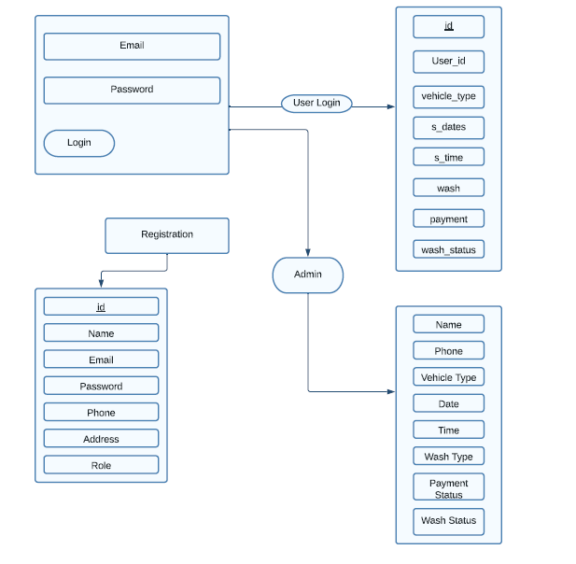

**Use Case Diagram:**

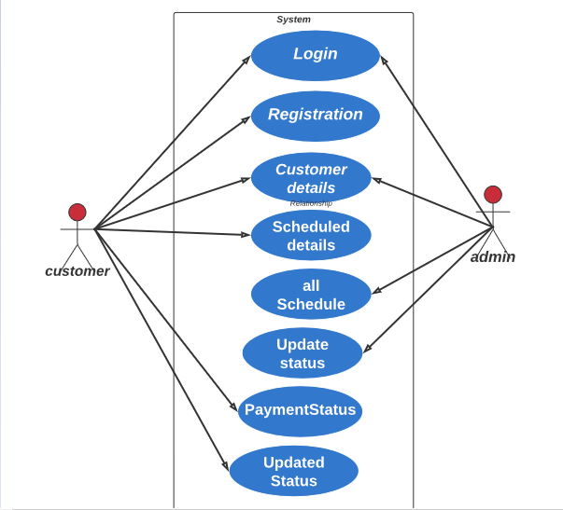

**ER Diagram:-**

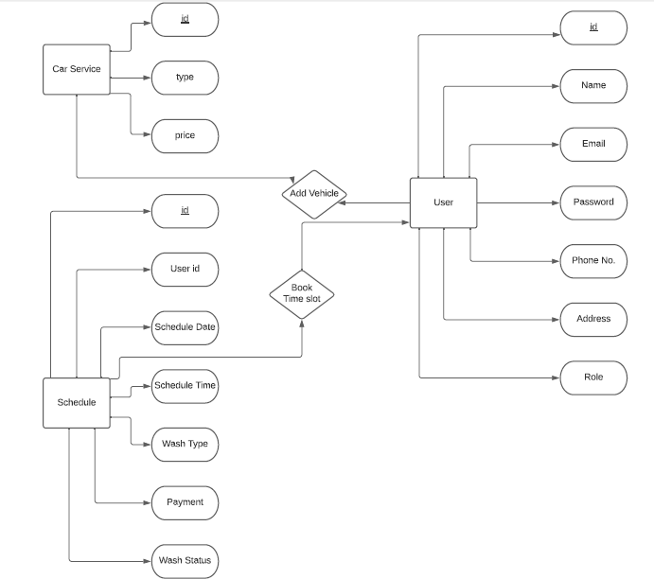

**Table Structure:-**

1. **User:**

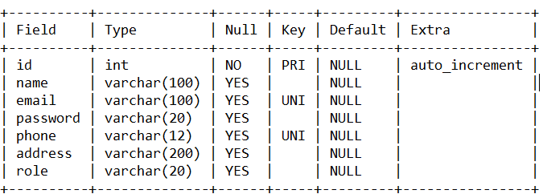

**2) Schedule:**

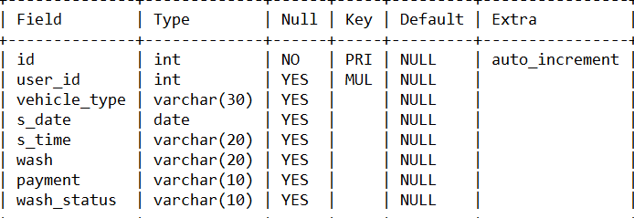

**3) c_service:**

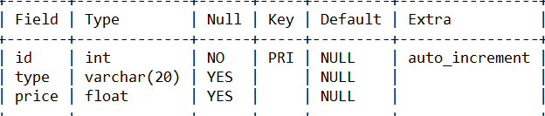

**Conclusion:**

This is to conclude that the project that I undertook was worked upon with a sincere effort. Most of the requirements have been fulfilled up to the mark and the requirements which have been remaining, can be completed with a short extension. Producing new customer service skills have changed past that used to cost you hours in comparing, searching, and waiting at the service centers and repair shops to get your vehicle serviced or repaired.

**Future Scope:-**

This technology benefits the customers or vehicle owners and leverages more significant revenues for companies across the automotive industry and auto service businesses. It is just for one service center in future we make it is common mean many service center owner can add into over app and also add their different services and then do login as admin and see all customer schedules for servicing. From this customers are also compare service charges of different centers and also can see the rating and accordingly choose the best service center.

**References:-**

•https://getbootstrap.com/

• https://reactjs.org/docs/