**ABSTRACT**

Automation is a trending topic in the 21st century making it play an important role in our daily lives. The main attraction of any automated system is reducing human labour, effort, time and errors due to human negligence. With the development of modern technology, smartphones have become a necessity for every person on this planet. Applications are being developed on Android systems that are useful to us in various ways. Another upcoming technology is natural language processing which enables us to command and control things with our voice. Combining all of these, our paper presents a microcontroller-based voice-controlled home automation system­ using smartphones.

The main objective of this project is to develop a home automation system using  
an Arduino board with Bluetooth being remotely controlled by any Android OS  
smart phone. As technology is advancing so houses are also getting smarter.  
Modern houses are gradually shifting from conventional switches to centralized  
control system, involving remote controlled switches. Presently, conventional wall switches located in different parts of the house makes it difficult for the user to go near them to operate. Even more it becomes more difficult for the elderly or physically handicapped people to do so. Remote controlled home automation system provides a most modern solution with smart phones.

The concept of Home Automation is gaining popularity as it helps in reducing human effort and errors and thus increasing the efficiency. With the help of Home Automation system, we can control different appliances like lights, fans, TV, AC etc. Additionally, a home automation system can also provide other features like security, alarms, emergency systems etc. can be integrated.

There are many types of Home Automation Systems like Bluetooth Controlled, Internet Controlled, RF Controlled, Remote Controlled (IR Remote) etc. Each type has its own advantages and disadvantages. In this project, we have designed a Voice Activated Home Automation system, where different appliances are controlled by sending a Voice Command.

**Table of Contents**

|  |  |  |
| --- | --- | --- |
| Chapter 1: INTRODUCTION | | |
| 1.1 | Background | 3 |
| 1.2 | Purpose | 4 |
| 1.3 | Method | 4 |
| 1.4 | Project Aim | 4 |
| 1.5 | Project Objective | 4 |
| 1.6 | Project Scope and Limitations | 4 |

|  |  |  |
| --- | --- | --- |
| Chapter 2: System Design | | |
| 2.1 | System Components | 5 |
| 2.1.1 | Hardware Requirement | 5 |
| 2.1.2 | Software Requirement | 6 |
| 2.2 | Description of Hardware Requirement | 6 |
| 2.2.1 | Arduino UNO | 6 |
| 2.2.2 | HC – 05 Bluetooth Module | 8 |
| 2.2.3 | Relay Boards | 9 |
| 2.2.4 | Android Based Phone | 9 |
| 2.3 | Description of Hardware Requirement | 10 |
| 2.3.1 | Arduino Ide | 10 |
| 2.3.2 | Proteus 8 | 11 |
| 2.4 | HC 05 Bluetooth Module Interfacing With Arduino | 12 |

|  |  |  |
| --- | --- | --- |
| Chapter 3: IMPLEMENTATION | | |
| 3.1 | Technical Specification | 13 |
| 3.2 | Designing the Circuit | 14 |

|  |
| --- |
| Chapter 4: METHODOLOGY 15,16 |

|  |  |  |
| --- | --- | --- |
| Chapter 5: CONCLUSION | | |
|  | Conclusion | 20 |
|  |  |  |

Reference 21

**CHAPTER - 1**

**INTRODUCTION**

The foremost aim of technology has been to increase efficiency and decrease effort. With the advent of ‘Internet of Things’ in the last decade, we have been pushing for ubiquitous computing in all spheres of life. It thus is of extreme importance to simplify human interfacing with technology. Automation is one such area that aims that achieves simplicity whilst increasing efficiency. Voice controlled Home Automation System aims to further the cause of automation so as to achieve the goal of simplicity. The primitive man realized that an effective way to communicate with one another is through voice. With minimum effort, ideas could be narrated with relative ease. When the first computers came around, achieving the level of sophistication so as to narrate commands using voice to a machine was only realized in science fiction. However with tremendous breakthroughs in the field, we are at the precipice of truly using voice to interface with devices. Using this effective yet ingrained form of communication we would humanize technology to a great extent. Voice controlled House Automation System deploys the use of voice to control devices.

* 1. **Background**

Nowadays, we have remote controls for our television sets and other electronic  
systems, which have made our lives real easy. Have you ever wondered about  
home automation which would give the facility of controlling tube lights, fans and other electrical appliances at home using a remote control? Off-course, Yes!   
 But, are the available options cost-effective? If the answer is No, we have found   
a solution to it. We have come up with a new system called Arduino based home  
automation using Bluetooth. This system is super-cost effective and can give the  
user, the ability to control any electronic device without even spending for a  
remote control.

This project helps the user to control all the electronic devices using his/her smartphone. Time is a very valuable thing. Everybody wants to save time as much as they can. New technologies are being introduced to save our time. To save peoples time we are introducing Home Automation system using Bluetooth with the help of this system. you can control your home appliances from your mobile phone. You can turn on/off your home appliances within the range of Bluetooth.

Voice controlled House Automation System leverages the power of Arduino to provide a holistic voice-controlled automation system. Using Natural Language Processing and the available hardware in most smartphones, it translates voice to be used for controlling electrical devices.

* 1. **Purpose**

The purpose of the project is to develop a prototype that can be used for controlling home electronics using voice commands. Based on the project background the prototype should aim to fulfil the following properties:

* Affordable: The use of inexpensive hardware and software is prioritized.
* Ease of use: The user shouldn’t need deep technological knowledge to kuse the prototype.
* Functional: It should not be more difficult to control devices using the prototype than with more conventional methods.
* Relevant functionality: The prototype should be able to perform tasks that are of interest to the user.
* Limit energy consumption: The prototype should be able to help the user limit the energy consumption in their home.
  1. **Method**

The purpose of the project is mostly focused on the user experience. Therefore, a user study was conducted in order to validate the project vision and formulate the prototype requirements have the correct focus. Since the field of speech recognition offers multiple software solutions it was necessary to conduct a study in order to analyze them with respect to the desired functionality of the prototype.

* 1. **Project Aim**

The aim of the project is to design and construct a home automation system that will remotely switch on or off any household appliances connected to it, using a microcontroller, voice dial on phone, or Bluetooth based android application.

**1.5 Project Objective**

The objective of this project is to implement a low cost, reliable and scalable home automation system that can be used to remotely switch on or off any household appliance, using a microcontroller to achieve hardware simplicity, low cost short messaging service for feedback and voice dial from any phone to toggle the switch state.

**1.6 Project scope and limitation**

This project work is complete on its own in remotely and automatically switching on or off of an electrical appliance not limited to household appliances and sends a feedback message indicating the new present state of the appliance.

**CHAPTER - 2**

**SYSTEM DESIGN**

**2.1 System Components**

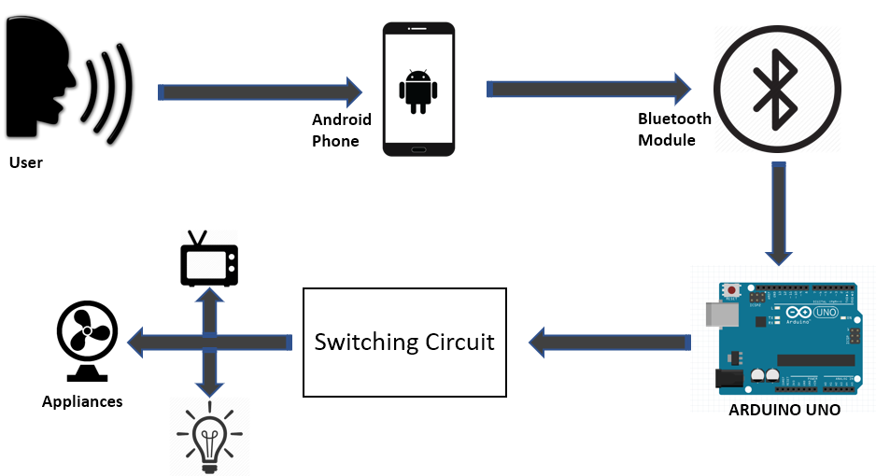

**Figure 1: Block Diagram of the System**

The Voice-operated Android and Arduino Home automation system uses an Android based Bluetooth enabled phone for its application and the Arduino Uno as the microcontroller. The key components of this system are:

**2.1.1 Hardware Requirement**

⮚ Arduino Uno R3 microcontroller

⮚ HC – 05 Bluetooth Module

⮚ 10 KΩ Resistor

⮚ 1 KΩ Resistor X 4

⮚ BC547 NPN Transistor X 4

⮚ 1N4007 Diode X 4

⮚ 5 V Relay X 4

⮚ Prototyping board (Bread board)

⮚ Connecting wires

⮚ 9 V Power supply

⮚ Smartphone or tablet (Bluetooth enabled)

**2.1.2 Software Requirement**

⮚ Arduino IDE

⮚ Proteus 8

⮚ Android application

**2.2 Description of Hardware Required**

**2.2.1 ARDUINO UNO**

The Arduino Uno is a microcontroller board based on the ATmega328P. It has 14 digital input/output pins (of which6 can be used as PWM outputs), 6 analog inputs, a 16MHz ceramic resonator, a USB connection, a power jack, an ICSP header, and a reset button. It contains everything needed to support the microcontroller. We either need to connect it to a computer using a USB cable or power it with an AC-to-DC adapter. The Arduino circuit acts as an interface between the software part and the hardware part of the project.

The Bluetooth module transmits the text to the Arduino Uno serial port. The text is matched against the various combinations of predefined texts to switch the appliances on/off. The appliance name and a command for on/off are stored as predefined command. For example, to switch on a television the user needs to say “television on” and to switch it off he needs to say “television off”. The appliances are connected via the relay boards to pin numbers 2, 3 and 4 of the Arduino Uno. When the matching text is detected the corresponding pin number is given a high or low output signal to switch the appliance on and off respectively.

|  |  |
| --- | --- |
| 1. Microcontroller | ATmega328P |
| 2. Operating Voltage | 5V |
| 3. Input Voltage (recommended) | 7-12V |
| 4. Input Voltage (limits) | 6-20V |
| 5. Digital I/O Pins | 14 |
| 6. Analog Input Pins | 6 |
| 7. DC Current per I/O Pin | 40 mA |
| 8. DC Current for 3.3V Pin | 50 mA |
| 9. Flash Memory | 32 KB of which 0.5 KB used by bootloader |
| 10.SRAM | 2 KB |
| 11.EEPROM | 1 KB |
| 12.Clock Speed | 16 MHz |

**⮚ Some Technical Specification of Arduino Uno are:**

**Circuit Diagram**

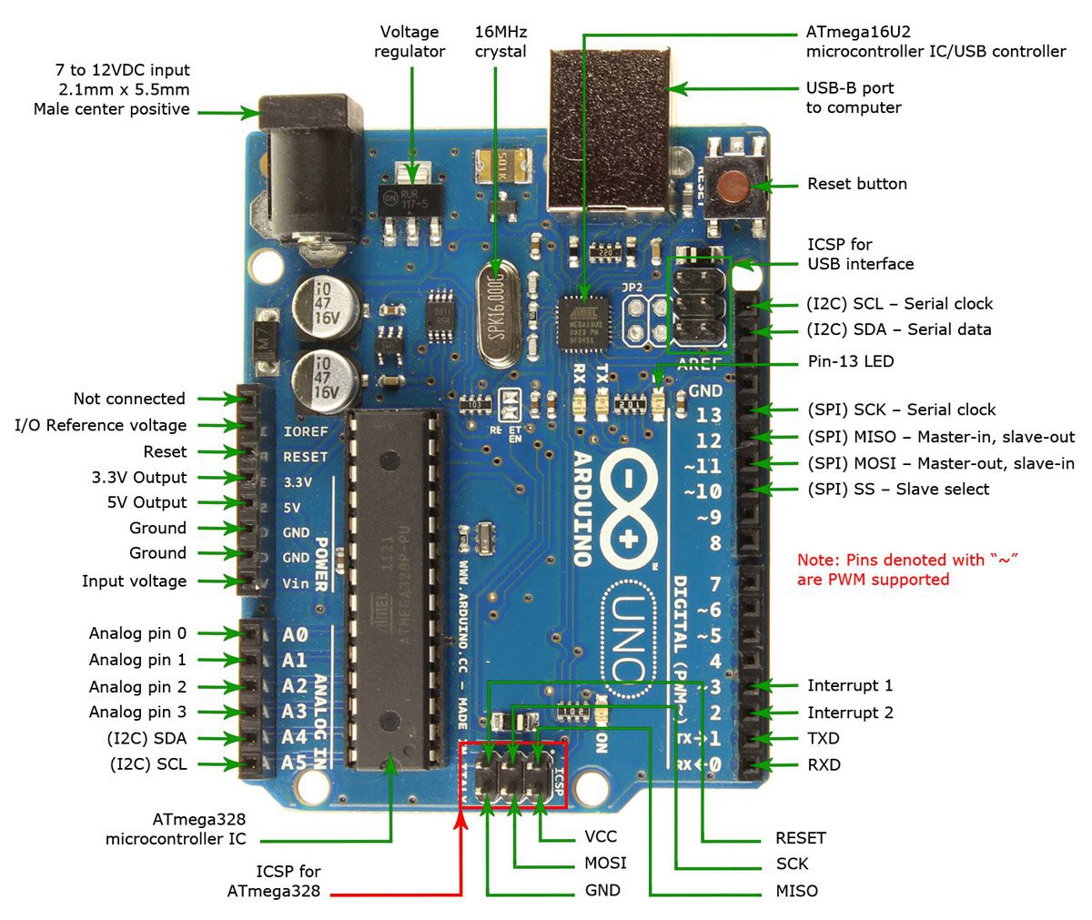

**Figure 2: ARDUINO UNO**

**2.2.2 HC – 05 Bluetooth Module**

Bluetooth is a wireless technology standard for exchanging data over short distances (using short-wavelength UHF radio waves in the ISM band from 2.4 to 2.485 GHz) from fixed and mobile devices and building personal area networks (PANs) . The Bluetooth module being used allows us to transmit and receive signals. It receives the text from the Android phone and transmits it to the serial port of the Arduino Uno.

HC-05 module is an easy to use Bluetooth SPP (Serial Port Protocol) module, designed for transparent wireless serial connection setup.

Serial port Bluetooth module is fully qualified Bluetooth V2.0+EDR (Enhanced Data Rate) 3Mbps Modulation with complete 2.4GHz radio transceiver and baseband. It uses CSR Bluecore 04-External single chip Bluetooth system with CMOS technology and with AFH(Adaptive Frequency Hopping Feature). It has the footprint as small as 12.7mmx27mm. Hope it will simplify your overall design/development cycle.

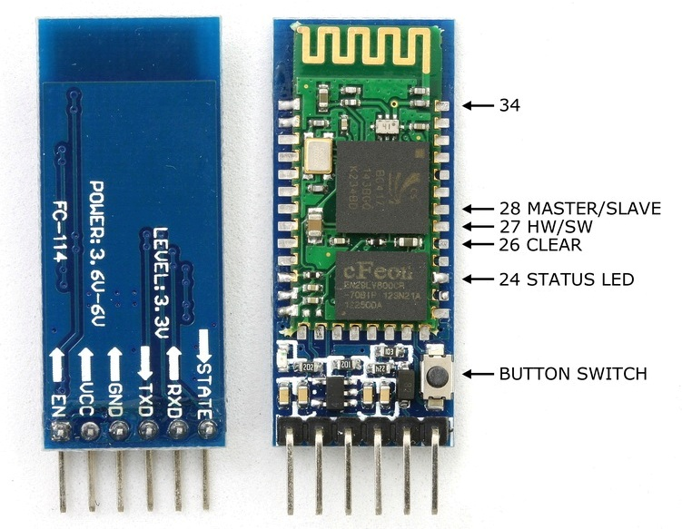

**Figure 3: HC – 05 Bluetooth Module**

**2.2.3 Relay Boards**

A relay is an electromagnetic switch. In other words, it is activated when a current is applied to it. Normally a relay is used in a circuit as a type of switch. There are different types of relays and they operate at different voltages. When a circuit is built the voltage that will trigger it has to be considered. In this project the relay circuit is used to turn the appliances on/off. The high/low signal is supplied from the Arduino Uno microcontroller. When a low voltage is given to the relay of an appliance it is turned off and when a high voltage is given it is turned on.

**2.2.4 Android Based Phone**

Android is a mobile operating system (OS) based on the Linux kernel and currently developed by Google. With a user interface based on direct manipulation, the OS uses touch inputs that loosely correspond to real-world actions, like swiping, tapping, pinching, and reverse pinching to manipulate on-screen objects, and a virtual keyboard. We have used the Android platform because of its huge market globally and it’s easy to use user interface. Applications on the Android phones extend the functionality of devices and are written primarily in the Java programming language using the Android software development kit (SDK). The voice recognizer which is an in-built feature of Android phones is used to build an application which the user can operate to automate the appliances in his house. The user interface of the application is shown below:

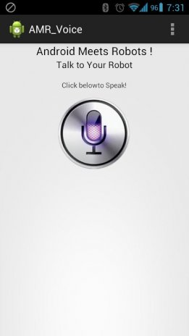

**Figure 4: user interface of the application**

**2.3 Description of Software Required**

**2.3.1 Arduino IDE**

Arduino IDE is a lightweight, cross-platform application that introduces programming to novices. It has both an online editor and an on-premise application, for users to have the option whether they want to save their sketches on the cloud or locally on their own computers. While Arduino IDE is highly-rated by users according to ease of use, it is also capable of performing complex processes without taxing computing resources. With Arduino IDE, users can easily access contributed libraries and receive up-to-date support for the latest Arduino boards, so they can create sketches that are backed by the newest version of the IDE.

Arduino IDE works on the three most popular operating systems: Windows, Mac OS, and Linux. Aside from that, the application is also accessible from the cloud. These options provide programmers with the choice of creating and saving their sketches on the cloud or building their programs locally and upload it directly to the board.

Arduino IDE is designed specifically for Arduino boards, it also supports connections with third-party hardware. This makes the use of the application more extensive rather than limited to proprietary boards.

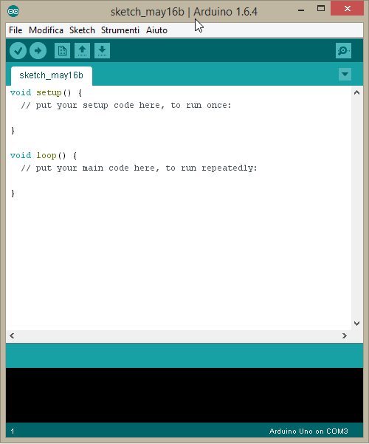

**Figure 5: Arduino IDE**

**2.3.2 Proteus 8**

[Proteus](http://www.labcenter.com/download/prodemo_download.cfm#professional) is a simulation and design software tool developed by [**Labcenter Electronics**](http://www.labcenter.com/index.cfm) for [**Electrical**](http://www.circuitstoday.com/circuit-design-and-simulation-softwares) **and Electronic circuit design**. It also possess [2D CAD drawing feature](http://www.circuitstoday.com/electronics-circuit-drawing-softwares). It deserves to bear the tagline “From concept to completion”.

**About Proteus**

It is a software suite containing [schematic](http://www.circuitstoday.com/pcb-design-and-layout-software), [simulation](http://www.circuitstoday.com/circuit-design-and-simulation-softwares) as well as [PCB designing](http://www.circuitstoday.com/how-to-build-pcb-online-using-web-based-eda-tools).

* [**ISIS**](http://www.labcenter.com/products/pcb/schematic_intro.cfm) is the software used to draw schematics and simulate the circuits in real time. The simulation allows human access during run time, thus providing real time simulation.
* [ARES](http://www.labcenter.com/products/pcb/pcb_intro.cfm)  is used for PCB designing. It has the feature of viewing output in 3D view of the designed PCB along  with components.
* The designer can also develop 2D drawings for the product.

**Features**

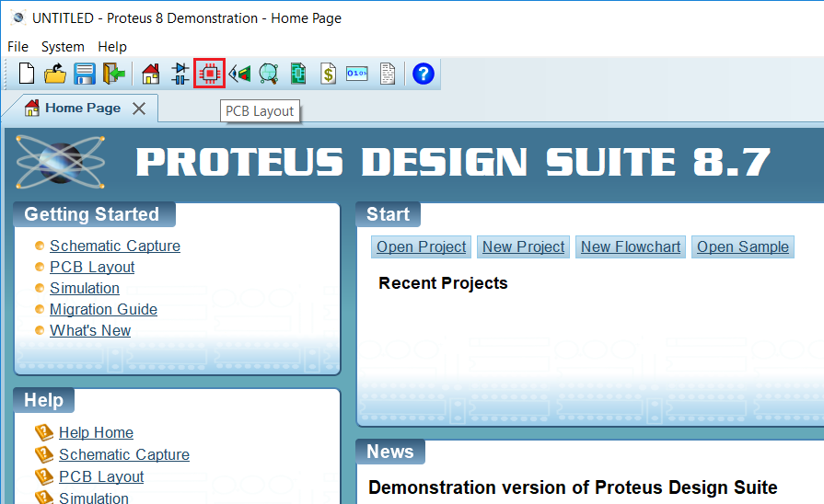ISIS has wide range of components in its library. It has sources, signal generators, measurement  and analysis tools like [**oscilloscope**](http://www.circuitstoday.com/best-analog-oscilloscope-guide), voltmeter, ammeter etc., probes for real time monitoring of the parameters of the circuit, [switches](http://www.circuitstoday.com/proteus-tutorial-switches-and-relays), [displays](http://www.circuitstoday.com/proteus-tutorial-led-and-bar-graph), loads like motors and lamps, discrete components like resistors, capacitors, inductors, transformers, digital and analog Integrated circuits, semi-conductor switches, relays, microcontrollers, processors, sensors etc. ARES offers PCB designing up to 14 inner layers, with surface mount and through hole packages. It is embedded with the foot prints of different category of components like ICs, transistors, headers, connectors and other discrete components. It offers Auto routing and manual routing options to the PCB Designer. The schematic drawn in the ISIS can be directly transferred ARES.

**Figure 6: Proteus design suite 8.7**

**2.4 HC-05 Bluetooth Module Interfacing with Arduino UNO**

HC-05 is a Bluetooth device used for wireless communication with Bluetooth  
enabled devices (like smartphone). It communicates with microcontrollers using serial communication (USART). Default settings of HC-05 Bluetooth module can be changed using certain AT commands. As HC-05 Bluetooth module has 3.3 V level for RX/TX and microcontroller can detect 3.3 V level, so, there is no need to shift TX voltage level of HC-05 module. But we need to shift the transmit voltage level from microcontroller to RX of HC- 05 module.

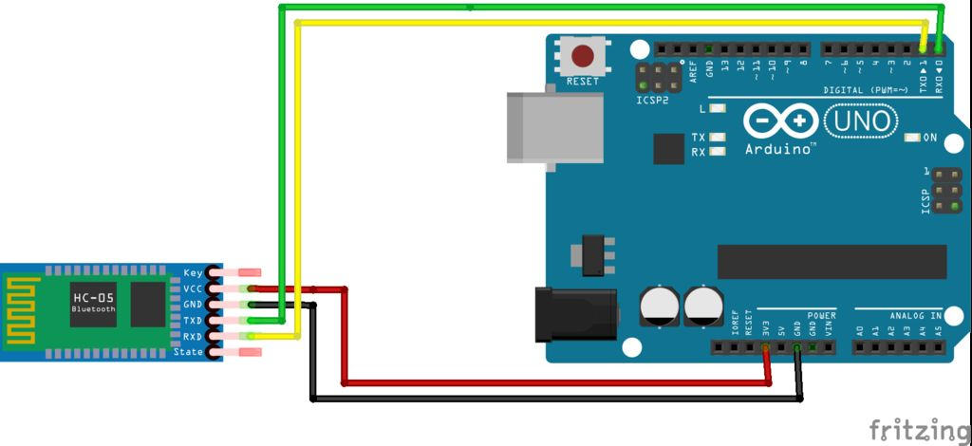

**Figure 7: Bluetooth Module Interfacing with Arduino UNO**

**CHAPTER 3**

**IMPLEMENTATION**

A low cost and efficient smart home system is presented in our design. This  
system has two main modules: the hardware interface module and the software  
communication module. At the heart of this system is the Arduino Mega 2560  
microcontroller which is also capable of functioning as a micro web server and the interface for all the hardware modules. All communication and controls in this system pass through the microcontroller.

**3.1 Technical Specification**

1) A smartphone or an Android mobile which should have the android app  
installed in it.

2) Bluetooth receiver module – Our project will be connected to the smartphone  
using Bluetooth technology.

3) Controller or the main processing circuit- In this project, Arduino Uno is the  
main controlling / processing unit. Also, this project can be developed using  
PIC18F4550, AVR ATmega32 and 8051 series like: 89s51, 89c51, 89s52, 89v51RD2.

4) LCD Display – The Liquid Crystal Display is optional but shows important  
messages like device status once command is received from Bluetooth.

5) Relays to control devices – We will use 12volt or less Single push single throw relays.

6) Output devices – For the demo purpose, we connected a DC-devices to a relay (DC bulb). You can connect any AC/DC devices to the other relays.

**3.2 Designing the Circuit**

We will now see the design of the Voice Activated Home Automation circuit. First, we will connect the Bluetooth Module to the Arduino. Since Bluetooth uses UART protocol, we need to use the RX and TX pins of the Arduino. We will be using “Software Serial” library to define our own RX and TX pins (Pin 2 is RX and Pin 3 is TX).

NOTE: We have left out the Bluetooth’s RX and Arduino’s TX connection as it is not used. In case you face a problem, connect a voltage divider to convert the Arduino TX’s 5V signal to Bluetooth RX’s 3.3V. Next, we will connect the relays to the Arduino. Since we used a readymade relay board with 4 – channels, all we need to do is to connect the inputs of the individual relays to the Arduino. For detailed connection like the resistor, transistor, diode and relay, refer the circuit diagram.

NOTE: We did not connect any load to the relay but you can always connect some small loads and check out the functioning. Be extra careful while using AC Mains with relay board. All the necessary connections are explained in the circuit diagram.

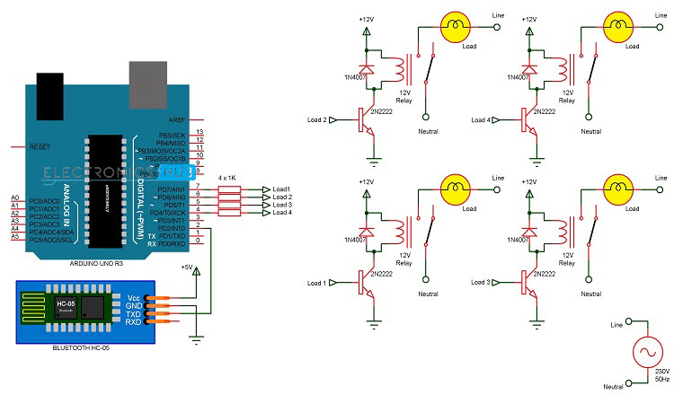

**Figure 8: Circuit Diagram**

**CHAPTER - 4**

**METHODOLOGY**

In this project, a simple Voice Activated Home Automation system is designed. Voice commands are used to control different appliances. We will now see the working of the project. All the connections are made as per the circuit diagram above.

After making the necessary connections, we have to switch on the power supply to the circuit. Now, we need to pair the Phone’s Bluetooth to the HC – 05 Bluetooth Module. Before that, we have to install the App mentioned above in the phone. The home screen of the app looks something like this.

Next step is to connect the phone with the Bluetooth module. For this, choose the option “Connect Robot” and select the appropriate Bluetooth Device. If the devices aren’t paired earlier, we need to pair them now using the Pin of the HC – 05 Bluetooth Module.

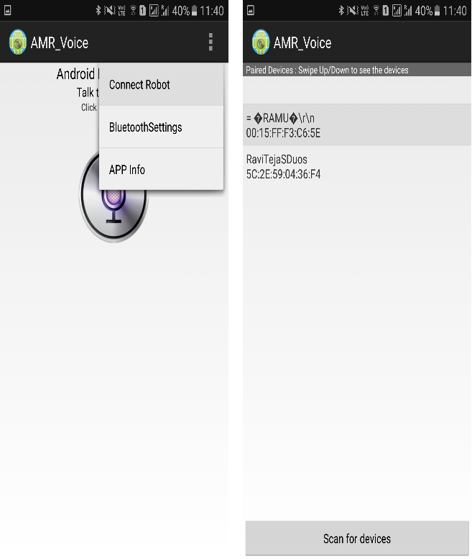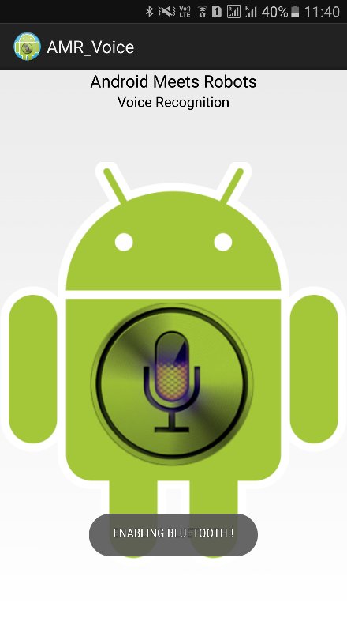

**Figure 9: Android app connecting with Bluetooth**

After successful connection, the devices are ready to transmit data. For that, press the press microphone icon on the app and start giving voice commands.

**NOTE**: Make sure that the voice recognition feature is enabled on the phone (this is usually associated with Google app).

For example, if we press the microphone icon and say “turn on light”, the app will recognize the command and the transfers it to the Bluetooth Module. Also, the command gets displayed on the screen for our reference.

When the string “turn on light” is detected by the app, it will send the string as “*turn on light#”. So, the actual message received by the Bluetooth Module is in the format of “*Message#”. The reason for padding the ‘*’ and ‘#’ at the begging and end of the string is to identify the starting and ending of the message.

We are able to delete the ‘#’ from the string but left out the ‘*’ in order to identify the starting of the string. The received message is compared with some predefined strings and if the message matches with any of them, then corresponding action like turning on or turning off the load happens.

We have used the following commands: “turn on AC”, “turn off AC”, “turn on light”, “turn off light”, “turn on TV”, “turn off TV”, “turn on fan”, “turn off fan”, “turn on all” and “turn off all”.

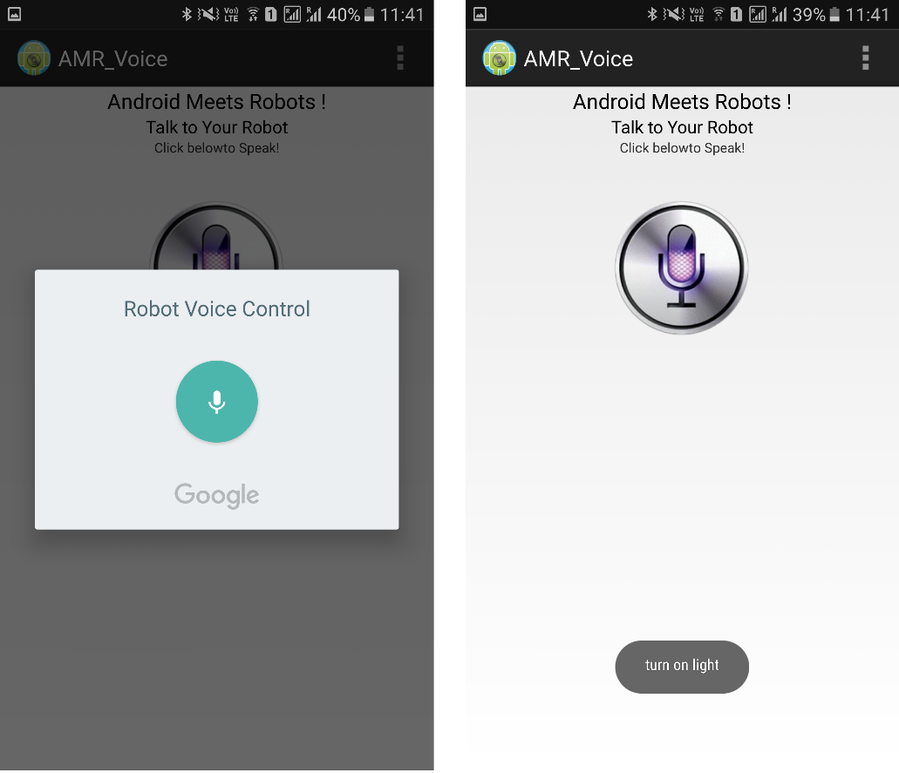

**­­**

**Figure 10: Voice input**

**Pros of Home Automation**

**1. Security**

Use your voice to turn on the lights when you get home so you worried about  
what’s hiding in the shadows, or in your pathways. Or automate to turn on when you aren’t home to look like you are to ward off potential robbers. Door locks are another automated home product that can increase your home security.

**2. Energy Efficiency**

Increase your home’s energy efficiency by remotely powering off systems and  
appliances when they aren’t in use. In addition to the standard home automation products that give you active control, some products actively monitor systems and arm the homeowner with knowledge, insight and guidance to achieve greater control and energy efficiency.

**3. Savings**

Home automation literally pays off. When you are able to use home systems  
and appliances only when needed, the savings will be apparent in the first  
utility bill. No more wasting money on lights left on when you aren’t home, or  
spending money on gas to drive home because you forgot to lock the door.  
Monetary savings are apparent, but you’ll also be saving time. No wasted trips  
home, no running through the house turning everything off, no time spent  
worrying about what was or wasn’t turned off.

**4. Convenience**

Don’t you hate having to rely on neighbors to watch your house when you’re  
gone? With home automation, convenient control of your home is at your fingertips. You don’t have to trust someone else with your most valued possessions.

**5. Comfort**

Ever leave for work in the morning when it was a comfortable 68° outside only  
to come home to a sweltering house because the temperature shot up to 90°?  
Connected home products like the Sensi™ Wi-Fi Thermostats let you  
conveniently adjust your home temperature from the mobile app so your  
family is always comfortable.

**Cons of Home Automation**

**1. Cost of Intelligence**

Installing state-of-the-art features inside a home results in a higher price tag for the property. The cost of an intelligent home that makes our lives convenient is high because some of the technology is relatively new. The cost of living expenses such as utilities, maintenance and repair of the technology can be expensive as well.

**2. Technology Learning Curve**

Owning a smart home means having to learn how to use your home. Unlike traditional homes, smart home technology requires you to adapt to the innovations within your living area such as security systems, air units and a remote that controls your entire house. For the technology-savvy family, the smart home will help achieve convenience faster, but for others, it will take  
reading manuals and learning how-to before the benefits of convenience pay off.

**3. Video Surveillance**

Video surveillance can be a wonderful tool in heightening security and deterring crime, but when the technology falls into the wrong hands, issues of privacy can occur. Security sensors within the doors and walls of a smart home use wireless technology to transfer signals to a central control unit that notifies emergency officials of any foreign activity.

**Applications**

⮚ Using this project, we can turn on or off appliances remotely i.e. using a  
phone or tablet.

⮚ The project can be further expanded to a smart home automation system  
by including some sensors like light sensors, temperature sensors, safety  
sensors etc. and automatically adjust different parameters like room  
lighting, air conditioning (room temperature), door locks etc. and transmit  
the information to our phone.

⮚ Additionally, we can connect to internet and control the home from remote  
location over internet and also monitor the safety.

**Future Development of the project**

⮚ Arduino based device control using Bluetooth on Smartphone project can  
be enhanced to control the speed of the fan or volume of the buzzer etc.

⮚ Home automation and Device controlling can be done using Internet of  
Things – IOT technology.

⮚ We can replace Bluetooth by GSM modem so that we can achieve device  
controlling by sending SMS using GSM modem.

CHAPTER - 5

CONCLUSION

The home automation system has been experimentally proven to work satisfactorily by connecting sample appliances to it and the appliances were successfully controlled from a wireless mobile device. We learned many skills such as soldering, wiring the circuit and other tools that we use for this project and was able to work together as a team during this project.  
The Bluetooth client was successfully tested on a multitude of different mobile phones from different manufacturers, thus proving its portability and wide compatibility. Thus, a low-cost home automation system was successfully designed, implemented and tested.

Reference

The web sites that provide the information’s:

•<http://www.autogates.com.my>  
•<http://www.usautomatic.com>  
•<http://www.amazinggates.com>  
•<http://www.microchip.co.uk>  
•<http://www.quora.com>  
•<http://www.quora.com>  
•<http://www.efy.com>  
•[www.electronicsworldforyou.com](http://www.electronicsworldforyou.com)