**Thesis proposal**

**Distributive Frequency of Energy Classification Using**

**Deep Boltzmann Machine**

**-------------------------------------------------------------------------------------------**

**Submitted By:**

**Abir Hosen**

**Exam Roll: ASH1511033M**

**Thesis Supervisor:**

**SaifurRahman**Assistant Professor,

Information And Communication Engineering



**Noakhali Science & Technology University**

DEPARTMENT OF INFORMATION & COMMUNICATION ENGINEERING

**SONAPUR – 3814**

# Declaration

This project proposal is submitted to the Information And Communication Engineering, Noakhali Science And technology University, Noakhali,Sonapur. So, here I declare that this project report has not been submitted elsewhere for the requirement of any kind of degree, diploma or publication.

Abir Hosen Ashik

B.Sc Student of ICE, NSTU

Roll No :ASH1511033M

Session :2014-2015

ACCEPTANCE

This project proposal is submitted to the Information And Communication Engineering, Noakhali Science And technology University, Noakhali,Sonapur.

SaifurRahman

Assistant Professor

Information and Communication Engineering

Noakhali Science And technology University

Sonapur - 3814, Bangladesh

**Table of Contents**

Abstract…………………………………………………………………………... 5

Introduction………………………………………………………………………. 6-8

Literature Review………………………………………………………………… 9-12

Objective.. ……………………………...……………………………………….. 13

Methodology……………………………………………………………………... 14

Expected Result…………………….…………………………………………….. 15

References…………………………………………………………………………16

**Abstract**

The paper, it’s going to show that, the distributed Energy in form of frequency in the template of simulated word that’s going to be classified through Deep Boltzmann Machine. The learning & classification methodology will be done by the Boltzmann Energy based Model applying Constructive Divergence following the rules of probability distribution.

This approach will also aim at the shortest unsupervised learning through meaningful & proper data collection & distribution process.

Following these procedures, it will be able to identify any object through the ionize radiation detection of any object.

Here Quantum Leap, Double shift experiment, Entanglement, the radiation predicts of Quantum Mechanics will be introduced with AI.

**Introduction**

Quantum Mechanics rules over every atom & tiny particle in every piece of matter in stars & planate in rock & building and in you & me. What I do here can have an immediate effect in somewhere else even if there’s no one there.

All follows classification mechanics, that allows us to predict the behavior of things with certainty.Single photons are attractive carriers of Quantum Information. Once produced, they can be reliably manipulated and can travel long distances unaffected[6].

Photons can be viewed in some sense as energy wave-packets of arbitrary spatio-temporal amplitude, moving at the speed of light. A single photon is a clean quantum system in which quantum information

can be encoded in various ways and transported even over long distances relatively safely.[6]

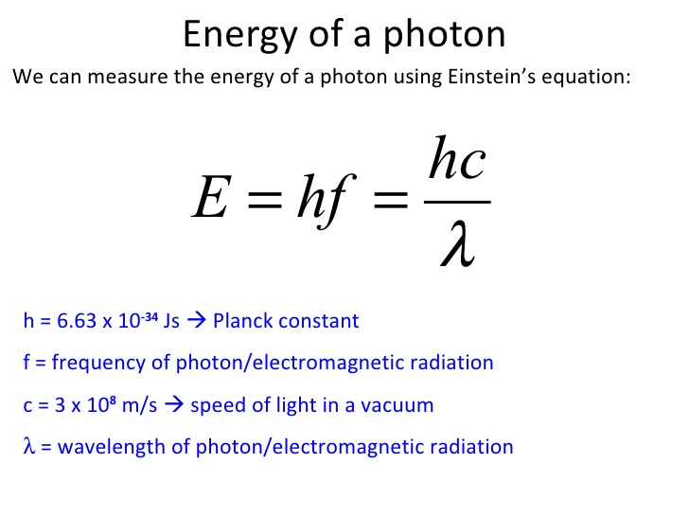

Radioactive isotopes, or radioisotopes for short, are elemental isotopes whosenuclei are unstable due to a lack or surplus of neutrons. This instability results inspontaneous nuclear decays which may be in the form of beta particles, alpha particles, orgamma rays. These decays are a primary source of radiation exposure for electronicdevices employed in terrestrial applications. [7]

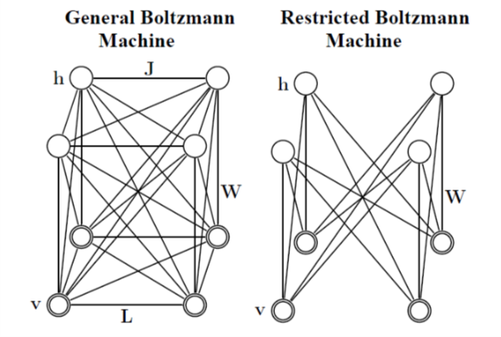

In this approach the photonic frequency identification according to it’s information is the main obstruct that will be tried to solve beside the huge data storage in minimal form with the purpose of easy learning process of Deep Boltzmann Machine. In this study addition of energic frequency classification concept going to be a high challenge with the Deep BoltzmannMachine.

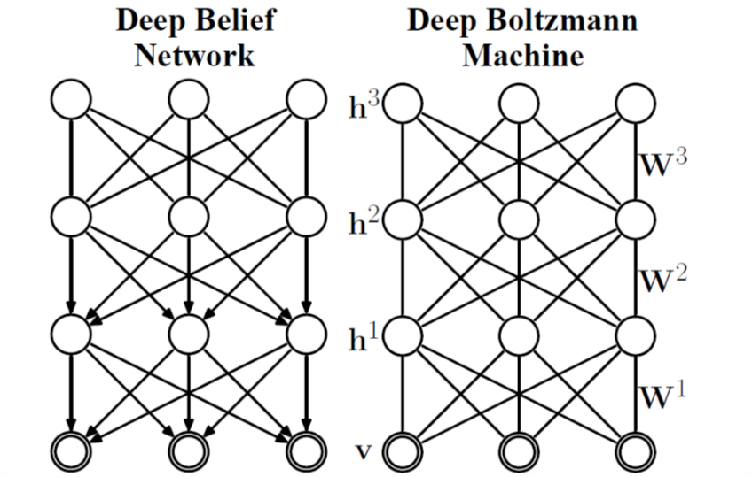

**Literature Review**

Here, we include related works in shortly. That is, different procedure that related with this Deep Boltzmann Machine Frequency Classification system.

Review 1: *Gas Classification Using Deep Convolutional Neural Networks.*

**PaiPeng 1,3, Xiaojin Zhao 1, Xiaofang Pan 2 and Wenbin Ye 1,\***

1 School of Electronic Science and Technology, Shenzhen University, Shenzhen 518060, China; pengpai_sh@szu.edu.cn (P.P.); eexjzhao@szu.edu.cn (X.Z.)

2 School of Information Engineering, Shenzhen University, Shenzhen 518060, China; eexpan@szu.edu.cn

3 Key Laboratory of Optoelectronic Devices and Systems of Ministry of Education and Guangdong Province, College of Optoelectronic Engineering, Shenzhen University, Shenzhen 518060, China

**\*** Correspondence: yewenbin@szu.edu.cn; Tel.: +86-755-2672-3212

Received: 8 November 2017; Accepted: 30 December 2017; Published: 8 January 2018

In this work, we propose a novel Deep Convolutional Neural Network (DCNN) tailored for

gas classification. Inspired by the great success of DCNN in the field of computer vision, we designed

a DCNN with up to 38 layers. In general, the proposed gas neural network, named GasNet, consists of:

six convolutional blocks, each block consist of six layers; a pooling layer; and a fully-connected layer.

Together, these various layers make up a powerful deep model for gas classification. Experimental

results show that the proposed DCNN method is an effective technique for classifying electronic nose

data. We also demonstrate that the DCNN method can provide higher classification accuracy than

comparable Support Vector Machine (SVM) methods and Multiple Layer Perceptron (MLP).

Review 2: *A fast learning algorithm for deep belief nets.*

**Geoffrey E. Hinton** and **Simon Osindero**

Department of Computer Science University of Toronto

10 Kings College Road

Toronto, Canada M5S 3G4

fhinton, [osinderog@cs.toronto.edu](mailto:osinderog@cs.toronto.edu)

**Yee-WhyeTeh**

Department of Computer Science

National University of Singapore

3 Science Drive 3, Singapore, 117543

[tehyw@comp.nus.edu.sg](mailto:tehyw@comp.nus.edu.sg)

We show how to use “complementary priors” to eliminate the explaining away effects that make inference difficult in densely-connected beliefnets that have many hidden layers. Using complementarypriors, we derive a fast, greedyalgorithmthat can learn deep, directed belief networksone layer at a time, provided the top two layersform anundirected associative memory. Thefast, greedy algorithm is used to initialize a slowerlearning procedure that fine-tunes the weights usinga contrastive version of the wake-sleep algorithm.After fine-tuning, a network with three

hidden layers forms a very good generative modelof the joint distribution of handwritten digit imagesand their labels. This generative model givesbetter digit classification than the best discriminativelearning algorithms. The low-dimensionalmanifolds on which the digits lie are modelled bylong ravines in the free-energy landscape of the

top-level associative memory and it is easy to explorethese ravines by using the directed connectionsto display what the associative memory hasin mind.

Review 3: *Deep Boltzmann Machines.*

**RuslanSalakhutdinov**

Department of Computer Science

University of Toronto

rsalakhu@cs.toronto.edu

**Geoffrey Hinton**

Department of Computer Science

University of Toronto

hinton@cs.toronto.edu

The original learning algorithm for Boltzmann machines (Hinton and Sejnowski, 1983) required randomly initialized Markov chains to approach their equilibrium distributions in order to estimate the data-dependent and dataindependent expectations that a connected pair of binary variables would both be on. The difference of these two expectations is the gradient required for maximum likelihood learning. Even with the help of simulated annealing, this learning procedure was too slow to be practical.

Review 4: *SINGLE PHOTONS FOR QUANTUM INFORMATION PROCESSING*

A DISSERTATION SUBMITTED TO THE DEPARTMENT OF PHYSICS AND THE COMMITTEE ON GRADUATE STUDIES OF STANFORD UNIVERSITY IN PARTIAL FULFILLMENT OF THE REQUIREMENTS FOR THE DEGREE OF DOCTOR OF PHILOSOPHY

David Fattal

September 2010

Single photons are attractive carriers of Quantum Information. Once produced, they

can be reliably manipulated and can travel long distances una_ected. They are the

main constituents of quantum communication protocols, and it is likely that they will

even play a major role in the development of quantum computers.

This work presents experimental and theoretical improvements of existing semiconductor

quantum dot single photon sources for their application to quantum information.

We demonstrate the experimental realization of some basic optical quantum

information protocols: entanglement generation and quantum state teleportation.

We also develop fabrication and optical characterization techniques for a new type of

quantum dot based single photon source, with photonic crystal technology.

Review 5: *The Concept of Probability in Quantum Mechanics*

Richard P. Feynman

1951

From about the beginning of the twentieth century experimental physicsamassed an impressive array of strange phenomena which demonstrated theinadequacy of classical physics. The attempts to discover a theoretical structurefor the new phenomena led at _rst to a confusion in which it appearedthat light,and electrons, sometimes behaved like waves and sometimes likeparticles. This apparent inconsistency was completely resolved in 1926 and1927 in the theory called quantum mechanics. The new theory asserts thatthere are experiments for which the exact outcome is fundamentally unpredictable,and that in these cases one has to be satis_ed with computingprobabilities of various outcomes. But far more fundamental was the discoverythat in nature the laws of combining probabilities were not those of theclassical probability theory of Laplace.

**Objective**

The papers working objective in short.

1. This approach can classify the different object through recognizing the outer radiation of frequency pattern.
2. Easy frequency recognition procedure, that will be the next challenge in here.
3. After proper learning energic frequency vector, that will identify the what next reaction going to happen in world (Simulated).
4. Supervised Gass classification using Convolutional Neural Network works in the same manner of data collecting process.
5. General Boltzmann Machine, Restricted Boltzmann Machine, Deep Belief Network will be discussed at a glance.
6. Brief discussion of Deep Boltzmann Machine & Energy based model will implement the complete ideology of the paper.
7. Learning procedure through weight updating will follow the Constructive Divergence.

**Methodology**

1. Energy Theory alike `Automatic reorganization of connected objects using multiple energy computed tomography` will help the research for data designing.
2. Ionize radiation measurement for data identification.
3. Bizarre Law for quantum mechanics.
4. Quantum Leap.
5. Double shift experiment.
6. Entanglement, the radiation predicts of Quantum Mechanics.
7. Quantum teleportation protocol.
8. Boltzmann Energy Based Model, Greedy Layer Wise Training for deep neural network to be applied for learning procedure.
9. Deep Boltzmann Machine comparing Deep Belief Network.
10. Constructive Divergence with new methodology.

**Expected Result**

AI based detection, identification & reaction of any radiation arounds the entire environment through thesystem that I present .

The procedure will implement the prediction of certainty through AI based system.

This procedure will be helpful for quantum research.

**References**

[1]. The wake-sleep algorithm for unsupervised neural networks, Geoffrey Hinton, 1995.

<http://www.cs.toronto.edu/~fritz/absps/ws.pdf>

[2] Deep Boltzmann Machines, RuslanSalakhutdinov, 2009

<http://proceedings.mlr.press/v5/salakhutdinov09a/salakhutdinov09a.pdf>

[3]. Contrastive Divergence, Oliver Woodford, 2012

<http://www.robots.ox.ac.uk/~ojw/files/NotesOnCD.pdf>

[4] A fast learning algorithm for deep belief nets.

[Hinton GE](https://www.ncbi.nlm.nih.gov/pubmed/?term=Hinton%20GE%5BAuthor%5D&cauthor=true&cauthor_uid=16764513)1, [Osindero S](https://www.ncbi.nlm.nih.gov/pubmed/?term=Osindero%20S%5BAuthor%5D&cauthor=true&cauthor_uid=16764513), [Teh YW](https://www.ncbi.nlm.nih.gov/pubmed/?term=Teh%20YW%5BAuthor%5D&cauthor=true&cauthor_uid=16764513).

<https://www.cs.toronto.edu/~hinton/absps/fastnc.pdf>

[5]Energy based models, YannLeCun, 2006,

<http://yann.lecun.com/exdb/publis/pdf/lecun-06.pdf>

[6] SINGLE PHOTONS FOR QUANTUM INFORMATION

PROCESSING, , David Fattal, September 2010

<https://web.stanford.edu/group/yamamotogroup/Thesis/DFthesis.pdf>

[7] Effects of ionizing radiation on nanomaterials and

III-V semiconductor devices. by Cory Cress

<http://scholarworks.rit.edu/cgi/viewcontent.cgi?article=5671&context=theses>