SOFTWARE PROJECT DOCUMENTATION
FOR

KILIMBOGA

IoT-Based Greenhouse Automation System

VERSION 2.0
PREPARED BY:

# | o | Name
1 | COM/B/01-00124/2022 | Sebastian Chanzu
2 | COM/B/01-00092/2022 | Victor Wanyungu
3 | COM/B/01-00086/2022 | Byrone Kingsly
4 | COM/B/01-00113/2022 | Antony Kariuki
5 | COM/B/01-00095/2022 | Faith Munyithya

MASINDE MULIRO UNIVERSITY OF SCIENCE AND TECHNOLOGY
DEPARTMENT OF COMPUTER SCIENCE
BCS 326 COMPUTER PROJECT ONE

Date prepared: 24/02/2026
Supervisor: Dr Rambim

Contents
CHAPTER ONE: INTRODUCTION 4
1.1 Purpose 4
1.2 Intended Audience and Reading Suggestions 4
1.3 Product Scope 4
1.4 Role of Agriculture 4
1.5 Background Information 5
1.6 Challenges Facing Greenhouse Farming 5
1.7 Project Objectives 5
CHAPTER TWO: OVERALL DESCRIPTION 6
2.1 Product Perspective 6
2.2 Product Functions 6
2.3 User Classes and Characteristics 6
2.4 Operating Environment 7
2.5 Design and Implementation Constraints 7
2.6 User Documentation 7
2.6.1 Introduction 7
2.6.2 System users 7
The system supports the following users: 7
2.6.3 System Access requirements 8
2.6.4 User Registration and login 8
2.7 Assumptions and Dependencies 10
CHAPTER THREE: EXTERNAL INTERFACE REQUIREMENTS 11
3.1 User Interfaces 11
3.1.1 Mobile Application (Farmer Interface) 11
3.1.2 Web Dashboard (Expert, Vendor, Admin Interface) 11
3.1.3 Admin Panel 11
3.2 Software Interfaces 11
CHAPTER FOUR: SYSTEM FEATURES 14
4.1 User Authentication and Account Management 14
4.1.1 Description and Priority 14
4.1.2 Stimulus/Response Sequences 14
4.1.3 Functional Requirements 14
4.2 Real-Time Greenhouse Monitoring 14
4.2.1 Description and Priority 14
4.2.2 Stimulus/Response Sequences 14
4.2.3 Functional Requirements 14
4.3 Automated Greenhouse Control 15
4.3.1 Description and Priority 15
4.3.2 Stimulus/Response Sequences 15
4.3.3 Functional Requirements 15
4.4 AI-Powered Crop Disease Detection 15
4.4.1 Description and Priority 15
4.4.2 Stimulus/Response Sequences 15
4.4.3 Functional Requirements 15
4.5 Communication and Expert Consultation 16
4.5.1 Description and Priority 16
4.5.2 Stimulus/Response Sequences 16
4.5.3 Functional Requirements 16
4.6 Vendor Marketplace 16
4.6.1 Description and Priority 16
4.6.2 Stimulus/Response Sequences 16
4.6.3 Functional Requirements 16
CHAPTER FIVE: NON-FUNCTIONAL REQUIREMENTS 17
5.1 Performance Requirements 17
5.2 Software Quality Attributes 17
5.3 Business Rules 17
CHAPTER SIX: USER INTERFACE SPECIFICATIONS 18
6.1 Web Interface 18
6.2 Mobile Application (Android) 18
6.3 IoT Sensor Integration Layer 18
6.4 Admin Panel (Web-Based) 19
6.5 Vendor & Expert Platform 19
6.6 Design Principles & UX Considerations 19
CHAPTER SEVEN: SYSTEM ARCHITECTURE 20
7.1 Architectural Design 20
7.2 Design Rationale 20
7.3 Class Diagram 21
AICHAPTER EIGHT: DATA DESIGN 22
8.1 Data Description 22
8.2 Data Dictionary 22
CHAPTER NINE: COMPONENT DESIGN 24
9.1 User Authentication Component 24
9.2 Sensor Data Collection Component 24
9.3 AI Disease Detection Component 24
CHAPTER TEN: REQUIREMENTS TRACEABILITY MATRIX 25
References 27

CHAPTER ONE: INTRODUCTION

1.1 Purpose
This document defines the functional and non-functional requirements for Kilimboga, an IoT-based greenhouse automation system. The document covers the complete system scope including sensor integration, mobile and web application interfaces, AI-powered crop disease detection, and market linkage features. It is intended to guide development, testing, and deployment of the Kilimboga platform.

1.2 Intended Audience and Reading Suggestions
This document is intended for the following stakeholders:
- Developers – Focus on Chapters 3 (External Interface Requirements), 4 (System Features), and 7 (System Architecture) for implementation guidance.
- Project Supervisors & Reviewers – Begin with the Abstract and Chapter 1, then review Chapter 4 for system features and Chapter 5 for nonfunctional requirements.
- Testers – Refer to Chapter 4 (System Features and Functional Requirements) and Chapter 10 (Requirements Matrix) for traceability.
- End Users (Farmers, Experts, Vendors) – Review Chapter 2 (User Classes and Characteristics) and Chapter 5 (User Interface Specifications) for system overview and interface design.
- Administrators – Chapter 2.3 (User Classes) and Chapter 5.4 (Admin Panel) are most relevant.

1.3 Product Scope
Kilimboga is an IoT-based smart greenhouse automation system designed to improve agricultural productivity for smallholder farmers in Kenya. The system provides:
- Real-time monitoring and automated control of greenhouse conditions (temperature, humidity, soil moisture, lighting, and nutrients).
- AI-powered crop disease detection via image uploads through a chatbot interface.
- Remote monitoring and actuation via a mobile application (Android & iOS) and a web dashboard.
- A marketplace platform connecting farmers with verified vendors and agro-veterinary experts.

Kilimboga addresses the persistent challenges faced by smallholder farmers including manual labor dependency, late disease detection, poor resource management, and limited market access. It aligns with national and global food security goals by promoting sustainable, technology-driven farming practices.

1.4 Role of Agriculture
Agriculture is essential for food production, economic growth, and environmental sustainability. It plays several key roles in society:
- Food Production – Agriculture provides essential food crops, dairy, and meat to nourish populations worldwide.
- Economic Growth – It creates employment opportunities in farming, processing, transportation, and trade, contributing to national economies.
- Raw Material Supply – Agriculture supports industries like textiles, biofuels, and pharmaceuticals with essential raw materials.
- Environmental Conservation – Sustainable farming protects soil, water, and biodiversity while reducing carbon footprints.
- Food Security – It ensures stable food supplies, reducing hunger and malnutrition globally.
- Global Trade – Many nations rely on agricultural exports, boosting economic stability.

1.5 Background Information
Smallholder farming plays a crucial role in global food production, contributing approximately 70% of the world's food supply while utilizing less than 25% of all agricultural land. However, smallholder farmers, particularly in Kenya, face significant challenges that hinder productivity and sustainability. Pests, diseases, high operational costs, lack of technical knowledge, and climate variability continue to affect yields and economic viability.

Kilimboga has emerged as a solution to mitigate some of these challenges by providing a remotely controlled environment for crop production. It aims to help farmers monitor and control all activities in the greenhouse remotely, thereby reducing resource wastage, minimizing the time spent on manual tasks, and improving crop production. The app integrates sensors that monitor soil moisture, temperature, lighting, humidity, and nutrients, then alerts the farmer in case of low or high levels so they can regulate all activities from the comfort of their environment.

1.6 Challenges Facing Greenhouse Farming
- Resource management problems such as inefficient use of water and fertilizers.
- Difficulty in maintaining optimal conditions for greenhouse crops.
- Delayed detection of crop pests and diseases, leading to low yields.
- Limited technical support since all activities are performed manually.

1.7 Project Objectives
The Kilimboga IoT-based system aims to:
- Automate greenhouse monitoring and control processes to improve productivity.
- Develop an AI-powered image recognition system that allows farmers to upload crop images for instant disease diagnosis and tailored treatment recommendations, and provide real-time data and alerts for proactive decision-making.
- Link farmers with nearby agro-veterinary experts for personalized crop treatment solutions based on real-time disease diagnostics, and improve market access by connecting farmers directly to buyers and cooperatives.

CHAPTER TWO: OVERALL DESCRIPTION

2.1 Product Perspective
Kilimboga is a new, self-contained product that addresses critical gaps in existing greenhouse management systems. It integrates IoT hardware, cloud computing, mobile and web applications, and AI-powered services into a unified platform. The system is composed of the following major subsystems:
- IoT Sensor Layer – Collects real-time environmental data (temperature, humidity, soil moisture, light, nutrients) from the greenhouse.
- Actuator Control Layer – Automates irrigation, ventilation, lighting, and nutrient delivery systems.
- Cloud & Edge Processing Layer – Stores, processes, and transmits sensor data to user interfaces.
- Mobile Application (Android & iOS) – Farmer-facing interface for monitoring, remote control, AI chatbot, and marketplace access.
- Web Dashboard – Expert, vendor, and admin interface for analytics, consultation, and product management.
- AI & Machine Learning Module – Powers crop disease detection from uploaded images and generates agricultural insights via the app.

2.2 Product Functions
The major functions of Kilimboga include:
- Real-time greenhouse environment monitoring (temperature, humidity, soil moisture, lighting, nutrients).
- Automated actuation of irrigation, ventilation, lighting, and nutrient systems.
- Remote monitoring and manual override via mobile app and web dashboard.
- AI-powered crop disease and pest detection via image uploads.
- Instant alerts and push notifications for threshold breaches.
- Farmer-to-farmer and farmer-to-expert communication chat.
- Vendor marketplace for purchasing seeds, fertilizers, and agricultural tools.
- Expert consultation booking and advisory services.
- Reporting and analytics on greenhouse performance and market trends.
- Role-based access control for farmers, experts, vendors, and administrators.

2.3 User Classes and Characteristics

User Class | Characteristics | Access Level
Farmer | Primary user; monitors greenhouse, receives alerts, uploads crop photos, accesses marketplace. May have limited technical knowledge. | Mobile app full access; web read-only
Expert (Agro-vet) | Provides crop advice and consultations. Reviews disease reports and chats with farmers. | Web & mobile; consultation and advisory features
Vendor | Lists and sells agricultural products (seeds, fertilizers, tools) through the marketplace. | Web dashboard; product management & orders
Admin | Manages all user accounts, reviews system logs, ensures security and data integrity. | Full system access including admin panel

2.4 Operating Environment
The Kilimboga system will operate in the following environment:
- Mobile Application: Android smartphones.
- Web Application: Modern browsers (Chrome, Firefox, Safari, Edge) on desktop and tablet devices.
- IoT Hardware: Microcontrollers Wi-Fi and Bluetooth connectivity for sensor and actuator integration.
- Cloud Platform: Cloud-hosted backend for data storage, processing, and real-time communication.
- Connectivity: Requires stable internet connectivity for full functionality; partial offline mode available for the mobile app.
- Communication Protocols: Wi-Fi for IoT messaging.

2.5 Design and Implementation Constraints
- The system must support multiple communication protocols (Wi-Fi, Bluetooth) for IoT device connectivity.
- The mobile application must function in offline mode for previously recorded data when internet is unavailable.
- AI model inference for disease detection must be optimized for mobile hardware constraints.
- Data security must comply with applicable data protection regulations.
- The system must be designed for scalability to accommodate larger greenhouse setups.
- Backup power provisions must be accounted for in hardware design to ensure minimal downtime.

2.6 User Documentation

2.6.1 Introduction
The purpose of user documentation for Kilimboga is to provide farmers, experts, vendors, and administrators with clear guidance on how to use the system effectively. It ensures that smallholder farmers with limited technical backgrounds can confidently operate the mobile app, monitor greenhouse conditions, control actuators remotely, and use the AI chatbot for crop disease detection. It also guides vendors on how to list products on the marketplace and helps experts manage consultations and advisory services through the platform.

2.6.2 System users

The system supports the following users:
1. Farmers
- Primary users of the mobile app
- Monitor greenhouse conditions (temperature, humidity, soil moisture)
- Receive alerts and remotely control actuators (irrigation, ventilation, lighting)
- Upload crop photos to AI chatbot for disease detection
- Access marketplace to purchase agricultural inputs
- Connect to fellow farmers and also experts.
2. Experts (Agro-veterinarians)
- Provide professional crop advisory services
- Review AI disease reports and farmer consultation requests
- Communicate with farmers via the chat feature
3. Vendors
- Supply seeds, fertilizers, pesticides, and farming tools
- List and manage products on the marketplace via web dashboard
- Track farmer orders and monitor market trends
- Require admin approval before accessing the marketplace
4. Administrators
- Manage all user accounts (approve, suspend, modify)
- Monitor system logs and device activity
- Ensure data security and system integrity
- Have the highest level of access across the entire platform

2.6.3 System Access requirements
To use the system, users require:
- A device (smartphone).
- Internet connection (for web and mobile access).
- A supported web browser such as Chrome, Edge, or Firefox (for expert and vendors).

2.6.4 User Registration and login
1:Farmers:
Installation
- Visit the Google Play Store or Apple App Store.
- Search for Kilimboga.
- Tap Install.
- Once installed, open the app and create an account
Logging In
- Open the app.
- Enter your registered email and password.
- Tap Login.
Setting Up Your greenhouse profile
- Tap on the icon at the middle bottom.
- Enter:
  - Farm name
  - Location
  - Type of crops you are growing.
- Save your details.
- This creates a new greenhouse and generates growth schedule for the crop provided as well as best farming practices for best results.
How to operate devices.
- After acquiring the iot devices in your greenhouse you can operate them remotely from any location.
- Here is an example of the actuator controller screen.
- You can control water levels, temperature and humidity in your greenhouse by turning them either on or off.
. How to purchase products
- Tap on the grid icon on the left of the screen.
- Clip on the market option.
- Choose a product you would like to purchase
- Order now or add to cart.
- Proceed to pay for the product.
- you can also filter product according to preference.

How to contact an Expert?
- Tap on the grid icon on your left corner.
- Tap on the expert option.
- Choose the expert you would like to contact.
- You can either call them or hold a meeting with then.

Uploading photos
- To talk to AI tap on the Kilimboga AI option.
- You can also upload photos of affected plants to the AI and get recommendations

2: For experts and vendors
On website platform
- Enter your registered email and password.
E.g. sebspacex@gmail.com
- Password: Seb#@Evayo1
- Tap Login
5.1 Dashboard
The dashboard displays number of monthly orders, best seller , sales overview analytics and delivered orders.
5.2 Updating products on the website
- On the side bar tap on the products
- Tap on the plus icon to add available products
- Add product name, description, Category, Upload image, quantity and price.
- Click add product.

5.3 Tracking orders
- On the side bar, tap on orders option
- To check all delivered orders click on delivered
- To check pending ones click on pending.

2.7 Assumptions and Dependencies
The following assumptions and dependencies apply to this project:
- Farmers have access to smartphones with Android operating systems.
- Internet connectivity is available at or near greenhouse locations, at least periodically.
- IoT sensors and actuators will be procured and configured prior to software deployment.
- The AI disease detection model will be trained on a sufficient and diverse dataset of Kenyan crop diseases.
- Third-party cloud services (AWS/Firebase) will maintain 99%+ uptime SLAs.
- Vendors will be verified by the admin before gaining marketplace access.
- Farmers using the system will receive basic onboarding training.

CHAPTER THREE: EXTERNAL INTERFACE REQUIREMENTS

3.1 User Interfaces

3.1.1 Mobile Application (Farmer Interface)
The mobile application serves as the primary interface for farmers. Key interface characteristics include:
- Minimalistic and intuitive design with user-friendly icons and simple navigation.
- Dashboard displaying real-time sensor data (temperature, humidity, soil moisture) through graphs and charts.
- Push notification panel for alerts on critical greenhouse conditions.
- AI Chatbot screen where farmers can upload plant images and receive disease detection responses.
- Remote actuation controls for toggling irrigation, lighting, and ventilation systems on/off.
- Chatroom for farmer-to-farmer communication as well as communication with experts.
- Marketplace screen for browsing and ordering agricultural products.
- Dark mode and adjustable themes for visibility in different lighting conditions.
- Offline mode that retains previously recorded data without internet connectivity.

3.1.2 Web Dashboard (Expert, Vendor, Admin Interface)
The web-based dashboard provides comprehensive monitoring, analytics, and management features:
- Left-side navigation menu for quick access to all features.
- Data visualization through graphs and color-coded indicators for easy interpretation.
- Role-based views: Experts see consultations; Vendors see marketplace and orders; Admins see all user accounts and system logs.
- Responsive design supporting desktops, tablets, and large-screen mobile devices.
- Report generation for market performance, system health, and greenhouse trends.

3.1.3 Admin Panel
A dedicated admin panel for system administrators:
- User management tools for approving, suspending, or modifying farmer, vendor, and expert verification accounts.
- System logs displaying greenhouse activities and device operation history.
- Performance metrics dashboard showing system uptime, active users, and alert history.
- Data backup and security management interface.

3.2 Software Interfaces
The Kilimboga system communicates internally and externally through REST APIs and MQTT for IoT device communication.
Flutter Mobile App Interfaces
- Communicates with the Node.js backend via REST APIs over HTTPS
- Receives real-time sensor data updates via WebSocket connection
- Sends crop images to the AI Python microservice via HTTP multipart form data
- Integrates with push notification services for greenhouse alerts
React Vite Web Dashboard Interfaces
- Communicates with the Node.js backend via REST APIs over HTTPS
- Fetches real-time and purchase and order data for visualization
- Interfaces with the marketplace and consultation modules via backend endpoints
Backend Endpoints (Node.js)
- POST /api/auth/register
- POST /api/auth/login
- GET /api/greenhouse/sensors
- POST /api/greenhouse/actuators/control
- GET /api/greenhouse/alerts
- POST /api/disease/analyze
- GET /api/marketplace/products
- POST /api/marketplace/orders
- GET /api/consultations
- POST /api/chat/message
AI Microservice Endpoints (Python)
- POST /analyze/disease — receives crop image and returns diagnosis and treatment recommendation
- POST /analyze/insights — receives crop type and returns agronomic growth insights.
3.3 Communication Interfaces
All Kilimboga system components communicate over HTTP/HTTPS using JSON data format. IoT sensors communicate with the backend using the MQTT protocol for lightweight, real-time data transmission.
Data Flow: Flutter App / React Web → Node.js Backend → Python AI Service → Database
IoT Sensors → MQTT Broker → Node.js Backend → Database → Flutter App / React Web
- All REST interactions are stateless
- WebSocket connections are used for real-time sensor data streaming to the Flutter app and React dashboard
- Push notifications are delivered to the Flutter app via a notification service
- All data in transit is encrypted using SSL/TLS
3.4 Hardware Interfaces
The Kilimboga system requires the following hardware components:
IoT Sensors
- Soil moisture sensor — measures water content in greenhouse soil
- Temperature and humidity sensor— monitors greenhouse climate
- Light intensity sensor— measures natural light levels
- Soil nutrient/pH sensor — monitors soil chemical composition
Actuators
- Irrigation valve actuator — controls water flow to irrigation zones
- Ventilation motor actuator — controls fans within the greenhouse.
- Lighting actuator — controls artificial grow lights
- Nutrient pump actuator — manages fertilizer and nutrient solution delivery
Microcontroller / Gateway
- Microcontroller to interface sensors and actuators
- Wi-Fi module for connectivity to the Node.js backend via MQTT
- Bluetooth for short-range device communication
Client Devices
- Android smartphones for the Flutter mobile app
- Desktop or tablet with a modern browser (Chrome, Firefox, Safari) for the React Vite web dashboard
Server Environment
- Cloud-hosted server environment for the Node.js backend and Python AI microservice
- Sufficient storage for time-series sensor data, crop images, and marketplace data

CHAPTER FOUR: SYSTEM FEATURES

4.1 User Authentication and Account Management

4.1.1 Description and Priority
This feature enables all user types (Farmers, Experts, Vendors, Admins) to securely create, manage, and access their accounts with appropriate role-based permissions. Priority: High.

4.1.2 Stimulus/Response Sequences
- User opens the app/web and selects 'Register'. System presents a registration form with role selection.
- User fills in credentials and submits. System validates inputs and creates the account.
- User logs in with credentials. System authenticates and grants role-based dashboard access.
- Admin approves vendor accounts. Vendor receives confirmation and gains marketplace access.

4.1.3 Functional Requirements
REQ-1.1: The system shall allow farmers, experts, vendors, and admins to create accounts with unique credentials.
REQ-1.2: The system shall provide secure user authentication using encrypted passwords and optional two-factor authentication (2FA).
REQ-1.3: The system shall implement role-based access control (RBAC) ensuring each user type accesses only authorized features.
REQ-1.4: The system shall allow admins to approve, suspend, or deactivate vendor and expert accounts.

4.2 Real-Time Greenhouse Monitoring

4.2.1 Description and Priority
Integration with IoT sensors to collect, display, and analyze real-time greenhouse environment data including temperature, humidity, soil moisture, lighting levels, and soil nutrient concentrations. Priority: High.

4.2.2 Stimulus/Response Sequences
- IoT sensors continuously collect environmental data. Data is transmitted to cloud via MQTT.
- Cloud backend processes and stores the data. Mobile app and web dashboard update in real time.
- Sensor reading exceeds predefined threshold. System generates and sends alert to farmer.

4.2.3 Functional Requirements
REQ-2.1: The system shall integrate with sensors to collect real-time data for temperature, humidity, soil moisture, lighting, and nutrient levels.
REQ-2.2: The system shall display real-time and historical analytical data to farmers via the mobile app and web dashboard.
REQ-2.3: The system shall generate automated alerts based on predefined thresholds for critical greenhouse conditions.
REQ-2.4: The system shall allow farmers to remotely monitor all greenhouse conditions from any location.

4.3 Automated Greenhouse Control

4.3.1 Description and Priority
Automated actuation of greenhouse systems based on sensor readings and predefined rules, with manual override capabilities for farmers. Priority: High.

4.3.2 Stimulus/Response Sequences
- Soil moisture drops below threshold. System automatically activates irrigation actuator.
- Irrigation reaches target moisture level. System automatically closes irrigation valves.
- Farmer manually overrides irrigation via app. System updates actuator state and confirms action.

4.3.3 Functional Requirements
REQ-3.1: The system shall control irrigation actuators to automatically manage water delivery based on soil moisture readings.
REQ-3.2: The system shall control ventilation actuators (roof vents, side windows) for temperature and humidity regulation.
REQ-3.3: The system shall control lighting actuators based on time schedules or light sensor readings.
REQ-3.4: The system shall control nutrient and pH actuators to manage fertilizer delivery.
REQ-3.5: The system shall allow farmers to manually override automated actuator controls via the mobile app.

4.4 AI-Powered Crop Disease Detection

4.4.1 Description and Priority
An AI-based chatbot and image recognition system that allows farmers to upload photos of affected crops and receive automated disease or pest diagnoses with treatment recommendations. Priority: High.

4.4.2 Stimulus/Response Sequences
- Farmer notices abnormality in crop and opens the AI chatbot in the mobile app.
- Farmer uploads a photo of the affected crop. System sends image to AI processing module.
- AI model analyzes image and identifies disease or pest. System returns diagnosis and treatment recommendations.
- Farmer follows recommendations or escalates to an expert via the platform.

4.4.3 Functional Requirements
REQ-4.1: The system shall allow farmers to upload images of affected crops via the mobile app chatbot interface.
REQ-4.2: The system shall use AI/ML image recognition to identify crop diseases and pests from uploaded photos.
REQ-4.3: The system shall provide treatment recommendations corresponding to identified diseases or pests.
REQ-4.4: The system shall generate AI-driven agronomic insights about chosen crops, growth periods, and yield improvement strategies.

4.5 Communication and Expert Consultation

4.5.1 Description and Priority
A communication platform enabling farmer-to-farmer and farmer-to-expert messaging, as well as expert consultation bookings for urgent crop care. Priority: Medium.

4.5.2 Stimulus/Response Sequences
- Farmer initiates a chat with an expert via the app. System routes message to the selected expert.
- Expert responds with recommendations. Farmer receives push notification and reads the reply.
- Farmer books an online consultation. Expert receives booking request and confirms or reschedules.

4.5.3 Functional Requirements
REQ-5.1: The system shall provide a chat feature for farmer-to-farmer and farmer-to-expert communication.
REQ-5.2: The system shall allow farmers to book online consultations with agro-veterinary experts.
REQ-5.3: The system shall support push notifications and alerts for important messages and agricultural insights.

4.6 Vendor Marketplace

4.6.1 Description and Priority
An integrated e-commerce marketplace enabling verified vendors to list and sell agricultural products, and farmers to browse and purchase seeds, fertilizers, pesticides, and tools. Priority: Medium.

4.6.2 Stimulus/Response Sequences
- Vendor registers and admin approves their account. Vendor logs into web dashboard and lists products.
- Farmer browses marketplace on mobile app and places an order. System notifies vendor and processes the order.
- Vendor fulfills the order. Farmer receives delivery confirmation and can provide feedback.

4.6.3 Functional Requirements
REQ-6.1: The system shall allow verified vendors to create and manage product listings via the web dashboard.
REQ-6.2: The system shall allow farmers to browse, search, and purchase agricultural products via the mobile app.
REQ-6.3: The system shall provide order tracking and management for both farmers and vendors.
REQ-6.4: The system shall allow vendors to track market trends and monitor their sales analytics.

CHAPTER FIVE: NON-FUNCTIONAL REQUIREMENTS

5.1 Performance Requirements
- Sensor data must be refreshed and displayed on the mobile app within 5 seconds of collection.
- Alert notifications must be delivered within 10 seconds of a threshold breach event.
- AI disease detection must return a response within 30 seconds of image upload under normal network conditions.
- The system must support at least 500 concurrent users without performance degradation.
- The web dashboard must load within 3 seconds on a standard broadband connection.

5.2 Software Quality Attributes
- Scalability: The system shall support expansion for larger greenhouse setups and increasing numbers of users without architectural redesign.
- Reliability: The system shall maintain 99% uptime and incorporate backup power provisions for IoT devices to minimize operational disruption.
- Security: The system shall protect user data and device access through SSL/TLS encryption, 2FA authentication, and role-based access control.
- Energy Efficiency: The system shall optimize actuator scheduling and sensor polling intervals to reduce electricity and data transmission costs.
- Usability: The interface shall be designed for farmers with minimal technical training, featuring simple navigation, intuitive icons, and multilingual support.
- Maintainability: The codebase shall follow modular design principles to allow independent updates to individual components.
- Portability: The mobile application shall function on both Android (8.0+) and iOS (13.0+) platforms.

5.3 Business Rules
- Only admin-verified vendors may list and sell products on the marketplace.
- Expert consultations are only accessible to registered and authenticated farmers.
- Automated actuator controls may only be overridden by the authorized account holder (farmer).
- AI disease detection results are advisory only; farmers are encouraged to seek expert confirmation for serious cases.
- All user data is private by default and shall not be shared with third parties without explicit consent.

CHAPTER SIX: USER INTERFACE SPECIFICATIONS

6.1 Web Interface
The web-based dashboard provides comprehensive greenhouse monitoring, data visualization, and system control for experts, vendors, and administrators.

Key Features:
- User Authentication: Secure login and role-based access (Expert, Vendor, Admin).
- Dashboard: Displays real-time sensor data and market analysis through graphs and charts.
- Market Integration: Allows vendors to upload products, check market trends, and track orders.
- Reports & Analytics: Detailed reports on market performance, trends, and system health.

Interface Design:
- Navigation: Left-side menu for quick access to all platform features.
- Data Visualization: Graphs and color-coded indicators for easy interpretation.
- Responsiveness: Optimized for desktops, tablets, and large-screen mobile devices.

6.2 Mobile Application (Android)
The mobile app provides farmers with on-the-go monitoring and control of their greenhouse environment.

Key Features:
- User Authentication: Secure login with role-based access (Farmer, Expert, Vendor, Admin).
- Real-Time Monitoring: Live readings of temperature, humidity, and soil moisture via charts.
- Remote Actuation: Toggle irrigation, lighting, and ventilation systems remotely.
- Push Notifications: Instant alerts for greenhouse condition changes and AI-diagnosed diseases.
- AI Chatbot: Image upload interface for disease detection and treatment recommendations.
- Market Integration: Browse and order from vendor marketplace within the app.
- Reports & Analytics: Greenhouse performance reports and trend analysis.

Interface Design:
- Minimalistic & Intuitive: User-friendly icons with simple, accessible navigation.
- Offline Mode: Previously recorded data is accessible without an internet connection.
- Dark Mode: Adjustable themes for visibility in varied lighting environments.

6.3 IoT Sensor Integration Layer
This layer manages the connection between physical hardware sensors/actuators and the software platform.

Key Features:
- Automated Data Collection: Sensors capture real-time environmental readings and transmit via MQTT.
- Cloud Syncing: Data stored and retrieved from the cloud backend in near real-time.
- Device Connectivity: Supports Wi-Fi (IEEE 802.11) and Bluetooth (BLE) communication protocols.

6.4 Admin Panel (Web-Based)
Enables system administrators to manage users, review system performance, and enforce security.

Key Features:
- User Management: Approve, suspend, or modify accounts for farmers, vendors, and experts.
- System Logs: Track all greenhouse activities, actuator events, and device operations.
- Data Backup & Security: Ensure data integrity and prevent unauthorized system access.
- Performance Metrics: Dashboard showing system uptime, active users, and alert history.

6.5 Vendor & Expert Platform
Connects farmers with vendors for agricultural products and experts for professional advisory services.

Key Features:
- Expert Consultation: Farmers can book and conduct online consultations with agro-experts.
- Marketplace: Vendors can list and manage agricultural product sales.
- Order Management: End-to-end order tracking for farmers and vendors.
- Chat & Messaging: Secure, real-time communication between farmers and experts.

6.6 Design Principles & UX Considerations
- User-Friendly Navigation: Simple layouts, intuitive icons, and clear labeling across all interfaces.
- Accessibility: Support for multiple languages and planned text-to-speech functionality.
- Security Measures: SSL/TLS encryption, 2FA authentication, and role-based access controls.
- Cross-Platform Compatibility: Seamless performance on web and mobile platforms.

CHAPTER SEVEN: SYSTEM ARCHITECTURE

7.1 Architectural Design
Kilimboga follows a layered, modular architecture organized into five key subsystems. Each subsystem has clearly defined responsibilities and communicates with adjacent layers through well-defined interfaces.

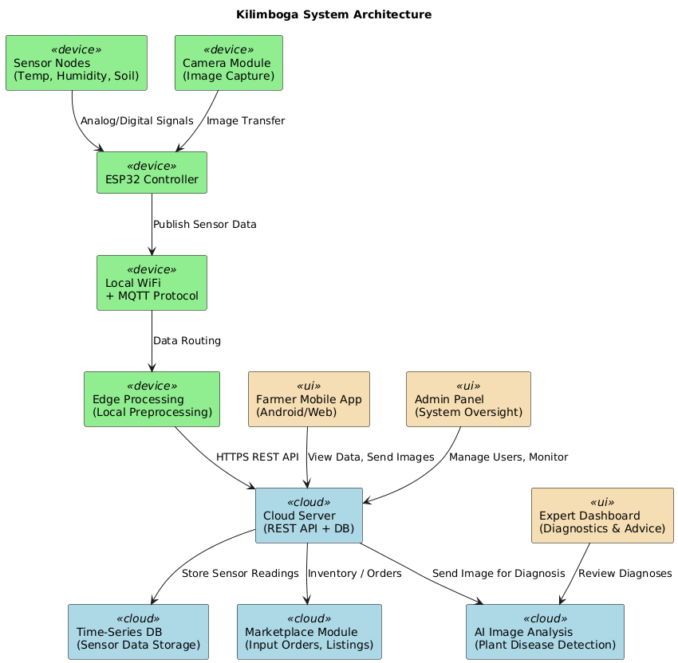

7.2 Design Rationale
A layered microservices-inspired architecture was selected for Kilimboga for the following reasons:
- Separation of Concerns: Each layer handles a distinct responsibility, simplifying development, testing, and maintenance.
- Scalability: Independent scaling of the cloud backend, AI module, and application layers is possible as the user base grows.
- Flexibility: The IoT hardware layer can be updated or upgraded without affecting application software.
- Reliability: Edge processing capabilities ensure that critical actuator controls continue functioning even during temporary cloud connectivity loss.

Alternative architectures considered included a monolithic architecture (rejected due to poor scalability and maintainability) and a fully edge-based architecture (rejected due to high hardware costs and limited AI processing capability on embedded devices).

7.3 Class Diagram
The class diagram outlines the system’s object-oriented structure, detailing the key classes, their attributes, and the relationships between them. This diagram serves as the blueprint for the system's architecture, guiding the development and ensuring all functional requirements are addressed.
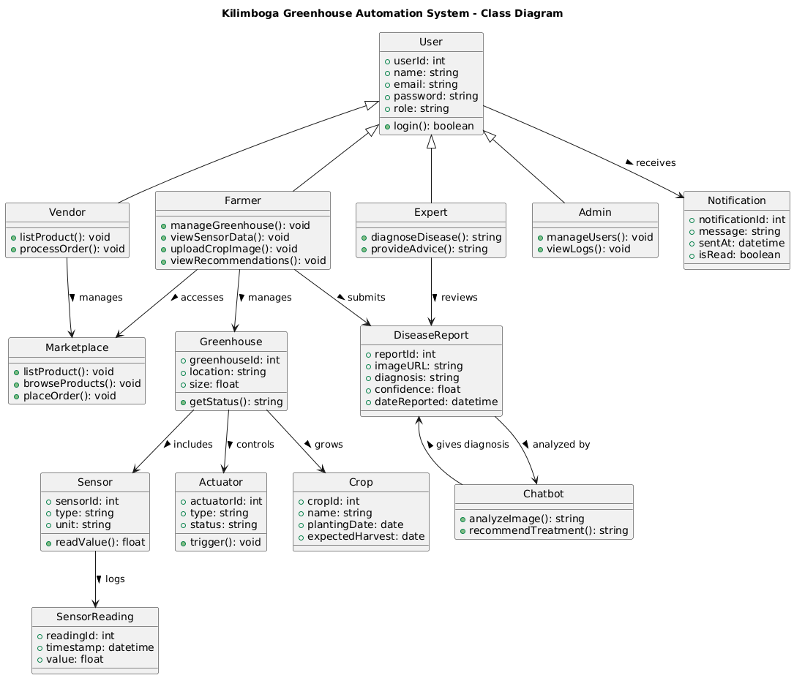

AICHAPTER EIGHT: DATA DESIGN

8.1 Data Description
Kilimboga's information domain is organized into the following major data entities stored in a cloud-hosted relational and document-based database:
- User Data: Stores account information, roles, authentication credentials, and profile details for all user types.
- Sensor Data: Time-series records of greenhouse environment readings (temperature, humidity, soil moisture, light, nutrients) linked to specific greenhouse installations.
- Actuator State: Current and historical on/off states and configuration of all greenhouse actuators.
- Alert Records: Log of all threshold breach events, timestamps, and farmer acknowledgement status.
- Crop Disease Records: Uploaded images, AI analysis results, and treatment recommendations linked to specific farmer accounts.
- Marketplace Data: Vendor product listings, inventory, pricing, and order transaction records.
- Consultation Records: Booking details, chat logs, and expert recommendations between farmers and agro-vets.

8.2 Data Dictionary

Entity / Attribute | Type | Description
User
user_id | UUID | Unique identifier for each user account.
name | String | Full name of the user.
email | String | User email address used for authentication.
role | Enum | User role: Farmer, Expert, Vendor, or Admin.
password_hash | String | Hashed and salted user password.
SensorReading
reading_id | UUID | Unique identifier for each sensor reading.
greenhouse_id | UUID | Reference to the associated greenhouse.
temperature | Float | Temperature in degrees Celsius.
humidity | Float | Relative humidity percentage.
soil_moisture | Float | Soil moisture level as a percentage.
timestamp | DateTime | Date and time of the sensor reading.
DiseaseReport
report_id | UUID | Unique identifier for each disease detection report.
farmer_id | UUID | Reference to the submitting farmer's account.
image_url | String | URL of the uploaded crop image in cloud storage.
diagnosis | String | AI-generated disease or pest identification result.
recommendation | Text | AI-generated treatment recommendation.
Product
product_id | UUID | Unique identifier for each marketplace product.
vendor_id | UUID | Reference to the listing vendor's account.
name | String | Product name (e.g., 'NPK Fertilizer 50kg').
price | Decimal | Product price in KES.
stock_quantity | Integer | Available stock quantity.

CHAPTER NINE: COMPONENT DESIGN

9.1 User Authentication Component
The authentication module handles user registration, login, and session management using JWT tokens.

FUNCTION authenticateUser(email, password):
1. Retrieve user record from DB where email = email
2. IF user not found THEN return error 'Invalid credentials'
3. HASH input password and compare with stored hash
4. IF match THEN generate JWT token with user role payload
5. RETURN token and user profile to client

9.2 Sensor Data Collection Component
This component manages data ingestion from IoT sensors and triggers threshold alert evaluation.

FUNCTION ingestSensorData(greenhouse_id, sensorPayload):
1. Validate sensorPayload schema
2. Store reading in time-series database with timestamp
3. FOR EACH parameter IN [temperature, humidity, moisture]:
a. Retrieve threshold config for greenhouse_id
b. IF value exceeds threshold THEN trigger alert(farmer_id, parameter)
4. Push updated readings to connected mobile/web clients via WebSocket

9.3 AI Disease Detection Component
Processes uploaded crop images through the AI model and returns diagnosis results.

FUNCTION analyzeDisease(farmer_id, imageFile):
1. Validate imageFile format (JPEG, PNG, max 10MB)
2. Upload imageFile to cloud storage, obtain image_url
3. Send image_url to AI model inference endpoint
4. Receive diagnosis label and confidence score from model
5. Look up treatment recommendation from disease knowledge base
6. Save DiseaseReport record to database
7. RETURN diagnosis and recommendation to farmer

CHAPTER TEN: REQUIREMENTS TRACEABILITY MATRIX

The following matrix maps each functional requirement to its implementing system component(s).

Req. ID | Requirement Description | System Component | Priority
REQ-1.1 | Allow all user types to create accounts | Auth Module, User DB | High
REQ-1.2 | Secure authentication with encryption and 2FA | Auth Module | High
REQ-1.3 | Role-based access control (RBAC) | Auth Module, API Gateway | High
REQ-1.4 | Admin account approval/management | Admin Panel, User DB | High
REQ-2.1 | Integrate sensors for real-time data collection | IoT Sensor Layer, Cloud Backend | High
REQ-2.2 | Display real-time and historical data | Mobile App, Web Dashboard | High
REQ-2.3 | Generate automated threshold alerts | Alert Engine, Push Notification Service | High
REQ-2.4 | Remote greenhouse monitoring | Mobile App, Web Dashboard, Cloud | High
REQ-3.1 | Automated irrigation control | Actuator Control Layer, Sensor Layer | High
REQ-3.2 | Ventilation automation | Actuator Control Layer | High
REQ-3.3 | Automated lighting control | Actuator Control Layer | Medium
REQ-3.4 | Nutrient/pH actuator control | Actuator Control Layer | Medium
REQ-3.5 | Manual actuator override via mobile app | Mobile App, Actuator Control Layer | High
REQ-4.1 | Farmer image upload via chatbot | Mobile App AI Chatbot | High
REQ-4.2 | AI disease detection from images | AI/ML Module | High
REQ-4.3 | Treatment recommendations | AI/ML Module, Knowledge Base | High
REQ-4.4 | Agronomic AI insights | AI/ML Module | Medium
REQ-5.1 | Farmer-to-farmer and farmer-to-expert chat | Chat Module | Medium
REQ-5.2 | Expert consultation booking | Consultation Module, Web Dashboard | Medium
REQ-5.3 | Push notifications and alerts | Notification Service, Mobile App | High
REQ-6.1 | Vendor product listing and management | Marketplace Module, Web Dashboard | Medium
REQ-6.2 | Farmer marketplace access and purchases | Marketplace Module, Mobile App | Medium
REQ-6.3 | Order tracking and management | Order Management Module | Medium
REQ-6.4 | Vendor sales analytics | Analytics Module, Web Dashboard | Low

References
The following references informed the development of this SRS document:
- IEEE Std 830-1998. IEEE Recommended Practice for Software Requirements Specifications. IEEE Computer Society.
- Flutter, React and Node.js documentations.

