AI-Powered Smart Gym System
Use Cases and Use Case Diagrams - derived from the Requirements Engineering document. 51 use cases across 10 subsystems; each is mapped to the FR / UR / NFR IDs it realises.
Legend: ellipses = use cases (green = numbered UC, dashed white = supporting step); stick figures = actors; blue dashed arrow = «include»; orange dashed arrow = «extend» (extension points to the base use case).

0. System context & actors
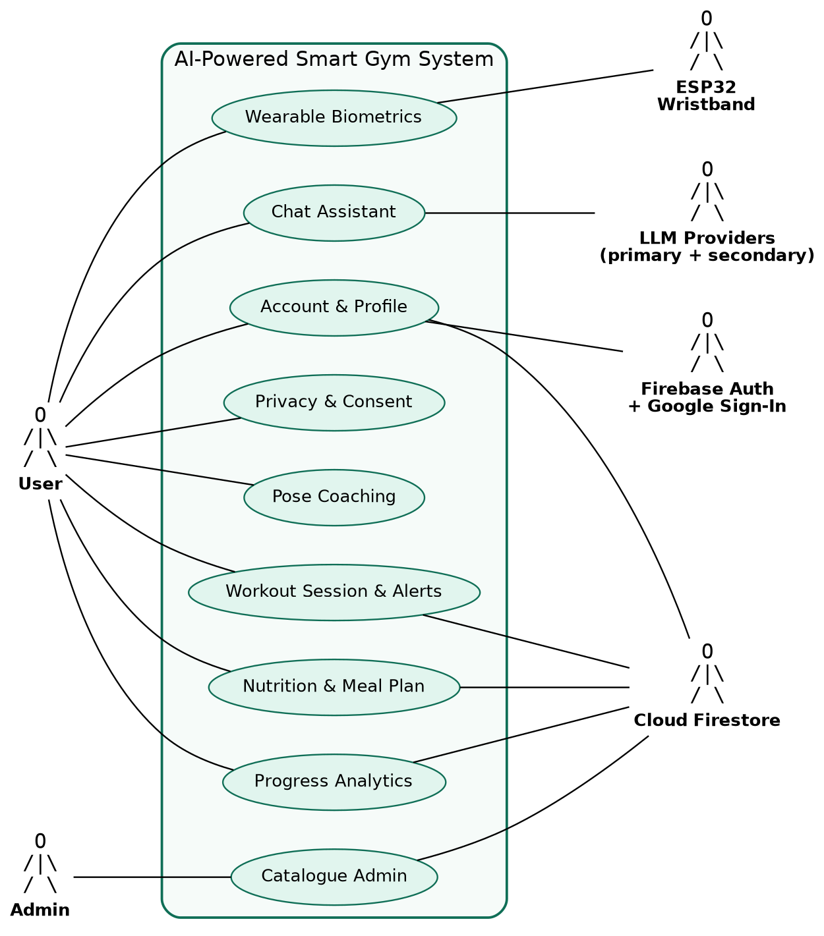
Actors: User (all four classes share the same use cases; the class only changes emphasis), Admin, and external systems Wristband, Firebase Auth, Firestore, LLM providers. The camera and BLE stack are platform services, not actors.

1. Account & authentication (FR-AUTH)
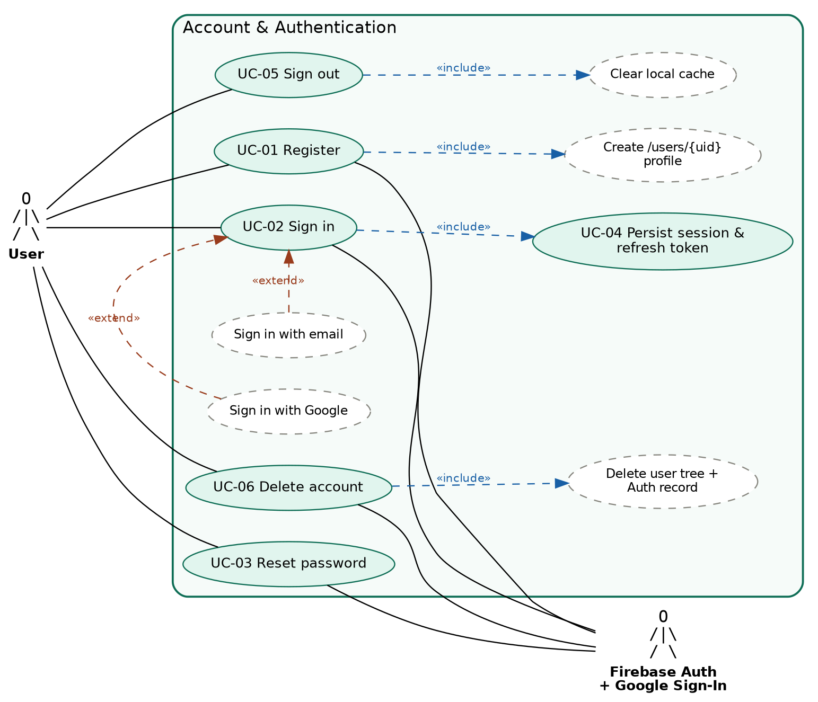
ID | Use case | Actor | Reqs
UC-01 | Register with email + password; profile document auto-created | User, Firebase Auth | FR-AUTH-01, 04
UC-02 | Sign in (email/password or Google; same UID if email matches) | User, Firebase Auth | FR-AUTH-02
UC-03 | Reset password (link sent without revealing if email exists) | User | FR-AUTH-03
UC-04 | Persist session and silently refresh token | System | FR-AUTH-05
UC-05 | Sign out and wipe PII, biometrics and chat from local cache | User | FR-AUTH-06
UC-06 | Permanently delete account and data | User | FR-AUTH-07, NFR-LEG-02

2. Profile, onboarding & goals (FR-PROF, FR-LOC)
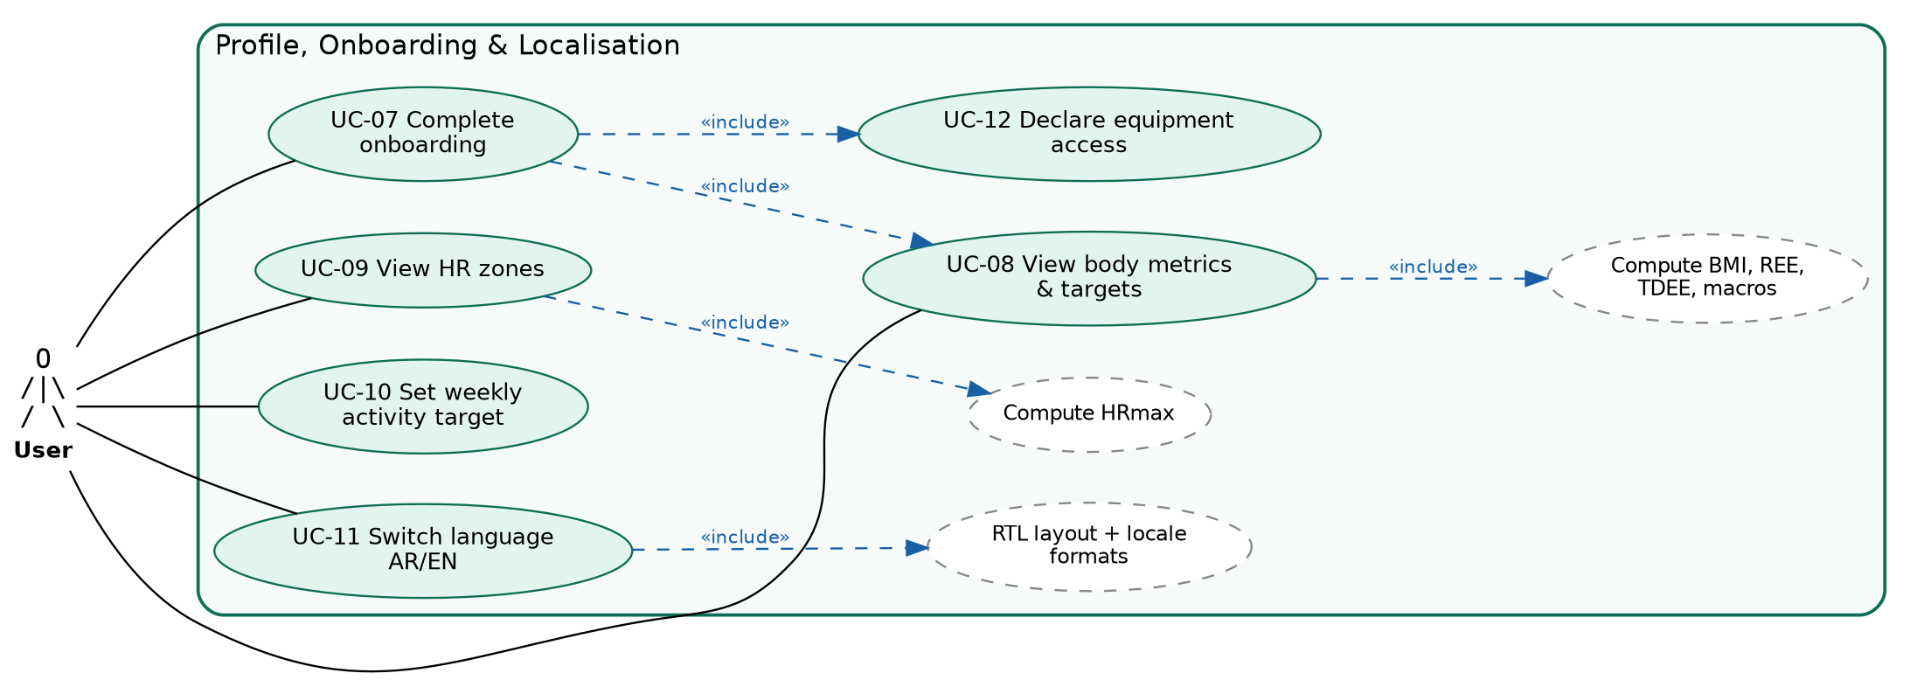
ID | Use case | Actor | Reqs
UC-07 | Complete onboarding (8 attributes, ≤ 8 screens) | User | FR-PROF-01
UC-08 | View/update BMI, REE (Mifflin-St Jeor), TDEE and macro targets | User | FR-PROF-02, 03, 04
UC-09 | View HRmax and five intensity zones | User | FR-PROF-05
UC-10 | View/override default weekly activity target | User | FR-PROF-06, NFR-LEG-06
UC-11 | Change interface language without restart (full RTL mirroring) | User | FR-PROF-07, FR-LOC-01–03
UC-12 | Declare equipment access to get a home/bodyweight plan | User | UR-HOME-02

3. Pose coaching (FR-CV)
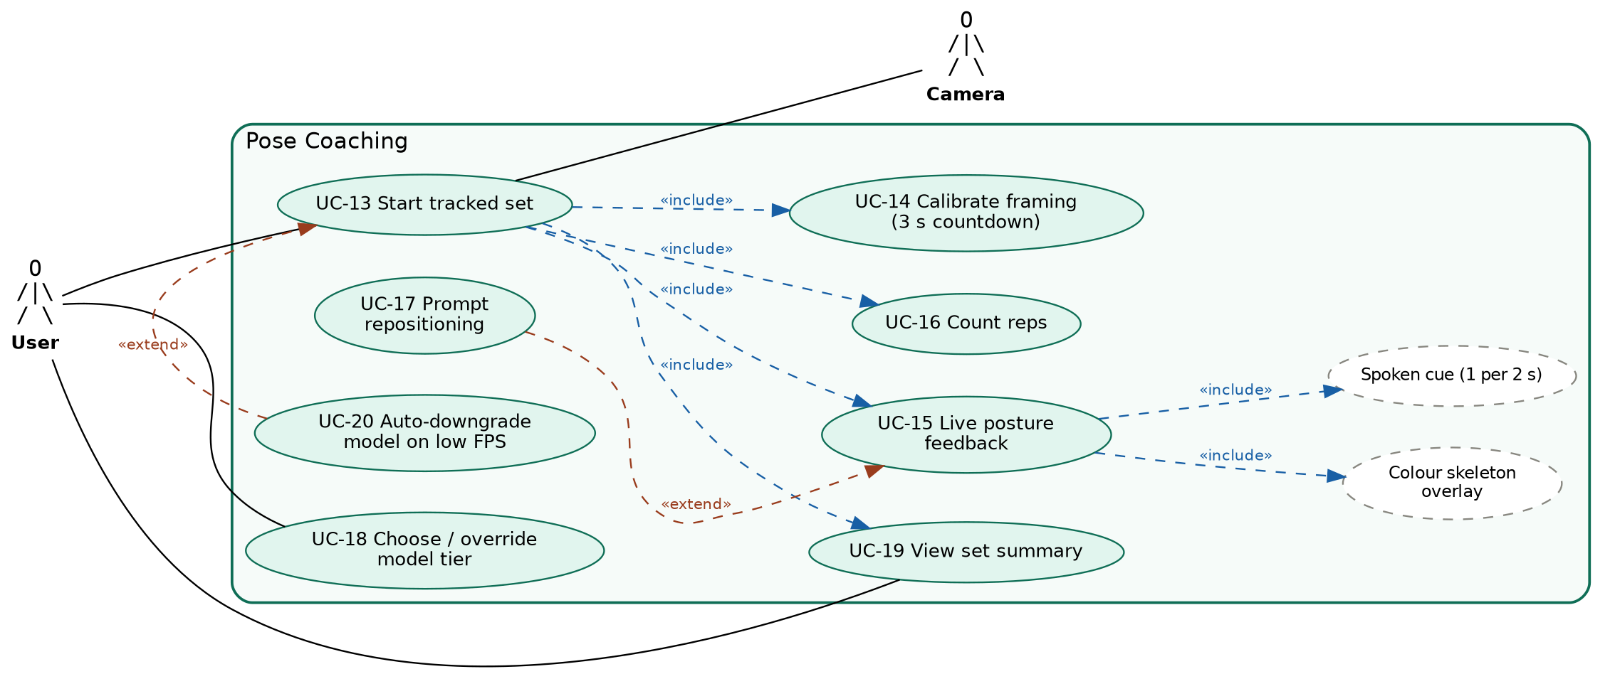
ID | Use case | Actor | Reqs
UC-13 | Start a tracked set for squat / deadlift / bench press (≤ 3 taps) | User | FR-CV-01, 02, 12; NFR-USE-03
UC-14 | Framing calibration with 3-second audible countdown | User | FR-CV-10
UC-15 | Receive live corrective feedback (overlay + TTS, knee valgus, depth, lean…) | User | FR-CV-04, 06, 07, 08
UC-16 | Automatic repetition counting with hysteresis | System | FR-CV-05, UR-EXP-01
UC-17 | Suspend scoring and prompt repositioning if landmarks missing > 1 s | System | FR-CV-09
UC-18 | Auto-select or manually override Lite/Full/Heavy model | User, System | FR-CV-03, NFR-COMP-03
UC-19 | View per-set summary (reps, TUT, ROM, tempo, form 0–100, faults) | User | FR-CV-14
UC-20 | Auto-downgrade model/resolution when FPS below floor for > 3 s | System | FR-CV-13, NFR-PWR-05

4. Workout session & safety (FR-ALRT, FR-DATA)
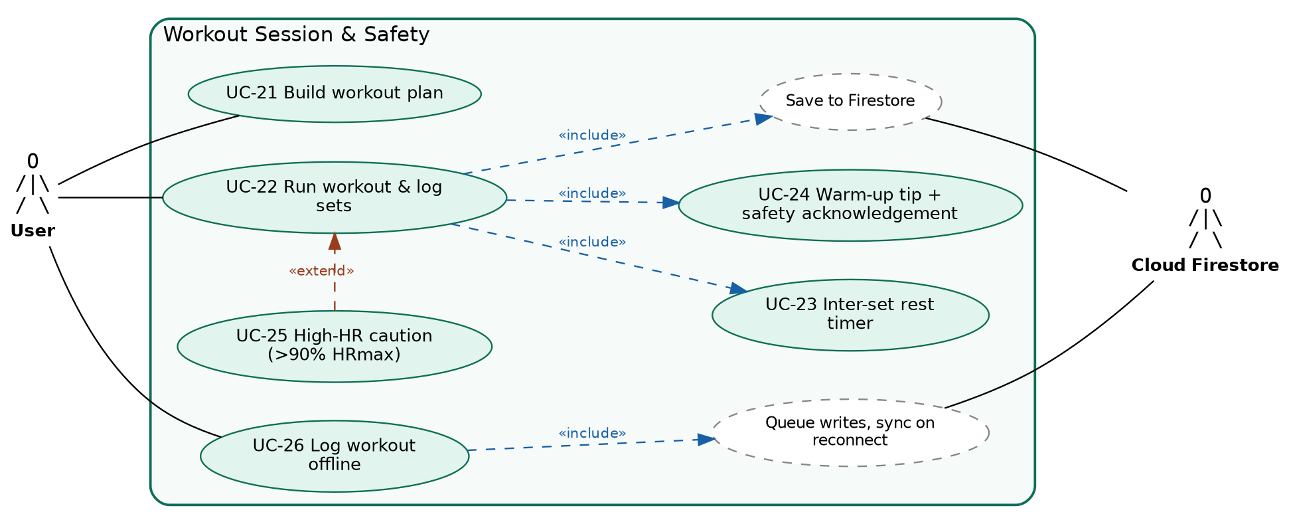
ID | Use case | Actor | Reqs
UC-21 | Build an ordered workout (exercises, sets, reps, load) | User | FR-ALRT-01
UC-22 | Run a workout and track per-set completion | User | FR-ALRT-01, FR-DATA-05
UC-23 | Automatic inter-set rest timer | System | FR-ALRT-02
UC-24 | See warm-up recommendation; acknowledge first-session safety notice | User | FR-ALRT-04, UR-NOV-02
UC-25 | Get caution when HR exceeds 90% of HRmax | System | FR-ALRT-03
UC-26 | Log workouts and food offline with zero loss, auto-reconcile | User | FR-DATA-03, NFR-REL-02, UR-EXP-02

5. Wristband & biometrics (BLE)
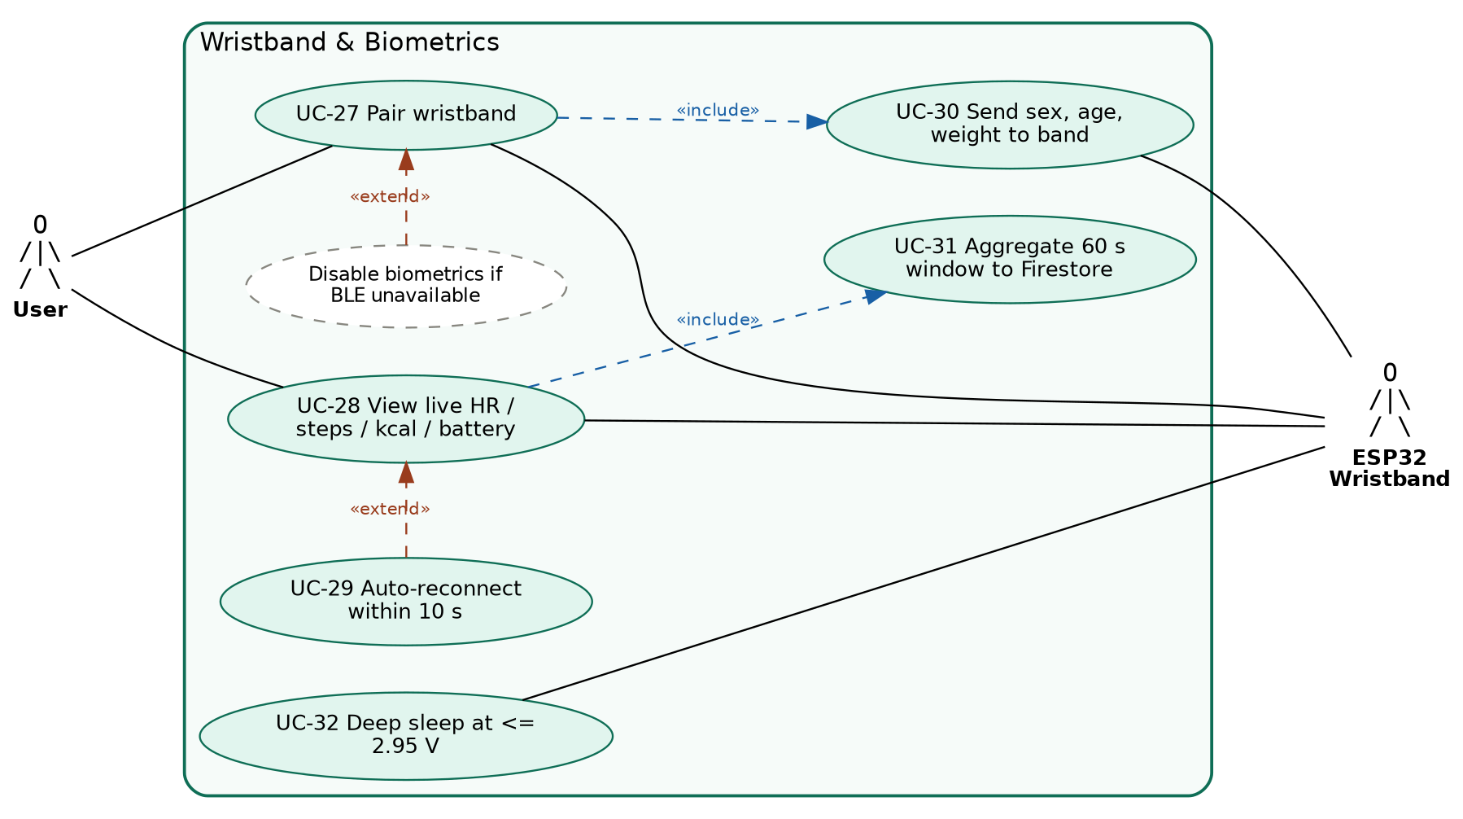
ID | Use case | Actor | Reqs
UC-27 | Pair and connect to the ESP32 band over BLE | User, Wristband | C-TECH-04, NFR-COMP-04
UC-28 | View live HR, calories, steps, battery (updates every 2 s, UI ≤ 200 ms) | User, Wristband | NFR-PERF-04
UC-29 | Automatically re-establish link on returning to range | System | NFR-REL-04
UC-30 | Send sex, age, weight to band for on-device calorie estimate | System, Wristband | Scope §1.2
UC-31 | Aggregate biometric samples into one document per 60 s | System | FR-DATA-04, NFR-PERF-12
UC-32 | Band enters deep sleep to protect the cell on low battery | Wristband | NFR-PWR-06

6. Nutrition & meal planning (FR-NUT)
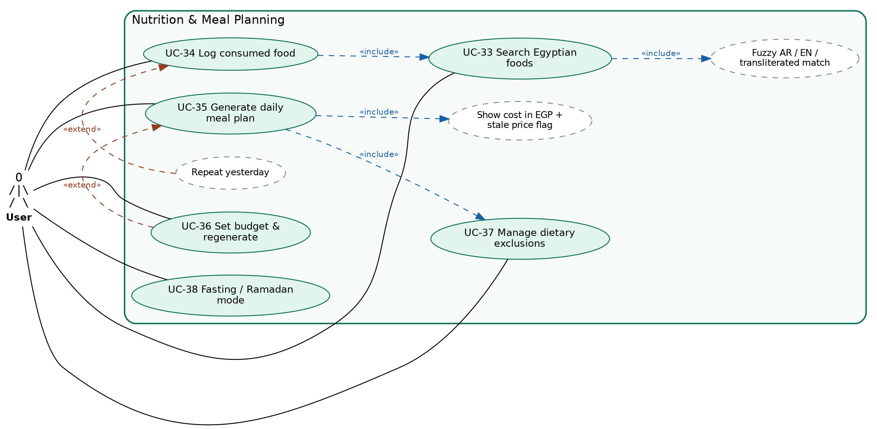
ID | Use case | Actor | Reqs
UC-33 | Search foods in Arabic, English or transliteration (offline, ≤ 500 ms) | User | FR-NUT-04, FR-DATA-07, UR-NUT-01
UC-34 | Log foods by search, portion or repeat-yesterday; running totals | User | FR-NUT-07
UC-35 | Generate daily plan (3 meals + ≤ 2 snacks) within TDEE ±5%, protein ±10% | User | FR-NUT-05, UR-NUT-02
UC-36 | Set a daily budget ceiling; view plan cost in EGP; regenerate | User | FR-NUT-03, 06
UC-37 | Record exclusions; excluded foods never appear in a plan | User | FR-NUT-09, UR-NUT-03
UC-38 | Fasting mode with custom eating window and Ramadan preset | User | FR-NUT-08

7. Bilingual chat assistant (FR-CHAT)
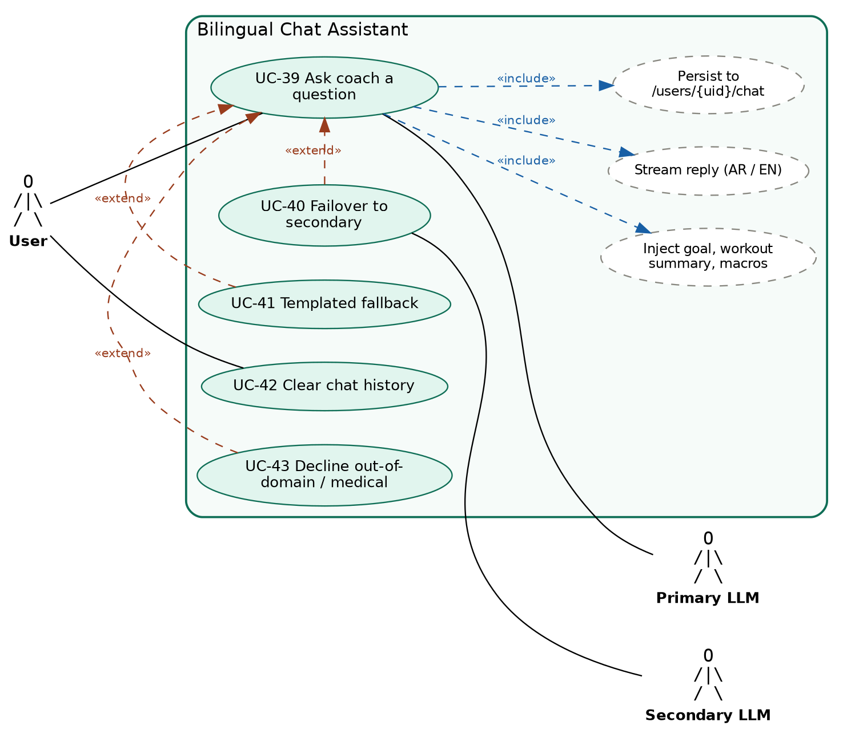
ID | Use case | Actor | Reqs
UC-39 | Ask a fitness/nutrition question; streamed reply in MSA, Egyptian Arabic or English | User, LLM | FR-CHAT-01, 04, 05
UC-40 | Fail over to secondary provider on error / timeout / 5 s no first token | System | FR-CHAT-02, NFR-REL-05
UC-41 | Return cached/templated answer when both providers are down | System | FR-CHAT-08
UC-42 | Clear stored chat history | User | FR-CHAT-07
UC-43 | Politely decline out-of-domain or medical requests; show disclaimer | System | FR-CHAT-03, 06

8. Progress analytics (FR-ANL)
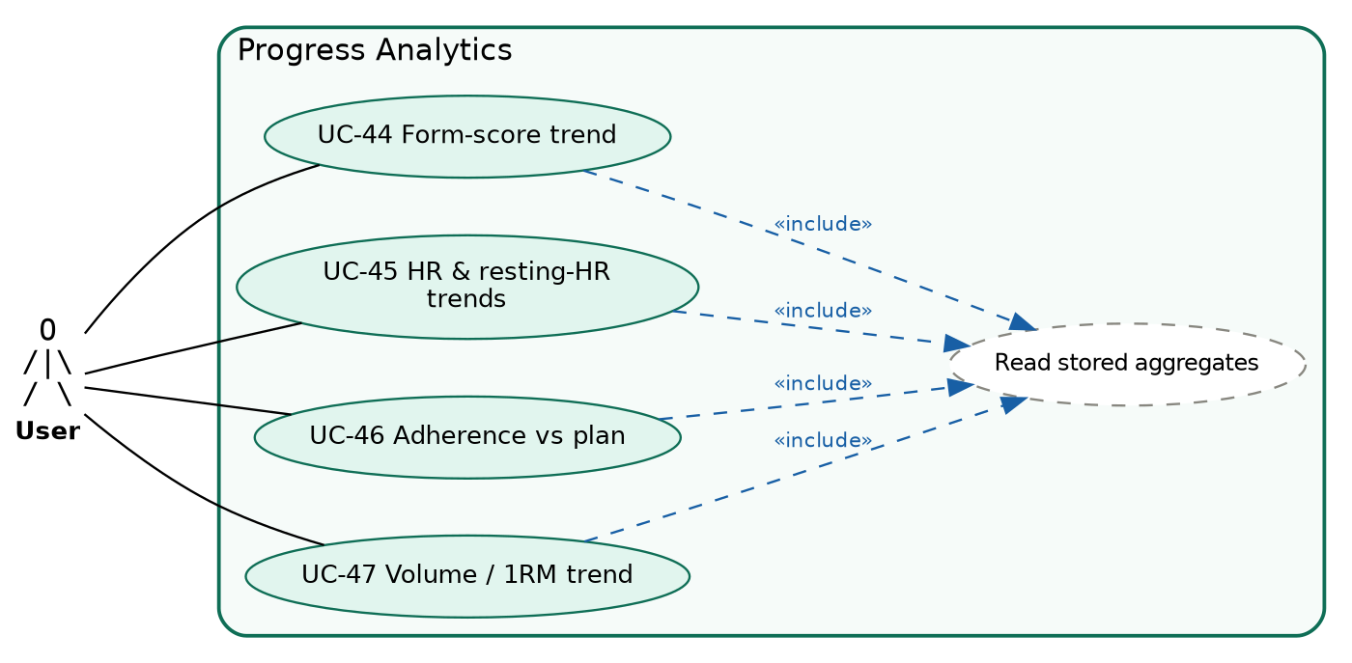
ID | Use case | Actor | Reqs
UC-44 | Chart mean form score per exercise over time | User | FR-ANL-03
UC-45 | Chart per-session HR and resting HR | User | FR-ANL-04
UC-46 | Track sessions completed vs planned and minutes vs weekly target | User | FR-ANL-05
UC-47 | View load / volume / 1RM trends | User | UR-EXP (no FR yet)

9. Admin & privacy (FR-DATA, NFR-SEC, NFR-LEG)
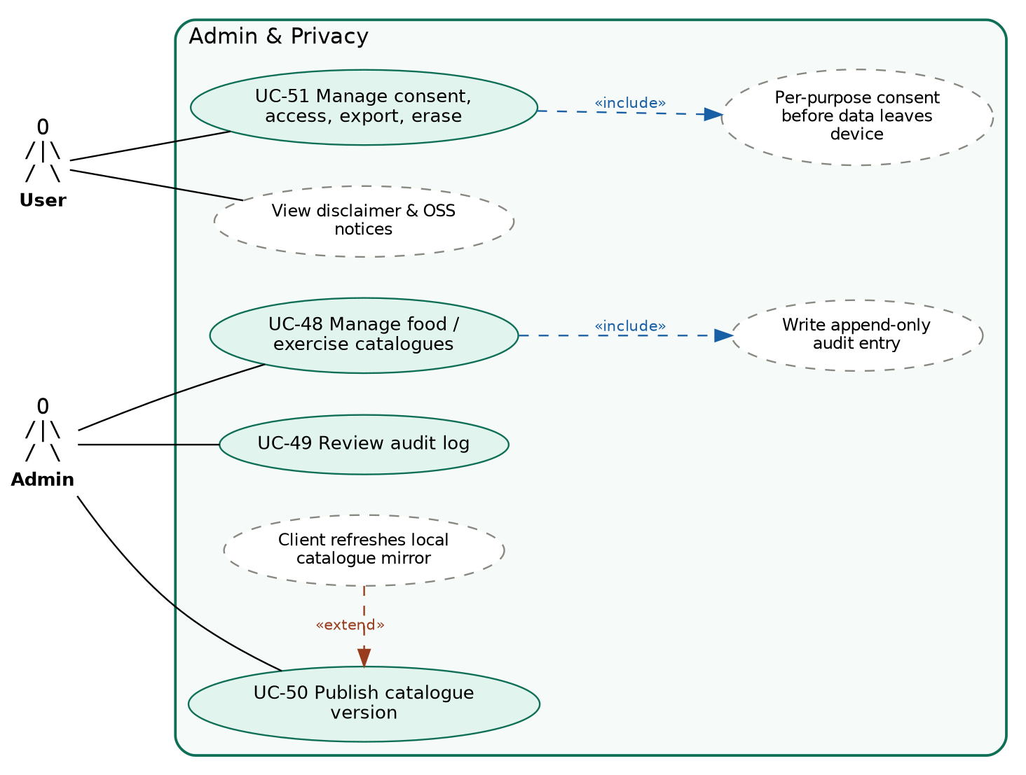
ID | Use case | Actor | Reqs
UC-48 | Add/edit foods and exercises (read-all, admin-write) | Admin | FR-DATA-06, NFR-SEC-12
UC-49 | Review the append-only audit log | Admin | NFR-SEC-12
UC-50 | Publish catalogue version; clients refresh local mirror | Admin, System | FR-DATA-07
UC-51 | Grant/withdraw consent; access, correct, erase data; read disclaimers and licences | User | NFR-LEG-01–04, NFR-SEC-06–07

