**Prominent Inter-Hemispheric Rest EEG Differences Reflect Similar Motor Imagery EEG Patterns**

Mohammad Y. M. Naser1, Sylvia Bhattacharya,1*

1The Neuro-Interaction Innovation Lab, Kennesaw State University, Department of Electrical and Computer Engineering, Marietta, GA, United States

**\* Correspondence:**Sylvia Bhattacharya  
Sbhatta6@kennesaw.edu

Keywords: keyword1, keyword2, keyword3, keyword4, keyword5. (Min.5-Max. 8)

Abstract

--------------------------------------

# Introduction

Brain-Computer Interface (BCI) has been an active field of research for over five decades, beginning with the pioneering work of Jacques Vidal [1]. It offers the compelling potential to decode human brain signals and translate them into commands for controlling electronic equipment. This capability holds tremendous promise, particularly for empowering individuals with disabilities by enabling them to operate assistive devices, prosthetic limbs, communication tools, and others. Despite significant progress, BCI continues to face a range of hardware and software challenges that hinder its full potential, regardless of the paradigm used.

The Motor Imagery-Electroencephalography (MI-EEG)-paradigm is one of the popular BCI paradigms. MI refers to the distinct neural patterns generated when imagining physical movements, such as lifting a hand, moving a foot, or manipulating the tongue. While MI-EEG systems show great promise for BCI applications, they are particularly affected by substantial cross-subject and temporal variabilities—commonly referred to as nonstationary behavior. This fluctuation in signal properties across individuals or over time remains one of the most significant obstacles to achieving commercially viable BCI systems, as highlighted by numerous researchers [2]. Although Machine Learning (ML) classifiers have long been the cornerstone for achieving reasonable accuracy in decoding MI-EEG signals, they too are hindered by the inherent nonstationarity of MI-EEG signals, limiting their robustness and practical application.

## Problem Statement

While some nonstationarities, such as those caused by age [3][4] or gender [5][6], are relatively stable and predictable, changing little over time, others, such as emotional state [7][8], can shift rapidly and unpredictably. To address this, users must undergo frequent training sessions to create personalized models tailored to their current neural state. This retraining process is required every time the user’s neural behavior changes, making it a constant necessity for effective BCI usage.

During these sessions, users complete multiple cycles of controlled MI tasks, which involve repeatedly imagining physical movements, with each movement type corresponding to a specific command for the end application. These sessions can last from minutes to hours. However, neural shifts triggered by emotional or physiological changes can occur multiple times a day, requiring the retraining process to be repeated each time. This makes the *train-then-use* framework highly impractical. Frequent retraining disrupts users' routines, reduces system usability, and renders the approach unsuitable for real-world applications.

Given this challenge, the authors, like many others, emphasize the importance of adopting closed-loop feedback systems as the most practical approach for leveraging pre-trained MI models—in other words, a *calibrate-then-use* framework. These systems detect shifts in MI distributions and dynamically adjust classification parameters to maintain satisfactory performance levels. However, detecting these shifts still requires performing MI trials, reintroducing the disruption issue, albeit to a lesser extent.

This limitation has prompted the authors to explore alternative approaches that rely on indirect methods for adapting pre-trained models. Instead of directly detecting changes in MI distributions, the question arises: could these variations be inferred indirectly through resting-state EEG (or simply, Rest), yielding a *choose-then-use* framework? This intriguing question forms the central focus of the investigation presented in this article.

## Conceptual Framework

The proposed framework is shown in Figure 1-c, with the traditional frameworks illustrated in Figure 1-a and Figure 1-b. The choose-then-use framework leverages pre-trained ML models trained on large datasets. In real-time, the user—who may not have been involved in the original training—records a short segment of Rest EEG, reflecting brain activity when not engaged in specific tasks. Unlike MI tasks that require active effort, such as imagining physical movements, Rest EEG signals are passively collected during everyday activities like reading or using a phone. This makes data collection simple and non-intrusive. The system analyzes the Rest EEG segment to estimate the user’s MI characteristics and selects the most suitable pre-trained model. This model then translates the user’s MI signals into actionable commands, allowing seamless control of electronic devices.

Figure : A conceptual diagram of the envisioned framework alongside traditional frameworks for a BCI wheelchair application.

In essence, this framework uses resting-state neural activity as a personal identifier. Rather than requiring users to train models with their own data, it aligns them with pre-trained models based on their unique Rest EEG signals. This strategy removes the need for time-consuming training sessions and allows the system to monitor and adapt throughout the day, ensuring it stays aligned with the user’s neural state.

The proposed scheme is based on the assumption that Rest EEG can, to some extent, provide insights into MI characteristics. This hypothesis forms the foundation of the current investigation. The goal of this paper is not to conclusively validate or invalidate the hypothesis but to support it through empirical evidence.

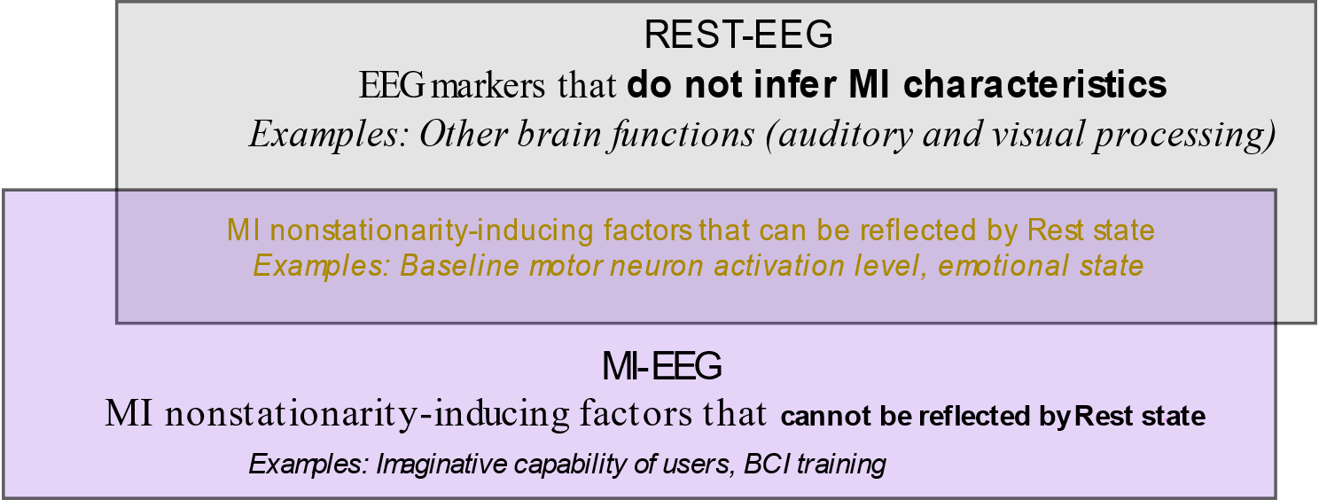

Figure 2 illustrates the interaction between the Rest and MI states, as pictured by the authors, depicting how information from Rest EEG may inform and influence the modeling of MI characteristics. The overlap area represents in the MI characteristics that can be reflected (caused, influenced) from the Rest state.

**Region “B”** is the factors that are specific the moment when the mental task is being performed such as the individual's imaginative capability—how vivid, robust, and consistent their imagination is over a given time frame, as well as their level of experience with the task ([10.1016/j.neuroimage.2013.04.097](https://doi.org/10.1016/j.neuroimage.2013.04.097), 10.1007/s00221-017-5039-8), their motor variability (even though there are no muscles involved but the imagination itself can and certainly will be different across trials). These factors can be controlled through experimental design and are therefore may be considered less of an issue. Also, there may be additional neurophysiological factors specific to the activation process of the motor neurons that affect differences in MI across subjects or over time that are not reflected by the Rest state, these are not the focus of the current investigation.

**Region “C”** corresponds to all rest state, which only specific Rest biomarkers can be utilized to quantify these nonstationarities affecting MI. EEG signals offer a crude means of inferring thousands of neural communications over very short periods of time, each corresponding to different tasks, commands, and mechanisms. Not all of these neural activities are relevant to MI. For instance, other brain functions in regions such as auditory and visual processing are not valuable for inferring MI as they exist in different spatial location away from the motor cortex (ISBN978-0071390118).

**Region “A”** shows the the characteristics of MI signals that are influenced by rest state, such as emotional state and/or imagining style of a person at specific time or whatever reason. Essentially, this reflects a specific momentary state of the individual. This component is what's being investigated—how to use Rest to infer some knowledge about MI.

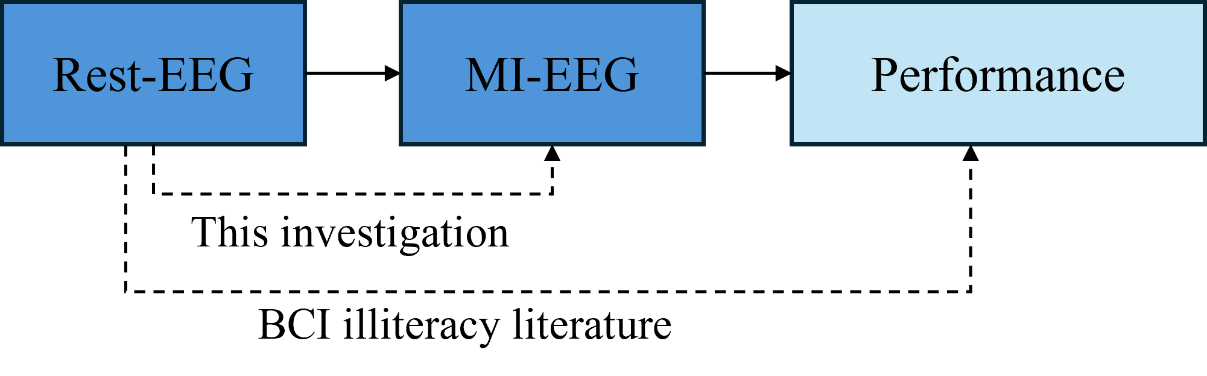What are the psychological/physiological explanation for this region is yet to be discovered but it’s supported by BCI illiteracy literature. The rationale behind using Rest signals to deduce MI characteristics is grounded in several publications addressing BCI illiteracy. These articles predict the performance of classifiers based on resting-state EEG recordings, aiming to identify individuals less likely to produce distinct MI signals. While these endeavors underscore the potential value of Rest signals, they do not directly establish a link between resting-state and MI signal characteristics, as their primary aim does not involve reducing or eliminating training requirements for MI-based BCIs. However, the connection they establish between Rest EEG and classifier performance relies on MI-related EEG signals, which are the central focus of this research. Consequently, the correlation between Rest and MI EEG characteristics is implicit in the findings reported in these articles (see Figure 3). The literature on BCI illiteracy is extensive, with several impactful articles contributing to the field. Below is a brief overview of some of the most influential works. First, the work of Benjamin Blankertz [9] has reported a Pearson correlation coefficient (r = 0.53) between a Rest-based EEG indicator and classification accuracy. This indicator is derived from the difference between the Power Spectral Density (PSD) of Rest recordings from two Laplacian channels over the motor cortex area and a noise curve. The correlation was established through a comprehensive study involving 80 subjects, treating each subject as a single data point. The subjects included both male and female participants and for three MI classes (right hand, left hand, and feet).

Figure : The working hypothesis of this work is supported by BCI illiteracy literature.

Secondly, the work of Ahn in [10] demonstrated a Pearson coefficient (r = 0.59) between Rest state indicators and classification accuracies. This indicator is derived from the relative power level of Theta and Alpha at Rest, where higher Theta and lower Alpha were associated with low-performing subjects. The study comprised 61 individuals of both genders and focused on two MI classes.

Thirdly, the work in [11] demonstrated Pearson coefficient (r = 0.65) between Rest and accuracy for 26 subjects (males and females). They utilized spectral entropy derived from the Rest PSD of the Delta, Theta, and Alpha rhythms of the EEG recordings. Also, when the Blankertz and Ahn indicators were tested in [11], they were shown to have r=0.29 and r=0.51 correlation coefficients, respectively. Although these values are lower than those reported in the original studies, they still demonstrate some correlation between the two states.

In addition to the aforementioned studies, other research sheds light on the relationship between Rest EEG signals and MI performance. For instance, the work in [12] conducted a study involving 105 subjects, revealing strong significant correlations between certain features of open-eye Rest in the Alpha band and MI performance. Also, the work in [13] observed a notable difference in connectivity strength between the supplementary motor area and the right dorsolateral prefrontal cortex among low- and high-MI performance groups. Similarly, the authors in [14] categorized 54 subjects into High and Low BCI performers, uncovering increased functional connectivity in the Alpha band in the right hemisphere among High compared to Low aptitude MI-BCI users. Additionally, the work in [15] investigated 10 subjects, employing spectral and imaginary coherence, and demonstrated increased activity around C3 during MI compared to Rest. And in [16], the authors reported discriminatory behavior when utilizing graph features for classification purposes. Furthermore, the work in [17] examined 4 MI tasks, revealing significant differences in network metrics between various tasks. Other studies include [18]-[21] as well.

In addition to BCI illiteracy research, the authors' previous research has highlighted a basic correlation between Rest and MI characteristics [22]. Specifically, a strong Pearson correlation (r>0.5) was noted between PSD-based features in both states for 12 out of 20 subjects. Additionally, each of the 20 subjects displayed at least one medium or strong correlation (r>0.3) between the two states. This provides additional support for the validity of the approach proposed in this article.

In short, the graph illustrates that Rest signals alone cannot fully infer MI characteristics, nor can all aspects of MI be deduced from Rest signals. However, Rest is believed to offer insights into MI characteristics to some extent and in a specific manner. It serves as a neural identifier of the subject at a given point in time, capturing many factors contributing to the EEG MI nonstationary behavior. Although scientific evidence supporting the claims above may be limited, connections between Rest and MI states have been indirectly investigated in other related domains, particularly in the context of BCI illiteracy.

This paper focuses on providing initial evidence for the possibility of using Rest-EEG to replace, or at least reduce, the need for subject-specific MI retraining. Since the BCI illiteracy research provided support for this hypothesis but it’s not very strong support, we are expecting to provide somewhat preliminary building blocks for future research results but never a definitive answer to replace or eliminate all training requirements. It is structured as follows: Chapter 2 introduces supporting evidence from the BCI illiteracy literature, as well as a glance of the current practices for reducing subject training in MI applications. Chapter 3 outlines the methodology used in this study. Chapter 4 presents the main results of the paper. Finally, Chapter 5 provides a discussion on the reported results and outlines directions for future work.

# Literature Review

The available strategy for mitigating training requirements involves leveraging the concept of Transfer Learning (TL) to minimize subject-specific data. TL is the process of transferring knowledge between different domains, namely source and target domains [23]. One possible categorization of the available techniques is:

1) Modifying classification pipelines for TL.

This method involves adapting classification pipelines to accommodate nonstationarities, either at the feature level or classifier level. One popular example is modifying the CSP-LDA pipeline, where LDA (Linear Discriminant Analysis) serves as the classifier, and CSP (Common Spatial Patterns) is the MI features.

Examples of such approaches include the work by [24], where a composite CSP was developed by weighting the covariance matrices of different subjects. This technique demonstrated higher performance values, particularly when the number of labeled testing data was limited.

Similarly, the authors of [25] devised an invariant version of CSP, resilient to nonstationarities, by incorporating a penalty term into the CSP objective function. This approach led to significant improvements, with most subjects scoring around 5% higher than baseline. The authors in [26] employed a different method to quantify nonstationarity, which resulted in slight enhancements in mitigating its effects.

In [27], the authors constructed a CSP model based on a large dataset and regularized the CSP objective function by incorporating terms controlling the global or local nature of the filter based on labeled testing datapoints, achieving accuracies of around 70% and above.

The work in [28] focused on regularizing both CSP and the classifier LDA towards specific datapoints, reducing calibration time for new subjects by leveraging data from other subjects. This approach yielded around a 2% increase in accuracy compared to the baseline model when the number of subject trials was low.

Additionally, [29] proposed four versions of regularized CSP algorithms and reviewed other regularization techniques. Their work concluded that regularizing CSP can result in significant improvements, with accuracy increases reaching as high as 10%.

2) Traditional TL in NNs using layer freezing.

This is the traditional definition of TL in the ML world. Examples include [30], where the authors constructed an end-to-end Convolutional Neural Network (CNN) with unprocessed EEG data as the input to the network. They performed TL by freezing the first 3 layers during training and completed the pipeline with new subject data. The pipeline produced results of around 50% accuracy (chance level being 20% for the 5 tasks considered). A similar technique was employed by [31] where the output layer was modified for the new testing datapoint and achieved around 65% accuracy values.

3) Raw data alignment.

This research field explores TL techniques applied to raw data, either in the Euclidean or Riemannian space. Examples on the former type include [32] where the authors utilized transport theory to jointly adapt the marginal and conditional distributions across domains in latent space. They combined training and testing data distributions and minimized the Wasserstein distance between them, testing several techniques for mapping the distributions together.

In [33], the authors focused on matching the marginal distribution between both domains. And in [34], an alignment matrix was determined to minimize the distance between the mean of features in the source and target spaces. They subsequently employed CSP features and various types of classifiers, including a CNN.

Regarding Riemannian alignment, [35] employed spatial covariance matrices in the Riemannian space to represent multi-channel EEG signals. A Riemannian geometry alignment algorithm was used to select source subjects with features similar to the current user as the transfer source. Features extracted from the Riemannian tangent space were then combined with those of the current user and calibrated using a balanced distribution adaptation algorithm. This process enabled the training of a classification model for the current user with only a small amount of new training data. Similarly, in [36], all covariance matrices were centered using a reference covariance matrix, which was derived from the EEG Rest state.

Other influential articles on zero-training MI models include [39–43]. The universalization of MI models is a well-established yet still highly active area of research, offering a variety of analytical approaches to address this challenge. Due to its breadth, it cannot be fully summarized in this subsection. Interested readers can refer to the extensive literature on the topic for further understanding, such as in [37][38].

The crucial point to note is that, besides NN-based TL (which is the least promising technique out of all), all previously mentioned methods require access to testing MI datapoints, whether labeled or unlabeled. This requirement constitutes the biggest drawback of these approaches, even if they were proven to be consistently effective. This distinction sets the work performed in this article apart from those studies in the literature. With this research, the authors aim to offer a fresh perspective and contribute to the ongoing discourse in this evolving field.

# Methods

## Dataset Description

The dataset used is BCI competition IV 2a [44], one of the most popular MI datasets. This dataset consists of data from 9 subjects, and it was modified to suit this work. The main modification was limiting the focus to two MI tasks: Left-Hand (LH) and Right-Hand (RH), and discarding certain channels from the original set. These two tasks were chosen because they are generally easier to classify than other tasks, such as feet or tongue movements. The channels were discarded as they did not provide significant value to justify the computational cost.

In the dataset, each subject completed a single session consisting of 6 runs in a single day. Within each run, there were 12 trials for each MI task. Consequently, a full session comprised a total of 144 trials, evenly distributed between both tasks, amounting to 72 trials per task. During the recording of each session, a 2-minute EEG recording was conducted while the subjects kept their eyes open, focusing on a fixation cross. Additionally, the subjects performed one minute of eye movements to calibrate the electrooculography (EOG) electrodes. The experimental protocol as well as the electrode montage are depicted in Figure 4

A total of 22 Ag/AgCl EEG electrodes and 3 monopolar EOG channels were employed in the study. No feedback was provided to the subjects who performed the MI tasks until the cue disappeared from the screen at the end of the sixth second. And all data were sampled at a frequency of 250 Hz. All the work described in this section was conducted using Python, utilizing MNE for data preparation and scikit-Learn for data processing.

## Dataset Preprocessing

Of the 22 EEG channels, only channels C3, Cz, C4, ch9, ch11, and channels 14 through 18 (highlighted in red in Figure 4a) were used, as these are believed to cover the motor cortex area associated with MI [45]. The preprocessing steps followed a straightforward procedure. Initially, a bandpass filter between 6 and 35 Hz was applied to retain the Alpha and Beta rhythms. Subsequently, Independent Component Analysis (ICA) was executed on the time-series data to eliminate ocular artifacts from the signals, resulting in the generation of 8 ICA components. The ICA component exhibiting the highest state: C3, representing the left-brain hemisphere, and C4, representing the right hemisphere.

Regarding the MI distributions, the CSP filters were employed. The underlying principle of CSP relies on identifying spatial filters that maximize the variance of EEG signals for one class while minimizing it for another class. These spatial filters are computed through an eigenvalue decomposition of the covariance matrices of the EEG signals for each class. By applying these spatial filters to the EEG data, CSP generates spatially filtered signals that highlight the most discriminative patterns associated with different classes. However, they do not provide information about individual class characteristics. Nevertheless, they are considered the gold standard in classifying MI tasks, and thus used for this work.

Figure : a) Electrode montage, b) The experimental protocol for the data used in this work

Our hypothesis is that a classifier should always follow what science tells us about MI (yellow/blue or whatever). This is the case only if the diff between the two hemispheres is very subtle because MI is about a hemisphere with its past state. (MI decreases in left hemi during right hand compared to baseline, so if left hemi equal right hemi at baseline, this is the pattern that we should always expect, given all of MI-specific nonstationarities are isolated). In other words, subtle hemi difference at rest is not necessarily going to get the same classifier but a classifier that follows the expected science is more likely to have subtle rest hemi difference.

Another point is that the diff in rest does contribute to changes in MI distribution, outside the non-stationarities that come with MI itself. So, in short my job in this paper is to show the correlation between Rest and MI for three groups representing the possible Rest state difference between the two hemispheres and MI.

MI is ERD which is about the hemi with its original state but since it only happens in one hemisphere, then it can be looked at between the two hemispheres as well.

# Results

## The PSD difference between brain hemispheres at Rest dictates, or at least dominates, the PSD difference observed during MI tasks.

During the execution of a motor imagery (MI) task, the contralateral brain hemisphere—opposite to the imagined movement—undergoes event-related desynchronization (ERD). This phenomenon is characterized by a reduction in power within specific frequency bands. ERD reflects a decrease in neuronal synchronization, leading to a more disorganized neuronal firing pattern compared to the baseline resting state. This disruption in rhythmic activity is indicative of cortical activation and is fundamental to the neural mechanisms underlying motor imagery processing.

Since this behavior occurs in only one hemisphere, and assuming that brain activity is initially symmetrical between the two hemispheres at baseline, the ERD effect can also be observed as a relative difference between the hemispheres. As the contralateral hemisphere exhibits ERD during MI tasks, its reduced neuronal synchronization creates an imbalance when compared to the ipsilateral hemisphere, which remains relatively unaffected.

***However, that is never the case.*** There are significant baseline differences in PSD between the two hemispheres at rest, which not only dominate but may also influence or contribute to the relative difference observed during MI tasks. While the exact nature of this relationship remains unclear, it undoubtedly plays a role in shaping MI characteristics to some extent.

The figures below illustrate the relationship between the PSD difference between hemispheres during Rest and MI across both datasets. If Rest had no contribution to MI, this relationship would appear flat. However, in all cases, there is a noticeable, albeit weak, correlation that suggests an underlying pattern. This relationship is not well-captured by linear regression due to the inherently non-linear nature of neural processing.

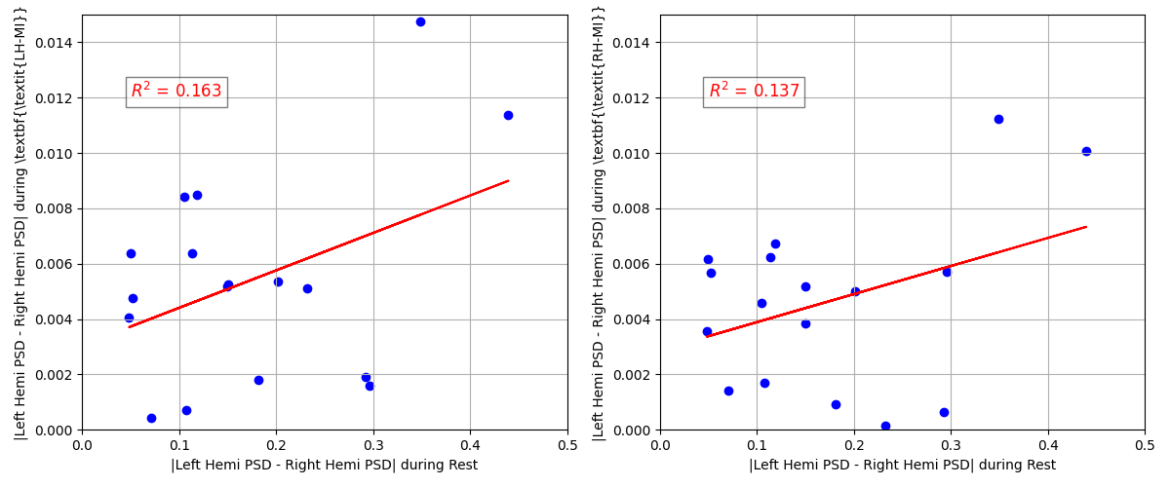

Figure : 2a

It’s much more difficult for 2b because it’s single channel so it’s highly susceptible to outliers.

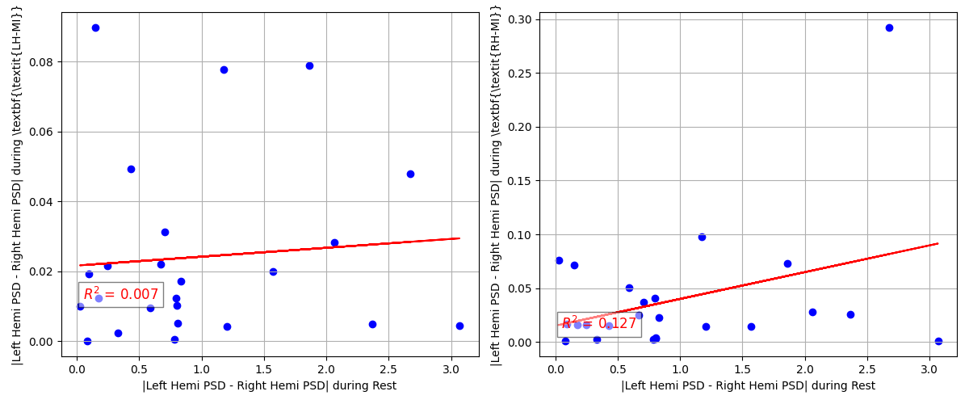

The large difference in magnitude between the x-axis (Rest) and the y-axis (MI) highlights how resting-state PSD differences are several orders of magnitude larger than those induced by MI tasks. This suggests that the pre-existing asymmetry between brain hemispheres at rest plays a dominant role, overshadowing the relative changes observed during MI.

In addition to the plots, the non parametric Spearman correlation metric was found between the two yielding the following:

2a LH: 0.21

2a RH: 0.14

2b LH: 0.09

2b RH: 0.09

Those results are no way going to follow the statistical norms because of the low SNR of EEG and the number of averages we are doing.

## Similar Rest correlates with similar MI

This section about the rest effect in MI but there’s also MI variability.

We agreed that the value (at least absolute value) of Rest is way greater than ERD associated with MI. from this we can say that:

* Same MI **necessarily** same Rest
* Same Rest **not necessarily** same MI

If life was perfect, we could have used the ERD/ERS as the only EEG feature (LH-MI causes ERD in right hemisphere and ERS in left hemisphere, or simply a task causes an increase in the same hemisphere and decrease in the other). So, such classifier should look like:

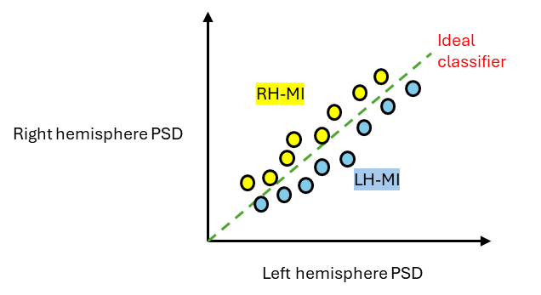

But due to the effect of Rest magnitude, this affects the actual distribution. In the case where Rest is higher in Right hemisphere (mostly blue on Rest maps),

the distribution becomes more of: **(A)**

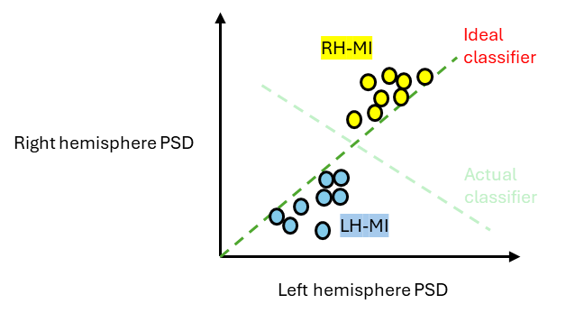

For the other case where Left is higher**: (B)**

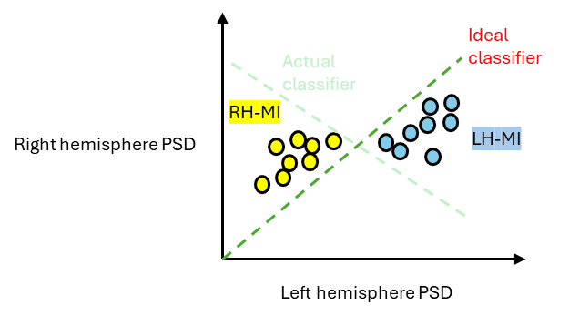

In the case both hemispheres are very close to each other, that means they are not good BCI performers (aligns with literature), and yields to all datapoints on one side of the ideal classifier (I don’t know exactly why).

If we focus on the two patterns of interest and take the ones that show this behavior in MI:

**Classifier switching or reduced training**

**2a dataset**

**Pattern A: 10,15,11,16,14 (strong blue)**

**Pattern B: 5,17 (strong yellow)**

* After everything is done, we should include results for variations of the non-scintifically supported decisions.

## BCI performance

## Comparison

To ensure a fair comparison, the evaluation is limited to studies conducted on the same dataset (BCI Competition IV 2a) and focused on binary tasks (only two classes at a time). This includes all attempts to create subject-independent models, regardless of the technique employed. Table 2 lists the two articles known to the authors that meet these criteria. The results shown for both references represent the best outcomes reported in their respective studies, including the optimal techniques, model parameters, and performances achieved across all nine subjects. The value for the proposed model is based on the 2 CSP case in Table I.

TABLE I

AVERAGE ACCURACIES ACHIEVED IN THIS WORK AND OTHER ARTICLES IN THE LITERATURE.

|  |  |
| --- | --- |
|  | **Average accuracy** |
| **Proposed [%]** |  |
| **Source [48] [%]** | 70.99 |
| **Source [47] [%]** | 72.92 |

The authors acknowledge that the other articles achieve slightly better results than those reported here, with differences of less than 4%. However, this performance metric does not fully capture the technique's effectiveness, as several factors also play a crucial role, including the complexity of the techniques used, the robustness of the models under various conditions, and individual differences between subjects—all of which significantly impact the usability of such techniques. For this reason, the authors argue that comparing the proposed model to the baseline model provides a more accurate representation of the technique's value.

Additionally, two other studies, [49] and [50], have investigated similar techniques using binary tasks from a different BCI competition dataset (III-Iva). These studies reported classification accuracies of 80.27% and 84.35%, respectively. While a direct comparison with our results is not entirely fair, these studies are included here for completeness. The better performance can likely be attributed to two factors: (1) the dataset includes only five subjects, compared to nine in our dataset, potentially making it easier to achieve favorable results, and (2) the binary classification tasks involve foot versus hand movements, which are inherently more distinct and provide greater discriminatory power.

This study explored the potential of using Rest EEG signals to infer MI characteristics in BCI systems. The approach addresses the significant challenges posed by high cross-subject and temporal variabilities in MI-EEG-based BCIs, which typically require extensive and frequent user training sessions, limiting their practical usability. The proposed framework seeks to reduce these training demands by employing Rest EEG signals as proxies for MI characteristics, facilitating the creation of zero-retraining BCI systems.

This approach represents a transformative shift in how BCI systems are designed and utilized. Instead of creating models individually tailored for each user, the focus moves toward building adaptable systems that evolve and improve as more data becomes available. With every new addition of resting-state signals, these systems could grow increasingly precise and efficient, paving the way for a wide range of practical applications in assistive technologies and beyond. A particularly compelling idea is the prospect of collecting resting-state signals and MI characteristics from a large cohort of individuals—potentially thousands—over time. Such a large-scale dataset could encompass a wide variety of factors, including mood fluctuations, levels of mental focus, and biological variations, enabling researchers to identify clusters of individuals with similar neural patterns. When a new user engages with the system, their resting-state EEG could be matched to the most suitable cluster, allowing the selection of an optimal pre-trained model in real time.

While this framework remains conceptual, it highlights the transformative potential of this approach for advancing BCI systems. The authors envision several avenues for future research, including:

• Investigating additional Rest EEG biomarkers: Beyond spectral features, exploring other Rest EEG biomarkers such as temporal dynamics, connectivity patterns, and nonlinear features could provide deeper insights into individual-specific characteristics influencing MI signals.

• Exploring relationships between Rest and MI states: Understanding the nature of the relationships between Rest and MI states is crucial for further explaining and supporting the hypothesis. Exploring how these states interact and influence each other could shed light on the underlying mechanisms driving nonstationarity in MI signals.

• Validation on diverse Datasets: Further validation of the proposed framework is essential to assess its generalizability across diverse datasets and real-world scenarios. Conducting experiments on larger and more diverse datasets, including populations with varying demographics and clinical conditions, would enhance the robustness and applicability of the approach.

• Adopting more advanced signal processing techniques such as multivariate decomposition techniques in [51] and [52], latest denoising technique [53], geometrical features [54][55], and connectivity metrics [56], as well as CNNs [57].

While the study offers some insights and potential directions for future research, it is important to acknowledge its limitations:

• The study’s reliance on a dataset with only 9 subjects limits the generalizability of its findings. Expanding to a larger and more diverse sample would enhance the representativeness of Rest EEG's predictive power in inferring MI characteristics across various populations and demographics.

One challenge in expanding the dataset lies in the need for a carefully designed approach that includes diverse Rest segments recorded under known and well-documented mental states, rather than generic or "blind" Rest segments. Understanding the specific context and meaning of these Rest segments is essential for exploring the framework’s limitations and determining the most effective ways to adapt and refine it for broader applications.

• Limited Rest EEG biomarkers: While the study primarily examines spectral features extracted from Rest EEG data, exploring additional biomarkers and combination of biomarkers could potentially improve the accuracy and robustness of zero-training classifiers.

• The determination of the number of subjects within each cluster was not based on scientifically-backed reasoning. The decision to use three clusters, each containing a uniform number of subjects, was part of the authors' initial plan and yielded the best results. However, different clustering configurations could produce varying results, indicating the need for a more scientifically rigorous approach to this aspect in future research.

• Interpretability of results: While the study provides statistical evidence of the relationship between Rest EEG and MI characteristics, the underlying neurophysiological mechanisms remain unclear. Future research should aim to elucidate these mechanisms to deepen our understanding of Rest EEG's predictive power in BCI applications.

[1] J. J. Vidal, “Toward Direct Brain-Computer Communication,” Annu. Rev. Biophys. Bioeng., vol. 2, no. 1, pp. 157–180, Jun. 1973, doi: 10.1146/annurev.bb.02.060173.001105.

[2] M. T. Sadiq, X. Yu, Z. Yuan, M. Z. Aziz, S. Siuly, and W. Ding, “Toward the Development of Versatile Brain–Computer Interfaces,” IEEE Trans. Artif. Intell., vol. 2, no. 4, pp. 314–328, Aug. 2021, doi: 10.1109/TAI.2021.3097307.

[3] O. Al Zoubi et al., “Predicting Age From Brain EEG Signals—A Machine Learning Approach,” Front. Aging Neurosci., vol. 10, p. 184, Jul. 2018, doi: 10.3389/fnagi.2018.00184.

[4] N. Schott, “Age-related differences in Motor Imagery: working memory as a mediator,” Experimental Aging Research, vol. 38, no. 5, pp. 559–583, Oct. 2012, doi: 10.1080/0361073X.2012.726045.

[5] J. Hu, “An approach to EEG-based gender recognition using entropy measurement methods,” Knowledge-Based Systems, vol. 140, pp. 134–141, Jan. 2018, doi: 10.1016/j.knosys.2017.10.032.

[6] P. Wang and J. Hu, “A hybrid model for EEG-based gender recognition,” Cogn Neurodyn, vol. 13, no. 6, pp. 541–554, Dec. 2019, doi: 10.1007/s11571-019-09543-y.

[7] S. M. Alarcao and M. J. Fonseca, “Emotions Recognition Using EEG Signals: A Survey,” IEEE Trans. Affective Comput., vol. 10, no. 3, pp. 374–393, Jul. 2019, doi: 10.1109/TAFFC.2017.2714671.

[8] B. Ko, “A Brief Review of Facial Emotion Recognition Based on Visual Information,” Sensors, vol. 18, no. 2, p. 401, Jan. 2018, doi: 10.3390/s18020401.

[9] B. Blankertz et al., “Neurophysiological predictor of SMR-based BCI performance,” NeuroImage, vol. 51, no. 4, pp. 1303–1309, Jul. 2010, doi: 10.1016/j.neuroimage.2010.03.022.

[10] M. Ahn, H. Cho, S. Ahn, and S. C. Jun, “High Theta and Low Alpha Powers May Be Indicative of BCI-Illiteracy in Motor Imagery,” PLoS ONE, vol. 8, no. 11, p. e80886, Nov. 2013, doi: 10.1371/journal.pone.0080886.

[11] R. Zhang et al., “Predicting Inter-session Performance of SMR-Based Brain–Computer Interface Using the Spectral Entropy of Resting-State EEG,” Brain Topogr, vol. 28, no. 5, pp. 680–690, Sep. 2015, doi: 10.1007/s10548-015-0429-3.

[12] K. Wang, F. Tian, M. Xu, S. Zhang, L. Xu, and D. Ming, “Resting-State EEG in Alpha Rhythm May Be Indicative of the Performance of Motor Imagery-Based Brain–Computer Interface,” Entropy, vol. 24, no. 11, p. 1556, Oct. 2022, doi: 10.3390/e24111556.

[13] M. Lee, J.-G. Yoon, and S.-W. Lee, “Predicting Motor Imagery Performance From Resting-State EEG Using Dynamic Causal Modeling,” Front. Hum. Neurosci., vol. 14, p. 321, Aug. 2020, doi: 10.3389/fnhum.2020.00321.

[14] N. Leeuwis, S. Yoon, and M. Alimardani, “Functional Connectivity Analysis in Motor-Imagery Brain Computer Interfaces,” Front. Hum. Neurosci., vol. 15, p. 732946, Oct. 2021, doi: 10.3389/fnhum.2021.732946.

[15] T. Cattai, S. Colonnese, M.-C. Corsi, D. S. Bassett, G. Scarano, and F. De Vico Fallani, “Characterization of Mental States through Node Connectivity between Brain Signals,” in 2018 26th European Signal Processing Conference (EUSIPCO), Rome: IEEE, Sep. 2018, pp. 1377–1381. doi: 10.23919/EUSIPCO.2018.8553000.

[16] C. A. Stefano Filho, R. Attux, and G. Castellano, “Can graph metrics be used for EEG-BCIs based on hand motor imagery?,” Biomedical Signal Processing and Control, vol. 40, pp. 359–365, Feb. 2018, doi: 10.1016/j.bspc.2017.09.026.

[17] W. Chang, W. Huang, G. Yan, and Y. Zhang, “EEG based Graph Network Analysis for Motor Imagery Task,” in 2021 6th International Conference on Computational Intelligence and Applications (ICCIA), Xiamen, China: IEEE, Jun. 2021, pp. 185–189. doi: 10.1109/ICCIA52886.2021.00043.

[18] A. Bamdadian, C. Guan, K. K. Ang, and J. Xu, “The predictive role of pre-cue EEG rhythms on MI-based BCI classification performance,” Journal of Neuroscience Methods, vol. 235, pp. 138–144, Sep. 2014, doi: 10.1016/j.jneumeth.2014.06.011.

[19] Y. Cui, S. Xie, Y. Fu, and X. Xie, “Predicting Motor Imagery BCI Performance Based on EEG Microstate Analysis,” Brain Sciences, vol. 13, no. 9, p. 1288, Sep. 2023, doi: 10.3390/brainsci13091288.

[20] M. Grosse-Wentrup and B. Schölkopf, “High gamma-power predicts performance in sensorimotor-rhythm brain–computer interfaces,” J. Neural Eng., vol. 9, no. 4, p. 046001, Aug. 2012, doi: 10.1088/1741-2560/9/4/046001.

[21] C. Jeunet, B. N’Kaoua, S. Subramanian, M. Hachet, and F. Lotte, “Predicting Mental Imagery-Based BCI Performance from Personality, Cognitive Profile and Neurophysiological Patterns,” PLoS ONE, vol. 10, no. 12, p. e0143962, Dec. 2015, doi: 10.1371/journal.pone.0143962.

[22] M. Y. M. Naser and S. Bhattacharya, “Resting EEG State, an Insight into Motor Imagery Signal Characteristics,” in 2023 15th Biomedical Engineering International Conference (BMEiCON), Tokyo, Japan: IEEE, Oct. 2023, pp. 1–5. doi: 10.1109/BMEiCON60347.2023.10321821.

[23] S. J. Pan and Q. Yang, “A Survey on Transfer Learning,” IEEE Trans. Knowl. Data Eng., vol. 22, no. 10, pp. 1345–1359, Oct. 2010, doi: 10.1109/TKDE.2009.191.

[24] Hyohyeong Kang, Yunjun Nam, and Seungjin Choi, “Composite Common Spatial Pattern for Subject-to-Subject Transfer,” IEEE Signal Process. Lett., vol. 16, no. 8, pp. 683–686, Aug. 2009, doi: 10.1109/LSP.2009.2022557.

[25] W. Samek, F. C. Meinecke, and K.-R. Muller, “Transferring Subspaces Between Subjects in Brain--Computer Interfacing,” IEEE Trans. Biomed. Eng., vol. 60, no. 8, pp. 2289–2298, Aug. 2013, doi: 10.1109/TBME.2013.2253608.

[26] Benjamin Blankertz, Motoaki Kawanabe2, Ryota Tomioka, Friederike U. Hohlefeld, Vadim Nikulin, and Klaus-Robert Müller, “Invariant Common Spatial Patterns: Alleviating Nonstationarities in Brain-Computer Interfacing,” Advances in Neural Information Processing Systems, vol. 20, 2007.

[27] D. Devlaminck, B. Wyns, M. Grosse-Wentrup, G. Otte, and P. Santens, “Multisubject Learning for Common Spatial Patterns in Motor-Imagery BCI,” Computational Intelligence and Neuroscience, vol. 2011, pp. 1–9, 2011, doi: 10.1155/2011/217987.

[28] F. Lotte and C. Guan, “Learning from other subjects helps reducing Brain-Computer Interface calibration time,” in 2010 IEEE International Conference on Acoustics, Speech and Signal Processing, Dallas, TX, USA: IEEE, 2010, pp. 614–617. doi: 10.1109/ICASSP.2010.5495183.

[29] F. Lotte and Cuntai Guan, “Regularizing Common Spatial Patterns to Improve BCI Designs: Unified Theory and New Algorithms,” IEEE Trans. Biomed. Eng., vol. 58, no. 2, pp. 355–362, Feb. 2011, doi: 10.1109/TBME.2010.2082539.

[30] F. Mattioli, C. Porcaro, and G. Baldassarre, “A 1D CNN for high accuracy classification and transfer learning in motor imagery EEG-based brain-computer interface,” J. Neural Eng., vol. 18, no. 6, p. 066053, Dec. 2021, doi: 10.1088/1741-2552/ac4430.

[31] F. Xu et al., “A transfer learning framework based on motor imagery rehabilitation for stroke,” Sci Rep, vol. 11, no. 1, p. 19783, Oct. 2021, doi: 10.1038/s41598-021-99114-1.

[32] P. Chen, H. Wang, X. Sun, H. Li, C. Grebogi, and Z. Gao, “Transfer Learning With Optimal Transportation and Frequency Mixup for EEG-Based Motor Imagery Recognition,” IEEE Trans. Neural Syst. Rehabil. Eng., vol. 30, pp. 2866–2875, 2022, doi: 10.1109/TNSRE.2022.3211881.

[33] M. Long, J. Wang, G. Ding, S. J. Pan, and P. S. Yu, “Adaptation Regularization: A General Framework for Transfer Learning,” IEEE Trans. Knowl. Data Eng., vol. 26, no. 5, pp. 1076–1089, May 2014, doi: 10.1109/TKDE.2013.111.

[34] X. Wang, R. Yang, and M. Huang, “An Unsupervised Deep-Transfer-Learning-Based Motor Imagery EEG Classification Scheme for Brain–Computer Interface,” Sensors, vol. 22, no. 6, p. 2241, Mar. 2022, doi: 10.3390/s22062241.

[35] Y. Liang and Y. Ma, “Calibrating EEG features in motor imagery classification tasks with a small amount of current data using multisource fusion transfer learning,” Biomedical Signal Processing and Control, vol. 62, p. 102101, Sep. 2020, doi: 10.1016/j.bspc.2020.102101.

[36] P. Zanini, M. Congedo, C. Jutten, S. Said, and Y. Berthoumieu, “Transfer Learning: A Riemannian Geometry Framework With Applications to Brain-Computer Interfaces,” IEEE Trans Biomed Eng, vol. 65, no. 5, pp. 1107–1116, May 2018, doi: 10.1109/TBME.2017.2742541.

[37] A. M. Azab, J. Toth, L. S. Mihaylova, and M. Arvaneh, “A review on transfer learning approaches in brain–computer interface,” in Signal Processing and Machine Learning for Brain-Machine Interfaces, T. Tanaka and M. Arvaneh, Eds., Institution of Engineering and Technology, 2018, pp. 81–101. doi: 10.1049/PBCE114E_ch5.

[38] D. Wu, Y. Xu, and B.-L. Lu, “Transfer Learning for EEG-Based Brain–Computer Interfaces: A Review of Progress Made Since 2016,” IEEE Trans. Cogn. Dev. Syst., vol. 14, no. 1, pp. 4–19, Mar. 2022, doi: 10.1109/TCDS.2020.3007453.

[39] Zhao, Xianghong, et al. "Transferring common spatial filters with semi-supervised learning for zero-training motor imagery brain-computer interface." IEEE Access 7 (2019): 58120-58130.

[40] Jeong, Ji Hyeok, Dong-Joo Kim, and Hyungmin Kim. "Hybrid zero-training BCI based on convolutional neural network for lower-limb motor-imagery." 2021 9th International Winter Conference on Brain-Computer Interface (BCI). IEEE, 2021.

[41] Feng, Jin, et al. "Classification of motor imagery electroencephalogram signals by using adaptive cross-subject transfer learning." Frontiers in Human Neuroscience 16 (2022): 1068165.

[42] Sun, Biao, et al. "Golden subject is everyone: A subject transfer neural network for motor imagery-based brain computer interfaces." Neural Networks 151 (2022): 111-120.

[43] Kim, Kyungdo, Kwangsoo Kim, and Seung-Bo Lee. "PRISM: Deep metric learning based personal grouping method to reduce intersubject variability for motor imagery brain-computer interface." Neurocomputing (2024): 127805.

[44] “BCI Competition IV.” Accessed: Aug. 01, 2022. [Online]. Available: <https://www.bbci.de/competition/iv/>

[45] E. Guttmann-Flury, X. Sheng, and X. Zhu, “Channel selection from source localization: A review of four EEG-based brain–computer interfaces paradigms,” Behav Res, vol. 55, no. 4, pp. 1980–2003, Jul. 2022, doi: 10.3758/s13428-022-01897-2.

[46] P. Welch, “The use of fast Fourier transform for the estimation of power spectra: A method based on time averaging over short, modified periodograms,” IEEE Trans. Audio Electroacoust., vol. 15, no. 2, pp. 70–73, Jun. 1967, doi: 10.1109/TAU.1967.1161901.

[47] P. Gaur, R. B. Pachori, H. Wang, and G. Prasad, “A multivariate empirical mode decomposition based filtering for subject independent BCI,” in 2016 27th Irish Signals and Systems Conference (ISSC), Londonderry, United Kingdom: IEEE, Jun. 2016, pp. 1–7. doi: 10.1109/ISSC.2016.7528480.

[48] F. Lotte, Cuntai Guan, and Kai Keng Ang, “Comparison of designs towards a subject-independent brain-computer interface based on motor imagery,” in 2009 Annual International Conference of the IEEE Engineering in Medicine and Biology Society, Minneapolis, MN: IEEE, Sep. 2009, pp. 4543–4546. doi: 10.1109/IEMBS.2009.5334126.

[49] Md. A. M. Joadder, S. Siuly, E. Kabir, H. Wang, and Y. Zhang, “A New Design of Mental State Classification for Subject Independent BCI Systems,” IRBM, vol. 40, no. 5, pp. 297–305, Oct. 2019, doi: 10.1016/j.irbm.2019.05.004.

[50] X. Yu, M. Z. Aziz, M. T. Sadiq, Z. Fan, and G. Xiao, “A New Framework for Automatic Detection of Motor and Mental Imagery EEG Signals for Robust BCI Systems,” IEEE Trans. Instrum. Meas., vol. 70, pp. 1–12, 2021, doi: 10.1109/TIM.2021.3069026.

[51] M. T. Sadiq et al., “Motor Imagery EEG Signals Decoding by Multivariate Empirical Wavelet Transform-Based Framework for Robust Brain–Computer Interfaces,” IEEE Access, vol. 7, pp. 171431–171451, 2019, doi: 10.1109/ACCESS.2019.2956018.

[52] M. T. Sadiq et al., “Motor Imagery BCI Classification Based on Multivariate Variational Mode Decomposition,” IEEE Trans. Emerg. Top. Comput. Intell., vol. 6, no. 5, pp. 1177–1189, Oct. 2022, doi: 10.1109/TETCI.2022.3147030.

[53] M. T. Sadiq, X. Yu, Z. Yuan, and M. Z. Aziz, “Motor imagery BCI classification based on novel two‐dimensional modelling in empirical wavelet transform,” Electron. lett., vol. 56, no. 25, pp. 1367–1369, Dec. 2020, doi: 10.1049/el.2020.2509.

[54] H. Akbari, M. T. Sadiq, M. Payan, S. S. Esmaili, H. Baghri, and H. Bagheri, “Depression Detection Based on Geometrical Features Extracted from SODP Shape of EEG Signals and Binary PSO,” TS, vol. 38, no. 1, pp. 13–26, Feb. 2021, doi: 10.18280/ts.380102.

[55] H. Akbari et al., “Recognizing seizure using Poincaré plot of EEG signals and graphical features in DWT domain,” BLL, vol. 124, no. 01, pp. 12–24, 2022, doi: 10.4149/BLL_2023_002.

[56] M. Y. M. Naser and S. Bhattacharya, “Fusion of Brain Functional Connectivity Metrics for Motor Imagery Eeg Classification,” 2024. doi: 10.2139/ssrn.4725065.

[57] M. T. Sadiq, M. Z. Aziz, A. Almogren, A. Yousaf, S. Siuly, and A. U. Rehman, “Exploiting pretrained CNN models for the development of an EEG-based robust BCI framework,” Computers in Biology and Medicine, vol. 143, p. 105242, Apr. 2022, doi: 10.1016/j.compbiomed.2022.105242.