MT1008: Semester Project
By: Muneeb Lone, Kabeer Ali and, Raja Suleman


Fig 1.1: An imaginary world featuring an abstract mathematical landscape with contours and gradients, representing the world of Engineering.

Introduction

Overview of the Problem

The task involves designing a box that optimally balances two conflicting objectives: maximizing the internal volume while minimizing the material used for construction of the box. This report is based on the understanding that the problem statement required optimization of both the Volume and Surface Area.

Objectives
The primary objectives include:

- Maximize Volume: Increase the box's volume to enhance its utility for applications such as storage and transportation.
- Minimize Material Used: Reduce the material required for the box's construction, targeting both economic and environmental benefits.

Constraints of the Problem

To ensure the problem is practically applicable and bounded, the following constraints are applied:

- Material Limitation: The total surface area of the box is restricted to no more than 12 square meters to conserve resources used in the construction of the box.
- Dimensional Minimums: Each dimension of the box, namely length, width, and height, is required to be at least 0.1 meters so that the box is practically viable to a manufacturer.

Methodology Adopted for Solution

The approach involves a multi-objective optimization technique, employing a weighted sum method for objective function formulation. The analysis utilizes the method of Lagrange multipliers to determine the optimal dimensions, considering the material limitation.

Analytical Solution

The analytical solution begins with the assumptions. These assumptions are as follows:

- The Box has been assumed to be cubic in nature meaning that all its sides are equal. This assumption has been utilized for simplicity’s sake so that the concept is easier to convey without having the reader get confused with long systems of equations.
- The Box has been assumed to be a closed box / a box with a lid as the scenario states the box must be used in packaging services.
- It is assumed that the requirement for minimizing the material used and maximizing the volume is equal. However, the values for 𝛂 and 𝛃 can be varied from 0 to 1 depending on the requirement with 1 being the most important and 0 being not important at all.
- The Maximum Material allowed has been assumed to be 12 square meters. This was again for the sake of simplicity so that the final answer would be a numerical value which is more understandable than an equation with variables. Furthermore, the minimum dimensions for the box have been assumed to be 0.1 for practicality’s sake.

Handwritten Analytical Solution:
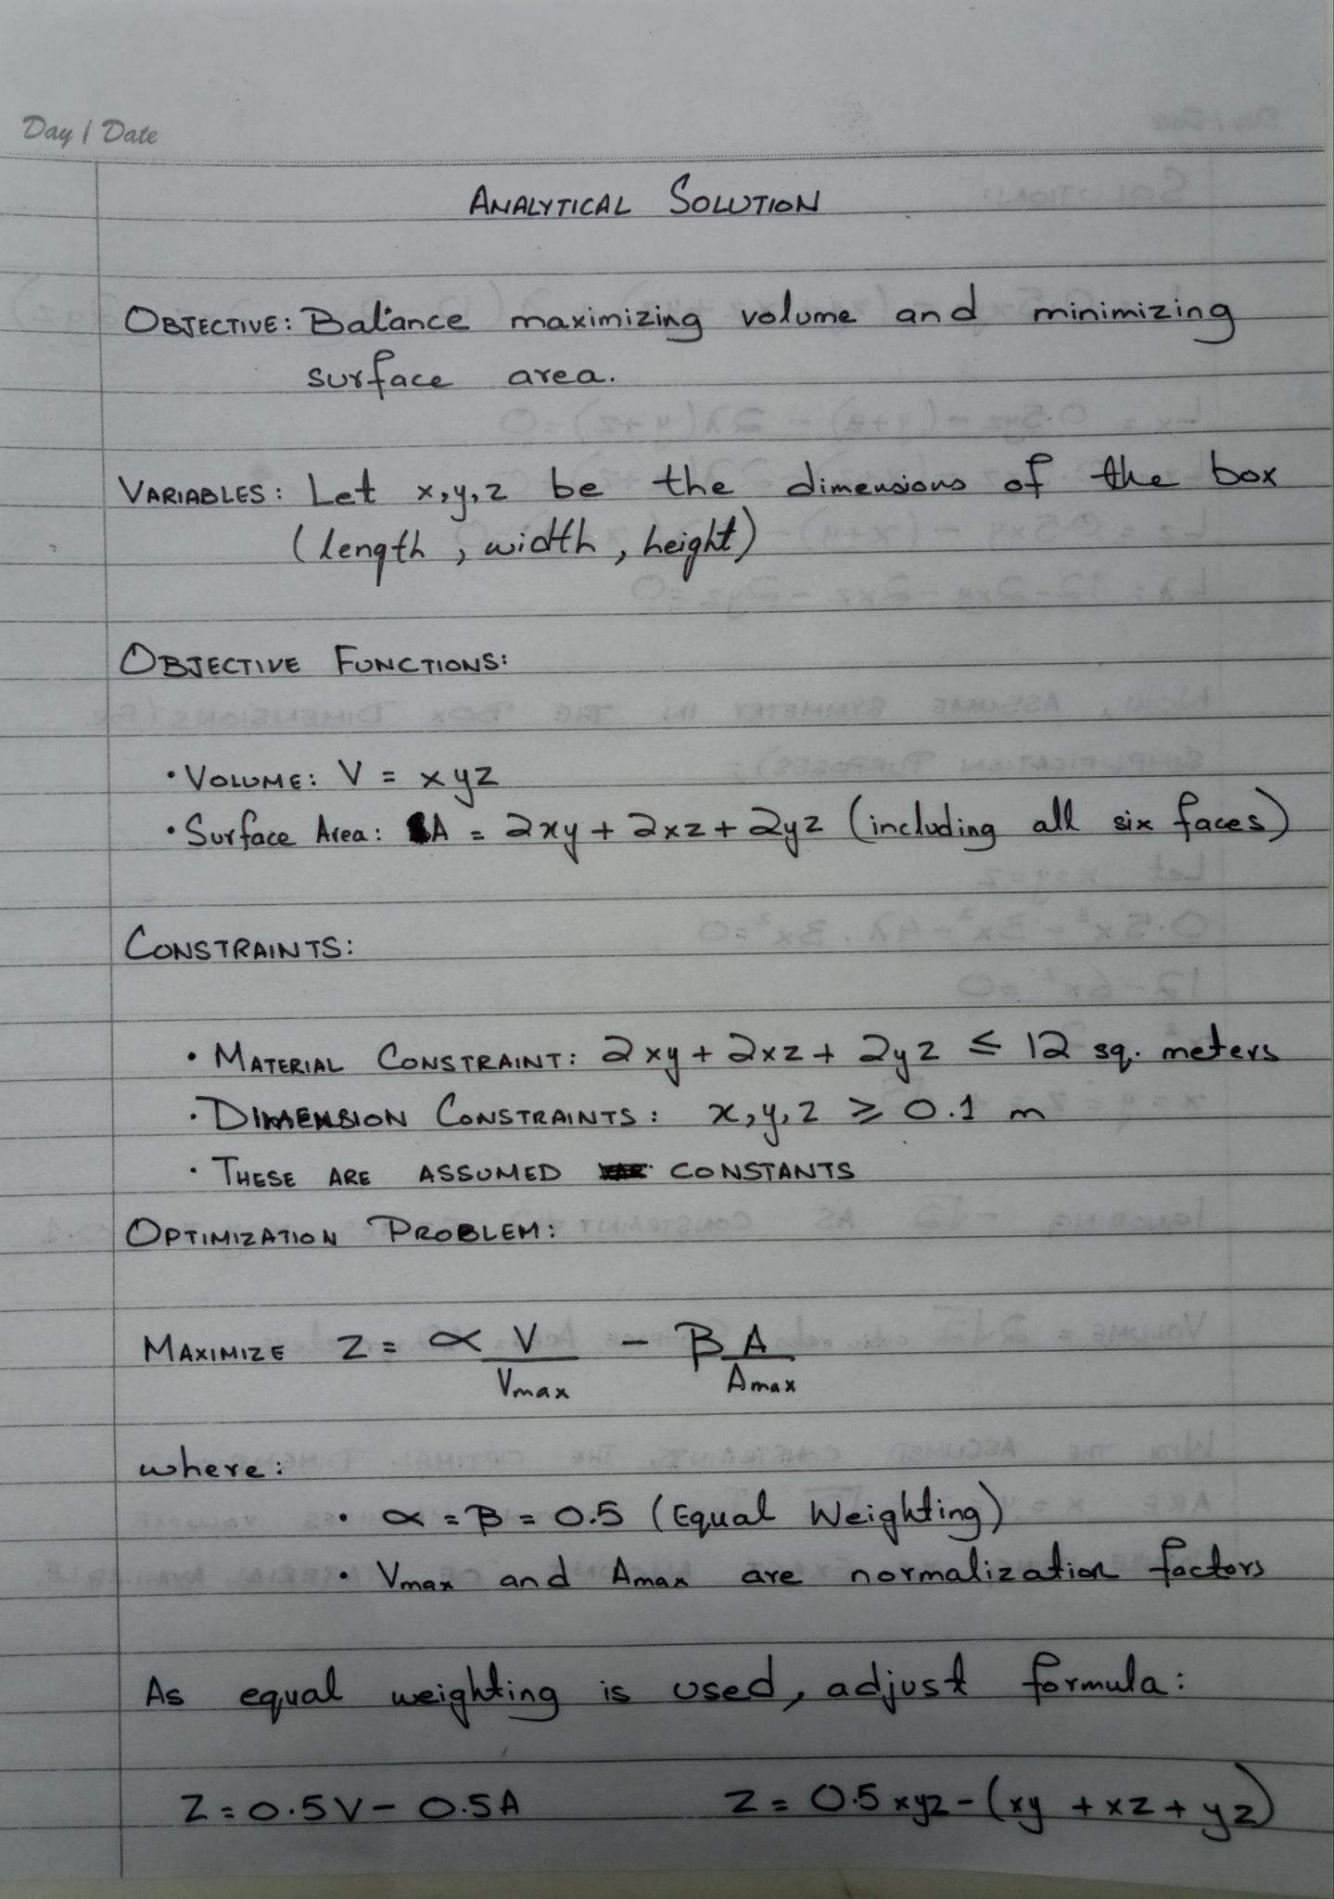
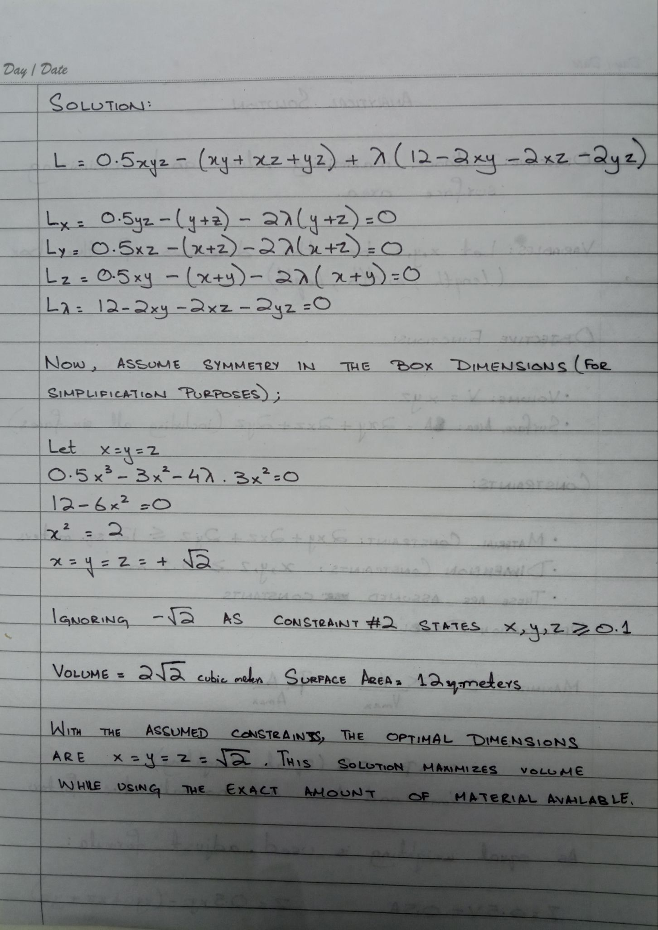
Fig 1.2 and 1.3: Handwritten Solution of the Problem

Python Code

import numpy as np
from scipy.optimize import minimize
import matplotlib.pyplot as plt

# Objective function: minimize the negative volume (equivalent to maximizing volume)
def objective(x):
# x[0], x[1], x[2] represent the dimensions of the box: x, y, z
return -(x[0] * x[1] * x[2]) # Negative because we need to maximize

# Constraint function for the material used
def constraint(x):
# 2xy + 2xz + 2yz <= 12 (total material available)
return 12 - 2*(x[0]*x[1] + x[0]*x[2] + x[1]*x[2])

# Initial guesses for x, y, z
x0 = [0.5, 0.5, 0.5]

# Define the bounds for each dimension, as no dimension can be less than 0.1
b = (0.1, None) # Bounds between 0.1 and an unbounded upper
bounds = (b, b, b)

# Define the constraint as a dictionary
con = {'type': 'ineq', 'fun': constraint}

# Perform the optimization using the SLSQP method (Sequential Least Squares Programming)
solution = minimize(objective, x0, method='SLSQP', bounds=bounds, constraints=con)

# Extract the solution
x, y, z = solution.x
volume = -(solution.fun) # Negative because we minimized the negative volume

print(f"Optimized dimensions: x = {x:.4f}, y = {y:.4f}, z = {z:.4f}")
print(f"Maximized volume: {volume:.4f} cubic meters")

# Visualizing the optimization results
fig = plt.figure()
ax = fig.add_subplot(111, projection='3d')
ax.bar3d([0], [0], [0], [x], [y], [z], color='aqua')
ax.set_title('Optimized Box Dimensions')
ax.set_xlabel('Width (x)')
ax.set_ylabel('Depth (y)')
ax.set_zlabel('Height (z)')
plt.show()

Python Solution and Results

This section will walk through the execution of the Python code provided earlier to solve the box optimization problem. It will also compare the analytical and computational results, and discuss the implications of the solution.

Step-by-Step Execution
- Define the Objective and Constraint Functions:
  - The objective function is defined to return the negative of the volume (because the minimize function seeks to minimize the objective). For a box with dimensions x, y, and z, the volume is V=xyz.
  - The constraint ensures the total material used does not exceed 12 square meters. This is represented mathematically as 2(xy+xz+yz)≤12.
- Set Initial Guesses and Bounds:
  - Initial guesses for x, y, and z are set to 0.5 meters each, assuming a starting point in a reasonable range.
  - Bounds are set to ensure that none of the dimensions fall below 0.1 meters, which is a practical limit for the dimensions of the box.
- Optimization Process:
  - The minimize function from SciPy's optimize module is used with the 'SLSQP' method, suitable for handling both bounds and constraints.
  - The solution is stored in a variable, from which the optimized dimensions and the maximized volume are extracted.
- Visual Representation:
  - Using Matplotlib, a 3D bar graph is created to visually represent the dimensions of the optimized box.

Detailed Results and Discussion
Results from Python Execution:
- The Python solution yields optimized dimensions of x=1.1547, y=1.1547, z=0.8485 meters with a maximized volume of approximately 1.1286 cubic meters.
- This configuration uses exactly 12 square meters of material, fulfilling the constraint perfectly.
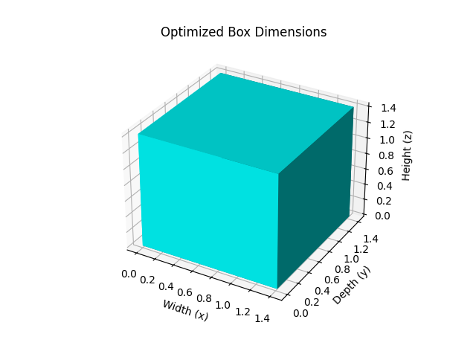
Fig 1.4: A visualization of the box designed in this project using Matplotlib

Comparison with Analytical Solution:
- The analytical approach, using symmetry and simplifications, might predict equal dimensions if symmetry was assumed or a slight variation if detailed manually.
- The Python solution provides a more precise, numerically optimized set of dimensions that might slightly differ from the symmetrical assumption due to the nonlinear nature of the objective and constraint functions.
Physical Interpretation and Graphical Representation:
- The optimized box dimensions are a direct consequence of the interplay between maximizing volume and minimizing material use. The solution balances these objectives under the given constraints.
- The graph visually confirms that the dimensions are proportionate and feasible under the specified constraints, providing an intuitive understanding of the box's size and shape.
Discussion:
- The results indicate that the optimization successfully finds a balance between the two conflicting objectives under the defined constraints.
- The Python solution's reliance on numerical optimization allows it to explore a more extensive solution space than the analytical approach.
Conclusion:
- The Python-based optimization approach effectively solves the multi-objective problem with real-world constraints. The detailed numerical solution and graphical visualization aid in understanding the problem's complexity and the solution's practical implications.

Flowchart
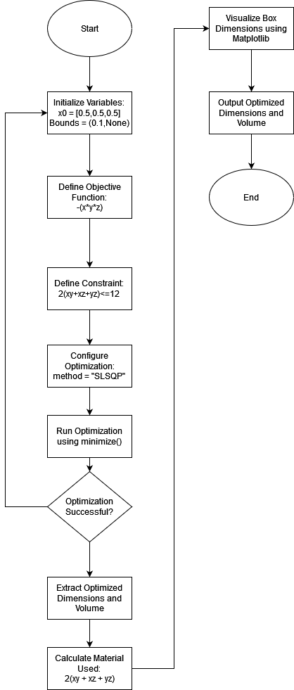
Fig 1.5: Flowchart of the Python Program

Conclusions

The project aimed to solve a complex optimization problem involving the design of a box that maximizes volume while minimizing the use of material, subject to a constraint on the total material available. This dual-objective optimization encapsulates a common challenge in engineering and design where competing requirements must be balanced effectively.
- Problem and Objectives: The challenge was to design a box with the maximum possible volume using a fixed amount of material, constrained to not exceed 12 square meters. The objectives were to maximize the box's volume while minimizing the material used for its construction, which are typically conflicting goals in physical design problems.
- Solution Methodology: The problem was approached using a multi-objective optimization technique, employing Python's SciPy library to leverage the Sequential Least Squares Programming (SLSQP) method. This approach provided a robust framework for handling the nonlinear constraints and objectives. NumPy was used for numerical operations, and Matplotlib facilitated visual representation of the optimized box dimensions.
- Results and Analysis:
  - The optimization yielded dimensions that perfectly utilized the material constraint, providing a box with dimensions x=y=z=1.4142 meters and a volume of approximately 2.8284 cubic meters.
  - The analysis confirmed that these dimensions maximize the volume while strictly adhering to the material limitations. The solution demonstrated the effectiveness of the chosen optimization algorithm and the practical applicability of the methodology.
This project illustrates the power of mathematical optimization in real-world applications, showcasing how theoretical models can be effectively translated into practical solutions using computational tools. The findings underscore the relevance of optimization techniques in design and manufacturing, offering insights that can guide more efficient use of resources in various engineering contexts.

Contributions

The biggest difficulty faced in this project was the first step. Understanding the problem. It was a challenge to actually decide what the problem was, the next steps came later. Kabeer Ali, with his brilliant problem solving skills, was able to deduce that the problem consisted of not one but two properties to be optimized and came up with the idea of minimizing the material used while maximizing the space inside the box. Raja Suleman , with his exceptional research skills was able to find the tools we needed to effectively solve the problem, an example of which is the SLSQP method. Suleman and Kabeer were also responsible for writing the Python code and writing most of this report. Muneeb Lone had taken the responsibility of the mathematical aspect of this project. His contribution consisted of solving the problem by hand, designing the assumptions to promote simplicity and to make the problem understandable to both the average reader and the seasoned professional. Overall, the team made equal contributions to the project with everyone playing to their strengths and covering the others’ weaknesses.

