Q1:

.386
.model flat, stdcall
.stack 4096
ExitProcess proto, dwExitCode:dword
include Irvine32.inc

.data

enterMsg byte "Enter a number: ",0
displayMsg byte "Entire Stack: ",0
pushMsg byte " Pushed ",0
popMsg byte " Popped ",0
choiceMsg byte "Enter your choice: ",0
pMsg byte "1. Push",0
ppMsg byte "2. Pop",0
dMsg byte "3. Display",0
pushError byte "Stack is full",0
popError byte "Stack is empty",0
testmsg byte "Meow",0

;Assuming arbitrary size, change here if needed
myStack dd 50 DUP(?)
myStackSize dd 50
myStackCapacity dd 0
choice byte ?
num dd ?

.code
main PROC

xor eax, eax
xor ebx, ebx
xor ecx, ecx
xor edx, edx

call stackInitialize
call displayProc

startLabel:

call readChar
call writechar
call crlf
mov choice, al

cmp al,"1"
je pushLabel
jne check1
pushLabel:
call pushProc
jmp startLabel
check1:
cmp al, '2'
je popLabel
jne check2
popLabel:
call popProc
jmp startLabel
jne check2

check2:
cmp al, '3'
je displayLabel
jne exitLabel
displayLabel:
call displayStackProc
jmp startLabel

exitLabel:

exit
main ENDP

displayProc proc
mov edx, offset choiceMsg
call writestring
call crlf
mov edx, offset pMsg
call writestring
call crlf
mov edx, offset ppMsg
call writestring
call crlf
mov edx, offset dMsg
call writestring
call crlf
ret
displayProc endP

stackInitialize Proc

mov esi, offset myStack
mov ecx, myStackSize
mov ebx, 0
mov myStackCapacity, ebx
initLoop:
mov ebx, 0
mov [esi], ebx
loop initLoop
mov esi, offset myStack
ret
stackInitialize endP

pushProc proc

mov ebx, myStackCapacity

cmp ebx, myStackSize ;if ebx >= size, stack full
jne stackFree
mov edx, offset pushError
call writestring
call crlf
jmp exitPush

stackFree:
inc ebx
mov myStackCapacity, ebx
call readint
mov eax, 78
mov [esi], eax
add esi,4
mov edx, offset pushMsg
call writestring
call crlf
jmp exitPush
exitPush:

ret

pushProc endp

popProc PROC

mov ebx, mystackCapacity
cmp ebx, 0
JE popErrorLabel

mov eax, [esi]
call writeint
sub esi, 4
mov edx, offset popMsg
call writestring
call crlf
jmp exitLabel

popErrorLabel:
mov edx, offset popError
call writestring
call crlf

exitLabel:
ret

popProc endP

displayStackProc PROC

mov edi, esi
mov ecx, myStackCapacity
cmp myStackCapacity, 0
JE errorLabel
mov edx, offset displayMsg
call writestring
call crlf
printLoop:
mov eax, [edi]
call writeint
call crlf
sub edi, 4
loop printLoop
jmp exitLabel

errorLabel:
mov edx ,offset popError
call writestring
call crlf

exitLabel:
ret

displayStackProc endp

END main
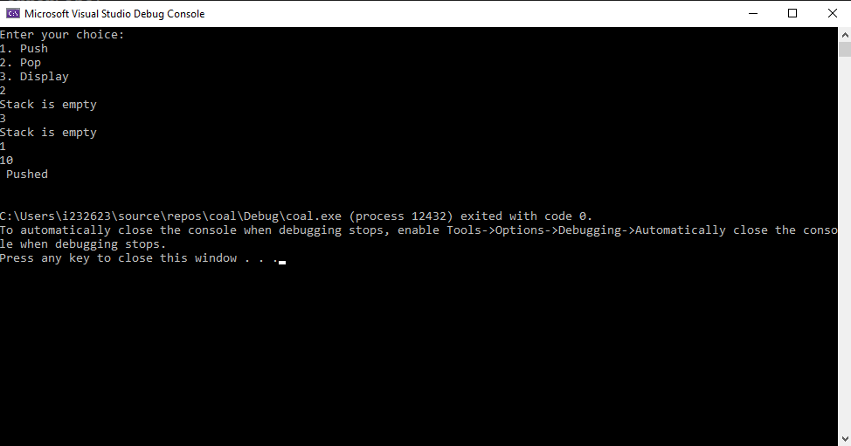

Q2:

;Code is correct but getting access exception due to windows settings so could not add screenshot. PLEASE consider
.386
.model flat, stdcall
.stack 4096
ExitProcess proto, dwExitCode:dword
include Irvine32.inc

.data

intArray dd 1,2,3,4,5,6,7,8,9,10
comparisonArray dd 1,2,3,4,5,6,7,8,9,10
equalFlag byte 1

equalMsg byte "Arrays are equal",0
unequalMsg byte "Arrays are not equal",0
space byte " ",0

.code
main PROC
mov esi, 0
mov edi, 0
mov edi, offset intArray
div3loop:

mov edx, 0
mov ebx, 3
div ebx
cmp edx, 0
jz setLSB
jnz clearLSB

setLSB:
mov eax, [edi]
or eax, 1
mov [edi], eax
xor eax, eax
add edi, 4
dec ecx
jmp div3loop

clearLSB:
mov eax, [edi]
and eax, 0111Eh
mov [edi], eax
xor eax, eax
add edi, 4
dec ecx
jmp div3loop

loop div3loop

displayarr1:
mov eax, [edi]
call writeint
call writestring
add edi, 4
loop displayarr1

mov edi, offset intArray
invertLoop:
mov eax, [edi]
not eax
mov [edi], eax
add edi, 8 ;0th inverted, skip to 2 (0 based indexing)
loop invertLoop

mov edi, offset intArray
mov ecx, 10
mov edx, offset space
displayarr2:
mov eax, [edi]
call writeint
call writestring
add edi, 4
loop displayarr2

mov edi, offset intarray
mov esi, offset comparisonarray
compareLoop:
mov eax, [edi]
mov ebx, [esi]
cmp eax, ebx
jne unequalLabel
add edi, 4
add esi, 4
loop compareLoop

unequalLabel:
mov cl,0
mov equalFlag, cl

cmp equalFlag, 1
je equalArrays

mov edx, offset unequalmsg
call writestring
call crlf
jmp exitProgLabel

equalArrays:
mov edx, offset equalmsg
call writestring
call crlf

exitProgLabel:

exit
main endp
END main

Q4:

;Code is correct but getting access exception due to windows settings so could not add screenshot. PLEASE consider (2)

.386
.model flat, stdcall
.stack 4096
ExitProcess proto, dwExitCode:dword
include Irvine32.inc

;store files into array one at a time, sort array, print to file
.data

file1name byte "File1.txt",0
file2name byte "File2.txt",0
file3name byte "Results.txt",0

file1handler byte ?
file2handler byte ?
file3handler byte ?

file1count dd 246
file2count dd 179

buffer1 byte 246 dup(?),0
buffer2 byte 179 dup(?),0
buffer3 byte 425 dup(?),0
.code
main PROC

mov edx, offset file1name
call openinputfile
mov ecx, file1count
mov edx, offset buffer1
call readfromfile
mov ebx, offset buffer1
call bubblesort

call printBuffer1

mov edx, offset file2name
call openinputfile
mov ecx, file2count
mov edx, offset buffer2
call readfromfile
mov ebx, offset buffer2
call bubblesort

call printBuffer2

mov ecx, 246
mov edi, offset buffer3
mov esi, offset buffer1
combineLoop1:
mov ebx, [edi]
mov [esi], ebx
add edi,4
add esi,4
loop combineloop1

mov ecx, 179
mov edi, offset buffer3
mov esi, offset buffer1
combineloop2:
mov ebx, [edi]
mov [esi], ebx
add edi,4
add esi,4

loop combineloop2

exit
main endp

bubblesort proc

mov esi, ebx
mov ecx, file1count
dec ecx
outerLoop:

mov eax, [esi]
mov ebx, [esi+4]
cmp eax, ebx
jg swaps
add esi, 4
dec ecx
jmp outerloop
swaps:
mov edx, eax
mov eax, ebx
mov ebx ,edx
xor edx,edx
mov [esi], eax
mov [esi+4], ebx
loop outerloop

bubblesort endp

printBuffer1 proc
mov esi, offset buffer1
mov ecx, lengthof buffer1
printLoop:
mov eax, [esi]
call writeint
add esi,4
loop printLoop
ret
printBuffer1 endp

printBuffer2 proc
mov esi, offset buffer2
mov ecx, lengthof buffer2
printLoop:
mov eax, [esi]
call writeint
add esi,4
loop printLoop
ret
printBuffer2 endp

printBuffer3 proc
mov esi, offset buffer3
mov ecx, lengthof buffer3
printLoop:
mov eax, [esi]
call writeint
add esi,4
loop printLoop
ret
printBuffer3 endp

END main

