Task 1:

.386
.model flat, stdcall
.stack 4096
ExitProcess PROTO,dwExitCode:DWORD

.data

.code
main PROC

mov eax,10
mov ecx,15
add eax,ecx

mov ebx,15
mov edx,12
sub ebx,edx

mov al,10
mov ah,10
add al,ah
sub al,ah

mov bl,10
mov bh,10
add bl,bh
sub bl,bh

invoke ExitProcess, 0

main ENDP
END main
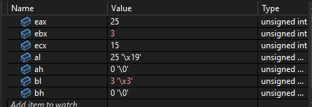

EAX contains answer 25 but since 25 is not greater than 2^8 it is stored in AL while the rest of the register is 0

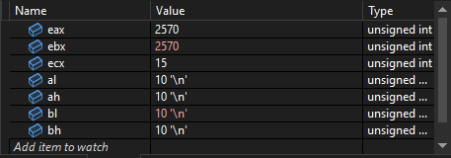

10 is added to both higher and lower registers
32bit number ends up being: 0000101000001010 which is 2570 in decimal.

Task 2:
.386
.model flat, stdcall
.stack 4096
ExitProcess PROTO,dwExitCode:DWORD

.data

.code
main PROC

mov eax,10
mov ecx,5
add eax,ecx

mov ebx,15
mov edx,5
sub ebx,edx

mov al,10
mov ah,5
add al,ah
sub al,ah

mov bl,10
mov bh,5
add bl,bh
sub bl,bh

invoke ExitProcess, 0

main ENDP
END main
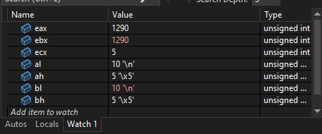

Same principle as before just changed values according to roll number

Task 3:
.386
.model flat, stdcall
.stack 4096
ExitProcess PROTO,dwExitCode:DWORD

.data
val1 DWORD ?
val2 DWORD ?
sum DWORD ?
.code
main PROC

mov eax,10000
mov val1,eax
mov ebx,565
mov val2, ebx
add eax,ebx
mov sum,eax

;Address for all 3 is 0x00BC4000

invoke ExitProcess, 0

main ENDP
END main
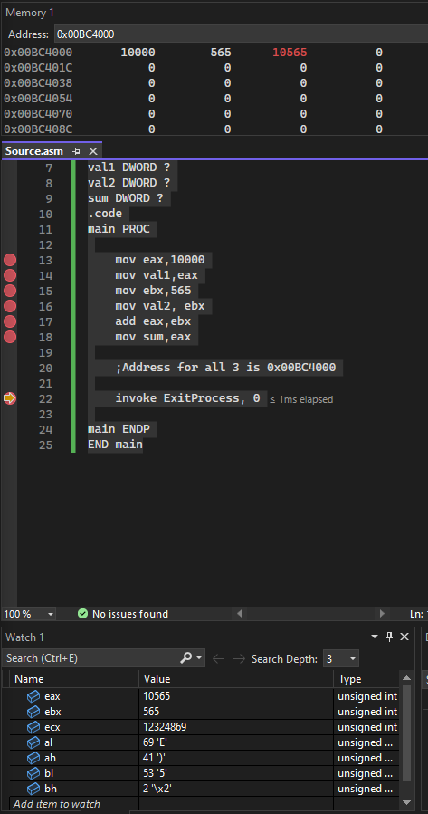

Task 4:

.386
.model flat, stdcall
.stack 4096
ExitProcess PROTO,dwExitCode:DWORD

.data
val1 DWORD ?
val2 DWORD ?
sum DWORD ?
.code
main PROC

mov val1,2625
mov val2,2623

mov ecx,val1 ;ecx -> 2625
mov edx,val2 ;edx -> 2623

invoke ExitProcess, 0

main ENDP
END main

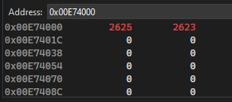
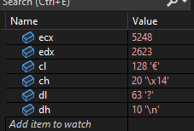

Task 5:
.386
.model flat, stdcall
.stack 4096
ExitProcess PROTO,dwExitCode:DWORD

.data
val1 DWORD ?
val2 DWORD ?
sum DWORD ?
.code
main PROC

mov val1,2025
mov val2,2004

mov ecx,val1 ;ecx -> 2025
mov edx,val2 ;edx -> 2004
sub ecx,edx

invoke ExitProcess, 0

main ENDP
END main

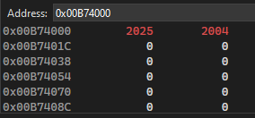
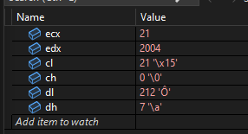

Task 6:
.386
.model flat, stdcall
.stack 4096
ExitProcess PROTO,dwExitCode:DWORD

.data

.code
main PROC

mov eax,1010b
mov ebx,0101b
add eax,ebx

invoke ExitProcess, 0

main ENDP
END main
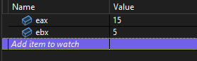

Task 7:
.386
.model flat, stdcall
.stack 4096
ExitProcess PROTO,dwExitCode:DWORD

.data

.code
main PROC

mov eax,1010h
mov ebx,0101h
add eax,ebx

invoke ExitProcess, 0

main ENDP
END main
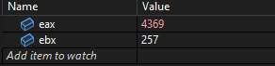

Task 8:
.386
.model flat, stdcall
.stack 4096
ExitProcess PROTO,dwExitCode:DWORD

.data

.code
main PROC

mov eax,1010o
mov ebx,0101o
add eax,ebx

invoke ExitProcess, 0

main ENDP
END main
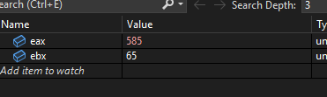

Task 9:

.386
.model flat, stdcall
.stack 4096
ExitProcess PROTO,dwExitCode:DWORD

.data

.code
main PROC

mov eax,150
mov ebx,20
mov ecx,2589

add eax,ebx ;eax->170
add eax,ecx ;eax->2759

invoke ExitProcess, 0

main ENDP
END main
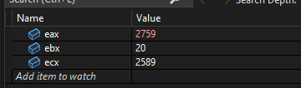

Task 10:

.386
.model flat, stdcall
.stack 4096
ExitProcess PROTO,dwExitCode:DWORD

.data

.code
main PROC

mov ax,5
mov bl,10
add ax,bl

invoke ExitProcess, 0

main ENDP
END main

Cannot add 8bit register with 16bit register hence error

Task 11:

.386
.386
.model flat, stdcall
.stack 4096
ExitProcess PROTO,dwExitCode:DWORD

.data

.code
main PROC

mov eax,5h
mov ebx,10b
add eax,ebx

invoke ExitProcess, 0

main ENDP
END main

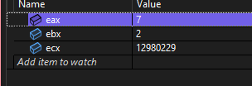

Values are stored as binary on backend anyway after conversions so operations can be performed

Task 12:
.386
.model flat, stdcall
.stack 4096
ExitProcess PROTO,dwExitCode:DWORD

.data

.code
main PROC

mov eax,5o
mov ebx,10b
add eax,ebx

invoke ExitProcess, 0

main ENDP
END main
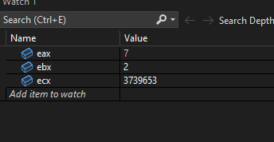
Values are stored as binary on backend anyway after conversions so operations can be performed

Task 13:

.386
.model flat, stdcall
.stack 4096
ExitProcess PROTO,dwExitCode:DWORD

.data

.code
main PROC

mov eax,5o
mov ebx,10h
add eax,ebx

invoke ExitProcess, 0

main ENDP
END main
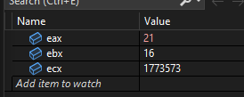

Task 14:
.386
.model flat, stdcall
.stack 4096
ExitProcess PROTO,dwExitCode:DWORD

.data

.code
main PROC

mov eax,5
mov ebx,10
and eax,ebx ; eax -> 0
or eax,ebx ; eax->10
xor eax,ebx ; eax->0
not eax ; eax->4294967295

invoke ExitProcess, 0

main ENDP
END main

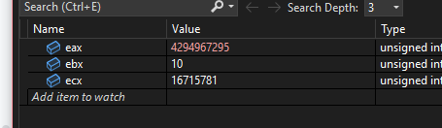

Task 15:
.386
.model flat, stdcall
.stack 4096
ExitProcess PROTO,dwExitCode:DWORD

.data

.code
main PROC

mov eax,5
mov ebx,10
XOR ebx,eax
XOR eax,ebx
XOR ebx,eax

invoke ExitProcess, 0

main ENDP
END main
