Q1:
.386
.model flat,stdcall
.stack 4096
ExitProcess proto, dwExitCode: dword

.data

arr1 dword 0,1,2,3,4,5,6,7,8,9
arr2 dword 9,8,7,6,5,4,3,2,1,0
arr3 dword 10 DUP(?)
arrSize dword 10

.code
main PROC

mov edi, offset arr1
mov esi, offset arr2
mov ecx, arrSize

mov_to_end:
add esi,4
loop mov_to_end
mov ecx, arrSize
L1:
mov eax, [edi]
mov ebx, [esi]
add eax,ebx
mov [edi],eax
add edi,4
sub esi,4
loop L1
mov esi, offset arr1
mov edi, offset arr3
mov ecx, arrSize
L2:
mov eax,[esi]
mov [edi], eax
add edi,4
add esi,4
loop L2

mov ecx, arrSize
mov edi, offset arr1
mov esi, offset arr2

mov_to_end2:
add esi,4
loop mov_to_end2
mov ecx, arrSize

L3:
mov eax, [edi]
mov ebx, [esi]
sub eax,ebx
mov [edi],eax
add edi,4
sub esi,4
loop L3

INVOKE ExitProcess,0
main ENDP
END main

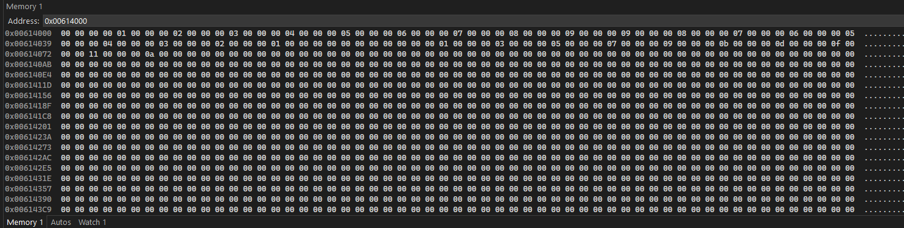

Q2:
Sign flag is set because the resulting answer is a negative number and as registers cannot store negative numbers, two’s complement convention is used and sign flag is set when a negative number is stored in the registers.
Carry Flag is set when a borrow is generated i.e when a larger number is subtracted from a smaller number
.386
.model flat,stdcall
.stack 4096
ExitProcess proto, dwExitCode: dword

.data

var1 dd -30
var2 dd -20

.code
main PROC

mov eax, var1
mov ebx, var2
sub eax,ebx

INVOKE ExitProcess,0
main ENDP
END main
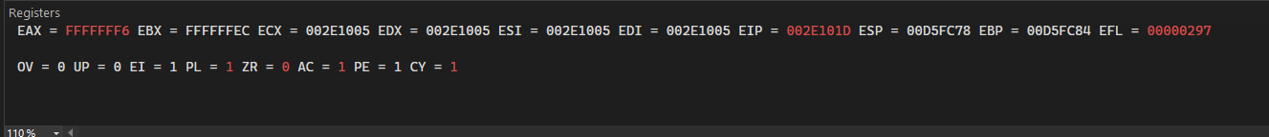
Q3:
Edx has decimal value
.386
.model flat,stdcall
.stack 4096
ExitProcess proto, dwExitCode: dword

.data

var1 dd 0Ah

.code
main PROC

mov eax,var1
mov ebx, 16
L1:
mov edx,0
div ebx
cmp eax,16
jae L1

INVOKE ExitProcess,0
main ENDP
END main

Q4:
.386
.model flat,stdcall
.stack 4096
ExitProcess proto, dwExitCode: dword

.data

arr dword 1,2,3,4,5,6,7,8,9,10,11,12,13,14,15,16,17,18,19,20
odd_arr dword 10 DUP(?)
arrSize dword 20

.code
main PROC

mov bx, 2
mov esi, offset arr
mov edi, offset odd_arr
mov ecx, 20
L1:
mov dx, 0
mov ax, [esi]
div bx
cmp dx, 0
jne move_to_arr
loop L1

jmp set_count

move_to_arr:

mov ax, [esi]
mov [edi], ax
add esi,2
add edi,2

set_count:
mov ecx, 20
mov esi, offset odd_arr
mask1:
mov ax, [esi]
AND ax, 2623
OR ax,2623
add esi,2
loop mask1

exit_prog:

INVOKE ExitProcess,0
main ENDP
END main

Q5:
.386
.model flat,stdcall
.stack 4096
ExitProcess proto, dwExitCode: dword

.data

arr dword 1,2,3,4,5,6,7,8,9,10,11,12,13,14,15,16,17,18,19,20
odd_arr dword 10 DUP(?)
arrSize1 dword 20
arrSize2 dword 10

.code
main PROC

mov esi, offset arr
mov edi, offset odd_arr
mov ecx, arrSize1
L1:
mov ax,[esi]
mov dx,0
mov bx,2
div bx
cmp dx,0
je L1
push ecx
mov cx, [esi]
mov [edi],cx
add esi, 2
add edi,2
pop ecx
exitloop:

INVOKE ExitProcess,0
main ENDP
END main

