**INPUTS :** l1 = [ "0 ", "pi/6", "pi/4", "pi/3", "pi/2"];

l2 = [ "2*pi/3 ", "pi ", "2*pi ", "0.429*pi", "0.683*pi"];

terms = 20;

**FUNCTIONS :**

plotting – **Input:** list with value in strings, no of terms considered

**Output:** list of convergent value for the inputted list

sine , cosine , tangent – **Input:** No of terms, radian value

**Output:** list of increasing no of terms in Taylor series

converge – **Input:** list of float values **Output :** convergent term index

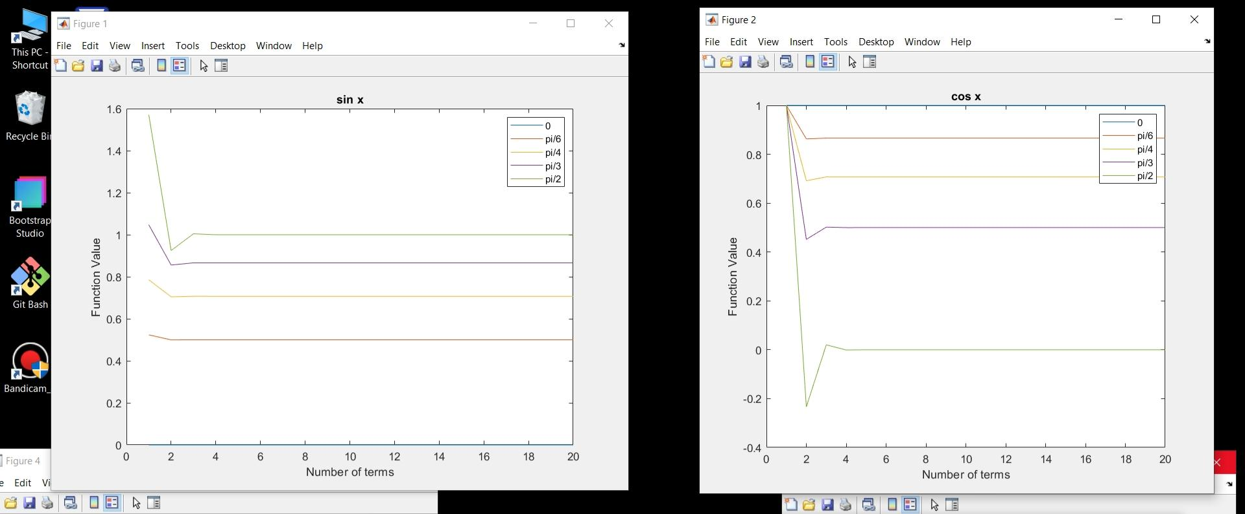**PLOTS & OUTPUT :**

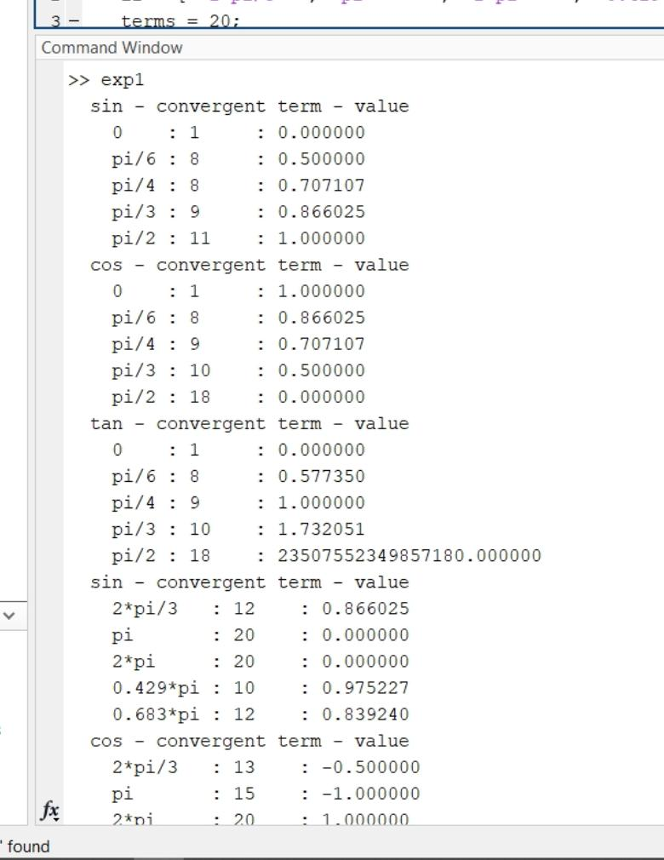

The first term in Taylor series for sin is **x.** In the plot , for the number of terms as 1 , the function value is the value for which we are finding convergent term

We know that , **SIN(0) = 0 , SIN(Pi/6) = ½ = 0.5 , SIN(Pi/2) = 1** , in the output, we got the same as convergent term.



The first term in Taylor series for cos is **1.** In the plot , for the number of terms as 1 , the function value is 1 for every input.

We know that , **COS(0) = 1 , COS(Pi/2) = 0** , in the output, we got the same as convergent term.

As **COS(Pi/4) = SIN(Pi/4) ,** we got same value what we got in previous sin plot.

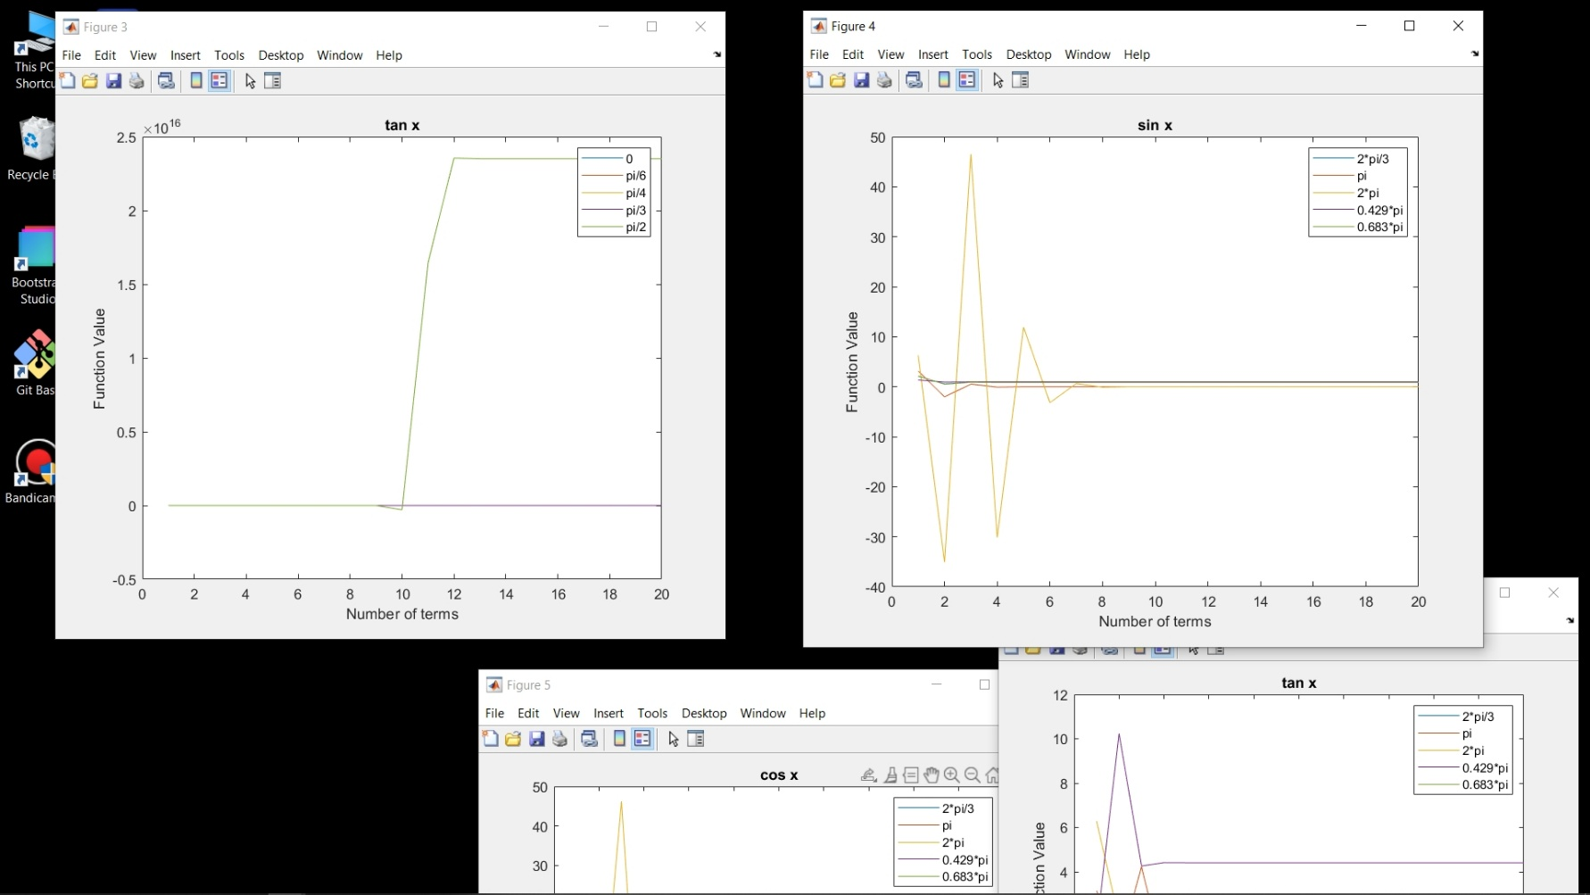

We know that , **SIN(0) = 0 , COS(0) = 1 , TAN(0) = SIN(0)/COS(0) = 0/1 = 0** and **SIN(Pi/4) = COS(Pi/4) = 1/√2 , TAN(Pi/4) = SIN(Pi/4)/COS(Pi/4) = 1**  , in the output, we got the same as convergent term.

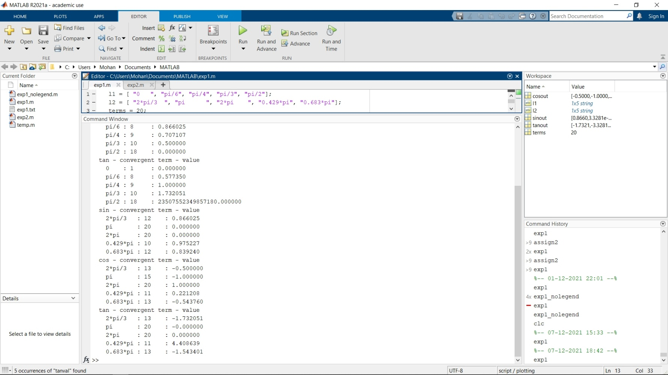****

The first term in Taylor series for sin is **x.** In the plot , for the number of terms as 1 , the function value is the value for which we are finding convergent term

We know that , **SIN(Pi) = 0 , SIN(2Pi) = 0** , in the output, we got the same as convergent term.

Since , **SIN(2Pi/3) = SIN(120°) = SIN(90°+30°) = COS(30°) = 0.866025,** we got the same value which we got for COS(Pi/6) in previous cos plot.

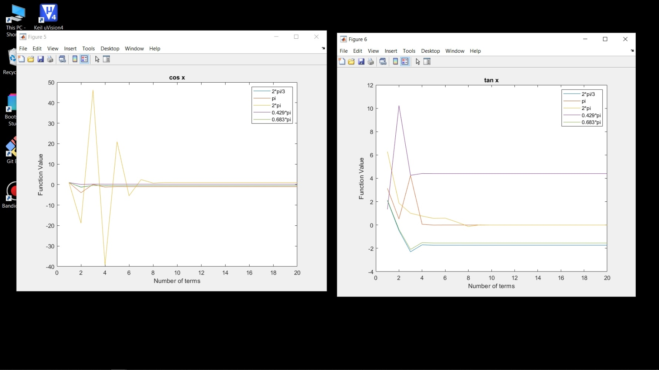

The first term in Taylor series for cos is **1.** In the plot , for the number of terms as 1 , the function value is 1 for every input.

We know that , **COS(Pi) = -1 , COS(2*Pi) = 1**, in the output, we got the same as convergent term.

Since , **COS(2Pi/3) = COS(120°) = COS(90°+30°) = -SIN(30°) = -0.50000,** we got the same value which we got for SIN(Pi/6) in previous cos plot.



We know that , **SIN(Pi) = SIN(2Pi) = 0 and** **COS(Pi) = -1 , COS(2*Pi) = 1**

And so, **TAN(Pi) = SIN(Pi)/COS(Pi) = 0/-1 = 0** and **TAN(2Pi) = SIN(2Pi)/COS(2Pi) = 0/1 = 0**  , in the output, we got the same as convergent term.