Machine Learning Midterm Report
Breast Cancer Wisconsin and Wine Classification
Mohammad Nour AL ELAWI
23040102012
İstanbul Topkapı Üniversitesi
Department of Computer Engineering
11 November 2026

1. Loading the Datasets

1.1 Load both datasets from scikit-learn
This study evaluates two built-in datasets distributed through scikit-learn: the Breast Cancer Wisconsin diagnostic dataset and the Wine recognition dataset. The datasets were loaded independently using load_breast_cancer() and load_wine(). Both datasets were retained throughout the analysis; no dataset was substituted or omitted.
The Breast Cancer Wisconsin dataset contains 569 observations and 30 numerical features. Its original target labels are 0 and 1, corresponding to malignant and benign cases, respectively. The Wine dataset contains 178 observations and 13 numerical features with three original target classes: 0, 1, and 2.
Dataset overview table included below.
Dataset | Samples | Features | Classes | Class counts
Breast Cancer | 569 | 30 | malignant, benign | {np.int64(0): np.int64(212), np.int64(1): np.int64(357)}
Wine | 178 | 13 | class_0, class_1, class_2 | {np.int64(0): np.int64(59), np.int64(1): np.int64(71), np.int64(2): np.int64(48)}

1.2 Create the data frames
For each dataset, the feature matrix X was converted into a pandas DataFrame using the original scikit-learn feature names. The target vector y was stored separately, so the target was not included among the predictors. Original class labels were preserved. For Breast Cancer evaluation, class 0 was treated as the positive malignant class only when calculating malignant-case evaluation measures; the training labels themselves were not recoded.
Dataset loading outputs are included in the executed notebooks.
These outputs are displayed in cells 0 of both executed notebooks and preserve the original scikit-learn feature names, class labels, target names, and class counts.
Interpretation: retaining the original feature names and target labels preserves traceability to the scikit-learn sources and prevents ambiguity when interpreting classification errors.

2. Dataset Quality Checks

2.1 Missing values and duplicates
Missing-value counts were calculated independently for every feature column, and duplicate feature rows were counted without altering the data. Both datasets contained no missing feature values and no duplicate feature rows. Consequently, no imputation step was added. This decision was made after inspection and was not used to conceal or repair any observations.
Missing-value and duplicate-check tables included below.
dataset | missing_values_total | duplicate_rows
Breast Cancer | 0 | 0
Wine | 0 | 0
The executed quality-check cells report zero missing values in every feature column and zero duplicate feature rows for both datasets.

2.2 Potential outliers
Potential outliers were identified using the interquartile-range rule. An observation was flagged for a feature when it fell below Q1 minus 1.5 times the IQR or above Q3 plus 1.5 times the IQR. These flags indicate unusual values rather than confirmed errors. No observations were deleted, clipped, or otherwise modified.
Unusually large measurements can influence algorithms differently. They can distort Euclidean distances for K-nearest neighbours and affect the scale of unsupervised distance calculations. Tree-based models are generally less sensitive to monotonic feature scaling because they learn threshold splits, although unusual observations can still influence the learned partition. The outlier analysis therefore informed interpretation but did not become a feature-selection or deletion rule.
IQR outlier-count summary included below.
dataset | features_with_flags | total_iqr_flags | maximum_flags_in_one_feature
Breast Cancer | 29 | 608 | 65
Wine | 7 | 21 | 4
The IQR counts are available in cell 2 of each executed notebook. They are diagnostic flags only; no rows were removed or clipped.

2.3 Data types
All predictors in both datasets are numerical floating-point features. No categorical predictors were present. The dtype output was retained for every feature, and no silent type conversion was performed.
Feature dtype summary included below.
dataset | numeric_features | categorical_features | dtypes
Breast Cancer | 30 | 0 | float64
Wine | 13 | 0 | float64
Cell 2 of each executed notebook shows every feature dtype. All predictors are float64 numerical features; categorical-feature count is zero for both datasets.
Interpretation: the absence of missing values and categorical columns simplifies preprocessing, but the different physical units and ranges make a training-only scaling comparison important for distance-based methods.

3. Exploratory Data Analysis (EDA)

3.1 Descriptive statistics
For every feature, the analysis reported the mean, median, minimum, maximum, standard deviation, first quartile, and third quartile. These statistics were calculated for descriptive purposes only and were not used to fit preprocessing or select features.
Descriptive-statistics tables included below.
feature | mean | median | min | max | std | Q1 | Q3 | dataset
mean radius | 14.1273 | 13.3700 | 6.9810 | 28.1100 | 3.5240 | 11.7000 | 15.7800 | Breast Cancer
mean texture | 19.2896 | 18.8400 | 9.7100 | 39.2800 | 4.3010 | 16.1700 | 21.8000 | Breast Cancer
mean perimeter | 91.9690 | 86.2400 | 43.7900 | 188.5000 | 24.2990 | 75.1700 | 104.1000 | Breast Cancer
mean area | 654.8891 | 551.1000 | 143.5000 | 2501.0000 | 351.9141 | 420.3000 | 782.7000 | Breast Cancer
mean smoothness | 0.0964 | 0.0959 | 0.0526 | 0.1634 | 0.0141 | 0.0864 | 0.1053 | Breast Cancer
mean compactness | 0.1043 | 0.0926 | 0.0194 | 0.3454 | 0.0528 | 0.0649 | 0.1304 | Breast Cancer
mean concavity | 0.0888 | 0.0615 | 0.0000 | 0.4268 | 0.0797 | 0.0296 | 0.1307 | Breast Cancer
mean concave points | 0.0489 | 0.0335 | 0.0000 | 0.2012 | 0.0388 | 0.0203 | 0.0740 | Breast Cancer
mean symmetry | 0.1812 | 0.1792 | 0.1060 | 0.3040 | 0.0274 | 0.1619 | 0.1957 | Breast Cancer
mean fractal dimension | 0.0628 | 0.0615 | 0.0500 | 0.0974 | 0.0071 | 0.0577 | 0.0661 | Breast Cancer
radius error | 0.4052 | 0.3242 | 0.1115 | 2.8730 | 0.2773 | 0.2324 | 0.4789 | Breast Cancer
texture error | 1.2169 | 1.1080 | 0.3602 | 4.8850 | 0.5516 | 0.8339 | 1.4740 | Breast Cancer
perimeter error | 2.8661 | 2.2870 | 0.7570 | 21.9800 | 2.0219 | 1.6060 | 3.3570 | Breast Cancer
area error | 40.3371 | 24.5300 | 6.8020 | 542.2000 | 45.4910 | 17.8500 | 45.1900 | Breast Cancer
smoothness error | 0.0070 | 0.0064 | 0.0017 | 0.0311 | 0.0030 | 0.0052 | 0.0081 | Breast Cancer
compactness error | 0.0255 | 0.0204 | 0.0023 | 0.1354 | 0.0179 | 0.0131 | 0.0324 | Breast Cancer
concavity error | 0.0319 | 0.0259 | 0.0000 | 0.3960 | 0.0302 | 0.0151 | 0.0420 | Breast Cancer
concave points error | 0.0118 | 0.0109 | 0.0000 | 0.0528 | 0.0062 | 0.0076 | 0.0147 | Breast Cancer
symmetry error | 0.0205 | 0.0187 | 0.0079 | 0.0790 | 0.0083 | 0.0152 | 0.0235 | Breast Cancer
fractal dimension error | 0.0038 | 0.0032 | 0.0009 | 0.0298 | 0.0026 | 0.0022 | 0.0046 | Breast Cancer
worst radius | 16.2692 | 14.9700 | 7.9300 | 36.0400 | 4.8332 | 13.0100 | 18.7900 | Breast Cancer
worst texture | 25.6772 | 25.4100 | 12.0200 | 49.5400 | 6.1463 | 21.0800 | 29.7200 | Breast Cancer
worst perimeter | 107.2612 | 97.6600 | 50.4100 | 251.2000 | 33.6025 | 84.1100 | 125.4000 | Breast Cancer
worst area | 880.5831 | 686.5000 | 185.2000 | 4254.0000 | 569.3570 | 515.3000 | 1084.0000 | Breast Cancer
worst smoothness | 0.1324 | 0.1313 | 0.0712 | 0.2226 | 0.0228 | 0.1166 | 0.1460 | Breast Cancer
worst compactness | 0.2543 | 0.2119 | 0.0273 | 1.0580 | 0.1573 | 0.1472 | 0.3391 | Breast Cancer
worst concavity | 0.2722 | 0.2267 | 0.0000 | 1.2520 | 0.2086 | 0.1145 | 0.3829 | Breast Cancer
worst concave points | 0.1146 | 0.0999 | 0.0000 | 0.2910 | 0.0657 | 0.0649 | 0.1614 | Breast Cancer
worst symmetry | 0.2901 | 0.2822 | 0.1565 | 0.6638 | 0.0619 | 0.2504 | 0.3179 | Breast Cancer
worst fractal dimension | 0.0839 | 0.0800 | 0.0550 | 0.2075 | 0.0181 | 0.0715 | 0.0921 | Breast Cancer
alcohol | 13.0006 | 13.0500 | 11.0300 | 14.8300 | 0.8118 | 12.3625 | 13.6775 | Wine
malic_acid | 2.3363 | 1.8650 | 0.7400 | 5.8000 | 1.1171 | 1.6025 | 3.0825 | Wine
ash | 2.3665 | 2.3600 | 1.3600 | 3.2300 | 0.2743 | 2.2100 | 2.5575 | Wine
alcalinity_of_ash | 19.4949 | 19.5000 | 10.6000 | 30.0000 | 3.3396 | 17.2000 | 21.5000 | Wine
magnesium | 99.7416 | 98.0000 | 70.0000 | 162.0000 | 14.2825 | 88.0000 | 107.0000 | Wine
total_phenols | 2.2951 | 2.3550 | 0.9800 | 3.8800 | 0.6259 | 1.7425 | 2.8000 | Wine
flavanoids | 2.0293 | 2.1350 | 0.3400 | 5.0800 | 0.9989 | 1.2050 | 2.8750 | Wine
nonflavanoid_phenols | 0.3619 | 0.3400 | 0.1300 | 0.6600 | 0.1245 | 0.2700 | 0.4375 | Wine
proanthocyanins | 1.5909 | 1.5550 | 0.4100 | 3.5800 | 0.5724 | 1.2500 | 1.9500 | Wine
color_intensity | 5.0581 | 4.6900 | 1.2800 | 13.0000 | 2.3183 | 3.2200 | 6.2000 | Wine
hue | 0.9574 | 0.9650 | 0.4800 | 1.7100 | 0.2286 | 0.7825 | 1.1200 | Wine
od280/od315_of_diluted_wines | 2.6117 | 2.7800 | 1.2700 | 4.0000 | 0.7100 | 1.9375 | 3.1700 | Wine
proline | 746.8933 | 673.5000 | 278.0000 | 1680.0000 | 314.9075 | 500.5000 | 985.0000 | Wine

3.2 Class distribution and correlations
Class-distribution plots were produced for both datasets. Pearson correlation matrices were also calculated for the feature columns. To identify the three strongest unique feature pairs, diagonal entries and mirrored matrix entries were excluded, and pairs were ranked by absolute correlation.
Class-distribution figures included below.
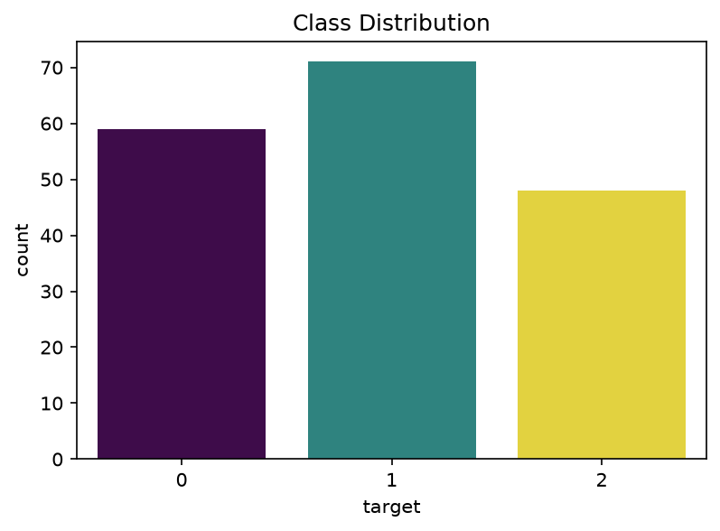
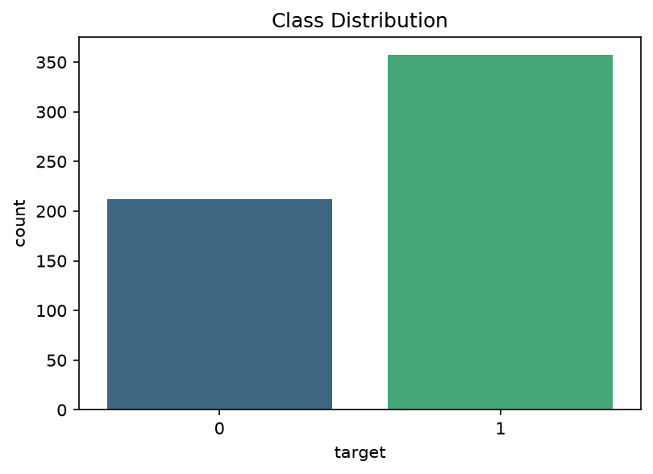
Pearson correlation heatmaps included below.
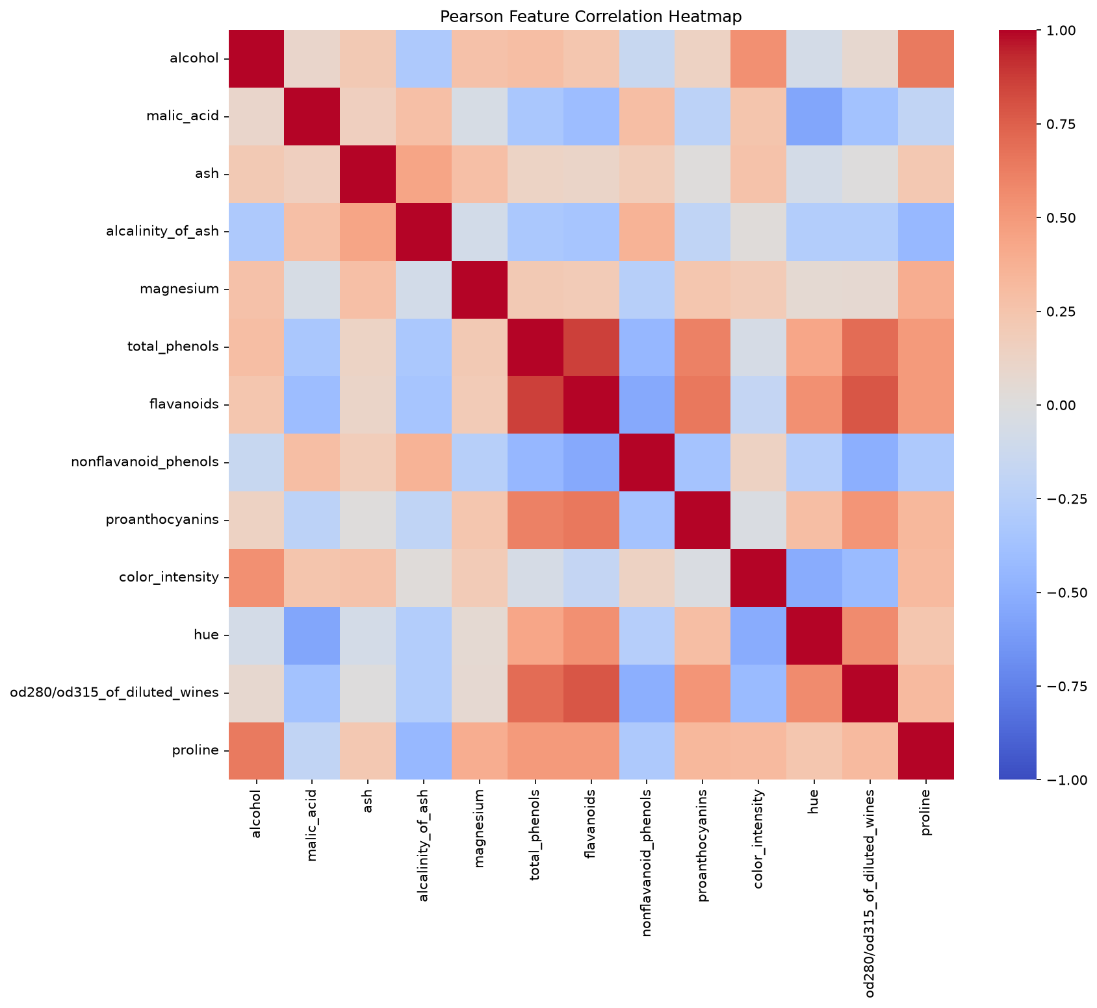
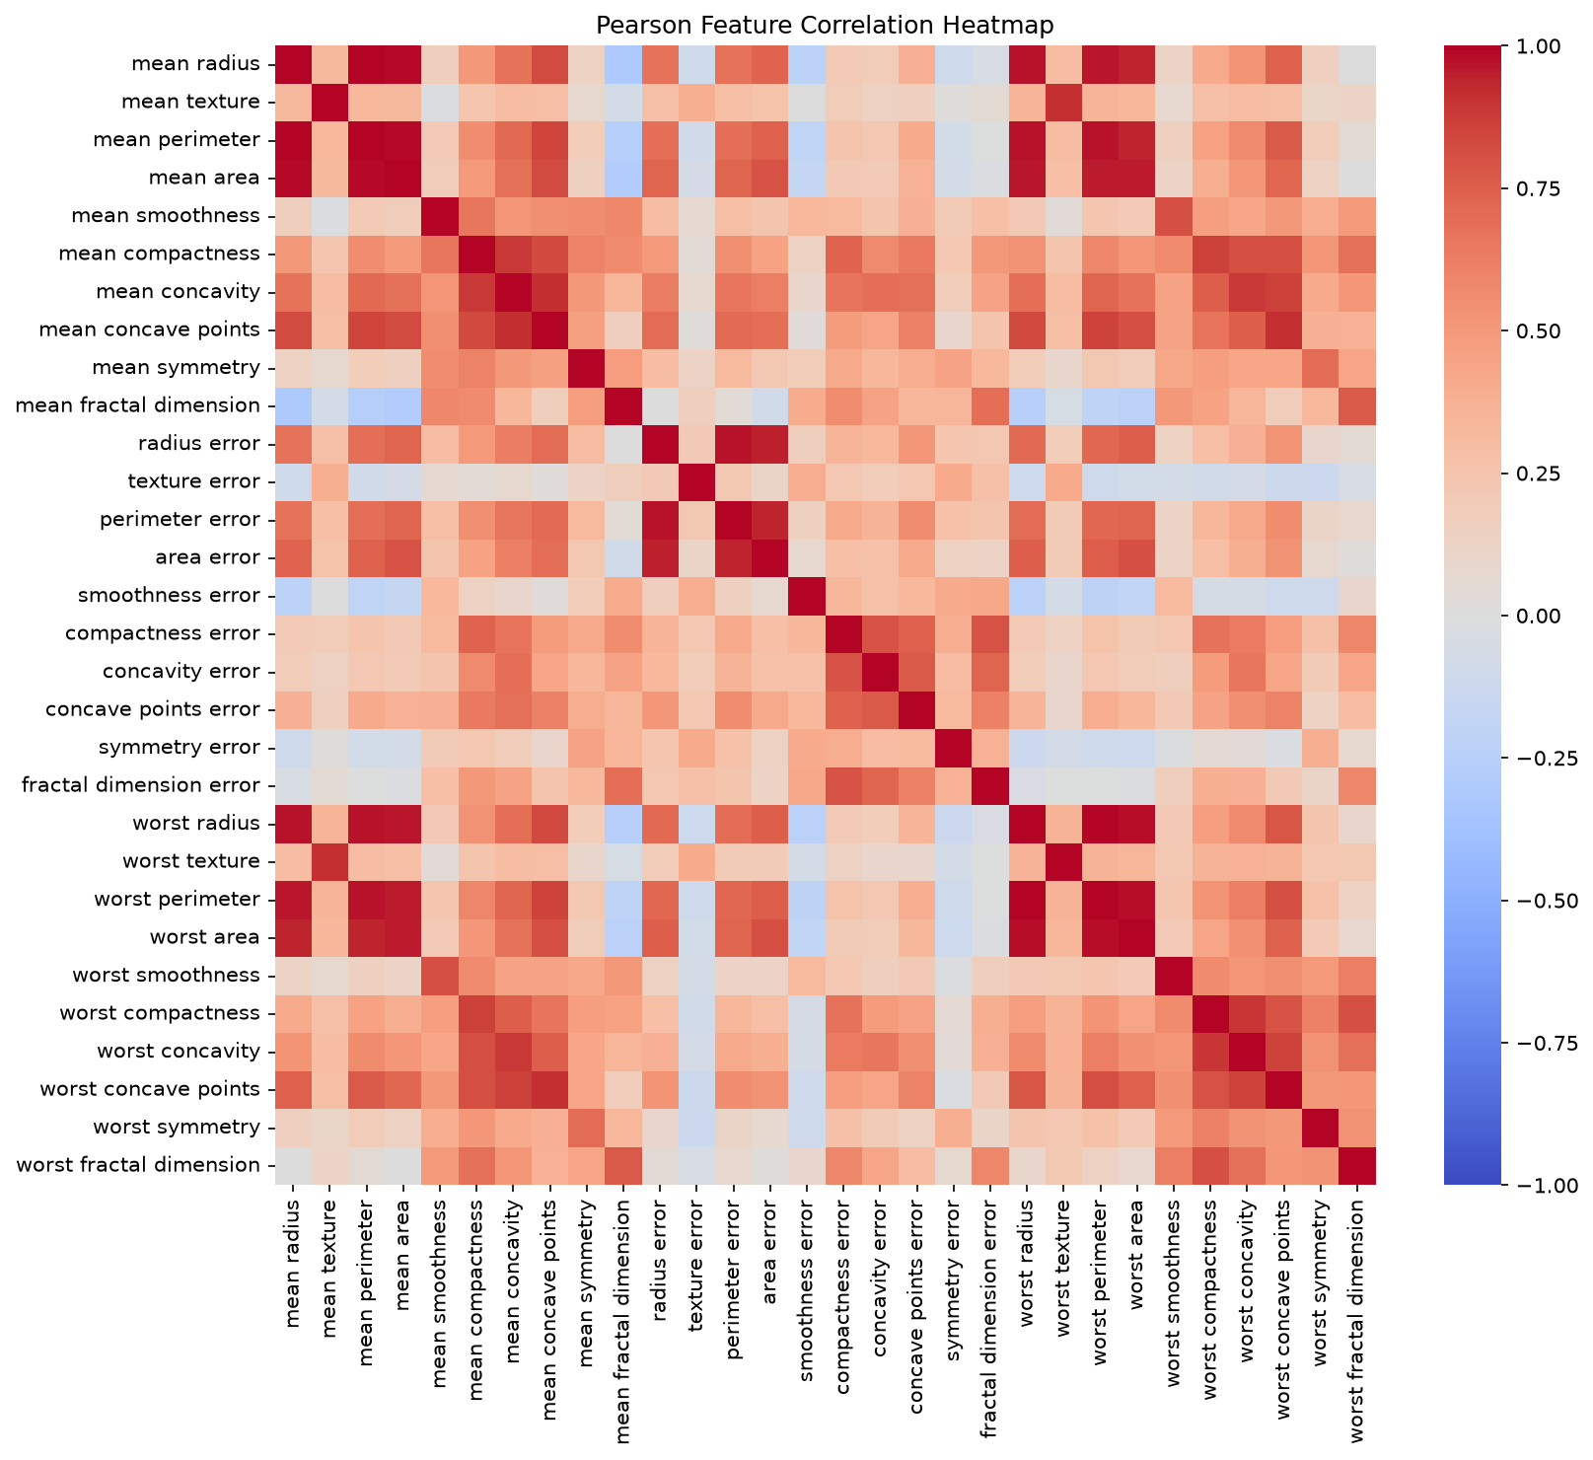
Top-three unique correlation pairs are reported in the executed notebooks.
The top-three unique Pearson pairs for each dataset are printed in cell 4 of the corresponding executed notebook after the heatmap.

3.3 Boxplots
Boxplots were produced in readable groups so that every feature could be inspected. The figures illustrate differences in feature ranges and identify potential extreme values. These plots were not used to remove observations or select a subset of predictors.
EDA boxplot figures included below.
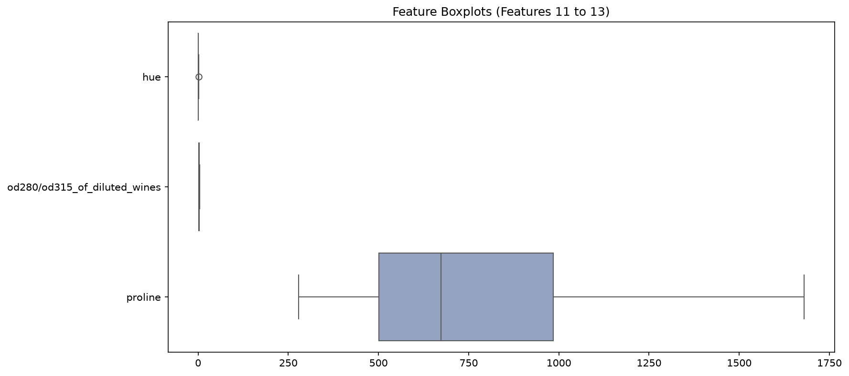
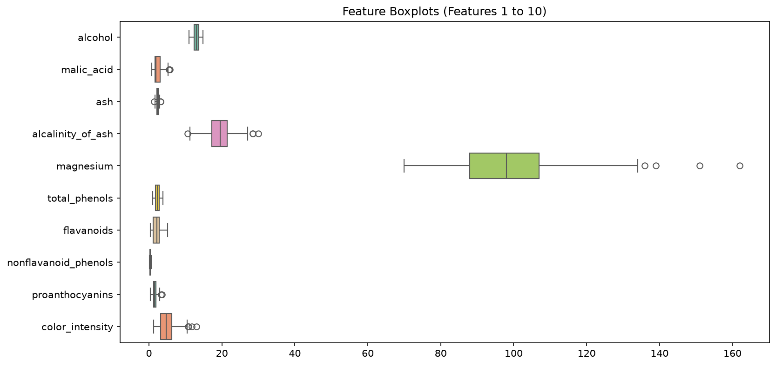
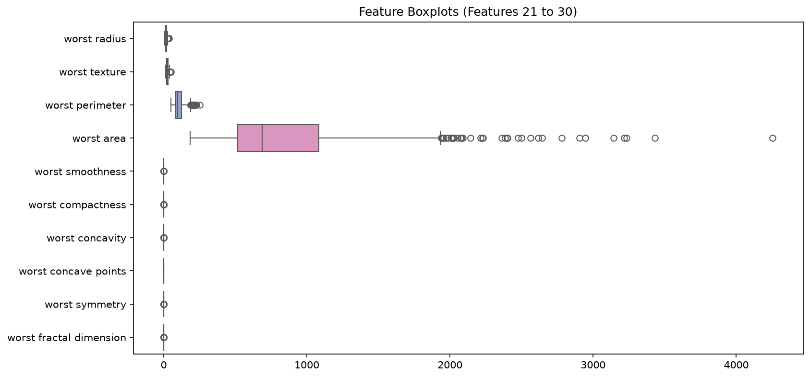
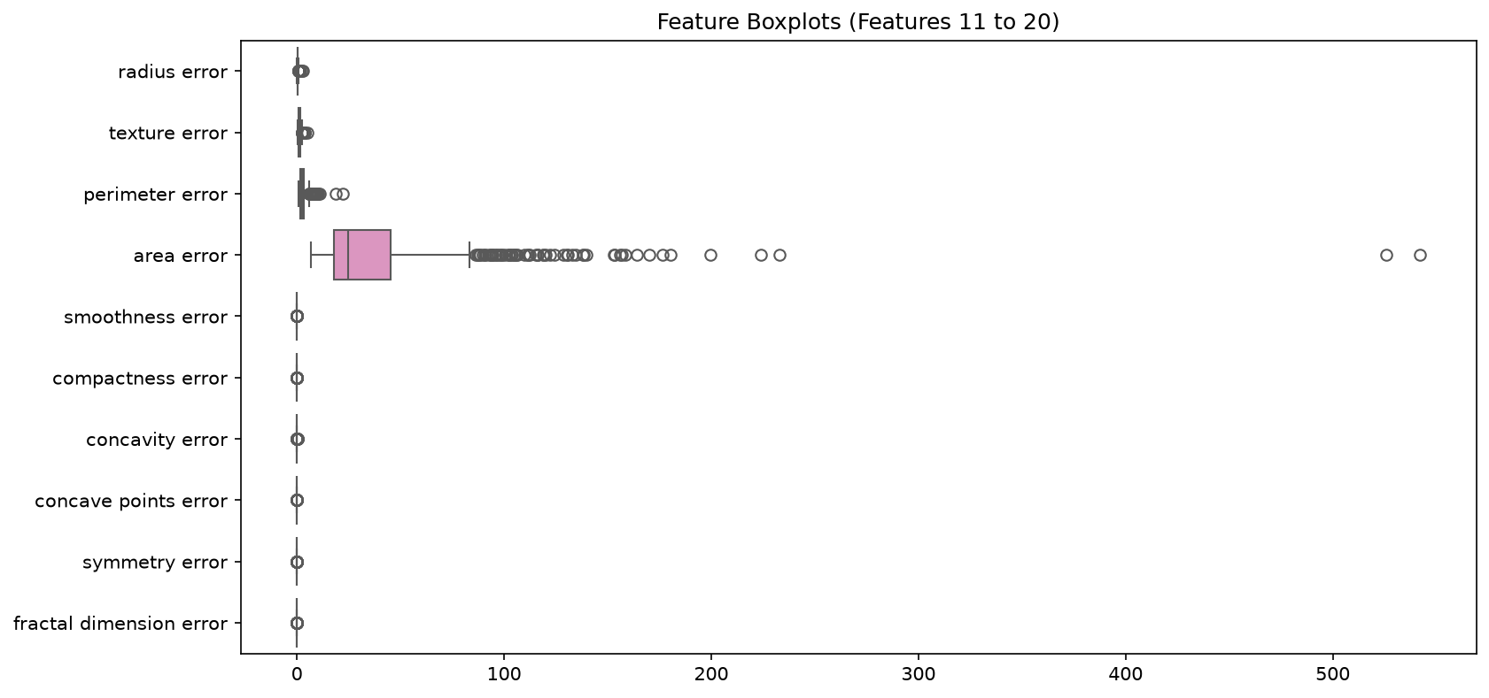
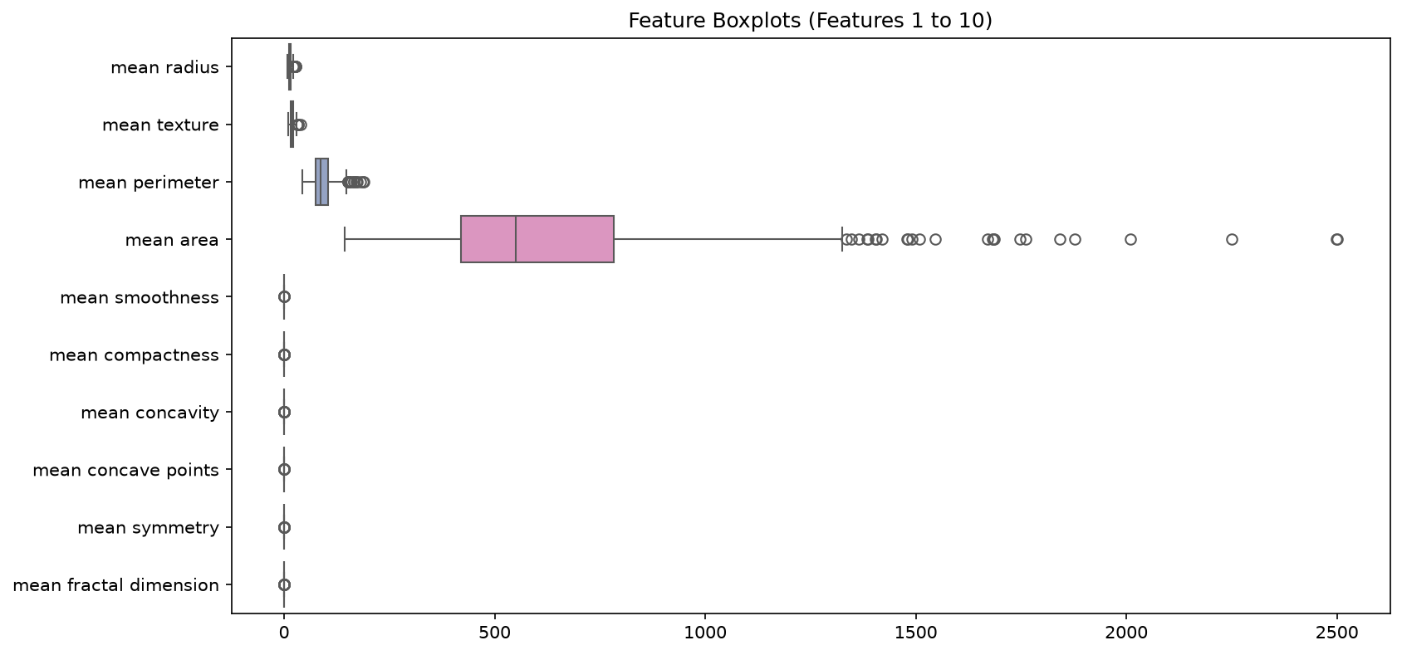
Interpretation: the EDA demonstrates that the two datasets have different feature scales and correlation structures. These descriptive differences motivate comparing unscaled and StandardScaler representations while keeping the original feature set unchanged.

4. Splitting the Datasets

4.1 Fixed test set and repeated training/validation splits
A fixed test set was reserved once for each dataset using train_test_split with test_size=0.20, stratify=y, and random_state=42. The resulting test indices were kept unchanged for the entire assignment. The remaining 80 percent was split three times using test_size=0.125, stratification by the labels, and random_state values 42, 52, and 62. These splits produce approximately 70 percent training, 10 percent validation, and 20 percent testing of the complete dataset.
The three seeds change only the training/validation membership. They do not create three different test sets and should not be interpreted as three-fold cross-validation. Original pandas row indices were preserved, and the same indices were used for every algorithm, parameter setting, and representation within a seed.
Split-summary tables included below.
seed | subset | n | percent | class_counts | original_indices | dataset
42 | train | 398 | 69.9500 | {0: np.int64(149), 1: np.int64(249)} | 301,390,420,356,446,56,82,221,339,364,37,263,341,210,514,234,99,533,482,69,484,192,392,81,245,529,91,35,456,351,79,272,270,177,469,46,163,181,107,108,332,48,262,362,379,531,146,382,562,325,98,377,400,532,539,500,100,438,460,274,419,207,441,172,411,315,347,144,306,148,233,57,36,372,409,282,287,416,68,369,61,478,512,278,143,265,165,474,561,413,67,432,42,236,54,374,548,401,201,458,162,159,32,171,337,229,312,277,322,304,290,436,241,106,249,348,136,334,178,2,398,368,47,503,62,554,116,546,202,89,297,124,253,521,330,5,251,538,166,182,268,195,138,19,470,286,226,414,188,59,218,510,345,430,208,8,3,160,403,149,133,65,294,371,209,509,404,179,485,357,219,547,141,556,97,388,300,25,53,448,412,565,130,225,255,118,499,493,437,303,497,216,384,506,389,536,222,324,492,175,11,299,545,566,142,12,260,502,338,335,105,443,122,259,80,450,476,331,0,227,311,74,421,487,76,530,28,318,276,396,31,555,86,329,327,196,370,220,426,442,243,498,212,88,113,323,17,319,494,252,63,365,463,472,317,90,184,285,440,126,29,380,558,449,367,240,525,326,264,373,320,271,10,395,9,114,40,232,508,4,352,101,543,153,244,187,183,169,21,155,486,154,238,280,189,505,34,30,511,520,314,376,254,387,137,517,145,475,466,58,305,33,479,402,429,109,342,397,120,173,451,129,110,111,18,239,427,435,349,193,55,78,309,273,418,190,283,139,44,366,559,459,563,513,289,6,248,16,336,211,447,170,425,462,491,410,125,45,156,360,407,215,72,524,378,355,52,391,103,455,302,424,22,550,480,115,515,131,26,152,112,346,477,161,250,481,281,92,147,43,119,71,94,123,551,191,213,313 | Breast Cancer
42 | validation | 57 | 10.0200 | {0: np.int64(21), 1: np.int64(36)} | 454,49,50,197,393,96,333,557,60,151,293,444,489,66,117,27,490,473,39,186,7,394,258,522,465,135,471,386,38,405,15,84,560,93,457,134,453,13,75,383,422,214,174,157,224,534,544,132,381,552,230,176,279,87,164,350,185 | Breast Cancer
42 | test | 114 | 20.0400 | {0: np.int64(42), 1: np.int64(72)} | 256,428,501,363,564,464,358,343,516,567,292,199,527,121,353,495,541,537,308,242,223,261,467,288,549,406,23,415,266,359,247,354,452,528,85,41,310,275,526,433,217,158,267,417,64,340,307,206,375,408,284,542,507,73,150,431,316,167,168,445,399,553,295,235,77,385,291,20,518,496,231,361,140,468,328,237,194,439,269,434,204,104,70,540,205,51,483,568,200,523,423,519,535,321,83,296,1,344,203,298,127,24,14,102,180,461,246,198,504,95,128,257,228,488 | Breast Cancer
52 | train | 398 | 69.9500 | {0: np.int64(149), 1: np.int64(249)} | 427,81,294,47,12,46,249,348,312,245,139,211,536,183,416,166,52,67,258,116,11,403,8,118,60,131,309,557,101,383,119,554,376,420,97,74,432,401,184,151,75,163,404,339,147,547,336,59,16,551,160,236,219,503,185,437,498,34,471,61,480,327,341,255,224,463,32,469,271,226,324,350,436,171,524,497,365,279,227,280,442,520,378,162,329,525,182,154,494,364,157,562,515,239,2,421,250,137,15,302,322,529,387,96,512,165,409,190,430,132,56,3,145,110,202,196,76,89,384,170,446,548,58,565,208,122,479,543,398,534,505,323,530,337,106,6,300,333,293,558,449,176,29,109,331,490,35,262,65,555,560,80,42,481,79,48,259,330,478,320,146,319,550,429,189,10,411,486,418,477,285,424,233,484,209,533,371,188,252,443,325,299,112,313,451,222,107,44,114,457,136,115,84,0,425,303,453,178,407,349,556,179,511,458,244,38,37,317,419,392,92,100,36,346,393,338,212,277,175,55,470,455,367,472,31,108,473,238,545,326,517,282,489,509,213,195,161,117,39,45,362,334,289,40,391,221,93,454,493,94,544,386,120,57,532,413,475,448,125,155,66,332,450,214,25,377,286,422,177,68,264,521,290,370,396,174,287,388,216,373,368,134,193,148,447,173,513,33,28,22,172,248,197,381,306,62,394,301,144,283,352,460,152,273,539,43,297,30,130,215,405,186,440,126,5,435,156,240,201,251,315,9,91,164,18,220,143,229,133,17,88,49,492,26,304,27,444,502,103,153,311,356,485,210,7,207,491,366,191,561,4,456,72,272,487,414,347,466,552,138,538,129,563,412,546,63,54,50,71,522,459,390,86,69,234,389,410,476,441,241,314,19,53,149,105,514,270,21,566,232,345,192,402,78,253,397,268,281 | Breast Cancer
52 | validation | 57 | 10.0200 | {0: np.int64(21), 1: np.int64(36)} | 142,243,135,274,263,181,254,510,187,438,278,369,305,355,265,98,482,506,379,230,87,90,225,380,474,351,342,13,500,124,374,531,499,426,360,169,395,465,159,318,99,113,335,218,141,123,357,111,559,276,260,508,462,400,372,382,82 | Breast Cancer
52 | test | 114 | 20.0400 | {0: np.int64(42), 1: np.int64(72)} | 256,428,501,363,564,464,358,343,516,567,292,199,527,121,353,495,541,537,308,242,223,261,467,288,549,406,23,415,266,359,247,354,452,528,85,41,310,275,526,433,217,158,267,417,64,340,307,206,375,408,284,542,507,73,150,431,316,167,168,445,399,553,295,235,77,385,291,20,518,496,231,361,140,468,328,237,194,439,269,434,204,104,70,540,205,51,483,568,200,523,423,519,535,321,83,296,1,344,203,298,127,24,14,102,180,461,246,198,504,95,128,257,228,488 | Breast Cancer
62 | train | 398 | 69.9500 | {0: np.int64(149), 1: np.int64(249)} | 3,508,471,379,319,56,342,279,476,451,86,403,429,276,456,448,315,552,87,19,21,0,383,534,312,82,311,544,101,179,214,503,126,195,120,536,76,302,234,245,280,29,341,224,453,252,208,529,57,93,7,489,27,248,484,260,263,32,249,367,409,15,546,320,458,472,49,97,213,339,152,148,411,401,426,485,171,186,444,515,138,297,227,502,301,46,376,418,520,435,219,5,145,90,59,44,271,222,478,18,380,201,545,117,232,327,188,68,386,365,176,424,421,139,314,400,334,412,289,193,240,324,290,94,557,287,345,272,133,230,116,255,273,80,17,244,147,377,335,12,160,378,337,475,282,303,67,473,505,538,172,38,509,98,492,162,404,92,149,427,181,106,338,143,368,155,355,65,114,43,241,522,395,42,499,460,419,389,370,258,216,48,197,387,397,346,233,250,63,110,306,402,422,50,382,129,336,550,189,524,69,547,265,371,357,52,533,136,187,286,517,481,184,146,178,532,164,413,414,497,498,210,556,384,2,190,202,491,170,425,565,281,175,323,480,393,330,438,132,39,436,45,512,372,447,420,53,177,161,108,459,514,166,58,566,254,304,388,351,192,356,454,37,22,9,543,531,174,251,493,332,109,457,236,30,238,191,211,113,156,479,525,349,548,455,182,562,4,185,74,325,390,78,122,157,364,396,369,494,407,259,239,130,333,416,60,352,84,555,300,107,348,28,277,449,131,163,500,317,309,16,105,558,151,510,159,135,153,398,506,212,278,183,75,530,450,62,88,209,391,154,362,100,477,554,11,513,91,99,10,207,326,118,360,35,551,25,268,482,89,169,270,490,173,111,430,313,392,366,8,13,253,437,293,165,521,322,539,6,561,115,123,442,54,81,79,142,103,474,40,124,66,47,225,446,274,563,294 | Breast Cancer
62 | validation | 57 | 10.0200 | {0: np.int64(21), 1: np.int64(36)} | 61,299,410,33,134,119,36,220,350,487,347,373,226,440,470,137,318,486,560,221,381,264,374,329,432,405,285,262,196,144,465,31,469,394,141,218,26,71,305,331,112,511,96,125,441,34,559,243,72,443,466,55,463,283,229,215,462 | Breast Cancer
62 | test | 114 | 20.0400 | {0: np.int64(42), 1: np.int64(72)} | 256,428,501,363,564,464,358,343,516,567,292,199,527,121,353,495,541,537,308,242,223,261,467,288,549,406,23,415,266,359,247,354,452,528,85,41,310,275,526,433,217,158,267,417,64,340,307,206,375,408,284,542,507,73,150,431,316,167,168,445,399,553,295,235,77,385,291,20,518,496,231,361,140,468,328,237,194,439,269,434,204,104,70,540,205,51,483,568,200,523,423,519,535,321,83,296,1,344,203,298,127,24,14,102,180,461,246,198,504,95,128,257,228,488 | Breast Cancer
42 | train | 124 | 69.6600 | {0: np.int64(41), 1: np.int64(50), 2: np.int64(33)} | 163,148,116,122,115,147,46,141,57,168,36,159,103,29,23,68,101,50,11,113,114,34,27,125,165,49,74,83,162,31,30,25,44,149,26,9,63,13,77,24,142,85,144,109,41,71,78,16,92,47,90,96,150,69,133,138,91,124,15,126,139,140,95,82,56,40,12,161,99,61,136,170,156,3,154,104,37,111,53,135,76,106,32,118,119,43,21,80,65,72,153,17,67,128,146,175,55,84,73,117,70,127,8,88,87,59,54,39,45,2,81,19,174,171,52,137,167,5,151,107,131,152,172,75 | Wine
42 | validation | 18 | 10.1100 | {0: np.int64(6), 1: np.int64(7), 2: np.int64(5)} | 157,145,158,110,6,120,0,89,123,33,79,35,1,97,4,86,169,160 | Wine
42 | test | 36 | 20.2200 | {0: np.int64(12), 1: np.int64(14), 2: np.int64(10)} | 10,134,28,121,62,51,7,66,129,166,102,143,42,130,14,108,105,20,100,38,93,60,22,18,98,64,58,132,112,155,48,176,94,177,164,173 | Wine
52 | train | 124 | 69.6600 | {0: np.int64(41), 1: np.int64(50), 2: np.int64(33)} | 128,135,53,27,172,141,169,11,131,79,111,83,75,115,86,84,12,87,4,89,147,126,0,55,36,67,13,24,127,117,15,122,157,61,39,71,167,9,8,104,37,154,107,118,95,168,1,152,159,160,92,144,59,16,29,30,76,174,49,156,119,74,133,44,82,41,162,109,6,150,139,124,145,136,17,85,103,25,170,19,88,52,142,96,54,175,158,80,57,77,3,163,137,99,148,73,161,56,21,32,125,35,149,26,78,151,113,72,50,5,81,106,101,43,47,153,68,23,123,65,97,90,46,110 | Wine
52 | validation | 18 | 10.1100 | {0: np.int64(6), 1: np.int64(7), 2: np.int64(5)} | 165,116,69,45,34,146,114,91,33,40,2,138,120,171,140,31,70,63 | Wine
52 | test | 36 | 20.2200 | {0: np.int64(12), 1: np.int64(14), 2: np.int64(10)} | 10,134,28,121,62,51,7,66,129,166,102,143,42,130,14,108,105,20,100,38,93,60,22,18,98,64,58,132,112,155,48,176,94,177,164,173 | Wine
62 | train | 124 | 69.6600 | {0: np.int64(41), 1: np.int64(50), 2: np.int64(33)} | 13,97,140,156,11,136,77,161,57,78,50,88,149,63,61,3,157,47,55,141,153,4,122,120,76,5,79,33,0,139,169,117,65,95,147,85,19,1,174,159,41,163,26,16,8,69,21,110,23,30,125,160,75,92,106,6,148,84,135,70,44,81,127,36,37,142,53,170,152,82,103,119,40,109,34,167,24,172,118,56,72,91,158,165,12,71,138,52,111,46,133,49,89,162,86,45,171,144,104,87,83,116,39,54,99,96,59,90,43,126,31,74,35,131,115,17,114,32,113,73,80,137,145,154 | Wine
62 | validation | 18 | 10.1100 | {0: np.int64(6), 1: np.int64(7), 2: np.int64(5)} | 168,175,29,68,67,124,2,15,27,101,9,123,25,107,150,128,151,146 | Wine
62 | test | 36 | 20.2200 | {0: np.int64(12), 1: np.int64(14), 2: np.int64(10)} | 10,134,28,121,62,51,7,66,129,166,102,143,42,130,14,108,105,20,100,38,93,60,22,18,98,64,58,132,112,155,48,176,94,177,164,173 | Wine

4.2 Split verification
For every seed, training and validation indices were checked for overlap. Their union was checked against the fixed non-test portion, and the test indices were verified to remain identical across repetitions. Counts were also checked against the complete dataset size.
Interpretation: this design prevents test-set reuse during model selection while allowing the effect of training/validation membership to be summarized across the three prescribed seeds.

5. Data Preprocessing and Scaling

5.1 Missing-value handling
Because the quality checks found no missing values in either dataset, no imputer was added. This avoids introducing an unnecessary transformation and follows the requirement not to create artificial missing values.

5.2 Scaler selection
StandardScaler was selected before the experiments and used consistently for both datasets and all three seeds. The scaler transforms each feature using the training-subset mean and standard deviation.

5.3 Training-only fitting
A new StandardScaler instance was fitted separately for every dataset and seed, producing six fitted scalers. Each scaler was fitted only on its corresponding training features and then applied to the matching training, validation, and, for seed 42, fixed test features. Validation and test data were never used to fit or refit a scaler, and target labels were not scaled.
Seed-42 before/after scaling displays are included in the executed notebooks.
The executed Section 5 pipeline output contains the first five seed-42 training rows before and after StandardScaler transformation for every feature in both datasets.
Interpretation: scaling changes the numerical representation while preserving the original feature columns and sample indices. It is expected to matter most for Euclidean distance calculations, particularly KNN and K-Means.

6. Preparing the Two Data Representations
Each dataset and seed was represented in two ways. The unscaled representation retained the original feature values. The scaled representation contained the same original features and row indices after transformation by the scaler fitted on that seed’s training subset. No dimensionality reduction or feature selection was applied.
Representation and index-alignment verification is included in the executed pipeline output.
The pipeline preserves pandas indices for every unscaled and scaled training, validation, and test representation. The same seed-specific indices are reused across classifiers and K-Means.
Interpretation: using identical samples and settings across the two representations isolates the effect of feature scaling rather than confounding scaling with a change in data membership or feature selection.

7. Training the Classification Models

7.1 Required experiments
Three classifiers were trained on both representations, for all three seeds. Decision Trees used max_depth values 2, 3, 5, 10, and None, with random_state equal to the current seed. KNN used n_neighbors values 1, 3, 5, 7, and 11, uniform weights, and Euclidean distance. Gaussian Naive Bayes used its default settings. Each dataset therefore required 66 classifier fits: 11 configurations multiplied by two representations and three seeds. Across both datasets, this produced 132 classifier fits.

7.2 Experiment recording
Every fit was recorded with an experiment ID containing the dataset, algorithm, representation, parameter, and seed. The run table includes training accuracy and training macro-F1 as well as the validation metrics defined in Section 8. The seed-42 fitted models and preprocessing objects were retained for the final test evaluations.
Complete classifier run records are provided in classifier_runs.csv.
Complete raw run records are in classifier_runs.csv: 132 rows total, 66 rows per dataset.
Interpretation: the complete run inventory prevents selective reporting of low-scoring configurations and makes the comparison reproducible across datasets, representations, and seeds.

8. Measuring Validation Performance

8.1 Required metrics
For every classifier run, validation accuracy, macro-precision, macro-recall, macro-F1, and ROC-AUC were calculated. Macro averaging gives each class equal weight. Undefined precision or recall cases were handled with zero_division=0 after identifying the relevant class condition.
For Breast Cancer, malignant cases from original class 0 were converted temporarily to one and benign cases from original class 1 to zero for ROC-AUC evaluation. The probability column for original class 0 was used. The model’s original training labels were not changed. For Wine, ROC-AUC was calculated from class probabilities using one-versus-rest evaluation with multi_class="ovr" and average="macro"; hard class predictions were not used to calculate ROC-AUC.
Validation metric definitions and outputs are provided in classifier_runs.csv.
Metric columns are recorded in classifier_runs.csv as val_accuracy, val_precision_macro, val_recall_macro, val_f1_macro, and val_roc_auc.

8.2 Comparison and model selection
The 132 run records were summarized into 44 configuration rows, with means and sample standard deviations across the three seeds. The final configuration selection followed the required strict order: highest mean validation macro-F1; then highest mean validation accuracy; then lowest validation macro-F1 standard deviation; then alphabetically smallest configuration_id. Test performance was not used for selection, and the best individual seed was not substituted for the predeclared seed-42 fitted instance.
Two 66-row validation tables are provided by filtering classifier_runs.csv by dataset.
The two 66-row validation tables are available by filtering classifier_runs.csv on dataset. They contain training and validation metrics for every required configuration.
Two 22-row classifier summaries are included below.
dataset | configuration_id | val_f1_macro_mean | val_f1_macro_std | val_accuracy_mean | val_accuracy_std
breast_cancer | breast_cancer_decision_tree_scaled_10 | 0.9195 | 0.0112 | 0.9240 | 0.0101
breast_cancer | breast_cancer_decision_tree_scaled_2 | 0.9117 | 0.0236 | 0.9181 | 0.0203
breast_cancer | breast_cancer_decision_tree_scaled_3 | 0.9177 | 0.0304 | 0.9240 | 0.0268
breast_cancer | breast_cancer_decision_tree_scaled_5 | 0.9188 | 0.0227 | 0.9240 | 0.0203
breast_cancer | breast_cancer_decision_tree_scaled_None | 0.9195 | 0.0112 | 0.9240 | 0.0101
breast_cancer | breast_cancer_decision_tree_unscaled_10 | 0.9195 | 0.0112 | 0.9240 | 0.0101
breast_cancer | breast_cancer_decision_tree_unscaled_2 | 0.9117 | 0.0236 | 0.9181 | 0.0203
breast_cancer | breast_cancer_decision_tree_unscaled_3 | 0.9177 | 0.0304 | 0.9240 | 0.0268
breast_cancer | breast_cancer_decision_tree_unscaled_5 | 0.9188 | 0.0227 | 0.9240 | 0.0203
breast_cancer | breast_cancer_decision_tree_unscaled_None | 0.9195 | 0.0112 | 0.9240 | 0.0101
breast_cancer | breast_cancer_gaussian_nb_scaled_default | 0.9248 | 0.0201 | 0.9298 | 0.0175
breast_cancer | breast_cancer_gaussian_nb_unscaled_default | 0.9369 | 0.0226 | 0.9415 | 0.0203
breast_cancer | breast_cancer_knn_scaled_1 | 0.9369 | 0.0213 | 0.9415 | 0.0203
breast_cancer | breast_cancer_knn_scaled_11 | 0.9608 | 0.0395 | 0.9649 | 0.0351
breast_cancer | breast_cancer_knn_scaled_3 | 0.9547 | 0.0228 | 0.9591 | 0.0203
breast_cancer | breast_cancer_knn_scaled_5 | 0.9547 | 0.0228 | 0.9591 | 0.0203
breast_cancer | breast_cancer_knn_scaled_7 | 0.9677 | 0.0297 | 0.9708 | 0.0268
breast_cancer | breast_cancer_knn_unscaled_1 | 0.8786 | 0.0566 | 0.8889 | 0.0506
breast_cancer | breast_cancer_knn_unscaled_11 | 0.9155 | 0.0113 | 0.9240 | 0.0101
breast_cancer | breast_cancer_knn_unscaled_3 | 0.8910 | 0.0449 | 0.9006 | 0.0405
breast_cancer | breast_cancer_knn_unscaled_5 | 0.9107 | 0.0297 | 0.9181 | 0.0268
breast_cancer | breast_cancer_knn_unscaled_7 | 0.9040 | 0.0013 | 0.9123 | 0.0000
wine | wine_decision_tree_scaled_10 | 0.9462 | 0.0545 | 0.9444 | 0.0556
wine | wine_decision_tree_scaled_2 | 0.8481 | 0.0365 | 0.8519 | 0.0321
wine | wine_decision_tree_scaled_3 | 0.9462 | 0.0545 | 0.9444 | 0.0556
wine | wine_decision_tree_scaled_5 | 0.9462 | 0.0545 | 0.9444 | 0.0556
wine | wine_decision_tree_scaled_None | 0.9462 | 0.0545 | 0.9444 | 0.0556
wine | wine_decision_tree_unscaled_10 | 0.9462 | 0.0545 | 0.9444 | 0.0556
wine | wine_decision_tree_unscaled_2 | 0.8481 | 0.0365 | 0.8519 | 0.0321
wine | wine_decision_tree_unscaled_3 | 0.9462 | 0.0545 | 0.9444 | 0.0556
wine | wine_decision_tree_unscaled_5 | 0.9462 | 0.0545 | 0.9444 | 0.0556
wine | wine_decision_tree_unscaled_None | 0.9462 | 0.0545 | 0.9444 | 0.0556
wine | wine_gaussian_nb_scaled_default | 0.9638 | 0.0314 | 0.9630 | 0.0321
wine | wine_gaussian_nb_unscaled_default | 0.9638 | 0.0314 | 0.9630 | 0.0321
wine | wine_knn_scaled_1 | 0.9658 | 0.0296 | 0.9630 | 0.0321
wine | wine_knn_scaled_11 | 0.9814 | 0.0323 | 0.9815 | 0.0321
wine | wine_knn_scaled_3 | 0.9457 | 0.0558 | 0.9444 | 0.0556
wine | wine_knn_scaled_5 | 0.9814 | 0.0323 | 0.9815 | 0.0321
wine | wine_knn_scaled_7 | 0.9814 | 0.0323 | 0.9815 | 0.0321
wine | wine_knn_unscaled_1 | 0.6714 | 0.0226 | 0.7037 | 0.0321
wine | wine_knn_unscaled_11 | 0.6005 | 0.0010 | 0.6296 | 0.0321
wine | wine_knn_unscaled_3 | 0.6456 | 0.0429 | 0.6667 | 0.0556
wine | wine_knn_unscaled_5 | 0.6667 | 0.0399 | 0.7037 | 0.0321
wine | wine_knn_unscaled_7 | 0.6356 | 0.0316 | 0.6667 | 0.0000
Tree-depth and KNN parameter-comparison figures included below.
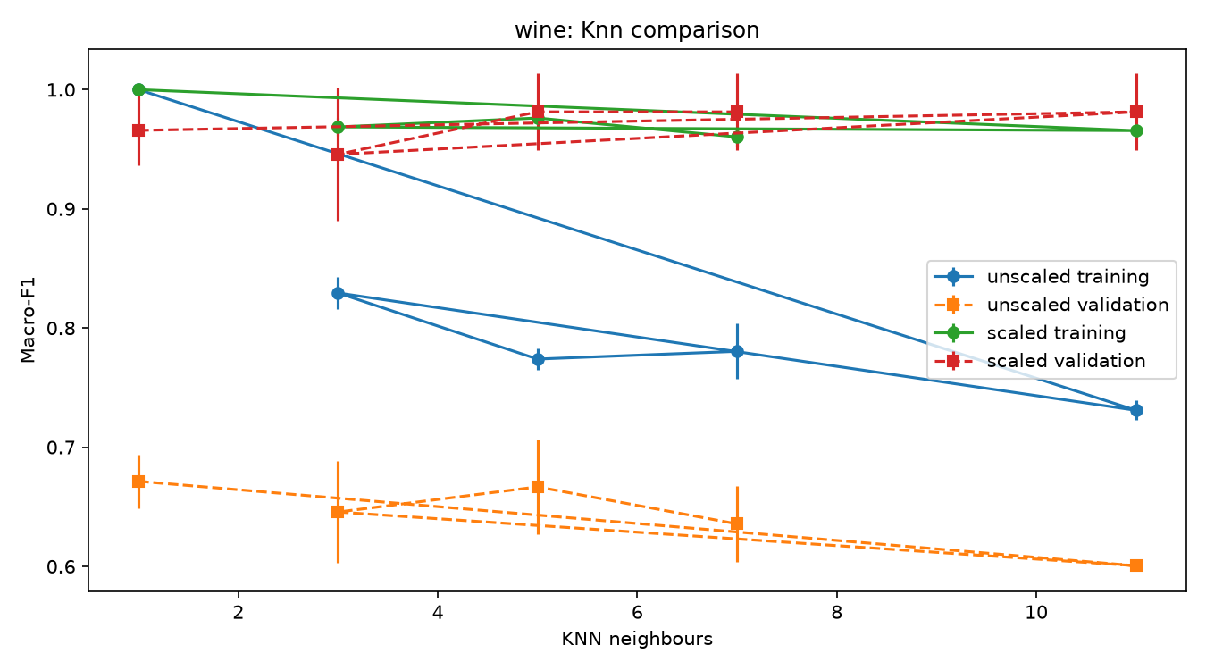
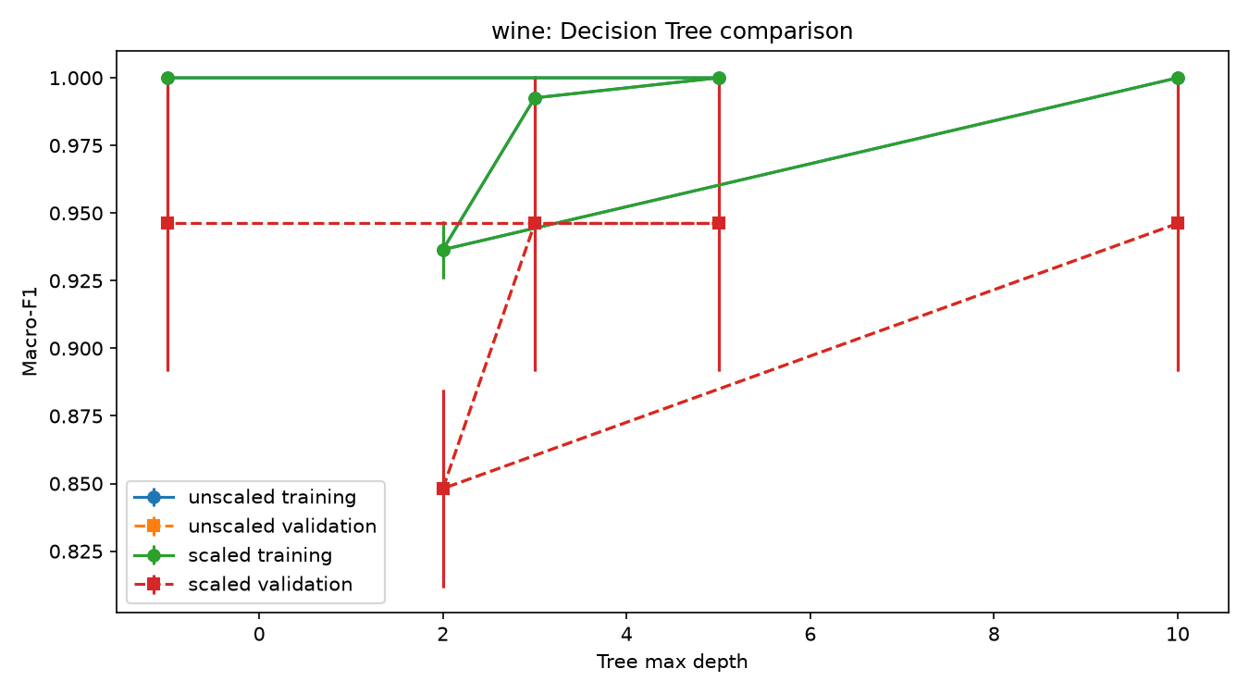
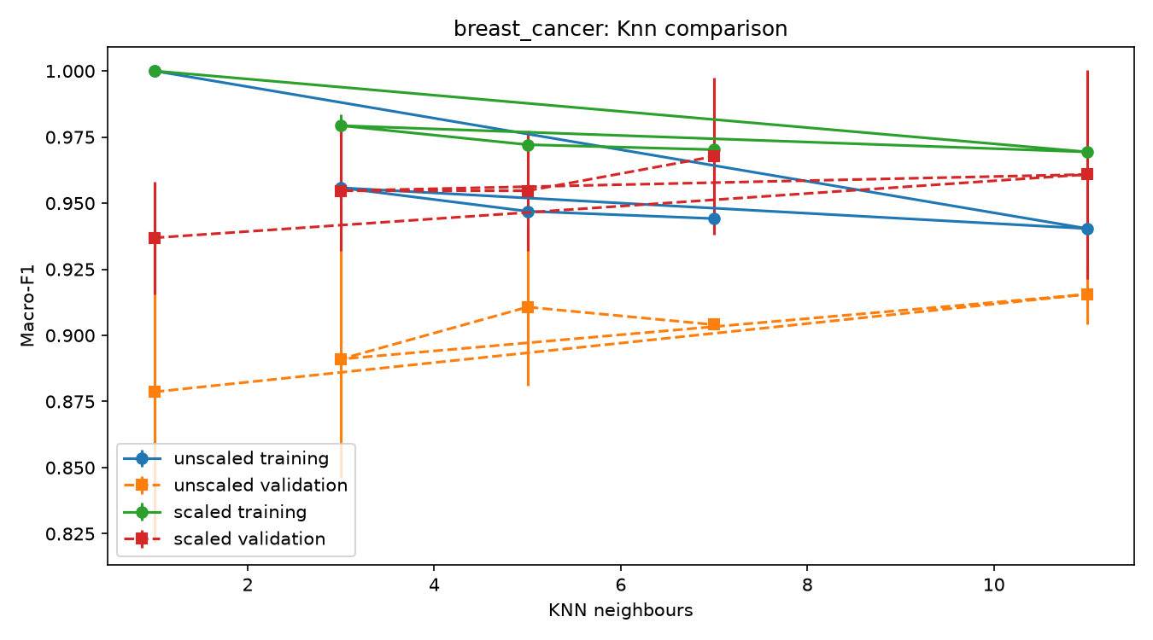
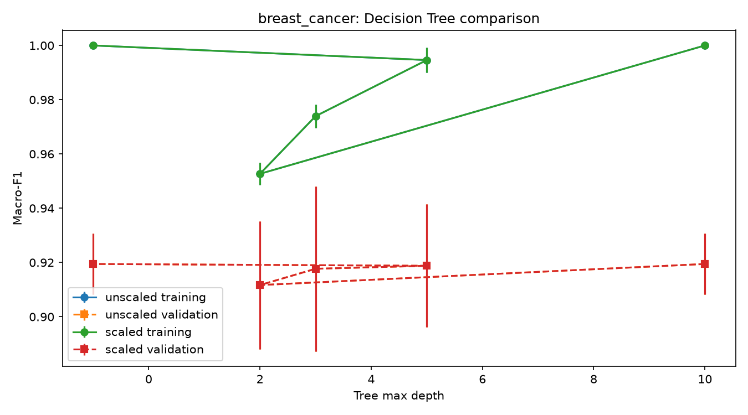
Interpretation: the comparison should be read in terms of both central performance and variation across the three repeated splits. The standard deviation describes split-to-split variability and is not a confidence interval or a claim of statistical significance.

9. Evaluating the Selected Models on the Test Sets

9.1 Final performance metrics
After validation-based selection was frozen, only the seed-42 fitted instance of each selected configuration was evaluated on its fixed test set. No candidate was refit on training plus validation data, and no test result was used to revise the selection.
Final classifier test table included below.
dataset | selected_algorithm | selected_representation | selected_parameter | evaluation_seed | validation_f1_mean | validation_f1_std | test_accuracy | test_precision_macro | test_recall_macro | test_f1_macro | test_roc_auc | selected_configuration_id
breast_cancer | knn | scaled | n_neighbors=7 | 42 | 0.9677 | 0.0297 | 0.9737 | 0.9800 | 0.9643 | 0.9713 | 0.9888 | breast_cancer_knn_scaled_7
wine | knn | scaled | n_neighbors=11 | 42 | 0.9814 | 0.0323 | 1.0000 | 1.0000 | 1.0000 | 1.0000 | 1.0000 | wine_knn_scaled_11
Per-class classification reports included below.
Breast Cancer classification report:
precision recall f1-score support
malignant 1.00 0.93 0.96 42
benign 0.96 1.00 0.98 72
accuracy 0.97 114
macro avg 0.98 0.96 0.97 114
weighted avg 0.97 0.97 0.97 114
Confusion matrix:
[[39 3]
[ 0 72]]
Breast Cancer manual malignant: TP=39, FP=0, FN=3, precision=1.0000, recall=0.9286, F1=0.9630
Wine classification report:
precision recall f1-score support
class_0 1.00 1.00 1.00 12
class_1 1.00 1.00 1.00 14
class_2 1.00 1.00 1.00 10
accuracy 1.00 36
macro avg 1.00 1.00 1.00 36
weighted avg 1.00 1.00 1.00 36
Confusion matrix:
[[12 0 0]
[ 0 14 0]
[ 0 0 10]]
Wine manual class_0 versus rest: TP=12, FP=0, FN=0, precision=1.0000, recall=1.0000, F1=1.0000

9.2 Confusion matrices and manual metric checks
A count-based confusion matrix was produced for each selected classifier. For Breast Cancer, the class order was [0, 1] = [malignant, benign]. With malignant as the positive class, the malignant true positives are the matrix entry for actual malignant and predicted malignant; malignant false negatives are actual malignant predicted benign; malignant false positives are actual benign predicted malignant; and malignant true negatives are actual benign predicted benign.
The malignant-class metrics were calculated manually from the matrix counts: precision = TP/(TP+FP), recall = TP/(TP+FN), and F1 = 2(precision)(recall)/(precision+recall). These values were compared against the malignant row in the classification report, not against a macro average.
For Wine, one class was selected and evaluated against all other classes. Its one-versus-rest TP, FP, FN, and TN counts were obtained from the 3-by-3 confusion matrix, and precision, recall, and F1 were calculated using the same formulas. These manual values were compared with the selected class row in the classification report.
Confusion-matrix figures included below.
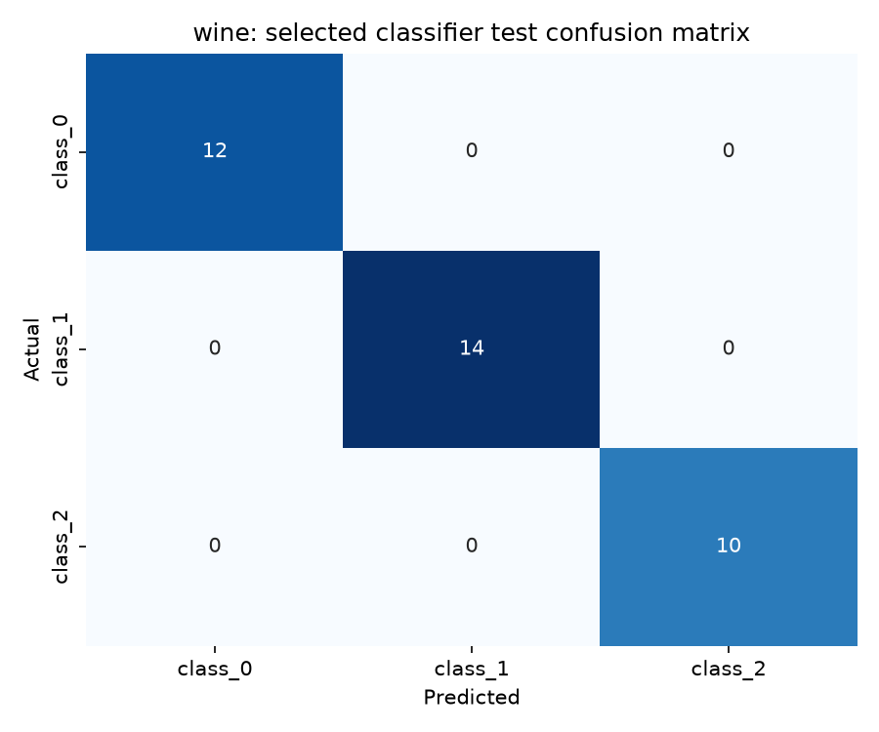
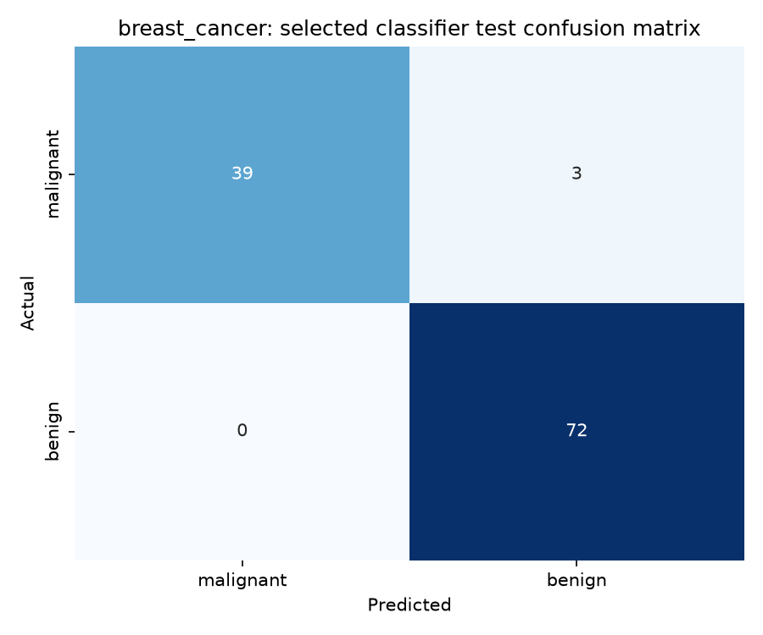
Manual confusion-matrix calculations are reported above and checked against the per-class reports.
Manual calculations and the corresponding classification reports are shown above. The values were calculated from confusion-matrix counts, not copied from macro averages.

9.3 ROC curves
The Breast Cancer ROC figure uses the temporary malignant-versus-benign evaluation target and the probability of original class 0. The Wine figure contains one one-versus-rest curve for each class and reports the macro one-versus-rest AUC. The curves are descriptive test outputs; no threshold was tuned using the test set.
In general, increasing a decision threshold tends to reduce predicted positives, which can lower false positives but increase false negatives. Decreasing the threshold generally has the opposite trade-off.
Breast Cancer ROC curve included below.
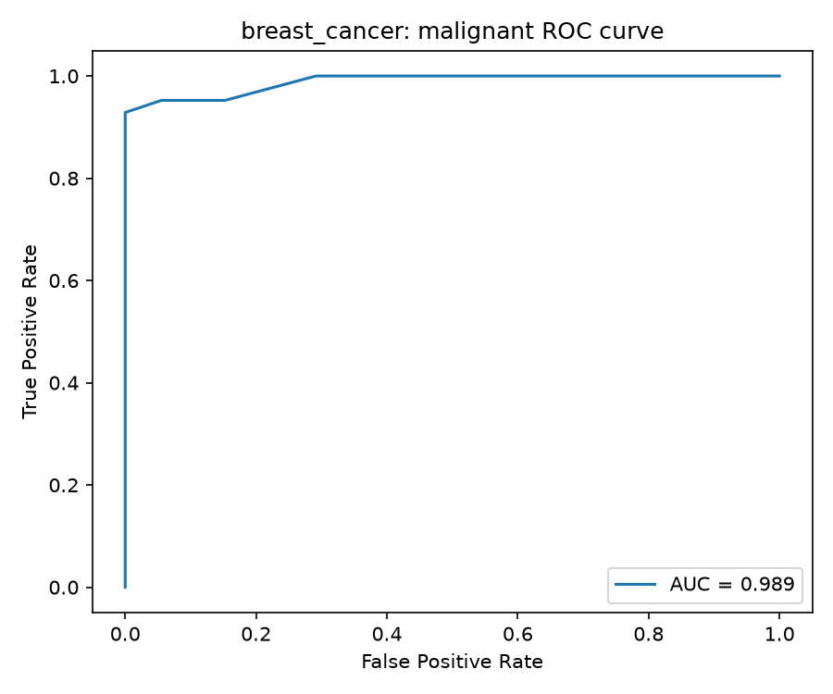
Wine one-versus-rest ROC curves included below.
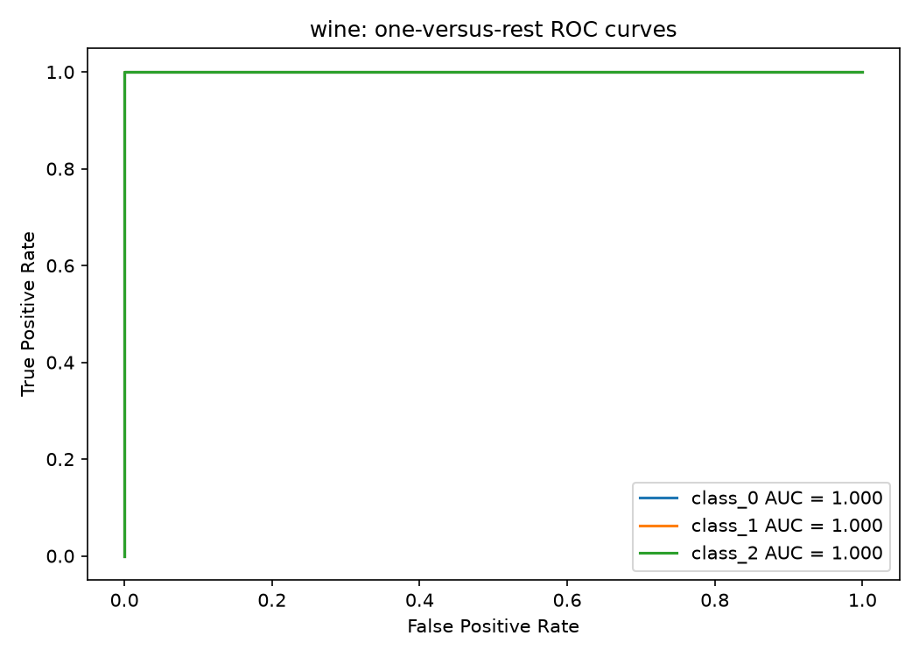

9.4 Error interpretation and limitation
One actual misclassification should be described for each dataset using its original test-row index, actual label, predicted label, and class meaning. If a selected classifier has no errors on a dataset, that absence should be reported directly rather than replaced by an invented example. A single error-free test result does not establish perfect generalisation.
Misclassification/no-error statements are included in the executed notebook output.
The executed notebook cell prints actual misclassified test-row indices when errors occur. For Wine, the selected seed-42 test evaluation has no misclassifications; this is reported as a fixed-split result, not proof of perfect generalisation.
A principal limitation is the small validation subset and the overlap that can occur among training/validation memberships across repetitions. The three repetitions are not independent test evaluations. In addition, the final test evaluation deliberately uses only the predeclared seed-42 fitted instance.

10. K-Means Clustering

10.1 Fit and validate the clustering models
K-Means was fitted for both datasets, both representations, and all three seeds, producing 12 fits. Breast Cancer used n_clusters=2 and Wine used n_clusters=3. Each model used random_state equal to the seed and n_init=10. Target labels were not passed to KMeans.fit. Training inertia and validation adjusted Rand index (ARI) and silhouette score were recorded.
K-Means run tables included below.
dataset | seed | representation | n_clusters | train_inertia | val_ari | val_silhouette
breast_cancer | 42 | unscaled | 2 | 51565380.5448 | 0.3995 | 0.6387
breast_cancer | 42 | scaled | 2 | 7918.8101 | 0.4516 | 0.2854
breast_cancer | 52 | unscaled | 2 | 49190782.1788 | 0.6122 | 0.6975
breast_cancer | 52 | scaled | 2 | 8003.0010 | 0.5586 | 0.3750
breast_cancer | 62 | unscaled | 2 | 53056488.4035 | 0.5013 | 0.6958
breast_cancer | 62 | scaled | 2 | 7922.5149 | 0.7336 | 0.2758
wine | 42 | unscaled | 3 | 1350496.4591 | 0.2828 | 0.4870
wine | 42 | scaled | 3 | 874.7391 | 1.0000 | 0.2516
wine | 52 | unscaled | 3 | 1303674.8207 | 0.4006 | 0.5559
wine | 52 | scaled | 3 | 890.4355 | 1.0000 | 0.3010
wine | 62 | unscaled | 3 | 1390754.2171 | 0.4006 | 0.6867
wine | 62 | scaled | 3 | 872.2466 | 1.0000 | 0.2726
K-Means summary tables included below.
dataset | representation | train_inertia_mean | train_inertia_std | val_ari_mean | val_ari_std | val_silhouette_mean | val_silhouette_std | valid_ari_count | valid_silhouette_count
breast_cancer | scaled | 7948.1087 | 47.5743 | 0.5813 | 0.1424 | 0.3121 | 0.0547 | 3 | 3
breast_cancer | unscaled | 51270883.7090 | 1949606.9972 | 0.5043 | 0.1064 | 0.6773 | 0.0334 | 3 | 3
wine | scaled | 879.1404 | 9.8609 | 1.0000 | 0.0000 | 0.2751 | 0.0248 | 3 | 3
wine | unscaled | 1348308.4990 | 43580.9098 | 0.3613 | 0.0680 | 0.5765 | 0.1014 | 3 | 3

10.2 Final cluster evaluation
For seed 42, the already fitted K-Means models predicted clusters for the fixed test set in both representations. This produced four final clustering evaluations. ARI compares the class and cluster partitions while accounting for chance; cluster IDs do not need to match class-number values. Silhouette was calculated in the same representation used for fitting. Raw inertia values were not interpreted as directly comparable across scaled and unscaled feature spaces.
The four class-versus-cluster contingency tables are printed in the executed notebooks.
The four contingency tables are printed in the executed Section 10 output for Breast Cancer/Wine and unscaled/scaled representations.
Final K-Means test table included below.
dataset | representation | seed | n_clusters | test_cluster_counts | test_ari | test_silhouette
breast_cancer | unscaled | 42 | 2 | {0: np.int64(86), 1: np.int64(28)} | 0.5585 | 0.7120
breast_cancer | scaled | 42 | 2 | {0: np.int64(74), 1: np.int64(40)} | 0.7354 | 0.3251
wine | unscaled | 42 | 3 | {0: np.int64(14), 1: np.int64(10), 2: np.int64(12)} | 0.3733 | 0.4929
wine | scaled | 42 | 3 | {0: np.int64(13), 1: np.int64(13), 2: np.int64(10)} | 0.9088 | 0.2711

10.3 Visualisation and interpretation
For each dataset, two original features were selected using the seed-42 training data and used consistently in paired test figures. The first panel shows true classes and the second shows predicted cluster IDs. These plots are two-dimensional projections of models fitted using all original features. They should therefore be interpreted alongside ARI, silhouette, and the contingency tables.
K-Means paired figures included below.
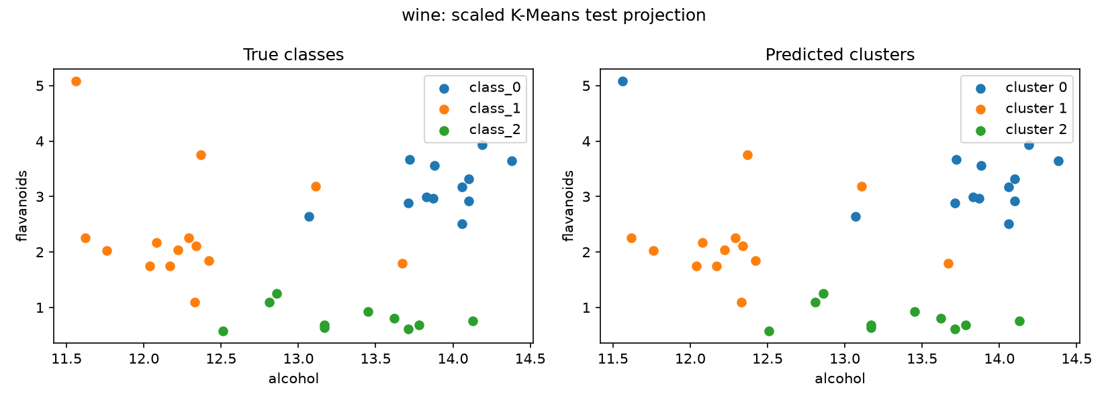
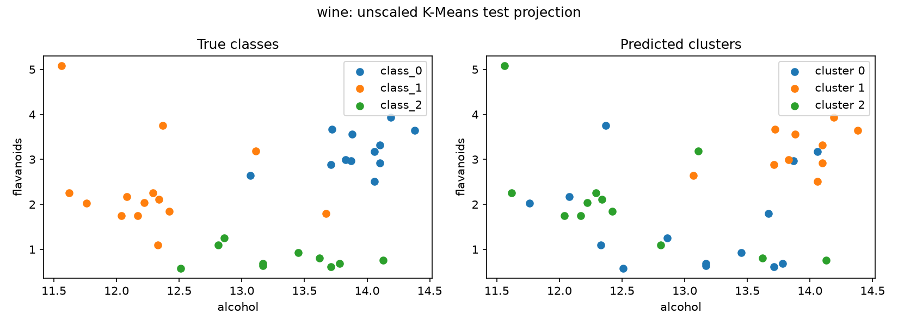
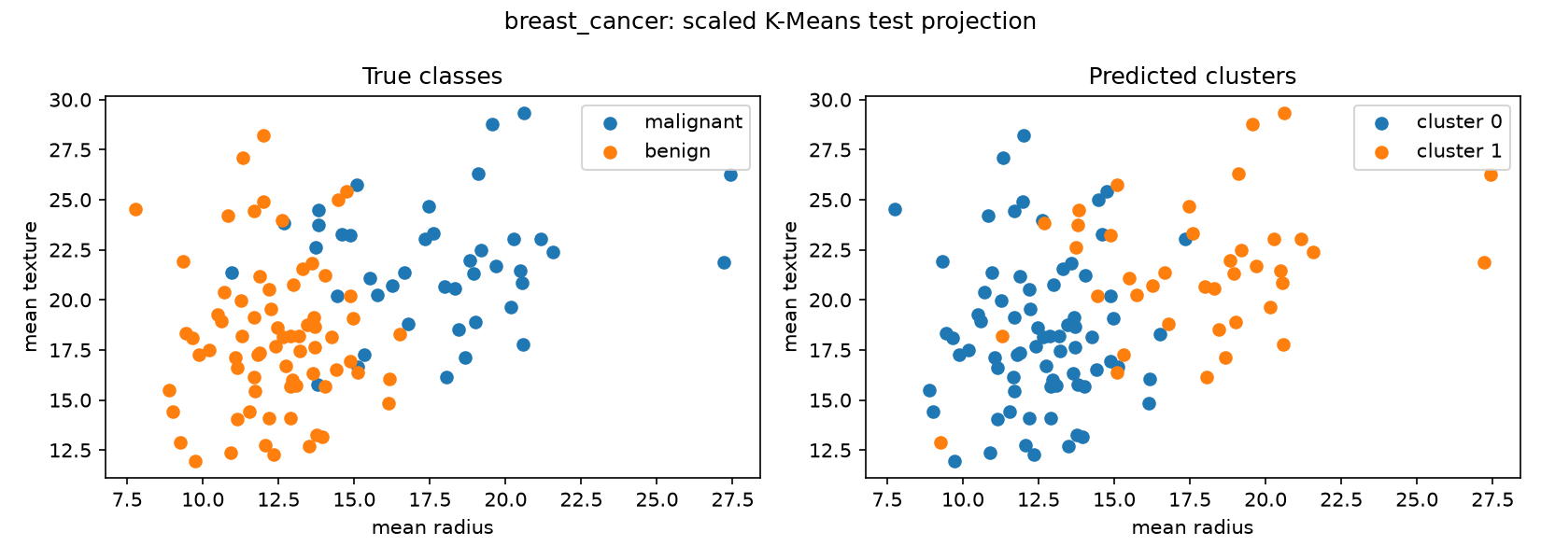
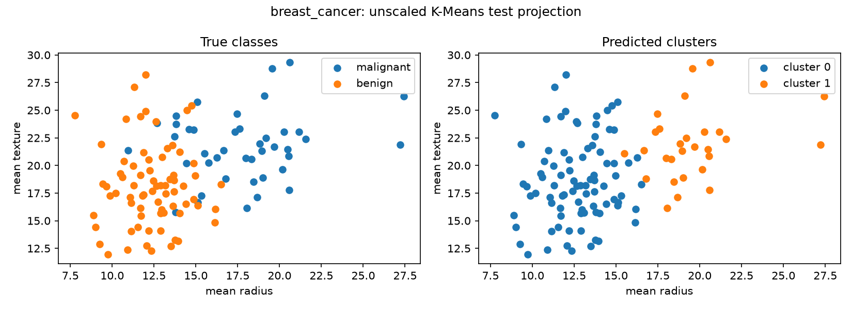
K-Means receives no target labels during fitting and attempts to organize observations according to feature-space geometry. The classifiers, in contrast, receive training labels and directly learn a mapping from features to classes. This difference explains why clusters can be mixed even when a supervised classifier performs well.

11. Comparing the Two Datasets
This section compares the datasets using the validation summaries, fixed seed-42 test evaluations, confusion matrices, and K-Means contingency tables. Exact values should be inserted from the generated CSV files and figures rather than inferred from general expectations.

11.1 Did the same classifier and representation perform best on both datasets?
The selected supervised configuration should be compared first by mean validation macro-F1 and then by the prescribed tie-breakers. The final test scores should be reported separately because test data were reserved for final evaluation. If both datasets select scaled KNN, this would indicate that distance-sensitive classification benefited from putting features on comparable scales; the different selected neighbour counts would still reflect dataset-specific class structure and sample size. If the selected configurations differ, the difference should be interpreted as evidence that the same inductive bias is not uniformly optimal across feature spaces.
Selected configurations and validation/test values included below.
dataset | selected_configuration_id | validation_f1_mean | validation_f1_std | test_accuracy | test_f1_macro | test_roc_auc
breast_cancer | breast_cancer_knn_scaled_7 | 0.9677 | 0.0297 | 0.9737 | 0.9713 | 0.9888
wine | wine_knn_scaled_11 | 0.9814 | 0.0323 | 1.0000 | 1.0000 | 1.0000

11.2 Which algorithm was most affected by scaling?
The expected largest scaling effect is for KNN because Euclidean distances are directly affected by feature units. K-Means is also distance-based and should be discussed separately in the clustering section. Decision Trees should show little or no change under monotonic scaling because threshold ordering is preserved. Gaussian Naive Bayes is not distance-based, so any scaling change should be interpreted through its distributional assumptions rather than attributed automatically to distance geometry.

11.3 Did deeper trees or larger neighbour counts always improve validation performance?
The parameter-comparison figures should be used to determine whether performance increases monotonically. A deeper tree can reduce bias but may increase variance or plateau once sufficient splits are available. Larger KNN neighbourhoods can smooth noisy decisions but may oversmooth class boundaries. The three-seed standard deviations should be reported alongside means to show whether a difference is stable across splits.

11.4 How did the main classification errors differ?
For Breast Cancer, errors should be described with particular attention to malignant false negatives because class 0 is the designated positive class for error interpretation. For Wine, the largest off-diagonal confusion should be identified from the 3-by-3 matrix, unless the selected classifier makes no errors on the fixed test set. The discussion should distinguish the medical meaning of a malignant false negative from the class-confusion meaning of a Wine misclassification.
Confusion-matrix comparison figures included above.

11.5 How did K-Means agreement with the true classes differ?
ARI and the contingency tables should be used rather than ordinary classification accuracy. Stronger ARI indicates greater agreement between the class partition and cluster partition after accounting for chance, but cluster IDs themselves do not represent class labels. Scaling may improve K-Means when large-unit features would otherwise dominate the geometry; silhouette must be interpreted within each feature representation and not treated as a direct cross-unit comparison.
K-Means ARI and contingency-table comparison included below.
dataset | representation | test_ari | test_silhouette | test_cluster_counts
breast_cancer | unscaled | 0.5585 | 0.7120 | {0: np.int64(86), 1: np.int64(28)}
breast_cancer | scaled | 0.7354 | 0.3251 | {0: np.int64(74), 1: np.int64(40)}
wine | unscaled | 0.3733 | 0.4929 | {0: np.int64(14), 1: np.int64(10), 2: np.int64(12)}
wine | scaled | 0.9088 | 0.2711 | {0: np.int64(13), 1: np.int64(13), 2: np.int64(10)}

11.6 What one change should be investigated next?
One defensible future investigation would be to predeclare additional validation repetitions or compare another distance-based method using the same training-only preprocessing discipline. This would be future work, not a result of the current experiment. Any proposed change should preserve the fixed test set and should not use test performance to tune the next model.
Overall conclusion: the study provides a controlled comparison of supervised and unsupervised learning across two datasets, with explicit handling of scaling, repeated training/validation splits, validation-only model selection, fixed seed-42 final testing, and transparent run inventories. The final report should replace every red placeholder with the corresponding table, figure, or value from the executed project files before submission.

