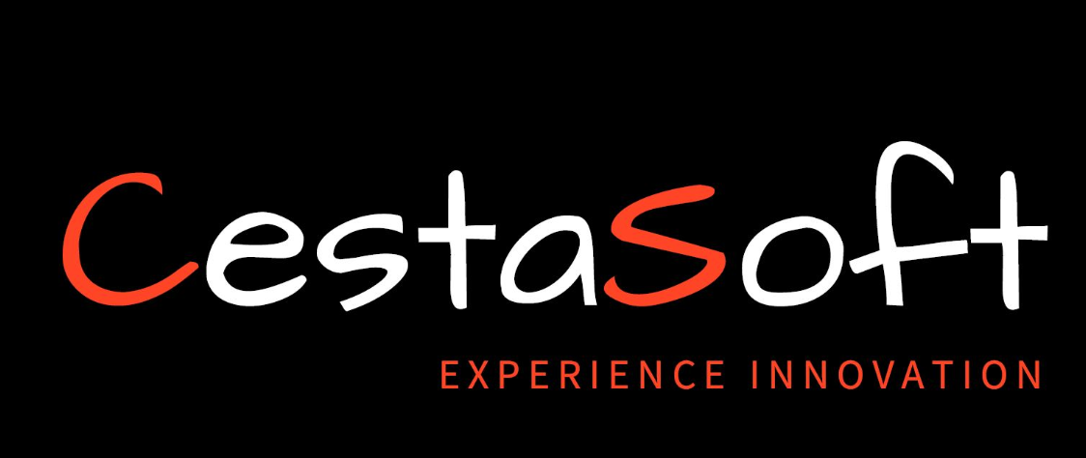 | Experience Innovation  Recruiter-ready professional profile

{{FULL_NAME}}
{{PROFESSIONAL_TITLE}}
Availability: {{AVAILABILITY}} | Region: {{REGION}}
Candidate Summary
{{CANDIDATE_SUMMARY}}
Skills
{{SKILLS_BLOCK}}
Qualification
Qualification | Institution | End Date
{{QUALIFICATION}} | {{INSTITUTION}} | {{END_DATE}}
Certifications
{{CERTIFICATION_1}}
{{CERTIFICATION_2}}
{{CERTIFICATION_3}}
Career Summary
Company | Position | Start Date | End Date
{{COMPANY}} | {{POSITION}} | {{START_DATE}} | {{END_DATE}}
Career History
Company Name | {{CAREER_ROLE_COMPANY}}
Job Title | {{CAREER_ROLE_TITLE}} | Start date | End date
 |  | {{CAREER_ROLE_START}} | {{CAREER_ROLE_END}}
Responsibilities:
{{RESPONSIBILITY_1}}
{{RESPONSIBILITY_2}}

Client Engagements:
{{CLIENT_ENGAGEMENTS_BLOCK}}

Projects (Linked to this role):
Project
{{PROJECT_NAME}}

Details
{{PROJECT_DETAILS}}

