High Performance Computing
MapReduce Assignment

Environment Setup
In this exercise, we will simulate the main stages of MapReduce using Python and standard command-line tools. A Hadoop cluster is not required.
You need:
- Python 3;
- a Linux, macOS, or WSL terminal;
- the standard sort command.

Linux / Ubuntu / WSL
Check that Python is installed:
python3 --version
If Python is not installed:
sudo apt update
sudo apt install python3
Windows users are recommended to use the Ubuntu/WSL environment that was also used for the MPI exercise.

macOS
Check Python using:
python3 --version
If necessary, Python can be installed using Homebrew:
brew install python

Objectives
The purpose of this exercise is to understand the basic MapReduce programming model and its data flow. You will implement mapper and reducer programs, observe how intermediate key–value pairs are grouped during the shuffle and sort stage, perform word counting, investigate the role of a combiner and partitioner, and implement a simple inverted index. You will also relate the practical exercises to scheduling, data locality, fault tolerance, and distributed storage concepts discussed in the lecture.

Part 1: Understanding Map and Reduce
Consider the following two documents:
doc1: data science data doc2: science needs data
For the Word Count problem, the mapper produces:

(word, 1)
for every occurrence of a word.

Mapper Output
Write all intermediate key–value pairs produced by the mapper.
For example:

(data, 1)
Complete the table.
Document | Mapper Output
doc1 | (data, 1), (science, 1), (data, 1)
doc2 | (science, 1), (needs, 1), (data, 1)

Document Mapper Output
doc1 doc2

Shuffle and Sort
Group all intermediate values having the same key.
Complete:

data → [ 1, 1, 1 ]

science → [ 1, 1 ]

needs → [ 1 ]

Reduce
The reducer calculates:

Write the final output:

count(w) = ∑︂ v_{i}.
i

(data, 3 )

(science, 2 )

(needs, 1 )
Answer:

  - What is the input key to the mapper in a document-processing MapReduce application?
Document ID, for example doc1 or doc2. In Hadoop, for a text file, it is the position of the line in the file.
  - What is the input value?
The text of the document, for example “data science data”
  - What key is produced by the Word Count mapper?
The word
  - What does the shuffle and sort stage do?
Collects the pairs from all mappers, puts pairs with the same key into one group and sorts the groups by key. Each group goes to its reducer
  - Why must all intermediate values having the same key reach the same reducer?
The reducer adds up all the 1s for one word. If the pairs for data went to two reducers, we would get (data, 2) and (data, 1) instead of the correct (data, 3)

Part 2: Implementing Word Count
Create a text file called:
input.txt
containing at least five lines of text. For example:
Parallel computing can process large datasets MapReduce processes data using map and reduce Parallel systems can process data faster
Data can be distributed across many machines MapReduce is designed for distributed processing

Mapper
Create:
mapper.py
The mapper should:
- read input from standard input;
- convert words to lowercase;
- extract individual words;
- output one pair

(word, 1)
for every word.
Use tab-separated output:
word 1
You may start with:

1
import sys import re
for line in sys. stdin :
line = line . strip (). lower ()
words = re. findall( r"[a- z0 -9 ’]+", line ) for word in words:
# Output the intermediate key - value pair # TODO
2
3
4
5
6
7
8
9
10
11
12
13
Run the mapper:
python3 mapper.py < input.txt
Save the output:
python3 mapper.py < input.txt > map_output.txt
Inspect:
cat map_output.txt

Shuffle and Sort
MapReduce groups intermediate data according to the key.
For this exercise, simulate the shuffle and sort stage using:
sort
Run:
python3 mapper.py < input.txt | sort
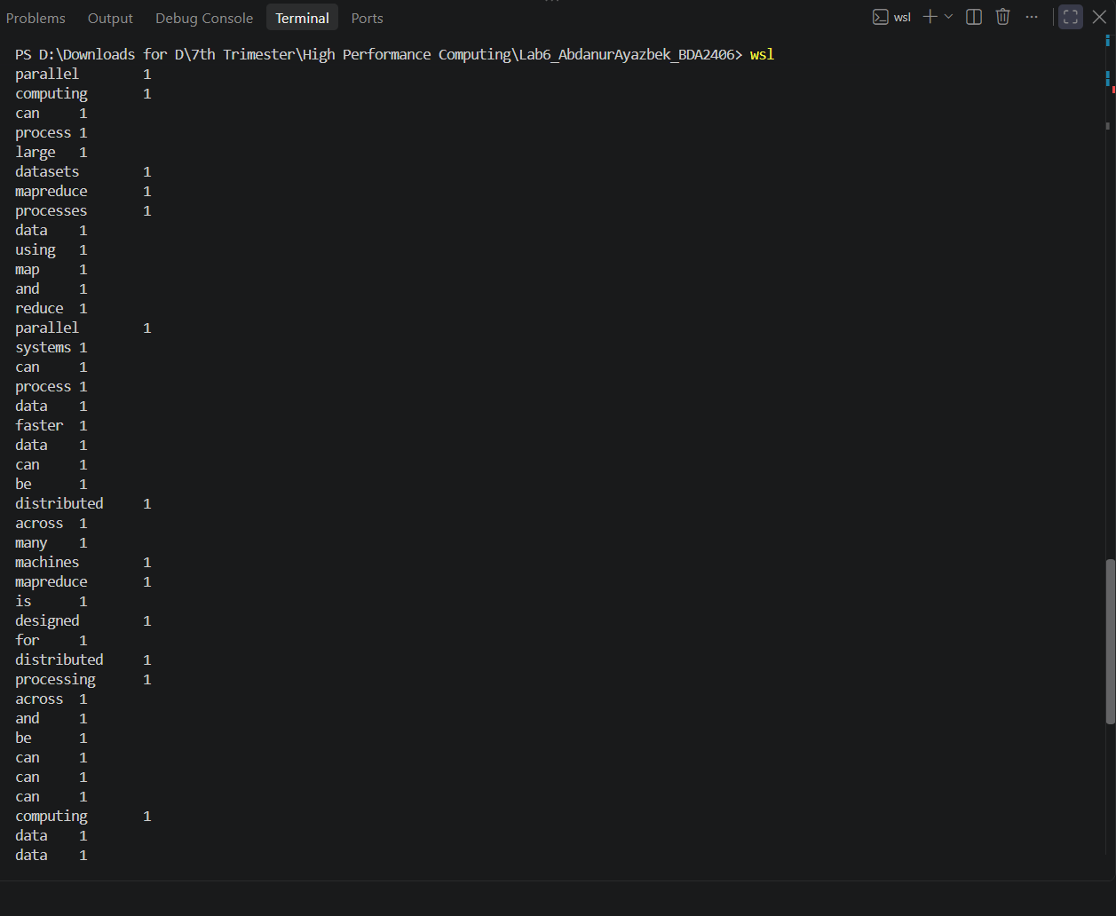
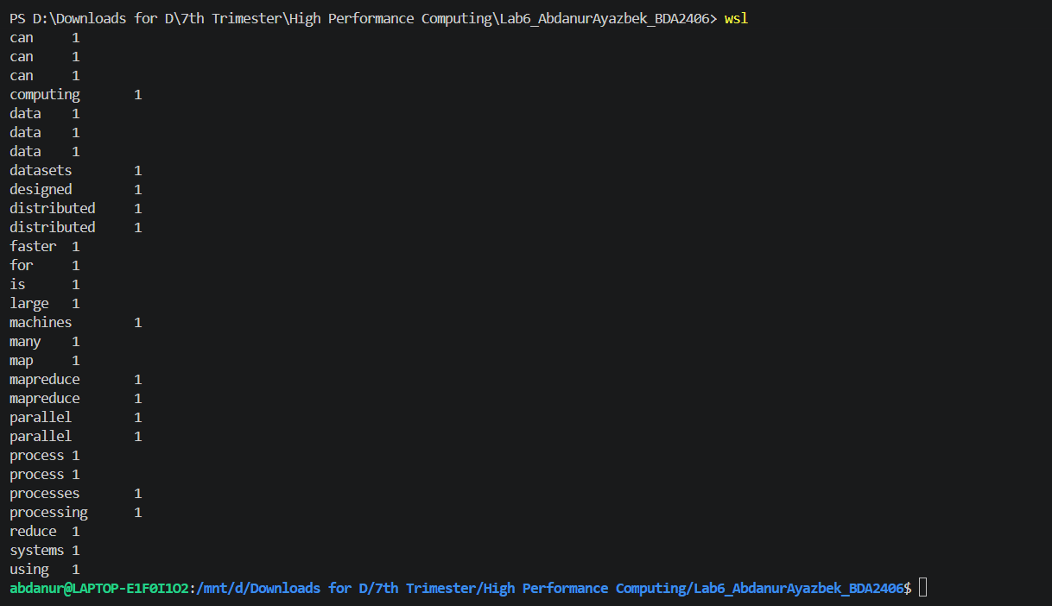
Observe how equal keys become adjacent. Answer:
- Does sort calculate the word counts?
No. It only puts equal words next to each other
- What useful property does sorting provide to the reducer?
Equal keys come one after another. So the reducer only compares each word with the previous one and keeps just one word and one count in memory

Reducer
Create:
reducer.py
The reducer receives sorted intermediate pairs and calculates the total count for every word. You may start with:

1
import sys
current_word = None current_count = 0
for line in sys. stdin : line = line . strip ()
word , count = line . split("\ t") count = int( count)
if word == current_word :
# TODO: update count
pass else :
# TODO: output previous word if necessary
# TODO: start counting a new word
pass
# TODO: output the final word
2
3
4
5
6
7
8
9
10
11
12
13
14
15
16
17
18
19
20
21
22
23
24
25
Run the complete MapReduce pipeline:
python3 mapper.py < input.txt | sort | python3 reducer.py
Save the final result:
python3 mapper.py < input.txt | sort | \ python3 reducer.py > output.txt
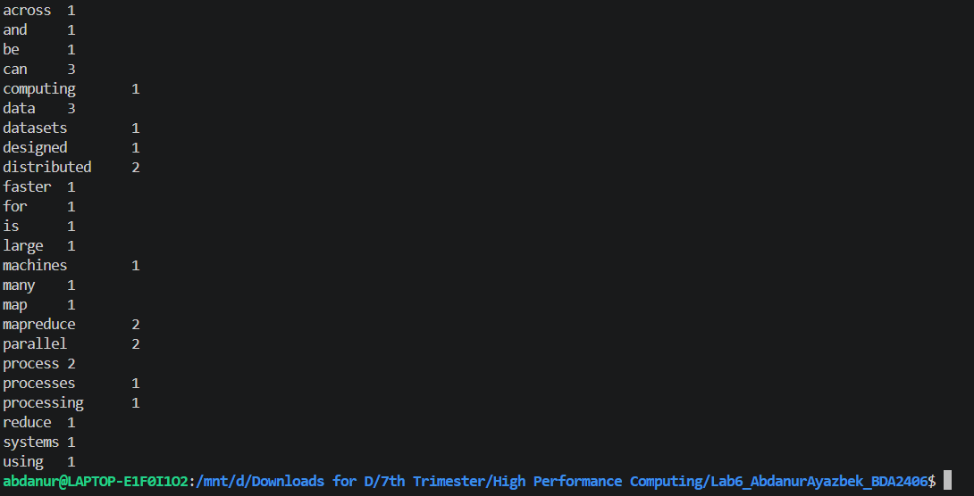

Part 3: Follow the Data Flow
Choose the following input:
red blue red blue green
red green blue
Write the data after each stage.

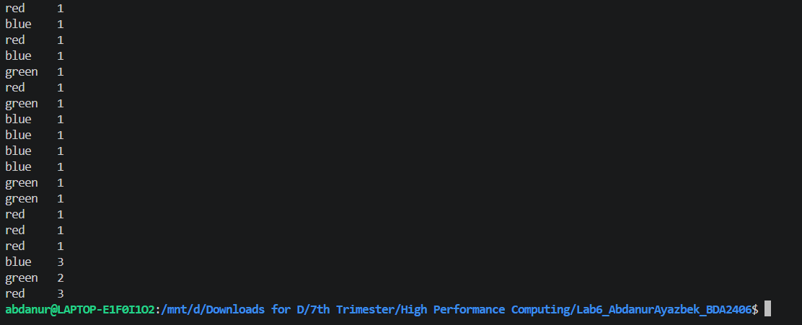Map Output
red 1
blue 1
red 1
blue 1
green 1
red 1
green 1
blue 1
After Shuffle and Sort
blue 1
blue 1
blue 1
green 1
green 1
red 1
red 1
red 1
Final Reduce Output
blue 3
green 2
red 3

Answer:
- Does a mapper need to know the final number of occurrences of a word?
No. It only outputs (word, 1) for every word it sees. The total is calculated later by the reducer
- Does one mapper need the output of another mapper before it can process its own input?
No. Each mapper works on its own part of the input, so all mappers can run at the same time
- Which stage brings together values generated by different mappers?
Shuffle and sort
- Is the reducer executed before all relevant mapper outputs become available?
No. The reducer starts only after all mapper outputs for its keys are ready. Otherwise the count would be incomplete

Part 4: Combiner
A combiner performs local aggregation after mapping and before the global shuffle.
Suppose two mappers independently process:
Mapper 1 input:
data data science data

Mapper 2 input:
science data science
Without a combiner, Mapper 1 produces:
data 1
data 1
science 1
data 1
Instead, a combiner could locally produce:
data 3
science 1

Task
Create:
combiner.py
You may reuse the same aggregation logic as the reducer. Create two input files:
part1.txt part2.txt
Run:
python3 mapper.py < part1.txt | sort | \ python3 combiner.py > combined1.txt

python3 mapper.py < part2.txt | sort | \ python3 combiner.py > combined2.txt
Combine both local outputs:
cat combined1.txt combined2.txt | sort | \ python3 reducer.py
Compare the number of records before and after using the combiner:
wc -l map_output.txt wc -l combined1.txt
Answer:
- Does a combiner change the final Word Count result?
- Does it reduce the number of intermediate records that may need to be transferred?
- Why can reducing intermediate data reduce network traffic?
- Why can a summation operation safely use a combiner?

Part 5: Partitioning
Assume that the system has two reducers:

R₀, R₁.
The partitioner determines which reducer receives each intermediate key. For this exercise, use the simple rule:
partition(k) = (︄∑︂ ASCII(c))︄ mod 2.
c∈k
For example, all occurrences of the same word must produce the same partition number. Calculate the partition for:

Key Reducer
data science parallel computer hadoop reduce
Answer:
- Can the same intermediate key be sent to two different reducers in a normal per-key reduc-tion?
- Can two different keys be sent to the same reducer?
- Why is partitioning necessary when several reducers are used?
- Does partitioning guarantee that all reducers receive exactly the same amount of work?

Part 6: Inverted Index
An inverted index maps every word to the documents containing that word.
Create the file:
documents.txt
containing:
doc1 parallel computing uses many processors doc2 mapreduce processes large data
doc3 parallel data processing is useful doc4 computing systems process data
Each line contains:

Create:
index_mapper.py
The mapper should emit:
(document ID, text).

for every word. For example:
parallel doc1 computing doc1
Then create:
index_reducer.py
(word, document ID)

The reducer should produce output similar to:

computing doc1,doc4
data doc2,doc3,doc4 parallel doc1,doc3
Do not print the same document ID more than once for the same word. Run:
python3 index_mapper.py < documents.txt | sort | \ python3 index_reducer.py

Questions
- What is the intermediate key in this application?
- What is the intermediate value?
- Why must all occurrences of one word be sent to the same reducer?
- How is this application different from Word Count?

Part 7: MapReduce Runtime
For each operation below, state whether it is mainly the responsibility of the programmer or the MapReduce runtime.
Operation Programmer / Runtime
Define the mapper Define the reducer Schedule map tasks
Group intermediate values by key Shuffle intermediate data
Detect failed workers Restart failed tasks
Choose what the application computes
Answer:
- Why is hiding scheduling and communication details useful to the programmer?
- What happens between the map and reduce phases?
- Why can intermediate data movement become expensive?

Part 8: Data Locality and Distributed Storage
Answer the following questions briefly.
- Why does a MapReduce scheduler try to execute a map task close to the physical location of its input data?
- What is meant by “moving computation to the data”?
- What is the purpose of a distributed file system in a MapReduce environment?
- What is the role of the HDFS NameNode?

- What is the role of an HDFS DataNode?
- Does the NameNode normally transfer the actual file contents between the client and DataN-odes?
- Why are file blocks replicated on several machines?
- How can replication improve fault tolerance?

Part 9: Short Discussion
Answer each question in 2–4 sentences.
- What is the difference between the Map phase and the Reduce phase?
- What is the purpose of the shuffle and sort stage?
- Why are key–value pairs central to the MapReduce model?
- What is the purpose of a combiner?
- What is the difference between a combiner and a partitioner?
- Why is Word Count naturally parallelizable?
- Give one example of a problem that is well suited to MapReduce.
- Give one example of a problem that would be difficult to express efficiently as a single MapReduce job.

Submission
Submit:
- mapper.py;
- reducer.py;
- combiner.py;
- index mapper.py;
- index reducer.py;
- input.txt and documents.txt;
- the final Word Count output;
- the final inverted-index output;
- completed tables;
- answers to all questions.
All submitted Python programs should run using Python 3.

