High Performance Computing
PGAS and UPC Exercise

Environment
This exercise uses concepts and syntax from Unified Parallel C (UPC).
UPC compiler commands depend on the implementation installed on the system. Use the UPC environment provided for the course or laboratory.
A typical UPC source file has the extension:
program.upc
and contains:
# include <upc.h>
1
Before starting the programming parts, verify that you can compile and run a simple UPC program in the environment provided by the instructor.

Objectives
The purpose of this exercise is to understand the basic ideas of the Partitioned Global Address Space (PGAS) programming model and to practice them using UPC. You will examine shared and private memory, determine data affinity, distinguish between local and non-local accesses, dis-tribute loop iterations among threads, use shared arrays, and apply synchronization when threads depend on data produced by other threads.

Part 1: Understanding the PGAS Model
Consider a program running with four threads:

T₀, T₁, T₂, T₃.
Each thread has private memory, while part of the program data belongs to a partitioned global address space.
Answer the following questions.
- What does PGAS stand for?
Partitioned Global Address Space
- What is meant by a global address space?
One memory space that all threads can read and write. Every shared variable has one address there, and all threads use this address to reach it, even when the memory is physically on different nodes
- Why is the global address space described as partitioned?
Because the global space is divided into parts, one part per thread. Each part is stored in the local memory of its own thread
- What is meant by the affinity of a shared data item?
The thread whose part of the global address space holds this data item. For this thread, access to the item is fast
- What is a local memory access?
An access by a thread to its private data or to shared data that has affinity to this same thread. It is fast because the data is in its own memory
- What is a non-local memory access?
An access by a thread to shared data that has affinity to another thread. It is slower because the data is in another part of memory and may need to go over the network

- Can a UPC thread access shared data that has affinity to another thread?
Yes. It uses normal code like x = A[5], and the system gets the value from the other thread’s part. Such access is just slower than a local one
- What important difference exists between non-local access in MPI and non-local access in a PGAS model?
In MPI, a process cannot reach the memory of another process directly. Both sides must take part with explicit messages: one process sends, the other receives. In PGAS, only the thread that needs the data acts. It reads or writes remote shared data with a normal access like A[5], and the system does the communication

Part 2: Shared and Private Variables
Assume:

THREADS = 4.
Consider:
shared int x;
shared int y[ THREADS ]; int z;
1
2
3
Answer the following.
- How many copies of x exist?
1
- Which thread has affinity to x?
Thread 0
- How many elements does y contain?
4, one element per thread
- Which thread has affinity to each element of y?
y[0] to thread 0, y[1] to thread 1, y[2] to thread 2, y[3] to thread 3. The default block size is 1, so elements are given to threads one by one in a cycle
- How many copies of z exist?
Four, one copy in the private memory of each thread
- Is z shared between the four threads?
No. Each thread has its own z, and other threads cannot see it
Complete the table.

Variable | Shared / Private | Affinity

x  y[0]  y[1]  y[2]  y[3]  z | Shared  Shared  Shared  Shared  Shared  Private | Thread 0  Thread 0  Thread 1  Thread 2  Thread 3  Each thread has its own copy

Part 3: Blocking and Affinity
UPC allows shared arrays to be distributed among threads using blocks.
Consider:
shared [4] int A [32];
1
and assume:

THREADS = 4.
The affinity of an element can be determined using:
⌊︃ ⌋︃
thread(i) = i mod THREADS.
block size
For this example:

block size = 4.
Array Elements | Thread with Affinity
A[0] to A[3] | 0
A[4] to A[7] | 1
A[8] to A[11] | 2
A[12] to A[15] | 3
A[16] to A[19] | 0
A[20] to A[23] | 1
A[24] to A[27] | 2
A[28] to A[31] | 3

Complete the table.

Array Elements Thread with Affinity
A[0]–A[3]
A[4]–A[7]
A[8]–A[11]
A[12]–A[15]
A[16]–A[19]
A[20]–A[23]
A[24]–A[27]
A[28]–A[31]

w
w

Answer:
- Which thread has affinity to A[2]?
Thread 0. ⌊2 / 4⌋ = 0, and 0 mod 4 = 0
- Which thread has affinity to A[6]?
Thread 1. ⌊6 / 4⌋ = 1, and 1 mod 4 = 1
- Which thread has affinity to A[13]?
Thread 3. ⌊13 / 4⌋ = 3, and 3 mod 4 = 3
- Which thread has affinity to A[22]?
Thread 1. ⌊22 / 4⌋ = 5, and 5 mod 4 = 1
- Why might the choice of block size affect program performance?
The block size decides which elements are stored in the memory of each thread. If a thread works on nearby elements and they are in one block, most of its accesses are local and fast. If the blocks do not match how threads use the data, many accesses go to other threads and become slow. Block size also affects balance: with shared [32] int A[32], all elements belong to thread 0, and the other threads get no data

Part 4: First UPC Program
Consider the following UPC program:
# include <stdio .h> # include <upc.h>
int main ()
{
printf(" Hello from thread % d of % d\ n", MYTHREAD , THREADS );
return 0;
}
1
2
3
4
5
6
7
8
9
10
Run the program using four UPC threads.
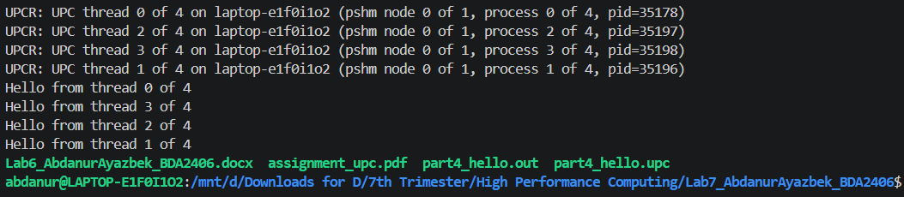
Record the output.
Threads | Printed Message
0 | Hello from thread 0 of 4
1 | Hello from thread 1 of 4
2 | Hello from thread 2 of 4
3 | Hello from thread 3 of 4
Actual print order in this run: thread 0, 3, 2, 1
Answer:
- What does MYTHREAD represent?
The number of the current thread, from 0 to THREADS minus 1. In this run it is 0, 1, 2 or 3
- What does THREADS represent?

The total number of UPC threads running the program. Here it is 4, because we ran the program with 4 threads
- Does every UPC thread execute the same program?
Yes. All 4 threads run the same code from main. They only differ in the value of MYTHREAD, so each one prints a different message. This is the SPMD (Single Program, Multiple Data) model
- Is the order of the printed messages guaranteed?
No. The threads run at the same time, and each one prints when it is ready. In our run the order was 0, 3, 2, 1, and another run can give a different order
- In what way is this execution model similar to MPI?
Like in MPI, several copies of the same program are started at once. MYTHREAD and THREADS work like the rank and the size in MPI, which we got with MPI_Comm_rank and MPI_Comm_size

Part 5: Parallel Vector Addition
Consider the vector operation:
C_{i} = A_{i} + B_{i}.
Use:

N = 1000.
Create three shared arrays:
# define N 1000
shared int A[ N]; shared int B[ N]; shared int C[ N];
1
2
3
4
5
Initialize the arrays so that:
A_{i} = i
and
B_{i} = 2i.
Then calculate:
C_{i} = A_{i} + B_{i}.
Use upc forall to distribute the iterations among UPC threads. You may use the following structure:
# include <stdio .h> # include <upc.h>
# define N 1000
shared int A[ N]; shared int B[ N]; shared int C[ N];
int main ()
{
int i;
upc_forall( i = 0; i < N; i++; & A[ i])
{
A[ i] = i;
B[ i] = 2 * i;
}
upc_barrier;
1
2
3
4
5
6
7
8
9
10
11
12
13
14
15
16
17
18
19
20
21

22  23  24  25  26  27  28  29 | upc_forall( i = 0; i < N; i++; & C[ i])  {  // Calculate C[ i]  }  upc_barrier;  if ( MYTHREAD == 0)
30 |  | {
31 |  |  | printf(" C [0] | = | % d\ n", | C [0]);
32 |  |  | printf(" C [10] | = | % d\ n", | C [10]);
33 |  |  | printf(" C [999] | = | % d\ n", | C [999]);
34 |  | }
35
36
return 0;
}
37
Complete and run the program.
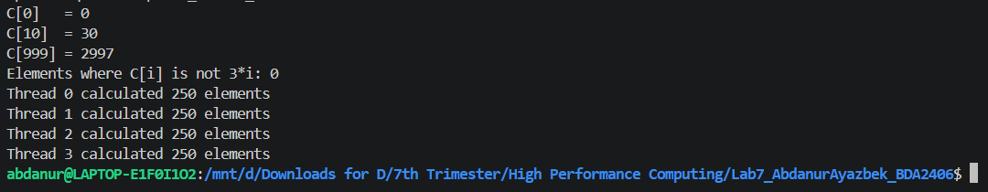
Verify that:
C_{i} = 3i.

Questions
- Can different values of C_{i} be calculated independently?
Yes. Each C[i] uses only A[i] and B[i], and no element of C depends on another one. So different threads can calculate them at the same time
- What is the purpose of upc forall?
To split the loop iterations among the threads, so each iteration is run by exactly one thread and not by all of them
- What does the fourth expression of upc forall specify?
The affinity expression. It decides which thread runs iteration i. Here it is &C[i], so the thread that has affinity to C[i] calculates C[i]
- Why is distributing work according to data affinity potentially useful?
The thread writes C[i] in its own part of memory, and with the default block size A[i] and B[i] are in the same part too. So all accesses are local and fast, and no data has to move between threads
- Does every thread calculate all N elements?
No. Each thread calculated only the 250 elements it has affinity to, and 4 x 250 = 1000 = N

Part 6: Observing Data Affinity
Use a smaller shared array:
shared int A [16];
1
Assume four threads.
UPC provides:
upc_threadof (& A[ i])
1
which returns the thread having affinity to the shared element. Write a program where thread 0 prints the affinity of every element:
if ( MYTHREAD == 0)
{
for ( int i = 0; i < 16; ++i)
{
printf(" A[% d] has affinity to thread % d\ n", i,
( int) upc_threadof (& A[ i]));
}
}
1
2
3
4
5
6
7
8
9
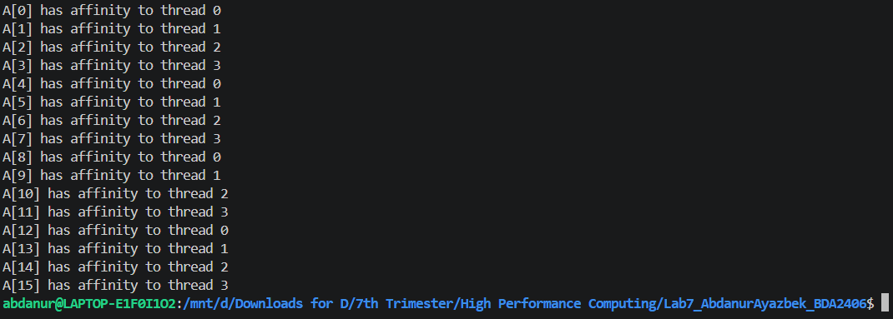
Complete the table from your output.

Element | Thread with Affinity
A[0] | 0
A[1] | 1
A[2] | 2
A[3] | 3
A[4] | 0
A[5] | 1
A[6] | 2
A[7] | 3

Answer:
- What is the default block size of a UPC shared array?
1, so each block holds one element and the elements are given to the threads one by one
- Does the distribution repeat after all threads receive one block?
Yes. After A[0] to A[3] go to threads 0 to 3, A[4] goes to thread 0 again. The cycle repeats every 4 elements, up to A[15]
- Would accessing an element having affinity to MYTHREAD normally be considered local or non-local?
Local. The element is stored in the part of memory that belongs to this same thread

Part 7: Local and Non-Local Access
Assume:
shared int A[ THREADS ];
1
and:

THREADS = 4.
Each element has affinity to the corresponding thread. Consider thread 0.
Classify the following accesses as primarily local or non-local from the point of view of thread
0.
Access | Local / Non-local
A[0] | Local
A[1] | Non-local
A[2] | Non-local
A[3] | Non-local

Now consider thread 2.
Access | Local / Non-local
A[0] | Non-local
A[1] | Non-local
A[2] | Local
A[3] | Non-local

Answer:
- Why can excessive non-local accesses reduce performance?
Each such access has to get data from the part of memory of another thread. This takes much longer than reading its own memory, and on a cluster it goes over the network. With many such accesses, threads spend most of their time waiting for data instead of computing
- Why should work preferably be assigned to a thread that has affinity to the data being processed?
Then the thread reads and writes the data in its own memory, so the accesses are local and fast, and no data moves between threads. This is what upc_forall with &C[i] did in Part 5
- How is this idea related to data locality discussed earlier in the course?
It is the same idea. Data locality means keeping data close to where it is used, because close data is faster to reach. In MapReduce we saw it as sending the computation to the node that stores the data. In PGAS, affinity shows which data is close to which thread, so giving work by affinity is how we get good locality
 | Part 8: Synchronization
 | Consider:
1 | shared int result[ THREADS ];
 | Every thread writes its own result:
1 | result[ MYTHREAD ] = MYTHREAD * 10;
 | Thread 0 then prints all values.
 | Complete the following program:
1 | # include <stdio .h>
2 | # include <upc.h>
3
4 | shared int result[ THREADS ];
5
6 | int main ()
7 | {
8 | result[ MYTHREAD ] = MYTHREAD * 10;
9
10 | // Add synchronization here
11
12 | if ( MYTHREAD == 0)
13 | {
14 | for ( int i = 0; i < THREADS ; ++i)
15 | {
16 | printf(" result [% d] = % d\ n",
17 | i, result[ i]);
18 | }
19 | }
20
21 | return 0;
22 | }
 | Use:
1 | upc_barrier;
 | before thread 0 reads the results.
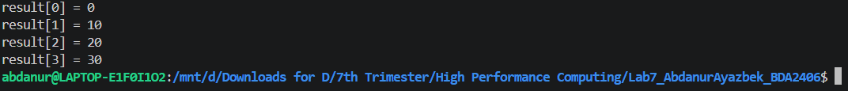
Run the program with four threads.

 | The expected values are:
 | 0, 10, 20, | 30.

Questions
- Why is a barrier required before thread 0 reads all results?
Thread 0 reads result[1], result[2] and result[3], which are written by other threads. Without a barrier it could read them before those threads write. The barrier makes sure all writes are done before thread 0 starts reading
- What does a thread do when it reaches upc barrier before the other threads?
It waits there. It continues only when all the other threads have also reached the barrier
- What potential problem could occur if the barrier were removed?
Thread 0 could print old values, for example 0 instead of 20, for threads that have not written yet. The output could also change from run to run. This is a race condition
- Does UPC automatically synchronize threads after every shared-memory operation?
No. Threads run independently, so the programmer must add synchronization like upc_barrier or locks wherever one thread needs data written by another

Part 9: Shared Pointers
Consider the following declarations:

1
int * p1 ;
shared int * p2 ; int * shared p3 ;
shared int * shared p4 ;
2
3
4
Complete the table.

Pointer | Pointer Location | Pointed-to Data

p1
p2 p3 p4
Use the terms:
- private;
- shared.
Answer:
- Which pointer type can be used to access arbitrary locations in the shared address space?
- What is meant by a pointer-to-shared?
- What locations may an ordinary C pointer safely reference in the UPC memory model?

Part 10: Dynamic Shared Memory
UPC provides different methods for dynamically allocating shared memory.
Consider:
upc_global_alloc (...)
1
and:
upc_all_alloc (...)
1
Answer the following.
- Which operation is collective?
- Which operation is normally expected to be called by one thread?
- When upc all alloc() is called, do all threads receive the same shared pointer?
- What function is used to free dynamically allocated shared memory?

Part 11: Comparing Programming Models
Complete the table.

Model | Multiple Memories | Non-local Access | Explicit Messages

OpenMP
MPI
PGAS / UPC

Then answer:
- What feature of PGAS makes it look similar to shared-memory programming?
- What feature of PGAS makes data locality still important?
- In MPI, how would a process normally obtain data stored by another process?
- In UPC, how can a thread obtain shared data having affinity to another thread?
- Why can PGAS be viewed as a model between traditional shared-memory and message-passing programming?

Part 12: Short Discussion
Answer each question briefly.
- What is data affinity in PGAS?
- What is the difference between shared and private data in UPC?
- What is the purpose of a blocked shared array?
- What is the purpose of upc forall?
- Why are local accesses generally preferable to non-local accesses?
- What is the purpose of upc barrier?
- What is the difference between a blocking barrier and a split-phase barrier?
- What problem can locks solve when several threads write to the same shared data?
- What is one major conceptual difference between UPC and MPI?
- What is one major conceptual difference between UPC and OpenMP?

Submission
Submit:
- the first UPC thread-identification program;
- the parallel vector addition program;
- the data-affinity experiment;
- the synchronization experiment;
- completed affinity and memory-layout tables;
- answers to all questions.
All source files should contain clear comments identifying the corresponding exercise part.

