Music Player created by 18BCE110-charmil mal,18BCE112-manav lohiya,18BCE125-mohammad asad khan.

It’s a music player application. it uses the following modules- tkinter, pygame, mutagen, os

import the following modules in your device before running it.

now that you've import the libraries.

open and run the python file (Amp music Player.py).

the first window you'll see will be:

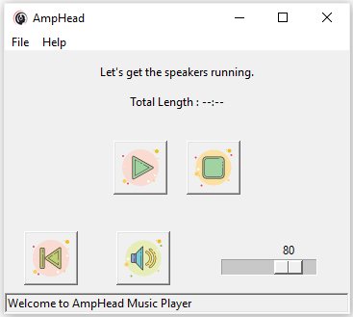

Then go to File -> open to select any .mp3 or .m4a file to play.

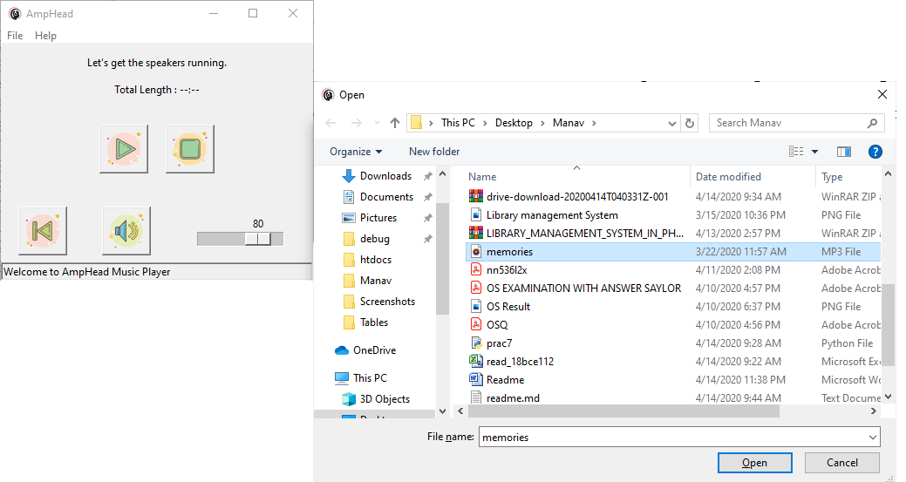

Note- If you don’t select any file, the Application will automatically choose default file, Memories – Maroon 5.

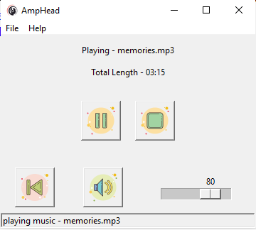

Now click on pause or press spacebar to pause the song.

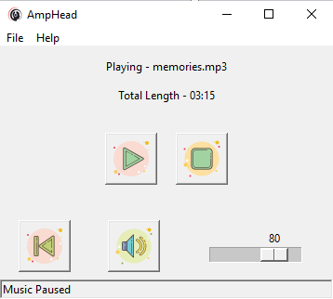

And press play or space bar to unpause it.

Note- You can also press Space bar to control media. (Play/Pause).



Click on the volume button to mute the audio and then again to unmute.

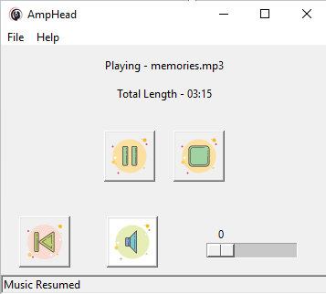

You can also slide the volume seek to set custom volume.

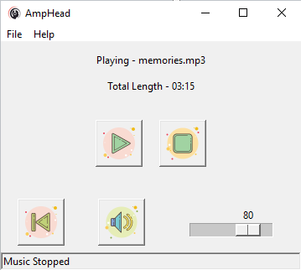

Press stop button to stop the music and play it again with the play button on spacebar.

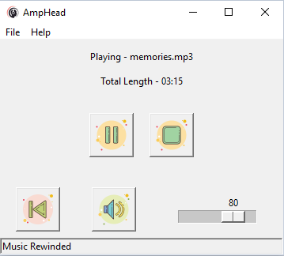

The rewind button also rewinds the music but doesn’t stop the music.