Arabic Sign Language

Problem Statement
In the Arab world, communication between deaf individuals and hearing communities is often hindered by the lack of widespread knowledge of Arabic Sign Language (ArSL). Human interpreters are not always available, which creates accessibility barriers in daily life, education, and services.

Objective
To build a real-time AI web application (Streamlit) that allows Arabic Sign Language users to be “heard” by translating their static hand signs into written Arabic text, displayed live on the screen.

Scope

In Scope
- Real-time webcam capture.
- Detection of static hand signs.
- Classification of signs to predefined Arabic words.
- Text display in the Streamlit interface.
- Basic confidence scoring.

Out of Scope (initial phase)
- Dynamic sign sequences.
- Full grammar translation or contextual sentence generation.
- Multi-language support.

Deliverables
- Streamlit web app (Python) with integrated trained model.
- Static sign classification model for Arabic Sign Language vocabulary.
- Data preprocessing and training scripts.
- Documentation (User manual + technical report).
- Demo video showcasing live translation.

Success Criteria / KPIs
- Classification accuracy ≥ 90% for the chosen static vocabulary.
- Average inference time ≤ 1 second on CPU.
- Stable real-time translation for at least 30 minutes continuous use.

Stakeholders
- Primary users: Deaf Arabic signers.
- Secondary users: Hearing individuals reading the text output.
- Team: Project manager, AI/ML engineer, Streamlit UI developer, tester/documentation.

High-Level Approach
- Input: Real-time webcam feed.
- Feature Extraction: Mediapipe Hands (keypoints).
- Model: Lightweight classifier (MLP/CNN) for static sign images or keypoints.
- UI: Streamlit app showing webcam feed, predicted word, and confidence.
- Deployment: Local Streamlit app, with potential future cloud deployment.

Dataset
- Public Arabic Sign Language datasets (for static signs).
- Data augmentation to improve robustness (lighting, angles, backgrounds).

Risks & Mitigations
Risk | Impact | Mitigation
Limited Arabic sign datasets | Reduced accuracy | Collect custom data, augment existing datasets
Variation in lighting/background | Detection errors | Use preprocessing + Mediapipe keypoints
Model overfitting on few signers | Poor generalization | Diverse data collection, signer-independent split
Hardware limitations | Slow inference | Use light models, keypoint-based classification

Assumptions & Constraints
- Static vocabulary only (e.g., alphabet, numbers, common words).
- Python 3.10+, Streamlit, Mediapipe, TensorFlow/PyTorch.
- Laptop or PC with webcam; no GPU required for inference.

Literature Review

Arabic Sign Language Recognition (Chronological)
Arabic Sign Language (ArSL) recognition has undergone significant development over the past decades, evolving from sensor-based systems to modern real-time AI-powered models. This literature review presents a chronological overview of key developments in the field, focusing on the progression of technologies, methodologies, and datasets that have shaped Arabic Sign Language recognition, including the adoption of landmark-based techniques and recent real-time applications.

Early Research (Pre-2010s)
Initial attempts at sign language recognition were based on sensor and glove technologies. Systems like PowerGlove-based recognizers captured hand flexion and orientation data to classify signs (Kadous, 1996). Similarly, early wearable and desk-based computer vision systems aimed to recognize signs in real time using specialized setups (Starner & Pentland, 1997). While these approaches achieved high precision in controlled environments, they required expensive, specialized hardware and were not practical for widespread use.

Traditional Vision Methods (2010–2015)
The 2010s marked a shift towards camera-based gesture recognition. Researchers adopted techniques such as skin color segmentation, contour detection, Hu moments, and SIFT/SURF features for static Arabic sign alphabet recognition (Elakkiya & Ezhilarasi, 2015). These methods reduced the reliance on gloves and sensors, allowing data collection through standard RGB cameras. However, their performance was often sensitive to changes in lighting, skin tone, and background, limiting their robustness in real-world scenarios.

Deep Learning & Dataset Expansion (2016–2018)
The emergence of deep learning, particularly convolutional neural networks (CNNs), revolutionized sign language recognition. Models such as AlexNet and VGG were adapted for Arabic Sign Language datasets, achieving significantly higher accuracy than traditional methods (Pigou et al., 2015). A landmark moment came with the release of the ArASL dataset in 2018, which included more than 54,000 images across 32 Arabic alphabet classes (Elakkiya et al., 2018). Researchers applied transfer learning from pretrained models to ArASL, achieving accuracy rates above 90% for isolated static signs, though most implementations remained offline.

Lightweight & Landmark-Based Pipelines (2019–2021)
Between 2019 and 2021, there was a clear focus on developing lightweight models suitable for real-time deployment. MobileNet and SqueezeNet architectures provided compact yet accurate solutions. A major technological shift was the introduction of MediaPipe Hands by Google (Zhang et al., 2020), which provided fast, CPU-based 2D and 3D hand landmark extraction. Researchers began combining MediaPipe’s landmark data with simple classifiers such as MLPs and SVMs to recognize Arabic alphabets in real time, maintaining high accuracy with minimal computational requirements.

Real-Time Applications & Kaggle Dataset (2022–Present)
Recent years have seen an increasing emphasis on practical, real-time Arabic Sign Language recognition applications. In 2022, Elmadoui released the Arabic Sign Language Unaugmented Dataset on Kaggle, containing 54,049 unaugmented images across 32 alphabet classes. This dataset has become a valuable resource for training lightweight classifiers without artificial augmentation. Contemporary studies combine this dataset with MediaPipe landmark extraction to build efficient, real-time models deployed in frameworks such as Streamlit, with a growing focus on signer-independent evaluation and robustness to environmental variation (Elmadoui, 2022; Zhang et al., 2020).

Conclusion
The literature reveals a clear chronological evolution in Arabic Sign Language recognition research. Early sensor-based methods prioritized precision but lacked scalability. Traditional vision-based techniques expanded accessibility but were sensitive to environmental changes. The deep learning era introduced large datasets and CNN models, significantly improving accuracy. Landmark-based pipelines combined speed and robustness, paving the way for real-time applications. Finally, the Kaggle dataset and frameworks like MediaPipe and Streamlit enable practical, deployable solutions that focus on real-world usability, accuracy, and signer-independence.

3. System Analysis & Design

3.1 System Overview
The Arabic Sign Language Translator system is designed to enable real-time interpretation of static Arabic sign language gestures into written Arabic text. The system uses a webcam as the primary input device to capture live video frames, which are processed using MediaPipe Hands to extract key landmarks from the signer's hand. These landmarks are then fed into a lightweight classification model trained on the Kaggle Arabic Sign Language Unaugmented Dataset to recognize specific static signs. The predicted word or letter is displayed on a Streamlit interface in real time, accompanied by a confidence score and a short recognition history.

3.2 Use Case Diagram
The use case diagram below illustrates the interactions between the different actors and the system. The primary actor is the signer (deaf user) who uses the webcam to perform signs. The AI Translator System processes the input and displays the recognized signs. Hearing users read the translated output, while administrators or developers can update the dataset and retrain the model.
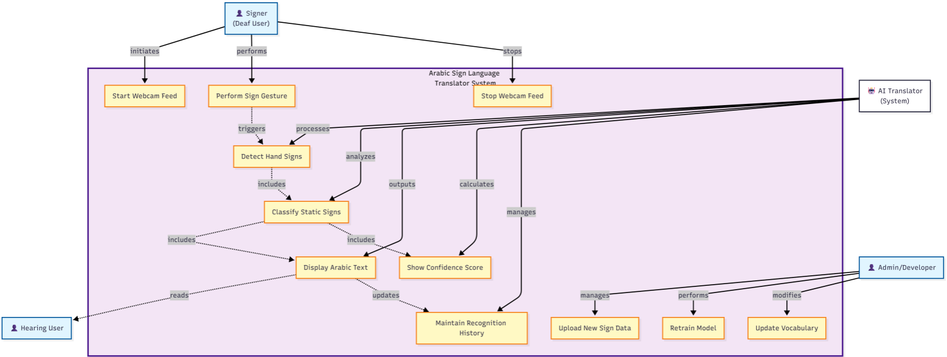

3.3 Data Flow Diagram / Functional Model
The following describes the data flow within the system. When the signer performs a sign in front of the webcam, the video frames are captured and passed to the hand landmark detection module. The extracted landmarks are forwarded to the classification model, which predicts the corresponding sign. The recognized sign and confidence score are then sent to the Streamlit interface for display, and a short history of recognized signs is maintained.
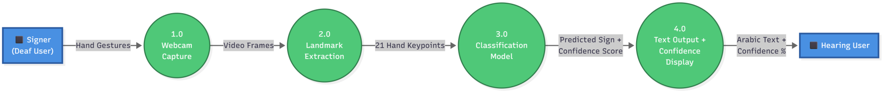

3.4 System Architecture Diagram
The system architecture is composed of the following components:
• Webcam Input: Captures real-time video stream from the user.
• Preprocessing: MediaPipe Hands detects and extracts 21 keypoints from the hand.
• Classification Model: A lightweight model (e.g., MLP/CNN) trained on Arabic sign language data.
• Streamlit Interface: Displays predictions, confidence scores, and history.
• Optional Admin Panel: Allows uploading new data and retraining the model.

3.5 Component Description
The system is modular to allow future expansion. The preprocessing and model inference modules can be replaced or upgraded without affecting the Streamlit interface. Similarly, the dataset can be updated with additional signs, and the model can be retrained to support new vocabulary without major structural changes.

3.6 Functional Requirements
- Webcam Integration – The app must capture live video input from the user’s webcam.
- Hand Detection – The system should detect and track the hand in real time.
- Sign Classification – The app must recognize predefined static signs (letters, numbers, common words).
- Text Output – The recognized sign should be displayed as Arabic text in real time.
- Confidence Score – Display a percentage score indicating prediction confidence.
- History Panel – Keep a short-term history of recent recognized signs.
- User Interface – Provide a simple Streamlit interface with start/stop camera controls.
- Documentation & Demo – Include usage guide, technical documentation, and a demo video.

3.7 Non-Functional Requirements
- Performance – End-to-end translation latency ≤ 1 second on CPU.
- Accuracy – At least 90% accuracy on test dataset of static signs.
- Reliability – System must run continuously for ≥ 30 minutes without crashing.
- Usability – Simple UI accessible to non-technical users, especially deaf individuals.
- Security & Privacy – No video should be stored by default; processing remains local.
- Scalability – Should support extension to larger vocabularies and dynamic signs in future.
- Maintainability – Code should be modular and documented for future improvements.

3.8 Project Timeline (Gantt Chart)
The following Gantt chart outlines the planned timeline for the development and deployment of the Arabic Sign Language Translator system. It covers the phases of project planning, model development, real-time deployment, MLOps integration, and final documentation and presentation.
