

Secure Stream Cipher System Using One-Time Pad, Key Exchange, and Message Authentication
Cryptographic course

Submitted to
Eng.Salma
Submitted by Mohamed Abdelaziz

Name | Sec | BN
Mazen Adel Abdallah | 2 | 47
Mohmmed Abdelaziz Khater | 2 | 54

Project Overview
This project implements a secure communication system using a stream cipher based on the One-Time Pad (OTP) methodology. The system ensures confidentiality, integrity, and authenticity through the use of Diffie-Hellman key exchange, symmetric encryption for seed transmission, and HMAC for authentication. Communication is handled through modular client-server components in Python.

Contents
Project Overview 2
Communication Flow 4
Client Side 4
Server Side 4
Code 4
Test Case 4
key_exchange 5
Purpose 5
Algorithm Details 5
Design Choices 5
Implementation with a test case: 6
Test Case output 7
Seed Encryption – AES-CBC 7
Purpose 7
Key Components 7
Algorithm Details : 7
Implementation with a test case: 8
Test Case output: 9
Seed Authentication 9
Purpose 9
Key Components : 9
Algorithm Details : 9
Implementation with a test case: 10
Test Case output: 11
Linear Congruential Generator 11
Purpose 11
Key Components : 11
Algorithm Details : 11
Design Choices: 11
Implementation with a test case: 12
Test Case output: 12

Communication Flow

Client Side
- Performs Diffie-Hellman key exchange.
- Encrypts and authenticates the seed.
- Sends encrypted file chunks using the stream cipher.

Server Side
- Completes the key exchange and derives shared key.
- Decrypts and verifies the seed.
- Receives encrypted file chunks and writes to output.

Code
- Refer to the client & server files as it is too big to be included here.

Test Case
- Input and output file

key_exchange
Purpose : Implements the Diffie-Hellman key exchange protocol.

Algorithm Details
Both parties agree on a large prime number p and a generator g.
- Each party generates a random private key:
  - Sender: private_key_A
  - Receiver: private_key_B
- Each party computes their public key:
  - $Sender: public_{key_{A}}= g^{\left\{private_{key_{A}}\right\}} mod p$
  - $Receiver:public_{key_{b}}=g^{\left\{private_{key_{b}}\right\}}modp$
- The parties exchange their public keys.
- Each party computes the shared secret:
  - $Sender:shared_{secret_{A}}=public_{key_{B}}^{\left\{private_{key_{A}}\right\}} mod p$
  - $Receiver:shared_{secret_{B}}=public_{key_{A}}^{\left\{private_{key_{B}}\right\}} mod p$
  - Due to the properties of modular exponentiation, both parties arrive at the same shared secret:shared_secretA​=shared_secretB​

Design Choices
Standard values for the base and the prime number from RFC 3526 (Group 14)

Implementation with a test case:
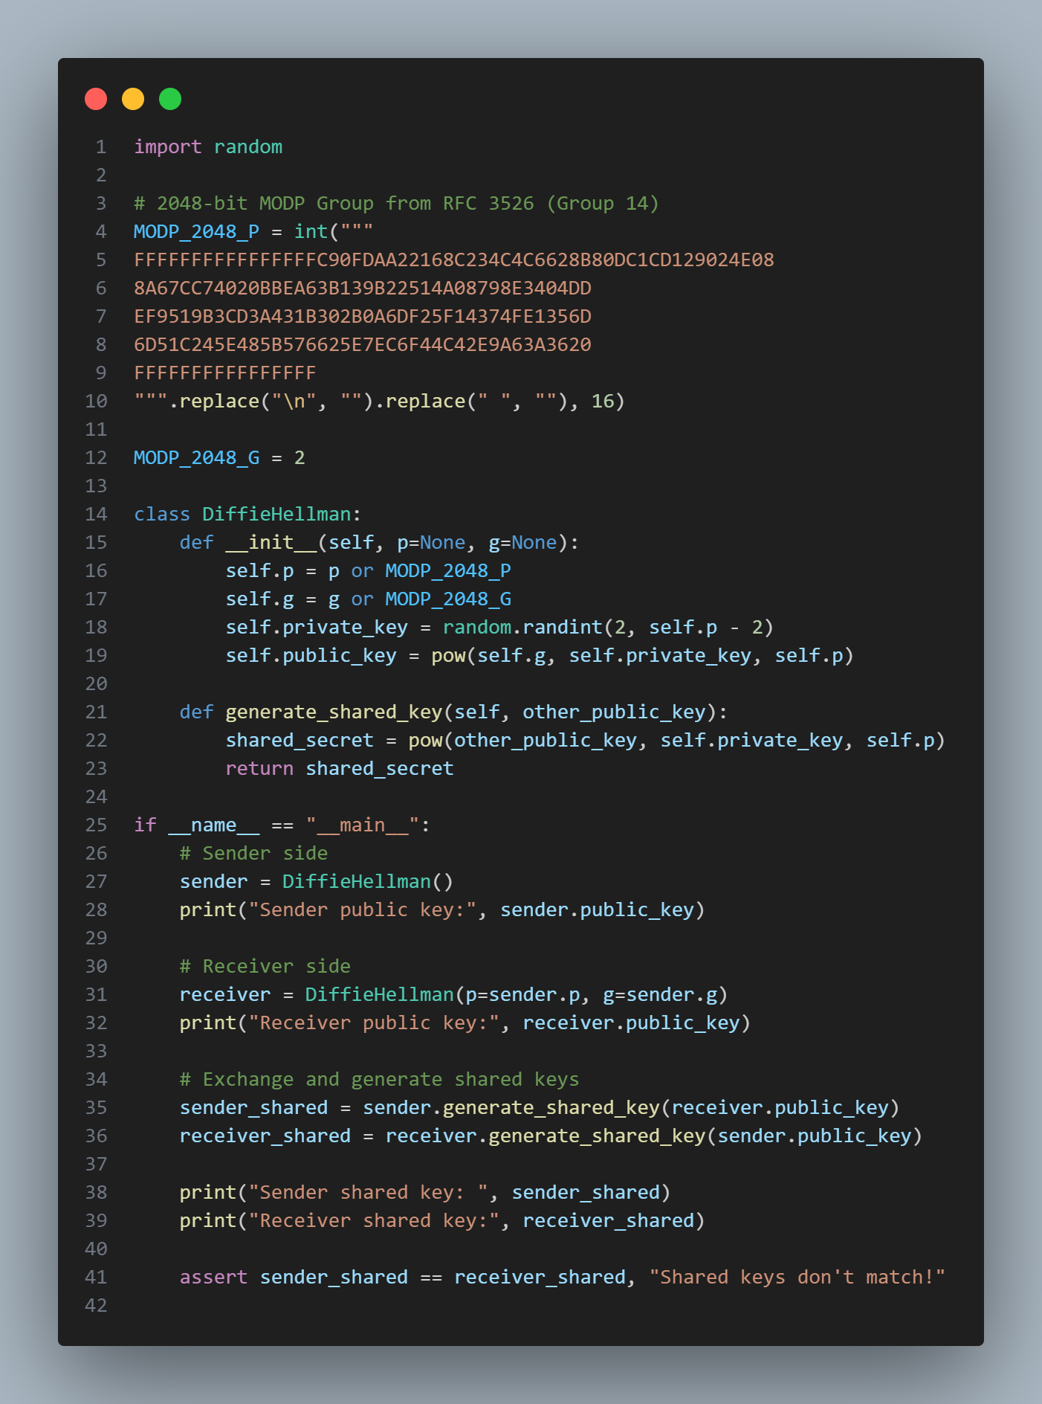

Test Case output
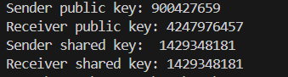

Seed Encryption – AES-CBC
Purpose : Encrypts the seed used by the stream cipher to ensure it remains confidential during transmission.

Key Components
- Key Derivation : Derives a 256-bit AES key from a shared secret using SHA-256.
- AES Encryption : Uses AES in CBC mode with PKCS7 padding to encrypt the seed.
- Initialization Vector (IV) : Generates a random IV for each encryption to ensure uniqueness.

Algorithm Details :
- Encryption :
  - Convert the seed to bytes.
  - Pad the seed to match the AES block size (16 bytes) using PKCS7 padding.
  - Generate a random IV.
  - Encrypt the padded seed using AES in CBC mode.
- Decryption :
  - Decrypt the ciphertext using AES in CBC mode.
  - Unpad the decrypted data to retrieve the original seed.

Implementation with a test case:
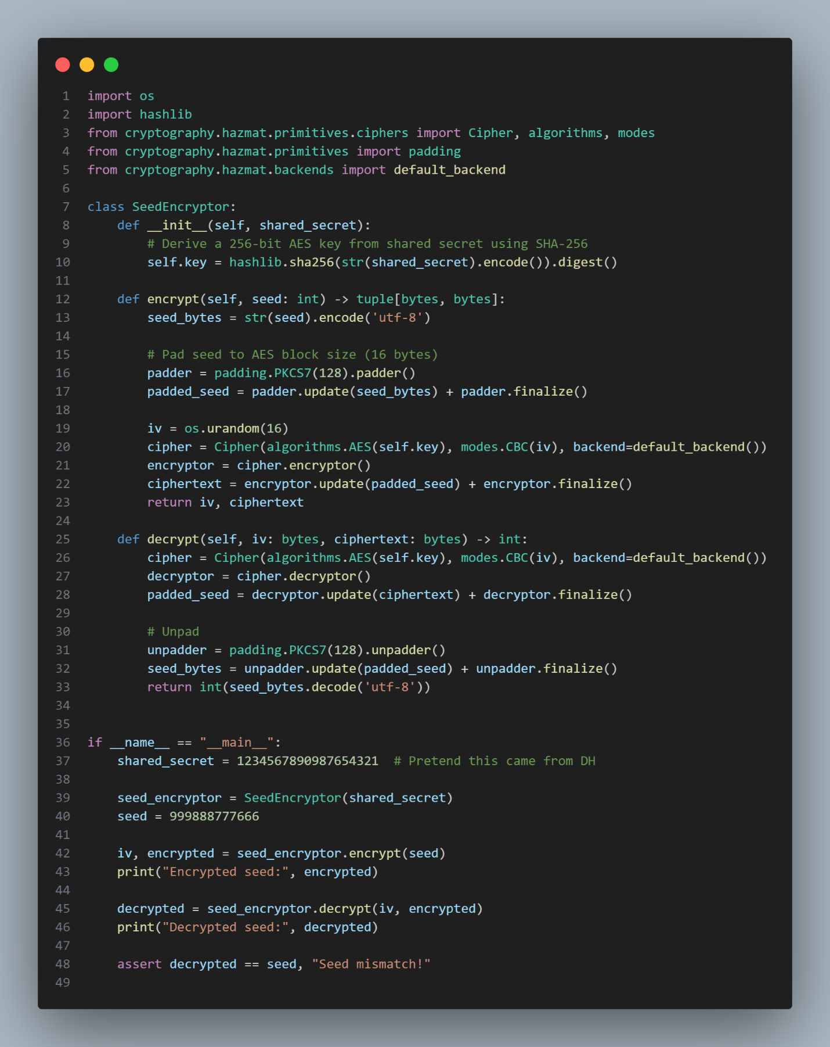

Test Case output:

Seed Authentication
Purpose : Authenticates the encrypted seed to ensure its integrity and prevent tampering.

Key Components :
- Key Derivation : Derives a 256-bit HMAC key from a shared secret using SHA-256.
- HMAC Generation : Computes an HMAC tag for the encrypted seed using HMAC-SHA256.
- Verification : Verifies the HMAC tag to ensure the encrypted seed has not been altered.

Algorithm Details :
- HMAC Generation :
  - Derive a key using SHA-256 hash of the shared secret.
  - Compute the HMAC tag for the encrypted seed using the derived key.
- Verification :
  - Recompute the expected HMAC tag for the received encrypted seed.
  - Compare the received HMAC tag with the recomputed tag using a constant-time comparison.

Implementation with a test case:
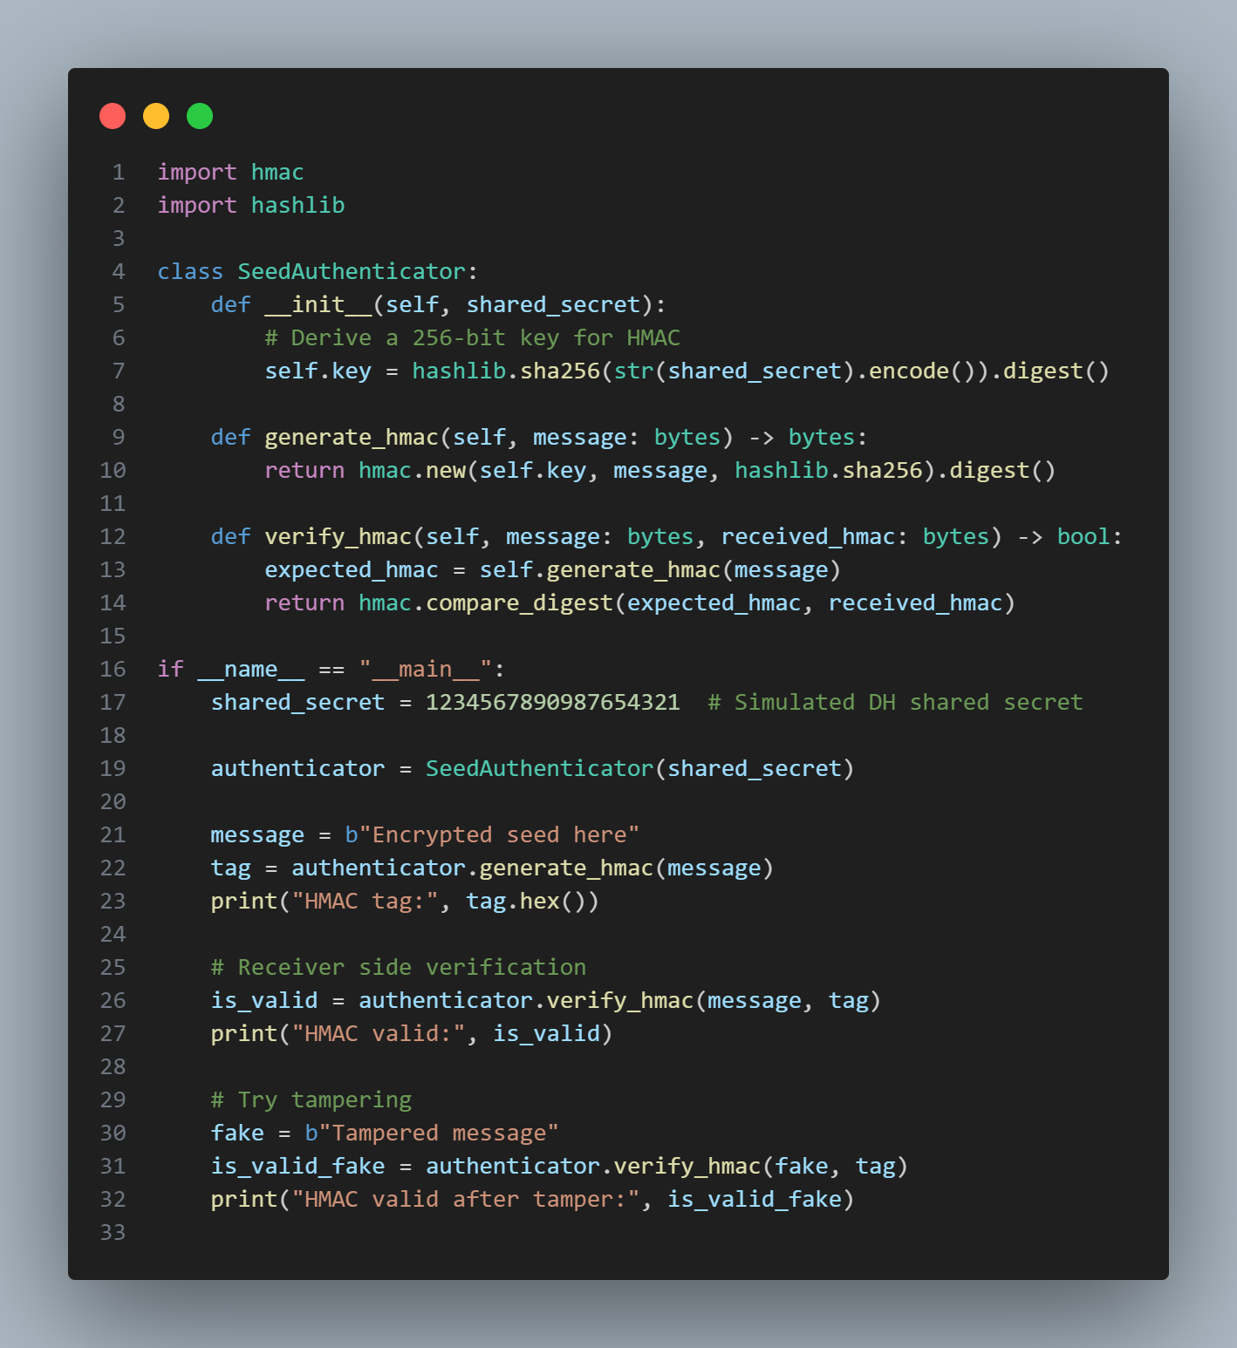

Test Case output:
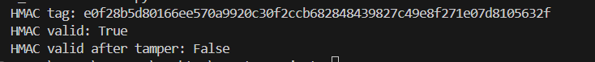

Linear Congruential Generator
Purpose : Generates a pseudorandom keystream for the stream cipher.

Key Components :
- Parameters : Multiplier (a), increment (c), modulus (m), and initial state (seed).
- Keystream Generation : Produces a sequence of pseudorandom numbers modulo 256 for use as a keystream.

Algorithm Details :
- Next State :Xn+1​=(a⋅Xn​+c)modm
- Keystream Generation :
  - Generate a sequence of pseudorandom numbers using the LCG formula.
  - Take each number modulo 256 to ensure it fits within a single byte.

Design Choices:
Following Park–Miller Parameters I choose a,c,m according.

Implementation with a test case:
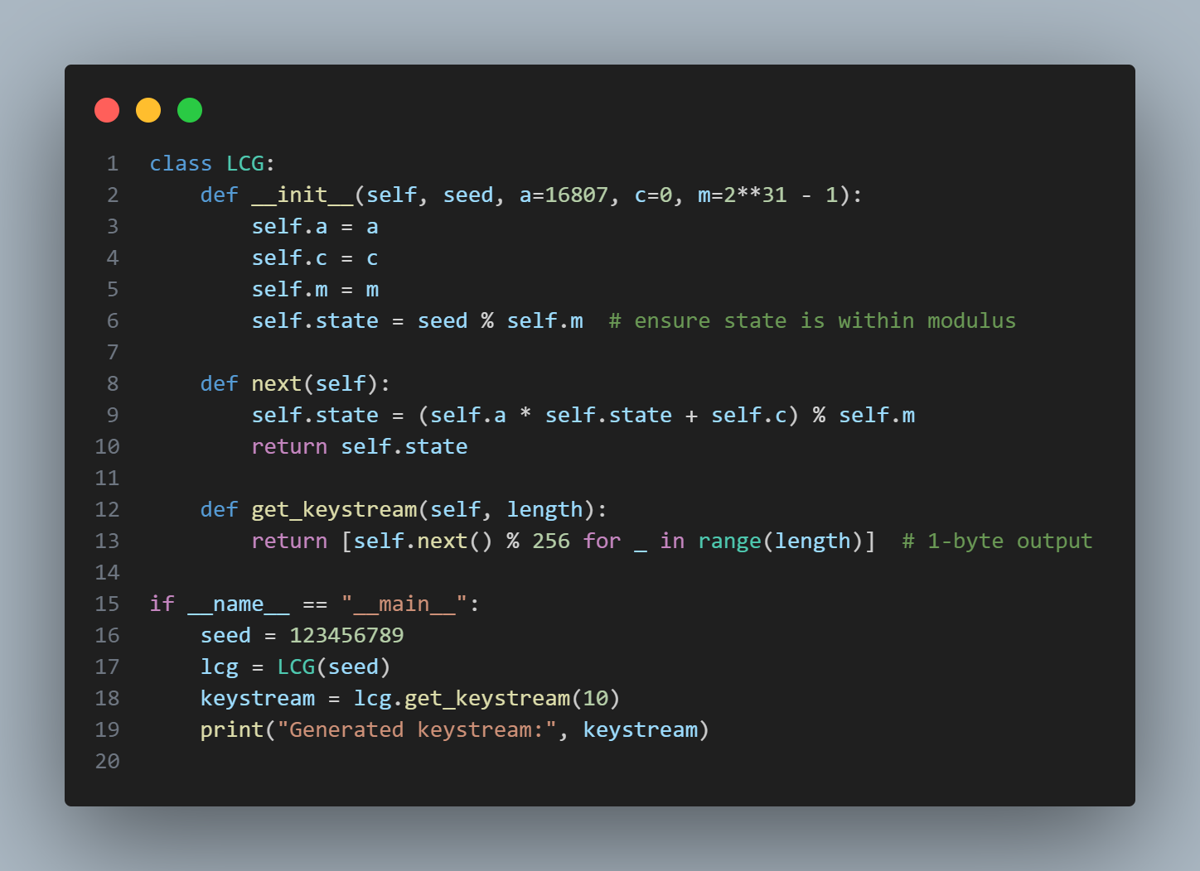

Test Case output:

