There are 21 landmarks: lets call them LM

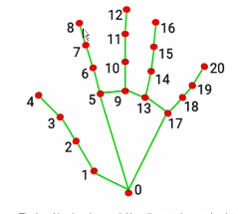

Hand_landmarker_result= matrix with 21 row, for each landmark, its X,Y,Z axis position

X-value increases to the right

Y-value increases going **DOWN** not up

**determine the position of the hand; up, left, right**

If up: y-value for fingers is greater than wrist (used LM1 for wrist instead of LM0 for better accuracy)

If right: x-value for wrist is less than fingers

If left: x-value for wrist is greater than fingers

**Move type: rock, paper or scissors**

**if up:**

If paper: LM5 y-value >LM8 y-value and so on for all 4 fingers

If scissors: LM5 y-value > LM8 and LM9 > LM12 BUT LM16 < LM13 and LM20<LM17

If rock: LM6 < LM8 and LM 10< LM12 and so on (all fingers closed)

**If right:**

Paper: LM5 x-value < LM8 and so on

Scissors: LM5 and LM9 < LM8 and LM12 and LM13 and LM17> LM16 and LM20

Rock: LM5 > LM8 and so on

**If left:**

**Flip the signs for right**