## Useful commands

### Get status f a dir

git status

### Add file(s) in commit

git add .

git add <filename>

# What is Version Control:

For Content, teams and Agility.

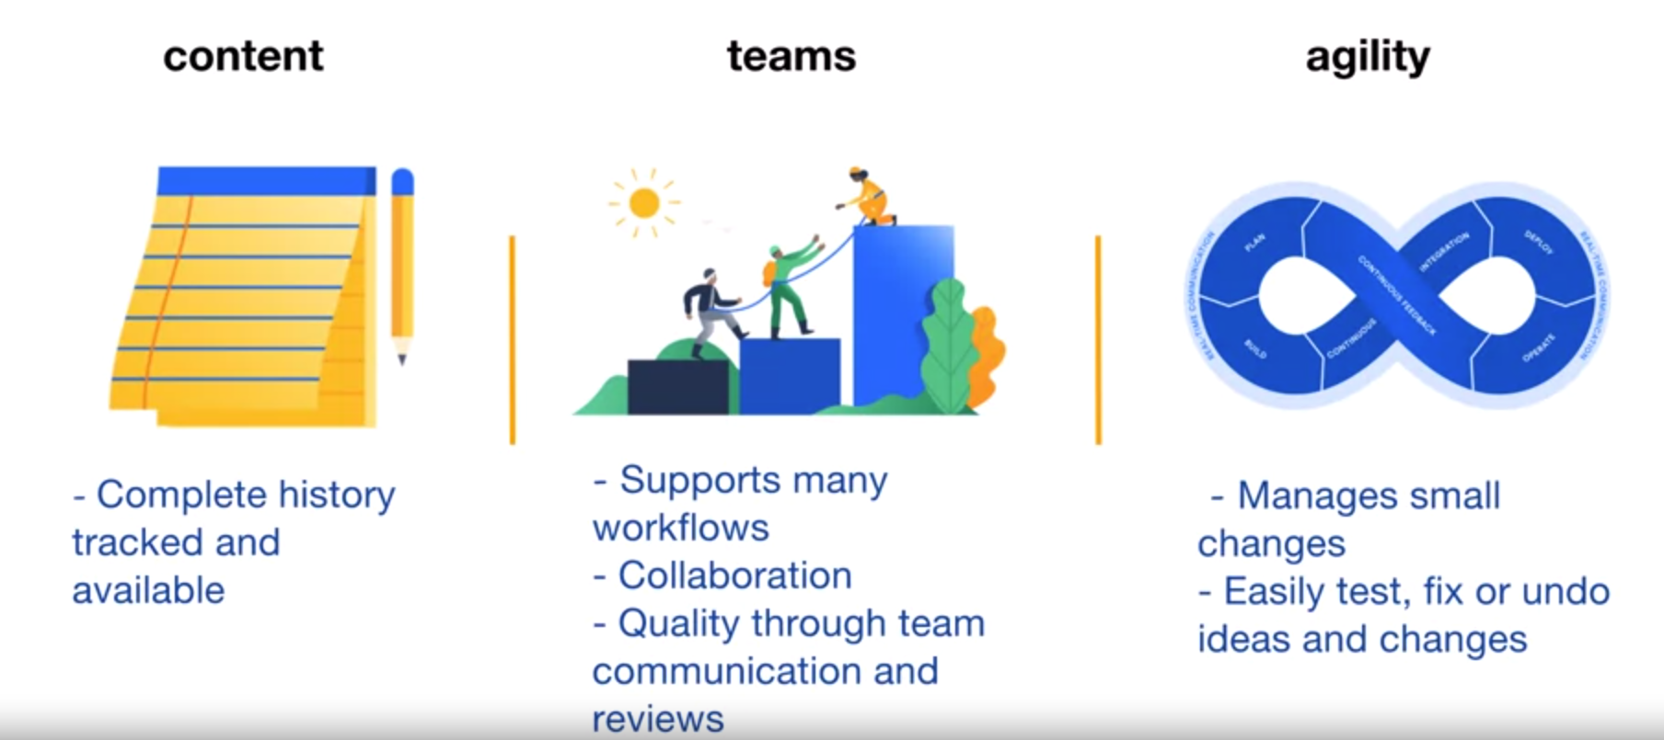

# Git:

Maintains full history of project.

Each commit is a snapshot of entire project.

But done is an efficient way: Each unique file is stored only once

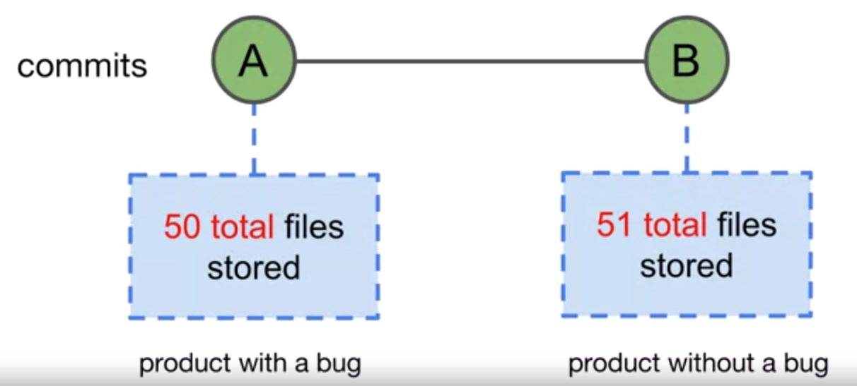

Best Practice: Create a separate branch for every feature/change and then commit to the main branch.

# Basic Git Syntax



## Git Command Example:

git status

## Git Command-- flags Example:

git status –short

## Git command --flags [arguments]

git add file.txt

git add .

# Git Locations

## Working Tree

A single commit’s directory and files

## Staging Area or Index

Files that are planned/ready for the next commit. **Add** command is used to achieve this.

## Local Repository

All the commits that have been made for the project. These commits contain the version history of the project. Also **contains staging area.**

## Project Directory

Contains all the project that is being handled. It contains **working tree** (files of single commit of the project – usually latest)and **.git** folder that contain staging area and all the commits of projects i.e. **Local Rep.**

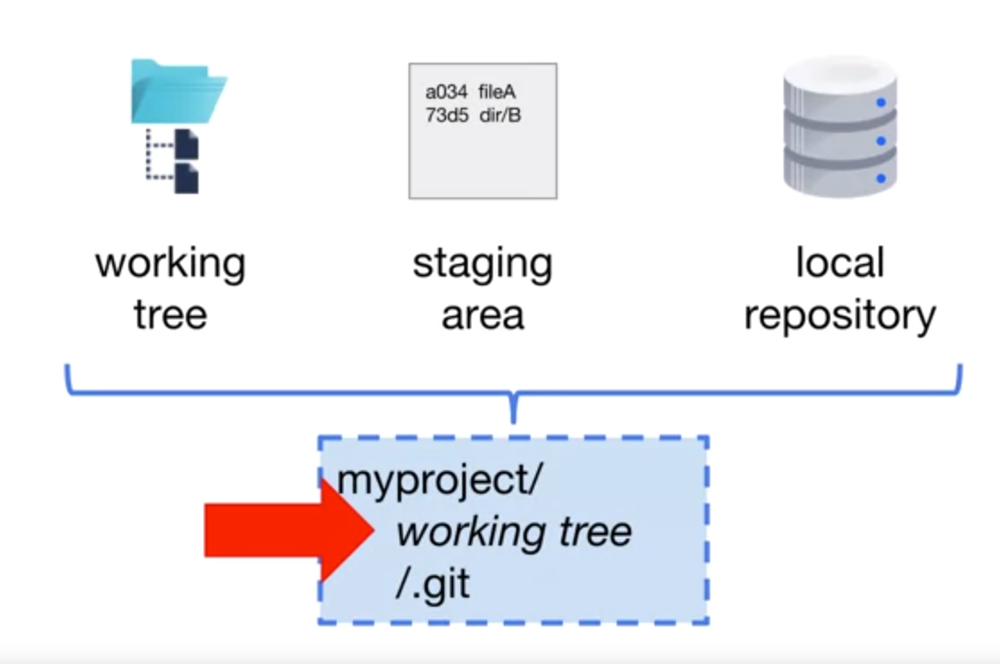

## Remote Repository

All the commits just like Local Rep but kept online/cloud. It is single **source of Truth**.

# Commit to a local repository

## Git Status

view the status of files in the working tree and specifically **staging area**. If you **add** anything it will appear in status

Enter following command to show staus (-s for short details)

**git status -s**

When a file is in working dir but not added to stage



**git add <filename>**

ORs

**git add .**

When a file is added to stage



**echo “Someting” > FileA.txt**

When something is modified in staged file



Add again to get latest changes into stage

# Push to Report Repo

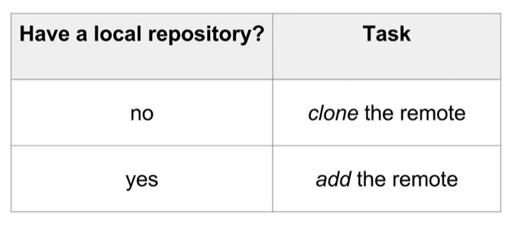

## Git Clone



If project name specified (as in option in command) it will be used as project directory. If not specified, then name in the URL (minus the .git) will be used.

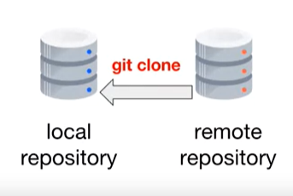

## Git Remote Add

When you have local repo already set and committed

