ANALYSTLAB AFRICA · DATA SCIENCE INTERNSHIP · WEEK 2

Data Preprocessing Report
From raw patient records to a machine-learning-ready dataset
Author: Molemi Molokoane · Dataset: Heart Failure Prediction (fedesoriano, Kaggle) · October 2026

1. Summary
This report documents every step taken to prepare the Heart Failure Prediction dataset (918 patients, 11 clinical features) for a model that predicts heart disease. The full code and outputs are in Week2_Feature_Engineering.ipynb; figure numbers in this report match the notebook.
Raw data | Final ML-ready data
918 rows, 12 columns, 5 text columns | 918 rows (734 train / 184 test), 14 numeric features + target
172 cholesterol and 1 blood-pressure values hidden as 0 | No missing values; missingness kept as a flag
Outliers in blood pressure, cholesterol and ST depression | Capped at the IQR fences, no patients removed
Features on scales from −2 to 600 | Continuous features robust-scaled (median 0, IQR 1)

Key principle: no data leakage. The data was split into training and test sets before any step that learns from the data. Imputation medians, outlier fences, encoders and the scaler were all fitted on the training set only and then applied unchanged to the test set, so test results will reflect performance on genuinely unseen patients.

2. Business problem
Heart disease is the world's leading cause of death, and early identification of high-risk patients saves lives and specialist time. The goal is a dataset from which a model can flag likely heart-disease patients (target heart_disease: 1 = disease, 0 = normal) using routine measurements. Because a missed diagnosis is far more costly than an extra test, preprocessing aimed to preserve every patient and every warning signal. The Business Understanding Report covers this in detail.

3. Data inspection: key observations
- Structure: 918 rows × 12 columns: 6 numeric (one of them, FastingBS, a 0/1 flag), 5 text categories and the binary target. Data types were correct on load.
- Missing values: no NaNs, but 172 patients (18.7%) have Cholesterol = 0 and one has RestingBP = 0, which is physically impossible. 88.4% of the patients with missing cholesterol have heart disease, against 47.7% of the rest, so the missingness itself is informative.
- Duplicates: none.
- Target balance: 55.3% heart disease, 44.7% normal: mildly imbalanced, so stratified splitting is sufficient.
- Strongest raw signals: a flat ST slope (83% disease vs 20% for an upward slope), asymptomatic chest pain (79%), exercise-induced angina (85% vs 35%) and male sex (63% vs 26%). Resting ECG separates the classes only weakly (52% to 66%).
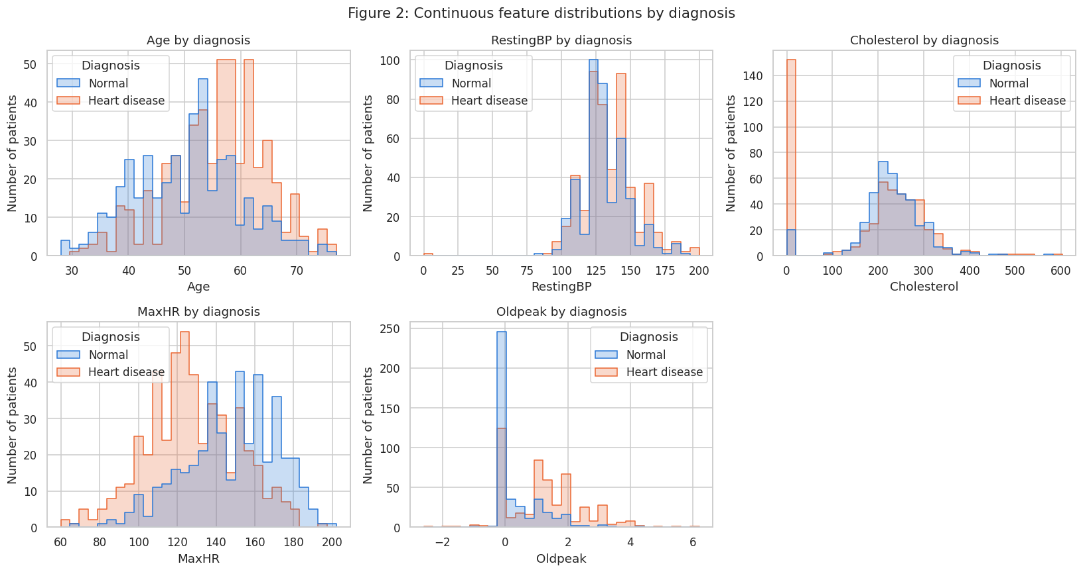
Figure 2. Continuous features by diagnosis. Note the spike of impossible zeros in Cholesterol.

4. Data cleaning
Step | Decision | Justification
Rename columns | e.g. Oldpeak → st_depression, FastingBS → fasting_blood_sugar | Descriptive snake_case names make the dataset self-explanatory
Hidden missing values | Cholesterol and RestingBP zeros → NaN; flag cholesterol_missing created first | A value of 0 is impossible; the flag keeps the strong signal carried by missingness
Duplicates | Checked and removed: 0 found | The check stays in the pipeline for future data
Data types | Text → category; flags → 0/1 integers | Documents meaning and reduces memory use
Range validation | All values within clinical limits; 13 negative st_depression values kept | Negative ST depression means ST elevation, a real clinical finding

5. Feature engineering
New feature | Definition | Outcome
cholesterol_missing | 1 if cholesterol was not recorded | Kept: r = 0.32 with the target, more signal than cholesterol itself
hr_pct_of_predicted | max heart rate ÷ (220 − age) | Removed in selection: r = 0.95 with max_heart_rate
has_st_depression | 1 if st_depression > 0 | Kept: 70% vs 35% disease rate; r = 0.76 with st_depression, below the 0.8 cutoff
age_group | <45, 45–54, 55–64, 65+ | Removed in selection: r = 0.94 with age

The dataset has no identifier, name or date columns, so no feature was removed purely as irrelevant; removals were decided with evidence during feature selection (section 10).
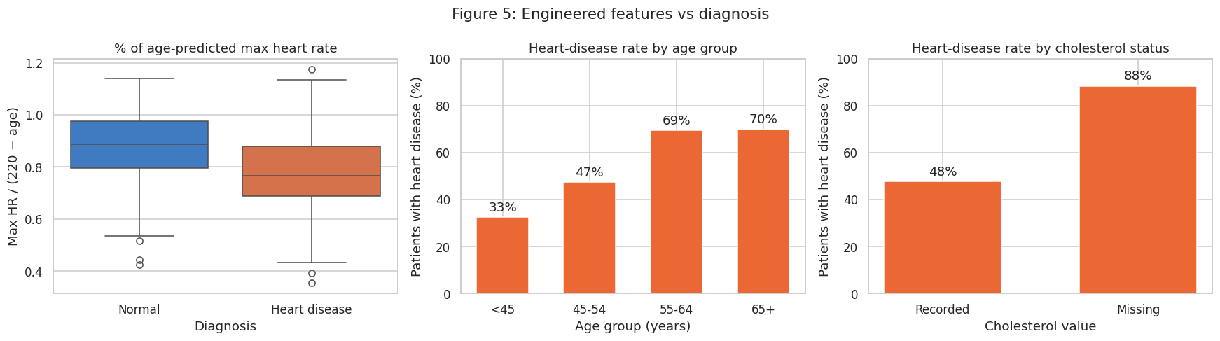
Figure 5. Engineered features against the diagnosis.

6. Train/test split
A stratified 80/20 split (random_state = 42) gave 734 training and 184 test patients, both with 55.3%/55.4% heart disease. Splitting first prevents information about test patients from leaking into the preprocessing statistics.

7. Missing-value imputation
Missing resting_bp and cholesterol values were filled with the training-set median for the patient's sex (cholesterol: 250 for women, 235 for men; resting_bp: 130 for both).
- Dropping rows was rejected: it would lose 19% of the data, mostly heart-disease patients, biasing the sample.
- The mean was rejected: cholesterol is right-skewed, so the median is more representative.
- Per-sex medians reflect that cholesterol levels differ between men and women.
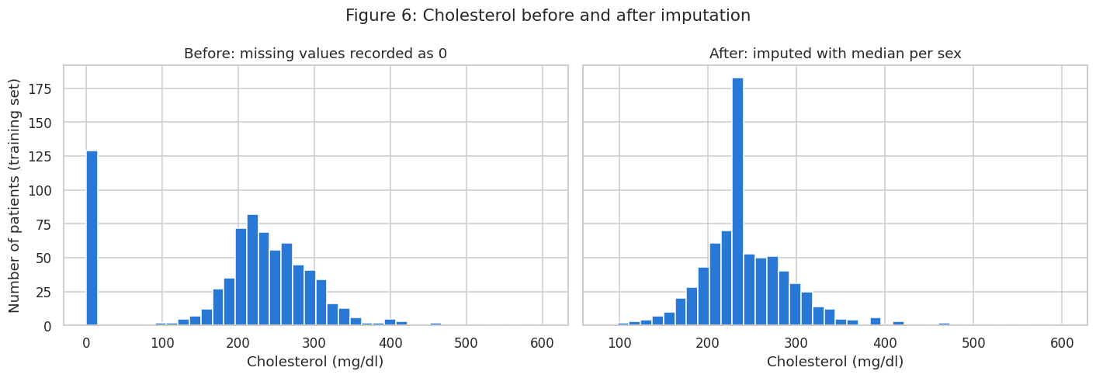
Figure 6. Cholesterol before and after imputation (training set).

8. Outlier detection and treatment
Outliers were detected on the training set with boxplots, the IQR rule (outside Q1 − 1.5×IQR or Q3 + 1.5×IQR) and Z-scores (|z| > 3). The IQR rule flagged 20 resting_bp, 33 cholesterol, 13 st_depression, 2 max_heart_rate and 2 hr_pct_of_predicted values; the Z-score flagged fewer (6, 10, 6, 0 and 1), because it assumes a normal distribution and its own mean and standard deviation are inflated by the outliers.
Treatment: capping (winsorising) at the training-set IQR fences. The values are clinically plausible (a cholesterol of 500 mg/dl does occur), so deleting those patients would discard real, often high-risk, cases. Capping keeps every patient while stopping extreme values from dominating distance- and gradient-based models. The IQR rule was preferred to the Z-score because several features are skewed.
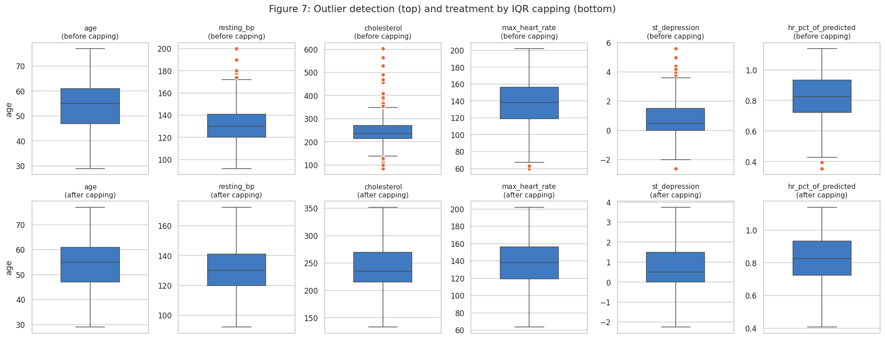
Figure 7. Boxplots before (top) and after (bottom) capping.

9. Encoding and scaling

9.1 Encoding
Variable | Technique | Why
sex, exercise_angina | Label encoding (0/1) | Binary: a single 0/1 column loses nothing and implies no false order
age_group | Ordinal encoding (0–3) | The age bands have a natural order
chest_pain_type, resting_ecg, st_slope | One-hot encoding, dropping one reference level | Nominal categories: label codes would invent an order. ST slope risk is not monotonic (Flat 83%, Down 78%, Up 20%)

The reference levels are the clinically normal or lowest-risk categories (ATA chest pain, Normal ECG, Up slope). Dropping one level per feature avoids the dummy-variable trap (perfect multicollinearity in linear models), and choosing these levels means each remaining column reads as “risk relative to normal”.

9.2 Scaling
StandardScaler, MinMaxScaler and RobustScaler were compared. RobustScaler was chosen for the six continuous features because it uses the median and IQR, which are not distorted by the remaining skew (st_depression) or by the cluster of imputed cholesterol values at the median. MinMaxScaler was rejected because it depends on the single most extreme values. The 0/1 columns were not scaled, to keep them interpretable. The scaler was fitted on the training set only.
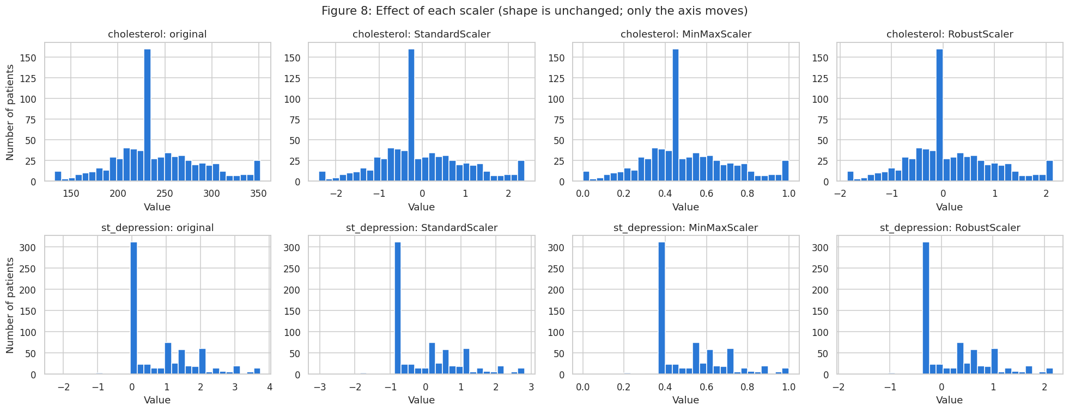
Figure 8. The three scalers change the axis, not the shape of the distribution.

10. Feature selection
Three methods were combined on the training set: a correlation heatmap, mutual information and random-forest importance. Two rules were fixed before looking at the results:
- Redundancy: for any pair of features correlated above |0.8|, remove the one with lower mutual information.
- Low relevance: remove a feature only if both methods rate it as uninformative (mutual information < 0.01 and random-forest importance < 0.02).
Removed feature | Reason
hr_pct_of_predicted | Redundant with max_heart_rate (r = 0.95), lower mutual information (0.059 vs 0.081)
age_group | Redundant with age (r = 0.94), lower mutual information
resting_ecg_LVH, resting_ecg_ST | Both methods near zero, so resting ECG is removed entirely
chest_pain_type_TA | Both methods near zero (only 46 patients); grouped with the ATA reference level

Most important features: st_slope_Flat, chest_pain_type_ASY, exercise_angina, st_depression and max_heart_rate, which rank in the top six for both methods. Two engineered features did not beat the raw columns they were derived from, and the rule was applied as written rather than adjusted after seeing the result. Cholesterol was kept although its linear correlation is only 0.06, because its mutual information ranks 6th, which points to a non-linear relationship.
Validation: a 5-fold cross-validated logistic regression scored ROC AUC 0.930 with all 19 features and 0.930 with the 14 selected ones, so the selection removed 5 columns without any loss of predictive power.
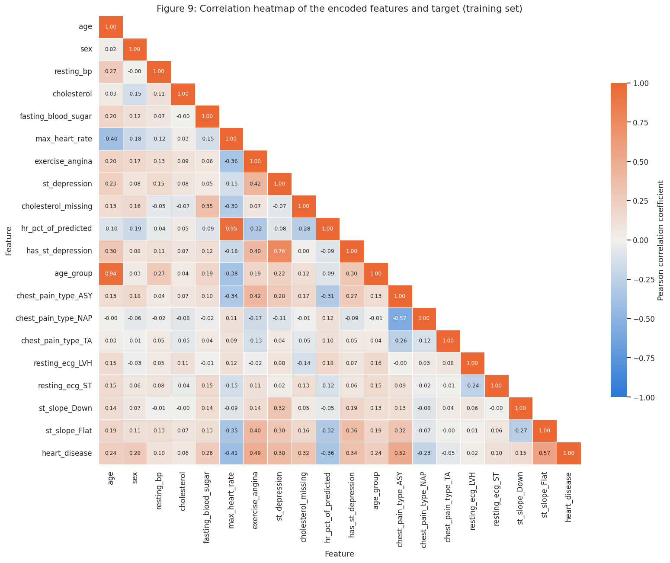
Figure 9. Correlation heatmap of the encoded features and the target (training set).
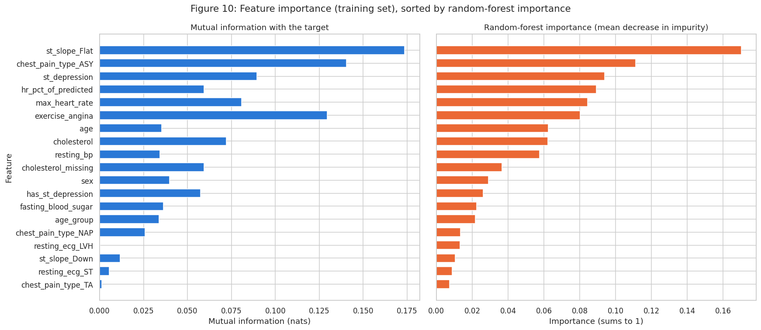
Figure 10. Mutual information and random-forest importance.

11. Final dataset and readiness
File | Contents
Data/heart.csv | Original Kaggle dataset, unchanged
Data/heart_cleaned.csv | Cleaned, imputed, capped, with engineered features; human-readable, with a split column
Data/heart_ml_ready_train.csv | 734 rows: 14 encoded, scaled features + heart_disease
Data/heart_ml_ready_test.csv | 184 rows, same columns, transformed with training-set statistics
Data/heart_ml_ready.csv | Both parts combined, with a split column

Final features: age, sex, resting_bp, cholesterol, fasting_blood_sugar, max_heart_rate, exercise_angina, st_depression, cholesterol_missing, has_st_depression, chest_pain_type_ASY, chest_pain_type_NAP, st_slope_Down, st_slope_Flat.
Is the dataset ready for machine learning? Yes. It has no missing values, only numeric features on comparable scales, no redundant features, a stratified split with an identical class balance, and every learned transformation fitted on training data alone. All automated readiness checks in the notebook pass.

Limitations and recommendations
- The data pools five hospitals with different recording practices (one did not record cholesterol). A model should be validated on local patient data before use.
- 79% of the patients are male, so model performance should be checked separately for women.
- Because missed diagnoses are costly, the modelling stage should prioritise recall and ROC AUC over plain accuracy.

