Data-Driven Demand Forecasting and Inventory Optimization for Small Businesses
Project report · WTM Tech Mentorship 2026 · Data Science · Group B
Mugisha Elisa · Muluka Zerga Lendino · Molemi Molokoane · Khadijat Ozohu Yusuf
Code and results: github.com/Mo-lemi/WTM-Data-Science-Group-B

Summary
A small shop has to decide what to buy before it knows what will sell. Using one year of real sales from a UK online gift shop, we forecast weekly sales of its 10 best-selling products and turned those forecasts into restock recommendations.
We tested two methods on 8 weeks of sales kept hidden from them. A simple average of the last 4 weeks beat a random forest model, missing by about 594 units per product per week, against 708. The hidden weeks were the busy run-up to Christmas, about twice as busy as the weeks the model learned from. We therefore use the simple average.
With the assumptions we state, the shop should reorder 6 of its top 10 products. The two clearest cases are Rabbit Night Light and Small Popcorn Holder. Real stock and delivery data would be needed before relying on the exact quantities.

1. Problem and audience
Many small businesses decide what to restock by guesswork. Popular products run out and lose sales, while slow products sit on the shelf and tie up money.
This project is for owners and managers of small retail businesses who have sales records but no forecasting tools. We asked: how much of each product will the shop sell in the coming weeks, and what should it buy more of?
The answer has two parts, like a weather forecast. The forecast says "It will rain tomorrow", and the restock step says "So take an umbrella".
Scope: weekly forecasts, 4 weeks ahead, for the top 10 products by quantity sold. We did not forecast all of the roughly 4,000 products, and the dataset contains no real stock or supplier data.

2. Data and preparation
We used the Online Retail dataset from the UCI Machine Learning Repository (Chen, 2015, licence CC BY 4.0). It has 541,909 rows covering 1 December 2010 to 9 December 2011, from a UK online gift shop with many wholesale customers. Customer IDs are anonymous numbers, and we publish no personal details.
Cleaning kept 517,350 rows and removed 24,559 (4.5%):
- Removed exact duplicates.
- Separated cancelled invoices, whose numbers start with C.
- Removed orders with a matching cancellation (same customer, product and quantity), 5,477 rows. Two orders of 80,995 and 74,215 units were cancelled within minutes and would otherwise have looked like best-sellers.
- Kept only positive quantities and prices.
- Removed non-product codes such as postage, fees and bank charges, 2,056 rows.
- Kept rows with no customer ID, using -1 in its place, because they are still real sales.

From the clean data, we built the top 10 list and a weekly sales table: 10 products over 54 weeks. We checked the cleaned-data totals, top 10 and revenue figures against the raw data using separate code.

3. Sales analysis
We loaded the clean data into a SQLite database and wrote five queries to describe the whole shop. Total revenue was about 9,710,101.
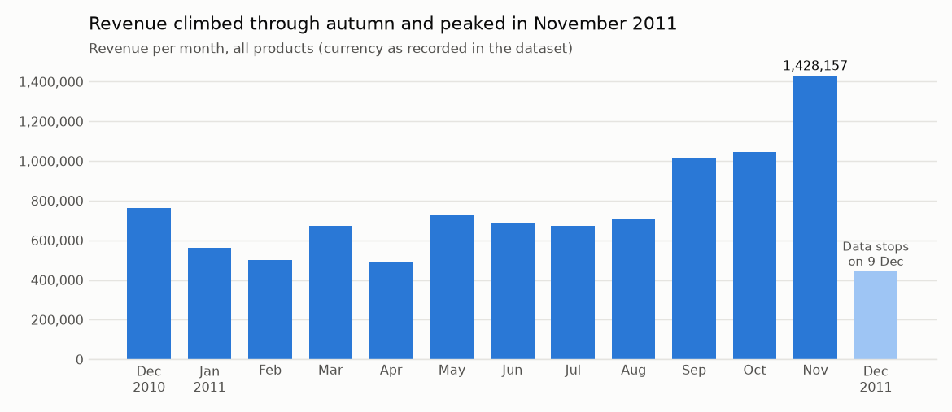
Figure 1. December 2011 is low only because the data stops on 9 December.
- Busiest month: November 2011, with revenue of about 1,428,157.
- Biggest market: the United Kingdom, at about 8,225,772 (85% of revenue). The Netherlands, EIRE, Germany and France follow.
- Selling the most is not the same as earning the most: Small Popcorn Holder sold the most units (56,661), while Regency Cakestand 3 Tier earned the most money (about 166,257), and isn't in the top 10 by quantity.
- Slowest products: the 10 listed sold just one unit each. They are tied, so they are examples, not "the 10 worst". One is a gift voucher, not stock on a shelf.

4. Forecasting and evaluation

How we tested
We removed the first and last weeks, because they are incomplete and their low totals have nothing to do with demand. That left 52 full weeks. We trained on the first 44 and hid the last 8 (10 October to 28 November 2011). We split by date, never at random, because a real shop only ever has the past to go on.
We compared two methods:
- Simple average (the baseline): next week's sales = the average of the last 4 weeks.
- Random forest (the ML model): learns from three clues: sales last week, sales 2 weeks ago, and the 4-week average. We fixed its settings in advance and did not change them after seeing the results.

Decisions we made:
- Removed Rabbit Night Light's weeks before its first sale (10 May 2011). Those zeros mean "not on sale yet", not "nobody wanted it".
- Left out a near-Christmas clue, although we had planned one. Each training row needs 4 earlier weeks of sales, so no training rows fall in November or December, and the model could not have learned from it.
- Set the week of 26 December 2011 to 0, because the shop made no sales from 24 December 2010 to 3 January 2011. This assumes it closes again.

Results
Method | MAE (units) | RMSE (units)
Simple average (baseline) | 593.9 | 1028.2
Random forest | 708.1 | 1201.5

MAE is the average miss, ignoring whether it was too high or too low. RMSE is similar, but big misses count much more. For both, lower is better. RMSE is well above MAE here because a few very large misses push it up. For example, Rabbit Night Light sold 5,593 in the week of 24 October, against a simple average forecast of 112.
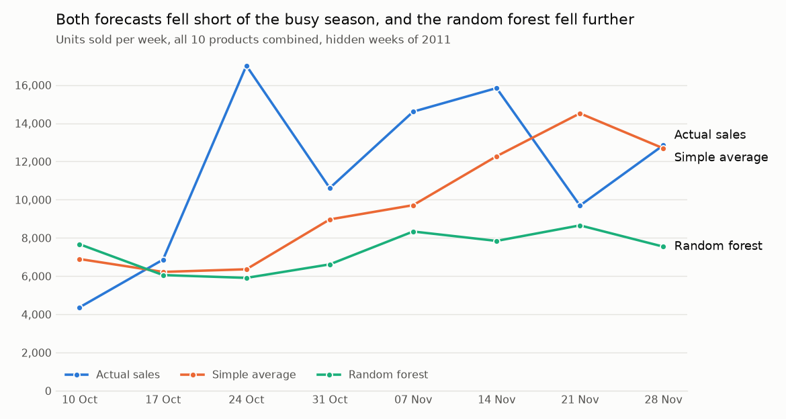
Figure 2. All 10 products combined. Across the 8 weeks, they sold 91,848 units, against forecasts of 77,634 (simple average) and 58,623 (random forest).

Why the simple method won
The hidden weeks averaged about twice the sales of the training weeks (1,148 against 585 units per product per week). A random forest predicts by averaging similar past weeks, so its highest forecast was 1,314 units, while actual sales reached 5,593. The simple average rises as recent sales rise, so it kept closer, although it was often a few weeks late. The random forest did better on 3 of the 10 products, but worse overall.
How we checked this: the test used only weeks hidden from training, and every clue used only earlier weeks. The random forest also lost with all 5 other random seeds we tried (MAE between 696 and 703), so this was not bad luck.

5. Restock recommendations
Reorder point = weekly forecast × delivery time + safety buffer. If stock is below the reorder point, the shop should reorder at least the difference. This step is arithmetic, not machine learning.
The dataset has no stock or delivery data, so the team agreed three assumptions:
- Delivery time: 2 weeks.
- Safety buffer: 1 week of forecast sales.
- Starting stock: 4 weeks of the product's usual sales, as if the shop bought for a normal month before the busy season. "Usual" means the average week from its first sale up to the week of 31 October 2011.

The decision is made at the start of the week of 5 December 2011, using the simple average forecast:
Product | Forecast per week | Reorder point | Assumed stock | Reorder? | Order at least
Rabbit Night Light | 3,416 | 10,249 | 2,124 | Yes | 8,125
Small Popcorn Holder | 3,267 | 9,801 | 3,220 | Yes | 6,581
Assorted Colour Bird Ornament | 1,256 | 3,768 | 2,475 | Yes | 1,293
Jumbo Bag Red Retrospot | 1,298 | 3,896 | 3,255 | Yes | 641
Mini Paint Set Vintage | 776 | 2,330 | 1,891 | Yes | 439
White Hanging Heart T-Light Holder | 880 | 2,639 | 2,323 | Yes | 316
World War 2 Gliders | 985 | 2,956 | 3,853 | No | 0
Pack of 12 London Tissues | 585 | 1,754 | 1,873 | No | 0
Pack of 72 Retrospot Cake Cases | 459 | 1,378 | 2,760 | No | 0
Pack of 60 Pink Paisley Cake Cases | 325 | 975 | 1,881 | No | 0

How firm this is: we tried 9 combinations of delivery time, buffer and starting stock. Rabbit Night Light and Small Popcorn Holder always needed reordering, Assorted Colour Bird Ornament needed it in 8, and both Cake Cases products never did. The other five depend more on the assumptions.
Caution: an order placed on 5 December would arrive around 19 December, just before the likely Christmas closure, and these products' sales fell week by week at that time last year (7,690, then 5,871, then 4,246 units). These numbers are a starting point, and the shop owner makes the final decision.

6. Dashboard
A five-page Power BI dashboard lets a shop owner explore these results:
- Business Overview: total revenue, monthly revenue and the top markets.
- Product Performance: the top products by units and by revenue, and products that sold only one unit.
- Demand Forecasting: actual sales against both forecasts for a chosen product, and the forecast for the next 3 weeks.
- Model Evaluation: MAE and RMSE for both methods, overall and for each product.
- Stock Recommendations: reorder points, assumed stock and how much to order.
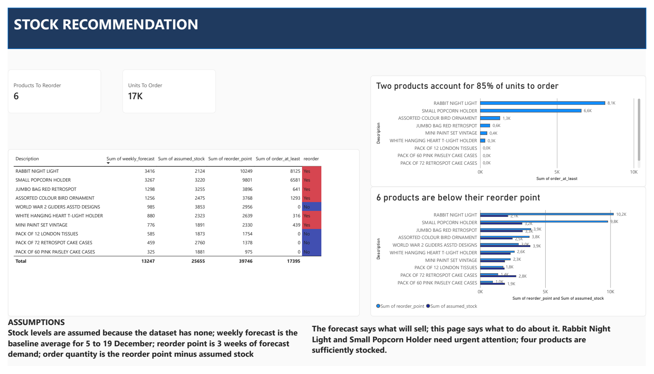
Figure 3. The Stock Recommendations page. The full dashboard and a PDF copy are in the repository's dashboard folder.

7. Limitations, lessons and next steps
Limitations:
- One year of data: the model sees the Christmas peak only once, so it cannot learn yearly patterns.
- One-week-ahead test: we tested forecasts one week ahead, but the final forecast goes up to 4 weeks ahead, so its real errors may be larger.
- December forecasts may be too high: the forecasts for 12 and 19 December don't include last year's fall before Christmas.
- Sudden spikes: one-week jumps can't be predicted from past sales alone.
- Sales are not the same as demand: with no stock data, a product that ran out would look like it had low demand.
- Assumptions: the stock, delivery and Christmas closure figures are assumed, not measured.
- One shop: results from a UK gift shop with many wholesale customers may not transfer to other businesses.

What we learned:
- Test a complex model against a simple one. The random forest sounded stronger, but the simple average did better on our test.
- Check the data behind the headline numbers. Two apparent best-sellers turned out to be huge orders that were cancelled within minutes.
- A good idea can still be unusable. We planned a near-Christmas clue, then dropped it when we found no training rows in November or December.
- State assumptions, and test them. Trying 9 combinations showed which restock decisions hold up and which depend on what we assumed.

With more time or data, we would:
- Use several years of sales, so a model can learn the Christmas pattern.
- Use the shop's real stock levels and delivery times.
- Test forecasts 4 weeks ahead, to match how the shop would really use them.
- Add known events, such as promotions and large wholesale orders, to help explain spikes.
- Extend beyond the top 10 products, and give a range instead of a single number.

8. Team contributions
Member | Role | Contribution
Mugisha Elisa | Data cleaning and EDA | Wrote the original cleaning and EDA notebook: data understanding, cleaning, charts, the top 10 list and the weekly sales table.
Muluka Zerga Lendino | SQL and sales analysis | Built the SQLite database and wrote the five sales queries, then re-ran them on the corrected data.
Molemi Molokoane | Forecasting and evaluation, team lead | Built the forecasts and their evaluation, drafted the restock assumptions and calculation, corrected the cleaning notebook, prepared the README and this report, and led the team.
Khadijat Ozohu Yusuf | Power BI dashboard and slides | Built the five-page Power BI dashboard, wrote the first version of its notes, and prepared the presentation slides.

Where members changed each other's work: Molemi corrected the handling of orders cancelled later, the top 10 grouping, the weekly sales table and the non-product charges in the cleaning notebook. Mugisha also applied the first three of these fixes in a separate copy, and the team kept Molemi's version, which used the shared Drive paths. Molemi also added a cell that displays Muluka's results in the SQL notebook, and re-ran it. In Khadijat's dashboard, Molemi corrected wording, tidied the charts, exported the PDF copy, and corrected the dashboard notes to match the final file. The whole team agreed the restock assumptions.

Reference
Chen, D. (2015). Online Retail [Dataset]. UCI Machine Learning Repository. https://doi.org/10.24432/C5BW33

