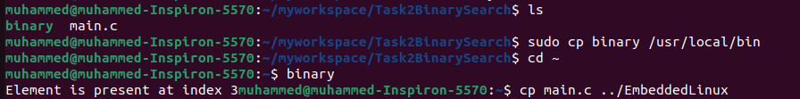

As shown when we write binary in home (any directory) the terminal can execute it and there is because all files in directory usr/local/bin are declared as PATH variables and terminal can read them from any location or directory.

