FREIGHT RATE
PREDICTION CHALLENGE
Machine Learning Engineer Assessment Report
Development period: January 1 - October 31, 2025
Final selected approach: XGBoost regression trained on log1p(posted_rate), using base and engineered features with a chronological validation strategy.

Internal chronological validation
Metric | Result
MAE | $121.52
RMSE | $637.75
MAPE | 5.32%
R² | 0.8254

These are internal holdout metrics, not the company's hidden validation score.

1. Executive Summary
This assessment develops a supervised regression model to predict freight posted rates from load, route, market, and time-related features. The labeled development data spans January through October 2025. Because the final use case requires predictions on future loads, model selection used a chronological holdout rather than a shuffled split.
The modeling process progressed from simple baselines to tree ensembles. Linear and Ridge regression were strong early performers, while XGBoost became the preferred model after feature-engineering and target-transformation experiments. A log-transformed target substantially reduced percentage error for XGBoost. The final tuned model achieved an internal validation MAE of $121.52 and MAPE of 5.32% on September-October 2025.
After model selection, the final workflow was refit on all labeled development data and used to generate predictions for all 12,000 hidden-validation loads. A separate December scenario file was also completed using the same trained model with transparent training-data-only fallbacks for market inputs that were not supplied in the December schema.

2. Dataset and Data Quality

2.1 Development data
- 48,000 labeled loads in total.
- Date range: January 1, 2025 through October 31, 2025.
- Target: posted_rate, a continuous freight-rate value.
- Features include route, distance, weight, equipment, geographic coordinates, market_index, quote_signal, and date.

2.2 Data-quality handling
- Negative weight values were treated as invalid sign errors and corrected with absolute value.
- Missing weight values were imputed with equipment-specific medians learned from the training split, with a global training median fallback.
- Missing market_index values were imputed using month-based medians learned from the training split, with a global training median fallback.
- Statistical outliers were generally retained because extreme freight-market observations can be valid rather than data-entry errors.
- Pickup and delivery coordinates passed the contiguous-US geographic sanity check.
Leakage control: All learned imputation statistics used during validation were estimated from the training period only. Deterministic feature calculations were recomputed after imputation where necessary.

3. Validation Strategy
A chronological split was used to better represent the real inference setting. A random split could mix earlier and later market conditions and produce an overly optimistic estimate of future performance.
Partition | Date range | Rows | Purpose
Training | Jan 1 - Aug 31, 2025 | 38,477 | Model fitting and training-only preprocessing
Validation | Sep 1 - Oct 31, 2025 | 9,523 | Unseen future-period model selection

Model selection and tuning were performed against this holdout. Once the final model and configuration were fixed, the model was refit on the full January-October development set before producing the final hidden-validation predictions.

4. Exploratory Findings and Feature Engineering

4.1 Key exploratory findings
- posted_rate is strongly right-skewed (skewness about 1.90). Applying log1p reduced skewness to about -0.49.
- distance has a strong relationship with posted_rate and remains the dominant structural feature.
- haversine_distance is highly redundant with road distance, while route_circuity captures more distinct route geometry.
- market_index varies through time but showed very similar distributions across equipment types, supporting time-based rather than equipment-specific imputation.
- quote_signal contained the largest IQR-based outlier share, around 4%, but those observations were retained.

4.2 Engineered features
Feature | Definition / purpose
estimated_base_cost | distance × quote_signal
market_adjusted_cost | estimated_base_cost × market_index
weight_distance_k | weight × distance / 1000
adjusted_rpm | quote_signal × market_index
haversine_distance | Straight-line geographic distance between pickup and delivery
route_circuity | Road distance / haversine distance
Temporal features | month, day_of_week, quarter, is_weekend

Feature decisions were not based on correlation alone. The engineered feature groups were tested on the chronological holdout, because highly correlated features can still be redundant while lower-correlation features may add useful non-linear signal.

5. Model Selection
Models were evaluated sequentially from a naive benchmark to increasingly flexible learners. The same chronological validation set was used for all comparisons.
Model | MAE | RMSE | MAPE | R²
Dummy | $1,178.80 | $1,526.23 | 83.43% | -0.0002
Linear Regression | $142.54 | $638.08 | 8.10% | 0.8252
Ridge | $142.53 | $638.08 | 8.10% | 0.8252
Decision Tree | $171.93 | $669.61 | 7.62% | 0.8075
Random Forest | $314.06 | $717.02 | 24.32% | 0.7792
XGBoost (base) | $147.53 | $652.63 | 7.01% | 0.8171

Ridge produced the best initial MAE and RMSE, confirming a strong approximately linear component in the data. XGBoost remained competitive and had lower percentage error, so both model families were retained for additional feature and target experiments.

5.1 Feature-set comparison
Candidate | MAE | RMSE | MAPE | R²
Ridge - Base | $142.53 | $638.08 | 8.10% | 0.8252
Ridge - Engineered | $144.40 | $639.80 | 8.49% | 0.8242
XGBoost - Base | $147.53 | $652.63 | 7.01% | 0.8171
XGBoost - Engineered | $145.44 | $648.69 | 6.40% | 0.8193

For XGBoost, the complete engineered feature set performed best among the tested feature groups. The improvement was modest in MAE but more meaningful in MAPE.

5.2 Target transformation

Candidate | MAE | RMSE | MAPE | R²
XGBoost - Log Target | $127.69 | $641.01 | 5.67% | 0.8236
Ridge - Raw Target | $142.53 | $638.08 | 8.10% | 0.8252
XGBoost - Raw Target | $145.44 | $648.69 | 6.40% | 0.8193
Ridge - Log Target | $424.39 | $887.54 | 20.30% | 0.6617

The log target materially improved XGBoost MAE and MAPE but harmed Ridge. Therefore, log transformation was retained only for XGBoost. Predictions were converted back to dollars with expm1 before evaluation and submission.

6. Final Model and Internal Validation
The final model was a regularized XGBoost regressor trained on log1p(posted_rate) using the base and engineered feature set.
Hyperparameter | Value
n_estimators | 600
learning_rate | 0.025
max_depth | 4
min_child_weight | 7
subsample | 0.75
colsample_bytree | 0.75
reg_alpha | 0.1
reg_lambda | 1.5
objective | reg:squarederror
random_state | 42

Metric | Training | Validation
MAE | $92.21 | $121.52
RMSE | $567.39 | $637.75
MAPE | 4.15% | 5.32%
R² | 0.8523 | 0.8254

The train-validation gap indicates some expected model complexity but not extreme overfitting. A second tuning step produced only marginal gains over the first tuned model, so further manual tuning was stopped to reduce the risk of overfitting model selection to the same validation period.
Selected internal result: Validation MAE = $121.52, RMSE = $637.75, MAPE = 5.32%, and R² = 0.8254.

7. Final Prediction Workflow
After model selection, preprocessing statistics were recalculated using the full labeled January-October development set, and the final XGBoost configuration was refit on all available labeled data.
- Generated 12,000 predictions for validation.csv.
- Saved the required two-column file: load_id,predicted_rate.
- Sanity checks found zero missing predictions, zero non-positive predictions, and zero duplicate load IDs.
- Prediction range was approximately $197 to $6,672, with a mean around $2,361.
The company calculates the final hidden validation metrics after submission. The internal holdout results reported in this document should not be interpreted as the hidden challenge score.

8. December Scenario
The December chart input contains 31 daily rows for a fixed Lexington to Fort Wayne load: 360 miles, Dry Van, 32,000 lb. Only the date varies. The reduced input schema does not provide market_index, quote_signal, or geographic coordinates required by the selected model.
To keep the same final model, a transparent inference adapter was used. Route coordinates were derived from the development-data route history. For market_index and quote_signal, the five most recent observations for the same Lexington → Fort Wayne, Dry Van combination were used to compute training-data-only fallback medians. No future December market information was used.
December fallback | Value
market_index | 0.90458
quote_signal | 1.87336

The resulting December predictions are nearly flat, which is expected because the physical load attributes remain fixed and only date-derived features change.
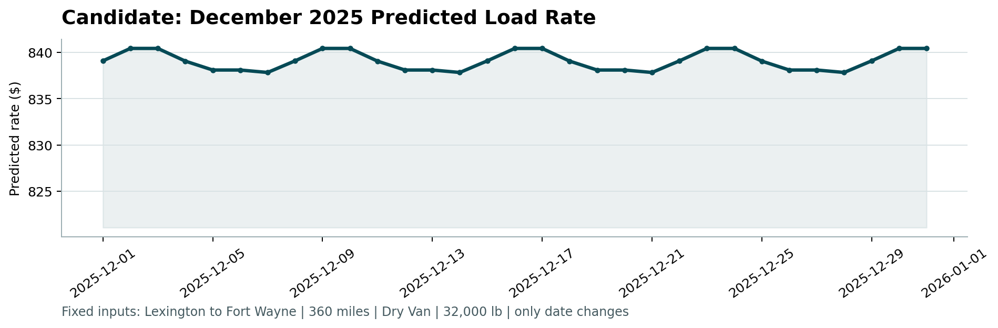
Figure 1. December 2025 predicted load rate generated by the provided scorer.

9. Scorer Validation
The provided score.py completed successfully and confirmed the required output formats:
- Validated 12,000 final predictions.
- Validated 31 fixed December predictions.
- Created scorer_results/candidate_december.png.
- Final validation metrics are calculated by Spotter after submission.

10. Limitations and Assumptions
- The chronological validation set covers only September and October 2025, so performance may change under larger market regime shifts.
- December market_index and quote_signal are not supplied; the report uses recent route/equipment history as an explicit fallback rather than claiming those future values are known.
- Several engineered features are algebraically correlated. Their inclusion was decided by validation performance rather than correlation alone.
- The hidden validation target is unavailable, so no claim is made about the final company score.

11. Conclusion
The final solution combines leakage-aware chronological validation, training-only preprocessing, targeted feature engineering, and a tuned XGBoost model trained on a log-transformed target. The selected model improved internal MAE from $142.53 for the strongest initial linear model to $121.52 while reducing MAPE to 5.32%. The final output files passed the provided scorer checks, and the workflow remains explicit about the assumptions required for the reduced-schema December scenario.

