**API_Bug001:** Dependents is spelled incorrectly when retrieving Employee details   
**Steps to Reproduce:**

1. Send a GET call to the following uri   
   <https://wmxrwq14uc.execute-api.us-east-1.amazonaws.com/Prod/api/employees>
2. In the JSON response body verify the spelling of “dependents” field

**Expected:** “dependents” should be spelled correctly   
**Actual:** Response body has “dependants” instead of “dependents”

**API_Bug002:** API Payload accepts invalid/special characters for “firstName” and “lastName”  
**Steps to Reproduce:**

1. Send a POST call to the following uri   
   <https://wmxrwq14uc.execute-api.us-east-1.amazonaws.com/Prod/api/employees>
2. In the JSON Body paste the following:  
   {

"firstName": "(@#@#%)&^>>#",

"lastName": "*()*&%$$%$><>)",

"dependants": "0"}  
3. Hit Send

**Expected:** System should not allow special characters for name fields and it should display an error message  
**Actual:** System allows users to add special character in the name fields.

**API_Bug003:** When adding an employee through API the UI does not display the employee details unless user refresh the page

**Steps to Reproduce:**

1. Send a POST call to the following uri   
   <https://wmxrwq14uc.execute-api.us-east-1.amazonaws.com/Prod/api/employees>
2. In the JSON Body paste the following:  
   {

"firstName": "Myname",

"lastName": "Good",

"dependants": "2"}  
3. Hit Send

**Expected:** The UI should display the new employee details without having to refresh   
**Actual:** User need to refresh to see the new employee details

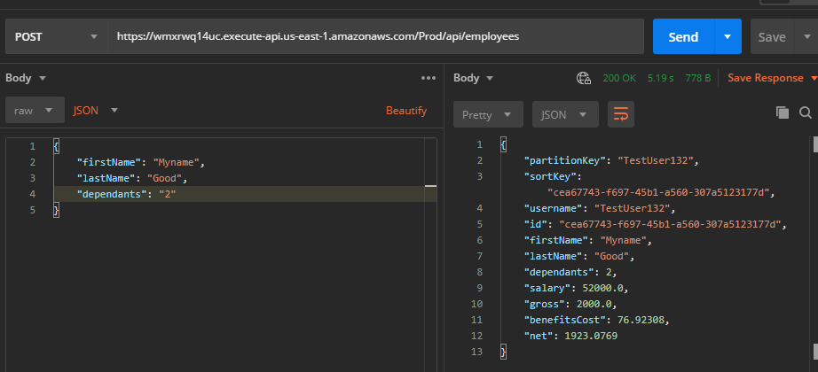

**API_Bug004:** User is able to make a delete request on already deleted employee  
**Steps to Reproduce:**

1. Send DELETE request to the following Uri   
   <https://wmxrwq14uc.execute-api.us-east-1.amazonaws.com/Prod/api/employees/8308f297-e602-4ed0-9729-9264051da31b>
2. Send another DELETE request again for the same employee
3. User gets 200 OK Status

**Expected:** User should see some error message for the delete request in the response body

**Actual:** User does not see any error message rather system returns 200 OK status

--Delete the same Employee again

**API_Bug005:** User Is able to make a PUT request for a deleted employee  
**Steps to Reproduce:**

1. Send a PUT Request to the following Uri   
   <https://wmxrwq14uc.execute-api.us-east-1.amazonaws.com/Prod/api/employees>
2. In the JSON body paste the info of a deleted employee and update value for “dependants” field  
   {

"id": "8308f297-e602-4ed0-9729-9264051da31b",

"firstName": "Delete",

"lastName": "Employee",

"dependants": 4

}  
3. Hit Send

**Expected:** User should not be able to update information of a deleted employee and system should throw error message  
**Actual:** User is able to update deleted employee with a 200 OK status

**API_Bug006:** Making API request by adding multiple forward slash / at the end of API endpoint does not throw any error message

**Steps to Reproduce:**

1. Make a GET request to the following URI and add multiple /  
   <https://wmxrwq14uc.execute-api.us-east-1.amazonaws.com/Prod/api/employees///////>
2. Hit Send
3. System returns Employee list

**Expected:** System should display error message for incorrect URI

**Actual:** System returns employee details with 200 OK Status

**API_Bug007:** System is adding a new employee record when making a PUT request for a deleted employee

**Steps to Reproduce:**

1. Make DELETE request to Delete an employee
2. Copy the ID for the Deleted Employee
3. Make a PUT call and make sure to pass the ID of the deleted employee and update any fields{

"id": "8308f297-e602-4ed0-9729-9264051da31b",

        "firstName": "Update",

        "lastName": "NewEmployee",

        "dependants": 6

}

1. System returns 200 OK status with updated fields
2. Check the Paylocity Benefits Dashboard and it shows a new employee being added with the following details

**Expected:** System should not be adding a new employee record in the Benefits dashboard and user should not be able to update details for a deleted employee   
**Actual:** System is creating a new employee record in the Paylocity Benefits Dashboard   
Please see attached screenshots.

--Update request and response for a deleted employee

--Paylocity Benefit Dashboard  
