

**Program: Computer Engineering and Software Systems- CESS**

***Course Code: CSE 227***

***Course Name: Database Systems (1)***

***Examination Committee***

**Prof. Dr. Hoda Korashy Mohamed**

**Ain Shams University**

**Faculty of Engineering**

**Spring Semester – 2020**

RESEARCH & PROJECT SUBMISSIONS

**Student Personal Information for Group Work**

|  |
| --- |
| **Student Names:** |
| Yomna Ahmed Mahmoud  Moaaz Essam |
|  |
|  |
|  |
|  |

|  |
| --- |
| **Student Codes:** |
| 18P4843 |
| 18P3776 |

**Plagiarism Statement**

I certify that this assignment / report is my own work, based on my personal study and/or research and that I have acknowledged all material and sources used in its preparation, whether they are books, articles, reports, lecture notes, and any other kind of document, electronic or personal communication. I also certify that this assignment / report has not been previously been submitted for assessment for another course. I certify that I have not copied in part or whole or otherwise plagiarized the work of other students and / or persons.

**Signature/Student Name:**

**Yomna Ahmed, Moaaz Essam**

**Date:**

**16/6/2020**

**Submission Contents**

**01: Solving Questions Part1**

**02: Design Project Part2**

**2.1 Introduction**

**2.2 Important Data & Reports**

**2.2.1 Data**

**2.2.2 Reports**

**2.3 Assumptions**

**2.4 EERD**

**2.5 Database Schema**

**2.6 Sample of SQL**

**2.7 Implementation**

Solving Questions Part1

**01**

***First Topic***

1.a

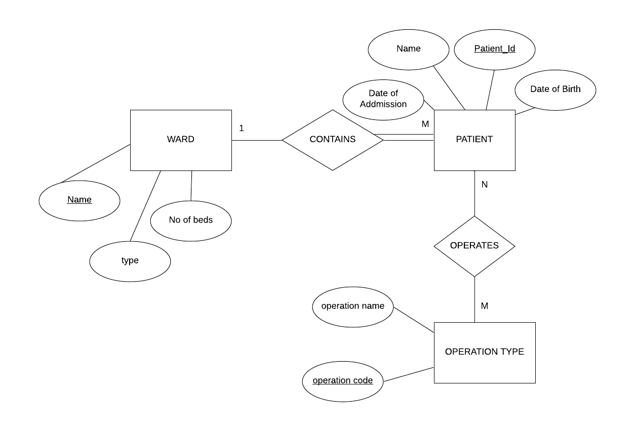

1.b

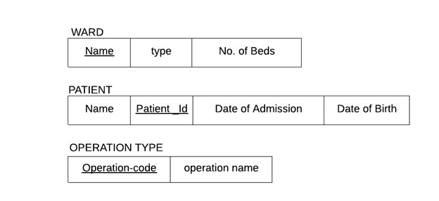

2. 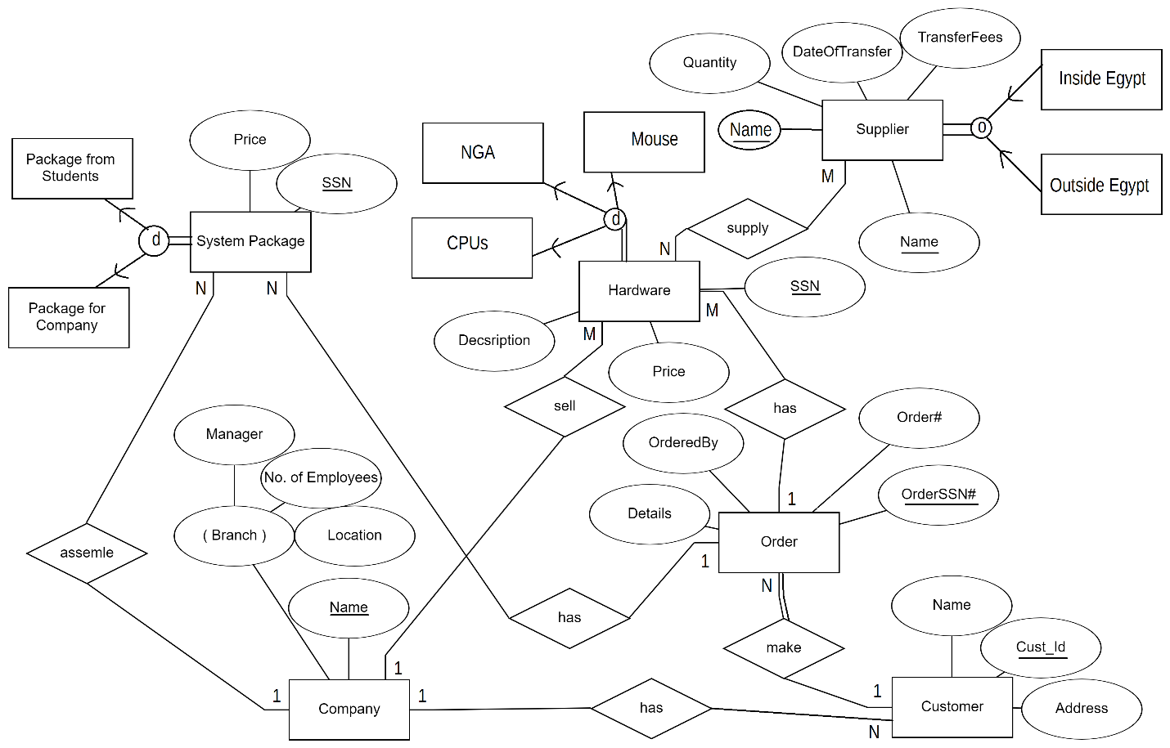

3.

3.1 the attribute Cust# of relation ORDER the references relation CUSTOMER

3.2 the attribute Order# of relation ORDER_ITEM the references relation ORDER

3.3 the attribute Item# of relation ORDER_ITEM the references relation ITEM

3.4 the attribute Order# of relation SHIPMENT the references relation ORDER

3.5 the attribute Warehouse# of relation SHIPMENT the references relation WAREHOUSE

4. For the following database schema:

EMPLOYEE (ESSN, FNAME, LNAME, BDATE, ADDR, SAL,DNO)

DEPARTMENT (DNO, DNAME, MGRSSN, BUDGET)

PROJECT (PNO, PNAME, PLOCATION, DNO)

WORKS-ON (ESSN, PNO, HOURS)

Write down the following expressions in SQL:

1. Retrieve the full name, address and birth date of all employees who work for the “Marketing” department.

Select FNAME, LNAME, ADDR, BDATE

From EMPLOYEE E, DEPARTMENT D

Where D.DNO=E.DNO AND DNAME = “Marketing”

1. List department names that have budge over L.E. 5000.

Select DNAME

From DEPARTMENT

Where BUDGET > 5000

1. Retrieve the names of all employees who work more than 10 hours per week on the “PRODUCTX” project, and works on department no. 5

Select FNAME, LNAME

From EMPLOYEE E, WORKS-ON W, PROJECT P

Where P.ESSN = E.ESSN AND P.PNO=W.PNO AND P.PNAME = “PRODUCTX” AND P.DNO = “5” AND W.HOURS > 10

Design Project Part2

**02**

***Second Topic***

**2.1 Introduction**

The railway reservation system facilitates the passengers to enquire about the trains available on the basis of source and destination, booking and cancellation of tickets, enquire about the status of the booked ticket. The aim of case study is to design and develop a database maintaining the records of different trains, train status, and passengers.

**2.2 Important Data & Reports**

**2.2.1 Data**

Station:

Station_id, name, NumberOfTrains , staff_capacity

Train: Train_Id,source,destination,arrival_time,departual_time,capacity,A_seats,B_seats,C_seats.

Passengers:

National_id, Name, Gender, DateOfBirth , Mobile, Seat_number, Train_Id

Ticket:

Ticket_Id , Status, booker_id , Train_Id ,Date

Department:

Dep_id, Name, Manager_id ,

Staff:

Staff_Id , name, address, mobile ,email,Salary,

Manager:

Manager_Id ,name, address, mobile, Department_id, email,Salary, authority_Level

Clerk:

Clerk_Id , name, address, mobile, email, Salary, window_number

TrainDriver:

Driver_Id, name, address, mobile, email, Salary, Train_Id , shift_time, License_Degree

**2.2.2 Reports**

Get trains id whose destination is to Alexandria

Get drivers id whose shift is morning

Get all info about passengers who are also from staff who are older than 20

Get clerk names in the station that work on window number 4

Get trains whose capacity more than 50 seats

Get the number of tickets reserved before certain date

Get the number of tickets reserved for a certain train that departs from Alexandria

Get staff names whose salary is between 2000$-3000$

Get the manager authority level for department number 3

Get department’s manager name & Email

**2.3 Assumptions**

We assume that’s only one train at a time travels to a certain station

The department has only one manager

The clerk works in only one window

The passenger can book more than one ticket

Ticket must be booked to only one passenger

One train can be driven by two drivers

Driver can work only one shift

**2.4 EER Diagram**

**ER Diagram using ERDplus Tool**

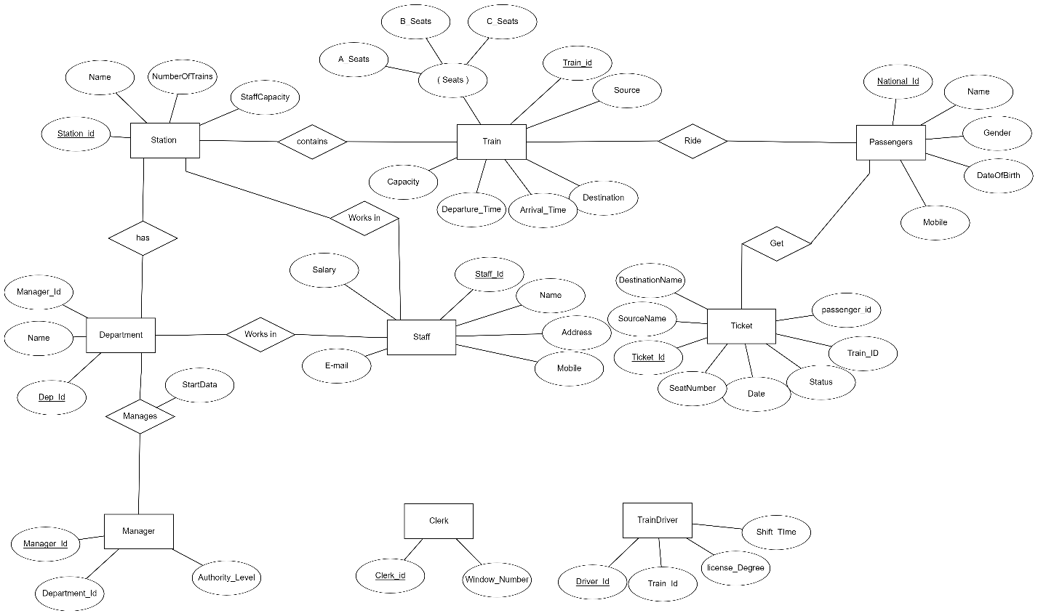

**EER Diagram finished with Paint program**

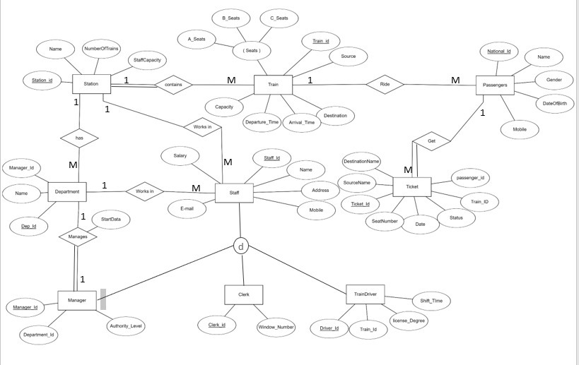

**2.5 Database Schema**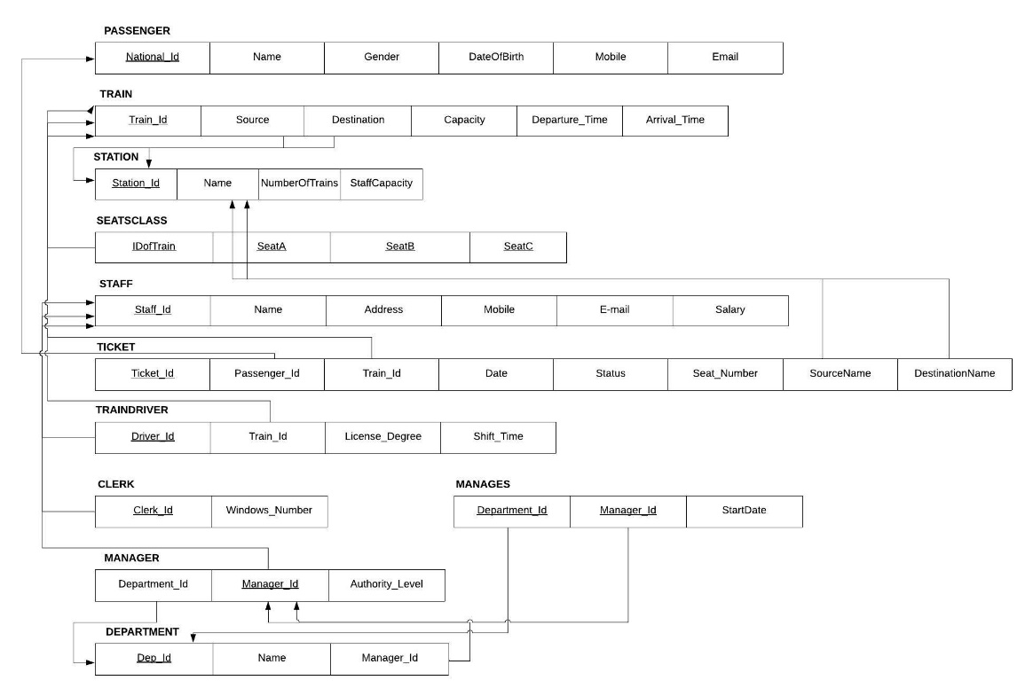

**2.6 Sample of SQL**

Create Table TRAIN(

Train_Id varchar(10) Not Null,

Source varchar(10) Default “Not Available”,

Destination varchar(10) Default “Not Available”,

Capacity Integer,

Departure_Time TIMESTAMP Not Null,

Arrival_Time TIMESTAMP

Primary Key(Train_Id),

Foregin Key (Source) References STATION

On Delete Cascade

On Update Cascade,

Foregin Key (Destination) References STATION

On Delete Cascade

On Update Cascade);

--------------------------------------------------------------------------------------------------------------------------------

Insert into TICKET (Train_Id, Ticket_Id, Passenger_Id,Source, Destination)

Select Train_Id, “12PTick”, “20299323”, “Alexandria”, “Cairo”

From TRAIN

Where Source = “Alexandria” AND Destination = “Cairo”

--------------------------------------------------------------------------------------------------------------------------------

Update PASSENGER

Set Email = “Dbase@gmail.com”

Where Nationa_Id = “22229119”

--------------------------------------------------------------------------------------------------------------------------------

Delete From MANAGER

Where Manager_Id = “22432978”

--------------------------------------------------------------------------------------------------------------------------------

**Retrieving Reports**

1-Get department’s manager name, email

Select Name, Email

From STAFF, MANAGER

Where Staff_Id = Manager_Id AND Department_Id = “Marketing”

2-Get the number of tickets reserved for a certain train that departs from Alexandria

Select Count (Ticket_Id)

From TICKET

Where Train_Id= “32A” AND Source like “%Alexandria%”

3-Get drivers id whose shift is morning:

Select Driver_Id

From TRAINDRIVER

Where Shift_Time = “Morning”

4-Get clerk names in the station that work on window number 4

Select Name

From STAFF

Where Staff_Id = (

Select Clerk_Id

From CLERK

Where Windows_Number = 4)

Order By Name DESC

5-Get staff names whose salary is between 2000$-3000$

Select Name

From STAFF

Where 2000 ≤ Salary ≤ 3000

6- Get all info about passengers who are also from staff who are older than 20

Select *

from PASSENGER inner join STAFF on National_Id = Staff_Id

Where DateOfBirth > “2000-5-10”

**2.7 Implementation**

**2.7.1 Part1: using ERD tool;**

**We used ERDplus tool**

It’s a database modeling tool for creating Entity Relationship Diagrams, Relational Schemas, Star Schemas, and SQL DDL statements.

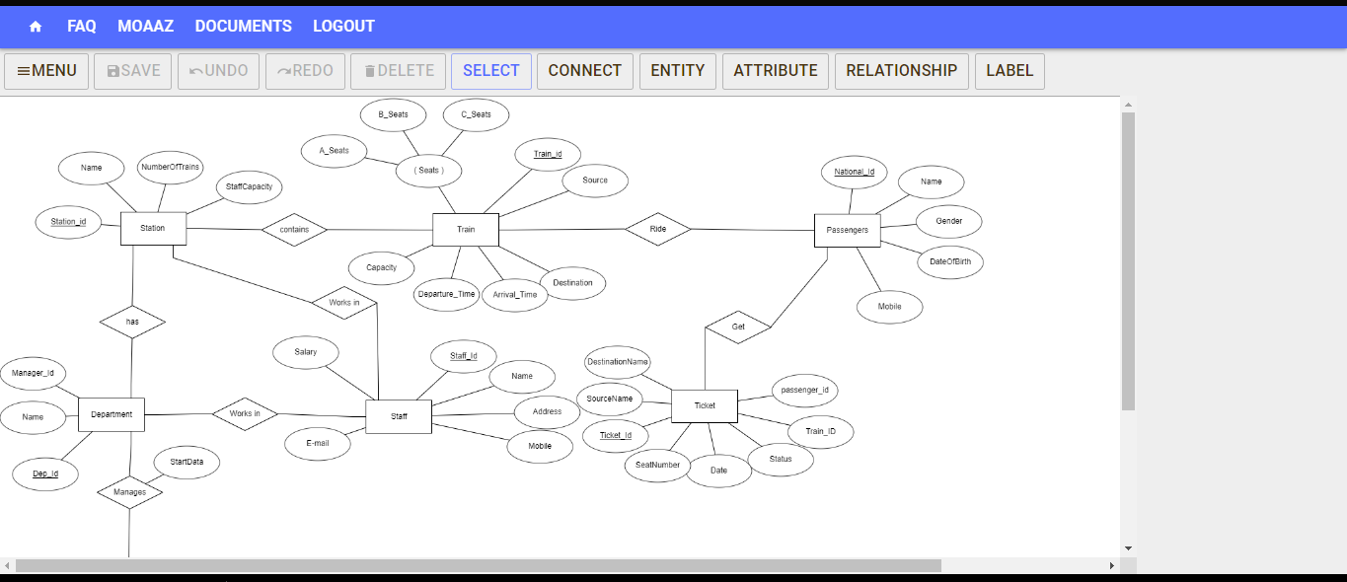

**Generated Relational Schema**

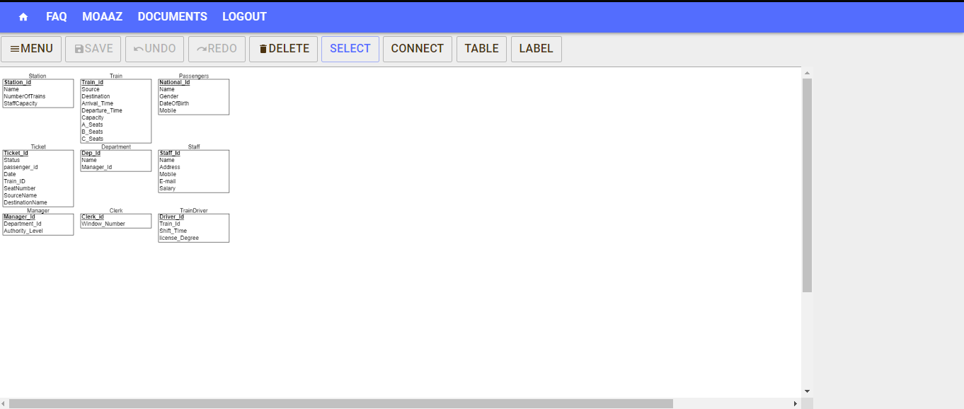

**Generated SQL**

CREATE TABLE Station

(

Station_id INT NOT NULL,

Name INT NOT NULL,

NumberOfTrains INT NOT NULL,

StaffCapacity INT NOT NULL,

PRIMARY KEY (Station_id)

);

CREATE TABLE Train

(

Train_id INT NOT NULL,

Source INT NOT NULL,

Destination INT NOT NULL,

Arrival_Time INT NOT NULL,

Departure_Time INT NOT NULL,

Capacity INT NOT NULL,

A_Seats INT NOT NULL,

B_Seats INT NOT NULL,

C_Seats INT NOT NULL,

PRIMARY KEY (Train_id)

);

CREATE TABLE Passengers

(

National_Id INT NOT NULL,

Name INT NOT NULL,

Gender INT NOT NULL,

DateOfBirth INT NOT NULL,

Mobile INT NOT NULL,

PRIMARY KEY (National_Id)

);

CREATE TABLE Ticket

(

Ticket_Id INT NOT NULL,

Status INT NOT NULL,

passenger_id INT NOT NULL,

Date INT NOT NULL,

Train_ID INT NOT NULL,

SeatNumber INT NOT NULL,

SourceName INT NOT NULL,

DestinationName INT NOT NULL,

PRIMARY KEY (Ticket_Id)

);

CREATE TABLE Department

(

Dep_Id INT NOT NULL,

Name INT NOT NULL,

Manager_Id INT NOT NULL,

PRIMARY KEY (Dep_Id)

);

CREATE TABLE Staff

(

Staff_Id INT NOT NULL,

Name INT NOT NULL,

Address INT NOT NULL,

Mobile INT NOT NULL,

E_mail INT NOT NULL,

Salary INT NOT NULL,

PRIMARY KEY (Staff_Id)

);

CREATE TABLE Manager

(

Manager_Id INT NOT NULL,

Department_Id INT NOT NULL,

Authority_Level INT NOT NULL,

PRIMARY KEY (Manager_Id)

);

CREATE TABLE Clerk

(

Clerk_id INT NOT NULL,

Window_Number INT NOT NULL,

PRIMARY KEY (Clerk_id)

);

CREATE TABLE TrainDriver

(

Driver_Id INT NOT NULL,

Train_Id INT NOT NULL,

Shift_TIme INT NOT NULL,

license_Degree INT NOT NULL,

PRIMARY KEY (Driver_Id)

);

**2.7.2 Part2: using SQL tool;**

**We used PhpMyAdmin tool**

It’s a free software tool written in PHP, intended to handle the administration of MySQL over the Web. And supports a wide range of operations on MySQL and MariaDB.

**Sample of SQL command**

**create**

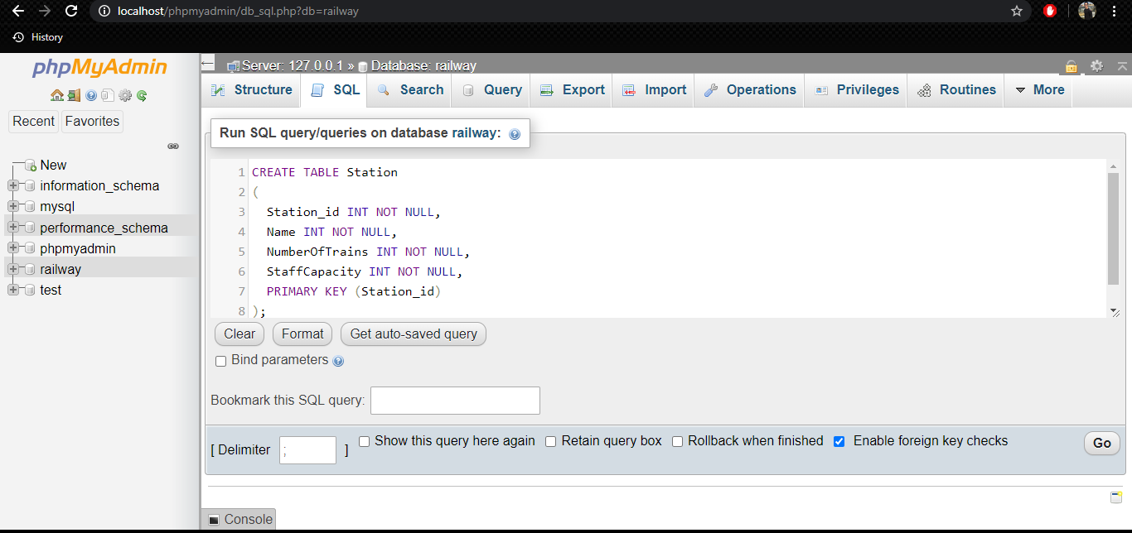

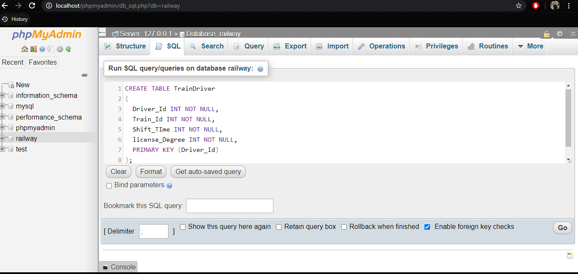

**Insert**

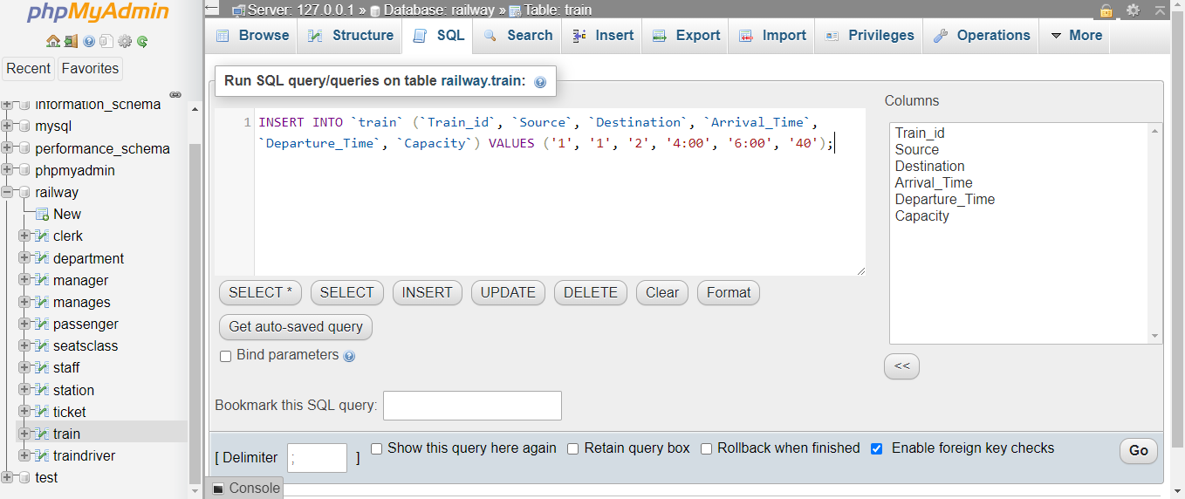

**Update**

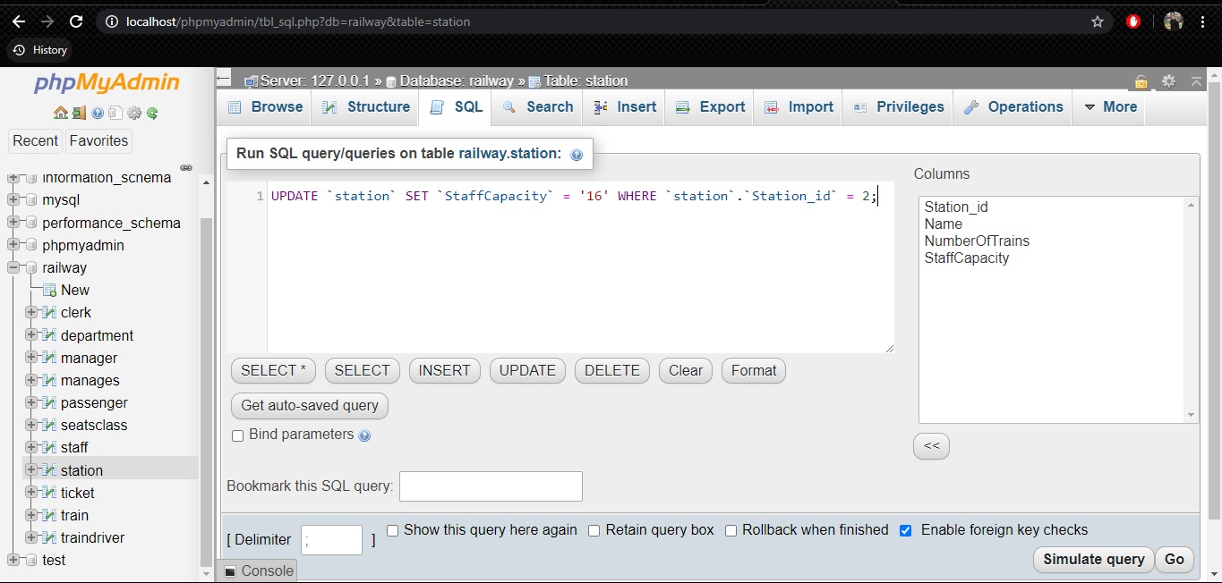

**Select**

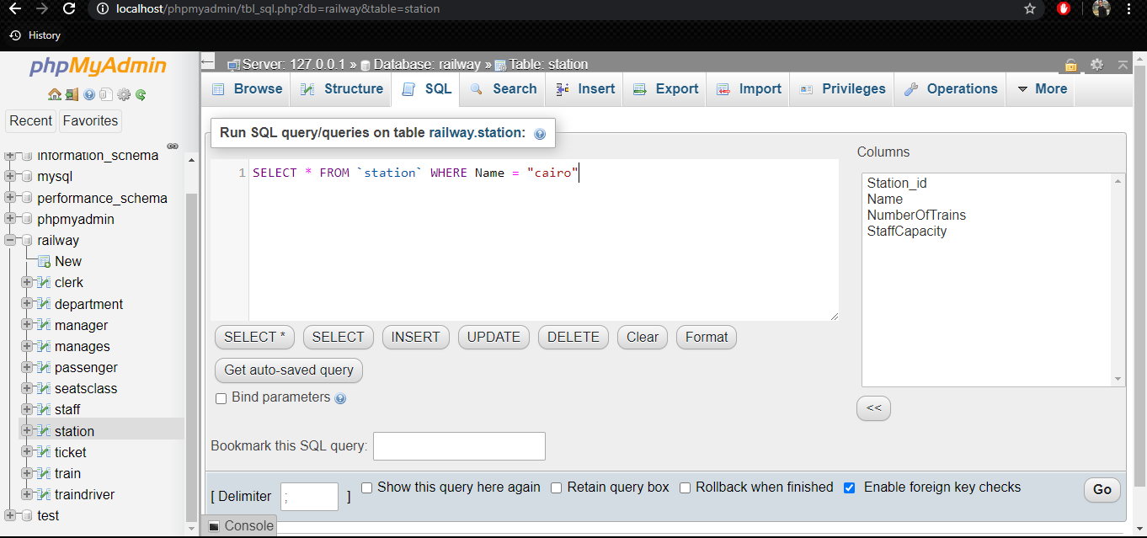

**Delete**

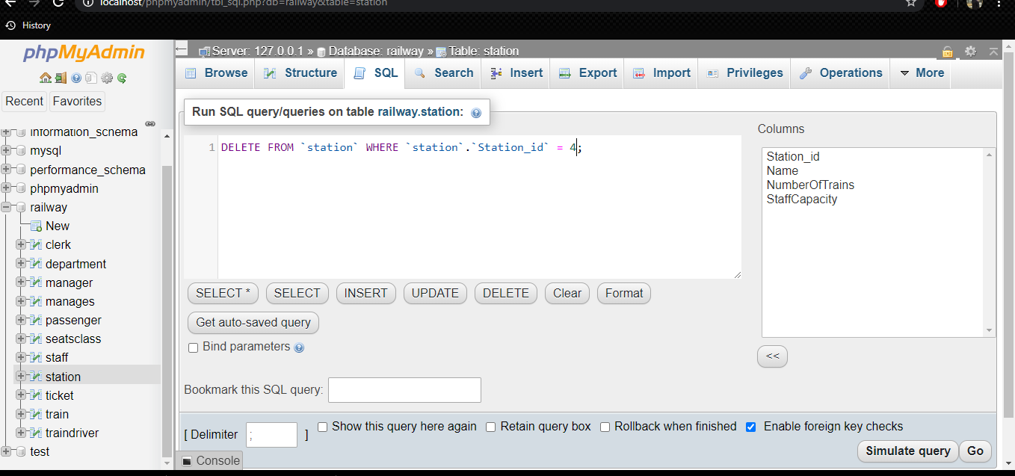

**Structure**

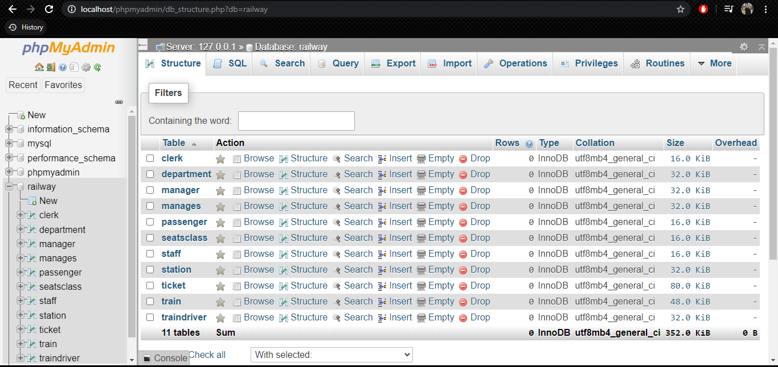

**Relational**

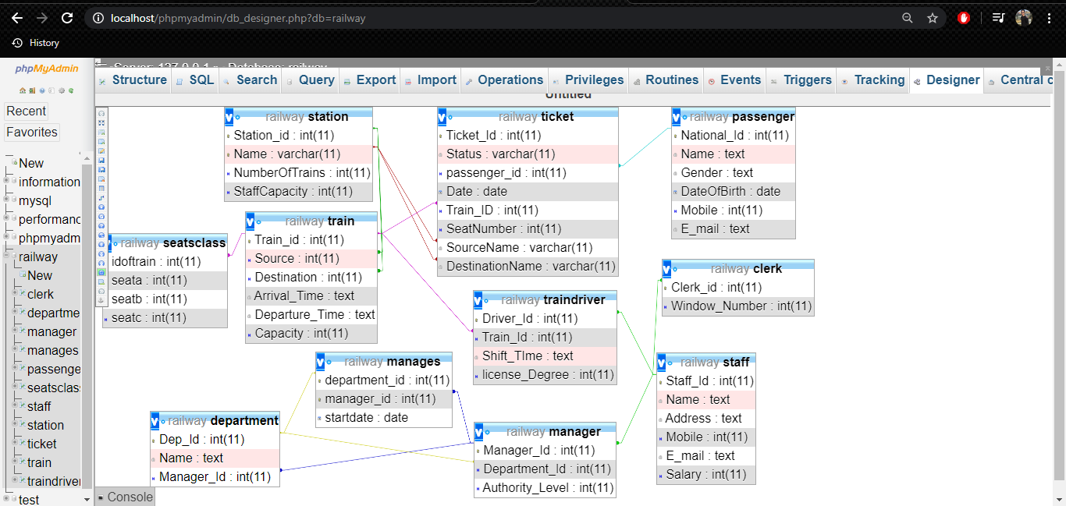

**2.8 References**

1. Fundamentals of database systems ( 7th edition, 2015) By Ramez Elmasri, Shamkant B. Navathe.
2. Database Systems: The Complete Book (2nd Edition) 2nd Edition by Hector Garcia-Molina (Author), Jeffrey D. Ullman (Author), Jennifer Widom (Author)
3. <https://erdplus.com/>
4. <https://www.phpmyadmin.net/>