Function Generator
(TIMER 555)

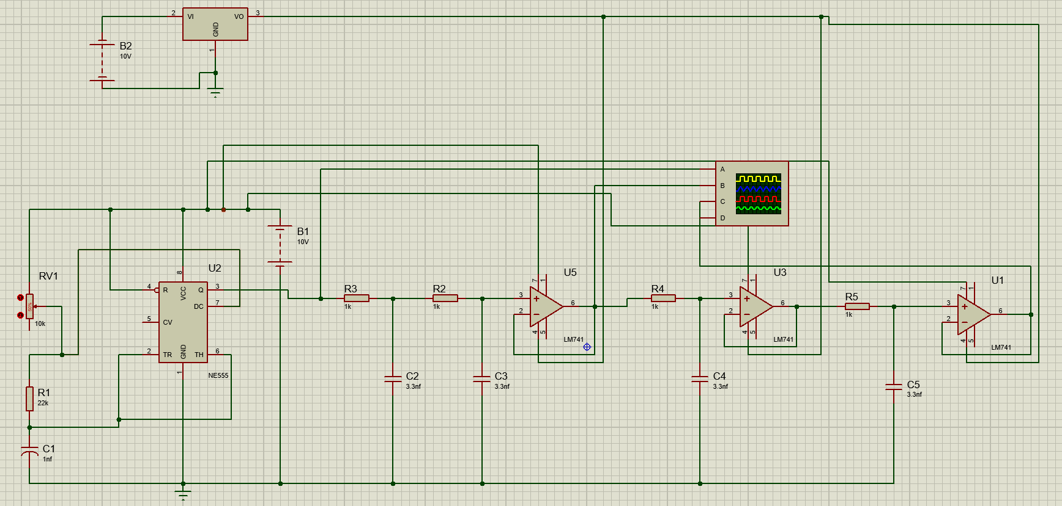

Name: Moatasem Osama

Objective:
The goal of this project is to design and construct a function generator capable of producing three distinct waveforms square, triangle, and sin.
Using an NE555 timer as the square wave source, an integrator op-amp to convert the square wave to a triangle wave, and a series of low-pass filter stages using LM741 op-amps to transform the triangle wave into a sine wave.
The generator will operate at an adjustable frequency around 30 kHz with an output amplitude of approximately ±10 V, suitable for educational demonstrations, signal testing, and basic electronic applications.
System Overview:
The function generator consists of three main stages:
- Square Wave Generation: An NE555 timer configured as an astable multivibrator produces a square wave with a peak amplitude of ±10 V and an adjustable frequency around 30kHz.
- Triangle Wave Generation: An LM741 op-amp configured as an integrator converts the square wave into a triangle wave by integrating the input signal.
- Sine Wave Generation: Two additional LM741 op-amps, configured as low-pass filters in a Sallen-Key topology, smooth the triangle wave into a sine wave by attenuating higher harmonics.
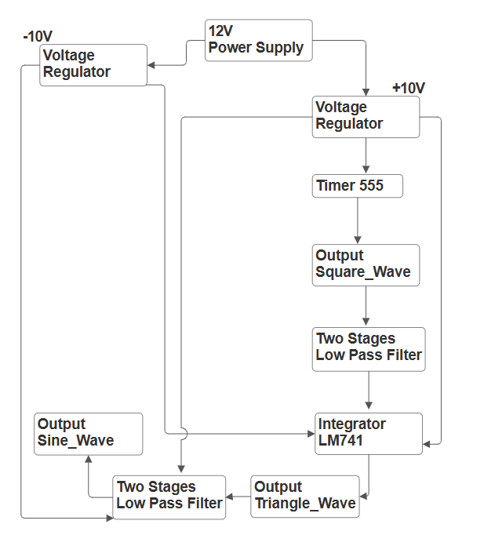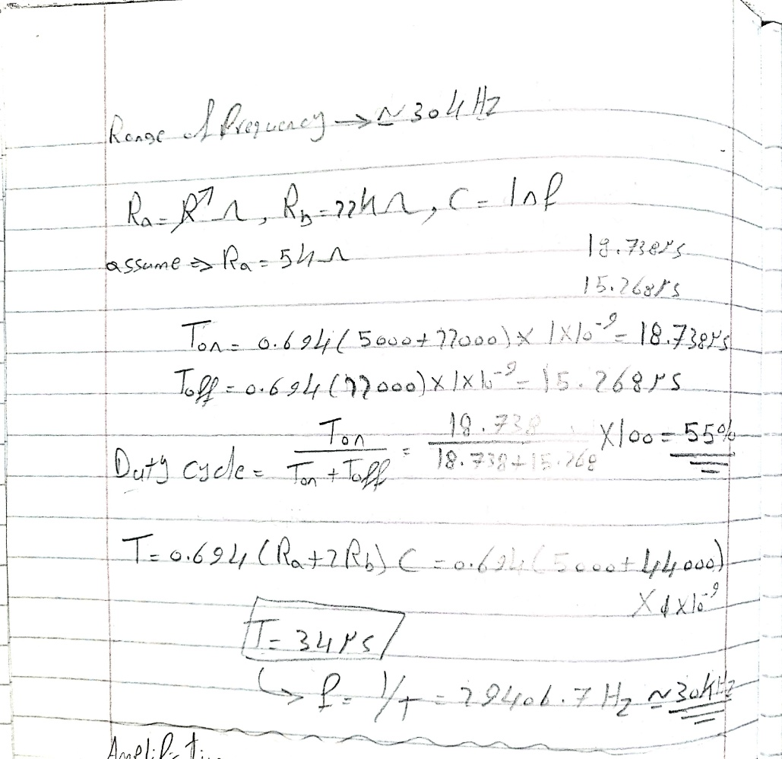
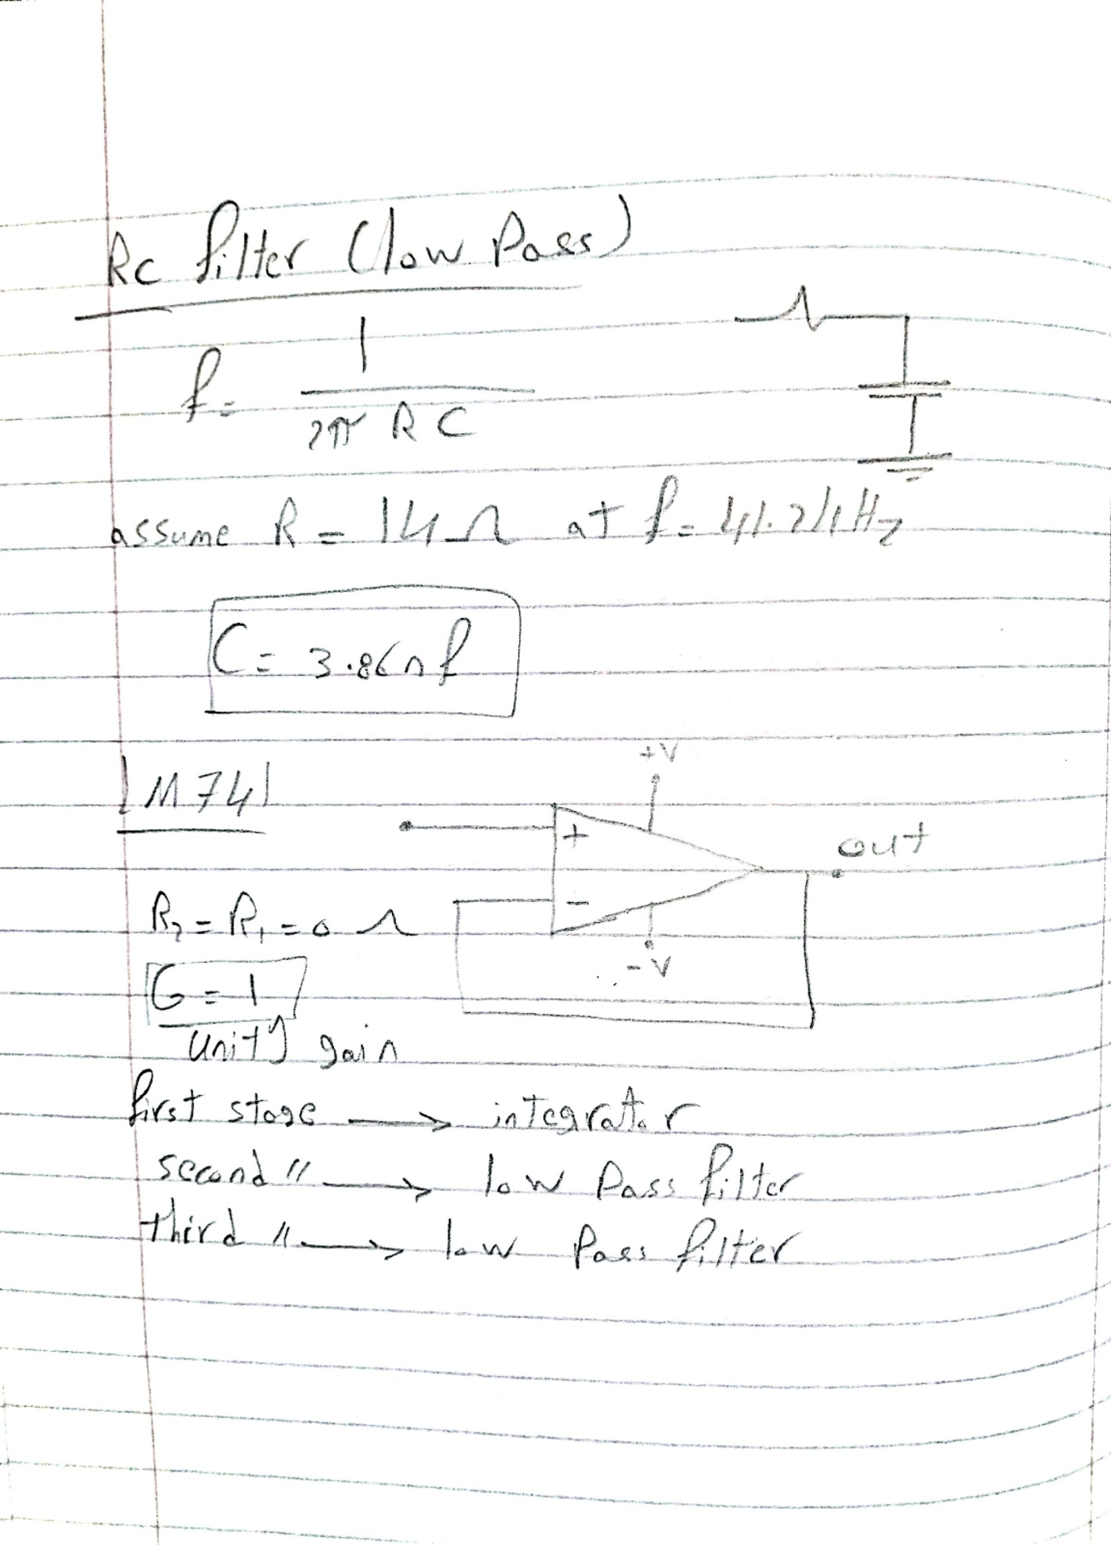
Power Calculations:
