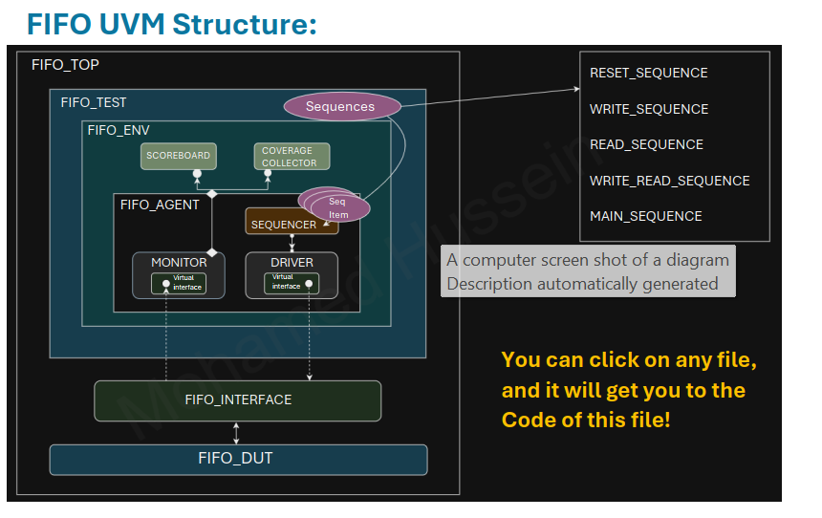
How it Works?
1. Top Module (FIFO_TOP.sv):
This is the highest level of your verification environment. It instantiates the design under test (DUT) and connects the DUT to the UVM testbench. The FIFO_TOP.sv module also instantiates the FIFO_IF (interface) and links it to the DUT, ensuring signals between the testbench and the DUT are connected correctly.
2. Interface (FIFO_IF.sv):
The FIFO_IF.sv defines the signals that connect to the FIFO DUT. This includes signals like clock, reset, write enable, read enable, data inputs, and outputs. The interface provides a structured mechanism to communicate with the DUT by grouping related signals together and making them accessible to the driver, monitor, and scoreboard.
3. UVM Testbench Flow:
The UVM testbench drives the verification process by generating stimulus, driving it into DUT, monitoring the outputs, and analyzing the results.
3.1 Configuration (FIFO_CONFIG.sv)
The configuration object holds parameters like FIFO depth, data width, and other operational settings. This configuration is passed to various components in the testbench to ensure a consistent environment for verification.
3.2 Sequences and Sequence Items
• FIFO_SEQUENCE_ITEM.sv:
This file defines the transaction object (sequence item) that carries the data
and control signals for write and read operations to/from the FIFO. It
abstracts the data transfer operations.
• FIFO_ SEQUENCE
This file define different sequences, which are collections of transactions.Each sequence class has a specific operation: resetting the FIFO, writing data,reading data, performing combined write-read operations, and orchestrating the overall verification flow (in the main sequence). The main sequencecontrols the order of operations and ensures different sequences areexecuted as part of the verification plan.

3.3 Sequencer (FIFO_SEQUENCER.sv)
The sequencer coordinates the execution of sequences. It sends the transaction (sequence item) to the driver, which will then apply it to the DUT. In your UVM testbench, the FIFO_SEQUENCER manages the flow of read and write sequences and other operations, ensuring the correct stimulus is generated.
3.4 Driver (FIFO_DRIVER.sv)
The driver takes the transaction objects from the sequencer and translates them into pin-level activity on the DUT using the interface. It drives the stimulus into the DUT through the FIFO_IF, such as asserting write or read enable signals, and providing the data input to the FIFO.
3.5 Monitor (FIFO_MONITOR.sv)
The monitor observes the DUT’s signals through the interface. It passively captures the inputs and outputs of the FIFO for analysis without modifying the DUT’s behavior. The monitor collects relevant data and forwards it to other components like the coverage collector and scoreboard.
4. Analysis Components
4.1 Scoreboard (FIFO_SCOREBOARD.sv)
The scoreboard is responsible for checking the functional correctness of the DUT. It compares the expected results (predicted by a reference model or logic) with the actual outputs observed by the monitor. In your project, the FIFO_SCOREBOARD will verify that the data written into the FIFO is correctly read out and that any underflow or overflow conditions are handled properly.
4.2 Coverage Collector (FIFO_COVERAGE_COLLECTOR.sv)
The coverage collector gathers coverage information, tracking how thoroughly the DUT has been tested. It looks at functional coverage metrics like whether all possible write-read combinations, FIFO full/empty conditions, and other critical scenarios have been exercised. This component provides insight into how much of the design has been verified.
5. Environment (FIFO_ENV.sv)
The environment is the container for all the UVM components, such as agents, scoreboard, and coverage collector. The FIFO_ENV instantiates the agents that control the driver, monitor, and sequencer and ensures that these components interact correctly. It also connects the environment’s agents to the scoreboard and coverage collector.
• FIFO_AGENT.sv:
The agent encapsulates the driver, monitor, and sequencer for the FIFO. It
coordinates their activities to ensure the interface is driven correctly and monitored
consistently. The agent simplifies managing these components by providing a
unified entity to control them.
6. Assertions (FIFO_SVA.sv)
The assertions module (FIFO_SVA.sv) defines SystemVerilog assertions (SVA) to check critical design properties. For example, assertions may ensure that the FIFO never overflows or underflows and that data integrity is maintained. These are runtime checks that trigger if the DUT violates any of the expected behaviors.
7. Test (FIFO_TEST.sv)
The test file (FIFO_TEST.sv) is where the overall test strategy is defined. This file extends the UVM test class and initiates the execution of the sequences. It configures the environment, runs the main sequence, and ensures the test runs as expected. You may have multiple tests targeting different aspects of the FIFO (e.g., stress tests, boundary condition tests,
Bugs Report:
1. Underflow signal implementation issue
- underflow is implemented as a combinational signal instead of a sequential one.
- Modification : made it following clock edge in the read always block
2. Missing conditions
- If both read and write enables are high simultaneously:
o When the FIFO is empty, only writing will take place.
o When the FIFO is full, only reading will take place.
3. Reset Behavior error
- Bug: there are some signals which their output haven’t been specified when reset signal takes place

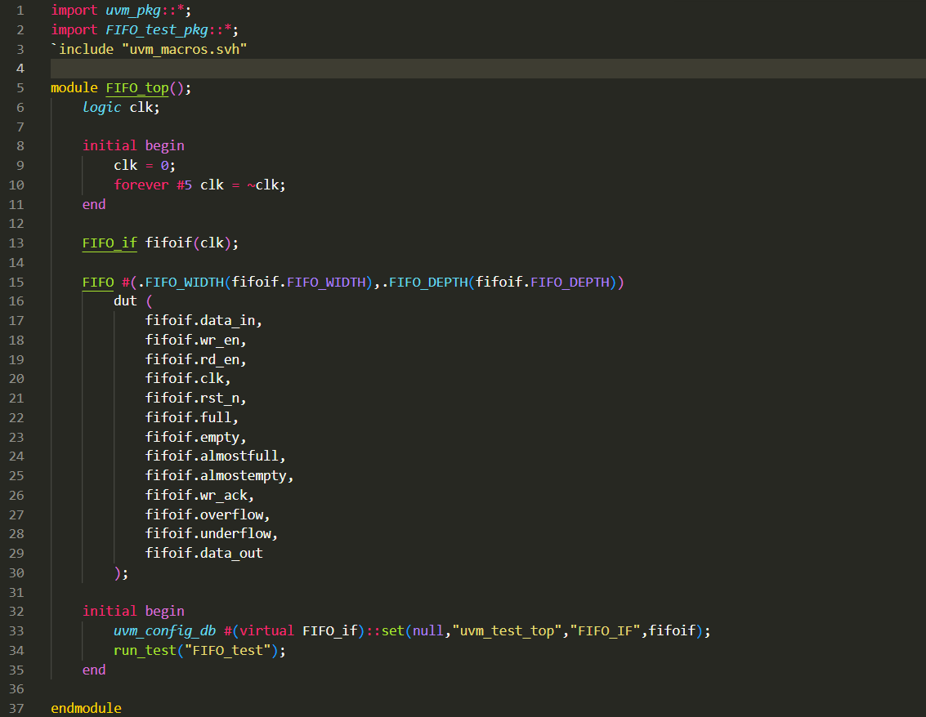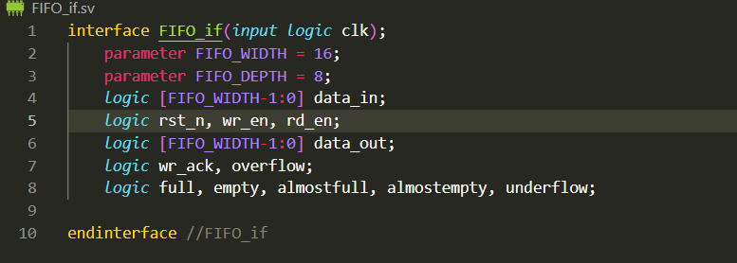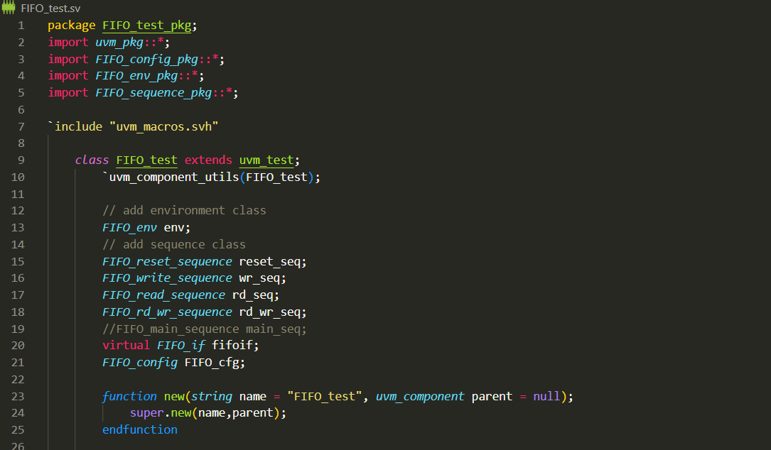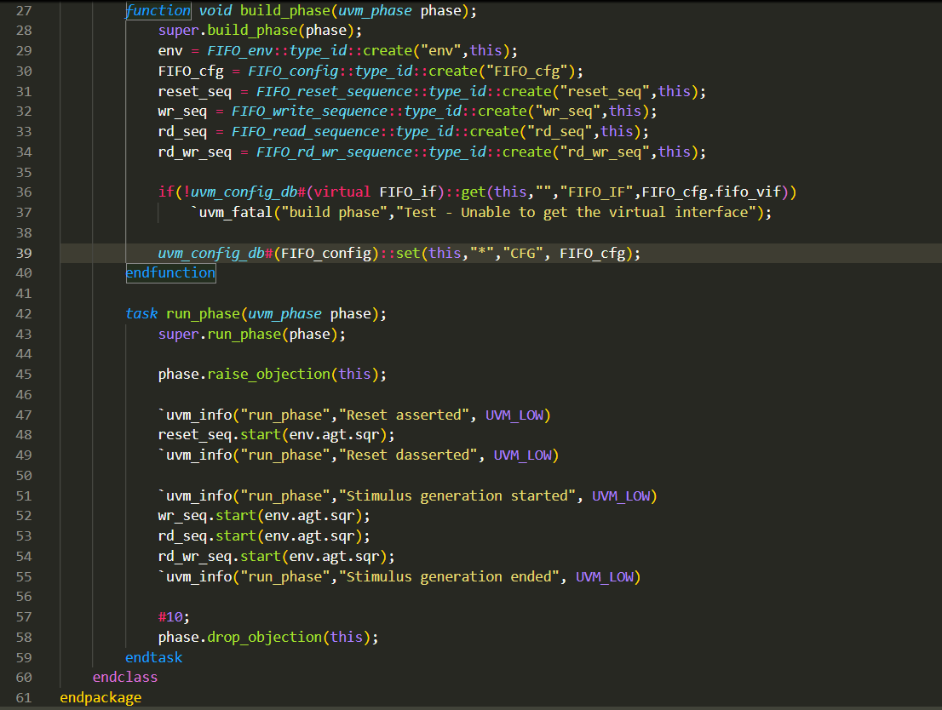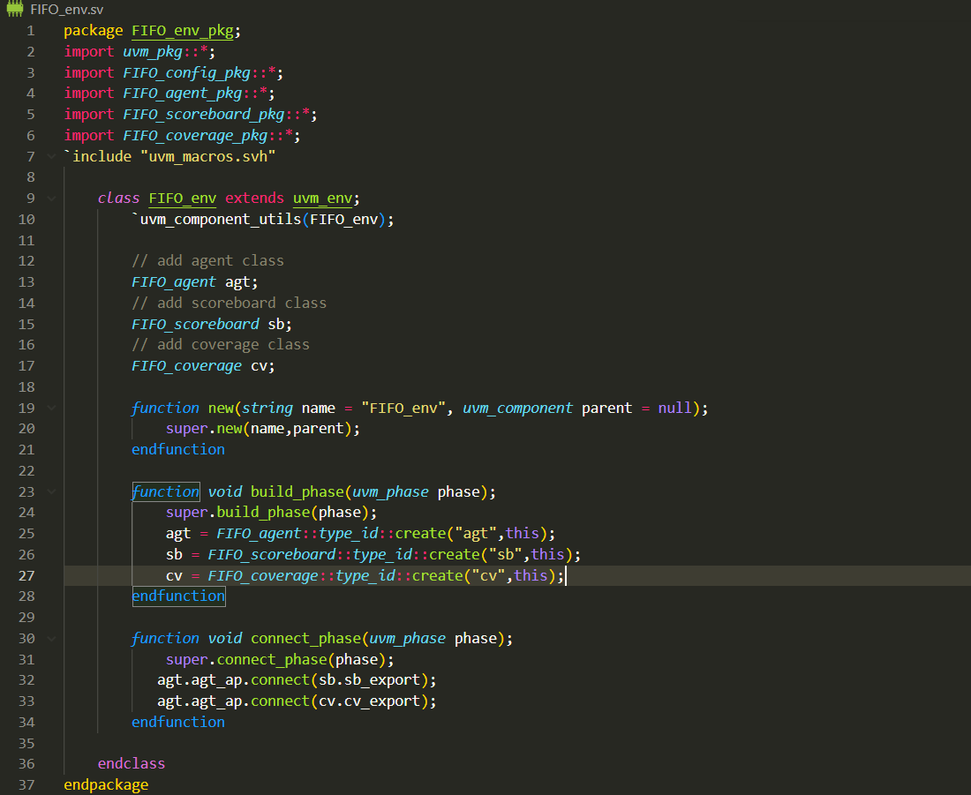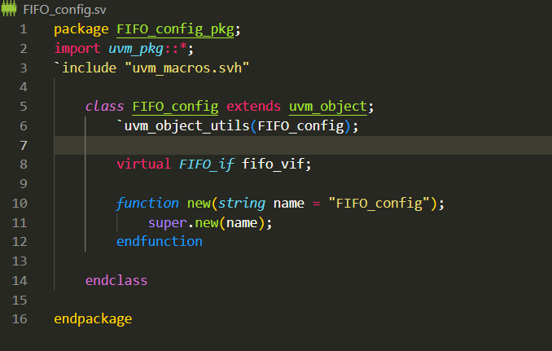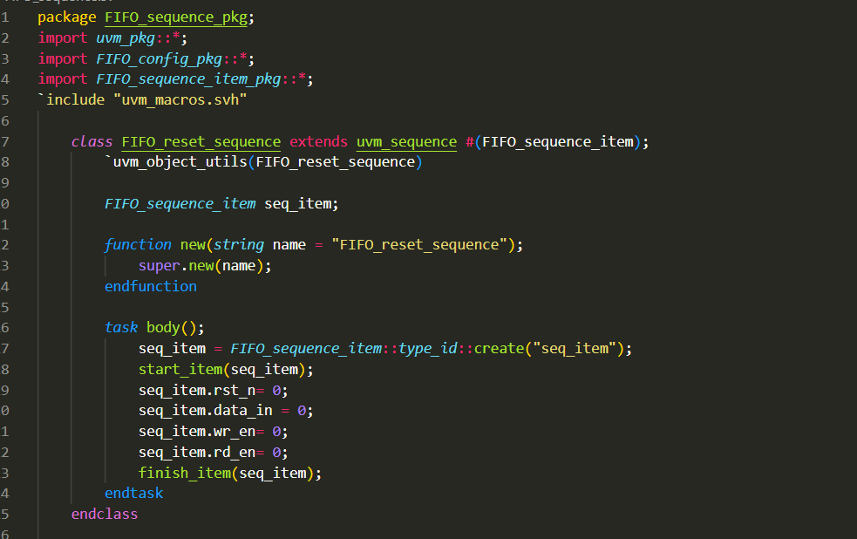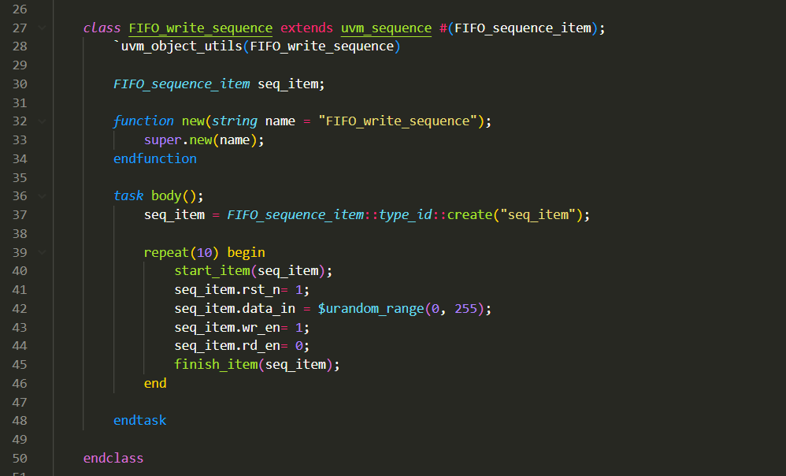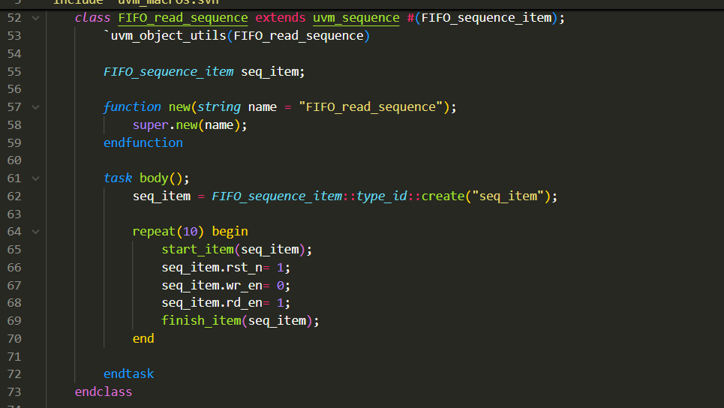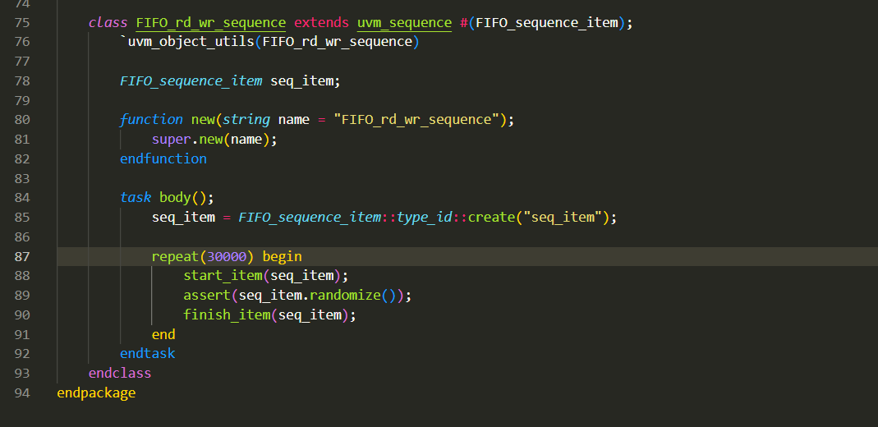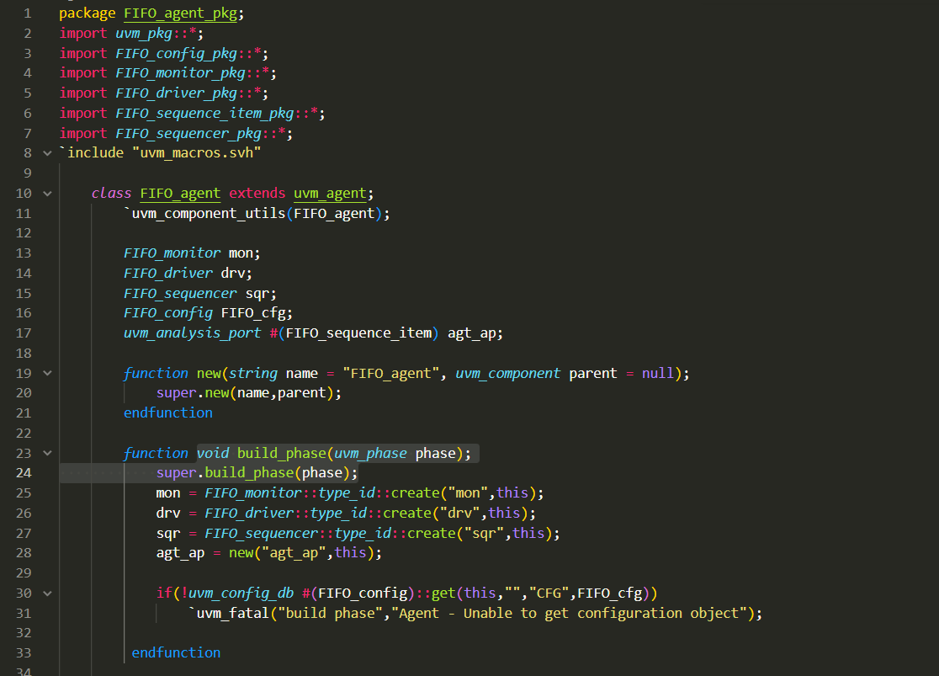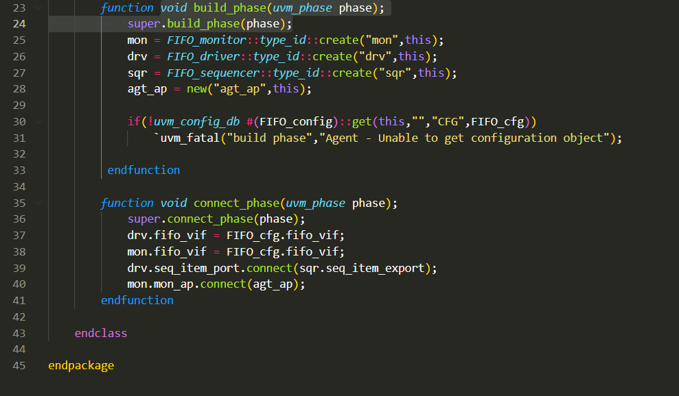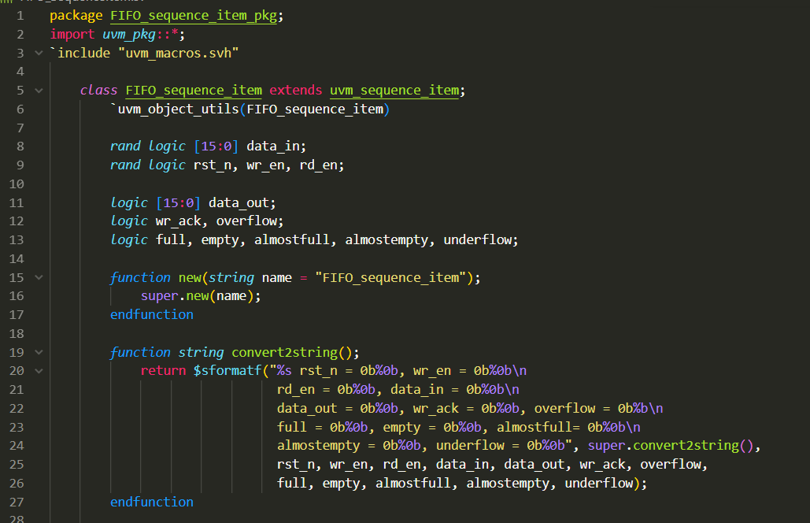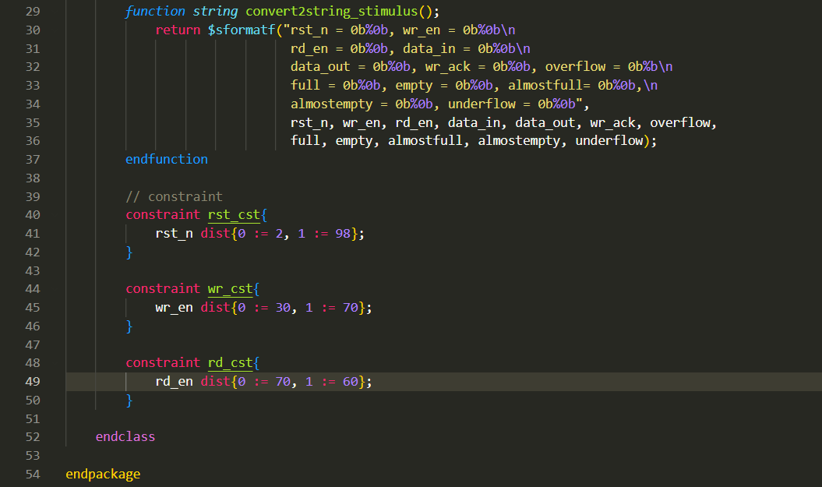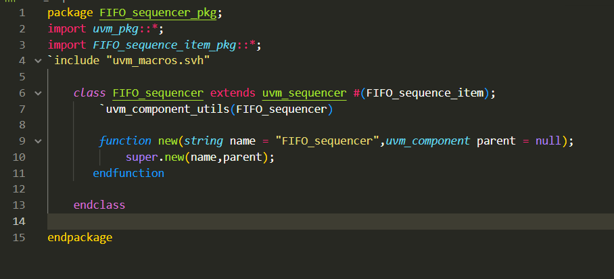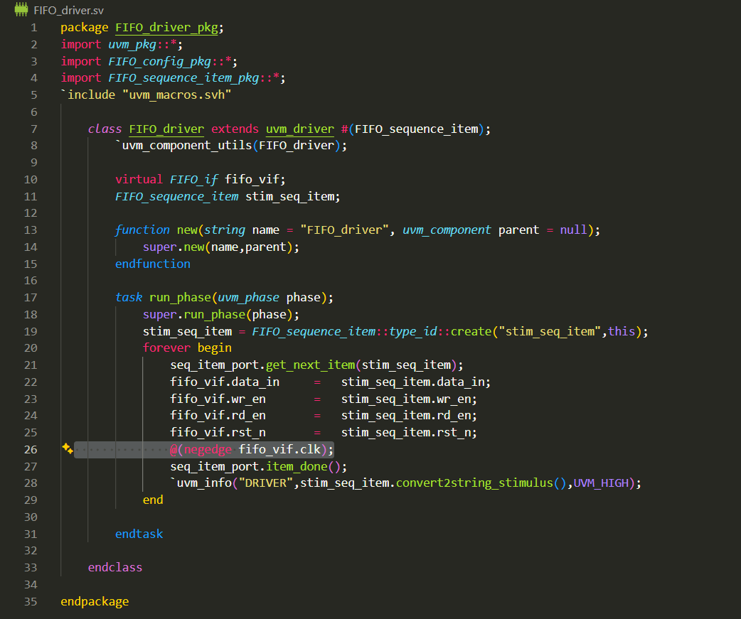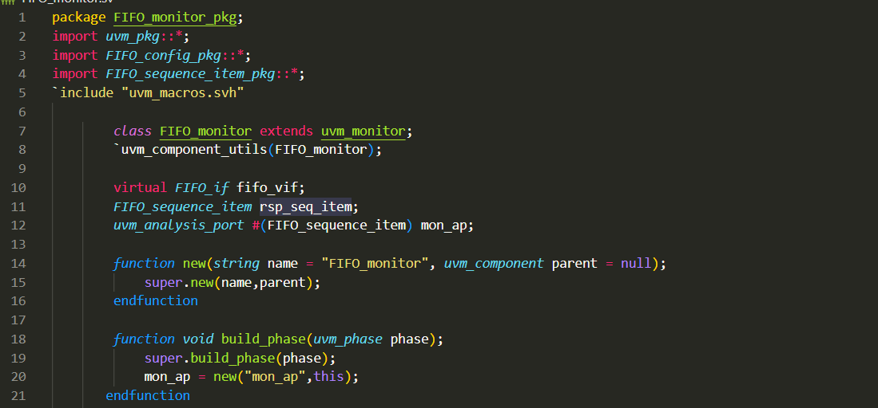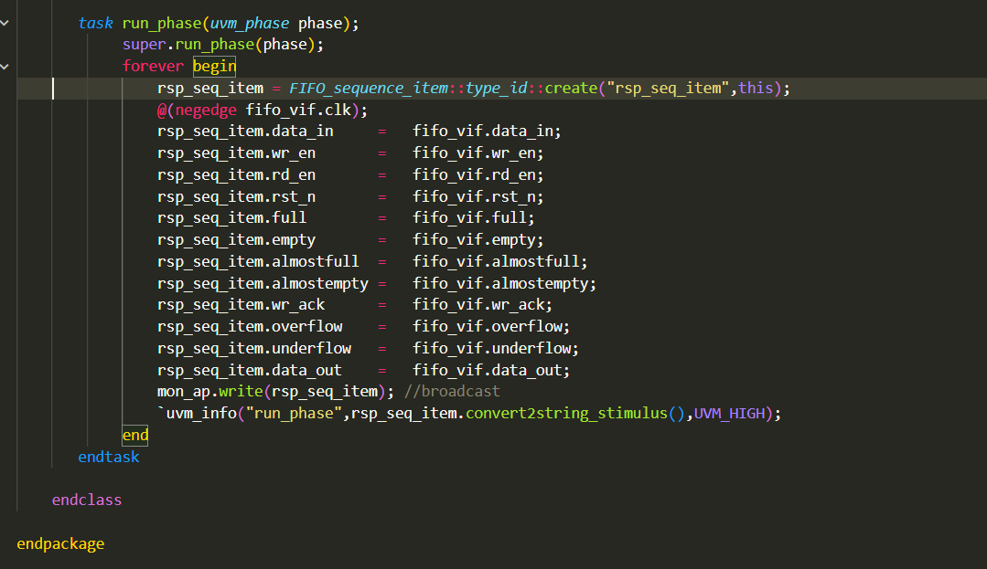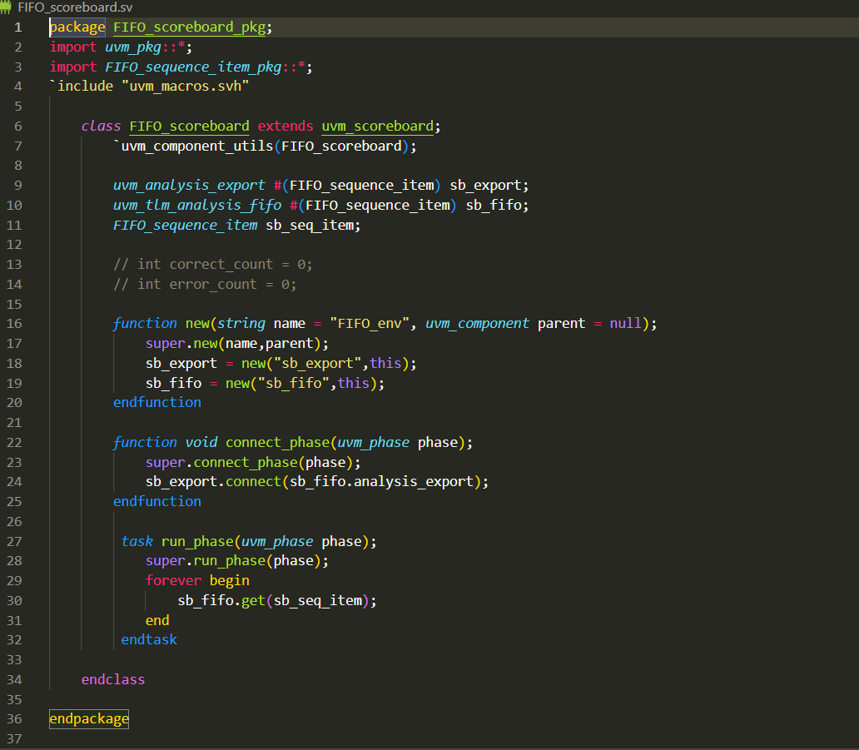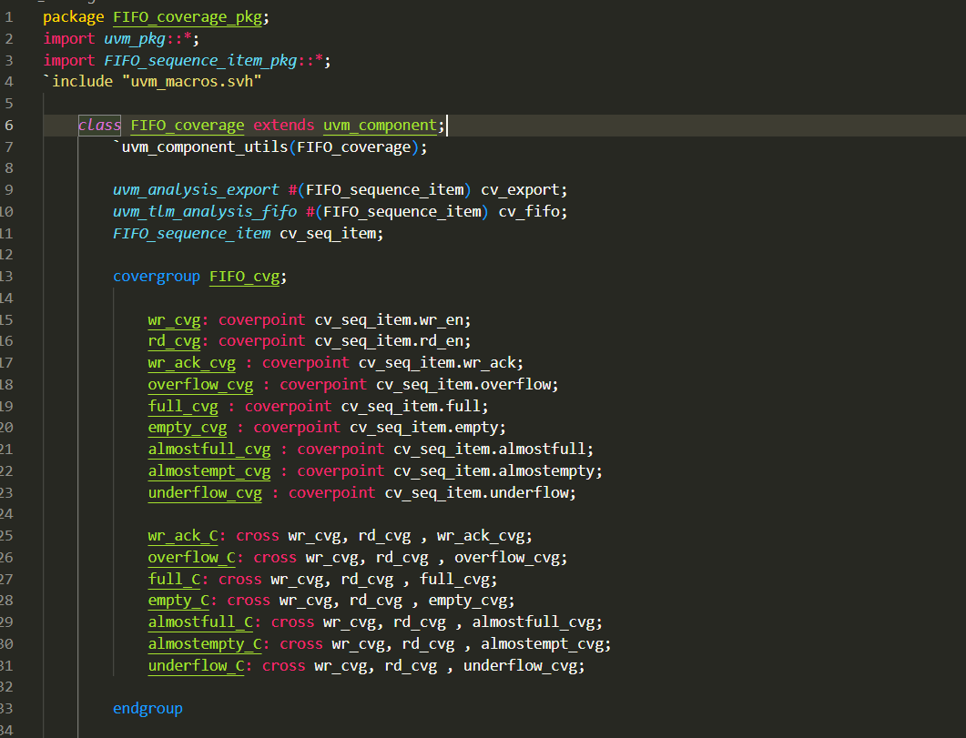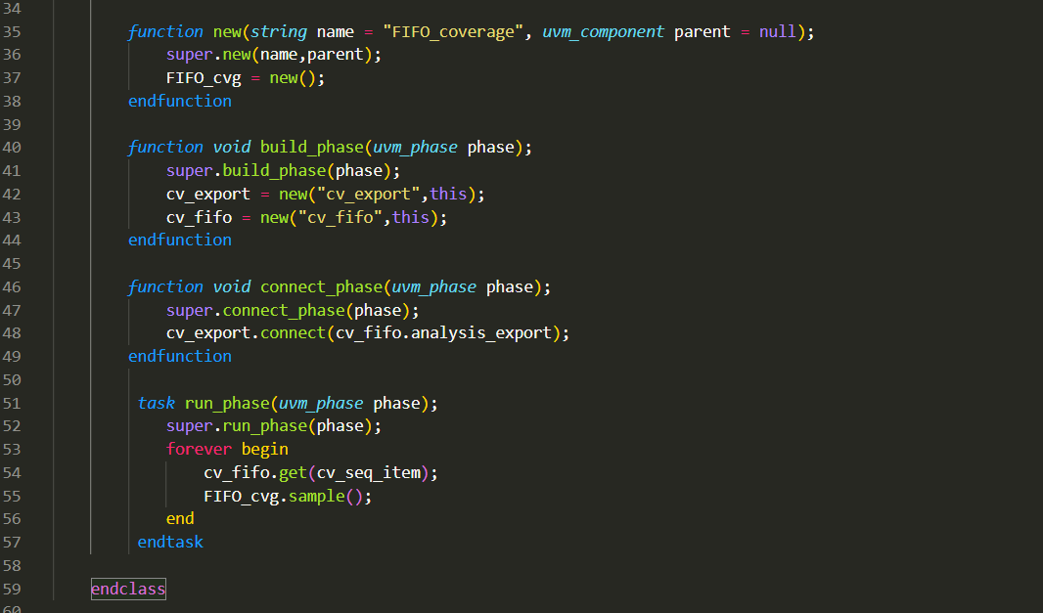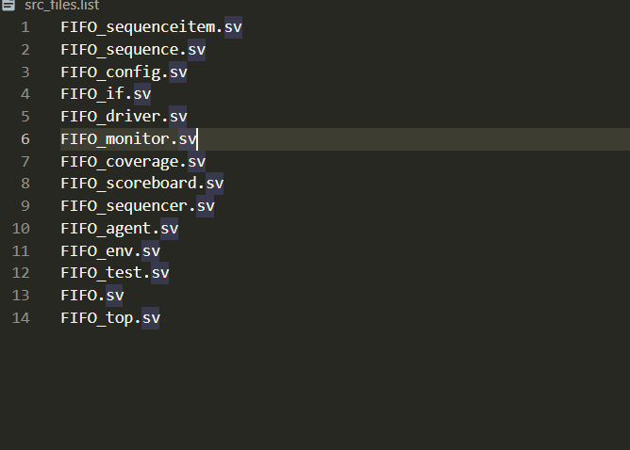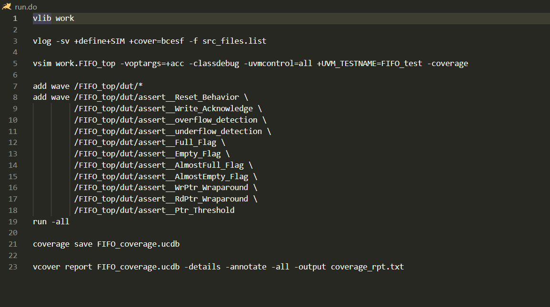
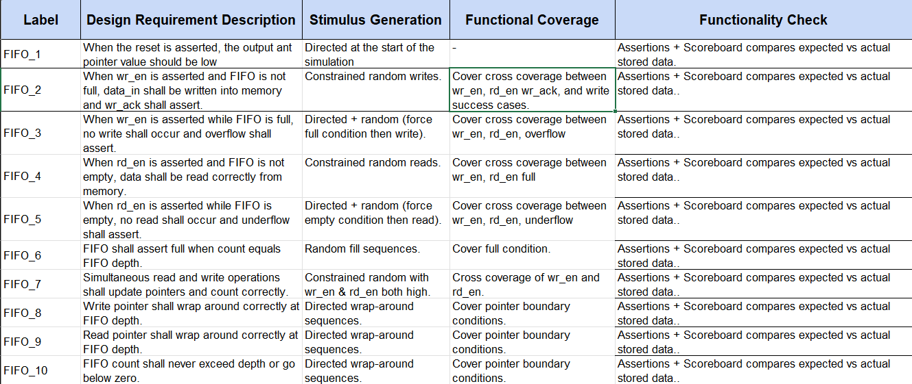
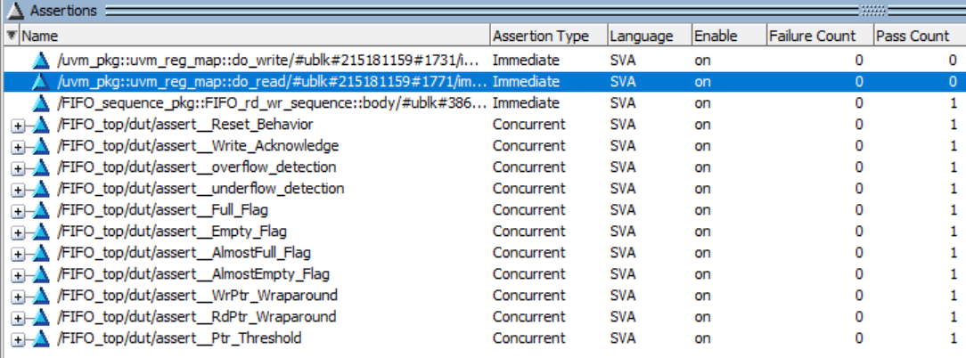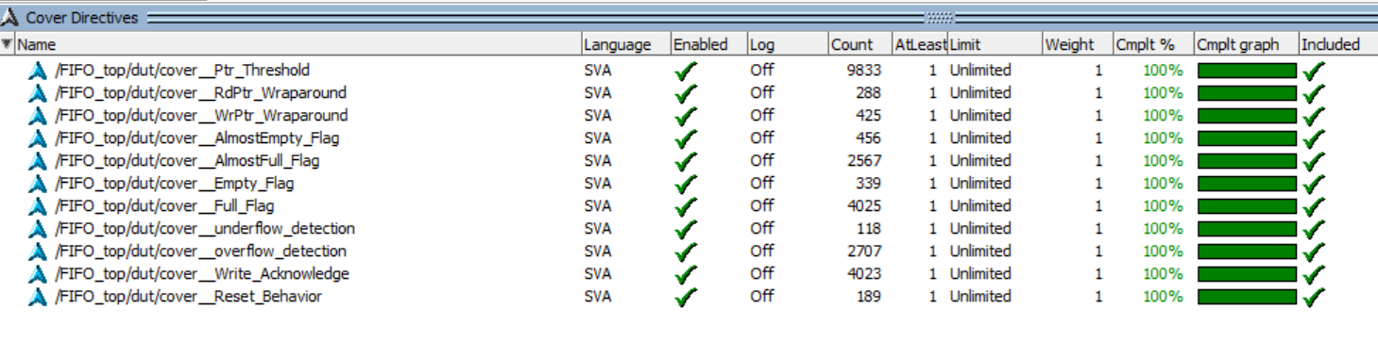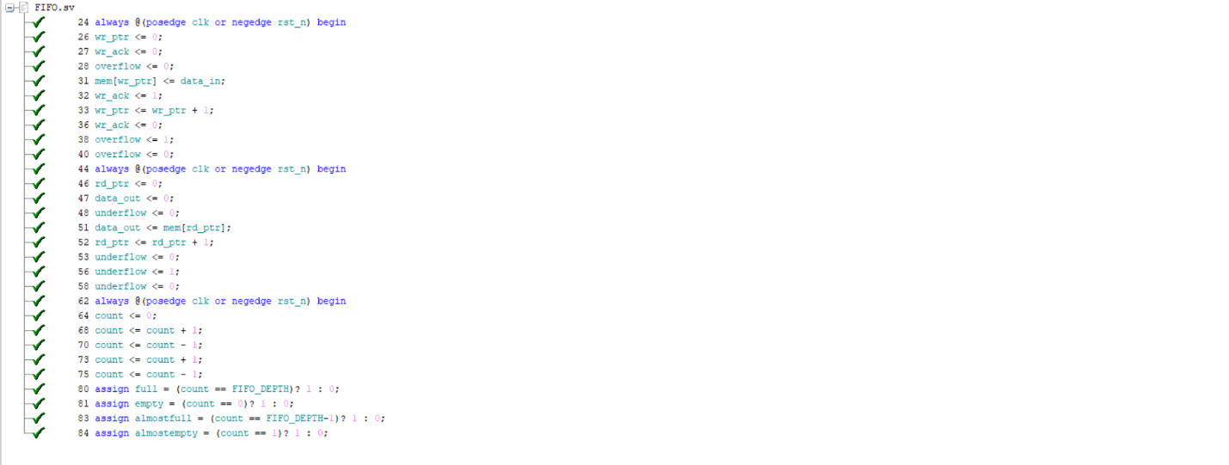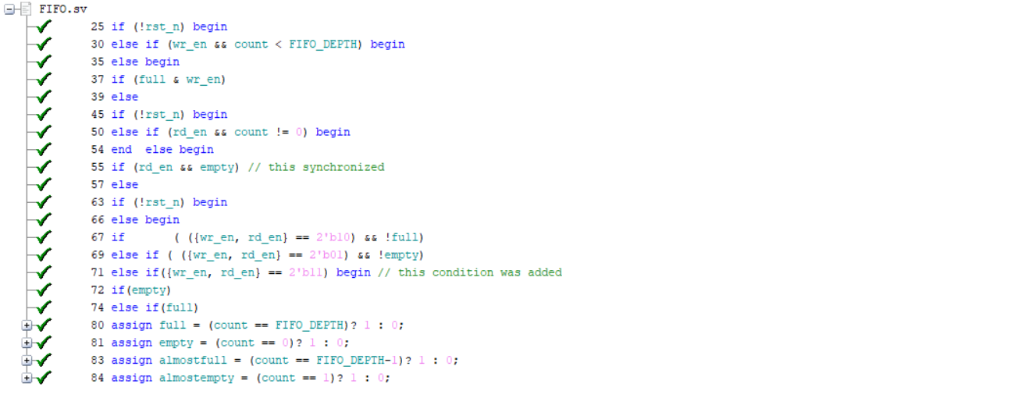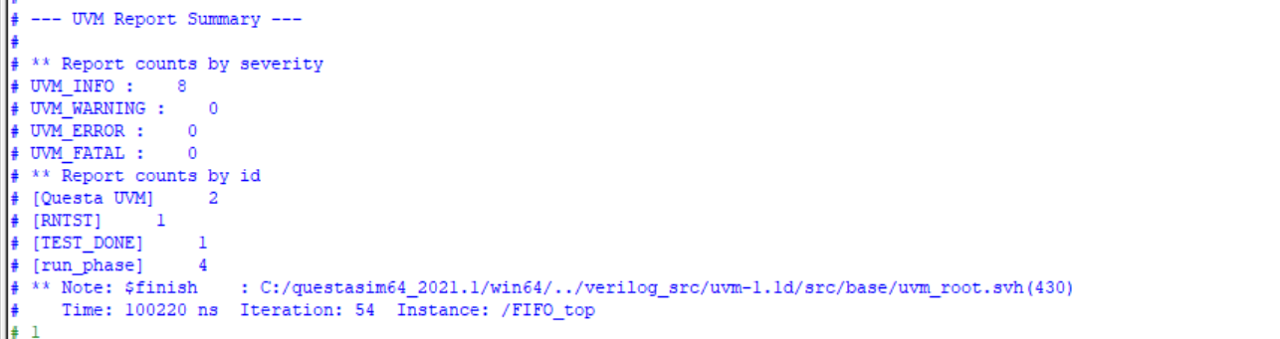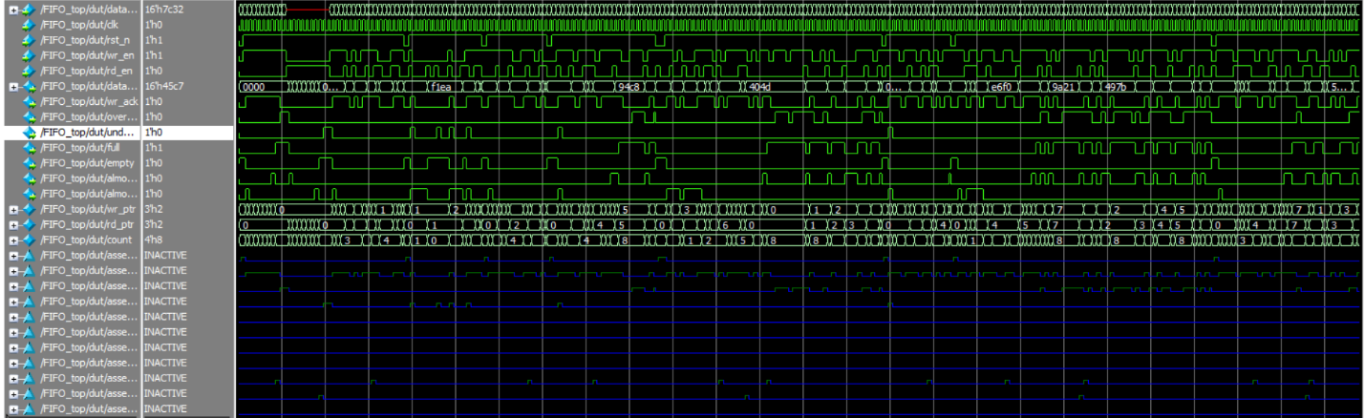
Assertion Name | SVA Code | Description
assert__Reset_Behavior | @(posedge clk) (!rst_n) |=> (count == 0 && wr_ptr == 0 && rd_ptr == 0); | After reset is asserted (rst_n = 0), count, wr_ptr, and rd_ptr must all be 0 on the next clock cycle.
assert__Write_Acknowledge | @(posedge clk) disable iff (!rst_n)  (wr_en && !full) |=> (wr_ack == 1); | When a write is enabled and the FIFO is not full, wr_ack must be high on the next clock cycle.
assert__overflow_detection | @(posedge clk) disable iff (!rst_n)  (wr_en && full) |=> (overflow == 1); | When a write is attempted on a full FIFO, the overflow flag must be asserted on the next clock cycle.
assert__underflow_detection | @(posedge clk) disable iff (!rst_n)  (rd_en && empty) |=> (underflow == 1); | When a read is attempted on an empty FIFO, the underflow flag must be asserted on the next clock cycle.
assert__Full_Flag | @(posedge clk) disable iff (!rst_n)  (count == FIFO_DEPTH) |-> (full == 1); | When count equals FIFO_DEPTH, the full flag must be immediately (same cycle) asserted.
assert__Empty_Flag | @(posedge clk) disable iff (!rst_n)  (count == 0) |-> (empty == 1); | When count equals 0, the empty flag must be immediately (same cycle) asserted.
assert__AlmostFull_Flag | @(posedge clk) disable iff (!rst_n)  (count == FIFO_DEPTH - 1) |-> (almostfull == 1); | When count equals FIFO_DEPTH-1, the almostfull flag must be immediately asserted.
assert__AlmostEmpty_Flag | @(posedge clk) disable iff (!rst_n)  (count == 1) |-> (almostempty == 1); | When count equals 1, the almostempty flag must be immediately asserted.
assert__WrPtr_Wraparound | @(posedge clk) disable iff (!rst_n)  (wr_ptr == FIFO_DEPTH-1 && wr_en && !full)  |=> (wr_ptr == 0); | When the write pointer reaches FIFO_DEPTH-1 and a valid write occurs, it must wrap around to 0 on the next cycle.
assert__RdPtr_Wraparound | @(posedge clk) disable iff (!rst_n)  (rd_ptr == FIFO_DEPTH-1 && rd_en && !empty)  |=> (rd_ptr == 0); | When the read pointer reaches FIFO_DEPTH-1 and a valid read occurs, it must wrap around to 0 on the next cycle.
assert__Ptr_Threshold | @(posedge clk) disable iff (!rst_n)  (wr_ptr < FIFO_DEPTH) &&  (rd_ptr < FIFO_DEPTH) &&  (count <= FIFO_DEPTH); | At all times, both pointers must remain within [0, FIFO_DEPTH-1] and count must never exceed FIFO_DEPTH.

