MIPI D_PHY

Introduction

MIPI stands for Mobile Industry Processor Interface.
MIPI is designed for mobile ecosystem mindset and has several application in wearable devices, mobile camera, display, telecom, automotive and others.

Here is MIPI CSI-PHY protocol looks like
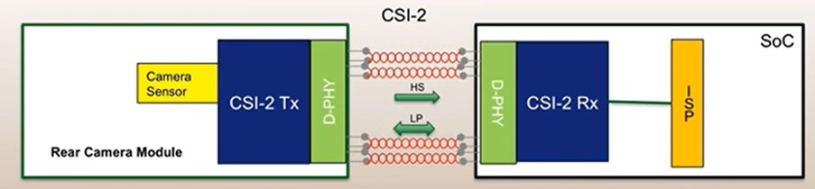
CSI: Camera Serial Interface
The MIPI CSI-2 protocol used to connect the camera and host processor

It consists of five layers
1- Physical Layer
2- Lane Merger Layer
3- Low level Protocol
4- Pixel to Byte conversion
5- Application Layer

Every application for MIPI protocol should consist of D-PHY layer which is responsible for transferring the data between the transmitter and receiver, the standard used in this implementation is version 1.2 of MIPI D-PHY.

MIPI D-PHY Overview

MIPI D-PHY has more than one mode of operation only those three low power, high speed and escape will be implemented.
Low Power operates at 10 Mb/sec maximum and used to send control signals like SOT and EOT.
High Speed is enabled by low power module and can be operate at range [80:1500] Mb/sec.

MIPI D-PHY consists of at least one data lane and up to four lanes each lane has two buses, while data transferring one holds the actual data (Dp) and other holds the inverse of data (Dn).

MIPI_TX
MIPI_RX
Clk
lane
Clk
lane
CLK_P
CLK_N
Clock Lane
Data
Lane
Data
Lane
Dp
Dn
Data Lane
link
One Unidirectional Date Lane

High speed transmission is achieved by using the dual edge clock, the data is transferred on both edges the positive and negative clock edges.

MIPI Functionality

