**Chapter Three “Networks”**

1) Define the following terms:

1. Computer network
2. File Transfer Protocol (FTP)
3. Metropolitan Area Network (MAN)
4. Hyper Text Markup Language (HTML)
5. Hyper Text Transfer Protocol (HTTP)
6. Internet browser

# Solution

**a) Computer network**

A computer network is a collection of computers, printers, and other equipment that are connected together so that they can communicate with each other.

**b) File Transfer Protocol (FTP)**

* FTP is a [protocol](http://www.webopedia.com/TERM/P/protocol.html) for exchanging [files](http://www.webopedia.com/TERM/F/file.html) over the [Internet.](http://www.webopedia.com/TERM/I/internet.html)
* FTP is most commonly used to [download](http://www.webopedia.com/TERM/D/download.html) a file from a server using the Internet or to [upload](http://www.webopedia.com/TERM/U/upload.html) a file to a server (e.g., uploading a Web page file to a server).

**c) Metropolitan Area Network (MAN)**

• A metropolitan area network (MAN) is a computer network that interconnects users with computer resources in a geographic area or region larger than that covered by even a large local area network ([LAN)](http://searchnetworking.techtarget.com/definition/local-area-network-LAN) but smaller than the area covered by a [wide area network (WAN).](http://searchenterprisewan.techtarget.com/definition/WAN)

**d) Hyper Text Markup Language (HTML)**

* HTML is the language used by information providers to represent their information.
* HTML is a markup language for describing web documents (web pages).
* A markup language is a set of markup tags
* HTML documents are described by HTML tags
* Each HTML tag describes different document content
* [HTTP](http://www.webopedia.com/TERM/H/HTTP.html) is the set of rules for transferring Web pages from a [server](http://www.webopedia.com/TERM/S/server.html) to a user's browser.

**e) Internet browser**

* A Web (Internet) browser is a program that can display and present information represented in HTML.

## 2) Classify computer networks based on the geographical area the network covers. Clarify your answer with drawing. Solution

We can classify computer networks based on the geographical area the network covers as:

**1-Personal Area Network (PAN)**

* A network that connect different personal devices such as a personal computer, laptop, smart phone and other network enabled personal devices is called personal area network as it connects the devices belongs to one person to each other.
* The purpose of this type of networking is usually reducing the amount of cabling as it is often done wirelessly. It is also used in transferring the data between different devices.
* A PAN can be connected for higher-level network such as the Internet by connecting one device in the PAN to the Internet then sharing its connection with other devices in the PAN.

•

Figure

1

shows an example of a personal area network.

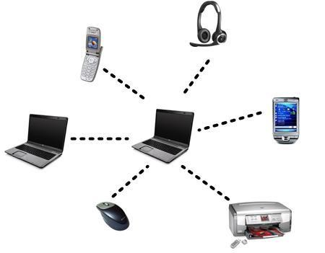

**Figure**

**1:**

**An example for a**

**Personal Area Network (PAN)**

**2-Local Area Network (LAN)**

* LAN is the class of network we encounter in the school, university, or at work. The technical description of LAN is connected devices that can communicate directly together.
* LANs consists of computers, connecting devices (called switches) and connecting media (cables or wireless media).
* A LAN can cover geographic area that range from a room in a building or laboratory in a university to an entire university campus.
* Figure 2 shows some examples of LANS.

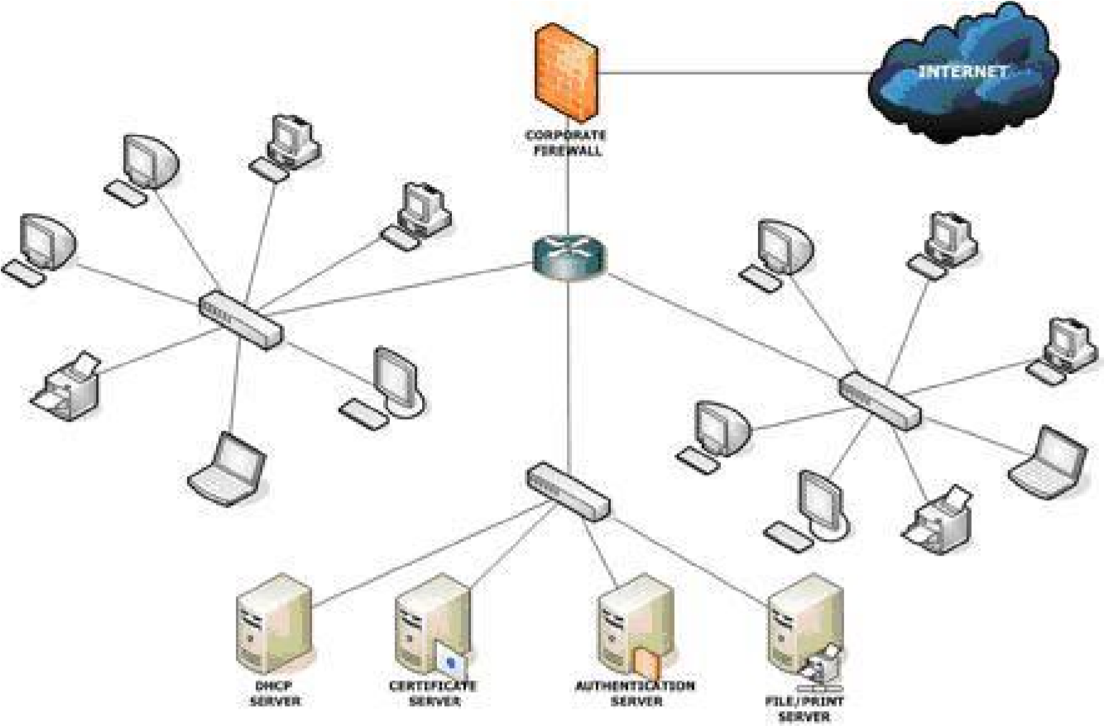

 **Figure 2 : Three connected LANs. The whole network is connected to the Internet**

**3-Metropolitan Area Network (MAN)**

* A MAN covers a larger geographical area than a LAN, ranging from several blocks of buildings to entire cities.
* MANs can also depend on communications channels of moderate-to-high data rates.
* A MAN might be owned and operated by a single organization, but it usually will be used by many individuals and organizations.
* Figure 3 shows an example of a MAN network.

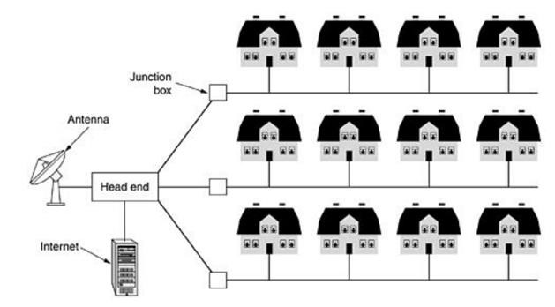

**Figure**

**3:**

**An**

**example of a MAN network**

**4-Wide Area Network (WAN)**

* WAN is a network that spans a very large geographical area.
* The distinguished example for a WAN is the Internet, which covers almost all the globe now.
* The Internet as a WAN network consists of a large number of networks. In fact, the Internet is a network of networks.
* Figure 4 shows an example of how a portion of the Internet may be formed.

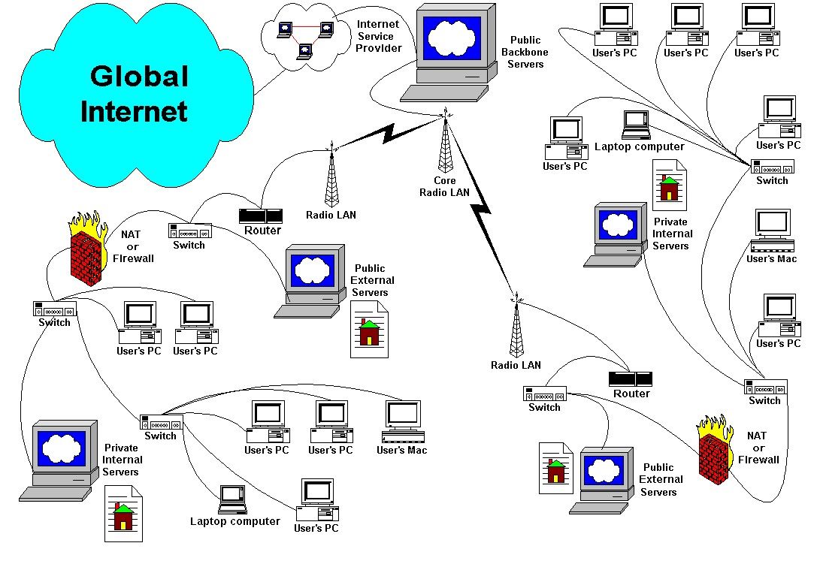

**Figure**

**4**

**:**

**An**

**example o**

**f how a portion of the Internet**

**may be formed**

## 3) Classify computer networks based on functional relationship between computers within the network. Clarify your answer with drawing.

# Solution

We can classify computer networks based on functional relationship between computers within the network as: **1-Peer-to-peer networks**

* Peer-to-peer networks are more commonly implemented where less than ten computers are involved and where strict security is not necessary. All computers have the same status, hence the term 'peer', and they communicate with each other on an equal footing. Files, such as word-processing or spreadsheet documents, can be shared across the network and all the computers on the network can share devices, such as printers or scanners,

which are connected to any one computer. Figure 5 represents the Peer

-

to

-

peer

functional relationship between computers

.

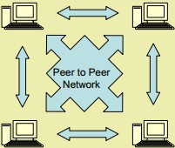

**Figure**

**5:**

**Peer**

**-**

**to**

**-**

**peer functional relationship between computers**

**2-Client/server networks**

* Client/server networks are more suitable for larger networks.
* A central computer, or 'server', acts as the storage location for files and applications shared on the network. Usually the server is a higher than average performance computer.
* The server also controls the network access of the other computers referred to as the 'client' computers.
* Figure 6 represents the client/server functional relationship between computers.

**_**

**_______________________________________________________________________**

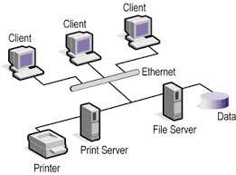

**Figure**

**6**

**:**

**Client/server functional relationship**

## 4) What are the benefits of constructing a computer network compared to using individual not connected computers? Solution

**Benefits of computer networks are :**

1. **Speed**: Networks provide a very rapid method for sharing and transferring files. Without a network, files are shared by copying them to floppy disks, then carrying or sending the disks from one computer to another.
2. **Cost**: The network version of most software programs are available at considerable savings when compared to buying individually licensed copies.
3. **Centralized Software Management**: One of the greatest benefits of installing a network at a school is the fact that all of the software can be loaded on one computer (the file server). This eliminates thatneed to spend time and energy installing updates and tracking files on independent computers throughout the building.
4. **Resource Sharing**: Sharing resources is another area in which a network exceeds stand-alone computers.
5. **Flexible Access:** School networks allow students to access their files from computers throughout the school. Students can begin an assignment in their classroom, save part of it on a public access area of the network, go to the media center after school to finish their work.
6. **Security:** Files and programs on a network can be designated as "copy inhibit," so that you do not have to worry about illegal copying of programs.

## 5) Give some examples of networking services in education, especially inside universities.

# Solution

1. **Learning labs**: While taking computer technology lessons, such as programming and application demonstration, the instructor and students need effective means for communication.
2. **Flexibility of access**: Each student at a university or a school should have her/his own storage space allocated on the university infrastructure. The student labs, tutorials, and assignments should be stored in that space. Network infrastructure makes it easy and flexible for a student to access his space from anywhere in the organization or even from outside the organization.
3. **File sharing**: Students often need to share learning materials with each other. The university or the school usually makes available some programs or learning materials for its students, employees and/or instructors.

## 6) The Internet is often considered the most complex engineered system on the earth surface

1. **Explain how the Internet gradually reached its current complexity**
2. **Who pays for the internet to run? Explain.**
3. **Who own the Internet? Explain.**

# Solution

1. Let university A built its own computer network for resource sharing inside it. Any student, instructor or employee sit in front of a networked computer inside the university can communicate and share information with any other one sit in front of his computer in the same university. Imagine that another university (university B) in the same city did the same. Imagine also that the two universities are agreed to connect to each other by connecting the two computer networks together. This agreement includes specification of what one at a university can access at the other university. In this way, we have a bigger computer network that consists of the two universities networks. Now, if university C connected its network to university’s B network, C’s users not only can access resources at B but also at A through B and we have a lager network.

In a similar growth pattern, The Internet become a network of networks that spans the globe. It is impossible to give an exact count of the number of networks or users that comprise the Internet, but it is easily in the thousands and millions respectively.

1. There is no clear answer to this question because the Internet is not one "thing". It is many things. No one central agency exists that charges individual Internet users. Rather, individuals and institutions who use the Internet pay a local or regional Internet service provider for their share of services. In turn, those smaller Internet service providers might purchase services from an even larger network. In this way, everyone who uses the Internet in some way pays for part of it.
2. No one actually owns the Internet, and no single person or organization controls the Internet in its entirety. The Internet is more of a concept than an actual tangible entity, and it relies on a physical infrastructure that connects [networks](http://www.webopedia.com/TERM/N/network.html) to other networks.

## 7) May people see that the World Wide Web (WWW) is the most useful Internet application

1. **Explain information providers and information consumer in considering the WWW**
2. **What are the relative advantages of the WWW as an information source compared to other sources?**
3. **What are the protocols used in running the WWW applications?**

# Solution

1. **Information providers and consumer**: A company needs its products and service to be known for the public. A university needs that learning programs, ways of admission, and perquisites for admission to be known for the interested students. Societies and organizations need their information to be publically available. These are possible information providers. A student wants to study engineering needs to know about each of the available engineering faculties, how they differ, what are the prerequisites. A customer wants to by a TV-set needs to know: where they are sold. How much they cost. What models are available? These are example for information consumers.
2. **WWW** is a mean for communicating information that has several **advantages**:
   * We can get the most current information from the WWW
   * We can get the information any time anywhere
   * The information is presented using text, graphics, videos, animations, etc.
   * The information is always there so that you can go back to what you seen before
3. **protocols used in running the WWW applications** are
   * + HTTP (Hypertext Transfer Protocol)
     + TCP/IP (Transmission Control Protocol/ Internet Protocol)
     + FTP (File Transfer Protocol)
     + UDP (User Datagram Protocol)
     + ISMP (Internet Control Message Protocol)

## 8) Explain the different rules played by the web browser and the web server in the WWW Internet applications. How they communicate together (with which protocol and in which format)?

# Solution

The web browser program asks a Web server for information represented in HTML. The information is transferred from the server to the browser according to specific set of standard rules and format so that any browser can get information from any server using the same set of rules and formats. These rules and formats are called a *protocol*. In case of web page transfer, the protocol is called *Hyper Text Transfer Protocol (HTTP)*. HTML, web servers, web browsers and HTTP are collectively termed *Work Wide Web or WW*W and, we think, this is one of the most useful applications of networking.

## 9) What is an Internet search engine? What its function? Give some examples.

* **Search engine** are themselves web sites that exists not for providing information but to provide users with URL given the keywords information needed for.

**Examples for web search engines**

* **Google** - The world's most popular search engine

11

* **Bing** Search: Microsoft's entry into the burgeoning search engine market. Better late than never.
* **Yahoo!** Search: The second largest search engine on the web (as defined by a September 2007 [Nielsen Netratings](http://www.nielsen-netratings.com/pr/pr_070919.pdf) report.)
* **AltaVista:** Launched in 1995, built by researchers at Digital Equipment Corporation's Western Research Laboratory. From 1996 powered Yahoo! Search, since 2003 - Yahoo technology powers AltaVista.
* **Alexa Internet**: A subsidiary of Amazon known more for providing website traffic information. Search was provided by Google, then Live Search, now inhouse applications run their own search.

## 10) How the Internet and the electronic mail system are used to get the final year result at faculty of engineering, Tanat University.

Each student at Tanta University is assigned an official electronic mailbox. Tanta University is assigned and electronic mailbox with address is -----------@f-eng.tanta.edu.eg

* After the final exam, the student regularly read his mail by logging to the mail reading page .
* An e-mail will finally reach the student that states that the result is ready
* As shown in the email of the result, the student must fill enquiries about all the courses of the year to get an access to his result
* After filling the enquiries, the student can enter and access his result

## 11) In considering the electronic mail system

## a) Explain what are the mail client, mail server and mailbox.

## b) What is the difference between personal and official emails

(a)

* **The mail client** is an application that can contact to a mail server to push messages to the mail server and pop messages from the mail server.

Examples for electronic mail client web sites are ***gmail.com*** and ***outlook.com***.

* **Mail servers:** a mail server is a computer, or a group of computers in a datacenter, that store, manage electronic mail boxes, and can communicate electronic mail message with other mail servers.

For example, a university such as Tanta university can has its own mail server. Each mail server must have and address. Other mail server and services reaches to a mail server to send it an email or for getting a mail from a mailbox using that address. Examples for mail server address or url are gmail.com, Hotmail.com. Let the Tanta university mail server is assigned the url “tu.edu.eg”. There are some setting done on other devices on the Internet to enable other mail servers to reach Tanta university mail server using the url.

* **Electronic Mailboxes:** Electronic Mailboxes are created and hosted on a mail server. Each mailbox is assigned an address that draw its name from the mail server name and an indicating name for the user using that mailbox.

For example, an instructor named Hamed Hemeda at tanta university may assigned the electronic mailbox with the addres:Hamed.Hemeda@tu.edu.eg. This is called an electronic mail address and is always on the form: MailBoxName@MailServerName without any spaces. Each mail address is assigned a *user name*, usually the text before the @ symbol, and a *password* for the security of the mailbox. Any user need to access the mailbox must provide the server with the correct user name and password.

(b)

**Official and personal electronic mails**:

Some companies allows creating mailboxes on their mail servers free of charge.

Examples for such companies are Google (---------@gmail.com) and Microsoft(----------@hotmail.com). Anyone can create a mailbox at google or at Microsoft. Usually such mailboxes is used for personal communications. Figure 3.9 shows the page where you can create an email account at google.

Companies and universities often have their own mail server that obey their own polices. A student at a university is assigned a mailbox of the university mailserver.

An employer at a company is assigned a mailbox on the company mail server. These mailboxes (at the university and at the company) are examples of the official mailboxes. They can be used officially. This means that an employee can receive a task to do by the official email and a student must treat messages arriving to him through the official mail seriously.

## 12) Explain the steps taken between mail clients and servers inside the electronic mail system when:

1. Someone whose email address someone@tu.edu.eg send an email to another one whose email address is anotherone@tu.edu.eg
2. Someone whose email address someone@tu.edu.eg send an email to another one whose email address is anotherone@gmail.com.

(a)

* The client contacts a mail server known as tu.edu.eg.
* The Internet has its resources that enable reaching that server if it is up and running the mail server software.
* The server then receive the message **and put it in the recipient mailbox if the** **recipient mailbox is on the** **same server.**

(b)

* What happen if someone who has the mail address someone @tu.edu.eg need to send a message to someone whose address is someone@gmail.com.
* In this case**, someone** write the message on the client, the client hands the message to the tu.edu.eg mail server.
* The tu.edu.eg server knows that the message should be forwarded to another mail server (gmail.com in this case),
* The tu.edu.eg server contacts the gmail.com server and send it the message. The Gmail.com receives the message and put it into someone mailbox waiting for someone to get it at any time.

## 13) What is the Internet newsgroup, how it is related to the email system?

* **Newsgroups** are a way to communicate with others on the Internet who share your interests.
* **An electronic discussion group** is a group of persons who have common interest to discuss a particular topic via e-mail.
* There are several methods that network-users can use to participate in electronic discussions; however, the basic purpose is to bring together persons with similar interests to **share information**, **ideas**, **problems**, **solutions**, and **opinions**.
* Since an **electronic discussion is conducted by e-mail**, it is commonly called a **mailing list.**
* If you find yourself interested in a topic, you can subscribe to a suitable mailing list. From then on, any message sent to the mailing list is automatically distributed as electronic mail to you--as well as to all previously subscribed members of that particular discussion.
* The beauty of a mailing list is that traffic (the mail generated by that list) covers a specific topic and the mail it generates comes straight to your electronic mailbox, without any extra work on your part.
* There are thousands of mailing lists operating on the Internet, dedicated to myriad topics. Some are created to serve local needs only (i.e., a list for the members of a regional computer user group), while many are open to anyone on the network.
* There are discussions on professional topics, vocational subjects, and topics of personal interest. You can roughly separate the thousands of mailing lists available on the Internet into the following groups : o Moderated Mailing Lists o Unmoderated Mailing Lists

## 14) Consider the Internet newsgroups (or mailing lists)

## a) Differentiate between Moderated vs. Unmoderated Mailing

## Lists

## b) Differentiate between Open vs. Closed mailing Lists

(a)

* **Moderated vs. Unmoderated Mailing Lists:** Mailing lists can be moderated or unmoderated.
* **Unmoderated Mailing Lists** : o Messages are automatically forwarded to all subscribers.
* **Moderated Mailing Lists:**
  + A moderator (a human being) first screens and perhaps combines similar messages before sending them to subscribers.

(b)

* **Open vs. Closed Lists:** Electronic discussions can also be "open" or "closed." - **Open Lists** **Discussion**:
  + Anyone can subscribe to it.
* **Closed Lists Discussion:**
  + Discussion is limited to a particular group of persons. o for example, those in a particular professional field.

**15) Resources available to download using the File Transfer Protocol (FTP) can be generally classified as Freeware, public domain, and shareware resources. Explain the difference between these types of resources.**

* **Freeware**:
  + When you download freeware, the author continues to carry the copyright to the software, but permits you to use the program free. You can share freeware with others, as long as you do not sell it .
* **Public Domain**:
  + When you download public domain software, you can use it freely. The creator carries no copyright, and has released it for anyone to use. There are no limits on distribution or sale--and anyone can modify the program .
* **Shareware**:
  + When you download shareware, the author continues to carry the copyright to the software, but you are permitted short-term use of the program for evaluation purposes at the end of evaluation period, you must either pay the copyright holder for the program or destroy all copies you've made of it.