Global Electronics Retailer – Data Analysis Report

Prepared By
Mohamed Daoud – Nov 2025

Project Overview
This project analyzes the Global Electronics Retailer dataset to evaluate sales performance, profitability, delivery efficiency, and product‑level trends. It demonstrates skills in data cleaning, transformation, pivot‑table analysis, insights extraction, and business recommendations.

Executive Summary
Total KPIs:
- Total Revenue: $55.7M
- Total Profit: $32.6M
- Total Units Sold: 62K
- Profit Margin: 58.6%

Insights show a clear seasonal dip in Q2, with strong Q4 recovery driven by holiday demand. Profitability remains consistent across months, indicating effective pricing strategy.

Dataset Used
The analysis combines data from:
- Sales (transactions, quantity, dates, currency)
- Products (brand, category, pricing)
- Customers (region, country)
- Stores (store metadata)
- Exchange Rates (currency → USD)

Data Cleaning Summary
- Standardized date formats
- Removed duplicates & checked missing values
- Fixed inconsistent region/country names
- Created calculated fields:
* Revenue (Qty × Unit Price USD)
* Cost (Qty × Unit Cost USD)
* Profit (Revenue − Cost)
* Delivery Days (Delivery Date − Order Date)
- Merged datasets using XLOOKUP.

Master Dataset Transformation
The Sales sheet was enriched with:
- Product Name, Subcategory, Category
- Region & Country
- Brand information
- Standardized pricing in USD
Result: A single analysis‑ready Master Table.

Exploratory Analysis (Pivot Tables)
Key pivot analyses created:
-Top Revenue‑Generating Products
-Average of Delivery by Country.
- Revenue by Month.
- Revenue by Country.
- Profit by Month
- Revenue vs. Profit Comparison
- Revenue by Category / Subcategory
- Profit by Brand
- Delivery Days Distribution

Key Insights (with Visuals)
- Strongest revenue months: Q1 & Q4
- Seasonal drop in March–April (Q2)
- Revenue & Profit trends are aligned → stable margins
- Computers & Home Appliances generate highest revenue
- Adventure Works & Contoso are top‑performing brands
- Most deliveries occur within 1–7 days; Canada shows slower delivery

Monthly Revenue Trend
Revenue increases strongly in Q1 and Q4 but dips in March–April due to
seasonal demand drops.

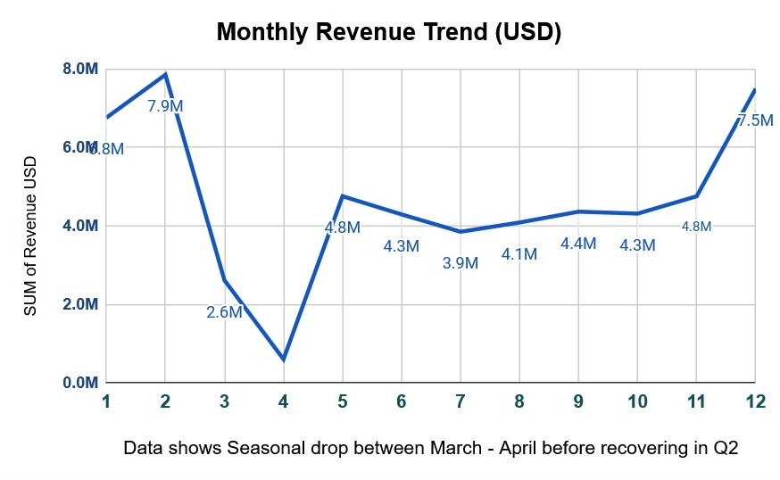
Monthly Profit Trend
Profit follows the same pattern as revenue, confirming stable
margins across months.

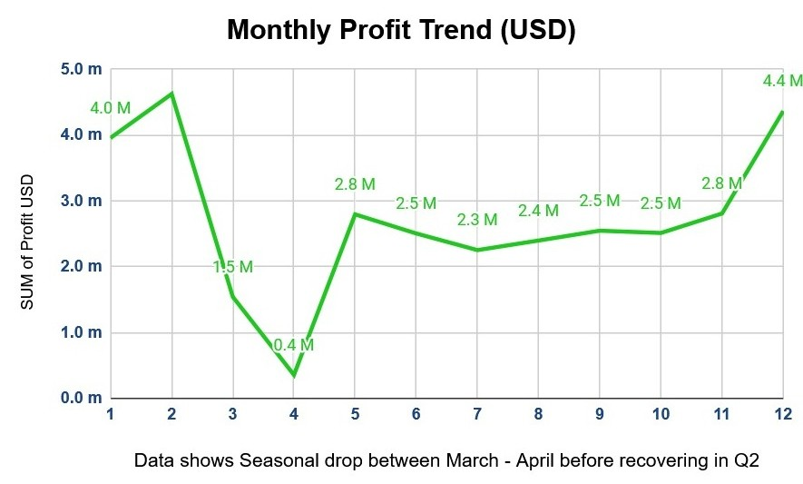

Revenue vs Profit Comparison
The alignment between profit and revenue shows strong
pricing control and cost efficiency.

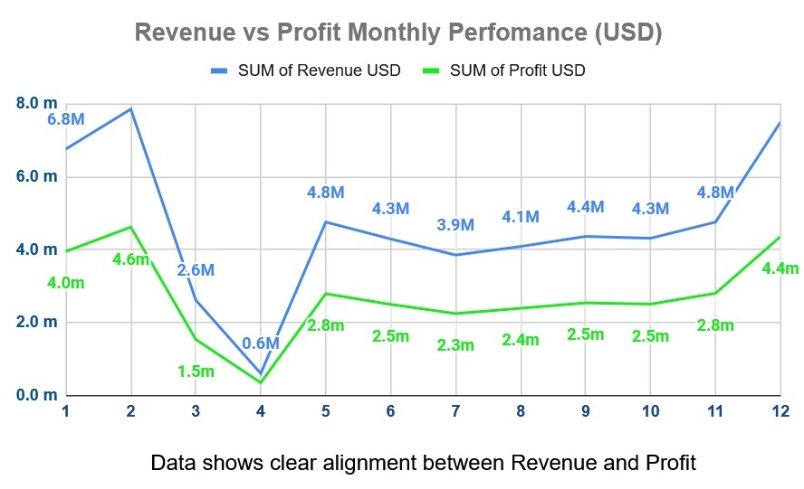

Sales by Category
Computers and Home Appliances generate most of the revenue.
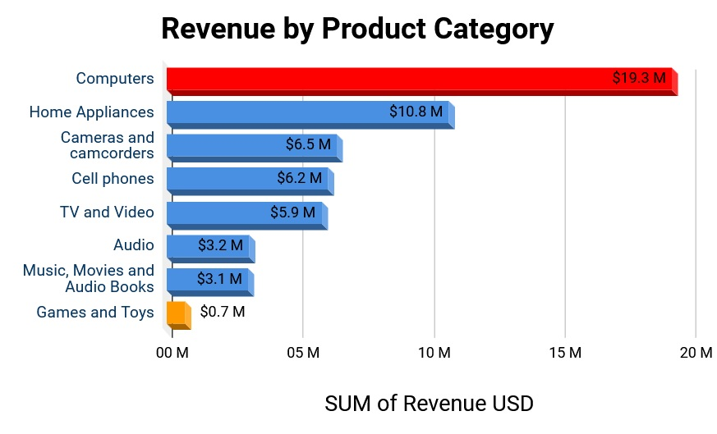

Delivery Days Distribution
Most deliveries happen within 1–7 days while Canada shows slower delivery.
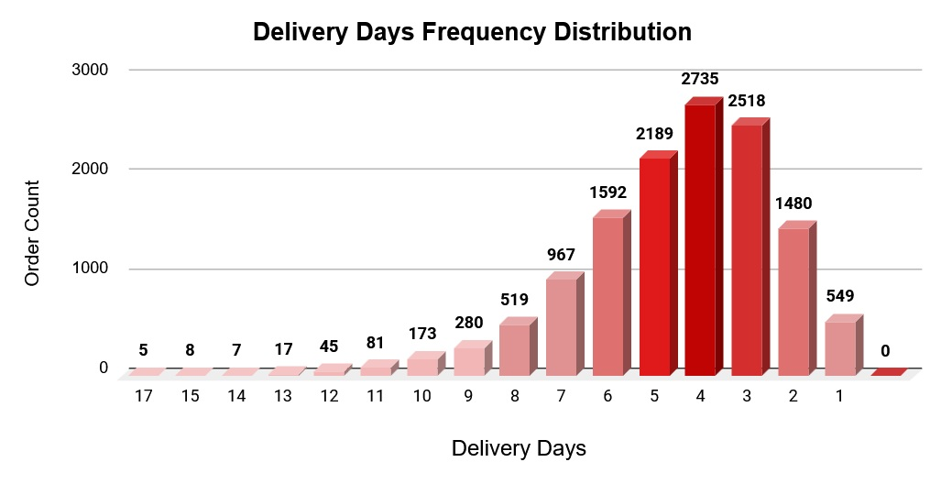

Dataset Limitations
- Single‑year data → limited trend analysis
- Missing delivery dates for some orders
- No demographic information (age, gender)
- No return/refund data → profit may be slightly overstated
- Limited geographic coverage

Business Recommendations
- Increase marketing & promotions in Q2 to offset seasonal drop
- Strengthen inventory planning for Q4 high‑demand period
- Optimize pricing for lower‑profit categories
- Improve delivery efficiency in slower regions (Canada)
- Prioritize investment in top‑performing brands & categories
- Build an automated dashboard (Power BI / Looker Studio)

Conclusion
This report reflects a full end‑to‑end analytics workflow: cleaning, enrichment, pivot analysis, KPI computation, insights, and recommendations. The dataset is now ready for dashboarding or predictive modeling.

