Windows server home lab>>>

----------------------------------------------
first thing install windows server 2025
then install windows 11 pro for users
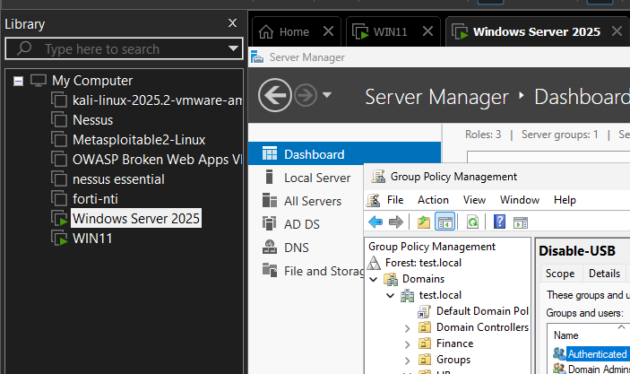

----------------------------------------------
first active active directory and assigned an ip 192.168.0.10

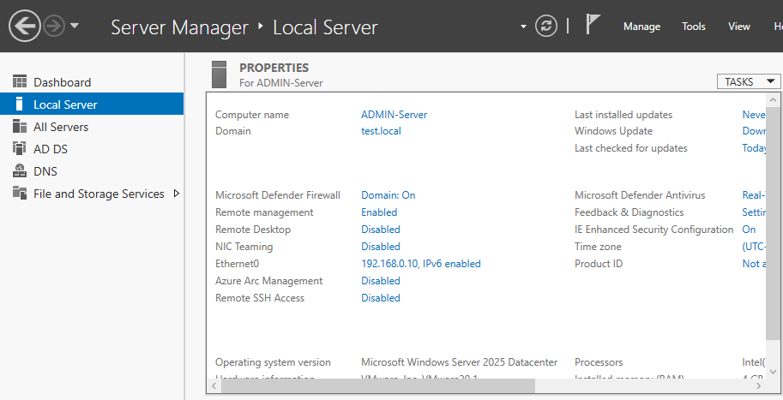

-----------------------------------------------
then make an OU , Groups and users
IT ,HR ,FINANCE ,SALES and Admin Group

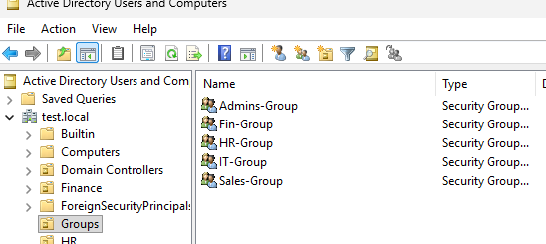

----------------------------------------------------
then add Windows 11 to the domain
Change name of Pc to PC11 , change time and date
and assigned ip 192.168.0.1X & DNS: 192.168.0.10
do it for all users
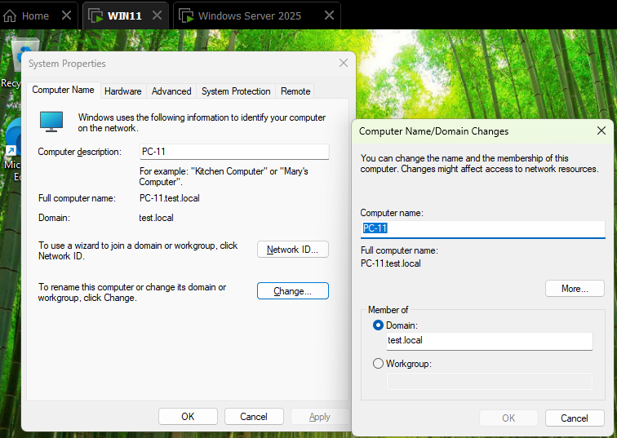

computers
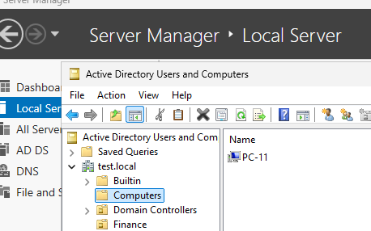

-----------------------------------------------------
ADD Group policy to users
------------------
ALL Policy to ALL USERS test.local
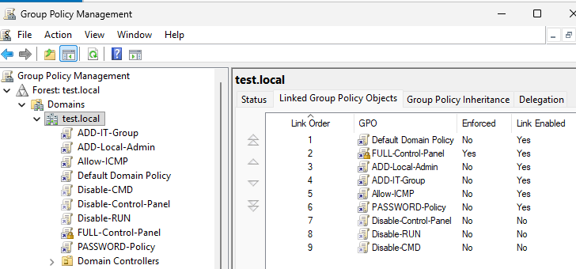

-------
HR
-------
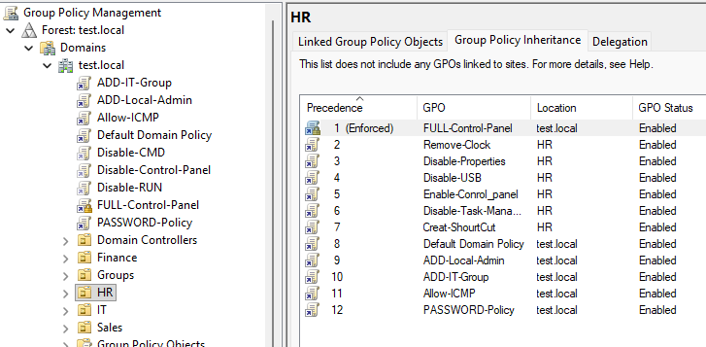

------
SALES
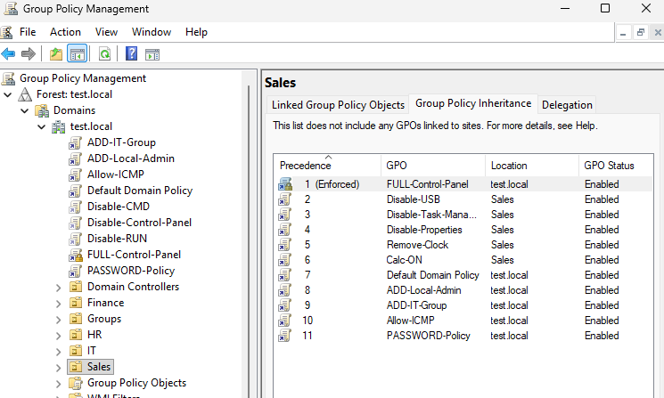

-------
FINANCE
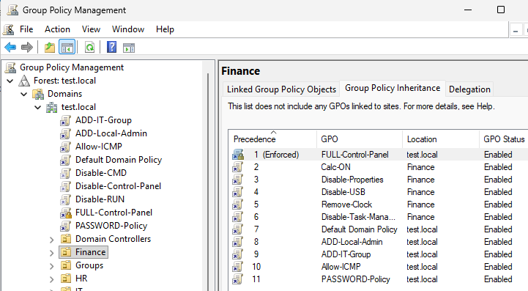

------------------
All Group Policy
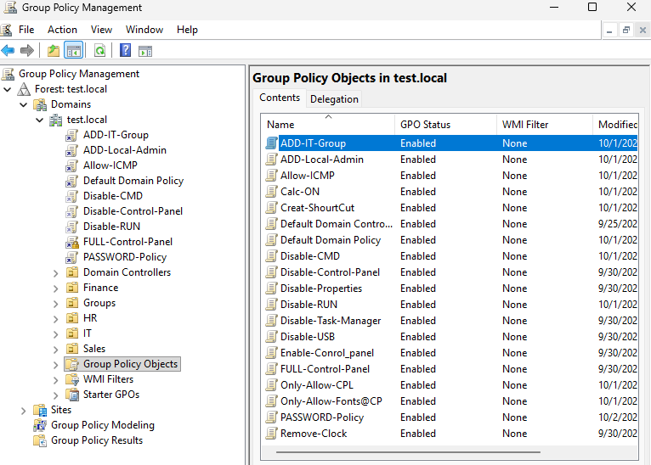
-----

-------
Scripts
--
auto run calculator
--
calc.exe
--
add admin to local computers
--
net user itadmin PASSWORD /add
net localgroup Administrators itadmin /add
--
add admin to administrator group
--
net localgroup administrators IT-Group /add
--------------------------------------------------------------
password policy
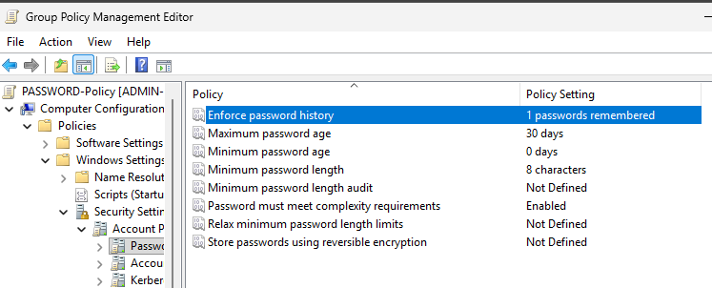

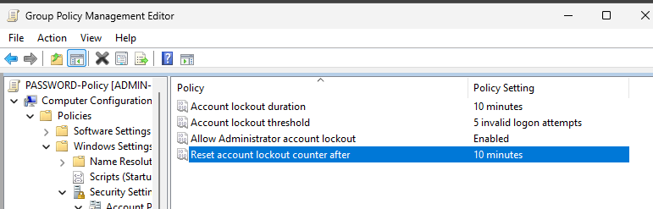

commands in RUN
---
cnpa.cpl >>>>>>>>>>>>> for change ip ethernet
sysdm.cpl >>>>>>>>>>>> for pc properties
dsa.msc >>>>>>>>>>>>>> for Active Directory
gpedit.msc >>>>>>>>>>>> enter group policy-Local
gpmc.msc >>>>>>>>>>>>> enter group policy
gpupdate >>>>>>>>>>>>> update policy that changed
gpupdate /force >>>>>>>> update all policies

