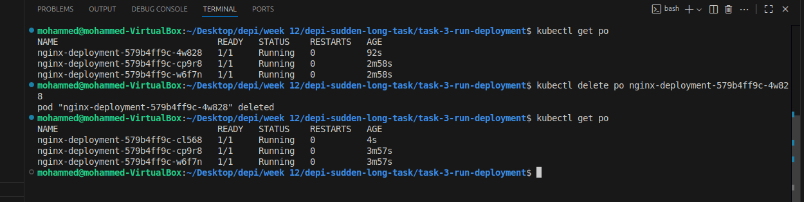

1-the deployment comes back but with different name

2-Difference between replicas and deployments

ReplicaSet

* If pods crashed it creates new one
* Changing the replicaset doesn’t change existing pods

Deployments

* Create and manages replicasets
* Can update pods without removing them
* If an update fails it rolls back to the last working update