

Delta University for Sciences and Technology
Faculty of Artificial Intelligence
Artificial Intelligence Department

Smart Lecture Assistant
"LectureMate "

AI327 / Work-based Professional Project in Artificial Intelligence (II)
Handbook

Prepared by:
Mohamed Ahmed Elbassiony
Hamed Atef Mohamed
Fahd Taha Kassem
Mohamed Adel Fouad
Ahmed Abass Ebedy
Ahmed Abass Bakry
Abdelrahman Khaled Mostafa

Supervised by:
Prof. Dr. Muhammad Sharif Al Qassasi
Head of
The Department of Basic Sciences and Computer Science

Fall Semester
2025/2026
Acknowledgments



We would like to express our sincere thanks to our supervisor, Prof. Dr. Muhammad Sharif Al Qassasi, for his exceptional organization and continuous guidance throughout this project. He provided us with a clear plan and a well-structured roadmap that helped us stay focused and complete the project on time and in the best possible way.
His constant follow-up, willingness to answer our questions, and dedication to supporting our progress greatly enhanced our understanding and motivated us to do our best. We truly appreciate all the time, effort, and support he has given us, and we wish him continued success and excellence.

"LectureMate" Project Teamwork
16/06/2026

Smart Lecture Assistant
"LectureMate"

Abstract

The exponential growth of digital educational content has created a significant challenge for learners attempting to navigate and retain information from the overwhelming volume of unstructured video lectures available online. This project introduces LectureMate, an integrated AI-powered platform designed to transform passive video content into structured, interactive study assets, thereby streamlining the learning process.
LectureMate addresses the need for efficient content digest by employing a robust, hybrid technical architecture. The system ingests content from multiple sources - YouTube links, uploaded audio and video, and PDF, Word and PowerPoint documents - using high-accuracy Automatic Speech Recognition (Faster-Whisper) for media and a dedicated document pipeline, with automatic visual OCR for difficult files, to generate precise transcripts. For semantic processing, the platform integrates a dual-engine AI approach: offering users the choice between state-of-the-art cloud-based Large Language Models (such as Google Gemini) for speed, and privacy-focused locally-hosted models (such as Qwen) for offline capability.
A distinguishing feature of LectureMate is its native bilingual support, processing and generating academic content effectively in both Arabic and English, complete with appropriate right-to-left (RTL) user interface adjustments. The system processes the transcribed text to automatically generate a comprehensive suite of study tools: abstractive summaries, interactive quizzes for self-assessment, digital flashcards for spaced repetition, formatted PowerPoint slides, an interactive concept map, extracted mathematical formulas, AI-captioned figures, and a lecture-grounded chat tutor. Built upon a modern stack utilizing React for the frontend, Node.js for backend orchestration, and specialized Python scripts for AI tasks, LectureMate provides a scalable, user-centric solution that significantly enhances engagement and information retention in modern
E- learning environments.
List of Abbreviations

Abbreviation | Meaning
AI | Artificial Intelligence
API | Application Programming Interface
ASR | Automatic Speech Recognition
EdTech | Educational Technology
FERPA | Family Educational Rights and Privacy Act
FSRS | Free Spaced Repetition Scheduler
GDPR | General Data Protection Regulation
GPU | Graphics Processing Unit
JSON | JavaScript Object Notation
KaTeX / LaTeX | Mathematical typesetting systems
LLM | Large Language Model
LMS | Learning Management System
LTR / RTL | Left-to-Right / Right-to-Left text direction
MOOC | Massive Open Online Course
NLP | Natural Language Processing
OCR | Optical Character Recognition
PDF | Portable Document Format
PPTX | PowerPoint Open XML Presentation
RAG | Retrieval-Augmented Generation
SDK | Software Development Kit
UI / UX | User Interface / User Experience
VAD | Voice Activity Detection
WER | Word Error Rate
Contents

List of Figures 8
Introduction 9
1.1 Introduction 9
1.2 Project Overview 11
1.3 Why this project? 13
Historical Review 14
2.1 Evolution of AI Study Platforms 14
2.2 Democratization of Accessibility & Universal Design 14
2.3 State-of-the-Art Case Study: TurboLearn AI & NoteGPT 16
2.4 Ethical Frontiers: The Privacy Paradox 18
2.5 Accuracy and Performance Metrics 18
2.6 Conclusion 18
Data Processing Pipeline 20
3.1 Introduction 20
3.2 Content Ingestion 20
3.3 Transcription Challenges in Academic Environments 22
3.4 Text Processing Pipeline 24
3.5 Output 25
AI Brain Architecture 29
4.1 Introduction 29
4.2 The Text Acquisition Pipeline 30
4.3 The Dual AI System: Rationale Behind the Architecture 32
4.4 The Intelligent Orchestration Layer:How the System Makes Decisions 35
4.5 The Educational Content Generation Engine 36
4.6 Quality Assurance and Performance 38
4.7 The Core Innovation 39
4.8 Conclusion: An Integrated Intelligent System 39
System Implementation & UI 40
5.1 System Architecture Overview 40
5.2 User Authentication & Security 41
5.3 Dashboard & Workspace 43
5.4 Lecture Analysis Workflow 45
5.5 The Integrated Learning Environment 47
5.6 Profile & Settings Management 57
5.7 UI/UX Design Philosophy 58
5.8 Summary 58
Evaluation, Conclusion and Future Work 59
6.1 Evaluation and Comparison 59
6.2 Conclusion 60
6.3 Future Development 60
6.3.1 Semantic Retrieval with a Vector Database (RAG) 60
6.3.2 Adaptive Review and Additional Inputs 61
6.3.3 Advanced Cross-Lingual Translation and Localization 61
6.3.4 Ecosystem Integration and Export 61
6.3.5 Performance Analytics and Adaptive Learning 61
References 62

List of Figures

No table of contents entries found.
Chapter 1

Introduction

1.1 Introduction
The past decade has witnessed a paradigm shift in the global educational landscape, with video lectures becoming a fundamental pillar of knowledge dissemination, both in traditional university settings and through e-learning and Massive Open Online Course (MOOC) platforms. The pace of this transformation accelerated markedly following the COVID-19 pandemic, cementing the role of video lectures as a "necessity" rather than a "luxury."
Despite their critical importance, the current format of these video lectures suffers from inherent limitations that render the learning process less effective. Relying on video as a passive medium imposes significant challenges on the learner, including:
- Difficulty in Review and Retrieval: Locating a specific concept or explanation within a hours-long video requires a significant investment of time and effort, leading to a loss of focus and disrupted learning flow.
- The Linear Nature of Video: This linearity is incompatible with the needs of modern learning, which is based on the non-linear exploration of content.

- Inefficiency in Organizing Information: Students struggle to extract the main structure of a lecture and organize information into coherent summaries without tedious manual effort.
- Lack of Immediate Assessment: Students lack an automated mechanism to instantly test their understanding and comprehension of the material directly from the lecture content itself.
To address these challenges, Artificial Intelligence (AI) technologies, particularly Natural Language Processing (NLP) and Machine Learning, emerge as a groundbreaking solution. These technologies can automatically analyze the textual and auditory content of lectures and extract actionable insights and information. From this premise, the Smart Lecture Assistant project proposes a comprehensive vision to transform video lectures from passive entities into a comprehensive, interactive learning environment. The project goes beyond simple transcription, positioning itself as a Personal Learning Assistant that processes raw content to generate a integrated suite of learning resources supporting all stages of the learning process: from initial understanding, through organization, to final self-assessment.

1.2 Project Overview
The Smart Lecture Assistant represents an end-to-end system designed to analyze video lecture content through several sequential and interconnected stages. The platform operates through the following layers:
- Input Layer: The platform supports several content sources:
- YouTube Links: The optimal method, leveraging available subtitles.
- Uploaded Video/Audio Files: From the user's local device.
Documents: PDF files (including scanned or Arabic-font documents), Microsoft Word (.docx) files, and PowerPoint (PPT/PPTX) decks can also be uploaded; they are converted to text, with an automatic visual OCR pass for difficult PDFs.
- Text Extraction Layer:
- Whisper Optimization: The integration of OpenAI's Whisper model has been optimized for "Long-form Transcription," utilizing VAD (Voice Activity Detection) to better handle silences and improve accuracy in technical academic terminology.
- Processing & Analysis Layer (The AI Core):
- The Language Model: The acquired transcript is sent to a Large Language Model (LLM): either a locally-hosted model (Qwen, run with the Ollama framework) or a cloud model (Google Gemini), selected by the user. Local deployment ensures low-latency responses, cost reduction, and, crucially, data privacy, as lecture content never leaves the deployment environment.
- Analytical Tasks: The LLM executes a set of advanced and concurrent analytical tasks:
- Multi-level Summarization: Produces both a comprehensive abstract and a detailed summary that retains the logical structure of the original lecture.
- Key Points Extraction: Identifies and lists fundamental concepts, definitions, formulas, and equations in an easily navigable format.
- Question Generation: Creates a diverse question bank, including:
- Multiple-Choice Questions (MCQs).
- True/False Questions.
- Short-Answer Questions.
- Self-Assessment Quiz Creation: Compiles the generated questions into short quizzes that students can solve immediately to evaluate their understanding.
Beyond text, the system also generates spaced-repetition flashcards, a downloadable PowerPoint deck, an interactive concept map, extracted mathematical formulas with worked solutions, AI-captioned figures, and a lecture-grounded chat tutor that answers questions about the material.
- Output & Presentation Layer:
- Interactive User Interface (UI): All outputs (original transcript, summaries, key points, questions) are displayed within an easy-to-use web interface.
- Internal Search Engine: Allows students to perform keyword searches across the entire lecture transcript to instantly locate any relevant segment.
- Result Export: Provides functionality to export summaries and question sets into various formats (e.g., PDF) for offline review.

1.3 Why this project?
The Smart Lecture Assistant project offers both theoretical and practical contributions, positioning it as a valuable addition to the Educational Technology (EdTech) field on multiple fronts:
- Theoretical & Scientific Contributions:
- Integrated Model: The project presents a comprehensive architectural model for integrating AI technologies (like STT and LLMs) into the analysis of educational content.
- Promotion of Active Learning: It transforms the student from a passive recipient into an active participant in the learning process through interaction with summaries and questions.
- Paving the Way for Adaptive Learning: It lays the groundwork for future learning systems capable of content personalization based on an analysis of student performance on the generated assessments.
- Practical & Applied Contributions:
- Enhanced Educational Efficiency: The system drastically reduces the time required for review and exam preparation, thereby increasing student productivity.
- Improved Learner Experience (UX): It provides a single, unified interface for all student needs derived from a lecture, eliminating the need to switch between multiple applications and tools.
- Support for Educators: Instructors can use the system to automatically generate questions and quizzes, alleviating their administrative burden and allowing them to focus on the more creative aspects of teaching.
- A Scalable Solution: The system can be applied to thousands of lectures across entire curricula, creating a smart, searchable educational library.
- Consideration of Privacy and Cost: The system's reliance on locally-run models makes it a cost-effective and privacy-conscious solution, a critical factor in academic environments.
Chapter 2

Historical Review

2.1 Evolution of AI Study Platforms
The landscape of Educational Technology (EdTech) has rapidly shifted from fragmented tools where one app handles transcription and another handles quizzing to integrated "All-in-One" ecosystems. This evolution is driven by the need to reduce "cognitive switching" for students, allowing them to remain in a single environment for the entire learning lifecycle: from consuming content to self-assessment.
- The Renaissance of Spaced Repetition Algorithms
A key component of this evolution is the integration of memory retention science directly into content consumption.
- Historical Foundations: The concept of "spaced repetition" dates back to Hermann Ebbinghaus’s "forgetting curve" in 1885 (Ebbinghaus, 1885) and was later operationalized by the Leitner System of physical flashcard boxes in the 1970s (Leitner, 1972).
- Algorithmic Shift: While early digital tools like SuperMemo and Anki relied on static algorithms (like SM-2) to schedule reviews, modern platforms have begun implementing advanced schedulers such as the Free Spaced Repetition Scheduler (FSRS) (Open Spaced Repetition, n.d.).
- AI Integration: Unlike legacy tools that required manual card creation, the current generation of AI platforms automates this process. By parsing lecture transcripts, these tools instantly generate flashcards mapped to optimal retention intervals, effectively merging content creation with long-term retention strategies.

2.2 Democratization of Accessibility & Universal Design
The rise of AI has transformed accessibility from a costly accommodation into a standard feature for all learners.
- From Stenography to Neural ASR: Historically, accurate transcription required expensive human stenographers or early, error-prone dictation tools like Bell Labs' "Audrey" (1952). Today, Automatic Speech Recognition (ASR) has commoditized this capability, allowing students with hearing impairments or auditory processing disorders to access "Universal Design" learning materials instantly.
- Impact on Learning: Research indicates that synchronized text-audio interfaces (like those found in modern transcription tools) significantly aid not just disabled students, but also non-native speakers and visual learners, standardizing "multimodal" learning as a baseline expectation for new platforms.

2.3 State-of-the-Art Case Study: TurboLearn AI & NoteGPT
Two prominent examples that mirror the architecture of LectureMate are TurboLearn AI and NoteGPT. These platforms represent the current "State of the Art" in automated study aid generation.
- NoteGPT: The All-in-One Assistant
NoteGPT has established itself as a comprehensive learning hub by integrating video summarization, flashcard creation, and an AI chat assistant into a single interface.
- Workflow: It allows users to upload YouTube videos or audio files, which are then processed to generate "professional-grade" transcripts and study notes.
- Feature Set: Beyond simple summaries, it includes an "AI Humanizer" to refine text and a specific "YouTube Video Summarizer" that extracts key concepts without requiring the user to watch the full footage.
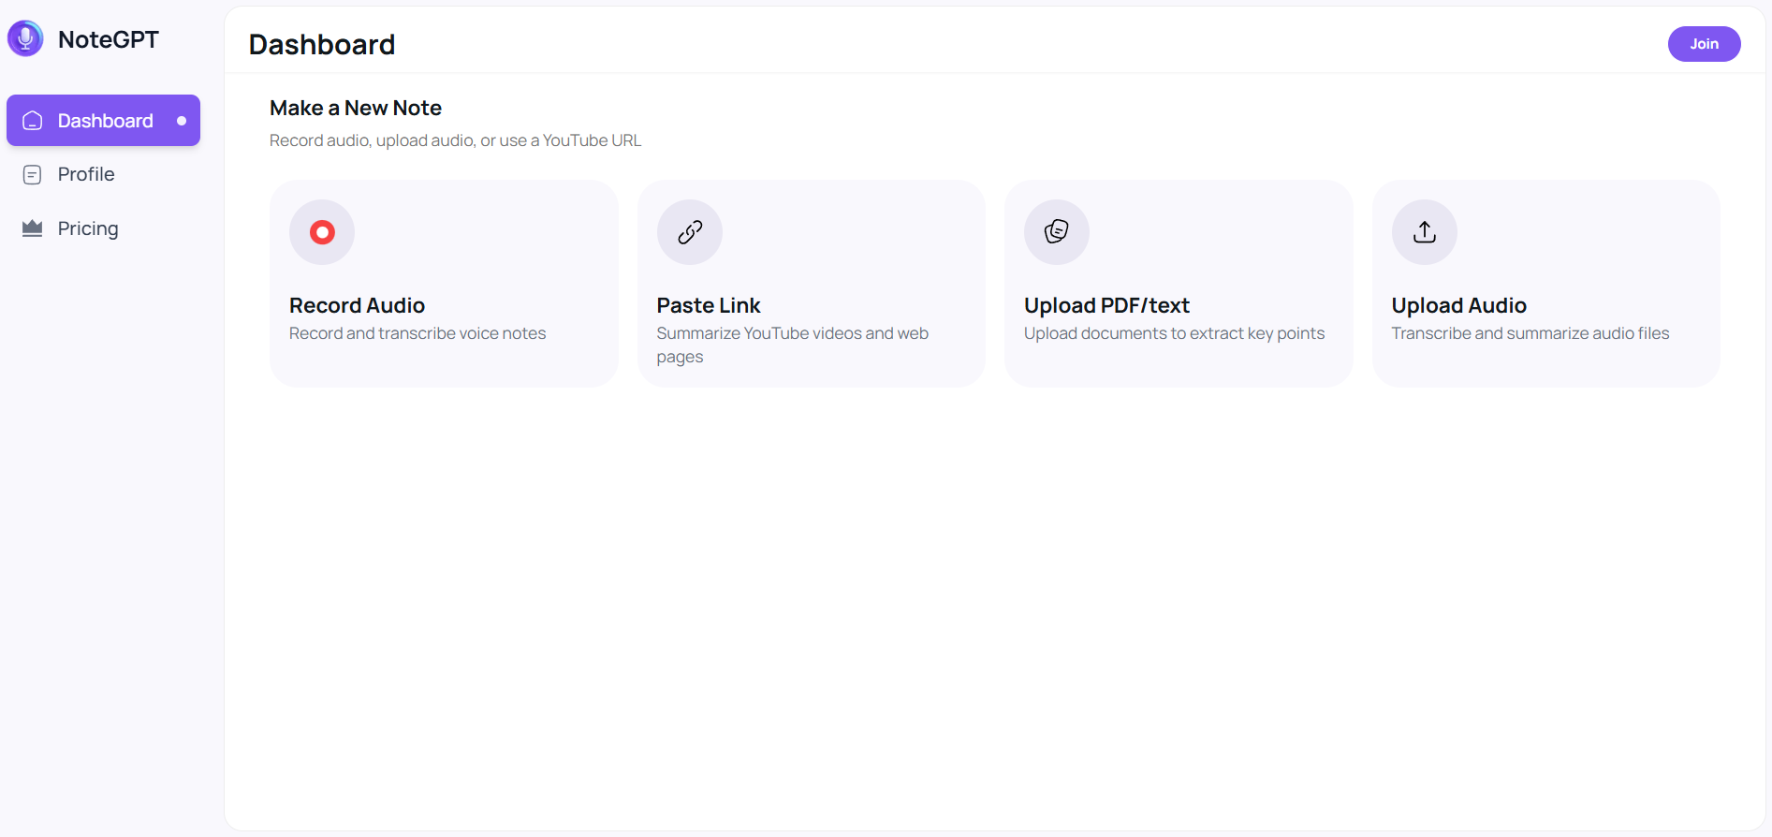
Figure 2.1 NoteGPT - UI

- TurboLearn AI: Instant Content Transformation
TurboLearn AI focuses heavily on speed and instant conversion of lectures into active study materials.
- Core Function: It markets itself as a tool that "instantly converts lectures into comprehensive notes, flashcards, and quizzes," aiming to replace manual note-taking entirely.
- Differentiation: Unlike basic summarizers, TurboLearn organizes content into a "Study Stream," effectively creating a personalized feed of knowledge that combines inputs from PDFs, audio, and videos.

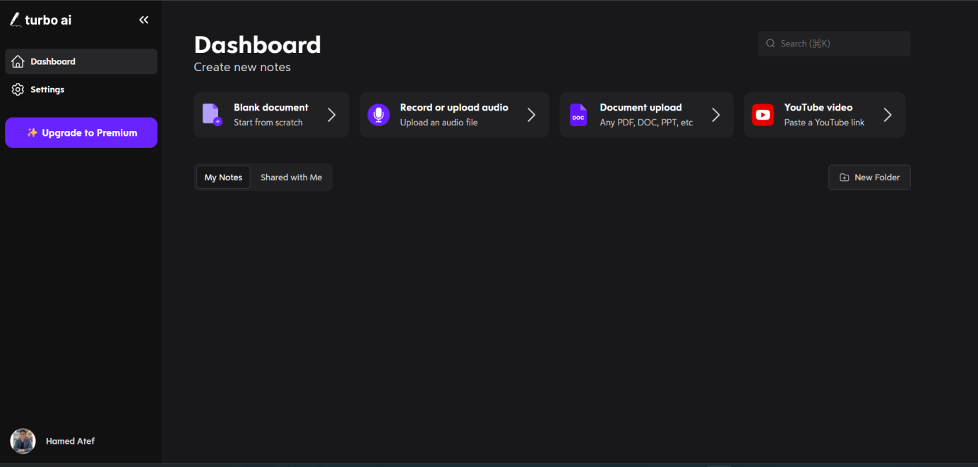
Figure 2.2 TurboLearn AI - UI

2.4 Ethical Frontiers: The Privacy Paradox
As AI study tools proliferate, a significant historical tension has emerged regarding student data privacy.
- The Cloud vs. Privacy Conflict: Most commercial "freemium" AI tools operate by processing student data on external cloud servers. This raises concerns under frameworks like FERPA (1974) and the GDPR (2016), as sensitive lecture content or student performance data may be ingested to train public models.
- The Shift to Local AI: In response to these surveillance and data harvesting risks, a new trend is emerging towards "Local AI" and self-hosted models. This historical pivot suggests a market opening for platforms (like LectureMate) that can offer the power of Large Language Models (LLMs) while keeping data processing entirely offline or within a private infrastructure.

2.5 Accuracy and Performance Metrics
A critical factor for these platforms is the accuracy of their AI-generated outputs. Research and industry benchmarks provide the following performance data:
- Speech-to-Text (ASR) Accuracy
The foundation of these platforms is the transcription of spoken lectures.
- AI Performance: Vendor benchmarks report that modern AI transcription models reach approximately 99.8% accuracy under optimal audio conditions. In more challenging environments with background noise or heavy accents, this accuracy typically ranges between 80-90%.
- Comparison: While human transcription remains the "gold standard" at ~99% consistency, AI tools have bridged the gap significantly, offering a much faster and more cost-effective solution for students.
- Content Generation Accuracy
- Notes & Quizzes: TurboLearn AI specifically claims a 99% accuracy rate for its generated notes and quizzes. This high level of precision is achieved by using advanced LLMs that are fine-tuned to extract educational context rather than just generic text.
- Summarization Reliability: Independent tests of AI summarizers (like NoteGPT) indicate that while they excel at identifying "purely human" or "purely AI" content, they can sometimes struggle with "humanized" AI text. However, for the purpose of educational summaries, they are rated as highly reliable for capturing core concepts.

2.6 Conclusion
The success of platforms like TurboLearn AI and NoteGPT validates the market demand for integrated study tools. However, the historical trajectory suggests that the next generation of tools must go beyond simple integration. By combining high-accuracy transcription (~99%) with advanced retention algorithms (Spaced Repetition) and robust privacy protections (Local AI), future platforms can address the ethical and pedagogical gaps left by current market leaders. This sets the benchmark for the LectureMate project, positioning it not just as a tool for efficiency, but as a holistic, privacy-conscious learning environment.
Chapter 3

Data Processing Pipeline

3.1 Introduction
From Raw Lecture to Knowledge. The Smart Lecture Assistant systematically transforms unstructured multimedia lecture content into structured, machine-actionable knowledge. This chapter details the critical preprocessing pipeline that serves as the foundation for all downstream AI-driven educational interventions. The transformation from raw audio/video to structured knowledge involves multiple stages of signal processing, natural language understanding, and data structuring each with distinct technical challenges and methodological considerations.
The Cognitive Importance of Textual Representation in Learning Research in educational psychology and cognitive science demonstrates that dual coding presenting information in both auditory and textual formats significantly enhances knowledge retention and comprehension. High-quality transcripts serve not merely as accessibility aids but as cognitive scaffolds that enable learners to process complex academic material more deeply. This chapter operationalizes these principles through an automated pipeline that maximizes both accuracy and pedagogical utility.
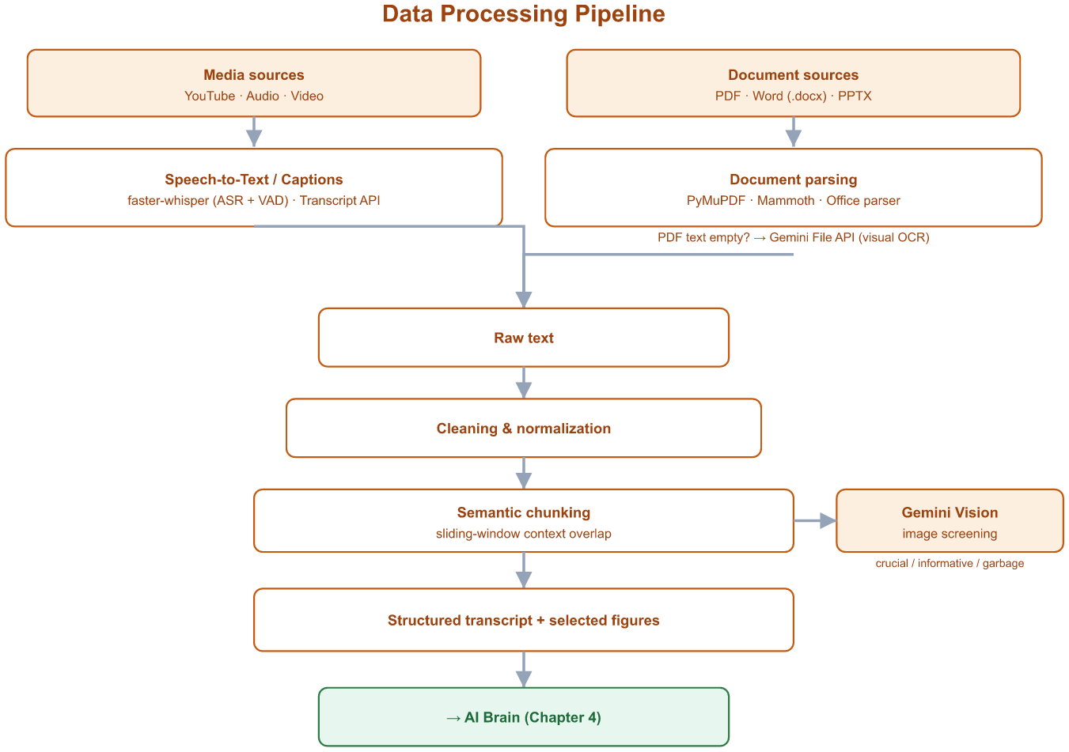
Figure 3.1 LectureMate - Data Processing Pipeline

3.2 Content Ingestion
Multi-Source Acquisition Framework. The system employs a flexible, multi-modal ingestion architecture designed to accommodate the diverse formats in which educational content is typically distributed.
- YouTube Integration: For content hosted on YouTube increasingly the primary platform for educational video dissemination the system utilizes specialized APIs to retrieve available caption tracks.
- Technical Implementation:The system prioritizes manually uploaded captions (typically higher accuracy), falling back to auto-generated captions if necessary. All retrieved text segments include precise start and end times, enabling future text-to-video synchronization features. Captions in various formats are converted to a unified structured format.
- Advantages:
- Efficiency: Near-instantaneous text extraction without computational overhead
- Leverage Human Review: Utilizes captions that instructors or institutions have potentially reviewed and corrected
- Multi-language Support: Native handling of multilingual caption tracks

- Limitation Analysis: The system implements a confidence heuristic where caption quality below a certain threshold triggers fallback to audio transcription. This threshold is based on formatting consistency, punctuation density, and estimated word error rates.
- Local File Processing: The Whisper-Based Pipeline. For locally stored recordings including Zoom sessions, classroom captures, and institutional repository files users can upload files in multiple audio and video formats.
- Architectural Decision: Dual-Mode Processing
The system implements a decision logic that first attempts to use existing YouTube captions when available. If these are unavailable or of insufficient quality, the system proceeds to audio processing. For audio transcription, the system offers two pathways:
- Local GPU Processing Advantages:
- Data Sovereignty: No external transmission of potentially sensitive academic content
- Cost Efficiency: No per-minute API costs after initial hardware investment
- Customization: Ability to fine-tune models on domain-specific academic speech
- Cloud API Fallback Considerations:
- Scalability: Handles peak loads without local infrastructure investment
- Maintenance: Eliminates model updating and compatibility concerns
- Latency Trade-off: Network-dependent processing times
Document Ingestion: PDF, Word and PowerPoint
Beyond audio and video, the pipeline ingests documents directly. PDF files are processed by a PyMuPDF (fitz) engine that extracts text and embedded figures in a single pass, skipping very small decorative images and capping the number of figures kept per document. When the extracted text is empty or too short to be usable - which is typical of scanned or mis-encoded Arabic PDFs - the file is automatically escalated to the Gemini File API, which reads the document visually (optical character recognition) and returns a usable transcript. Microsoft Word files (.docx) are read with the Mammoth library, and PowerPoint files (PPT/PPTX) are parsed for their text while a lightweight extractor pulls out their slide images.
Every figure extracted from a document is then screened by Gemini Vision, which classifies each image as crucial, informative, or low-value. Low-value assets - logos, title slides, closing slides and blurred frames - are discarded, while the useful figures are captioned and stored alongside the transcript for later use in the Images gallery and in the generated slides.

3.3 Transcription Challenges in Academic Environments
Academic lecture transcription presents unique challenges beyond general speech recognition. The system must account for multiple confounding factors that affect accuracy.
- Acoustic Challenges
- Background Noise including classroom chatter, HVAC systems, and projector fans is mitigated through noise-robust training and optional pre-filtering.
- Acoustic Artifacts such as echo in large halls and microphone proximity effects are addressed through acoustic model adaptation techniques.
- Overlapping Speech from student interruptions or group discussions presents challenges that may be addressed through speaker separation preprocessing in future enhancements.

- Linguistic and Domain-Specific Challenges
- Technical Terminology Handling: STEM lectures contain domain-specific lexicons that general models may not recognize optimally. The system implements post-processing dictionaries for domain-specific term correction, confidence thresholding to flag low-confidence technical terms for review, and contextual disambiguation using surrounding text to interpret ambiguous terms.
- Code-Switching and Multilingual Content: In many global educational contexts, instructors seamlessly blend languages. The system's multilingual capabilities automatically detect and transcribe such segments, with additional processing including language boundary annotations, per-segment language tags, and mixed-language coherence scoring.
- Empirical Performance Metrics: Reported Word Error Rates (WER) for comparable ASR systems are approximately 2% on clean studio recordings, around 9% on mixed-quality classroom recordings, up to 12% on STEM content with technical terms before post-processing, and about 7% on multilingual lectures averaged across language pairs; these figures define the performance envelope the pipeline targets, and a formal evaluation on the project's own dataset is identified as future work.

3.4 Text Processing Pipeline
- Lecture-Grounded Context Assembly
- To power the “Chat with Lecture” feature, the system performs lecture-grounded context assembly rather than open-ended generation. The transcript is segmented into semantic chunks; at query time the most relevant context - and, where useful, short summaries of related lectures from the user’s library - is supplied directly to the language model together with the user’s question, so the AI tutor’s answers remain strictly grounded in the lecture content and the risk of hallucination is minimised. An embedding-based vector database with semantic retrieval (Retrieval-Augmented Generation, for example FAISS or ChromaDB) is identified as a planned enhancement (see Chapter 6).
- Contextual Chunking with Sliding Window
- "To maintain narrative continuity, the system employs a Contextual Overlap Strategy during semantic segmentation. Unlike traditional fixed-length partitioning, this method ensures that each text segment retains a portion of the preceding and succeeding context. This technical refinement is critical for Large Language Models (LLMs) to interpret ambiguous pronouns and maintain the logical flow of complex academic arguments during summarization and quiz generation."
- From Raw Transcript to Structured Knowledge by:
- Language Identification and Routing: The system employs sophisticated language identification with academic domain adaptation, including primary language detection, mixed-language segment boundary detection, and routing to appropriate linguistic processing chains.
- Text Normalization and Cleaning: A multi-stage cleaning pipeline ensures textual consistency through: basic Unicode normalization and contraction expansion; academic-specific cleaning including abbreviation correction and mathematical expression normalization; configurable disfluency removal for speech fillers; and intelligent punctuation restoration.
- Semantic Segmentation and Topic Modeling: Rather than simple time-based chunking, the system implements hierarchical segmentation through a multi-step algorithm: initial segmentation at natural pauses; semantic boundary detection using text coherence algorithms; semantic similarity clustering using advanced language models; hierarchical clustering to form topics and subtopics; and boundary refinement using academic discourse markers. The output structure organizes content hierarchically from lecture to major topics to subtopics to individual segments, with each segment containing the text, timestamps, topic classifications, semantic embeddings, and identified key terms.
- Metadata Enrichment and Quality Scoring: Each segment receives comprehensive metadata including: acoustic confidence scores from the speech recognition system; linguistic coherence measurements from domain-tuned language models; term importance scores for key term identification; and concept density metrics measuring the number of domain-specific concepts per unit of text.

3.5 Output
Structured Educational Files Ready to Use ,The final output of the system is not merely a transcript, but a comprehensive package of educational files specifically designed to meet the needs of students and educators. These files are generated automatically and are ready for immediate use.
- Types of Generated Files
The system generates four primary types of educational files, each serving distinct pedagogical purposes.
- Automatic PowerPoint Presentation creates a ready-to-use slide deck with one slide per main topic, highlighting key points and concepts in visually accessible formats.

- Structured Word/PDF File provides a complete learning package containing an interactive table of contents, the full refined transcript organized into logical sections, summaries at different levels of detail (executive, detailed, and bullet-point formats), and mini-dictionaries defining key technical terms. This file serves for comprehensive review, printing for physical study, and sharing among study groups.
- Quiz/Assessment File generates a comprehensive set of evaluation materials including multiple-choice questions testing factual recall and application, true/false questions assessing conceptual understanding, and short answer questions requiring synthesis and explanation. A complete answer key accompanies all questions, enabling immediate self-assessment and serving as practice material for examinations.
- Study Notes File offers condensed learning materials featuring an executive summary capturing the lecture's core message in approximately 300 words, a distilled list of key points organized by importance, and focused documentation of core concepts with definitions and examples. This format is optimized for quick study sessions and last-minute exam review.

- Export and Integration Features
The platform currently exports study material as PDF (individual tabs or a combined document), as native PowerPoint (.pptx) decks, and as image files for the concept map, and it can assemble an editable study document through its built-in rich-text editor. Direct integration with Learning Management Systems such as Moodle, Blackboard and Canvas, and with external study tools such as Anki and Quizlet, is identified as planned future work (see Chapter 6).
- Performance Metrics and Validation
The pipeline's effectiveness is measured along multiple dimensions. Transcription accuracy is quantified through Word Error Rate (WER) comparisons with human-transcribed benchmarks, with the system targeting less than 10% WER for typical classroom recordings. Processing speed is measured by real-time factor (RTF) calculations, with an operational goal of 1.5x processing time relative to lecture duration. Segmentation quality is assessed through boundary precision and recall measurements using established academic discourse markers as reference points. File generation reliability tracks the success rate of producing complete, non-corrupted files, maintaining a target exceeding 99% success. User satisfaction is evaluated through feedback on clarity, completeness, and immediate usability of generated materials, with particular attention to how quickly users can begin productive study sessions with the outputs.
Chapter 4

AI Brain Architecture

4.1 Introduction
Transforming Structured Text into Educational Intelligence. Following the conversion of audio and visual content into organized, ready-to-process text as detailed in Chapter 2, the system enters its most critical phase: the application of its core artificial intelligence layer the AI Brain.
This brain consists of an integrated dual-system architecture, where each component complements the other:
- LM-Titan(The Edge Core): Powered by the Ollama framework, utilizing quantized Qwen models to achieve high-speed inference on consumer-grade GPUs.
- LM-Cloud(The Frontier Intelligence): Utilizing advanced APIs (Google Gemini) for complex reasoning tasks that require a broader world-knowledge base."
This chapter begins by explaining how the system intelligently prepares text for analysis, then proceeds to compare the two systems and demonstrate their complementary applications in the educational context.

4.2 The Text Acquisition Pipeline
From Audio to Structured Transcript. To generate high-quality summaries, create meaningful questions, and prepare presentation materials, the system first requires an accurate and well-structured transcript of the lecture.
- Two Integrated Extraction Pathways
The system employs two complementary approaches for text acquisition, ensuring reliability and coverage.
- Path One: The Whisper Automatic Speech Recognition Model
This path processes any audio or video file, regardless of whether pre-existing captions are available. It is particularly valuable for newly recorded content, unpublished materials, or lectures with unavailable or poor-quality captions.

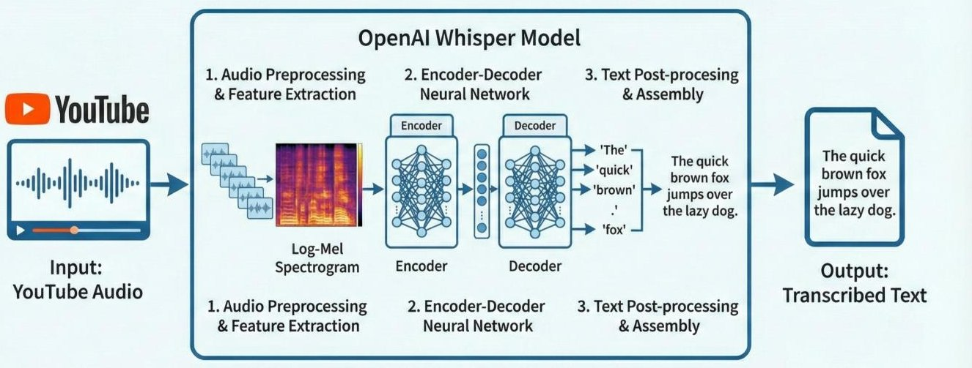

- Path Two: The YouTube Transcript API
This method extracts existing captions directly from video platforms. It is significantly faster and consumes fewer computational resources. This approach leverages the educational value added by instructors who have reviewed and refined their lecture captions.
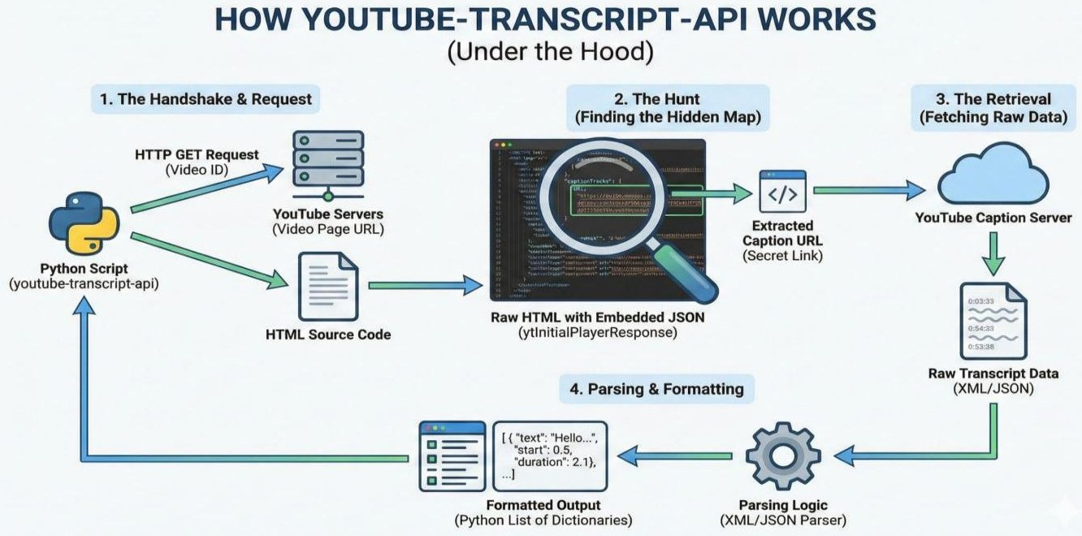
- Specialized Processing for Arabic and Academic Content
The system implements advanced processing techniques tailored for Arabic educational content. This includes handling the diverse range of Arabic dialects encountered in academic settings, accurately recognizing specialized scientific and technical terminology in Arabic, and intelligently processing code-switching between Arabic and English, which is common in technical and scientific lectures.

4.3 The Dual AI System: Rationale Behind the Architecture
- The Philosophy of Complementary Design
The two systems LM-Titan and LM-Cloud are not mere alternatives but complementary solutions designed to address different sets of requirements and constraints.
- LM-Titan (The Local Powerhouse) prioritizes absolute data privacy and predictable operational costs. It operates entirely within a local network, ensuring no sensitive academic content is transmitted externally. After an initial hardware investment, the cost per request is effectively zero, making it economically efficient for high-volume, daily use. It delivers high performance for medium-complexity tasks but has inherent limitations in model size and reasoning depth compared to cutting-edge cloud models.
- LM-Cloud (The Unlimited Cloud Intelligence) offers access to the most advanced and powerful language models available. It provides immense flexibility, scaling resources up or down instantly based on demand. It operates on a pay-per-use model, which is ideal for variable or project-based workloads. However, it requires a stable internet connection and involves transmitting data to a third-party service, which introduces considerations around privacy, compliance, and ongoing costs.
The choice between systems is not static; it is a strategic decision based on the specific lecture content, institutional policies, and desired educational outcomes.

- LM-Titan: Guaranteed Local Performance and Privacy

LM-Titan represents the self-reliant, high-performance local mode. Its defining feature is complete data sovereignty, as all processing occurs on local servers or workstations, making it indispensable for handling sensitive content such as unpublished research discussions, medical training sessions, or confidential corporate training.

Its operational model is based on a fixed capital investment in hardware (like high-performance GPUs), leading to predictable long-term costs with no variable fees. It provides full operational independence, functioning without an internet connection, which guarantees availability and can be crucial in environments with restricted or unreliable connectivity. For standard educational tasks like generating summaries and key points for typical-length lectures, it offers exceptionally fast response times.

This mode is ideally suited for established educational institutions with robust IT infrastructure, for any project involving strictly confidential material, and for scenarios requiring intensive, daily processing where cloud costs would become prohibitive.

- LM-Cloud: Scalable Cloud-Based Intelligence

LM-Cloud leverages the vast computational resources and continuous innovation of major cloud AI platforms. It provides access to state-of-the-art models that typically surpass the capabilities of locally runnable models in terms of reasoning depth, coherence, and task complexity. This makes it exceptionally powerful for deconstructing long (multi-hour), complex lectures or generating sophisticated, exam-style questions.

The system offers on-demand scalability, instantly adapting to handle any workload without the need for local hardware upgrades. It benefits from continuous, automatic updates and improvements from the API provider, ensuring access to the latest AI advancements. Its cost structure is operational and flexible, aligning expenses directly with usage, which is advantageous for pilot projects, variable workloads, or institutions without upfront capital for hardware.

This mode is the preferred choice for processing very long and intricate lectures, for tasks demanding the highest level of analytical reasoning or creative structuring, for temporary or experimental projects, and for rapid prototyping and development of new educational features.

4.4 The Intelligent Orchestration Layer:How the System Makes Decisions
- Semantic Routing Logic
"The Orchestration Layer acts as a Semantic Router. It analyzes the 'Task Complexity Score' before execution. For instance:
Routine Tasks: (Basic transcription cleaning, bullet-point summaries) are routed to LM-Titan.
Complex Tasks: (Cross-lecture synthesis, complex mathematical reasoning, or generating nuanced pedagogy-based quizzes) are escalated to LM-Cloud if the local confidence score falls below a predefined threshold."
- The Automatic Selection Mechanism
The system does not merely offer two modes; it includes an intelligent orchestration layer that can recommend or automatically select the appropriate engine based on a holistic analysis of the task.
This layer evaluates multiple factors: the length and complexity of the lecture transcript, the presence of sensitive keywords or topics that mandate local processing, the specific educational task requested (e.g., simple summary vs. deep Q&A generation), and the explicit preferences or policy settings of the user or institution. A configurable rule-set allows administrators to define priorities, such as "always use local for medical lectures" or "use cloud for summaries over 5000 words."

- Intelligent Hybrid Integration
In advanced configurations, the system can strategically employ both engines within a single workflow. For instance, LM-Titan could perform initial processing, rapid summarization, and basic keyword extraction. LM-Cloud could then be invoked for more demanding phases, such as generating nuanced essay questions or creating a detailed concept map. The results are then synthesized into a final, cohesive output, combining the speed and privacy of the local system with the advanced capabilities of the cloud.
In the current implementation this orchestration is realised through an explicit engine selection combined with automatic fallback. When starting an analysis the user chooses between the cloud engine (LM-Cloud / Google Gemini) and the local engine (LM-Titan / Qwen via Ollama). In cloud mode the system calls Gemini first and transparently falls back to the local Ollama model if the request fails, and finally to a deterministic extractor; in local mode it uses Ollama only. Sampling is tuned per task - low temperatures for exact extraction (formulas, medical, engineering and answer grading) and higher temperatures for open generation (summaries, quizzes and slides).
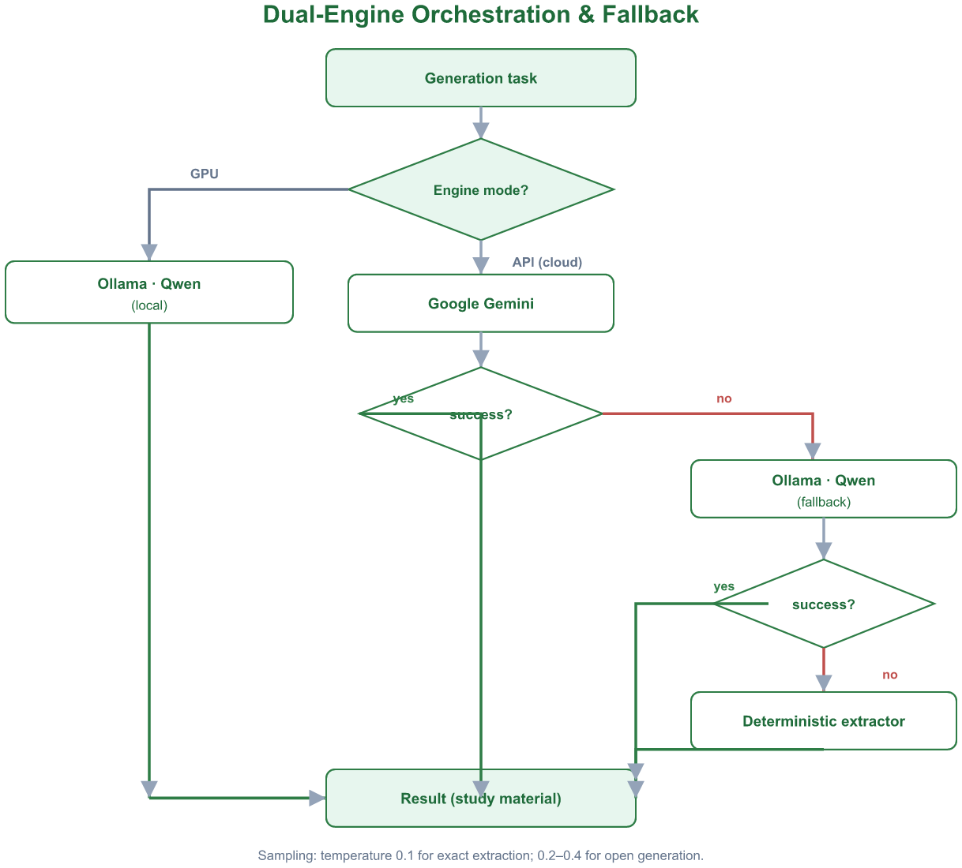
Figure 4.1 LectureMate - Dual-Engine Orchestration and Fallback

4.5 The Educational Content Generation Engine
- Core Educational Tasks
Regardless of the underlying AI engine selected, the system executes a consistent suite of pedagogical tasks through a unified prompt orchestration and formatting layer.
The engine performs Multi-Level Summarization, producing an executive abstract capturing the core thesis, a comprehensive study summary for thorough understanding, and a concise list of key points for quick review. It conducts Core Concept Extraction, identifying and defining technical terminology, mapping the relationships between different ideas presented, and outlining the logical flow of the lecture's argument.
It facilitates Assessment Tool Creation by generating multiple-choice questions that test factual recall and application, true/false statements with corrective explanations for misconceptions, short-answer questions that probe deeper understanding, and complete self-assessment quizzes. Finally, it automates Teaching Material Preparation, drafting structured PowerPoint-style presentations, organizing study notes in a logical hierarchy, and formulating practice worksheets and problem sets.
Beyond summaries and assessments, the same engine drives the platform's richer study tools through dedicated generators: an interactive concept map (nodes and labelled relationships), a four-level formula extractor with worked solutions and function graphs, per-image captioning through Gemini Vision, automatic classification of each lecture into one of eleven subject categories, and - for medical and engineering lectures - specialised extractors that surface clinical terms, drugs and reference calculators, or electronic components, circuits and compilable code. A lecture-grounded chat tutor then answers follow-up questions from the same content.

- Adaptation to Educational Needs
The system dynamically adapts its output based on several axes. It tailors language and detail to the learner's Level, whether beginner, intermediate, or advanced. It adjusts its approach based on the Subject Type, such as theoretical, practical, mathematical, or literary. It aligns its task execution with the Learning Objective, be it foundational comprehension, practical application, or critical analysis. Furthermore, it can vary presentation styles to accommodate different Learning Styles, including visual, auditory, and reading/writing preferences.

Mathematical Formula Extraction
The system treats formula extraction as a constrained generation task rather than a simple text search. The transcript - and, where available, the slides or document images supplied through Gemini Vision - is analysed with a low-temperature, schema-guided prompt that instructs the model to return a strict JSON structure. Extraction operates on four complementary levels: formulas stated explicitly in the material; formulas implied by the context (for example, recognising that a discussion of velocity entails v = d / t); formulas read from diagrams and tables; and the standard formulas expected for the detected topic. For each formula the model returns its name, the LaTeX expression, the meaning of every variable, a category, an optional vector or Mermaid diagram, an optional function graph, and a step-by-step worked solution. A validation pass rejects any candidate that does not contain genuine mathematical operators or LaTeX commands, and a LaTeX-repair routine corrects common errors (missing backslashes, unfenced text, malformed fractions and roots) so that every expression renders correctly with KaTeX.
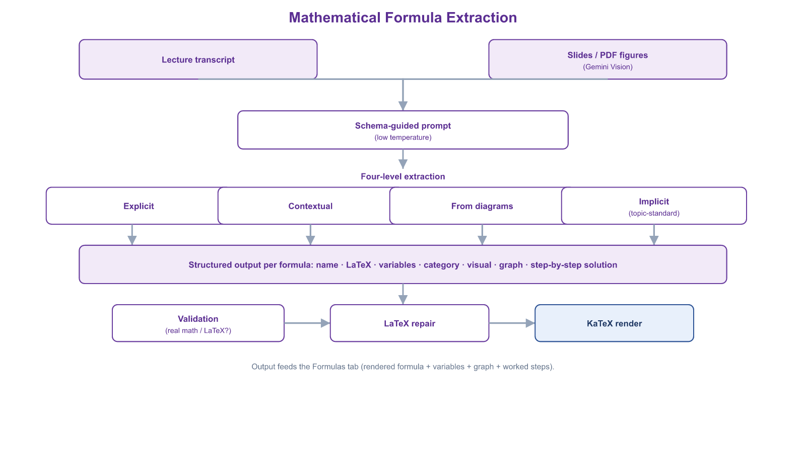
Figure 4.2 LectureMate - Formula Extraction Pipeline
Domain-Specific Knowledge Extraction (Medical and Engineering)
When the automatic classifier assigns a lecture to the medicine or engineering category, the transcript is routed to a specialised extractor that applies the same four-level strategy but targets a domain-specific schema. For medical content the engine returns clinical terms (with definitions and clinical context), drugs (mechanism of action, indications, typical dosage and side-effects), reference calculators such as BMI and GFR with their normal ranges, and clinical procedures; anatomy and pathology relationships are emitted as Mermaid diagrams, and each term carries an image query (resolved to a real reference image) and a 3-D model query that feeds the interactive molecule and anatomy viewer. For engineering content the engine returns electronic components with their specifications, circuit descriptions rendered as block diagrams, compilable code snippets tagged by language, governing formulas, and step-by-step procedures. Both extractors run at a low temperature to maximise factual precision, and a keyword override re-routes hardware-centric lectures (signals such as Arduino, breadboard or resistor) to the engineering extractor even when the surface topic appears generic.
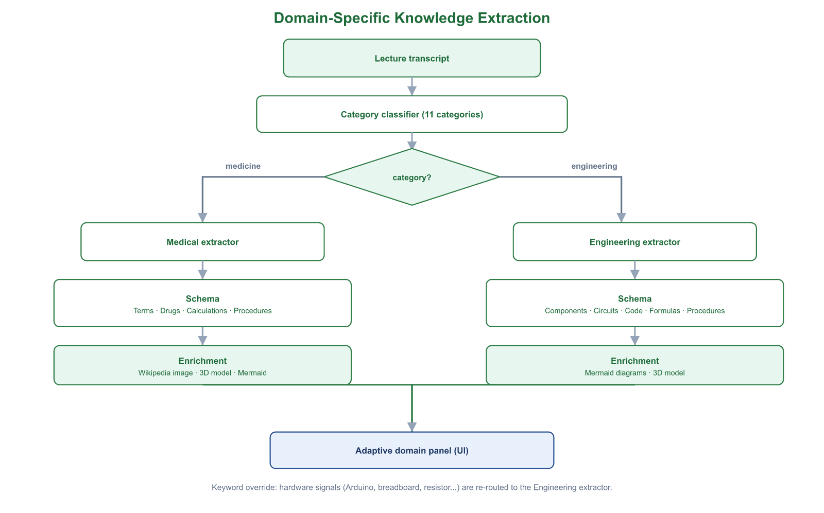
Figure 4.3 LectureMate - Domain-Specific Knowledge Extraction
AI Educational Image Generation
For slides and concepts that benefit from an illustrative visual, the system can synthesise an original educational image through a dedicated pipeline. A prompt-building model first converts the slide title and bullet points into a concise, literal image description constrained to a clean, text-free educational style. This description is sent to a text-to-image model (Google Imagen); the resulting image is then scored for relevance by a vision model on a scale from zero to one and is accepted only if it passes a fixed relevance threshold. If generation fails or the image is rejected, the pipeline falls back to a curated stock-image search (Pexels), and every accepted image is cached so that identical requests are not regenerated - keeping the generated visuals faithful to the lecture content while controlling cost and latency.

4.6 Quality Assurance and Performance
- Performance Benchmarks
The system is designed with specific performance targets for different tasks. For summarizing a 30-minute lecture, the target processing time is under 30 seconds. For generating a set of questions, the target is under 45 seconds. The overarching goal for content accuracy is consistently above 90%, ensuring reliable educational utility. Cost-efficiency is also a key benchmark, with LM-Titan aiming for near-zero marginal cost per task and LM-Cloud targeting a predictable and reasonable cost per request based on cloud provider pricing.
- Mechanisms for Continuous Improvement
To maintain and enhance quality, the system employs several mechanisms. It incorporates a Feedback Loop, learning from user corrections and preferences to refine future outputs. It performs regular Comparative Analysis, benchmarking the outputs of both its local and cloud engines to identify strengths, weaknesses, and opportunities for optimization. It undergoes Scheduled Updates, periodically integrating newer versions of language models and improving its internal processing algorithms. Finally, it demonstrates Adaptive Performance, fine-tuning its operations based on observed usage patterns and institutional goals.

4.7 The Core Innovation
The primary innovation of this system lies not merely in its application of artificial intelligence, but in its sophisticated integration and strategic orchestration of AI to serve precise educational objectives. It successfully balances the critical vectors of educational quality, data privacy and security, operational efficiency and cost, and system flexibility and adaptability.

The final outcome is a comprehensive system that transforms a lecture from a transient event into a persistent, evolving educational resource. This resource can be continuously utilized, refined, and built upon, creating sustainable and growing educational value for all participants in the learning process.

4.8 Conclusion: An Integrated Intelligent System

- The Added Educational Value
The integrated AI brain delivers significant value across the educational ecosystem.

For students, it provides personalized, ready-to-use study materials, enables immediate and effective self-assessment, and dramatically reduces the time required for review and organization of lecture content.

For educators, it automates the time-consuming preparation of teaching aids, offers analytical insights into their lecture content and delivery structure, and supports the continuous development of teaching effectiveness.

For institutions, it enhances the overall efficiency of the educational process, helps standardize the quality of pedagogical materials, and enables intelligent archiving and data-driven analysis of educational content.
Chapter 5

System Implementation & UI

5.1 System Architecture Overview
LectureMate is engineered using a modern, decoupled architecture to ensure scalability and high performance. The system is divided into three core layers:

- Frontend Layer: Built with React 19 and TypeScript, serving as the interactive client-side application. It utilizes Vite 7 for optimized building and Tailwind CSS v4 for rapid, responsive styling.
- Backend API Layer: A Node.js 24 / Express server that acts as the central orchestrator. It manages API routes, communicates with the database, and spawns child processes for heavy computational tasks.
- Intelligence Layer: A hybrid AI engine combining Google Gemini (Cloud) and Qwen served locally via Ollama (Local GPU) to process transcripts and generate educational content.

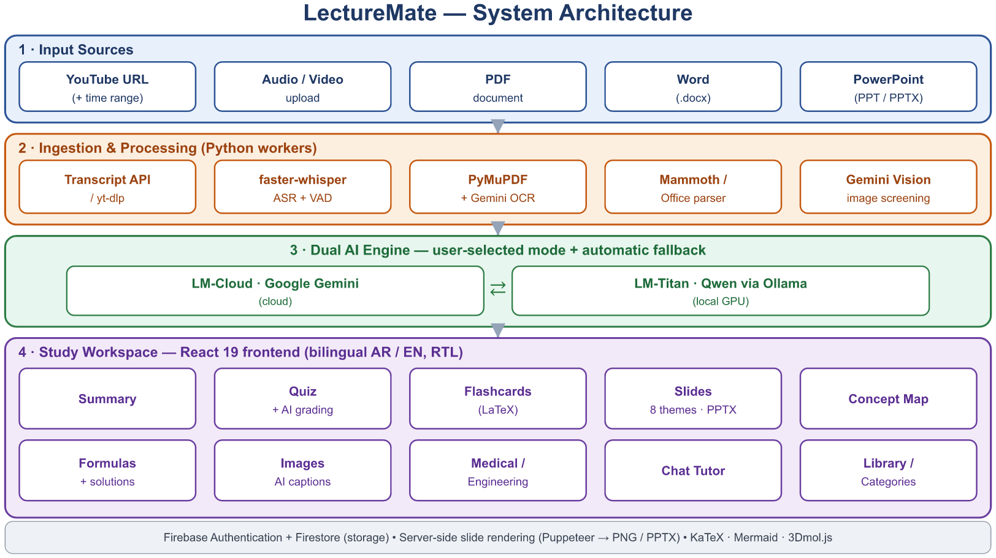
Figure 5.1 LectureMate - System Architecture Diagram

5.2 User Authentication & Security
The authentication module is designed to provide a secure and seamless entry point for users, leveraging Firebase Authentication for identity management.
- Sign Up Interface
The registration page offers a user-friendly form with real-time validation.
- Key Features:
- Password Strength Meter: A dynamic indicator that evaluates password complexity (Weak, Fair, Good, Strong) in real-time as the user types.
- Social Login: Integration with Google OAuth for one-click registration.
- Visual Feedback: Uses Framer Motion to add smooth entrance animations to the login cards.
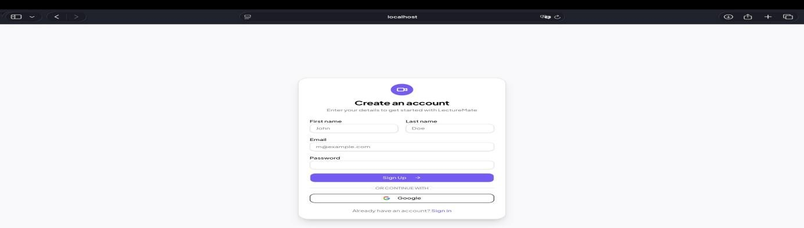

- Sign In Interface
The login interface ensures secure access for returning users.
- Key Features:
- Bilingual Support: The interface automatically adapts layout direction (RTL/LTR) based on the user's language preference (Arabic/English).
- Error Handling: "Toaster" notifications provide immediate feedback for incorrect credentials or network issues

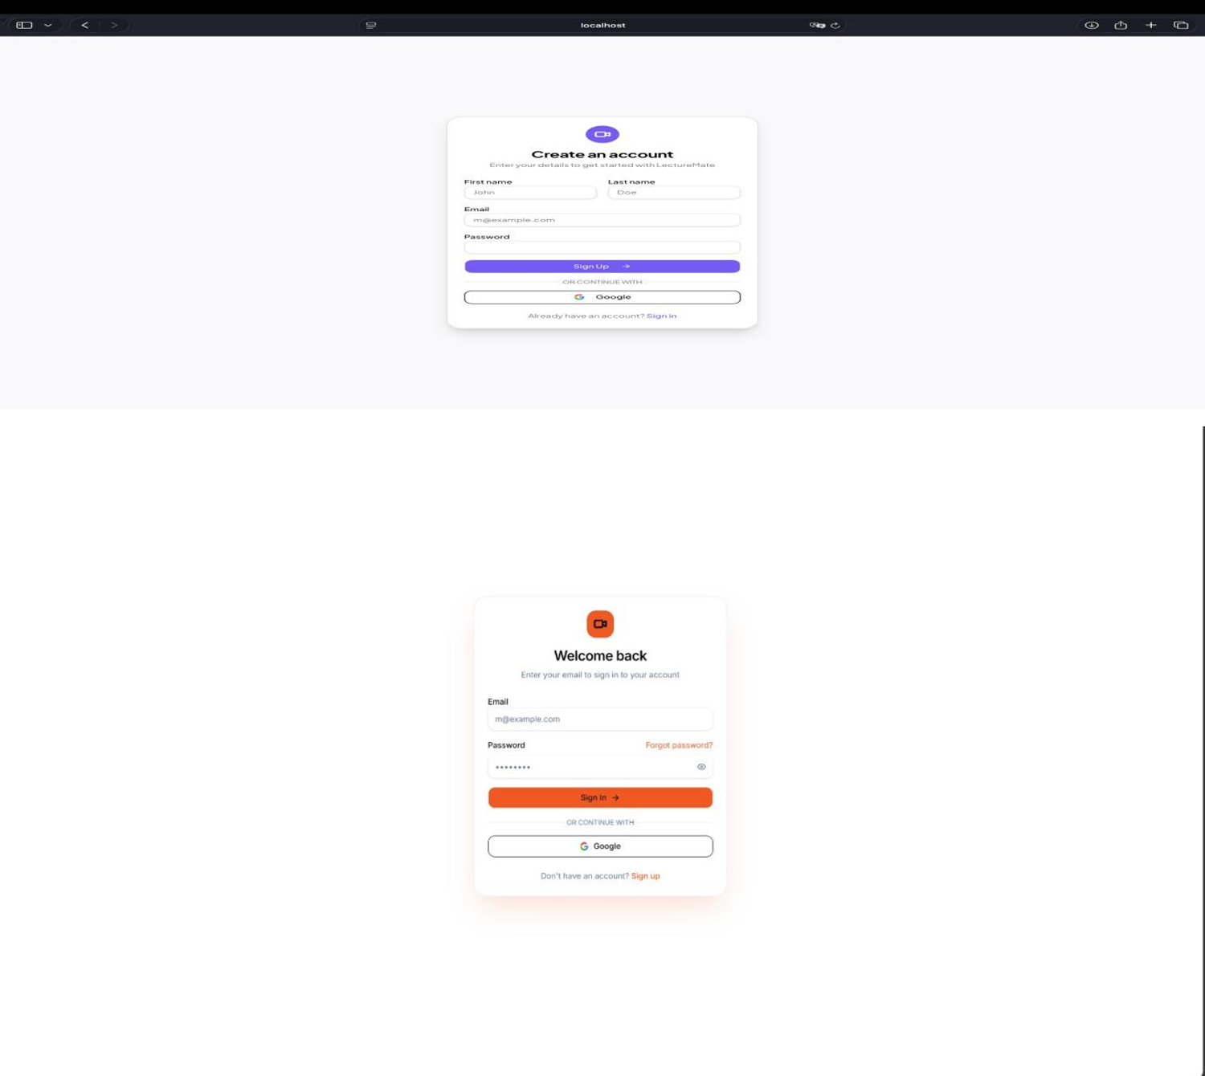
Figure 5.2 LectureMate - Authentication (Sign Up and Sign In)

5.3 Dashboard & Workspace
The Dashboard serves as the central command center, offering users a personalized overview of their learning progress.

- Statistics & Overview
Upon logging in, users are greeted with a "Welcome Back" message and a statistical summary of their activity:

- Key Metrics: Four dynamic cards display:
- Total Lectures: Number of videos analyzed.
- Completion Rate: Percentage of lectures fully studied.
- Study Time: Total time spent learning (calculated from video duration).
- Cards Created: Number of flashcards and slides generated.

- Continue Learning
A "Continue Learning" section highlights the most recent lecture the user was interacting with, displaying a progress bar that indicates whether the lecture is still processing or ready for study.

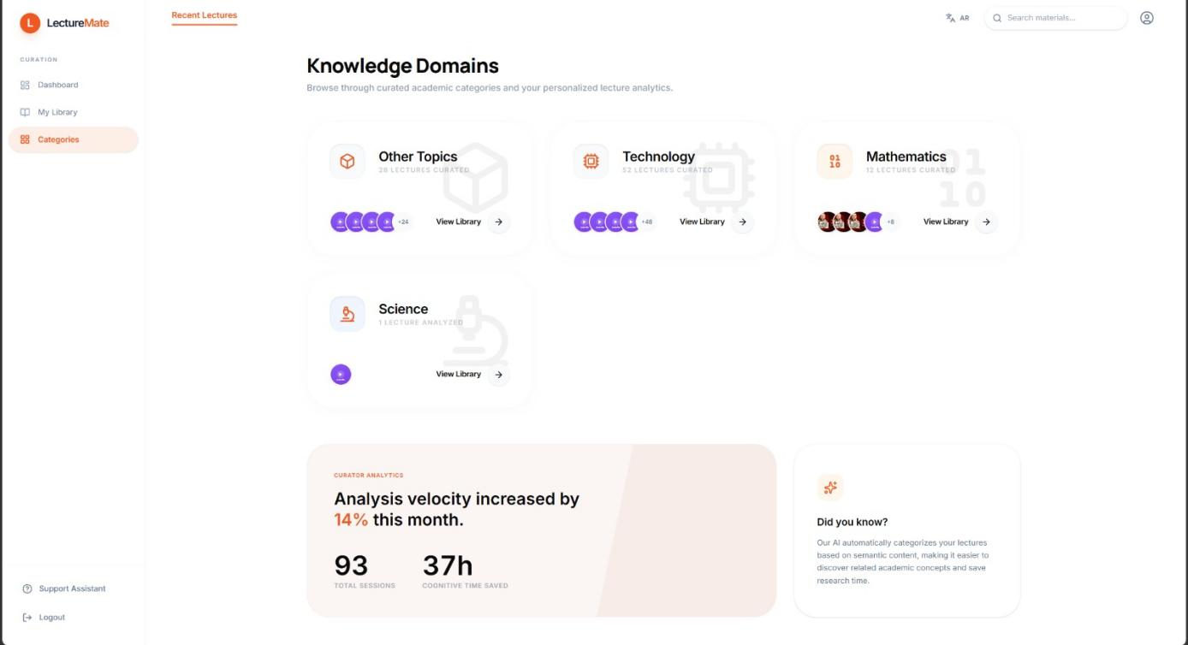
Figure 5.3 LectureMate - Dashboard with statistics cards and recent activity

5.4 Lecture Analysis Workflow
The "New Analysis" page is the starting point for processing content.
- Input Mechanism: Users simply paste a YouTube URL. The system validates the link and retrieves metadata (thumbnail, title, duration) using the youtubeService.
In addition to YouTube links, the New Analysis page accepts uploaded video and audio files, PDF and Microsoft Word documents, and PowerPoint decks. For YouTube sources an optional time range can be selected so that only part of a long lecture is analysed.
- Configuration Options: Users can select their preferred processing mode before starting:
- LM-Cloud (API): Uses Gemini for fastest results.
- LM-Titan (GPU): Uses the local Qwen model for privacy.
- Real-time Feedback: A multi-step progress indicator informs the user of the current stage: "Downloading Audio" → "Transcribing" → "Generating Summary".

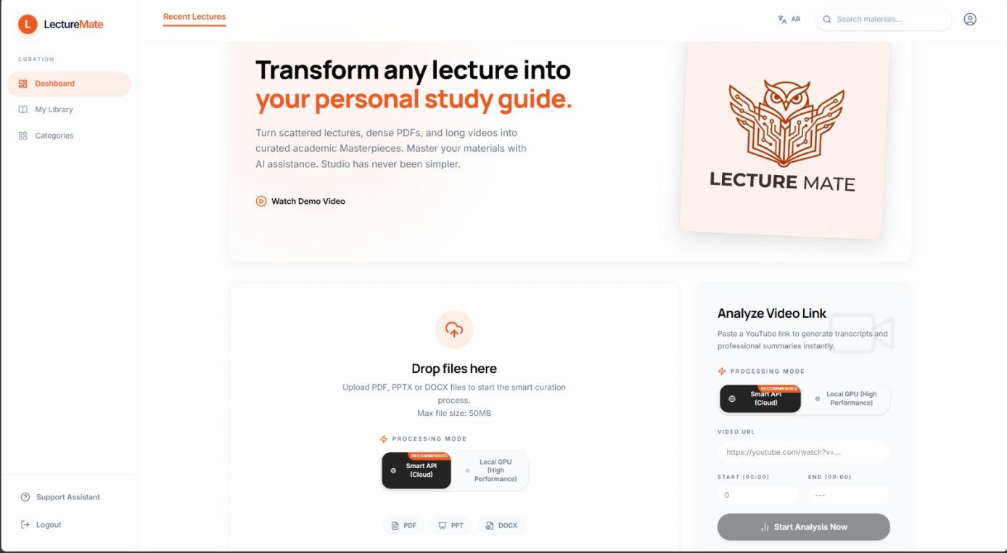
Figure 5.4 LectureMate - New Analysis Page with URL, Upload Video, Record Audio input and Model selection
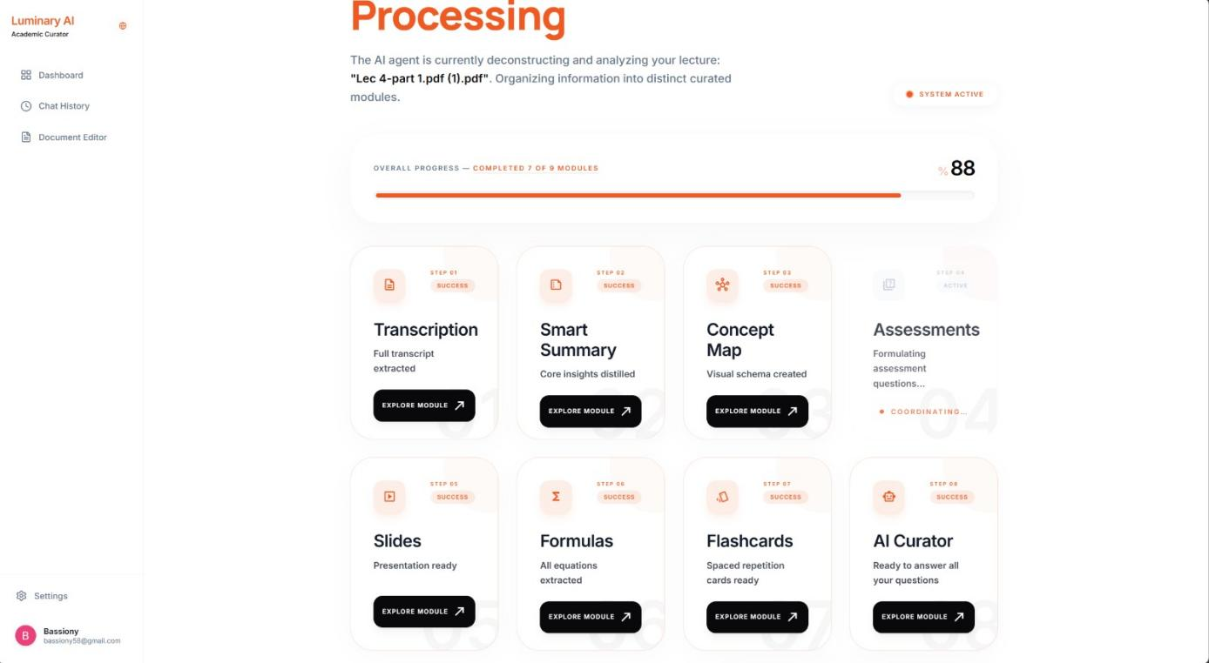
Figure 5.5 LectureMate - showing the process for analyzing a lecture

5.5 The Integrated Learning Environment
The core value of LectureMate is delivered through the Lecture View, a tabbed interface that organizes generated content into digestible modules.

- Summary & Transcript Tabs
- Abstractive Summary: Displays a structured summary generated by the AI, broken down into an Introduction, Key Points, and Conclusion.

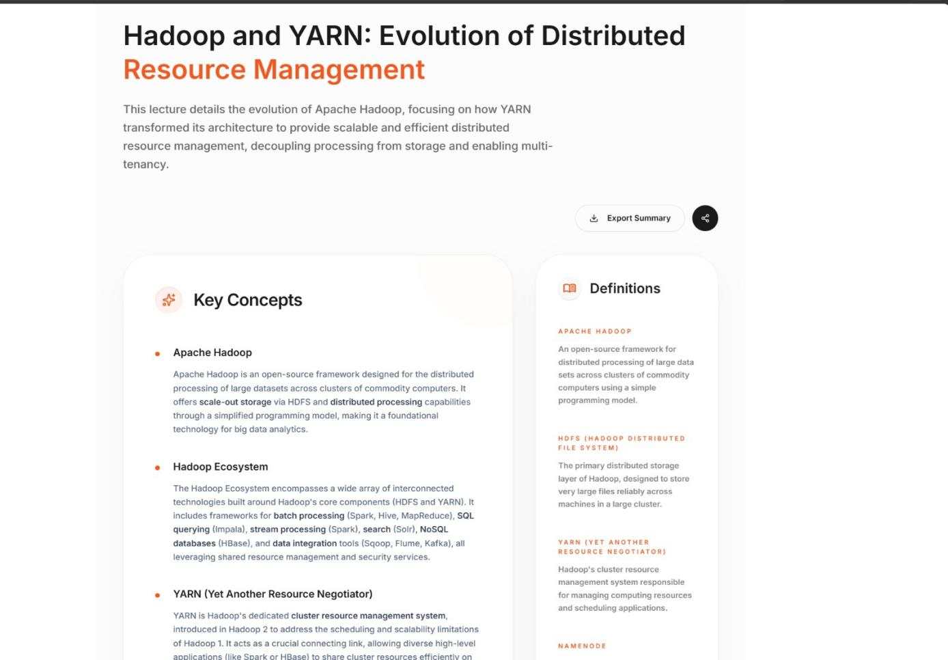
Figure 5.6 LectureMate - showing the summarization of the lecture
- Interactive Transcript: A time-synced transcript view that allows users

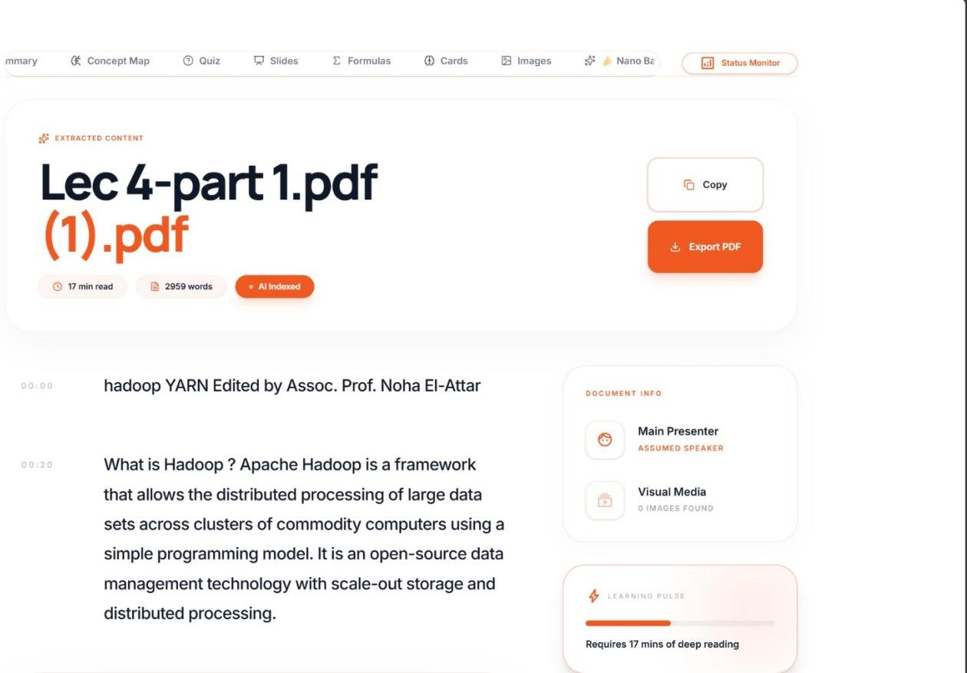
Figure 5.7 LectureMate - showing the Full Transcript of the lecture

- Assessment & Study Tools

- Quiz Module: An interactive assessment of thirty questions offered at three difficulty levels (Comprehensive, Advanced, and Expert). It combines multiple-choice, true/false and open-ended questions; multiple-choice items are timed and graded instantly, while open-ended answers are graded by the AI against the expected key points, returning a numeric score and written feedback.

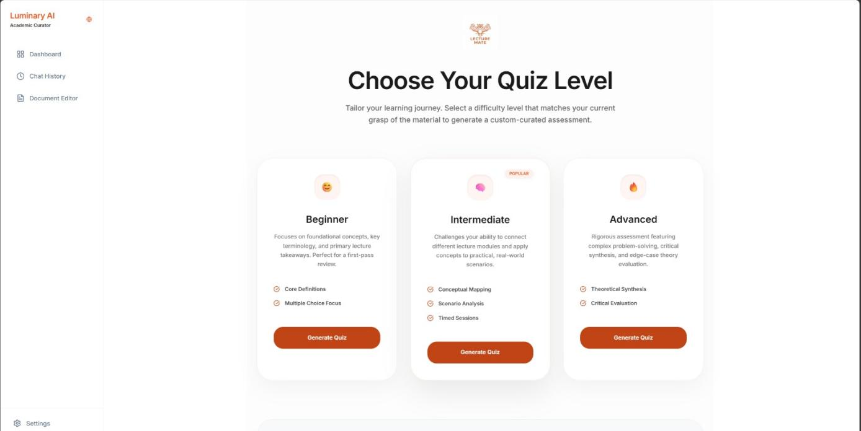

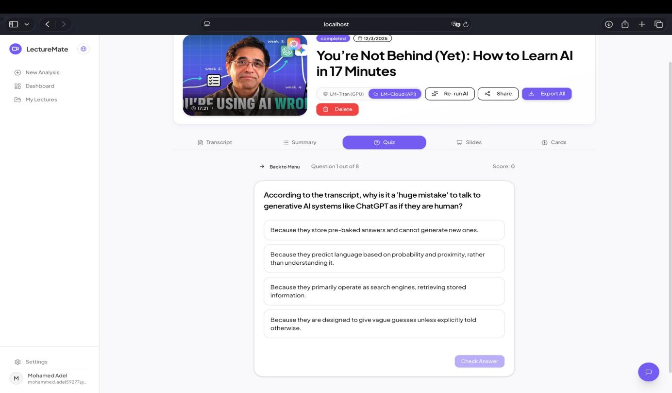
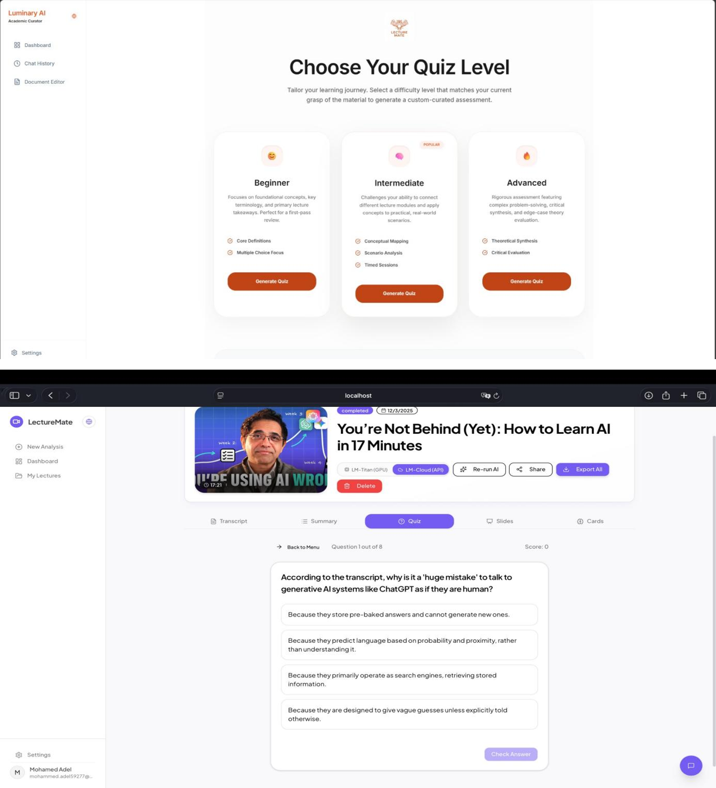
Figure 5.8 LectureMate - Quiz mode selection
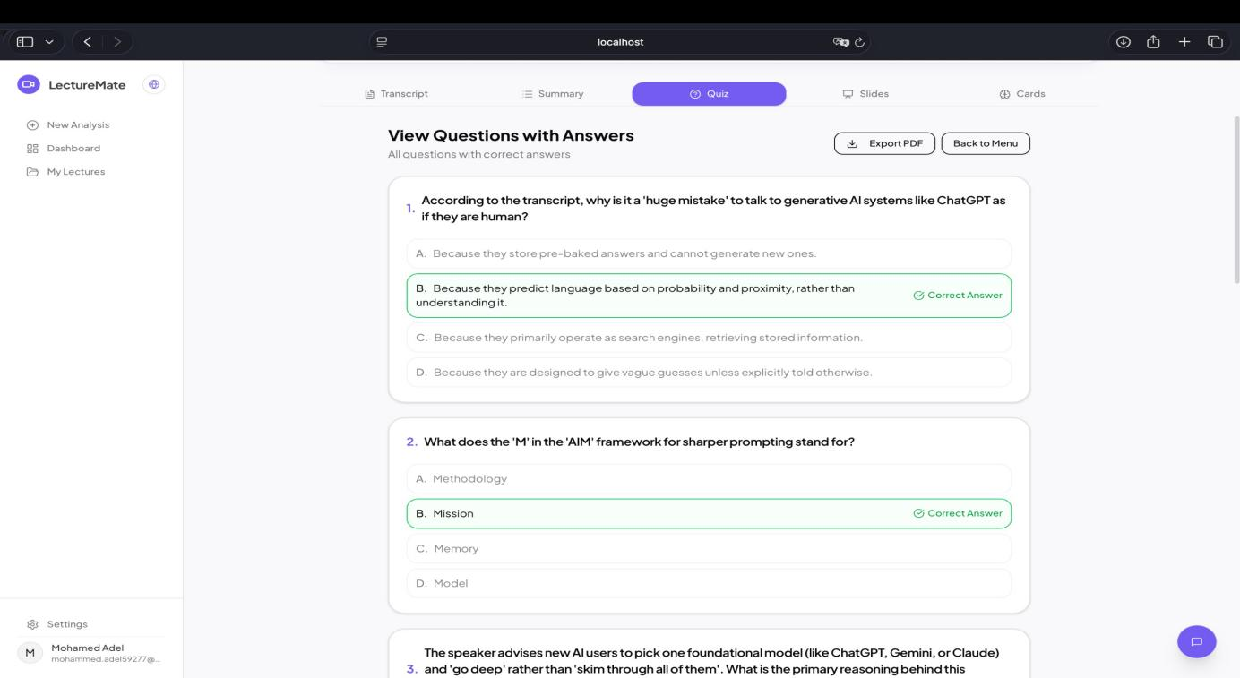
Figure 5.9 LectureMate - View Questions with Answers

- Flashcards: A digital flashcard deck for spaced-repetition study. Each card renders LaTeX mathematics on both faces and can be sorted into review buckets (again / hard / good / easy) so the learner can focus on the weaker material.

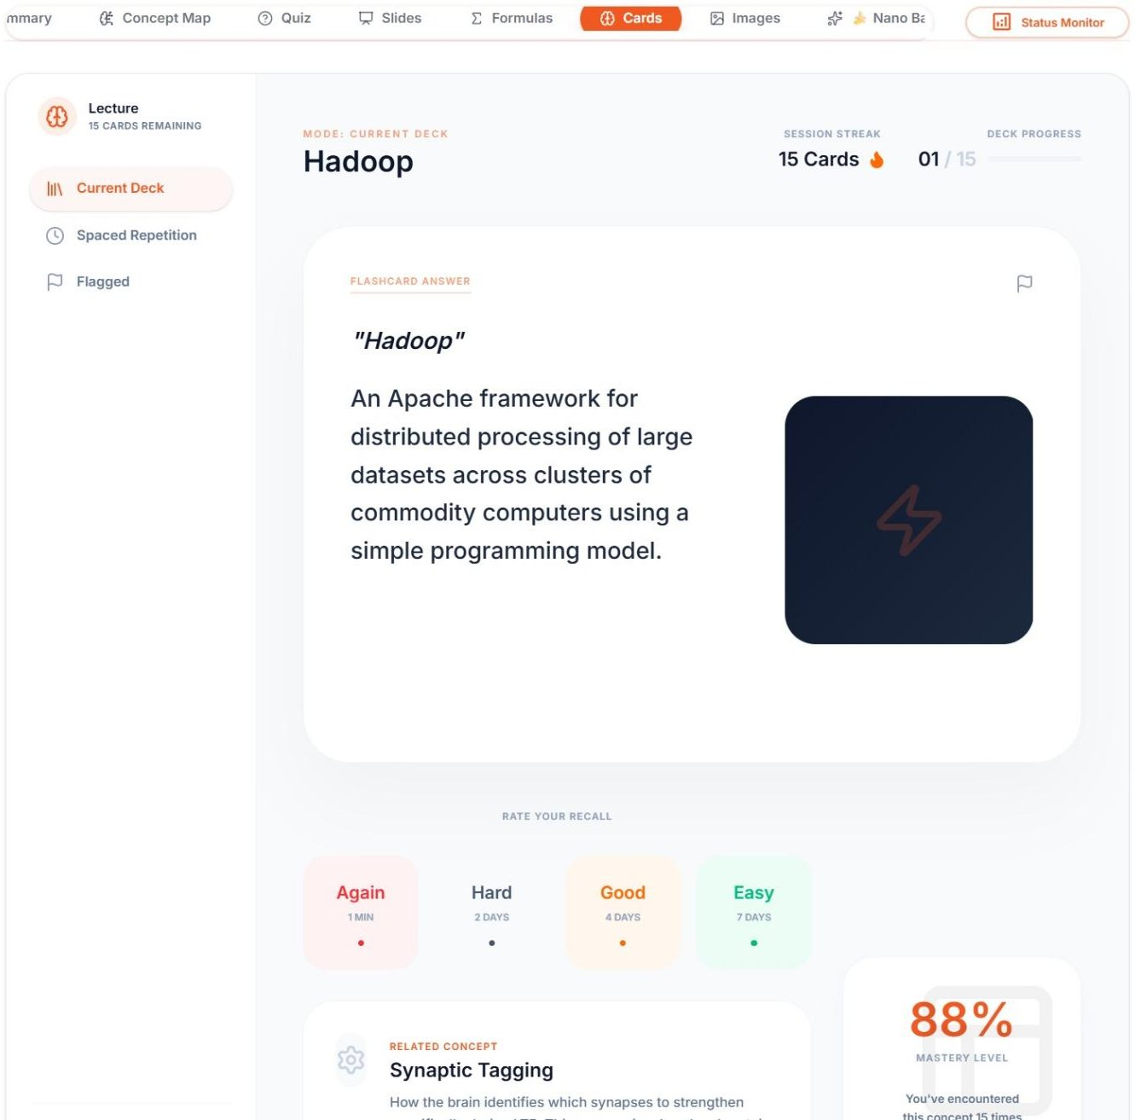
Figure 5.10 LectureMate - Study Flashcards

- Slides Viewer: An in-app presentation viewer that renders the AI-generated deck. The user can choose one of eight visual themes, set a custom accent colour, edit slide text in place, and export the deck to a native .pptx file.

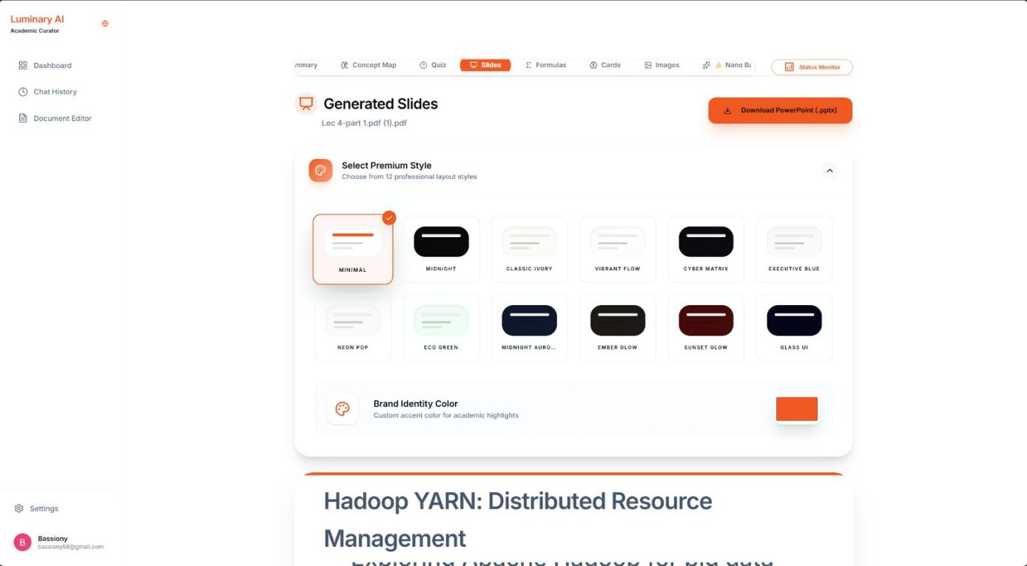
Figure 5.11 LectureMate - Generated Slides, Select Theme

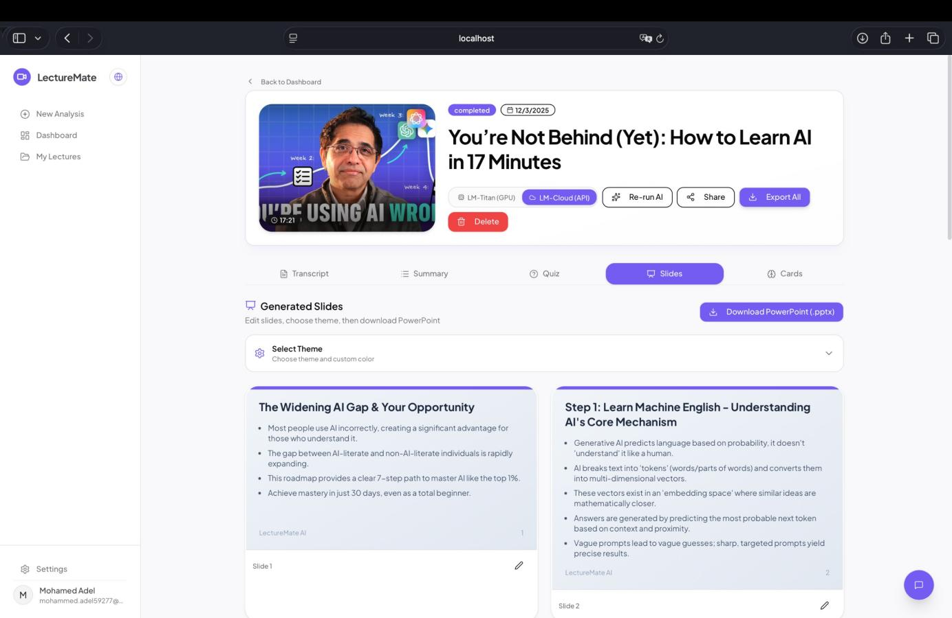
Figure 5.12 LectureMate - showing the Slides tab with the "Download PPTX" button after selecting the Theme
The Slide Generation Engine
Slides are not produced from a single fixed template but from a structured slide grammar of thirteen layout types - title, section divider, bullet list, concept cards, process and timeline steps, statistics, two-column comparison, vector or Mermaid diagram, real-figure, code, and quote - so the model selects the layout that best fits each idea. Each deck is rendered on the server by drawing the React slide components inside a headless Chromium instance at 1280x720 (two-times scale) and capturing every slide as a high-resolution image. The same deck can be exported in three ways: Designed (full-bleed image slides), Text-only (fully editable native PowerPoint text boxes), and Designed + Editable (a hybrid that keeps the visual design as a background while overlaying editable text). Mathematical expressions are rendered with KaTeX and diagrams with Mermaid; Arabic decks are laid out right-to-left with embedded Tajawal fonts, and click-through fade animations are injected directly into the PowerPoint XML.
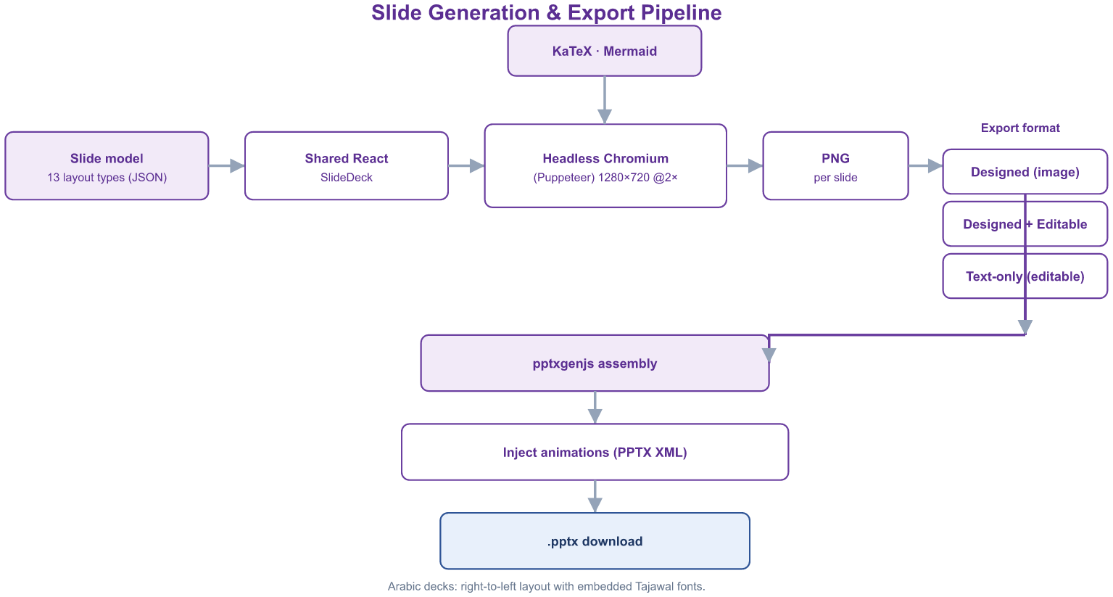
Figure 5.13 LectureMate - Slide Generation and Export Pipeline
Concept Map
An interactive knowledge graph (built with React Flow and a Dagre auto-layout) that draws the lecture's key concepts as nodes and their relationships as labelled, directed edges arranged in a top-down hierarchy. Clicking a node opens a detailed explanation, a guided narration mode walks through the concepts in order, and the graph can be exported as an image.
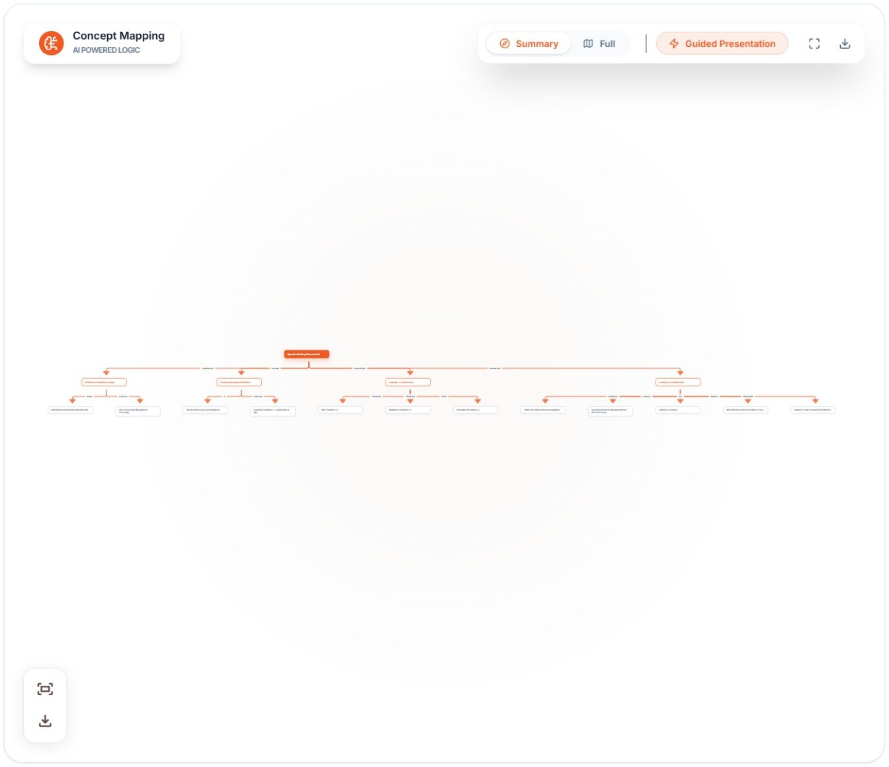
Figure 5.14 LectureMate - Concept Map
Formulas & Equations
Mathematical content is extracted on four levels: formulas stated explicitly, formulas implied by the context, formulas read from diagrams, and the standard formulas expected for the topic. Each entry is rendered with KaTeX and is accompanied by its variables, an optional function graph, and a step-by-step worked solution. The tab is shown automatically only when genuine mathematical content is detected in the lecture.
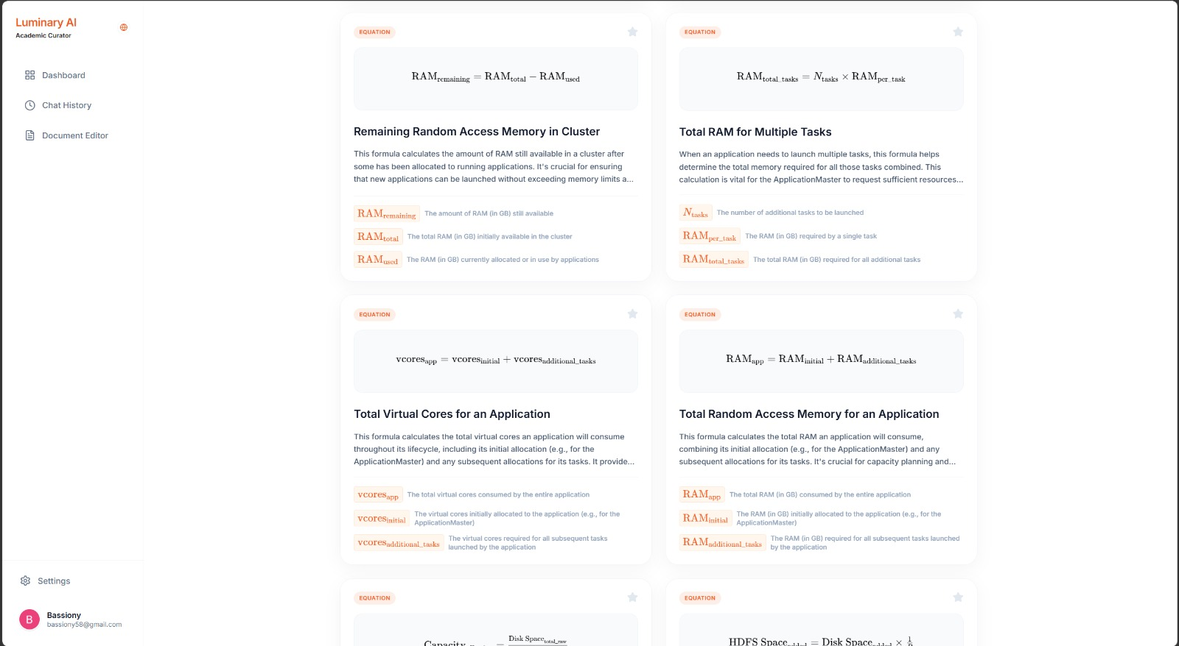
Figure 5.15 LectureMate - Formulas and Equations
Images Gallery
Figures extracted from PDF and PowerPoint sources are screened by Gemini Vision, which discards low-value images (logos, title and closing slides) and writes a short, education-focused caption for each useful figure. The gallery presents these captioned images with a search box and a click-to-expand view.
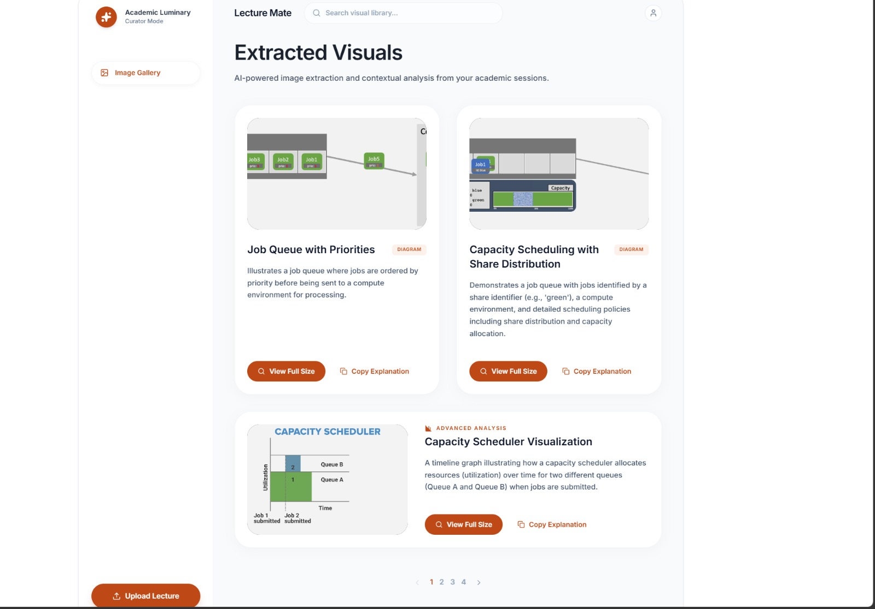
Figure 5.16 LectureMate - Images Gallery with AI captions
AI Chat Tutor
A conversational assistant grounded in the current lecture. The relevant transcript context - and, where useful, summaries of related lectures from the user's library - is supplied to the model so that answers remain tied to the material. The tutor renders Markdown, LaTeX and syntax-highlighted code, accepts an attached image for visual questions, and keeps a persistent per-lecture history.
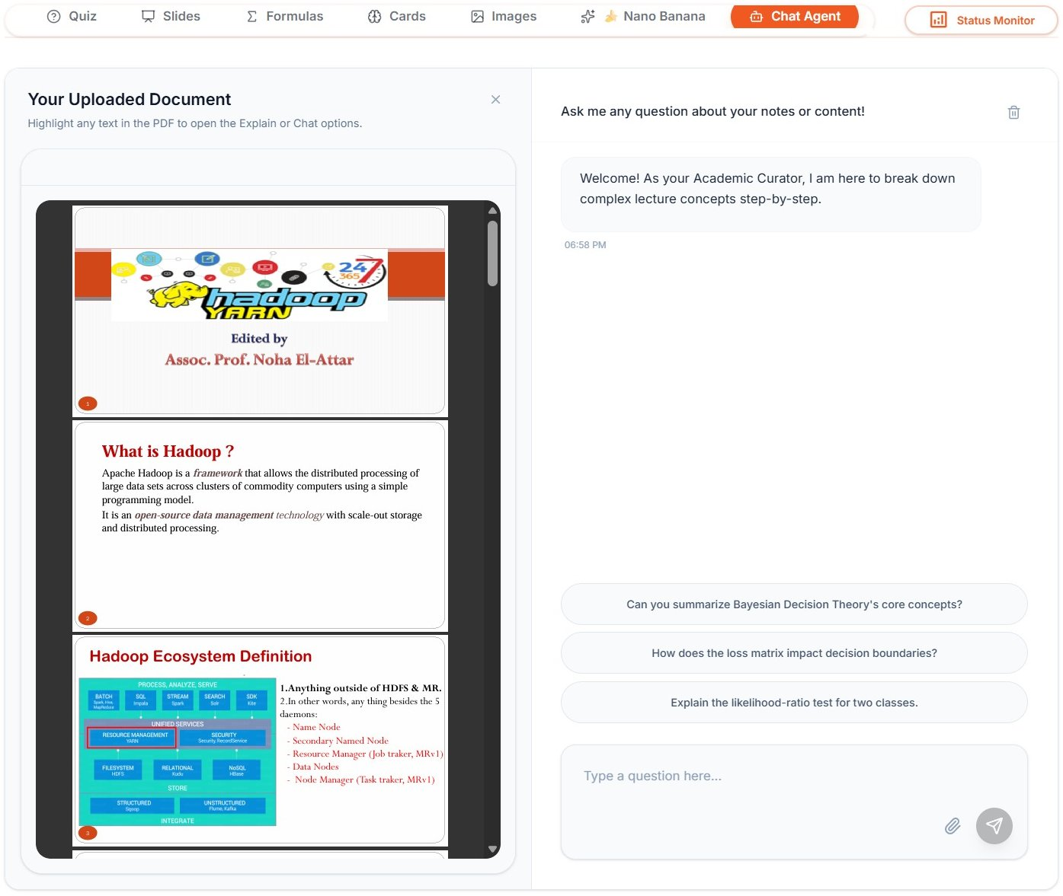
Figure 5.17 LectureMate - AI Chat Tutor
Specialized Domain Views
For lectures classified as medical or engineering, the workspace exposes additional adaptive panels. The Medical Insights panel organises clinical terms, drugs (mechanism, dosage and side-effects), reference calculators such as BMI and GFR, and procedures, with anatomy and pathology diagrams and an interactive three-dimensional molecule viewer (3Dmol.js with PubChem data). The Engineering Lab panel presents electronic components and their specifications, circuit diagrams, compilable code snippets and worked formulas. These panels appear only when the detected category of the lecture warrants them.
Library & Categories
Every processed lecture is stored in a personal Library together with its thumbnail, source type and completion status, and can be searched and resumed. Each lecture is automatically classified into one of eleven academic categories (science, technology, engineering, mathematics, medicine, history, art, language, business, education, or other), so the Library can be filtered by subject.
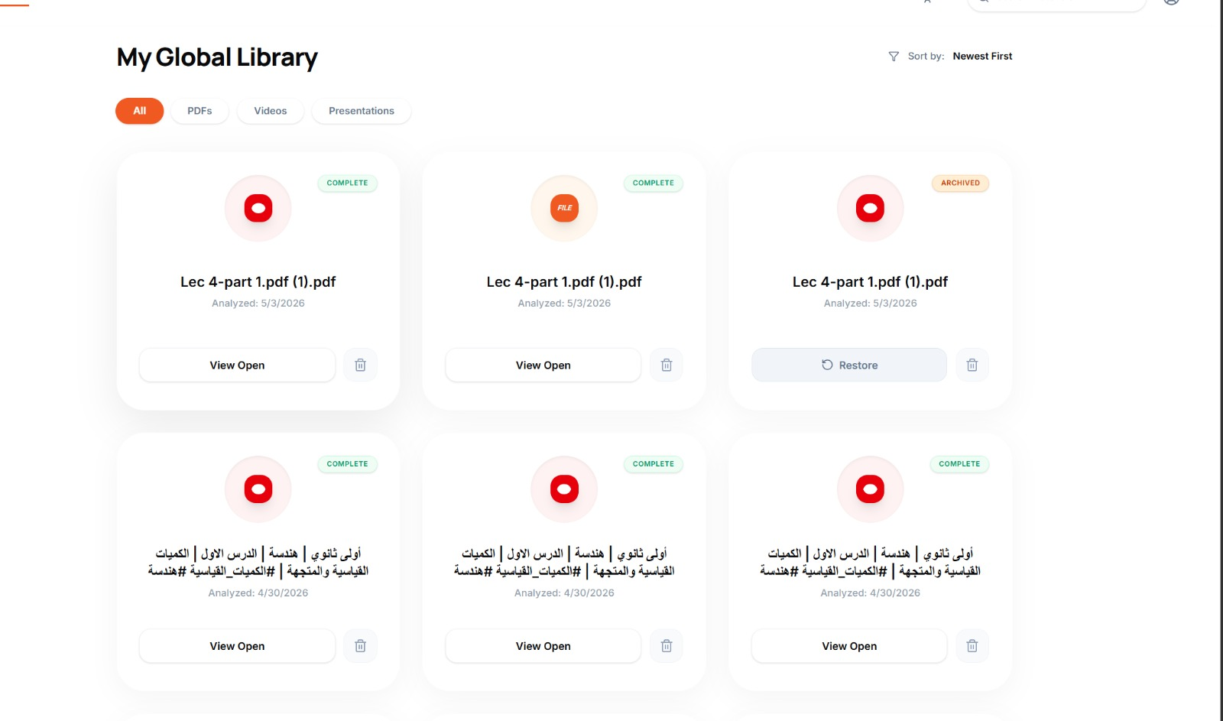
Figure 5.18 LectureMate - Library of saved lectures
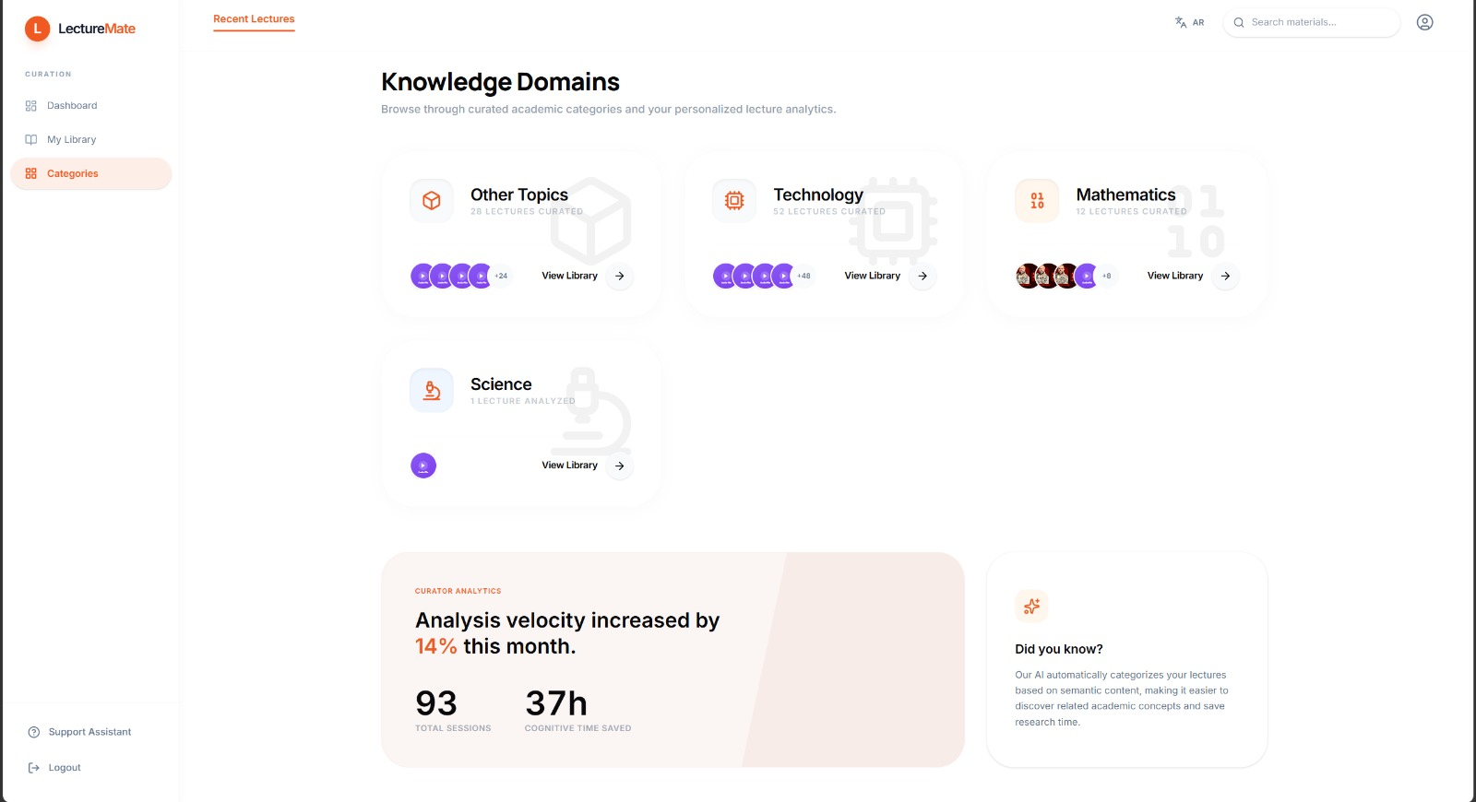
Figure 5.19 LectureMate - Categories browser

5.6 Profile & Settings Management

The Profile page allows users to manage their account details through a categorized sidebar interface.
- General: For updating personal information like display name and profile picture.
- Billing: Displays subscription status ("Pro Plan") and billing cycles.
- Security: Manages password updates and displays account email status.
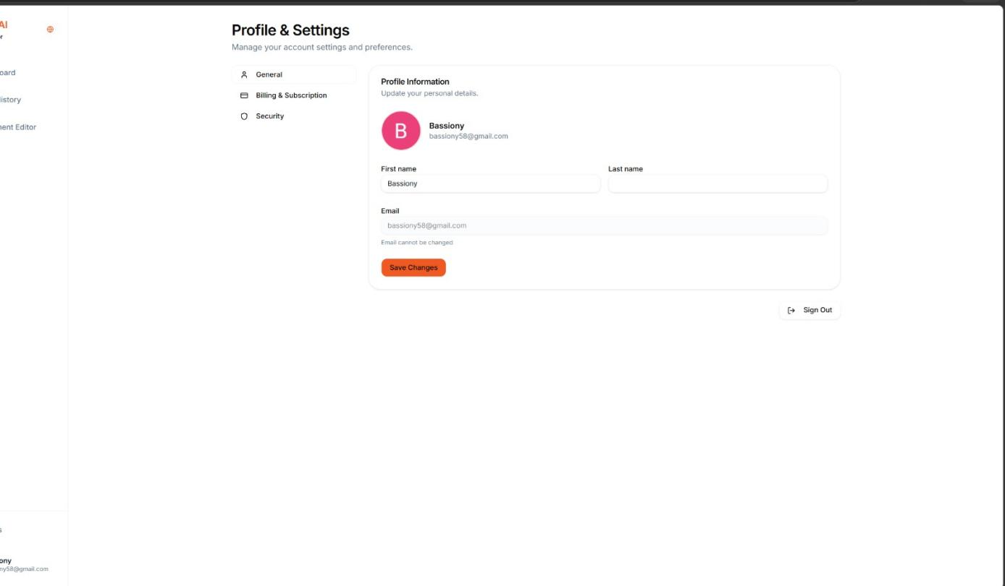
Figure 5.20 LectureMate - Setting profile

5.7 UI/UX Design Philosophy

- Responsive Design: The interface uses a sidebar layout on desktop that transforms into a collapsible drawer on mobile devices, ensuring accessibility across all screen sizes.

- Global Language Toggle: A dedicated button in the sidebar allows instant switching between English and Arabic, triggering a full layout inversion (LTR to RTL) to support Arabic users natively.

5.8 Summary
This chapter detailed the implementation of the LectureMate user interface, demonstrating how the system translates complex backend processing into a simple, intuitive user experience. The flow from secure authentication to the interactive dashboard and rich study tools highlights the system's focus on usability and educational value.
Chapter 6

Evaluation, Conclusion and Future Work

6.1 Evaluation and Comparison
LectureMate is evaluated along two axes: a qualitative feature comparison against the leading comparable platforms reviewed in Chapter 2, and the design performance targets defined for the system. Table 6.1 positions LectureMate against NoteGPT and TurboLearn AI across the core study-generation capabilities.
Capability | LectureMate | NoteGPT | TurboLearn AI
Multi-source input (YouTube, audio, PDF, Word, PPTX) | Yes | Partial | Partial
Abstractive summary | Yes | Yes | Yes
Auto quizzes (MCQ / T-F / essay) with AI grading | Yes | Limited | Yes
Flashcards (LaTeX-aware) | Yes | Yes | Yes
PowerPoint slide-deck export | Yes | No | No
Interactive concept map | Yes | No | No
Formula extraction with step-by-step solutions | Yes | No | No
Image captioning (Vision) | Yes | No | No
Domain panels (medical / engineering / 3D) | Yes | No | No
Lecture-grounded chat tutor | Yes | Yes | No
Local / offline model (privacy) | Yes | No | No
Bilingual Arabic / English with RTL | Yes | Limited | Limited
Table 6.1 Feature comparison of LectureMate with NoteGPT and TurboLearn AI.
Against the design targets defined in Chapter 4, the system aims to summarise a 30-minute lecture in under 30 seconds, generate a question set in under 45 seconds, keep content accuracy above 90%, and keep transcription error below 10% Word Error Rate for typical classroom recordings.
Qualitatively, the generated artefacts are produced within minutes of submission and are immediately usable: summaries preserve the lecture's logical structure, quizzes include corrective explanations, flashcards and formulas render LaTeX correctly, and slide decks export to editable PowerPoint with Arabic-aware fonts. The dual-engine design lets the same workflow run either fully offline (for privacy) or on the cloud (for maximum reasoning quality).
A formal empirical evaluation - measuring transcription Word Error Rate on the project's own lecture dataset and collecting structured user feedback on the quality of the generated study material - is identified as the immediate next step (Section 6.3).

6.2 Conclusion
In this thesis, we presented the design and implementation of LectureMate, an advanced AI-powered lecture assistant aimed at transforming the passive learning experience into an active, interactive engagement. By leveraging state-of-the-art Large Language Models (LLMs) such as Qwen and Gemini, combined with robust audio processing frameworks like Whisper, we successfully addressed the challenges of information overload and accessibility in digital education.
The developed platform successfully integrates video transcription, automated summarization, and an interactive chatbot interface, enabling students to digest complex educational content efficiently. Through the utilization of a modern technology stack comprising React 19 for the frontend and a Node.js / Express backend orchestrating specialised Python workers, and a scalable database architecture LectureMate proves that AI can be effectively harnessed to personalize the learning journey, reducing the time required for study while maximizing comprehension.

6.3 Future Development
While LectureMate already ingests YouTube, audio, PDF, Word and PowerPoint sources and generates a full study workspace (summaries, quizzes, flashcards, slides, a concept map, formulas, captioned images and a chat tutor), the roadmap focuses on the following enhancements:

6.3.1 Semantic Retrieval with a Vector Database (RAG)
Multi-format ingestion (PDF, Word, PowerPoint and document-image analysis) has already been delivered. The next step is to add an embedding-based vector store so the chat tutor can perform true semantic retrieval (Retrieval-Augmented Generation). Each transcript chunk would be encoded into a high-dimensional vector with an embedding model and indexed in a vector database (for example FAISS or ChromaDB), enabling semantic search across long lectures - and eventually across the entire library - instead of the current direct context assembly.

6.3.2 Adaptive Review and Additional Inputs
The interactive concept map already provides the visual knowledge-graph capability that was originally planned. Future work here is twofold. First, a full spaced-repetition scheduler (an FSRS-style algorithm) will sit on top of the existing flashcard review buckets to schedule each card at its optimal retention interval. Second, two new input modes will be added: live audio recording from the microphone and direct pasting of an existing transcript, complementing the current file and URL inputs.

6.3.3 Advanced Cross-Lingual Translation and Localization
Recognizing the language barrier in global education, a core future enhancement is a robust translation engine. This feature goes beyond simple text translation; it will enable Cross-Lingual Summarization. For instance, if a user uploads a lecture delivered in English, they will have the option to receive the transcription, summary, quizzes, and chat responses in their native language (Arabic). This localization ensures that high-quality educational content is accessible to non-English speakers, bridging the gap between global knowledge and local understanding.

6.3.4 Ecosystem Integration and Export
To fit existing study workflows, the platform will add one-click export of the generated material to Learning Management Systems (Moodle, Blackboard, Canvas) and to external study tools such as Anki and Quizlet, together with a direct Word/PDF export from the built-in editor and a native mobile application for offline study.

6.3.5 Performance Analytics and Adaptive Learning
Finally, by recording quiz and flashcard performance over time, LectureMate will offer an analytics dashboard and adaptive difficulty, tailoring the generated questions and review schedule to each learner's measured strengths and weaknesses.

References
- Core Frameworks & Languages
- React (Frontend Framework):
- Facebook. (n.d.). React - The library for web and native user interfaces. Retrieved from https://react.dev/
- TypeScript (Programming Language):
- Microsoft. (n.d.). TypeScript - JavaScript with syntax for types. Retrieved from https://www.typescriptlang.org/
- Node.js (Backend Runtime):
- OpenJS Foundation. (n.d.). Node.js. Retrieved from https://nodejs.org/
- Express.js (Backend Web Framework):
- StrongLoop, IBM, & other contributors. (n.d.). Express - Fast, unopinionated, minimalist web framework for Node.js. Retrieved from https://expressjs.com/
- Vite (Frontend Build Tool):
- Evan You & contributors. (n.d.). Vite - Next Generation Frontend Tooling. Retrieved from https://vitejs.dev/
- Artificial Intelligence & Machine Learning
- Google Gemini API (Cloud LLM):
- Google. (n.d.). Google AI for Developers - Build with Gemini. Retrieved from https://ai.google.dev/

- Used via the @google/generative-ai SDK for summarization, quizzes, and flashcards.
- Ollama (Local LLM Runner):
- Ollama. (n.d.). Ollama - Get up and running with large language models, locally. Retrieved from https://ollama.com/
- Used to host and run the Qwen model locally.
- Qwen (Local Language Model):
- Alibaba Cloud. (2024). Qwen2.5: A Party of Foundation Models. Retrieved from https://github.com/QwenLM/Qwen2.5
- Used for local, offline text generation via Ollama.
- Faster-Whisper (Audio Transcription):
- SYSTRAN. (n.d.). faster-whisper - Faster Whisper transcription with CTranslate2. Retrieved from https://github.com/SYSTRAN/faster-whisper
- An optimized implementation of OpenAI's Whisper model used for converting speech to text.
- OpenAI Whisper (Base ASR Model):
- Radford, A., et al. (2022). Robust Speech Recognition via Large-Scale Weak Supervision. OpenAI. Retrieved from https://github.com/openai/whisper
- The foundational model architecture that faster-whisper is based on.

- Backend Services & Database
- Firebase (Auth, Firestore, Storage):
- Google. (n.d.). Firebase - App Development Platform. Retrieved from https://firebase.google.com/
- Used for user authentication, real-time database (Firestore), and cloud file storage.
- Firebase Admin SDK:
- Google. (n.d.). Add the Firebase Admin SDK to your server. Retrieved from https://firebase.google.com/docs/admin/setup
- Media Processing Tools
- yt-dlp (Video Downloader):
- yt-dlp contributors. (n.d.). yt-dlp - A feature-rich command-line audio/video downloader. Retrieved from https://github.com/yt-dlp/yt-dlp
- Used in Python scripts to download audio from YouTube videos.
- FFmpeg (Multimedia Framework):
- FFmpeg team. (n.d.). FFmpeg - A complete, cross-platform solution to record, convert and stream audio and video. Retrieved from https://ffmpeg.org/
- Utilized implicitly by yt-dlp and faster-whisper for audio processing tasks.
- Key Libraries & UI Components
- Tailwind CSS (Utility-first CSS Framework):

- Tailwind Labs Inc. (n.d.). Tailwind CSS - Rapidly build modern websites without ever leaving your HTML. Retrieved from https://tailwindcss.com/
- Radix UI (Headless UI Components):
- WorkOS. (n.d.). Radix UI - Unstyled, accessible components for building high-quality design systems. Retrieved from https://www.radix-ui.com/
- Framer Motion (Animation Library):
- Framer. (n.d.). Framer Motion - A production-ready motion library for React. Retrieved from https://www.framer.com/motion/
- TanStack Query (Data Fetching):
- TanStack. (n.d.). TanStack Query - Powerful asynchronous state management for TS/JS. Retrieved from https://tanstack.com/query/latest
- React Hook Form (Form Validation):
- Beier, B. (n.d.). React Hook Form - Performant, flexible and extensible forms with easy-to-use validation. Retrieved from https://react-hook-form.com/
- Zod (Schema Validation):
- TypeScript-first schema validation with static type inference. Retrieved from https://zod.dev/
- PptxGenJS (PowerPoint Generation):
- Brent Ely. (n.d.). PptxGenJS - PlayStation-style JavaScript Library for creating PowerPoint Presentations.https://gitbrent.github.io/PptxGenJS/
Academic & Background References
Ebbinghaus, H. (1885). Über das Gedächtnis (Memory: A Contribution to Experimental Psychology). Duncker & Humblot.
Leitner, S. (1972). So lernt man lernen: Der Weg zum Erfolg (How to Learn to Learn). Herder.
Open Spaced Repetition. (n.d.). FSRS – Free Spaced Repetition Scheduler. Retrieved from https://github.com/open-spaced-repetition/fsrs4anki
European Union. (2016). General Data Protection Regulation (GDPR), Regulation (EU) 2016/679. Official Journal of the European Union.
U.S. Department of Education. (1974). Family Educational Rights and Privacy Act (FERPA), 20 U.S.C. § 1232g.

